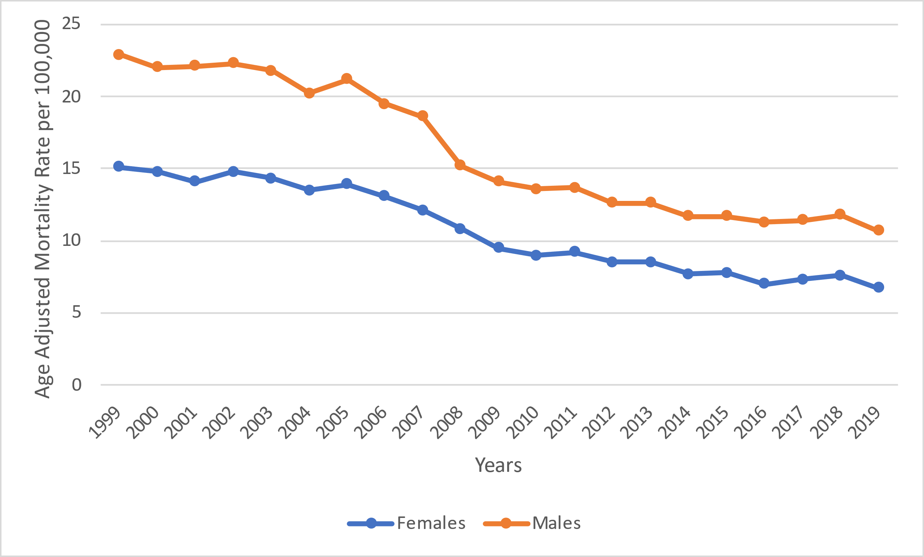
Supplementary Figure 1: DM and pneumonia related AAMRs per 100,000 stratified by years in adults in the United States, 1999 to 2019

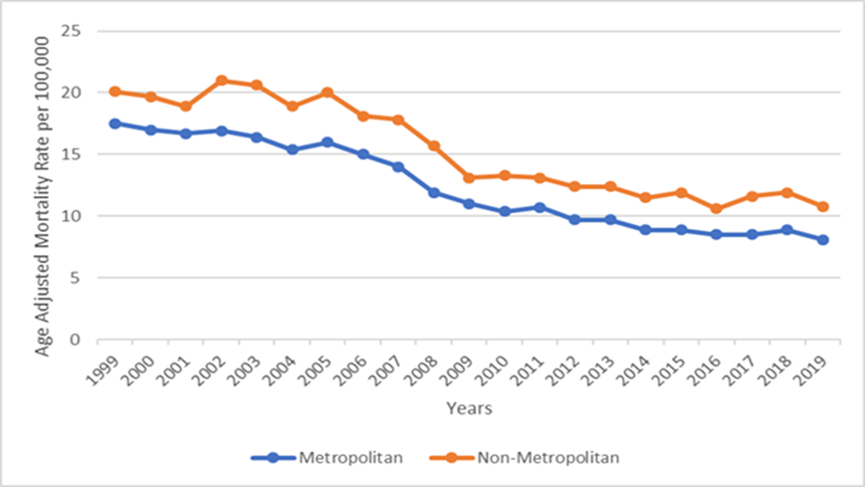
Supplementary Figure 2: DM and Pneumonia-related AAMRs per 100,000 by Urban-Rural status in adults in the United States, 1999 to 2019
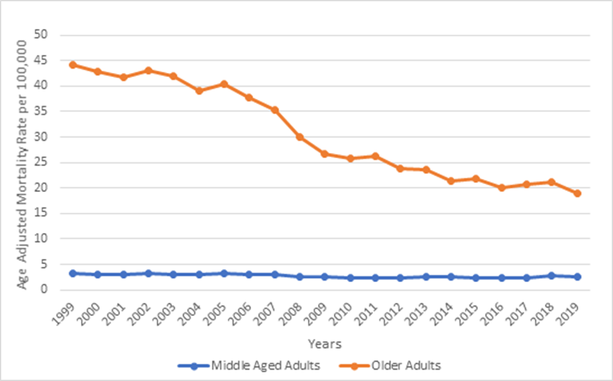
Supplemantary Figure 3
DM and pneumonia-related AAMRs per 100,000 by age group in adults in the United States, 1999 to 2019

Year | Overall | Female | Male
1999 | 17106 | 8841 | 8265
2000 | 16842 | 8757 | 8085
2001 | 16732 | 8469 | 8263
2002 | 17514 | 8973 | 8541
2003 | 17321 | 8774 | 8547
2004 | 16437 | 8345 | 8092
2005 | 17477 | 8734 | 8743
2006 | 16597 | 8379 | 8218
2007 | 15967 | 7885 | 8082
2008 | 13943 | 7155 | 6788
2009 | 12910 | 6425 | 6485
2010 | 12541 | 6162 | 6379
2011 | 13172 | 6506 | 6666
2012 | 12352 | 6065 | 6287
2013 | 12722 | 6186 | 6536
2014 | 11962 | 5705 | 6257
2015 | 12298 | 5890 | 6408
2016 | 11765 | 5378 | 6387
2017 | 12444 | 5798 | 6646
2018 | 13116 | 6045 | 7071
2019 | 12141 | 5482 | 6659

Supplementary Table 1: Overall and sex-stratified mortality among United States adults with DM and associated pneumonia from 1999-2019.

Year | Overall e | Female | Male
1999 | 18 (17.7-18.3) | 15.1(14.7-15.4) | 22.9(22.4-23.4)
2000 | 17.5 (17.2-17.8) | 14.8 (14.5-15.1) | 22(21.5-22.5)
2001 | 17.1 (16.9-17.4) | 14.1(13.8-14.4) | 22.1(21.6-22.6)
2002 | 17.6 (17.4-17.9) | 14.8(14.5-15.1) | 22.3(21.8-22.8)
2003 | 17.2 (16.9-17.4) | 14.3 (14-14.6) | 21.8(21.3-22.3)
2004 | 16.1 (15.8-16.3) | 13.5 (13.2-13.7) | 20.2(19.7-20.6)
2005 | 16.7 (16.5-17) | 13.9 (13.6-14.2) | 21.2(20.8-21.7)
2006 | 15.6 (15.3-15.8) | 13.1 (12.8-13.4) | 19.5(19-19.9)
2007 | 14.7 (14.5-14.9) | 12.1 (11.9-12.4) | 18.6(18.2-19)
2008 | 12.6 (12.4-12.8) | 10.8 (10.5-11) | 15.2(14.9-15.6)
2009 | 11.4 (11.2-11.6) | 9.5 (9.3-9.8) | 14.1(13.8-14.5)
2010 | 10.9 (10.7-11.1) | 9 (8.8-9.2) | 13.6(13.3-14)
2011 | 11.1 (10.9-11.3) | 9.2(9-9.5) | 13.7(13.4-14)
2012 | 10.2 (10-10.3) | 8.5 (8.3-8.7) | 12.6(12.2-12.9)
2013 | 10.2 (10-10.4) | 8.5 (8.2-8.7) | 12.6(12.3-12.9)
2014 | 9.4 (9.2-9.5) | 7.7 (7.5-7.9) | 11.7(11.4-12)
2015 | 9.4 (9.2-9.6) | 7.8 (7.6-8) | 11.7(11.4-12)
2016 | 8.8 (8.6-9) | 7 (6.8-7.2) | 11.3(11-11.6)
2017 | 9 (8.9-9.2) | 7.3 (7.1-7.5) | 11.4(11.2-11.7)
2018 | 9.4 (9.2-9.6) | 7.6 (7.4-7.8) | 11.8(11.5-12.1)
2019 | 8.5 (8.3-8.6) | 6.7 (6.6-6.9) | 10.7(10.5-11)

Supplementary Table 2: Overall and sex-stratified AAMR in patients with DM and associated pneumonia per 100,000 in the United States from 1999-2019.

Year | NH American Indian or Alaska Native | NH Asian or Pacific Islander | NH Black or African American | NH White | Hispanic or Latino
1999 | 35.8(29.3-42.4) | 20.7(18.6-22.9) | 28.3(27.1-29.5) | 16.4(16.1-16.7) | 25.7(24.2-27.3)
2000 | 26.3(21.2-32.3) | 18.6(16.6-20.5) | 28.2(27-29.4) | 16(15.7-16.3) | 23.9(22.4-25.3)
2001 | 27.1(21.8-32.4) | 19.8(17.9-21.7) | 26.5(25.4-27.7) | 15.5(15.2-15.7) | 26.5(25-28)
2002 | 31.3(25.6-37) | 20.3(18.4-22.2) | 27.3(26.1-28.4) | 16.1(15.8-16.3) | 24.3(22.9-25.7)
2003 | 34.8(28.8-40.8) | 20.3(18.4-22.1) | 26.3(25.2-27.4) | 15.6(15.4-15.9) | 24.3(23-25.7)
2004 | 26.3(21.3-31.3) | 19(17.2-20.7) | 25.2(24.1-26.3) | 14.6(14.3-14.8) | 22.1(20.8-23.4)
2005 | 30(24.5-35.4) | 19(17.4-20.7) | 26.1(25-27.2) | 15.1(14.9-15.4) | 23.3(22-24.6)
2006 | 27.2(22.2-32.3) | 18.2(16.7-19.8) | 24.2(23.2-25.2) | 14.1(13.9-14.4) | 21.6(20.4-22.8)
2007 | 27.1(22.2-32) | 15.8(14.4-17.2) | 22.4(21.4-23.4) | 13.3(13-13.5) | 21.3(20.2-22.5)
2008 | 21.1(17-25.2) | 15.9(14.5-17.2) | 19.7(18.8-20.6) | 11.1(10.9-11.3) | 18.9(17.9-20)
2009 | 20(16-24.1) | 14.2(12.9-15.4) | 17.8(17-18.7) | 9.9(9.7-10.1) | 17.7(16.8-18.7)
2010 | 20.6(16.6-24.6) | 13.3(12.1-14.4) | 17.2(16.4-18) | 9.5(9.3-9.7) | 17.2(16.2-18.1)
2011 | 21(17.1-24.8) | 12.8(11.7-13.9) | 17.4(16.6-18.3) | 9.7(9.5-9.9) | 16.8(15.9-17.7)
2012 | 16.8(13.4-20.2) | 10.8(9.8-11.8) | 15.8(15-16.5) | 8.9(8.7-9.1) | 15.3(14.5-16.2)
2013 | 21.8(18-25.5) | 11.4(10.5-12.4) | 15.6(14.8-16.3) | 8.9(8.7-9) | 15.6(14.8-16.4)
2014 | 18.2(14.9-21.5) | 9.9(9.1-10.8) | 13.4(12.7-14.1) | 8.3(8.1-8.5) | 14(13.2-14.7)
2015 | 21.8(18.3-25.3) | 9.9(9-10.7) | 13(12.4-13.7) | 8.3(8.2-8.5) | 13.6(12.9-14.3)
2016 | 15.5(12.6-18.5) | 9.3(8.5-10.1) | 12.9(12.3-13.6) | 7.7(7.5-7.9) | 13(12.3-13.7)
2017 | 20.6(17.4-23.8) | 9.8(9-10.5) | 12.3(11.7-12.9) | 7.9(7.7-8.1) | 13.9(13.2-14.6)
2018 | 18(15.1-21) | 9.7(8.9-10.4) | 13.5(12.9-14.1) | 8.3(8.1-8.4) | 13.1(12.4-13.7)
2019 | 16.6(13.9-19.4) | 8.4(7.7-9.1) | 12.3(11.7-12.9) | 7.4(7.3-7.6) | 12.1(11.5-12.7)

Supplementary Table 3. Diabetes mellitus associated with Pneumonia AAMR per 100,000 stratified by race in the United States from 1999 to 2019.

 | Year |  | Metropolitan |  | Non-Metropolitan
1999 |  | 17.5(17.2-17.8) |  | 20.1(19.4-20.7)
2000 |  | 17(16.7-17.3) |  | 19.7(19.1-20.4)
2001 |  | 16.7(16.4-17) |  | 18.9(18.2-19.5)
2002 |  | 16.9(16.6-17.2) |  | 21(20.4-21.7)
2003 |  | 16.4(16.1-16.7) |  | 20.6(19.9-21.2)
2004 |  | 15.4(15.2-15.7) |  | 18.9(18.3-19.5)
2005 |  | 16(15.8-16.3) |  | 20(19.3-20.6)
2006 |  | 15(14.8-15.3) |  | 18.1(17.5-18.7)
2007 |  | 14(13.8-14.3) |  | 17.8(17.2-18.4)
2008 |  | 11.9(11.6-12.1) |  | 15.7(15.2-16.3)
2009 |  | 11(10.8-11.2) |  | 13.1(12.6-13.6)
2010 |  | 10.4(10.2-10.6) |  | 13.3(12.8-13.8)
2011 |  | 10.7(10.5-10.9) |  | 13.1(12.6-13.6)
2012 |  | 9.7(9.5-9.9) |  | 12.4(11.9-12.8)
2013 |  | 9.7(9.5-9.9) |  | 12.4(11.9-12.8)
2014 |  | 8.9(8.8-9.1) |  | 11.5(11-11.9)
2015 |  | 8.9(8.7-9.1) |  | 11.9(11.4-12.3)
2016 |  | 8.5(8.3-8.6) |  | 10.6(10.1-11)
2017 |  | 8.5(8.4-8.7) |  | 11.6(11.2-12.1)
2018 |  | 8.9(8.7-9.1) |  | 11.9(11.5-12.4)
2019 |  | 8.1(7.9-8.2) |  | 10.8(10.3-11.2)

Supplementary Table 4. AAMR in patients with Diabets Mellitus associated with Pneumonia per 100,000 stratified by urban-rural classification in the United States from 1999 to 2019.

Year | Middle age Adults (45-64) | Old Adults (65+)
1999 | 3.2(3-3.3) | 44.1(43.4-44.8)
2000 | 3.1(2.9-3.2) | 42.9(42.2-43.6)
2001 | 3.1(3-3.3) | 41.7(41.1-42.4)
2002 | 3.2(3-3.3) | 43.1(42.4-43.8)
2003 | 3.1(2.9-3.2) | 42(41.3-42.6)
2004 | 2.9(2.8-3) | 39.2(38.5-39.8)
2005 | 3.2(3-3.3) | 40.5(39.9-41.2)
2006 | 3(2.9-3.1) | 37.7(37.1-38.3)
2007 | 3(2.8-3.1) | 35.4(34.8-36)
2008 | 2.6(2.5-2.7) | 30(29.5-30.6)
2009 | 2.6(2.5-2.8) | 26.7(26.2-27.2)
2010 | 2.3(2.2-2.4) | 25.8(25.3-26.3)
2011 | 2.4(2.3-2.5) | 26.3(25.8-26.8)
2012 | 2.4(2.3-2.5) | 23.9(23.4-24.3)
2013 | 2.5(2.4-2.6) | 23.7(23.3-24.2)
2014 | 2.5(2.4-2.6) | 21.4(21-21.9)
2015 | 2.3(2.2-2.4) | 21.8(21.3-22.2)
2016 | 2.3(2.2-2.4) | 20.1(19.7-20.5)
2017 | 2.4(2.3-2.5) | 20.8(20.4-21.2)
2018 | 2.7(2.6-2.8) | 21.2(20.8-21.6)
2019 | 2.5(2.4-2.6) | 18.9(18.6-19.3)

.

Supplementary Table 5. Diabetes Mellitus associated with Pneumonia related AAMR per 100,000 stratified by age group in the United States from 1999 to 2019.

Year | Northeast | Midwest | South | West
1999 | 16.6(16.1-17.2) | 18.8(18.3-19.4) | 16.8(16.4-17.3) | 20.6(20-21.3)
2000 | 16.8(16.2-17.4) | 17.3(16.7-17.8) | 16.8(16.4-17.3) | 19.7(19.1-20.4)
2001 | 15.7(15.2-16.2) | 16.7(16.2-17.2) | 16.5(16.1-16.9) | 20.1(19.4-20.7)
2002 | 16.2(15.7-16.8) | 17.7(17.1-18.2) | 17.2(16.8-17.6) | 19.8(19.2-20.4)
2003 | 15.4(14.9-15.9) | 17.3(16.8-17.8) | 16.5(16.1-16.9) | 19.9(19.3-20.5)
2004 | 14.3(13.8-14.8) | 16.5(16-17) | 15.3(14.9-15.7) | 18.6(18-19.2)
2005 | 14.6(14.1-15.1) | 17.4(16.9-17.9) | 15.9(15.5-16.3) | 19.4(18.8-20)
2006 | 13.5(13-14) | 16(15.5-16.5) | 14.8(14.5-15.2) | 18.3(17.7-18.8)
2007 | 12.5(12-13) | 15.2(14.7-15.7) | 14.2(13.9-14.6) | 17(16.4-17.5)
2008 | 10.5(10.1-11) | 13(12.6-13.5) | 12(11.6-12.3) | 15(14.5-15.5)
2009 | 9.3(8.9-9.7) | 11.6(11.2-12) | 11.1(10.8-11.4) | 13.4(12.9-13.9)
2010 | 9.1(8.8-9.5) | 10.6(10.2-11) | 10.9(10.6-11.2) | 12.7(12.2-13.1)
2011 | 9.8(9.4-10.2) | 11.3(10.9-11.7) | 10.4(10.1-10.7) | 13.2(12.7-13.6)
2012 | 8.8(8.4-9.1) | 10(9.7-10.4) | 10(9.7-10.3) | 11.6(11.2-12)
2013 | 8.9(8.5-9.2) | 9.8(9.4-10.2) | 10.2(9.9-10.5) | 11.6(11.2-12)
2014 | 8.5(8.1-8.9) | 9.1(8.7-9.4) | 9.5(9.2-9.8) | 10(9.7-10.4)
2015 | 8.6(8.2-8.9) | 9.2(8.8-9.6) | 9.4(9.1-9.7) | 10.3(9.9-10.7)
2016 | 7.6(7.3-7.9) | 8.2(7.8-8.5) | 9.1(8.8-9.3) | 9.9(9.5-10.2)
2017 | 7.6(7.2-7.9) | 8.4(8-8.7) | 9.3(9-9.5) | 10.6(10.3-11)
2018 | 8(7.7-8.4) | 8.9(8.5-9.2) | 9.7(9.4-10) | 10.4(10.1-10.8)
2019 | 7.5(7.1-7.8) | 7.6(7.3-7.9) | 8.9(8.7-9.2) | 9.4(9.1-9.8)

Supplementary Table 6. Diabetes Mellitus associated with Pneumonia-related AAMR per 100,000 stratified by census region in the United States from 1999 to 2019.

State | Age Adjusted Rate (95% CI)
Alabama | 13.9(13.5-14.2)
Alaska | 8.4(7.3-9.5)
Arizona | 7.8(7.5-8)
Arkansas | 11.8(11.4-12.2)
California | 18.3(18.1-18.4)
Colorado | 8.2(7.8-8.5)
Connecticut | 10.4(10.1-10.8)
Delaware | 10.5(9.8-11.3)
District of Columbia | 17.6(16.4-18.9)
Florida | 6(5.9-6.1)
Georgia | 9.3(9.1-9.6)
Hawaii | 12(11.4-12.6)
Idaho | 10.5(9.9-11.1)
Illinois | 11(10.8-11.3)
Indiana | 12.5(12.2-12.8)
Iowa | 12.8(12.4-13.2)
Kansas | 11.2(10.8-11.7)
Kentucky | 18.3(17.9-18.8)
Louisiana | 9.1(8.8-9.4)
Maine | 10.3(9.8-10.9)
Maryland | 14.6(14.2-14.9)
Massachusetts | 10.5(10.2-10.7)
Michigan | 11.3(11.1-11.5)
Minnesota | 13(12.7-13.4)
Mississippi | 14.9(14.4-15.4)
Missouri | 10.9(10.6-11.2)
Montana | 10(9.3-10.6)
Nebraska | 14.1(13.5-14.7)
Nevada | 6.4(6-6.8)
New Hampshire | 12.3(11.6-12.9)
New Jersey | 9.5(9.3-9.7)
New Mexico | 12.5(11.9-13)
New York | 12.1(12-12.3)
North Carolina | 15.5(15.2-15.8)
North Dakota | 13.9(12.9-14.8)
Ohio | 16.2(16-16.5)
Oklahoma | 19.6(19.1-20.1)
Oregon | 11.1(10.7-11.5)
Pennsylvania | 10.8(10.6-11)
Rhode Island | 15.6(14.8-16.4)
South Carolina | 13.7(13.3-14.1)
South Dakota | 15.3(14.4-16.2)
Tennessee | 15.1(14.7-15.4)
Texas | 15(14.8-15.2)
Utah | 11.2(10.6-11.7)
Vermont | 17.3(16.2-18.4)
Virginia | 9.6(9.4-9.9)
Washington | 12.5(12.2-12.8)
West Virginia | 19.6(18.9-20.3)
Wisconsin | 11(10.7-11.3)
Wyoming | 10.8(9.8-11.8)

Supplementary Table 7. Diabetes Mellitus and Pneumonia- Related AAMR per 100,000 stratified by state in the United States from 1999 to 2019.

Interval of Years | APC (95% CI)
Overall | -3.65%(-4.86 to -2.43)
1999–2006 | -1.55% (-2.43 to -0.67)
2006–2009 | -11.03% (-18.29 to -3.13)
2009–2019 | -2.80% (-3.69 to -1.91)
Female
1999–2006 | -1.68% (-2.94 to -0.40)
2006-2009 | -10.65% (-17.67 to -3.03)
2009–2019 | -3.29% (-4.17 to -2.40).
Male
1999–2006 | -1.66% (-3.01 to -0.29)
2006–2009 | -12.32% (-22.32 to -1.03
2009–2019 | -2.30% (-3.19 to -1.4)
Race
American Indian or Alaska Native
1999–2019 | −3.27% (−4.16 to −2.37)
Asian or Pacific Islander
1999–2005 | -0.87% (-3.55 to 1.88),
2005–2014 | −6.90% (−8.35 to −5.42)
2014–2019 | −2.15% (−5.18 to 0.97)
Black or African American
1999–2005 | -1.96% (-4.02 to 0.13),
2005–2015 | −6.52% (−7.60 to −5.43),
2015-2019 | -0.19% (-4.31 to 4.10).
White
1999–2006 | −1.65% (−2.54 to −0.74)
2006–2009 | −12.15% (−19.61 to −4.0)
2009-2019 | −2.72% (−3.67 to −1.77)
Hispanic or Latino
1999–2019 | -3.98% (−4.34 to −3.63).
Urbanisation
Metropolitan
1999–2006 | -1.83% (-2.82 to -0.83),
2006–2009 | -10.93% (-18.06 to -3.18)
2009–2019 | −2.89% (−3.75 to −2.01)
Non-Metropolitan
1999–2005 | 0.14% (−2.11 to 2.46)
2005–2010 | −8.41% (−13.26 to −3.29)
2010–2019 | −1.79% (−3.24 to -0.32)
Census Region
Northeast
1999–2019 | -3.98% (-5.28 to -2.65)
Midwest
1999–2019 | -4.08% (-5.60 to -2.54).
South
1999–2019 | -3.08% (-4.10 to -2.04)
West
1999–2019 | -3.8% (-5.94 to -1.63)
Age
Middle Aged Adults
1999–2007 | -0.77% (-2.0 to 0.45)
2007–2010 | -7.7% (-19.48 to 5.59)
2010–2019 | 0.85% (−0.44 to 2.17)
Elderly Adults
1999–2006 | -1.75% (-3.02 to -0.46)
2006–2009 | −11.90% (-21.12 to −1.61)
2009-2019 | −3.22% (−4.14 to −2.29)

Supplementary Table 8. Summary APCs of Diabetes Mellitus Associated with Pneumonia Related AAMR per 100,000 in the United States from 1999 to 2019.

