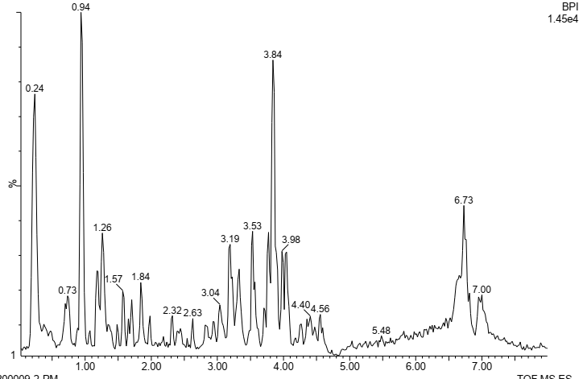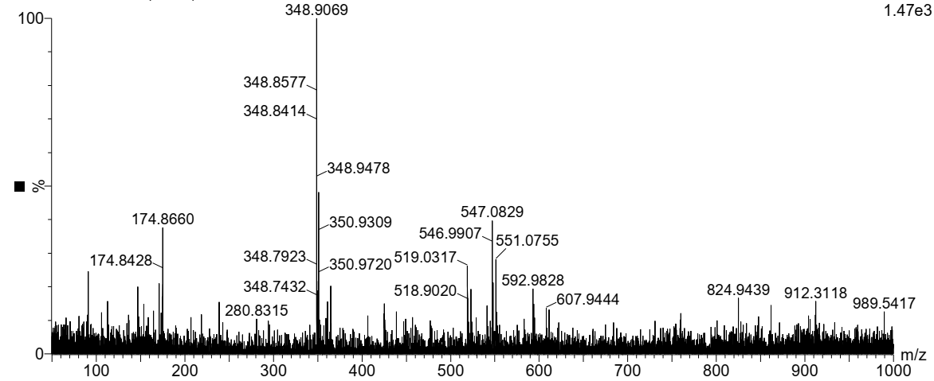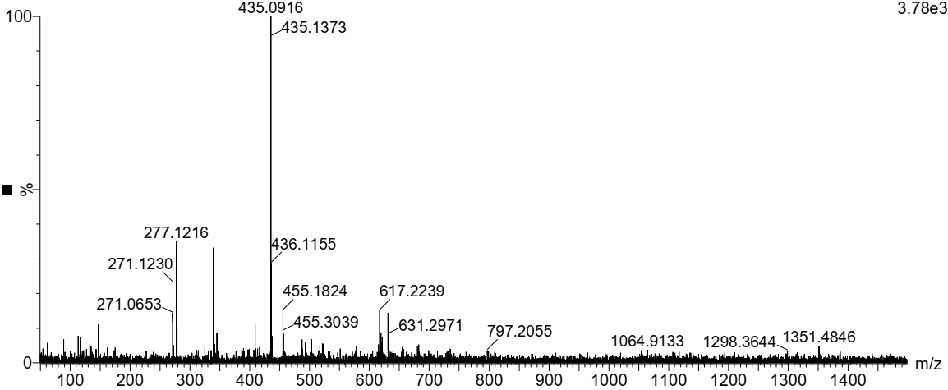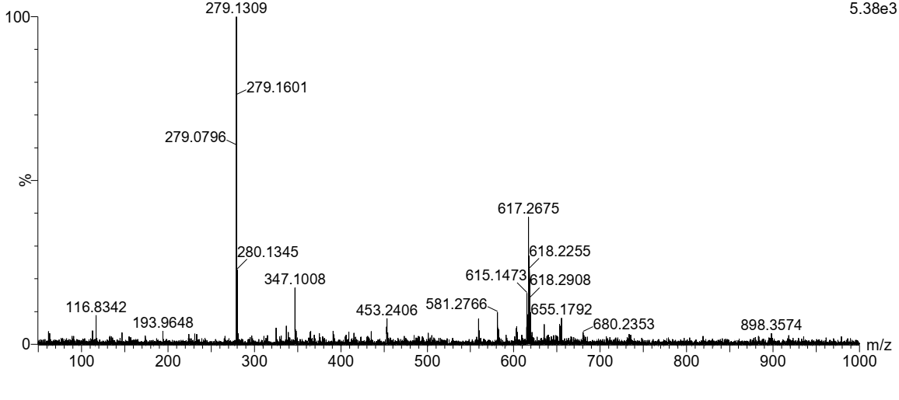
Phloridzin
D
C
B
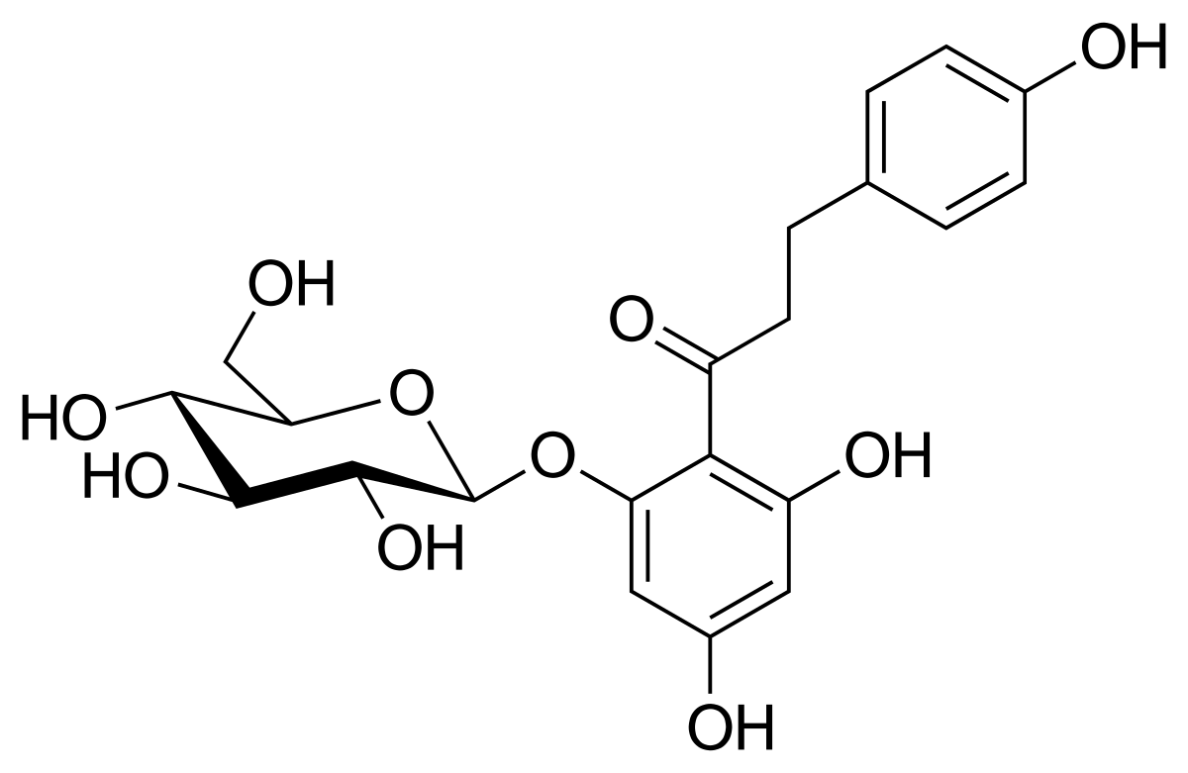
Nitidine
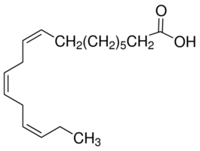

Linoleic acid
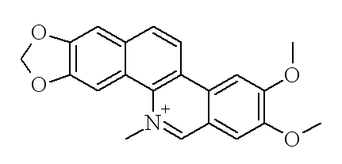
z
y
x
A

min

Figure 1: LC fingerprint of the methanolic extract of P. muellerianus. (A). B, C and D are MS spectra of compounds x (Nitidine), y (Phloridzin) and z (Linoleic acid), respectively.

