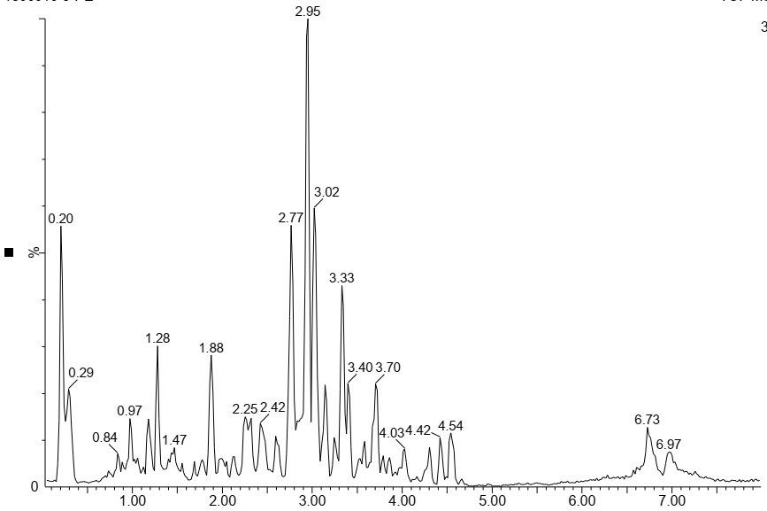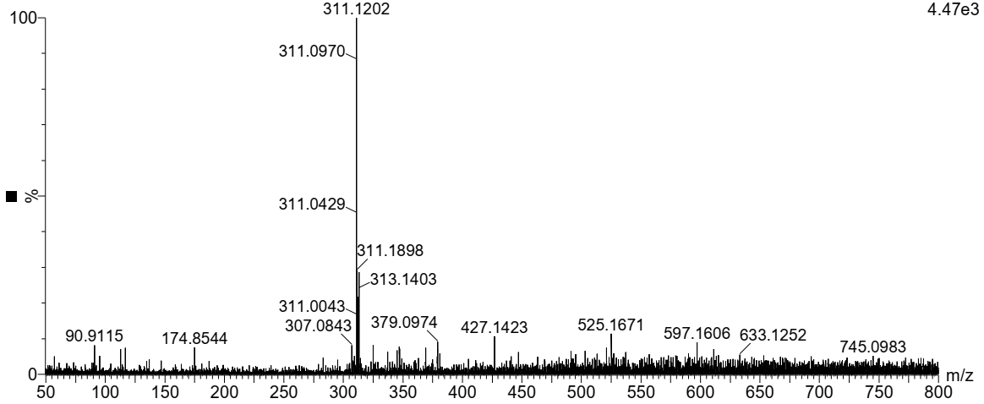
c
b
a
min

Docosane
D
C
B

A

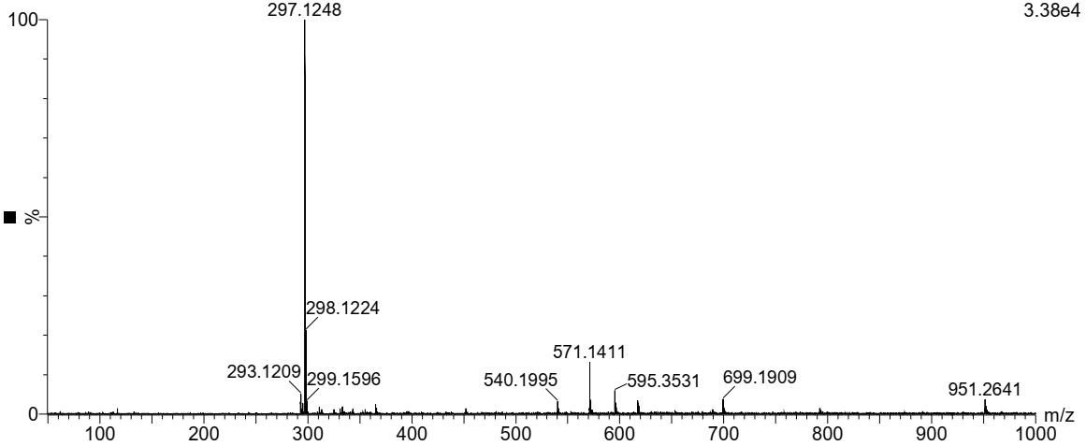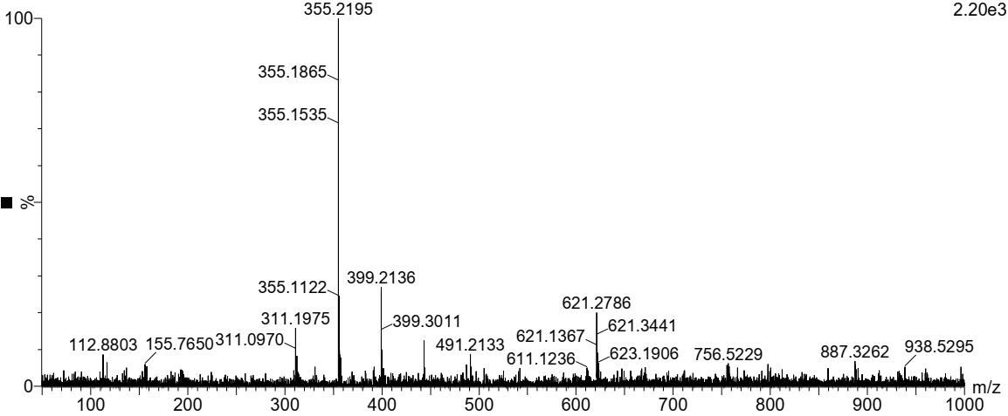

Chlorogenic acid
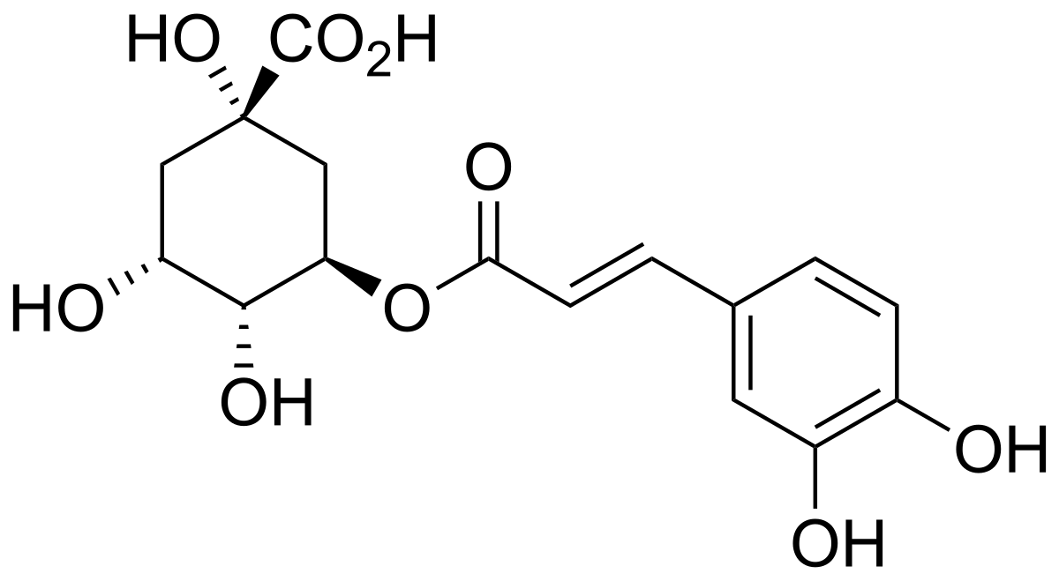

Cardanol
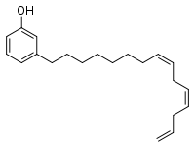
Figure 2: LC fingerprint of the methanolic extract of F. exasperata (A). B, C and D are MS spectra of compounds a (docosane), b (cardanol) and c (chlorogenic acid), respectively.

