Supplementary Files
Article title: Operationalizing Health Systems Strengthening in Decentralized Settings: A Leadership- and Management-Centred Approach from Kenya.
Journal name: BMC Health Services Research
Authors’ information:
Keiko Kita¹, Kevin Oria², Kenzo Takahashi³
¹ Graduate School of Public Health, Teikyo University, Tokyo, Japan
² Great Lakes University of Kisumu, Kisumu, Kenya
³ Division of Health Sciences, Aomori University of Health and Welfare, Aomori, Japan

Corresponding author:
Keiko Kita
Graduate School of Public Health, Teikyo University
2-11-1, Kaga, Itabashi-ku, Tokyo, Japan 173-8605
E-mail:kkbluemoon@gmail.com

- Supplementary File 1. Quantitative Survey Questionnaire
- Supplementary File 2. Interview Guide

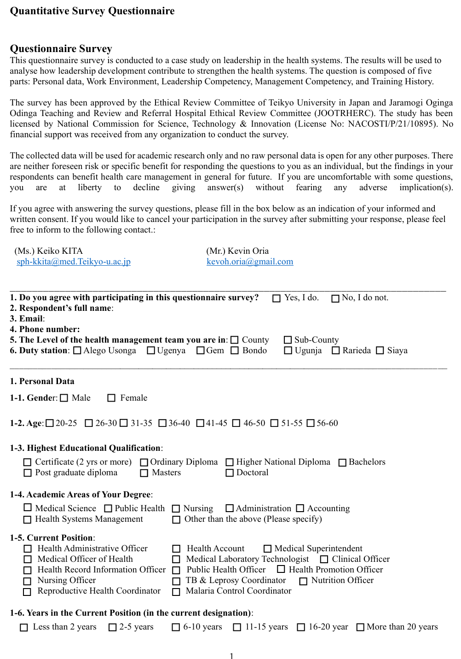
Supplementary File 1. Quantitative Survey Questionnaire

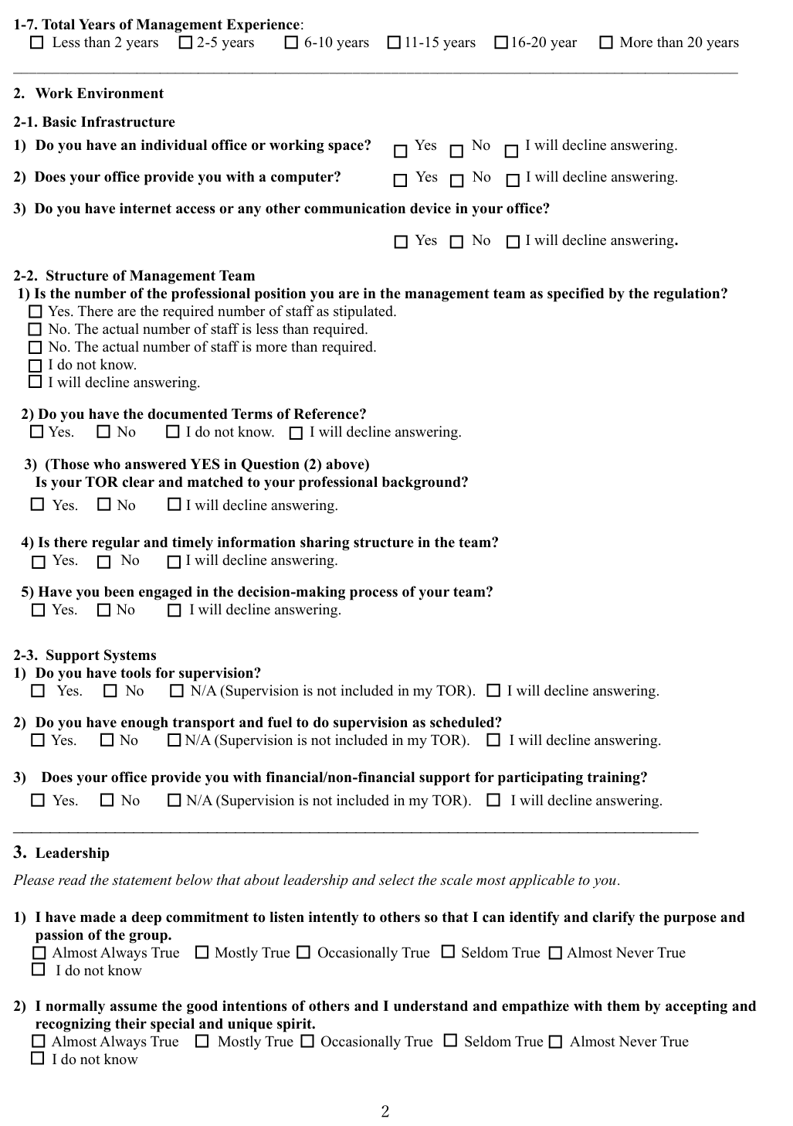
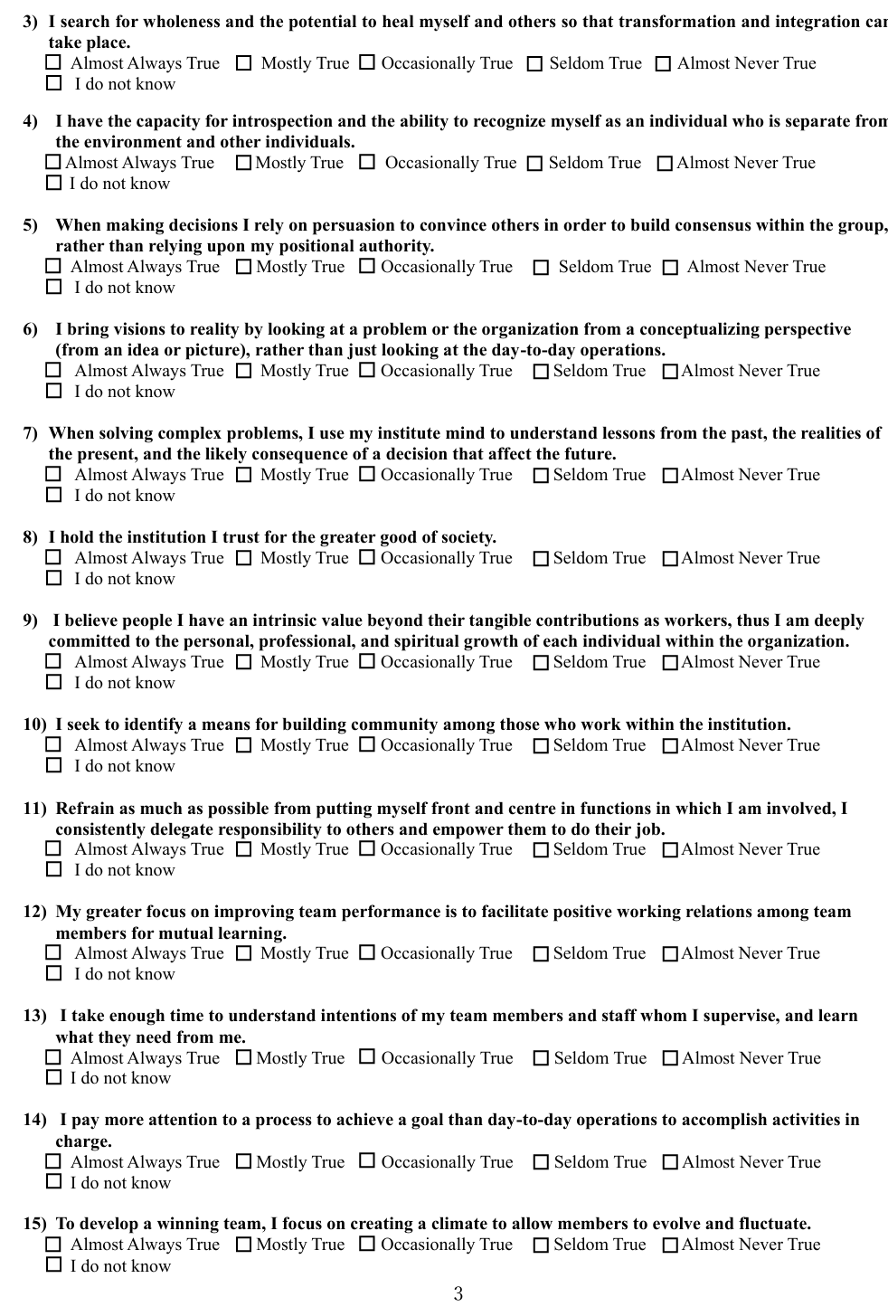
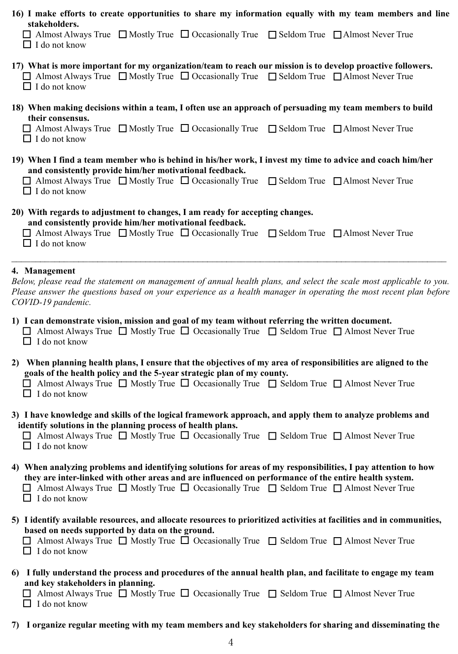
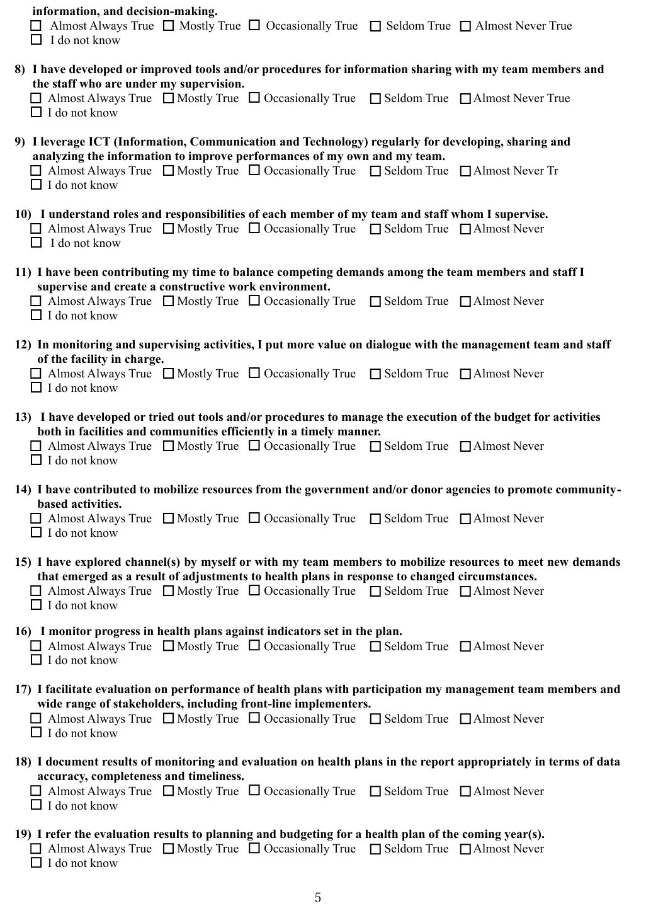
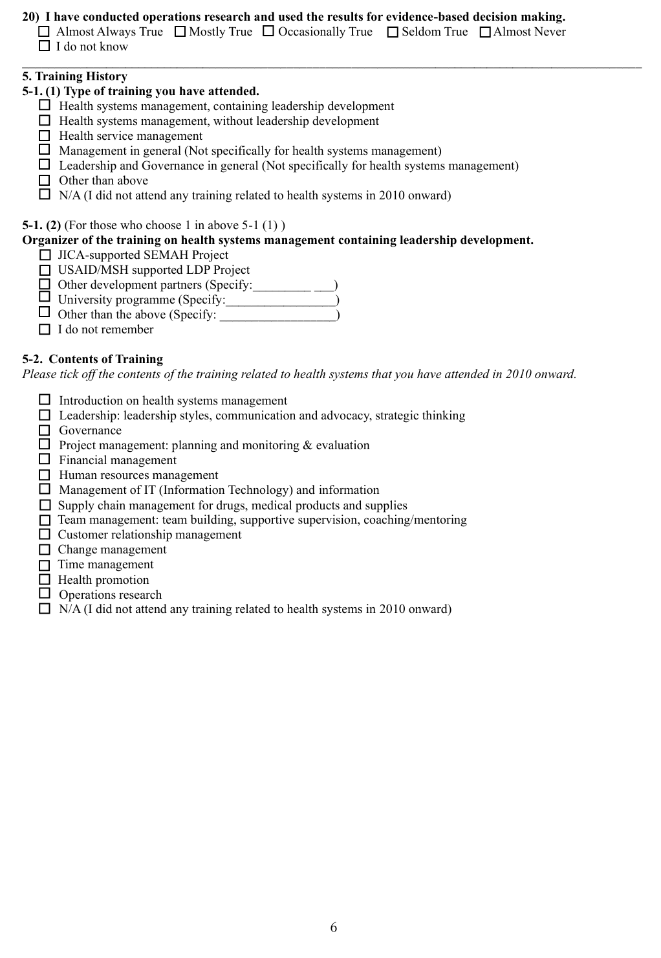
Supplementary File 2. Interview Guide
Interview Guide
Respondent’s Information

Name of respondent: _________________________________ Date of interview: _______________
Mobile: _________________________ Email: _______________________________________

Introduction
Good morning/afternoon. My name is [Interviewer’s Name] from [Interviewer’s Organization]. We kindly request your participation in this interview to understand your leadership perspectives and practices in your assigned roles. This study has been approved by the Ethical Review Committee of Teikyo University, Japan, and the Jaramogi Oginga Odinga Teaching and Referral Hospital Ethical Review Committee (JOOTRHERC). It has also been licensed by the National Commission for Science, Technology and Innovation (NACOSTI) (License No. NACOSTI/P/21/10895).
The information collected will be used for academic research purposes only. No personally identifiable information will be disclosed. There are no foreseeable risks or direct benefits to you as an individual for participating in this interview. But the findings may contribute to improvements in health care management in the future. Participation is voluntary, and you may decline to answer any question or withdraw at any time without any negative consequences.

- Management of Health Plan
  - When facilitating the formulation of annual health plans, what do you usually pay attention to improve service delivery with limited resources?
  - What kinds of considerations or actions do you take to execute the planned activities in a timely and appropriate manner to improve service delivery with limited resources?
- External Factors Influencing Performance of Health Managers
2-1. What external factors enable you to demonstrate your leading and managing competencies through health plan management?
2-2. What external factors make it difficult to fully demonstrate your leading and managing competencies?
- Effectiveness of Training to Develop Leadership and Management Competencies for HSS
3-1. Recalling the training you have participated in, in what ways has the training influenced your performance in managing health plans?
3-2. What differences have you observed between managers who have participated in comprehensive health systems training and those who have not?

