

Supplementary Information for
Ethnic diversity fosters the social integration of refugee students.

Zsófia Boda^{1*}, Georg Lorenz^{2*}, Malte Jansen^{2,3}, Petra Stanat², Aileen Edele^{4,5}

¹ Department of Sociology and Institute for Social and Economic Research, University of Essex, Colchester CO4 3SQ, United Kingdom.
² Institute for Educational Quality Improvement (IQB), Humboldt-Universität zu Berlin; 10099 Berlin, Germany.
³ Centre for International Student Assessment (ZIB); 80333 Munich, Germany.
⁴ Berlin Institute for Integration and Migration Research (BIM); 10099 Berlin, Germany.
⁵ Department of Education Studies, Humboldt-Universität zu Berlin; 10099 Berlin, Germany.

* Corresponding authors: Zsófia Boda (zsofia.boda@essex.ac.uk); Georg Lorenz (georg.lorenz@iqb.hu-berlin.de).

This PDF file includes:

Supplementary Information Text
Figures S1 to S3
Tables S1 to S8
SI References

Supplementary Information Text

Appendix A: Complete set of MRQAP results.
Table S1 shows how the estimated probabilities of receiving friendship and rejection nominations vary between ethnic majority adolescents (the reference category), first-generation immigrant adolescents, second-generation immigrant adolescents, and refugee adolescents after controlling for the adolescents’ gender, age, academic achievement, language skills, and length of stay in Germany. The results stem from two MRQAPs, one having the probability of receiving friendship nominations as the dependent variable and one having the probability of receiving rejection nominations as the dependent variable. The statistical procedure is described in Appendix D. The results demonstrate that refugee students, in comparison to ethnic majority students, have a lower probability of being nominated as friends (ß = -0.067, p < 0.001) and a higher probability of being rejected (ß = 0.041, p < 0.001). Table S1 also shows that gender, age, length of stay in Germany, and academic achievement predict the probability of being nominated as a friend, while language skills matter for the probability of being rejected by classmates. These results confirm that the findings presented in Fig 1 in the main text are robust to controlling for possible confounders.
Table S2 presents the full results from the MRQAPs underlying the results displayed in Fig 3 in the main text.

TABLE S1 ABOUT HERE
TABLE S2 ABOUT HERE

Appendix B: Information on the analyzed samples and robustness checks across the samples.
A sample of 39,154 students from 1,807 classrooms was used to create Fig 1. Descriptive statistics of the analyzed variables by immigrant status are provided in Table S3. To create Fig 3, we kept only classrooms in the sample that were attended by at least one refugee student. This sample comprised 6,390 students from 304 classrooms, and descriptive statistics of the analyzed variables by immigrant status can be found in Table S4. A replication of Fig 1 using this subsample is provided in Fig S1.
To create Fig 2, we further restricted our sample to classrooms in which at least 15 students participated in the sociometric part of the questionnaire (i.e., the part in which the students were asked about friendships and rejections). This procedure followed the aim of avoiding bias in our results due to nonparticipating peers who would also have nominated refugee students if they had participated. Such selection bias could be severe since, in Fig 2, we report absolute values regarding peer nominations instead of averages. Another reason for our decision was that the average valid class sizes varied across the different diversity levels, with high-diversity settings having the smallest valid class sizes. Given that the number of friendship and rejection nominations in the different diversity settings is among the most important messages of Fig 2, we wanted to avoid bias in our results due to the differential participation rates across the different diversity levels. The resulting sample consisted of 5,328 students from 237 classrooms. Descriptive statistics of the analyzed variables by immigrant status are provided in Table S5. A replication of Fig 2 using the less restrictive sample that was used to create Fig 3 is provided in Fig S2.
TABLE S3 ABOUT HERE
TABLE S4 ABOUT HERE
TABLE S5 ABOUT HERE
FIG S1 ABOUT HERE
FIG S2 ABOUT HERE

Appendix C: Excerpt from student questionnaire.
Fig S3 about here

Appendix D: Description of the Multiple Regression Quadratic Assignment Procedure.
Mathematically, the Multiple Regression Quadratic Assignment Procedure (MRQAP) is defined in a similar way to linear regression models, but the data are arranged in matrices instead of vectors:
$$y_{ij}=β_{0}+\sum_{k=1}^{m}{β_{k}{(x}_{ij}^{k})+e_{ij}}.$$
Here, $y$ stands for the dependent matrix (that is, friendships or rejections), with indexes i and j representing two students from this matrix. Furthermore, m shows the number of independent matrices x^{k} (that is, the number of independent variables). Parameter $β$^{k} stands for a coefficient, and e_{ij} is an error term. When x^{k} represents a friendship (rejection) network, $x_{ij}^{k}$ indicates that i names j as a friend (i rejects j). The parameters of MRQAPs can be interpreted as similar to the parameters of a linear regression model because they are estimated with ordinary least squares (OLS) estimators. However, the statistical significance of the estimates is calculated using permutations to take into account dependencies between the observations (1). For this, the OLS regression results are compared to a large number of OLS regression results conducted from “random” data: data for which the dependent matrix y has been permuted. The proportion of “random” regression coefficients that are at least as large as our actual coefficient directly translates to a p-value for the given parameter. We used Y-permuted MRQAPs because they represent the most conservative method to obtain statistical inference among MRQAP models. We conducted 1,000 permutations. Cases with missing information on friendship and/or rejection nominations as well as on any of the predictor variables were excluded from the analyses.

Appendix E: Robustness check of Fig 3 results.
Tables S6-S8 display several models that serve us to investigate the robustness of our main results. Table S6 presents the results from MRQAPs that mimic those presented in Table S2 but additionally include classroom fixed effects. Table S7 presents the results from MRQAPs that mimic those presented in Table S2 but use the proportion of immigrants in a classroom as a measure of diversity instead of the dissimilarity index. Table S8 presents the results from MRQAPs that mimic those presented in Table S2 but use the proportion of immigrants in a classroom as a measure of diversity instead of the dissimilarity index and additionally consider that diversity differs across the German federal states.

The diversity-related tendency of nominating refugee students in the robustness models is substantively similar to those in the main model. We see differences regarding two effects: 1) the interaction between native → refugee friendship nominations and diversity (p _{classroom dummy model} = 0.084, p _{immigrant proportion model} = 0.105, p classroom and federal state model = 0.174, p _{main model} = 0.045; see tables S6, S7, S8, and S2, respectively) and 2) the interaction between refugee → refugee rejections and diversity (p _{classroom dummy model} = 0.095, p _{immigrant proportion model} = 0.100, p classroom and federal state model = 0.115, p _{main mode}= 0.023). These differences may be due to decreased statistical power (especially in case of the refugee → refugee nominations, since only few classrooms had been attended by more than two refugees). It is important to note, however, that the signs of these parameters are the same as the ones in the main models. Therefore, we conclude that the differences in the p-values do not affect our substantive conclusions.

Table S6 around here
Table S7 around here
Table S8 around here
Fig. S1. Friendships and rejections based on immigration status.
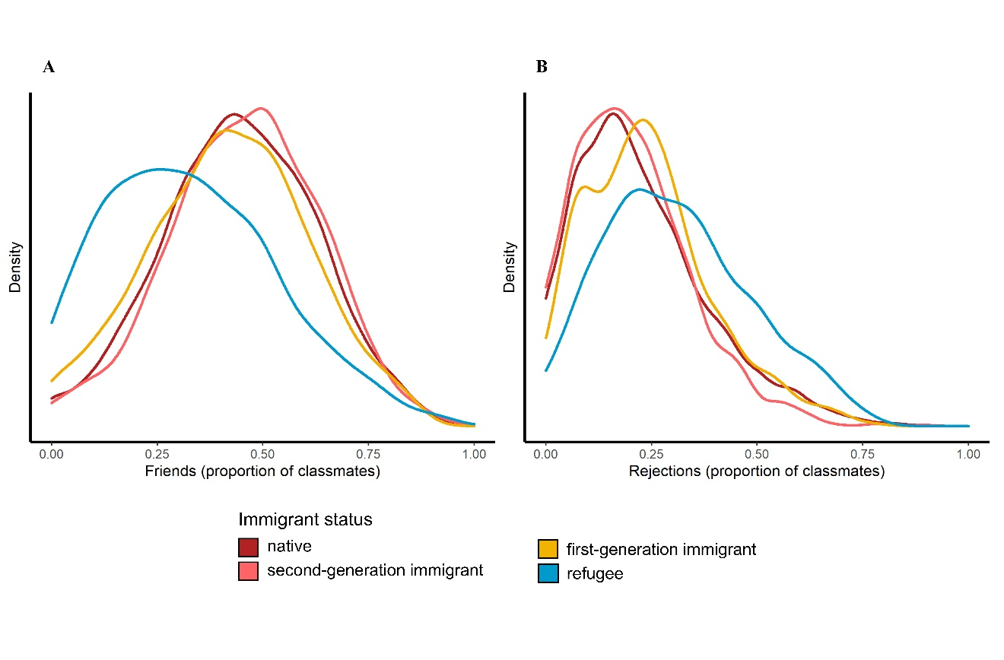 Replication of Fig 1 based on the subsample including only classrooms attended by at least one refugee student. N _{students} = 6,390. N _{classrooms} = 304.

Fig. S2. Typical friendship and rejection ego networks of refugee students.
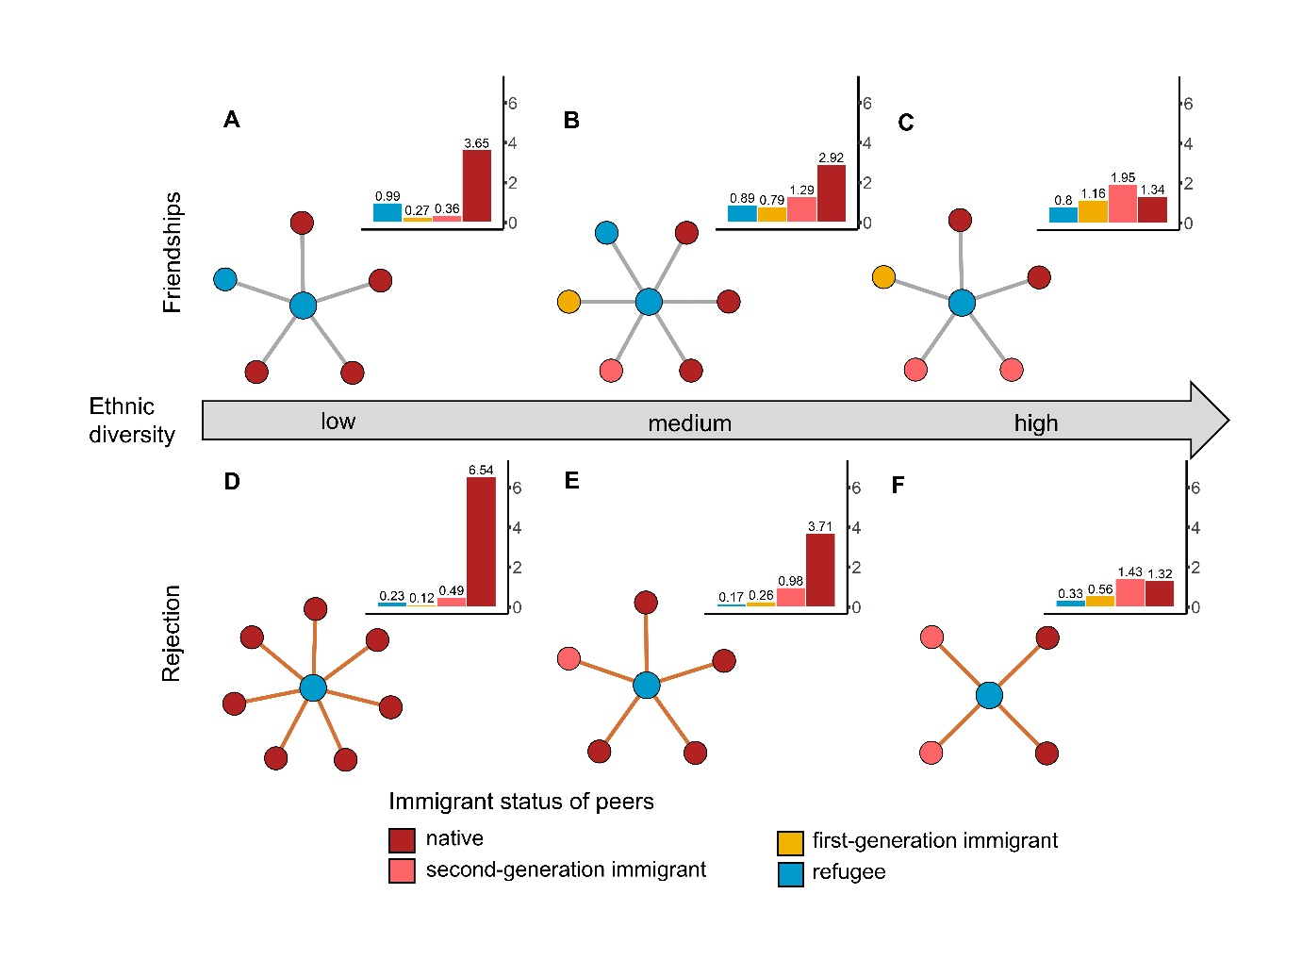 Replication of Fig 2 based on the larger subsample also used to create Fig 3. The bar plots show the rounded average number of friendship (upper panel) and rejection (lower panel) nominations of refugee students by immigrant status group. The network plots map the average number of nominations (e.g., the total number of friends). In addition, the network plots are a proportionate representation of the ethnic composition of nominations of refugee students (e.g., the number of native friends). Note that not every bar can be represented in the network plots by the value of the closest integer to its actual mean due to our primary goal to represent the total number of nominations accurately. This sample includes classrooms in which fewer than 15 students participated in the sociometric questionnaire that included questions about friendships and rejections. N _{students} = 6,390. N _{classrooms} = 304.

Fig. S3. Questionnaire items used to collect sociometric information.
Next, we are interested in who you spend your time with.
First, please take the list with the names of your classmates, which was handed to you by the test coordinator, and put it next to this sheet. The arrows should fit together.
Then, please check each classmate for whom the statement matches. If the question does not fit any classmate, do not check any box. No one else will know your answers.

Who are you friends with? | Who would you not want to sit next to? | … | …

Translated from German.

Table S1. Probabilities of receiving friendship and rejection nominations estimated from multivariate MRQAPs.
 | Friendship |  | Rejection
 | Estimate | p | Estimate | p
Intercept (native receiver) | 0.441 | <0.001 | 0.219 | <0.001
1st-gen immigrant receiver | 0.006 | 0.181 | -0.012 | 0.436
2nd-gen immigrant receiver | 0.018 | 0.001 | -0.029 | 0.043
Refugee receiver | -0.067 | <0.001 | 0.041 | <0.001
Gender of receiver | -0.002 | 0.009 | -0.026 | <0.001
Age of receiver | -0.050 | <0.001 | 0.056 | <0.001
Length of stay of receiver | 0.006 | <0.001 | <0.001 | 0.018
Language skills of receiver | 0.003 | 0.150 | -0.009 | <0.001
Academic achievement of receiver | 0.013 | <0.001 | -0.019 | <0.001

N _{students} = 6,390. N _{classrooms} = 304.

Table S2. Complete results of MRQAP models used to create Fig 3.
 | Friendship |  | Rejection
 | Estimate | p | Estimate | p
Intercept (native → native) | 0.442 | 0.008 | 0.286 | 0.265
× diversity | 0.012 | 0.012 | -0.087 | 0.499
Native → refugee | -0.164 | <0.001 | 0.110 | <0.001
× diversity | 0.086 | 0.045 | -0.058 | 0.006
Native → 1st-gen immigrant | 0.008 | 0.355 | -0.006 | 0.046
× diversity | -0.085 | 0.085 | 0.046 | 0.304
Native → 2nd-gen immigrant | 0.042 | 0.009 | -0.028 | 0.341
× diversity | -0.092 | 0.001 | 0.028 | 0.359
1st-gen immigrant → native | 0.097 | 0.011 | -0.137 | 0.001
× diversity | -0.144 | 0.003 | 0.174 | 0.004
1st-gen immigrant → refugee | 0.077 | 0.228 | -0.223 | 0.016
× diversity | 0.018 | 0.446 | 0.318 | 0.010
1st-gen immigrant → 1st-gen immigrant | 0.008 | 0.245 | -0.119 | 0.142
× diversity | 0.044 | 0.357 | 0.203 | 0.115
1st-gen immigrant → 2nd-gen immigrant | 0.043 | 0.070 | -0.212 | 0.004
× diversity | 0.021 | 0.235 | 0.253 | 0.006
2nd-gen immigrant → native | 0.027 | 0.068 | -0.095 | 0.001
× diversity | -0.076 | 0.003 | 0.126 | 0.001
2nd-gen immigrant → refugee | -0.061 | 0.020 | 0.015 | 0.230
× diversity | 0.010 | 0.199 | -0.003 | 0.414
2nd-gen immigrant → 2nd-gen immigrant | 0.101 | 0.119 | -0.045 | 0.247
× diversity | -0.131 | 0.229 | 0.035 | 0.224
2nd-gen immigrant → 1st-gen immigrant | -0.111 | 0.450 | 0.060 | 0.203
× diversity | 0.127 | 0.419 | -0.066 | 0.197
Refugee → native | -0.096 | <0.001 | -0.110 | <0.001
× diversity | 0.032 | 0.414 | 0.076 | 0.031
Refugee → 1st-gen immigrant | -0.006 | 0.495 | -0.125 | 0.186
× diversity | 0.003 | 0.411 | 0.104 | 0.369
Refugee → 2nd-gen immigrant | 0.220 | 0.007 | -0.101 | 0.045
× diversity | -0.219 | 0.056 | 0.094 | 0.092
Refugee → refugee | 0.096 | 0.001 | -0.226 | 0.004
× diversity | -0.152 | <0.001 | 0.277 | 0.023
Same country of origin (excl. Germany) | 0.191 | 0.262 | 0.149 | 0.187
× diversity | -0.083 | 0.198 | -0.202 | 0.111
Gender of receiver | 0.017 | <0.001 | -0.032 | <0.001
Gender of sender | -0.010 | <0.001 | 0.010 | 0.001
Same gender | 0.248 | <0.001 | -0.061 | <0.001
Age of receiver | -0.003 | 0.069 | 0.041 | 0.001
Age of sender | 0.002 | 0.173 | -0.027 | <0.001
Age similarity | 0.064 | <0.001 | -0.020 | 0.015
Length of stay of receiver | -0.001 | 0.331 | 0.009 | <0.001
Length of stay of sender | 0.000 | 0.419 | 0.003 | 0.319
Similarity in length of stay | 0.009 | <0.001 | -0.003 | 0.458
Language skills of receiver | -0.006 | <0.001 | -0.002 | <0.001
Language skills of sender | 0.002 | 0.215 | -0.010 | 0.001
Similarity in language skills | 0.013 | <0.001 | -0.003 | <0.001
Academic achievement of receiver | 0.005 | 0.113 | -0.008 | 0.010
Academic achievement of sender | 0.014 | <0.001 | -0.020 | <0.001
Similarity in academic achievement | 0.021 | <0.001 | -0.010 | <0.001

N _{students} = 6,390. N _{classrooms} = 304.

Table S3. Characteristics of analyzed sample.
 | Sample  (N =39,154) |  | Ethnic majority  (N = 25,659) | Refugee  (N = 487) |  | First-generation immigrant  (N = 1,771) | Second-generation immigrant  (N = 8,514) | Missing cases
Student characteristics | mean | SD | mean | mean |  | mean | mean | N
Language skills | 0.1 | 1.8 | 0.4 | -2.9 | -1.4 |  | -0.3 | 0
Mathematics achievement | 2.9 | 1.1 | 3.0 | 2.6 | 2.8 |  | 2.8 | 0
Age | 15.6 | 0.6 | 15.5 | 16.6 | 16.1 |  | 15.5 | 361
Length of stay in Germany (in years) | -- |  | -- | 2.8 | 8.3 |  | -- | 0
 | % |  | % | % | % |  | % | N
Female | 49.0 |  | 49.7 | 35.9 | 47.9 |  | 50.5 | 0
Classroom characteristics | mean | SD | mean | mean |  | mean | mean | N
Classroom diversity | 0.5 | 0.2 | 0.4 | 0.7 | 0.7 |  | 0.7 | 0
Size | 24.9 | 3.9 | 24.8 | 23.2 | 24.2 |  | 25.3 | 0
Network characteristics | mean | SD | mean | mean |  | mean | mean | N
Density (friendships) | 0.4 | 0.1 | 0.4 | 0.3 | 0.4 |  | 0.4 | 0
Density (rejections) | 0.2 | 0.1 | 0.2 | 0.2 | 0.2 |  | 0.2 | 0
Indegrees (friendships) | 8.5 | 3.9 | 8.8 | 5.2 | 7.7 |  | 8.7 | 0
Indegrees (rejections) | 4.0 | 3.0 | 4.1 | 5.4 | 4.1 |  | 3.8 | 0

Student characteristics, classroom characteristics, and network characteristics of the sample used to create Fig 1.

Table S4. Characteristics of subsample.
 | Sample  (N =6,390) |  | Ethnic majority  (N = 3,571) | Refugee  (N = 487) | First-generation immigrant  (N = 472) | Second-generation immigrant  (N = 1,374) | Missing cases
Student characteristics | mean | SD | mean | mean | mean | mean | N
Language skills | -0.9 | 1.8 | -0.3 | -2.9 | -2.0 | -1.0 | 0
Mathematics achievement | 2.7 | 1.1 | 2.8 | 2.6 | 2.7 | 2.7 | 0
Age | 15.8 | 0.8 | 15.7 | 16.6 | 16.3 | 15.6 | 29
Length of stay in Germany (in years) | -- |  | -- | 2.8 | 7.1 | -- | 0
 | % |  | % | % | % | % | N
Female | 45.5 |  | 46.5 | 35.9 | 46.0 | 47.5 | 0
Classroom characteristics | mean | SD | mean | mean | mean | mean | N
Classroom diversity | 0.6 | 0.2 | 0.5 | 0.7 | 0.8 | 0.8 | 0
Size | 24.5 | 3.7 | 24.8 | 23.2 | 23.5 | 24.5 | 0
Network characteristics | mean | SD | mean | mean | mean | mean | N
Density (friendships) | 0.3 | 0.1 | 0.3 | 0.3 | 0.3 | 0.3 | 0
Density (rejections) | 0.2 | 0.1 | 0.2 | 0.2 | 0.2 | 0.2 | 0
Indegrees (friendships) | 7.9 | 3.8 | 8.4 | 5.2 | 7.0 | 8.3 | 0
Indegrees (rejections) | 4.2 | 3.0 | 4.2 | 5.4 | 4.1 | 3.7 | 0

Student characteristics, classroom characteristics, and network characteristics of the subsample used to create Fig 3.

Table S5. Characteristics of subsample.
 | Sample  (N =5,328) |  | Ethnic majority  (N = 3,119) | Refugee  (N = 360) | First-generation immigrant  (N = 367) |  | Second-generation immigrant  (N = 1,151) | Missing cases
Student characteristics | mean | SD | mean | mean | mean |  | mean | N
Language skills | -0.8 | 1.8 | -0.2 | -2.9 |  | -2.0 | -1.0 | 0
Mathematics achievement | 2.8 | 1.1 | 2.8 | 2.6 |  | 2.7 | 2.7 | 0
Age | 15.8 | 0.7 | 15.7 | 16.6 |  | 16.3 | 15.6 | 17
Length of stay in Germany (in years) | -- |  | -- | 2.8 |  | 7.1 | -- | 0
 | % |  | % | % |  | % | % | N
Female | 45.6 |  | 46.6 | 36.9 |  | 45.0 | 46.8 | 42
Classroom characteristics | mean | SD | mean | mean | mean |  | mean | N
Classroom diversity | 0.6 | 0.2 | 0.5 | 0.6 |  | 0.7 | 0.8 | 0
Size | 25.1 | 3.1 | 25.3 | 24.6 |  | 24.4 | 25.1 | 0
Network characteristics | mean | SD | mean | mean | mean |  | mean | N
Density (friendships) | 0.4 | 0.1 | 0.4 | 0.3 |  | 0.3 | 0.4 | 0
Density (rejections) | 0.2 | 0.1 | 0.2 | 0.2 |  | 0.2 | 0.2 | 0
Indegrees (friendships) | 8.5 | 3.8 | 8.9 | 5.6 |  | 7.6 | 8.8 | 0
Indegrees (rejections) | 4.5 | 3.1 | 4.5 | 6.1 |  | 4.6 | 4.0 | 0

Student characteristics, classroom characteristics, and network characteristics of the subsample used to create Fig 2.

Table S6. Results of classroom-fixed-effect MRQAP models.
 | Friendship |  | Rejection
 | Estimate | p | Estimate | p
Intercept (native → native) | 0.659 | <0.001 | 0.184 | 0.327
302 class dummies | y e s |  | y e s
Native → refugee | -0.161 | <0.001 | 0.124 | <0.001
× diversity | 0.054 | 0.084 | -0.076 | 0.009
Native → 1st-gen immigrant | 0.000 | 0.488 | 0.038 | 0.107
× diversity | -0.078 | 0.075 | -0.021 | 0.330
Native → 2nd-gen immigrant | 0.056 | 0.002 | 0.000 | 0.481
× diversity | -0.108 | <0.001 | 0.000 | 0.468
1st-gen immigrant → native | 0.085 | 0.012 | -0.109 | <0.001
× diversity | -0.132 | 0.012 | 0.133 | 0.002
1st-gen immigrant → refugee | 0.077 | 0.226 | -0.205 | 0.007
× diversity | 0.000 | 0.489 | 0.270 | 0.007
1st-gen immigrant → 1st-gen immigrant | 0.073 | 0.308 | -0.166 | 0.083
× diversity | -0.043 | 0.403 | 0.207 | 0.065
1st-gen immigrant → 2nd-gen immigrant | 0.127 | 0.080 | -0.218 | 0.004
× diversity | -0.073 | 0.232 | 0.250 | 0.004
2nd-gen immigrant → native | 0.044 | 0.028 | -0.072 | <0.001
× diversity | -0.095 | 0.004 | 0.106 | <0.001
2nd-gen immigrant → refugee | -0.114 | 0.041 | 0.019 | 0.363
× diversity | 0.064 | 0.219 | 0.005 | 0.459
2nd-gen immigrant → 2nd-gen immigrant | -0.035 | 0.255 | -0.003 | 0.497
× diversity | 0.047 | 0.237 | 0.001 | 0.477
2nd-gen immigrant → 1st-gen immigrant | -0.020 | 0.407 | 0.069 | 0.225
× diversity | 0.024 | 0.408 | -0.086 | 0.204
Refugee → native | -0.083 | 0.001 | -0.085 | <0.001
× diversity | -0.014 | 0.349 | 0.043 | 0.082
Refugee → 1st-gen immigrant | 0.010 | 0.469 | -0.082 | 0.180
× diversity | -0.031 | 0.401 | 0.024 | 0.413
Refugee → 2nd-gen immigrant | 0.139 | 0.022 | -0.121 | 0.021
× diversity | -0.100 | 0.139 | 0.133 | 0.044
Refugee → refugee | 0.285 | 0.001 | -0.150 | 0.035
× diversity | -0.429 | <0.001 | 0.145 | 0.095
Same country of origin (excl. Germany) | 0.072 | 0.162 | 0.037 | 0.291
× diversity | 0.037 | 0.349 | -0.066 | 0.203
Gender of receiver | 0.011 | 0.001 | -0.034 | <0.001
Gender of sender | -0.016 | <0.001 | 0.009 | <0.001
Same gender | 0.251 | <0.001 | -0.061 | <0.001
Age of receiver | -0.045 | <0.001 | 0.034 | <0.001
Age of sender | -0.045 | <0.001 | -0.035 | <0.001
Age similarity | 0.064 | <0.001 | -0.017 | 0.046
Length of stay of receiver | 0.000 | 0.477 | 0.007 | <0.001
Length of stay of sender | 0.000 | 0.385 | 0.001 | 0.223
Similarity in length of stay | 0.007 | <0.001 | -0.001 | 0.281
Language skills of receiver | -0.006 | <0.001 | 0.003 | 0.005
Language skills of sender | 0.002 | 0.127 | -0.005 | <0.001
Similarity in language skills | 0.012 | <0.001 | -0.003 | 0.002
Academic achievement of receiver | 0.004 | 0.004 | -0.005 | <0.001
Academic achievement of sender | 0.014 | <0.001 | -0.018 | <0.001
Similarity in academic achievement | 0.022 | <0.001 | -0.012 | <0.001

N _{students} = 6,390. N _{classrooms} = 304. The diversity main effect is excluded to avoid multicollinearity.

Table S7. Results of MRQAP models with immigrant proportion instead of diversity.
 | Friendship |  | Rejection
 | Estimate | p | Estimate | p
Intercept (native → native) | 0.441 | <0.001 | 0.256 | 0.050
× immigrant proportion | 0.021 | 0.044 | -0.090 | 0.170
Native → refugee | -0.144 | <0.001 | 0.099 | <0.001
× immigrant proportion | 0.083 | 0.105 | -0.060 | <0.001
Native → 1st-gen immigrant | -0.015 | 0.087 | 0.013 | <0.001
× immigrant proportion | -0.076 | 0.095 | 0.027 | 0.080
Native → 2nd-gen immigrant | 0.018 | 0.020 | -0.025 | 0.220
× immigrant proportion | -0.087 | <0.001 | 0.036 | 0.210
1st-gen immigrant → native | 0.061 | 0.039 | -0.106 | <0.001
× immigrant proportion | -0.136 | 0.007 | 0.191 | <0.001
1st-gen immigrant → refugee | 0.112 | 0.036 | -0.146 | 0.010
× immigrant proportion | -0.037 | 0.188 | 0.291 | 0.010
1st-gen immigrant → 1st-gen immigrant | 0.043 | 0.338 | -0.129 | 0.060
× immigrant proportion | -0.018 | 0.460 | 0.249 | 0.030
1st-gen immigrant → 2nd-gen immigrant | 0.078 | 0.094 | -0.086 | 0.260
× immigrant proportion | -0.041 | 0.351 | 0.114 | 0.330
2nd-gen immigrant → native | 0.011 | 0.080 | -0.071 | <0.001
× immigrant proportion | -0.079 | <0.001 | 0.136 | <0.001
2nd-gen immigrant → refugee | -0.084 | 0.006 | -0.009 | 0.120
× immigrant proportion | 0.047 | 0.386 | 0.047 | 0.380
2nd-gen immigrant → 2nd-gen immigrant | -0.008 | 0.119 | -0.059 | 0.310
× immigrant proportion | -0.001 | 0.013 | 0.076 | 0.220
2nd-gen immigrant → 1st-gen immigrant | 0.008 | 0.449 | 0.018 | 0.100
× immigrant proportion | -0.034 | 0.410 | -0.031 | 0.050
Refugee → native | -0.090 | <0.001 | -0.095 | <0.001
× immigrant proportion | 0.035 | 0.452 | 0.079 | 0.090
Refugee → 1st-gen immigrant | 0.054 | 0.344 | -0.105 | 0.010
× immigrant proportion | -0.422 | 0.128 | 0.482 | 0.160
Refugee → 2nd-gen immigrant | 0.076 | 0.044 | -0.062 | 0.250
× immigrant proportion | -0.050 | 0.221 | 0.058 | 0.410
Refugee → refugee | 0.080 | 0.023 | -0.061 | 0.060
× immigrant proportion | -0.165 | 0.006 | 0.122 | 0.100
Same country of origin (excl. Germany) | 0.138 | <0.001 | -0.101 | <0.001
× immigrant proportion | -0.015 | 0.018 | 0.127 | 0.020
Gender of receiver | 0.017 | <0.001 | -0.032 | <0.001
Gender of sender | -0.010 | <0.001 | 0.011 | <0.001
Same gender | 0.248 | <0.001 | -0.061 | <0.001
Age of receiver | -0.003 | 0.047 | 0.042 | <0.001
Age of sender | 0.002 | 0.140 | -0.026 | <0.001
Age similarity | 0.063 | <0.001 | -0.019 | <0.001
Length of stay of receiver | -0.001 | 0.358 | 0.009 | <0.001
Length of stay of sender | 0.000 | 0.332 | 0.003 | 0.270
Similarity in length of stay | 0.009 | <0.001 | -0.003 | 0.440
Language skills of receiver | -0.006 | <0.001 | -0.002 | <0.001
Language skills of sender | 0.002 | 0.303 | -0.010 | <0.001
Similarity in language skills | 0.012 | <0.001 | -0.003 | <0.001
Academic achievement of receiver | 0.005 | 0.147 | -0.008 | 0.010
Academic achievement of sender | 0.014 | <0.001 | -0.020 | <0.001
Similarity in academic achievement | 0.021 | <0.001 | -0.010 | <0.001

N _{students} = 6,390. N _{classrooms} = 304.

Table S8. Results of MRQAP models with classroom- and state-level immigrant proportions.
 | Friendship |  | Rejection
 | Estimate | p | Estimate | p
Intercept (native → native) | 0.442 | <0.001 | 0.271 | <0.001
× immigrant proportion of classroom | 0.024 | 0.003 | -0.067 | 0.475
× immigrant proportion of federal state | -0.022 | 0.003 | -0.175 | 0.004
Native → refugee | -0.145 | <0.001 | 0.115 | <0.001
× immigrant proportion of classroom | 0.075 | 0.174 | -0.044 | 0.041
× immigrant proportion of federal state | 0.069 | 0.229 | -0.190 | 0.013
Native → 1st-gen immigrant | 0.032 | 0.493 | -0.005 | 0.006
× immigrant proportion of classroom | -0.030 | 0.195 | 0.002 | 0.095
× immigrant proportion of federal state | -0.504 | 0.012 | 0.215 | 0.429
Native → 2nd-gen immigrant | 0.034 | 0.009 | -0.031 | 0.185
× immigrant proportion of classroom | -0.069 | <0.001 | 0.024 | 0.229
× immigrant proportion of federal state | -0.158 | 0.113 | 0.088 | 0.423
1st-gen immigrant → native | 0.065 | 0.111 | -0.104 | 0.015
× immigrant proportion of classroom | -0.133 | 0.002 | 0.190 | 0.001
× immigrant proportion of federal state | -0.029 | 0.145 | -0.015 | 0.043
1st-gen immigrant → refugee | 0.152 | 0.028 | -0.182 | 0.010
× immigrant proportion of classroom | 0.009 | 0.259 | 0.236 | 0.014
× immigrant proportion of federal state | -0.454 | 0.244 | 0.483 | 0.211
1st-gen immigrant → 1st-gen immigrant | 0.088 | 0.168 | -0.147 | 0.117
× immigrant proportion of classroom | 0.067 | 0.257 | 0.212 | 0.109
× immigrant proportion of federal state | -0.690 | 0.011 | 0.274 | 0.447
1st-gen immigrant → 2nd-gen immigrant | 0.123 | 0.027 | -0.088 | 0.352
× immigrant proportion of classroom | -0.012 | 0.436 | 0.101 | 0.199
× immigrant proportion of federal state | -0.405 | 0.084 | 0.062 | 0.195
2nd-gen immigrant → native | 0.022 | 0.039 | -0.069 | 0.031
× immigrant proportion of classroom | -0.065 | <0.001 | 0.136 | <0.001
× immigrant proportion of federal state | -0.111 | 0.271 | 0.004 | 0.082
2nd-gen immigrant → refugee | -0.069 | 0.018 | -0.009 | 0.074
× immigrant proportion of classroom | 0.056 | 0.412 | 0.037 | 0.435
× immigrant proportion of federal state | -0.106 | 0.464 | 0.046 | 0.205
2nd-gen immigrant → 2nd-gen immigrant | -0.013 | 0.098 | -0.104 | 0.280
× immigrant proportion of classroom | -0.007 | 0.016 | 0.040 | 0.191
× immigrant proportion of federal state | 0.050 | 0.321 | 0.397 | 0.117
2nd-gen immigrant → 1st-gen immigrant | 0.044 | 0.351 | -0.015 | 0.122
× immigrant proportion of classroom | -0.012 | 0.464 | -0.067 | 0.018
× immigrant proportion of federal state | -0.306 | 0.177 | 0.350 | 0.158
Refugee → native | -0.118 | <0.001 | -0.076 | 0.003
× immigrant proportion of classroom | -0.007 | 0.161 | 0.097 | 0.019
× immigrant proportion of federal state | 0.383 | <0.001 | -0.200 | 0.014
Refugee → 1st-gen immigrant | 0.065 | 0.223 | -0.159 | 0.025
× immigrant proportion of classroom | -0.016 | 0.214 | 0.070 | 0.415
× immigrant proportion of federal state | -0.400 | 0.257 | 0.545 | 0.183
Refugee → 2nd-gen immigrant | 0.160 | 0.001 | -0.071 | 0.252
× immigrant proportion of classroom | 0.053 | 0.298 | 0.041 | 0.413
× immigrant proportion of federal state | -0.959 | 0.002 | 0.156 | 0.493
Refugee → refugee | 0.096 | 0.022 | -0.072 | 0.110
× immigrant proportion of classroom | -0.161 | 0.009 | 0.119 | 0.115
× immigrant proportion of federal state | -0.083 | 0.404 | 0.035 | 0.357
Same country of origin (excl. Germany) | 0.118 | <0.001 | -0.084 | 0.033
× immigrant proportion of classroom | -0.029 | 0.024 | 0.141 | 0.007
× immigrant proportion of federal state | 0.176 | 0.449 | -0.159 | 0.174
Gender of receiver | 0.017 | 0.001 | -0.032 | <0.001
Gender of sender | -0.010 | <0.001 | 0.011 | <0.001
Same gender | 0.248 | <0.001 | -0.061 | <0.001
Age of receiver | -0.009 | 0.012 | 0.037 | <0.001
Age of sender | -0.004 | 0.032 | -0.031 | <0.001
Age similarity | 0.063 | <0.001 | -0.022 | 0.019
Length of stay of receiver | -0.001 | 0.397 | 0.009 | <0.001
Length of stay of sender | 0.001 | 0.270 | 0.003 | 0.338
Similarity in length of stay | 0.009 | <0.001 | -0.002 | 0.440
Language skills of receiver | -0.006 | <0.001 | -0.002 | <0.001
Language skills of sender | 0.002 | 0.315 | -0.009 | <0.001
Similarity in language skills | 0.012 | <0.001 | -0.004 | 0.004
Academic achievement of receiver | 0.005 | 0.108 | -0.008 | 0.006
Academic achievement of sender | 0.014 | <0.001 | -0.019 | <0.001
Similarity in academic achievement | 0.021 | <0.001 | -0.011 | <0.001

N _{students} = 6,390. N _{classrooms} = 304.

SI References

1. D. Dekker, D. Krackhardt, T. A. Snijders, Sensitivity of MRQAP tests to collinearity and autocorrelation conditions. Psychometrika 72, 563–581 (2007).

