Appendix A. Full figure collection
The complete collection comprises the correlation of earth-skin temperature (TS) against all seven parameters, one page per parameter, in the format of Figure 3. The thermal figures serve as controls; the non-thermal figures carry the result. The code names are those used by NASA.
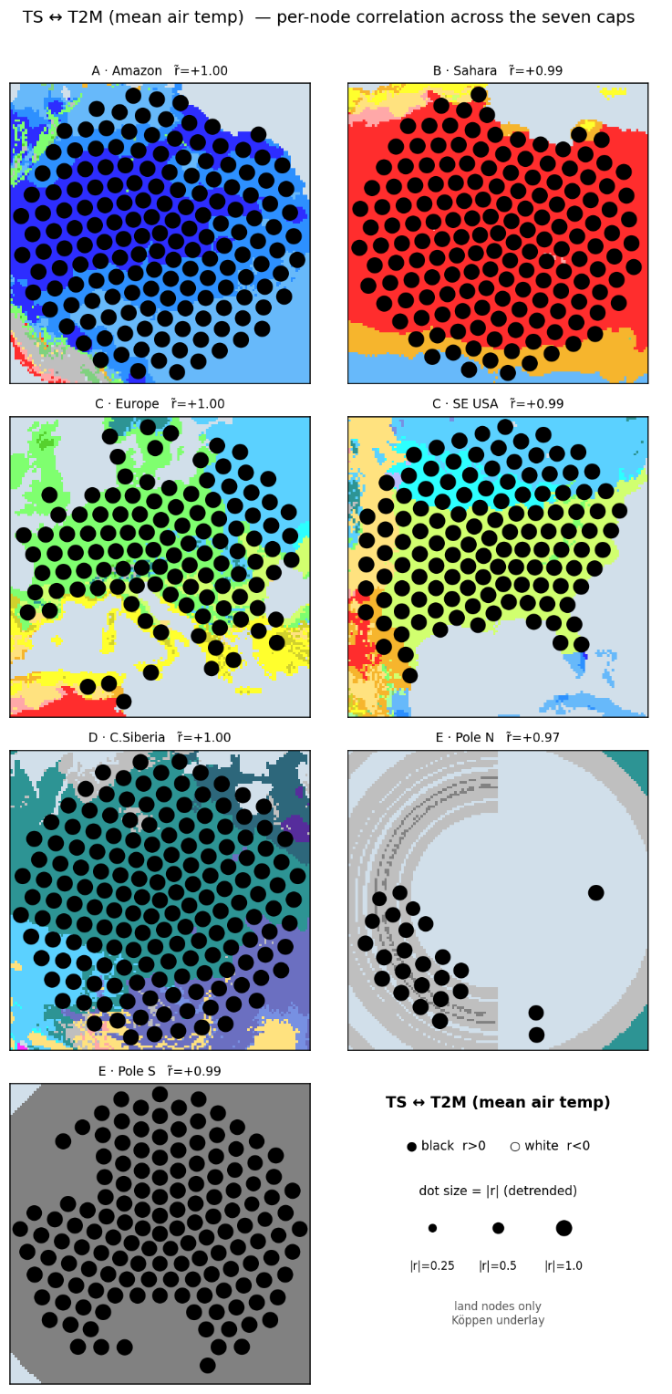 | 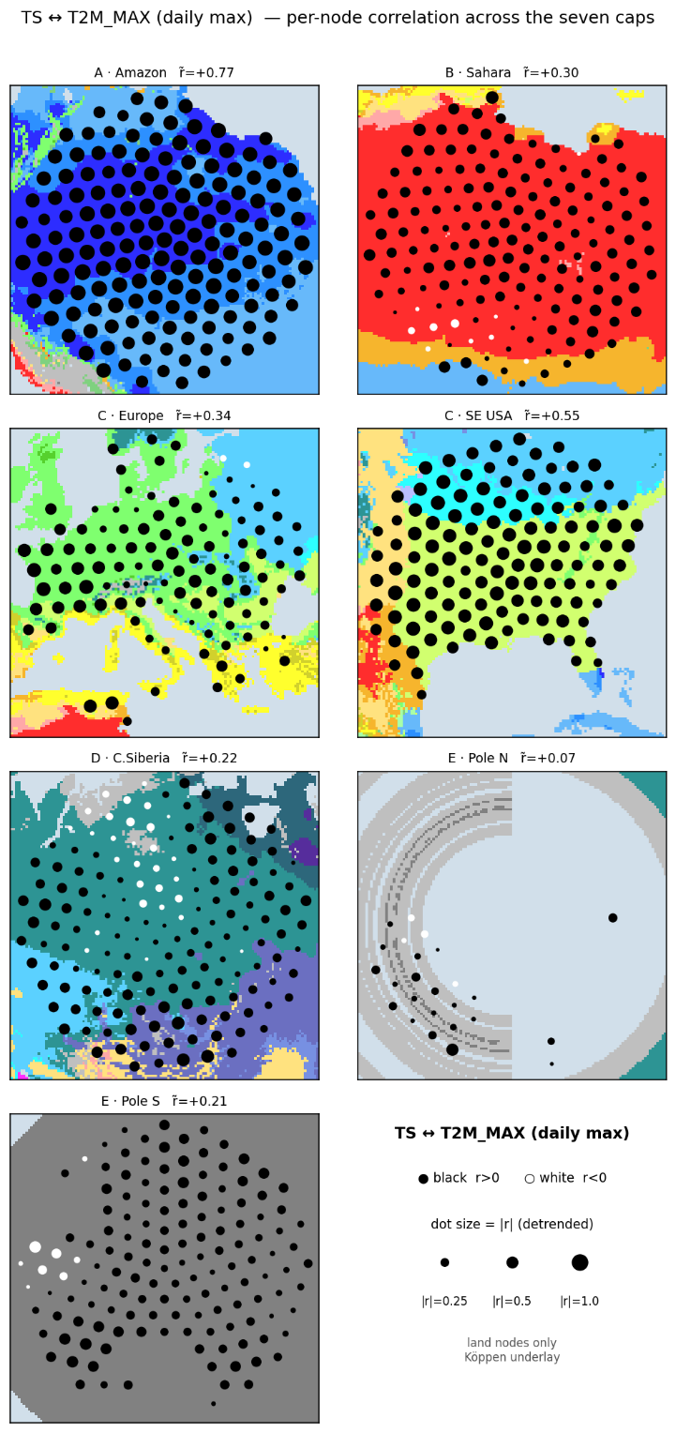
a | b
Figure A1. TS against T2M (mean air temperature) (a) and T2M_MAX (daily maximum) (b): node-level detrended correlation across the seven caps.
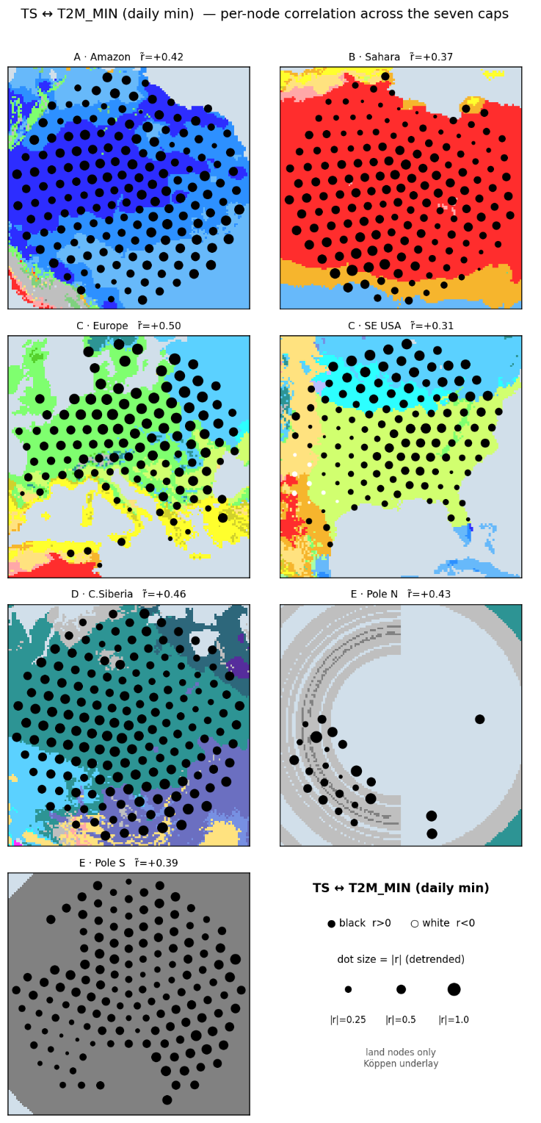 | 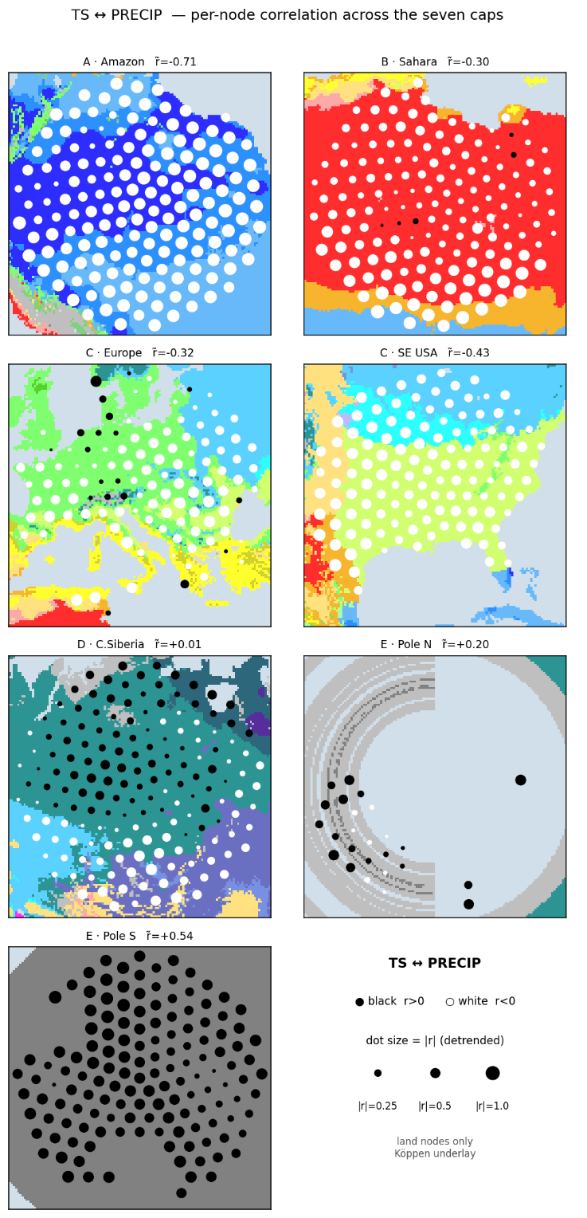
a | b
Figure A2. TS against T2M_MIN (daily minimum) (a), and PRECTOTCORR (precipitation) (b): node-level detrended correlation across the seven caps.
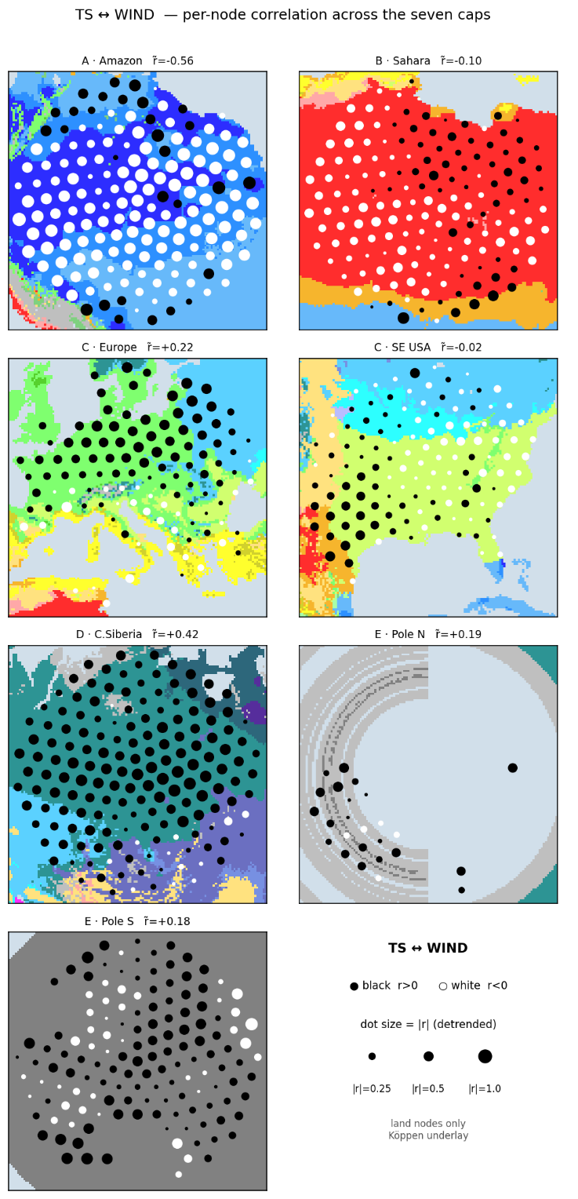
a
Figure A3. TS against WS2M (wind speed) (a): node-level detrended correlation across the seven caps.

