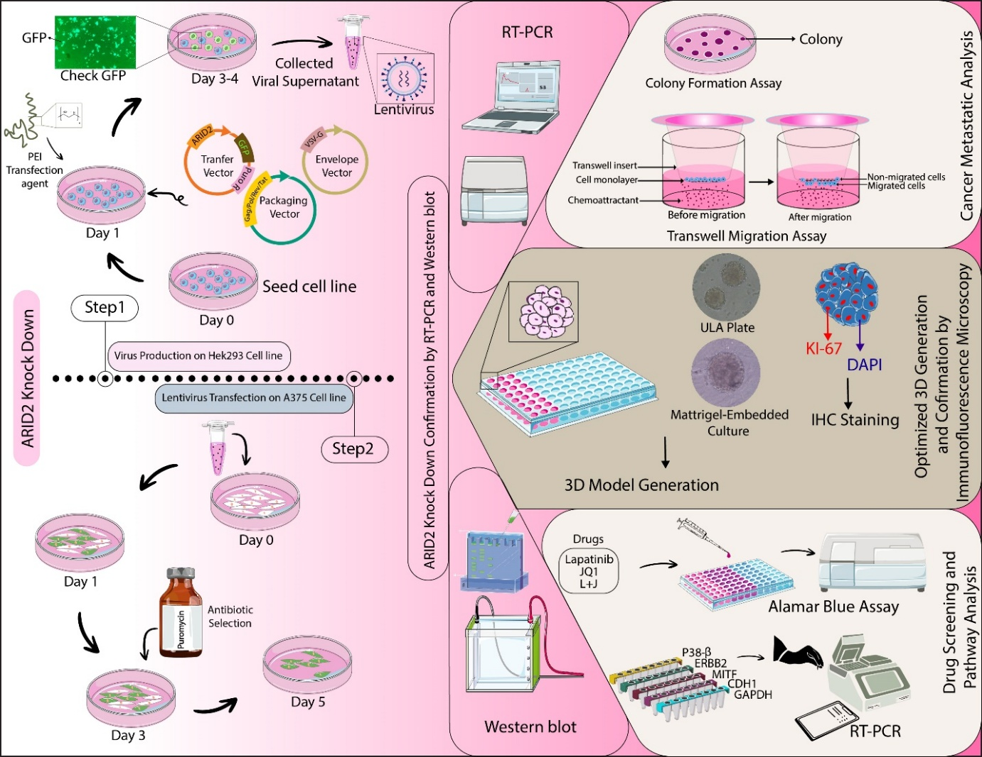
Graphical Abstract: Schematic overview of the experimental workflow used to investigate the impact of ARID2 knockdown on melanoma sensitivity to combined BET and EGFR/HER2 inhibition. ARID2 knockdown was achieved in A375 melanoma cells via lentiviral transduction and validated by RT–PCR and Western blotting. Functional effects were evaluated using 2D assays, including colony formation and Transwell migration, as well as physiologically relevant 3D spheroid models generated using ultra-low attachment plates and Matrigel embedding. Drug response to lapatinib and JQ1 (L+J), alone or in combination, was assessed by Alamar Blue viability assays, immunofluorescence staining (Ki-67/DAPI), and pathway-related gene expression analysis.

