Cloning
- Oligo Binding: Required concentration: 50 ng/µl in Annealing buffer
- Method: In a thermocycler, 2 minutes at 95°C and 50 minutes at 25°C.
- Plasmid digestion: was performed with two enzymes BamHI and EcoRI in X2 Tango buffer and Clean-up was performed with Gene All kit.
- Ligation
- Transformation in DH5 alpha cell
- Growing about 14 colonies and cultivating patch
- Plasmid extraction from overnight culture in liquid medium containing the antibiotic ampicillin with the pouya gene azma kit.
- Confirmation digest with XhoI enzyme (presence of the enzyme site on the sequence and absence of this site on the plasmid)
- PCR with sh-ARID2 primers
Gene | Sequence
sh-ARID2-Forward | AATTCCGACTAACAGCTGCCTTAATCTCGAGATTAAGGCAGCTGTTAGTCGGTTTTTG
Sh-ARID2-Reverse | GATCCAAAAACCGACTAACAGCTGCCTTAATCTCGAGATTAAGGCAGCTGTTAGTCGG

- Extraction from gel with Pouya gene Azma kit
- Sequencing
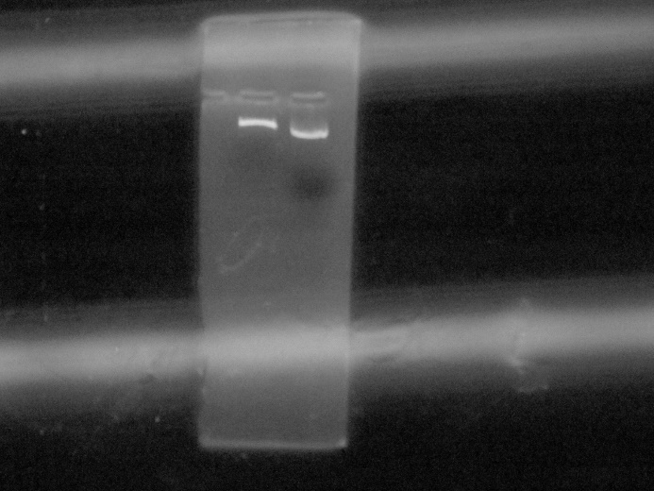
Figure 1: The right band of the undigested (supercoiled) plasmid and the left band of the plasmid digested with enzyme XhoI.

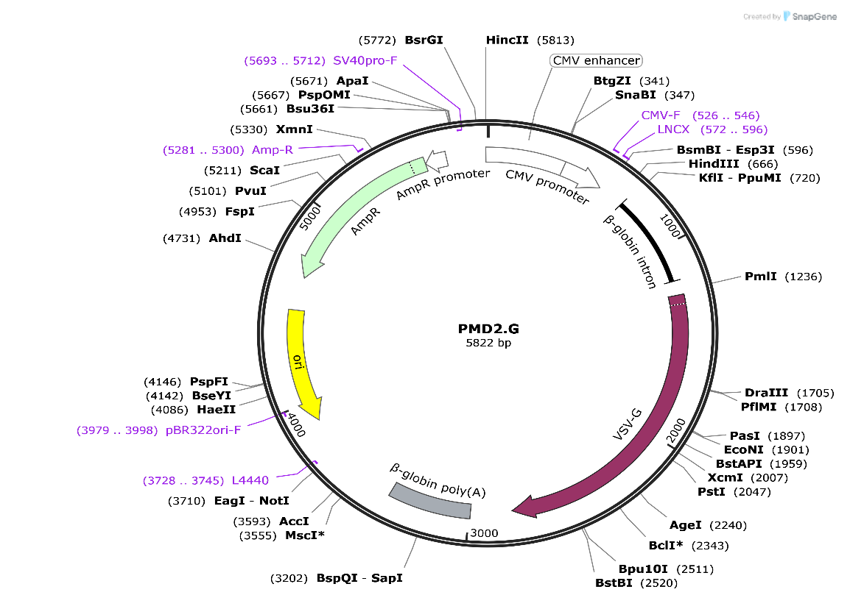
Figure 2. pMD2.G: VSV-G envelope expressing plasmid

Backbone
- Vector backbone
pMD2.G
- Vector type
Mammalian Expression, Lentiviral ; Envelope

Growth in Bacteria
- Bacterial Resistance(s)
Ampicillin, 100 μg/mL
- Growth Temperature
37°C
- Growth Strain(s)
NEB Stable
- Copy number
Low Copy

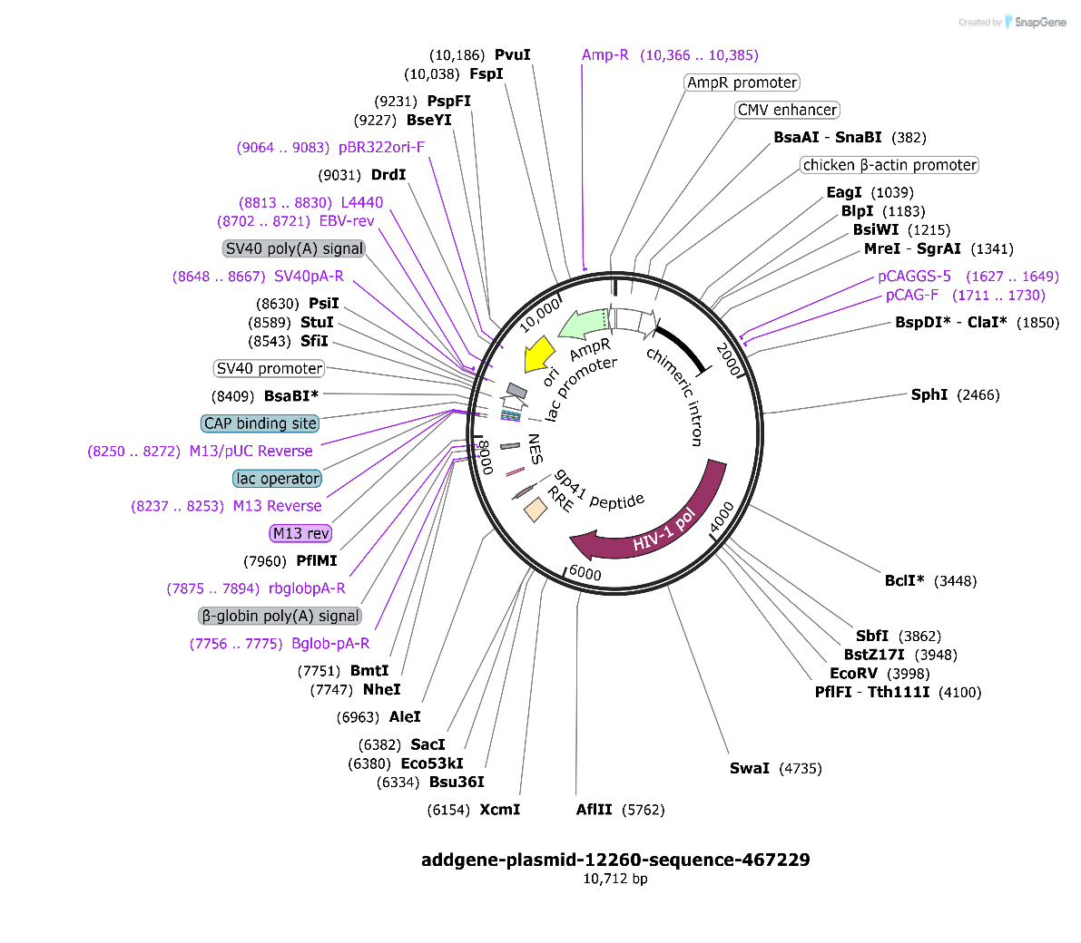
Figure 3. PsPAX2: 2nd generation lentiviral packaging plasmid
Backbone
- Vector backbone
psPAX2
- Backbone size (bp)10703
- Vector type
Mammalian Expression, Lentiviral ; Packaging

Growth in Bacteria
- Bacterial Resistance(s)
Ampicillin, 100 μg/mL
- Growth Temperature
37°C
- Growth Strain(s)
DH5alpha
- Copy number
High Copy

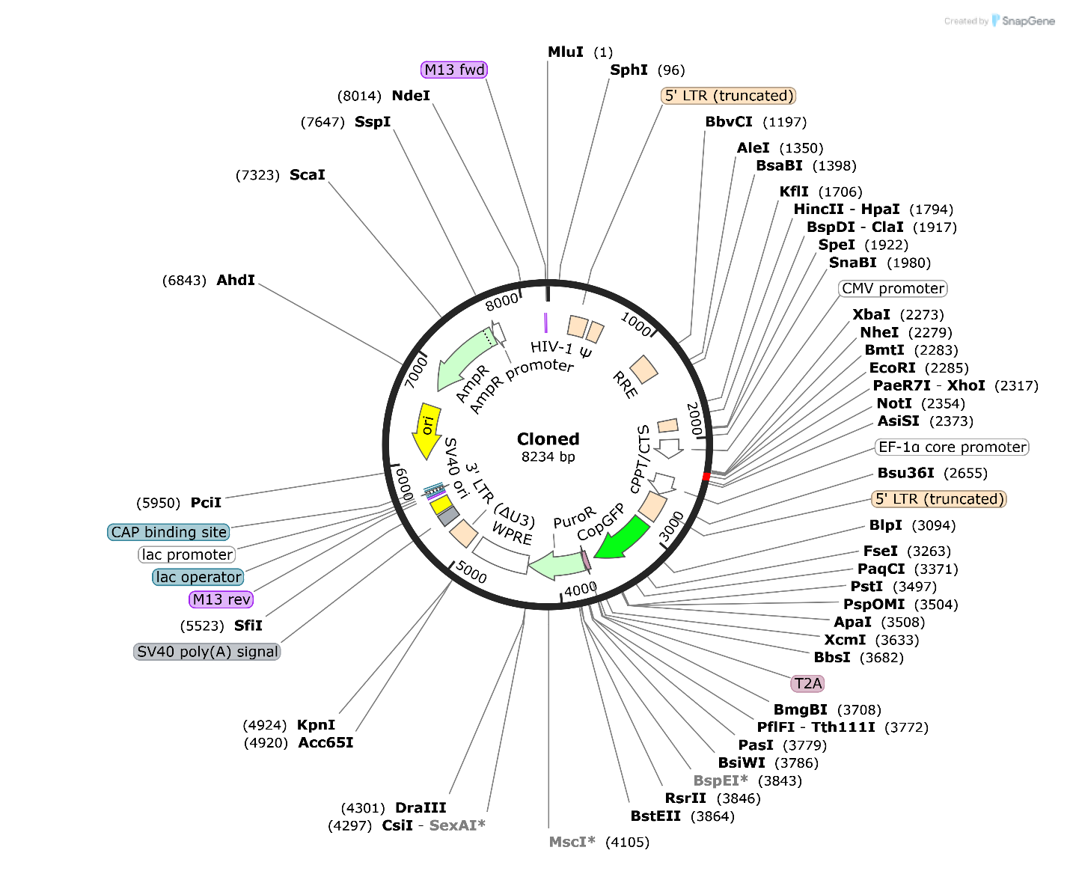
Figure 4. pCDH-CMV- arid2-Puro: Express gene of interest under CMV promoter

Backbone
- Vector backbone
pCDH-CMV- arid2-Puro
- Vector type
Mammalian Expression, Lentiviral
- Selectable markers
Puromycin

Growth in Bacteria
- Bacterial Resistance(s)
Ampicillin, 100 μg/mL
- Growth Temperature
37°C
- Growth Strain(s)
DH5 alpha

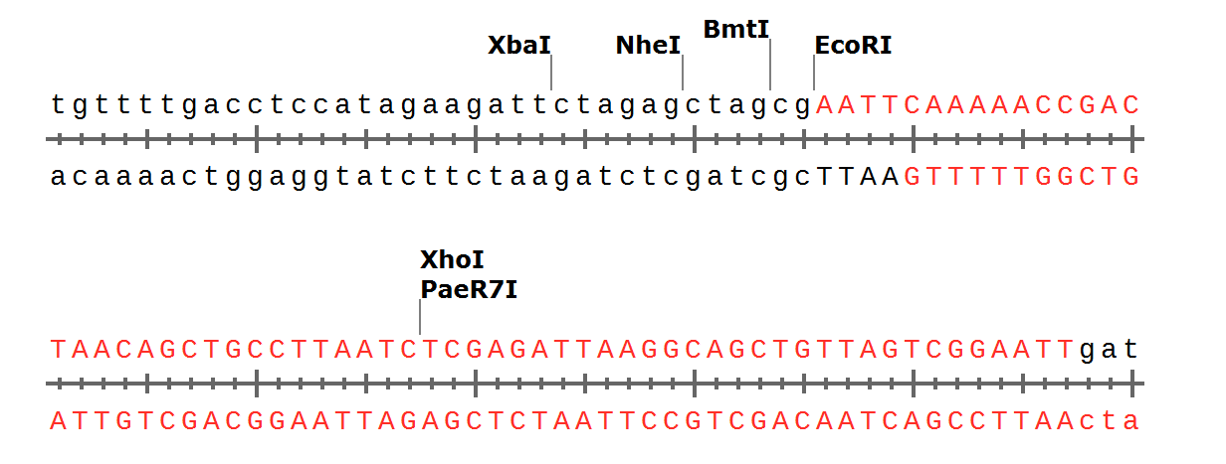

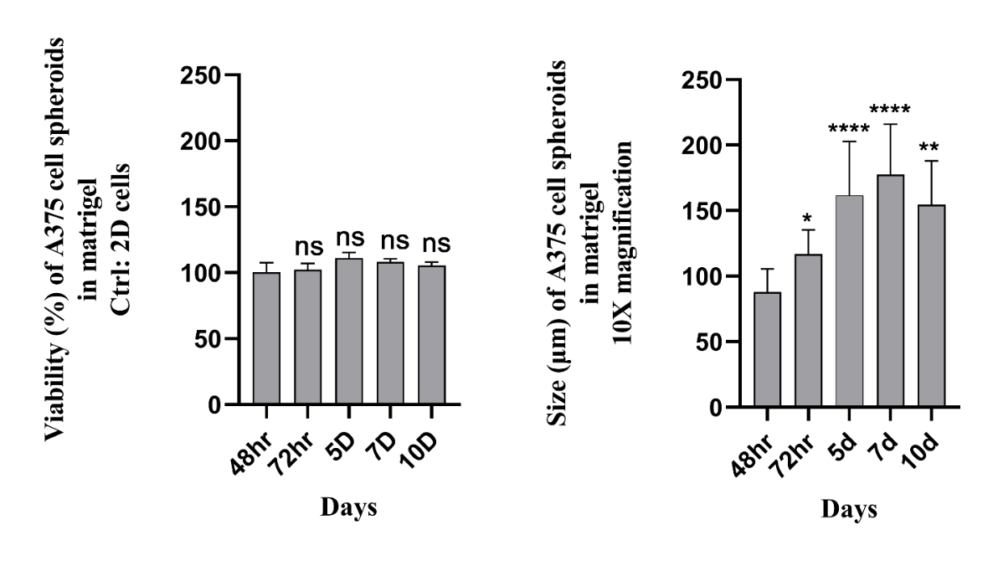
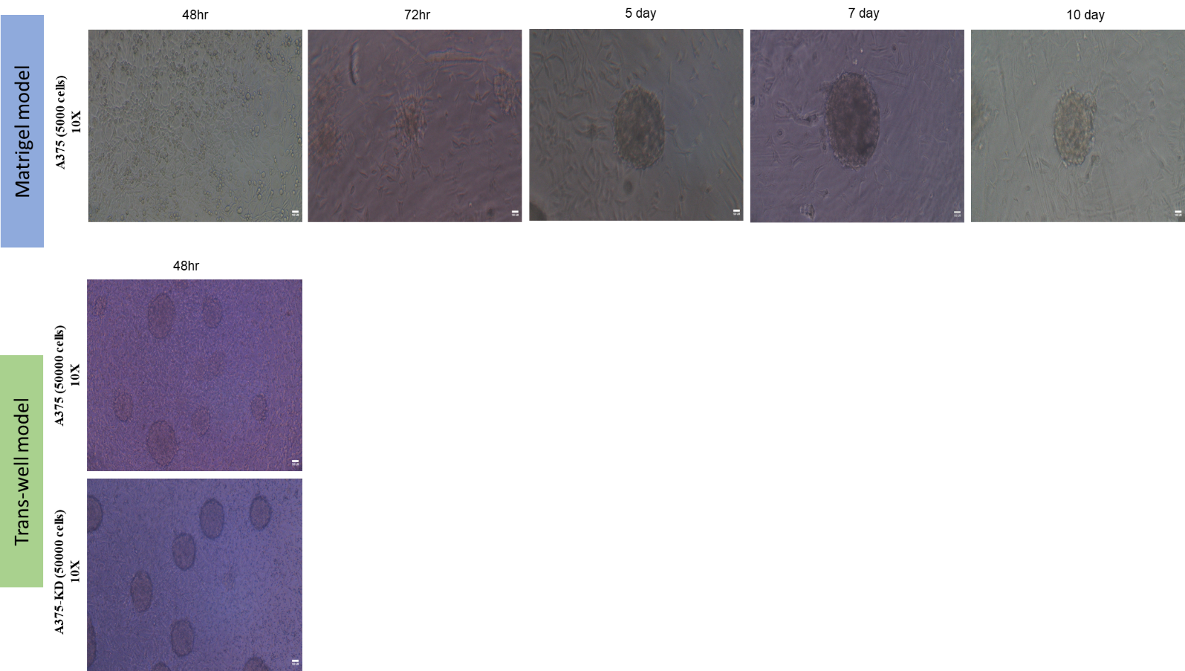
Figure 5. 3D model generation in trans-well and matrigel. (A) Representative images showing formation and progression of cell aggregates within trans-well and matrigel over the culture period (48hr, 72hr, Day 5, Day 7 and Day 10). $×$10 magnification, Scale bar: 100 µm. (B) The percentage of A375 cell spheroids viability and size was measured on different days (48hr, 72hr, Day 5, Day 7 and Day 10).

B.
A.

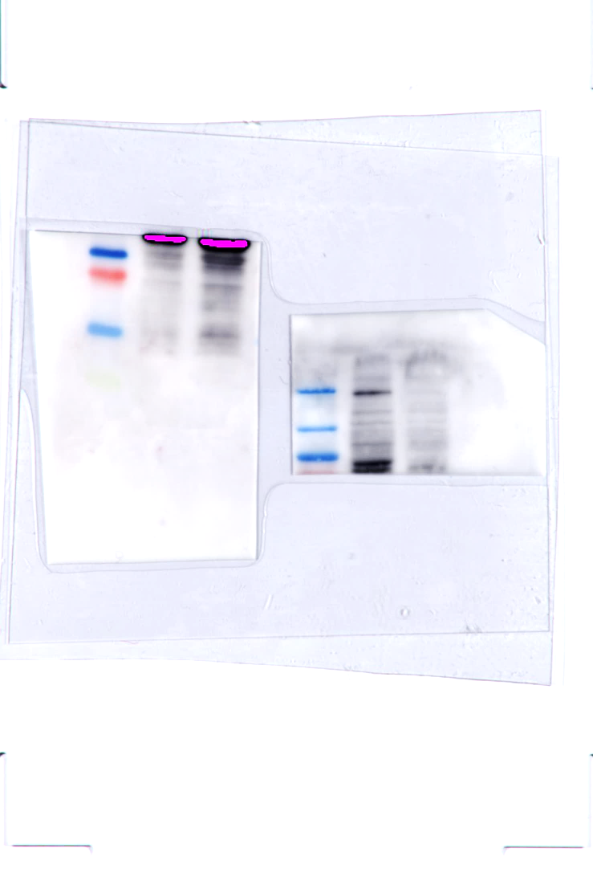

A375-ARID2/KD
Ctrl-PCDH
200k/ARID2

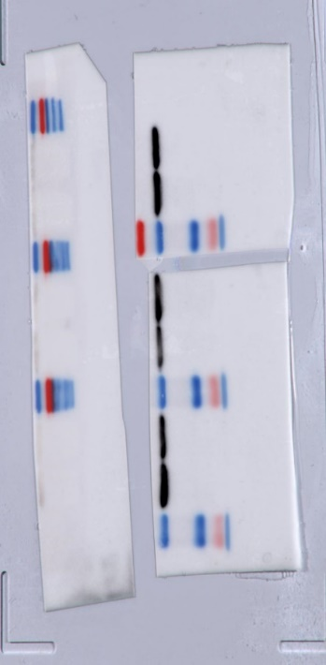

Ctrl-PCDH
A375-ARID2/KD
55k/Bactin

Figure 6. Full-length, uncropped Western blot corresponding to Figure 1B. The complete original blot from which the representative lanes shown in Figure 1B were selected is presented. The blot contains the Control and experimental samples shown in Figure 1B, together with additional samples from the same experiment. The full-length image is provided to ensure transparency and facilitate verification of the representative blot presented in the main figure.

