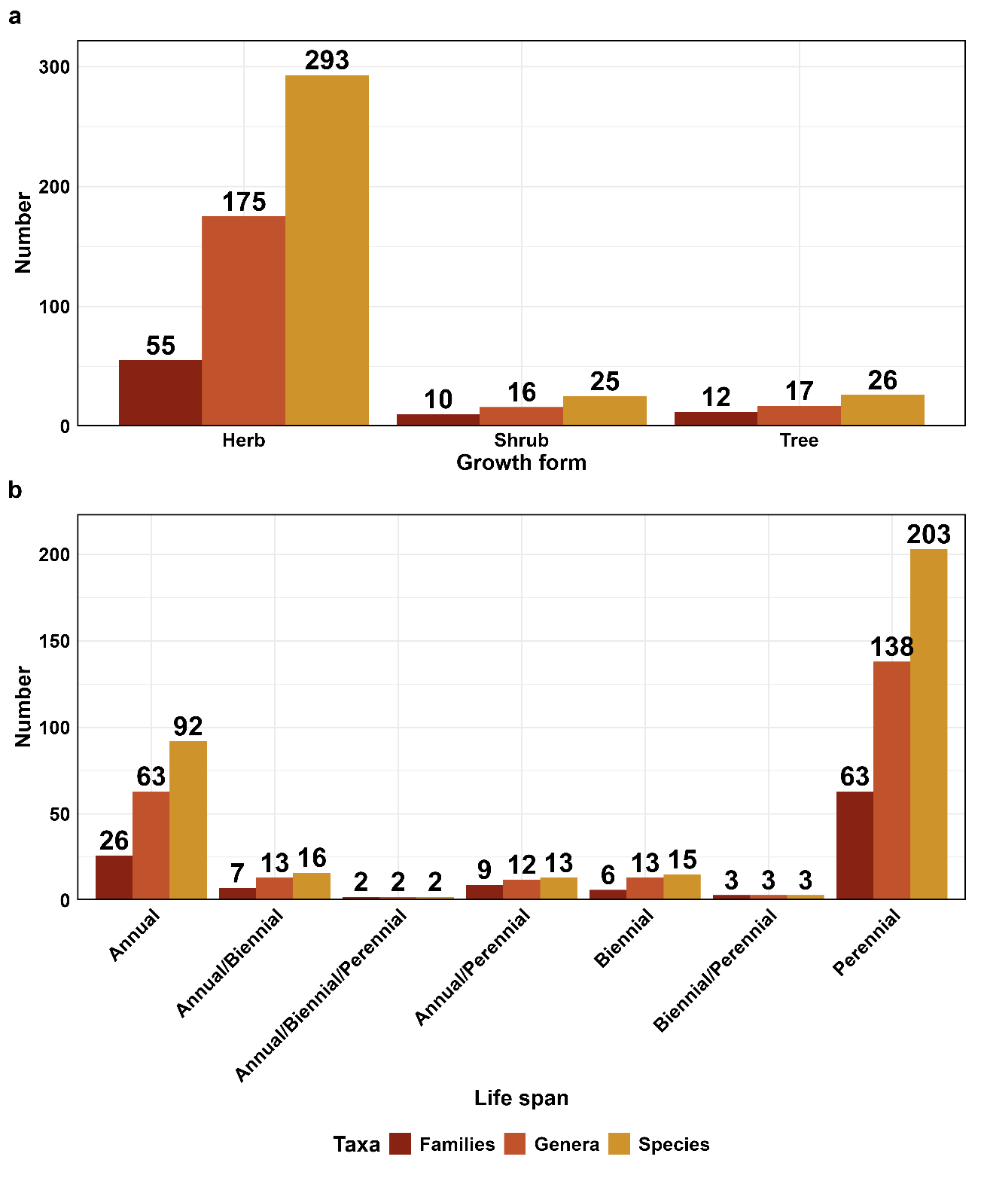
Fig. S1 (a) Growth form composition (herbs, shrubs, trees) of plant species in the Kashmir Himalaya. (b) Life span distribution (annual, biennial, perennial, and mixed categories).
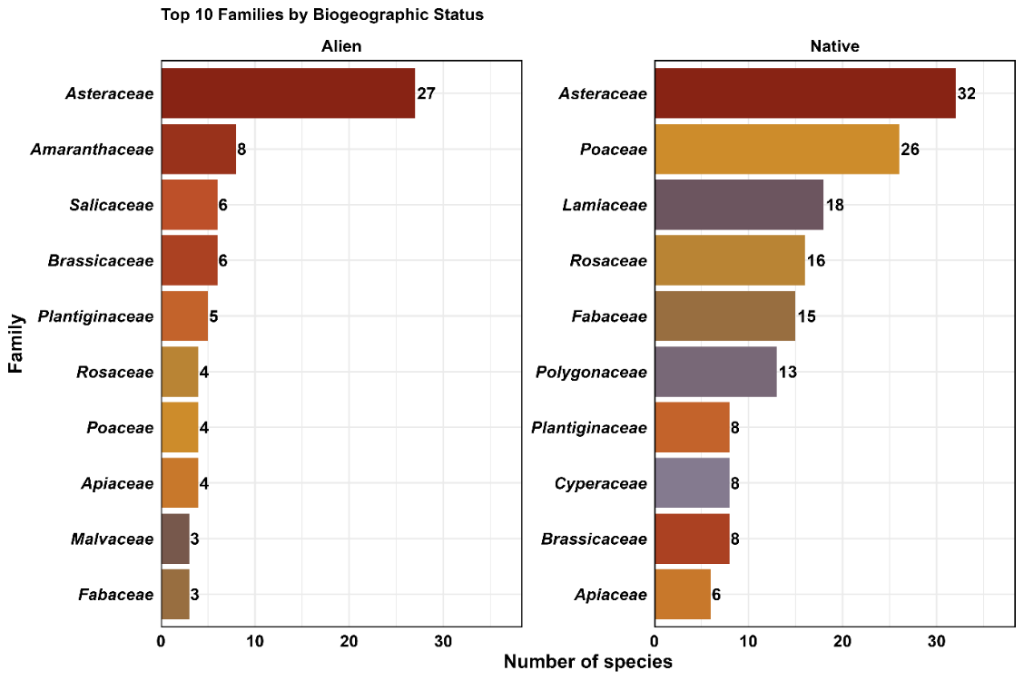
Fig. S2. Dominant plant families contributing to alien and native species richness in the Kashmir Himalaya.

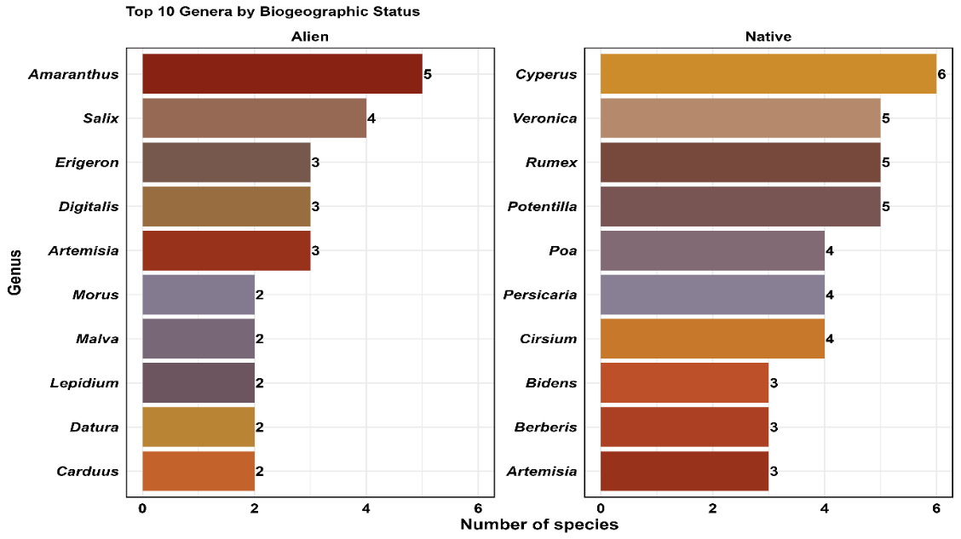
Fig. S3 Dominant genera contributing to alien and native species richness in the Kashmir Himalaya.

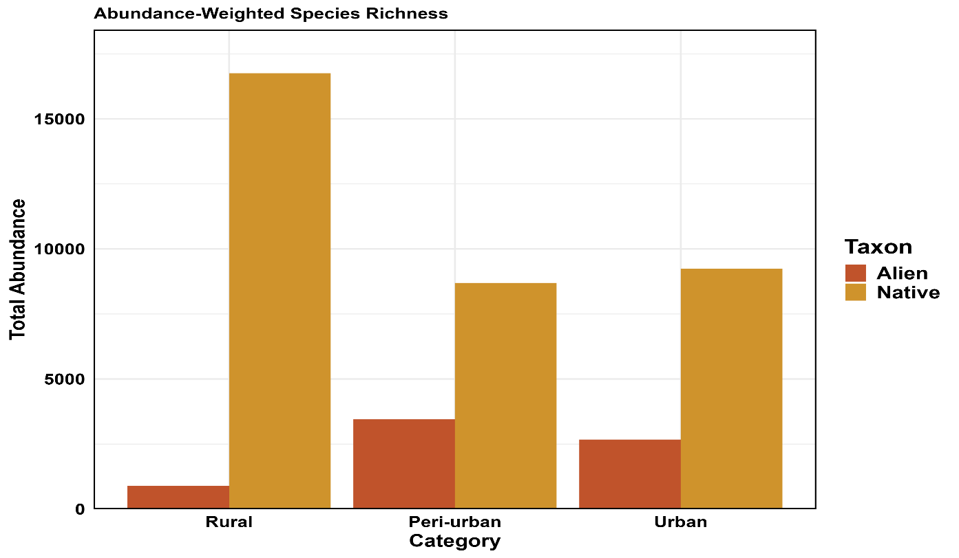

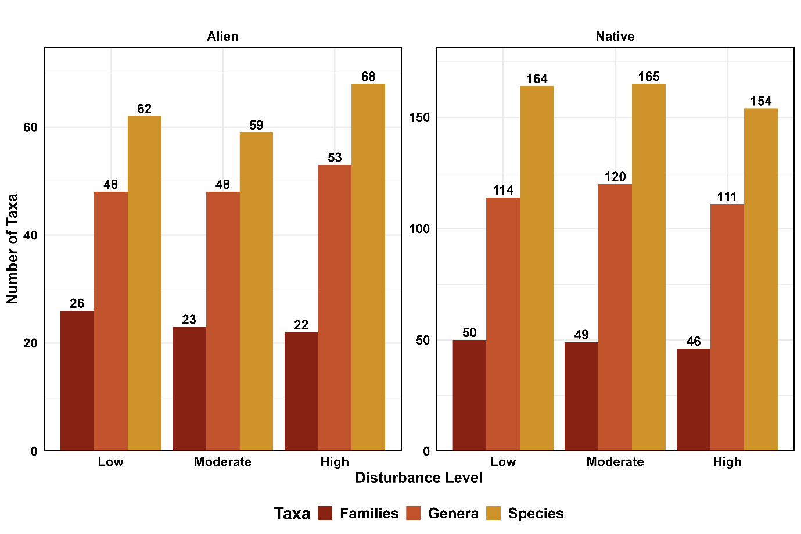
Fig. S4 Abundance-weighted species richness of native and alien taxa across the urban-rural gradient.

Fig. S5 Taxonomic richness of alien and native plant assemblages across three disturbance levels (low, moderate, and high). Bars represent the number of families, genera, and species recorded within each disturbance category.

Table S1 Conspectus of vascular plant species recorded across urban, peri-urban, and rural landscapes in the Kashmir Himalaya, categorized by taxonomic group, growth form, and biogeographic status.
Taxonomic group | Growth form | Biogeographic status | Species
Dicot | Herb | Native | 163
Dicot | Herb | Alien | 74
Dicot | Shrub | Native | 20
Dicot | Tree | Alien | 14
Dicot | Tree | Native | 7
Dicot | Shrub | Alien | 4
Gymnosperm | Tree | Native | 4
Gymnosperm | Shrub | Native | 1
Gymnosperm | Tree | Alien | 1
Monocot | Herb | Native | 41
Monocot | Herb | Alien | 8
Pteridophyte | Herb | Native | 5
Pteridophyte | Herb | Alien | 2

Table S2. PERMANOVA results for variation in community composition in relation to urbanization, disturbance, and site effects. Degrees of freedom (Df), sums of squares (SumOfSqs), proportion of explained variation (R²), pseudo-F statistics (F), and permutation-based p-values are shown. Significance codes: *** p < 0.001; ns, not significant.
Factor | Df | SumOfSqs | R² | F | p-value | Significance
Urbanization | 2 | 2.110 | 0.050 | 3.883 | <0.001 | ***
Disturbance | 2 | 0.616 | 0.015 | 1.092 | 0.289 | ns
Site | 24 | 9.908 | 0.236 | 1.605 | <0.001 | ***
Combined Model | 4 | 2.725 | 0.065 | 2.512 | <0.001 | ***
Residual | 145 | 39.327 | 0.935 | - | - | -
Total | 149 | 42.052 | 1.000 | - | - | -
*p < 0.001; ns = not significant
Table S3. Pairwise PERMANOVA comparisons of community composition among urbanization classes. The table shows the R² values, permutation-based p-values, and significance levels for comparisons between urban, peri-urban, and rural classes. Significance codes: *** p < 0.001; ns, not significant.
Comparison | R² | p-value | Significance
Urban vs Rural | 0.057 | <0.001 | ***
Urban vs Peri-urban | 0.013 | 0.099 | ns
Rural vs Peri-urban | 0.059 | <0.001 | ***

Table S4 Distance-based redundancy analysis (dbRDA) results for community composition of all, native, and alien species. The table presents the overall model and the effects of elevation, urbanization, and disturbance, with degrees of freedom (Df), sums of squares (SumOfSqs), pseudo-F statistics (F), permutation-based p-values, and significance levels. Significance codes: *** p < 0.001; ** p < 0.01; ns, not significant.
Species Group | Model | Df | SumOfSqs | F | p-value | Significance
All Species | Overall Model | 5 | 3.856 | 2.732 | <0.001 | ***
All Species | Elevation | 1 | 2.451 | 8.683 | <0.001 | ***
All Species | Urbanization | 2 | 0.763 | 1.352 | 0.092 | ns
All Species | Disturbance | 2 | 0.642 | 1.136 | 0.244 | ns
Native Species | Overall Model | 5 | 2.481 | 2.021 | 0.007 | **
Native Species | Elevation | 1 | 1.701 | 6.929 | <0.001 | ***
Native Species | Urbanization | 2 | 0.500 | 1.017 | 0.369 | ns
Native Species | Disturbance | 2 | 0.280 | 0.571 | 0.882 | ns
Alien Species | Overall Model | 5 | 2.460 | 1.982 | 0.006 | **
Alien Species | Elevation | 1 | 1.476 | 5.947 | <0.001 | ***
Alien Species | Urbanization | 2 | 0.403 | 0.811 | 0.616 | ns
Alien Species | Disturbance | 2 | 0.581 | 1.170 | 0.261 | ns

