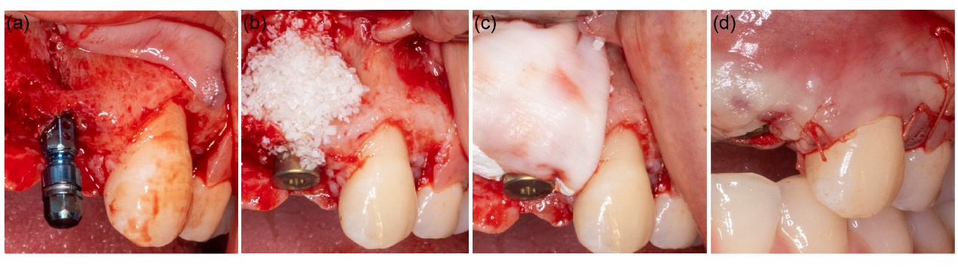
Figure S1. Standardized clinical protocol for simultaneous GBR in the anterior maxilla. (a) Diagnosis of the bone defect. (b) Placement of particulate bone substitute. (c) Application of the resorbable barrier membrane. (d) Tension-free primary closure.

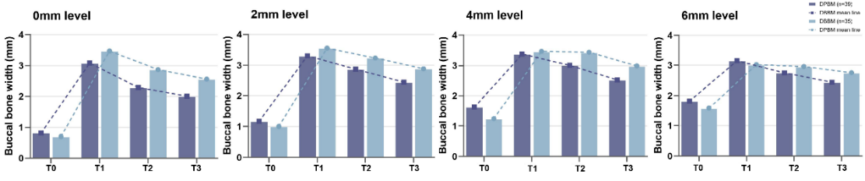
Figure S2. Buccal bone width over time at four measurement levels.

Table 3. Augmented bone volume change (ΔV) and volume maintenance rate (VMR).
Outcome | Group P (n=35) Mean ± SD | Group B (n=39) Mean ± SD | p ᵃ | Adjusted β (95% CI) ᵇ | p (adj) | ICC ᶜ | Group P (matched, n=20) Mean ± SD | Group B (matched, n=20) Mean ± SD | p ᵈ
ΔV₁ (T1−T0, mm³): graft volume placed | 151.9 ± 50.2 | 159.0 ± 39.9 | 0.500 | 4.8 (-19.4 to 29.0) | 0.699 | 0.63 | 147.8 ± 55.5 | 155.9 ± 39.9 | 0.601
ΔV₂ (T2−T0, mm³): 6-mo net gain | 110.0 ± 47.0 | 119.7 ± 42.0 | 0.352 | 9.3 (-13.3 to 31.9) | 0.420 | 0.49 | 101.0 ± 47.4 | 118.7 ± 44.8 | 0.226
ΔV₃ (T3−T0, mm³): 12-mo net gain | 74.1 ± 43.3 | 88.3 ± 38.9 | 0.049* | 14.7 (-7.5 to 36.8) | 0.195 | 0.52 | 70.9 ± 47.0 | 85.6 ± 44.6 | 0.323
VMR₆ (%): 6-mo volume maintenance | 74.6 ± 25.8 | 73.8 ± 14.6 | 0.837 | 2.2 (-9.5 to 13.9) | 0.715 | 0.83 | 71.1 ± 27.1 | 73.7 ± 15.5 | 0.287
VMR₁₂ (%): 12-mo volume maintenance | 48.0 ± 17.2 | 54.0 ± 18.0 | 0.143 | 7.6 (-2.3 to 17.5) | 0.134 | 0.41 | 47.1 ± 17.8 | 52.9 ± 23.0 | 0.337
Note: Bold = p < 0.05. Adjusted = multivariable linear regression (B−P). PSM = propensity-score–matched paired analysis.

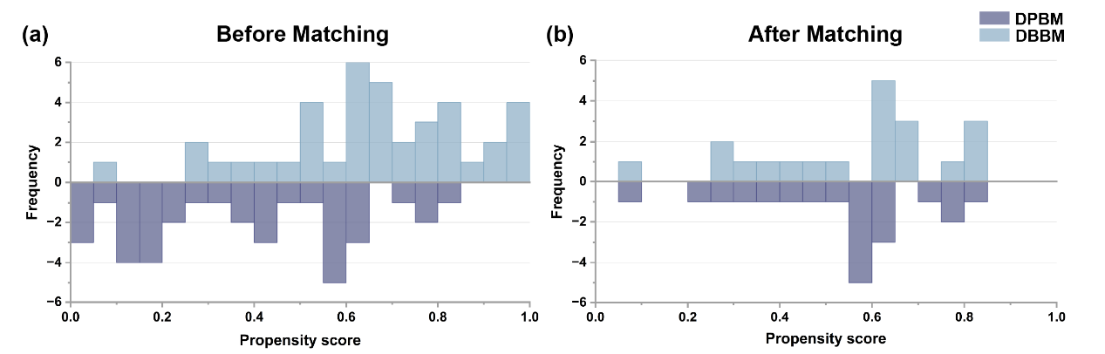
Figure S3. Distribution of propensity scores in the DPBM and DBBM groups before (a) and after (b) 1:1 nearest-neighbour matching.

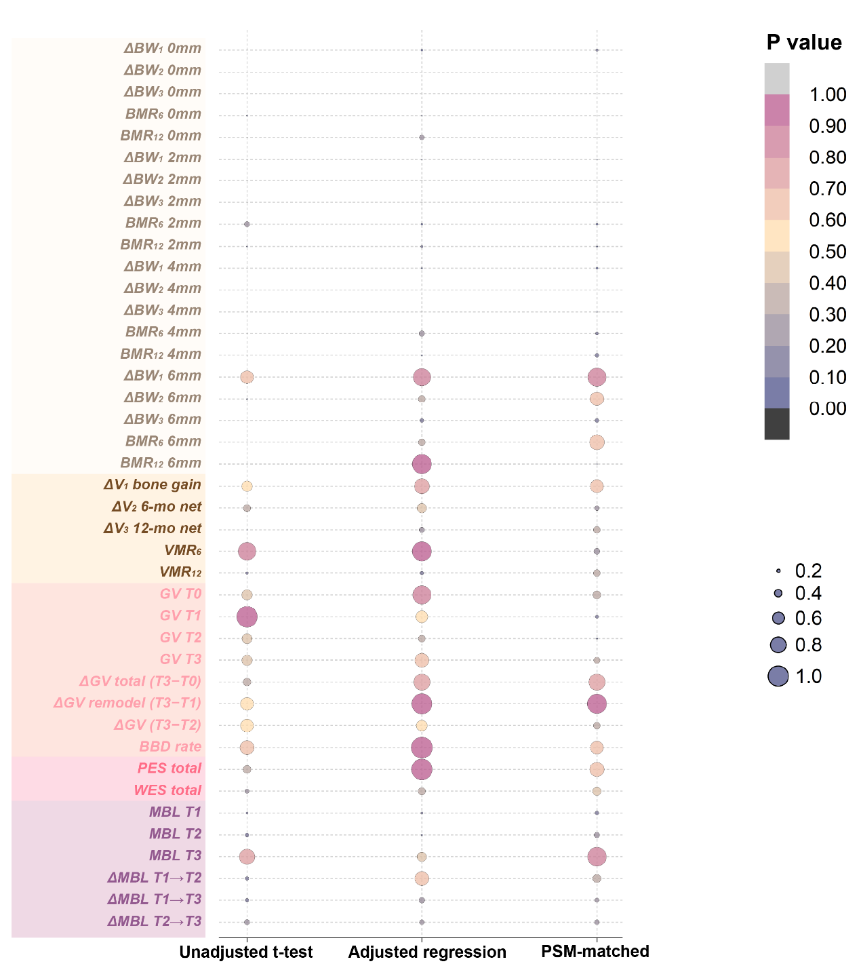
Figure S4. P-values for all 41 outcomes across three analytical methods (unadjusted t test or Mann–Whitney U test, covariate-adjusted mixed-effects regression, and PSM-matched paired analysis). Bubble colour and size encode the p-value. Rows are grouped by outcome domain (linear buccal bone width, volume, density, esthetics, and marginal bone
Table S1. Buccal bone density (grayscale value, GV).
Outcome | Group P (n=35) Mean ± SD | Group B (n=39) Mean ± SD | p ᵃ | Adjusted β (95% CI) ᵇ | p (adj) | ICC ᶜ | Group P (matched, n=20) Mean ± SD | Group B (matched, n=20) Mean ± SD | p ᵈ
GV at T0 (baseline density) | 630 ± 157 | 607 ± 121 | 0.479 | -6 (-78 to 65) | 0.863 | 0.00 | 661 ± 148 | 618 ± 124 | 0.372
GV at T1 (post-graft density) | 965 ± 240 | 905 ± 89 | 0.974 | -26 (-115 to 63) | 0.565 | 0.34 | 988 ± 201 | 916 ± 87 | 0.170
GV at T2 (6-mo density) | 1101 ± 281 | 1001 ± 109 | 0.468 | -54 (-161 to 53) | 0.322 | 0.61 | 1110 ± 225 | 1010 ± 111 | 0.076
GV at T3 (12-mo density) | 1246 ± 296 | 1162 ± 156 | 0.488 | -25 (-149 to 99) | 0.691 | 0.50 | 1258 ± 296 | 1191 ± 152 | 0.299
ΔGV total (T3−T0) | 616 ± 317 | 556 ± 188 | 0.369 | -23 (-166 to 120) | 0.754 | 0.13 | 598 ± 330 | 573 ± 174 | 0.762
ΔGV remodeling (T3−T1) | 281 ± 175 | 257 ± 148 | 0.596 | -0 (-89 to 89) | 0.999 | 0.18 | 270 ± 199 | 275 ± 150 | 0.903
ΔGV (T3−T2) | 145 ± 136 | 161 ± 126 | 0.596 | 28 (-47 to 102) | 0.466 | 0.52 | 148 ± 152 | 181 ± 141 | 0.334
BBD rate (%): GV(T3)/GV(T1)×100 | 130.6 ± 19.3 | 129.1 ± 18.0 | 0.720 | 0.1 (-10.2 to 10.4) | 0.989 | 0.15 | 128.0 ± 20.1 | 130.7 ± 17.9 | 0.604
Values are mean ± standard deviation.
ᵃ Unadjusted between-group comparison (independent-samples t test or Mann–Whitney U test according to distribution).
ᵇ Adjusted β (Bio-Oss minus THE Graft) from a linear mixed-effects model with a random intercept for patient, adjusted for age, sex, smoking status, tooth position, implant timing, preoperative buccal bone thickness, horizontal defect width, buccal dehiscence height, and implant diameter.
ᶜ ICC, patient-level intraclass correlation estimated from the mixed model.
ᵈ Propensity-score-matched sensitivity analysis (20 matched implant pairs); paired comparison. * p < 0.05. DPBM (THE Graft), Group P; DBBM (Bio-Oss), Group B.

Table S2. Secondary outcomes: esthetic scores (PES, WES) and marginal bone level (MBL).
Outcome | Group P (n=35) Mean ± SD | Group B (n=39) Mean ± SD | p ᵃ | Adjusted β (95% CI) ᵇ | p (adj) | ICC ᶜ | Group P (matched, n=20) Mean ± SD | Group B (matched, n=20) Mean ± SD | p ᵈ
Esthetic outcomes (12-month)
PES total (0–14) | 10.80 ± 1.57 | 11.08 ± 1.92 | 0.368 | 0.01 (-0.97 to 1.00) | 0.978 | 0.02 | 10.8 ± 1.5 | 11.1 ± 1.9 | 0.670
WES total (0–10) | 9.60 ± 0.55 | 9.74 ± 0.50 | 0.203 | 0.14 (-0.15 to 0.43) | 0.341 | 0.00 | 9.6 ± 0.6 | 9.8 ± 0.4 | 0.407
Marginal bone level (MBL)
MBL at T1 (mm) | 3.22 ± 0.91 | 2.86 ± 1.03 | 0.116 | -0.37 (-0.90 to 0.17) | 0.177 | 0.33 | 3.25 ± 0.81 | 2.79 ± 1.08 | 0.178
MBL at T2 (mm) | 2.80 ± 0.74 | 2.58 ± 0.68 | 0.190 | -0.35 (-0.74 to 0.04) | 0.077 | 0.32 | 2.82 ± 0.70 | 2.52 ± 0.75 | 0.250
MBL at T3 (mm) | 2.40 ± 0.84 | 2.34 ± 0.51 | 0.716 | -0.21 (-0.59 to 0.17) | 0.275 | 0.58 | 2.32 ± 0.87 | 2.28 ± 0.58 | 0.891
ΔMBL T1→T2 (6-mo change, mm) | -0.42 ± 0.60 | -0.28 ± 0.58 | 0.192 | 0.04 (-0.28 to 0.36) | 0.813 | 0.19 | -0.42 ± 0.55 | -0.28 ± 0.48 | 0.394
ΔMBL T1→T3 (12-mo change, mm) | -0.82 ± 0.90 | -0.52 ± 1.00 | 0.178 | 0.23 (-0.28 to 0.74) | 0.376 | 0.17 | -0.93 ± 0.92 | -0.51 ± 1.06 | 0.201
ΔMBL T2→T3 (6–12-mo change, mm) | -0.41 ± 0.57 | -0.25 ± 0.63 | 0.259 | 0.19 (-0.14 to 0.52) | 0.265 | 0.17 | -0.50 ± 0.60 | -0.23 ± 0.73 | 0.236
Note: Adjusted = multivariable linear regression (B−P). PSM = propensity-score–matched paired analysis.

