Additional file

Supplementary Figures and Tables

Supplementary Figures
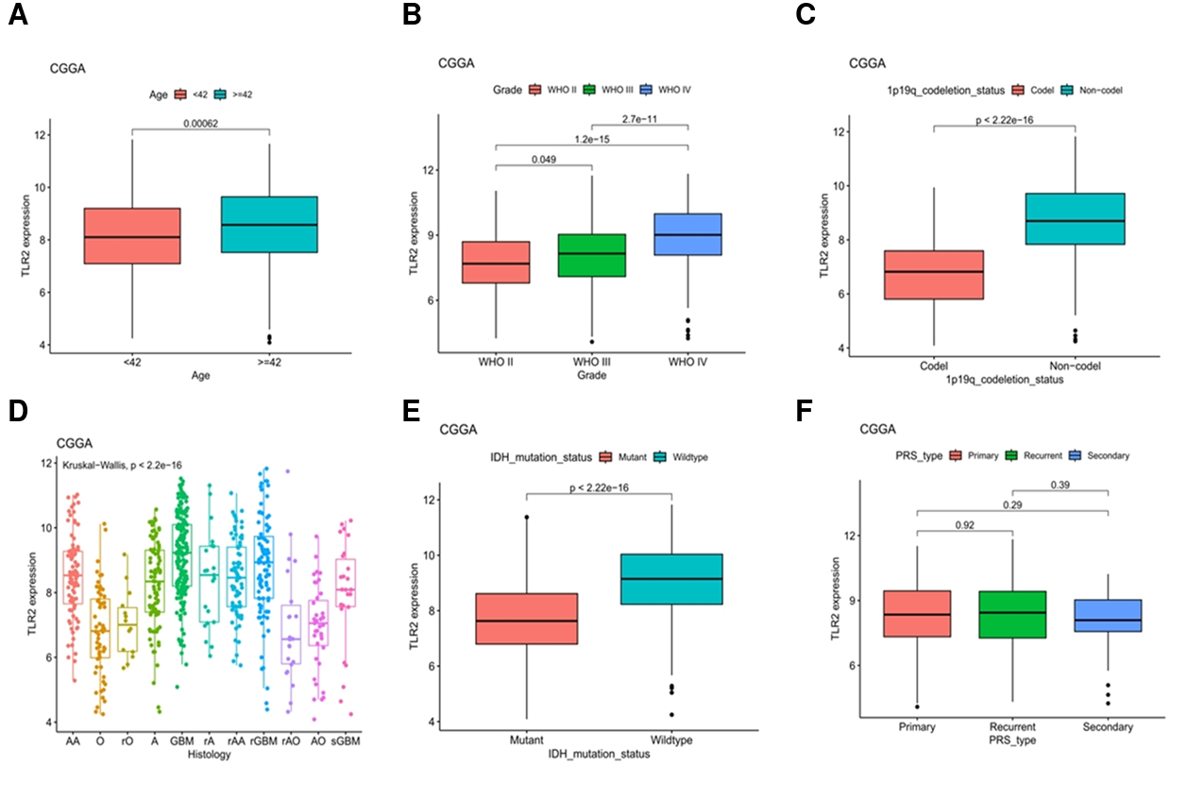
Supplementary Figure 1 | Associations between *TLR2* expression and clinicopathological characteristics in the CGGA cohort.** *TLR2* expression was compared according to (A) age (<42 vs. ≥42 years), (B) WHO grade (grades II–IV), (C) 1p/19q codeletion status, (D) histological subtype, (E) IDH mutation status, and (F) primary, recurrent, or secondary disease status. *P* values are shown in the corresponding panels.

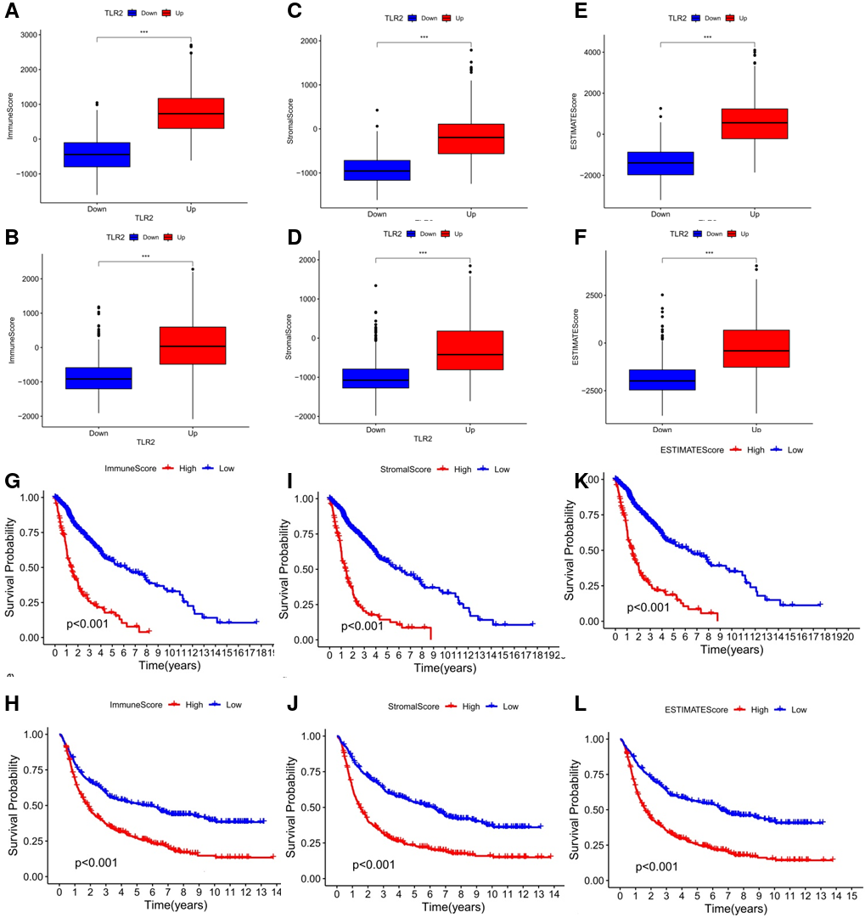
Supplementary Figure 2 | Associations of TLR2 expression with ESTIMATE-derived scores and patient survival in glioma. (A, B) ImmuneScore, (C, D) StromalScore, and (E, F) ESTIMATEScore in the TLR2-low and TLR2-high groups in the TCGA and CGGA cohorts, respectively. (G, H) Kaplan–Meier survival curves stratified by ImmuneScore, (I, J) StromalScore, and (K, L) ESTIMATEScore in the TCGA and CGGA cohorts, respectively. Higher scores were associated with shorter survival in both cohorts. Survival differences were evaluated using log-rank tests. TCGA, The Cancer Genome Atlas; CGGA, Chinese Glioma Genome Atlas; ESTIMATE, Estimation of STromal and Immune cells in MAlignant Tumor tissues using Expression data. ***P < 0.001.
Supplementary Figure 3 | TIMER2.0 analysis of the relationships among *TLR2* expression, immune-cell infiltration, and survival in GBM and LGG.** (A) Correlations of *TLR2* expression with tumor purity and the estimated infiltration levels of B cells, CD8⁺ T cells, CD4⁺ T cells, macrophages, neutrophils, and dendritic cells in GBM (upper row) and LGG (lower row). Correlation coefficients and *P* values are shown; partial correlations for immune-cell infiltration were adjusted for tumor purity. (B) Kaplan–Meier survival curves comparing high (top 50%) and low (bottom 50%) infiltration levels of the indicated immune-cell populations, or high and low *TLR2* expression, in GBM (upper row) and LGG (lower row). Survival differences were evaluated using log-rank tests, with *P* values shown in the corresponding panels.

Supplementary Tables

Supplementary Table1 Statistical table showing the proportion of immune cell subtypes in tumor tissues based on TLR2 expression.
 | Positive | Negative |  | P value
CD4+ | 0.807 | 0.244 | <0.0001
CD4+FOXP3+ | 0.015 | 0.002 | 0.049
CD68+ | 1.915 | 1.239 | 0.004
CD68+CD163- | 1.388 | 1.017 | 0.062
CD68+CD163+ | 1.041 | 0.529 | 0.009
TLR2+CD4+ | 0.439 | 0.028 | <0.0001
TLR2+CD4+ FOXP3+ | 0.012 | 0.001 | 0.059
TLR2+CD68+ | 0.519 | 0.058 | <0.0001
TLR2+CD68+CD163- | 0.298 | 0.042 | 0.0003
TLR2+CD68+CD163+ | 0.305 | 0.017 | <0.0001

Supplementary Table 2 Statistical table of effective scores (index cells: S100⁺ tumor cells).
 | Positive | Negative | P value
CD4+ | 1.199 | 0.6145 | <0.0001
CD4+FOXP3+ | 0.6127 | 0.4241 | 0.3249
CD68+ | 1.980 | 1.524 | 0.0013
CD68+CD163- | 1.695 | 1.406 | 0.0348
CD68+CD163+ | 1.321 | 0.7738 | 0.0004

Supplementary Table 3 Statistical table of effective proportion (EP) (index cells: S100⁺ tumor cells).
 | Positive | Negative | P value
CD4+ | 0.9147 | 0.7135 | 0.0019
CD4+FOXP3+ | 0.9984 | 0.9958 | 0.2672
CD68+ | 0.9717 | 0.8713 | 0.0262
CD68+CD163- | 0.9556 | 0.8712 | 0.0733
CD68+CD163+ | 0.8586 | 0.6566 | 0.0048

Supplementary Table 4 Statistical table of effective scores (index cells: TLR2⁺S100⁺ tumor cells).
 | Positive | Negative | P value
CD4+ | 1.198 | 0.2946 | <0.0001
CD4+FOXP3+ | 0.6124 | 0.3597 | 0.2517
CD68+ | 1.979 | 1.456 | 0.0003
CD68+CD163- | 1.977 | 1.385 | <0.0001
CD68+CD163+ | 1.320 | 0.7232 | <0.0001

Supplementary Table 5 Statistical table of effective proportion (EP) (index cells: TLR2⁺S100⁺ tumor cells).
 | Positive | Negative | P value
CD4+ | 0.914 | 0.699 | 0.0010
CD4+FOXP3+ | 0.997 | 1.000 | 0.3310
CD68+ | 0.9711 | 0.8421 | 0.0078
CD68+CD163- | 0.9552 | 0.8565 | 0.0429
CD68+CD163+ | 0.8575 | 0.6279 | 0.0016
S100 | 1.000 | 0.9429 | 0.0413

