Appendix 1. Search strategy Page2-3
Appendix2. Risk of bias of each outcome Page4-5
eFigure1. Pooled result of Length of hospital stay Page6
eFigure2. Pooled result of adverse events Page7
eFigure3. Subgroup analysis based on severity Page8
eFigure4. Funnel plot and Egger’s test Page9
eTable1. Leave-one-out method for sensitivity analysis Page10

Appendix 1. Search strategy
PubMed
- ("COVID-19"[Mesh] OR "SARS-CoV-2"[Mesh] OR "COVID-19"[tiab] OR "SARS-CoV-2"[tiab] OR "coronavirus disease 2019"[tiab] OR "2019-nCoV"[tiab] OR "severe acute respiratory syndrome coronavirus 2"[tiab] OR "ncov"[tiab])
- ("Hydroxymethylglutaryl-CoA Reductase Inhibitors"[Mesh] OR "Statins"[tiab] OR "Statin"[tiab] OR "Atorvastatin"[tiab] OR "Simvastatin"[tiab] OR "Rosuvastatin"[tiab] OR "Pravastatin"[tiab] OR "Lovastatin"[tiab] OR "Fluvastatin"[tiab] OR "Pitavastatin"[tiab] OR "Cerivastatin"[tiab])
- Rando*[tiab]
- #1 AND #2 AND #3

Cochrane Library
- ("COVID-19" OR "SARS-CoV-2" OR "coronavirus disease 2019" OR "2019-nCoV" OR "severe acute respiratory syndrome coronavirus 2")
- ("statin*" OR "hydroxymethylglutaryl-coa reductase inhibitor*" OR "atorvastatin" OR "simvastatin" OR "rosuvastatin" OR "pravastatin" OR "lovastatin" OR "fluvastatin")
- Rando*[tiab]
- #1 AND #2 AND #3

Embase
- exp coronavirus disease 2019/ or (covid 19 or sars cov 2 or coronavirus disease 2019 or 2019 ncov or severe acute respiratory syndrome coronavirus 2).ti,ab
- exp hydroxymethylglutaryl coa reductase inhibitor/ or (statin$ or atorvastatin or simvastatin or rosuvastatin or pravastatin or lovastatin or fluvastatin or pitavastatin or cerivastatin).ti,ab
- (rando*).ti,ab
- #1 AND #2 AND #3

Web of science
- ("COVID-19" OR "SARS-CoV-2" OR "coronavirus disease 2019" OR "2019-nCoV" OR "severe acute respiratory syndrome coronavirus 2" OR ncov)
- TS=(("statin*" OR "Hydroxymethylglutaryl-CoA Reductase Inhibitor*" OR "atorvastatin" OR "simvastatin" OR "rosuvastatin" OR "pravastatin" OR "lovastatin" OR "fluvastatin" OR "pitavastatin" OR "cerivastatin")
- TS=(rando*)
- #1 AND #2 AND #3

Appendix2. Risk of bias of each outcome
28-day all-cause mortality
Study | D1 | D2 | D3 | D4 | D5 | Overall
Eltahan et al. | Low risk | Low risk | Low risk | Low risk | Low risk | Low risk
Gaitan-Duarte et al. | Low risk | Low risk | Low risk | Low risk | Low risk | Low risk
Rafsanjani et al. | Low risk | Low risk | Low risk | Low risk | Low risk | Low risk
Shah et al. | Low risk | Low risk | Low risk | Low risk | Low risk | Low risk
Ghafoori et al. | Low risk | Low risk | Low risk | Low risk | Low risk | Low risk
Ghati et al. | Low risk | Low risk | Low risk | Low risk | Low risk | Low risk
Inspiration-s | Low risk | Low risk | Low risk | Low risk | Low risk | Low risk
REMAP-CAP | Low risk | Low risk | Low risk | Low risk | Low risk | Low risk
Taghavi et al. | Low risk | Low risk | Low risk | Low risk | Low risk | Low risk
Hejazi et al. | Low risk | Low risk | Low risk | Low risk | Low risk | Low risk

Patients requiring mechanical ventilation or ICU care
Study | D1 | D2 | D3 | D4 | D5 | Overall
Matli et al. | Low risk | Low risk | Low risk | Low risk | Low risk | Low risk
Davoodi et al. | Low risk | Low risk | Low risk | Low risk | Low risk | Low risk
Eltahan et al. | Low risk | Low risk | Low risk | Low risk | Low risk | Low risk
Gaitan-Duarte et al. | Low risk | Low risk | Low risk | Low risk | Low risk | Low risk
Ghati et al. | Low risk | Low risk | Low risk | Low risk | Low risk | Low risk
Rafsanjani et al. | Low risk | Low risk | Low risk | Low risk | Low risk | Low risk
Shah et al. | Low risk | Low risk | Low risk | Low risk | Low risk | Low risk
Ghafoori et al. | Low risk | Low risk | Low risk | Low risk | Low risk | Low risk

Length of hospital stay
Study | D1 | D2 | D3 | D4 | D5 | Overall
Davoodi et al. | Low risk | Low risk | Low risk | Low risk | Low risk | Low risk
Ghafoori et al. | Low risk | Some concerns | Low risk | Some concerns | Low risk | Some concerns
Ghati et al. | Low risk | Some concerns | Low risk | Some concerns | Low risk | Some concerns
Rafsanjani et al. | Low risk | Low risk | Low risk | Low risk | Low risk | Low risk
Taghavi et al. | Low risk | Low risk | Low risk | Low risk | Low risk | Low risk

Adverse effect
Study | D1 | D2 | D3 | D4 | D5 | Overall
Eltahan et al. | Low risk | Low risk | Low risk | Low risk | Low risk | Low risk
Ghati et al. | Low risk | Low risk | Low risk | Low risk | Low risk | Low risk
Matli et al. | Low risk | Low risk | Low risk | Low risk | Low risk | Low risk
REMAP-CAP | Low risk | Low risk | Low risk | Low risk | Low risk | Low risk

eFigure1. Pooled result of Length of hospital stay
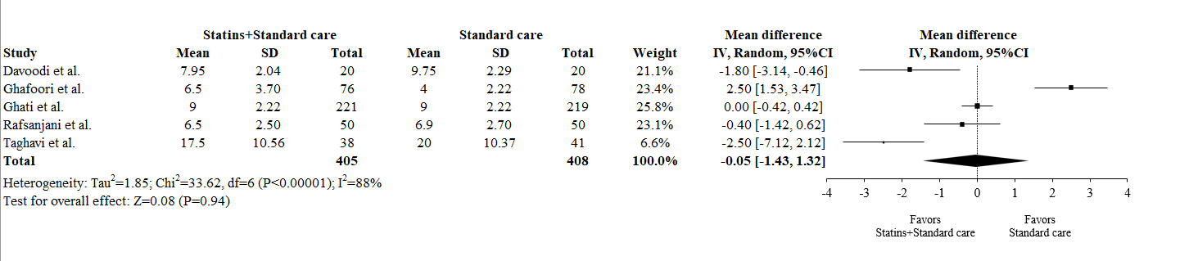

eFigure2. Pooled result of adverse events
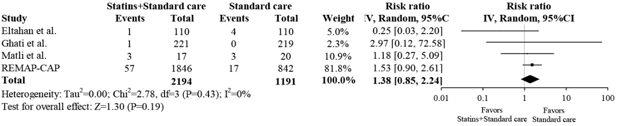

eFigure3. Subgroup analysis based on severity
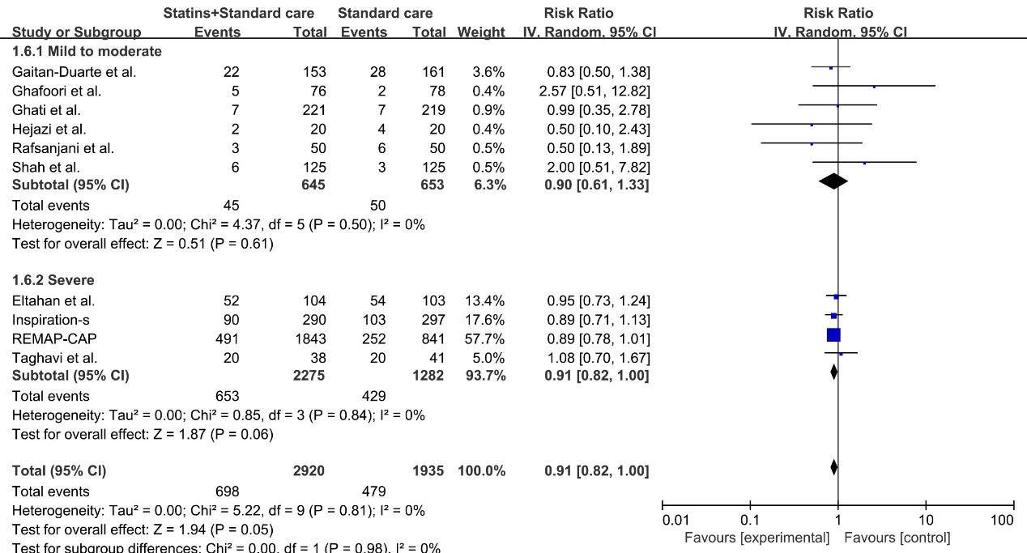

eFigure4. Funnel plot and Egger’s test
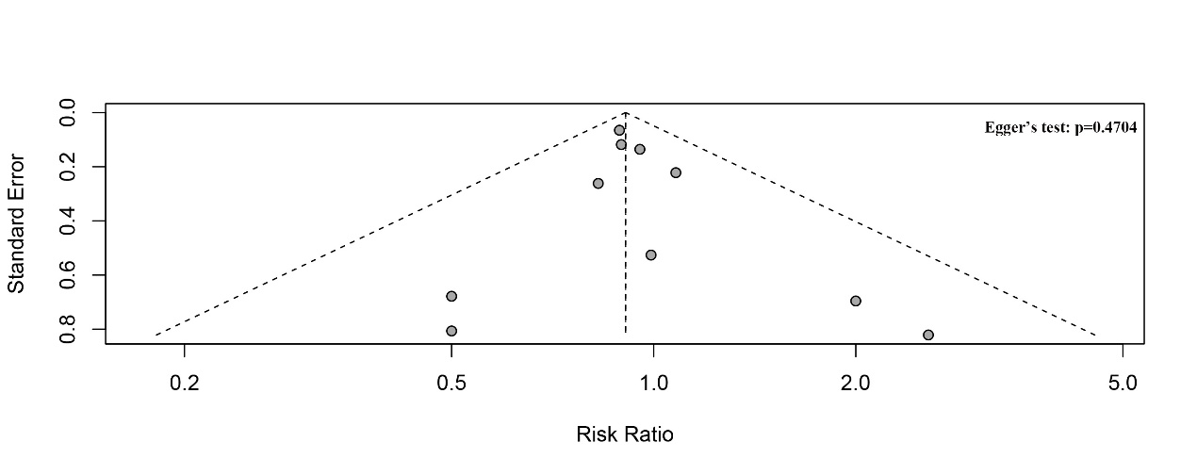

eTable1. Leave-one-out method for sensitivity analysis
Study | Risk Ratio,95%CI
28-day all-cause mortality
Eltahan et al. | 0.90 [0.81, 1.00]
Gaitan-Duarte et al. | 0.91 [0.83, 1.01]
Rafsanjani et al. | 0.91 [0.83, 1.00]
Shah et al. | 0.90 [0.82, 1.00]
Ghafoori et al. | 0.90 [0.82, 1.00]
Ghati et al. | 0.91 [0.82, 1.00]
Inspiration-s | 0.91 [0.82, 1.01]
REMAP-CAP | 0.94 [0.81, 1.09]
Taghavi et al. | 0.90 [0.81, 0.99]
Hejazi et al. | 0.91 [0.83, 1.00]
Patients requiring mechanical ventilation or ICU care
Matli et al. | 1.14 [0.67, 1.96]
Davoodi et al. | 1.22 [0.73, 2.04]
Eltahan et al. | 1.42 [0.68, 2.99]
Gaitan-Duarte et al. | 1.37 [0.65, 2.91]
Ghati et al. | 1.21 [0.67, 2.17]
Rafsanjani et al. | 1.22 [0.75, 1.97]
Shah et al. | 1.07 [0.65, 1.75]
Ghafoori et al. | 0.94 [0.72, 1.23]
Length of hospital stay
Davoodi et al. | 0.42 [-1.07, 1.92]
Ghafoori et al. | -0.62 [-1.53, 0.28]
Ghati et al. | -0.23 [-2.52, 2.06]
Rafsanjani et al. | -0.02 [-1.88, 1.83]
Taghavi et al. | 0.12 [-1.31, 1.55]
Adverse event
Eltahan et al. | 1.51 [0.92, 2.48]
Ghati et al. | 1.21 [0.59, 2.49]
Matli et al. | 1.17 [0.41, 3.34]
REMAP-CAP | 0.87 [0.28, 2.70]

