1. Appendices
Appendix Figure 1: VIF test for multicollinearity
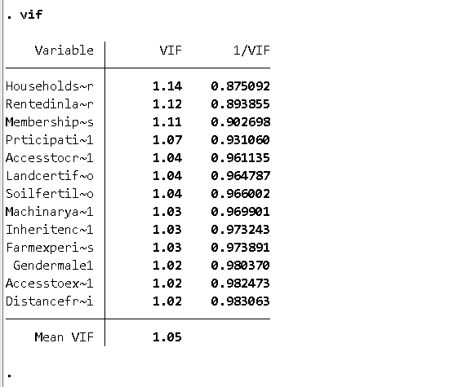

Appendix Figure 2: Correlation test for multicollinearity
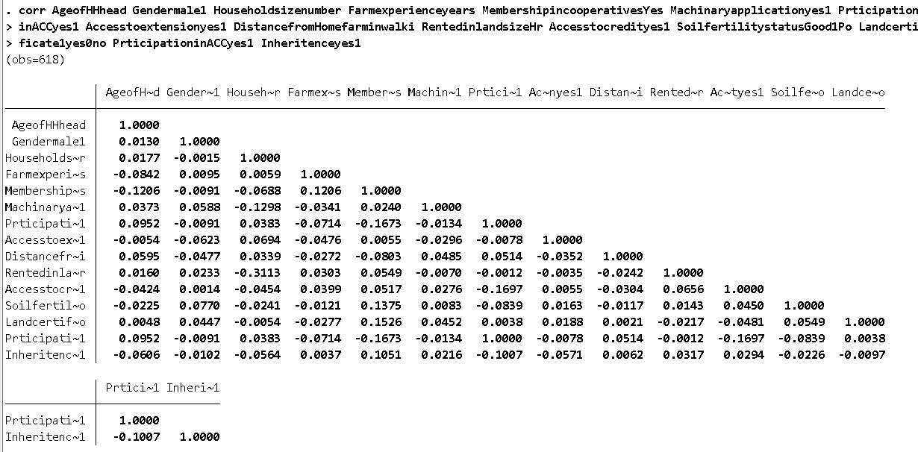

Appendix Figure 3: Tobit model Stata output in picture
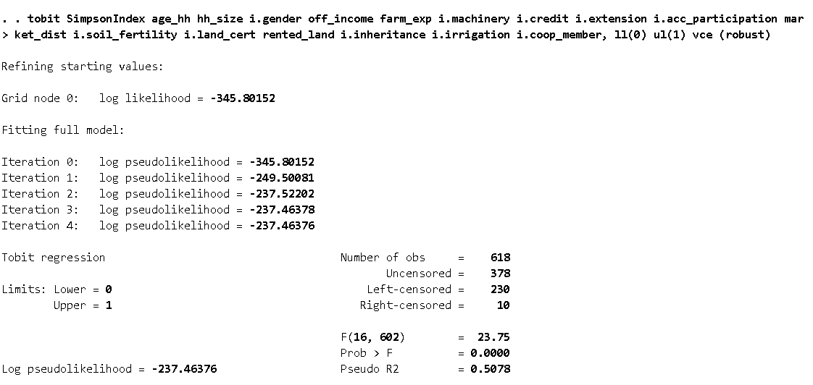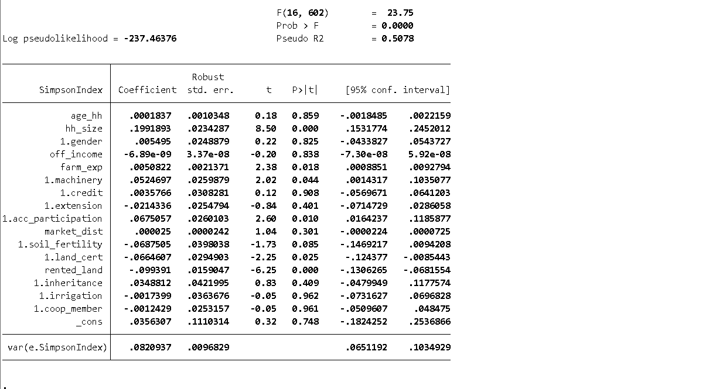
Appendix Figure 4: Marginal effect after Tobit in Stata picture
