Supplementary Information for
Non-Proteinogenic Amino Acid Catalysed Synthesis of Triazolo[5,1-b]quinazolinones with Promising Anti-inflammatory Activity
Dhamodharan Swathi, Vimal Dinesh Vishwa, Peeli Kumar Anjali, Muniyan Ramasamy Kuppusamy, Devendiran Parthiban*
Research Department of Chemistry, Rajeswari Vedachalam Govt Arts College, Chengalpattu, Tamilnadu, India-603001.
*Corresponding author, e-mail: nidhaksha@yahoo.co.in; orcid id 0000-0002-4254-5098

IR, ¹H NMR, ¹³C NMR and Mass spectral data of synthesised triazolo[5,1-b]quinazolinone
IR, ¹H NMR, ¹³C NMR and Mass spectral data of synthesised triazolo[5,1-b]quinazolinone

6,6-dimethyl-9-phenyl-5,6,7,9-tetrahydro-[1,2,4]triazolo[5,1-b]quinazolin-8(4H)-one (4a)
White solid; yield: %; mp: 254-255 °C (lit. 250-251 °C)¹; FT-IR (ATR, ν_{max}/cm⁻¹): 3028 (aromatic C–H stretch), 2958, 2873 (aliphatic C–H stretch), 1759 (C=O stretch), 1643 (C=N stretch), 1573, 1543 (aromatic C=C stretch), 1411 (C–N stretch), 883, 840 (C–H out-of-plane bending), 729, 694 (monosubstituted aromatic C–H bending); ¹H NMR (400 MHz, DMSO-d₆): δ 11.12 (1H, s, N–H proton of triazole ring), 7.68 (1H, s, triazole C3–H proton), 7.30–7.18 (5H, m, aromatic C–H protons), 6.21 (1H, s, C9–H methine proton), 3.33 (2H, s, C5–CH₂ methylene proton), 2.24 (1H, d, J = 16.2 Hz, C7–CH₂ methylene proton), 2.06 (1H, d, J = 16.2 Hz, C7–CH₂ methylene proton), 1.05 (3H, s, CH₃ proton), 0.97 (3H, s, CH₃ proton); ¹³C NMR (100 MHz, DMSO-d₆): δ 193.5, 150.9, 150.5, 147.4, 142.1, 128.7, 128.2, 127.4, 106.1, 58.4, 50.3, 35.2, 29.0, 27.3; HRMS (m/z): Calcd for C₁₆H₁₉N₄O [M+H]⁺: 295.1559, Found: 295.1488.
9-(4-fluorophenyl)-6,6-dimethyl-5,6,7,9-tetrahydro-[1,2,4]triazolo[5,1-b]quinazolin-8(4H)-one (4b)
White solid; yield: %; mp: >300 °C (lit. 306–308 °C)² ; FT-IR (ATR, ν_{max}/cm⁻¹): 3244 (N–H stretch), 3136 (aromatic C–H stretch), 2963, 2889 (aliphatic C–H stretch), 1643 (C=O stretch), 1547, 1504 (aromatic C=C stretch), 1412 (C–N stretch), 1215 (C–F stretch), 853, 829 (C–H out-of-plane bending); ¹H NMR (400 MHz, DMSO-d₆): δ 11.1 5 (1H, s, N–H proton of dihydropyrimidine ring), 7.70 (1H, s, triazole C–H proton), 7.22–7.25 (2H, m, aromatic C–H proton), 7.09–7.13 (2H, m, aromatic C–H proton), 6.23 (1H, s, C–H methine proton), 2.54 (2H, m, –CH₂– methylene proton), 2.22 (1H, d, J = 16.2 Hz, –CH₂– methylene proton), 2.11 (1H, d, J = 16.2 Hz, –CH₂- methylene proton), 1.05 (3H, s, CH₃ proton), 0.97 (3H, s, CH₃ proton); ¹³C NMR (125 MHz, DMSO-d₆): δ 193.4, 162.9, 161.0, 150.9, 150.6, 147.2, 138.3, 129.5, 129.4, 115.6, 115.4, 105.8, 57.7, 50.2, 40.1, 32.6, 28.8, 27.3; HRMS (m/z): Calcd for C₁₇H₁₇FN₄O [M+H]⁺: 313.1464, Found: 313.1399.
9-(4-chlorophenyl)-6,6-dimethyl-5,6,7,9-tetrahydro-[1,2,4]triazolo[5,1-b]quinazolin-8(4H)-one (4c)
White solid; yield: %; mp: 295-297 °C (lit. 292-295 °C)¹; FT-IR (ATR, ν_{max}/cm⁻¹): 3028 (aromatic C–H stretch), 2916, 2846 (aliphatic C–H stretch), 1762 (C=O stretch), 1643 (C=N stretch), 1573, 1546 (aromatic C=C stretch), 1411 (C–N stretch), 883, 837 (C–H out-of-plane bending), 725 (C–Cl stretch); ¹H NMR (400 MHz, DMSO-d₆): δ 11.18 (1H, s, N–H proton of triazole ring), 7.71 (1H, s, triazole C3–H proton), 7.36 (2H, d, J = 8.4 Hz, aromatic C–H proton), 7.21 (2H, d, J = 8.4 Hz, aromatic C–H proton), 6.23 (1H, s, C9–H methine proton), 3.35 (2H, s, C5–CH₂ methylene proton), 2.24 (1H, d, J = 16.2 Hz, C7–CH₂ methylene proton), 2.09 (1H, d, J = 16.2 Hz, C7–CH₂ methylene proton), 1.05 (3H, s, CH₃ proton), 0.97 (3H, s, CH₃ proton); ¹³C NMR (100 MHz, DMSO-d₆): δ 193.5, 151.1, 150.7, 147.3, 141.0, 132.8, 129.4, 128.8, 105.7, 57.9, 51.2, 27.9, 27.4, 22.9; HRMS (m/z): Calcd for C₁₆H₁₈ClN₄O [M+H]⁺: 329.1119, Found: 329.1097.
9-(2-chlorophenyl)-6,6-dimethyl-5,6,7,9-tetrahydro-[1,2,4]triazolo[5,1-b]quinazolin-8(4H)-one (4d)
White solid; yield: %; mp:282-285 °C (lit. > 300 °C)¹; FT-IR (ATR, ν_{max}/cm⁻¹): 3240 (N–H stretch), 3086 (aromatic C–H stretch), 2959, 2870 (aliphatic C–H stretch), 1639 (C=O stretch), 1574, 1547 (aromatic C=C stretch), 1416 (C–N stretch), 752 (C–Cl stretch); ¹H NMR (400 MHz, DMSO-d₆): δ 11.21 (1H, s, N–H proton), 7.71 (1H, s, triazole C3–H proton), 7.25–7.38 (4H, m, aromatic C–H proton), 6.57 (1H, s, C9–H methine proton), 3.36 (2H, s, C5–CH₂ methylene proton), 2.59 (1H, d, J = 16.4 Hz, C7–CH₂ methylene proton), 2.22 (1H, d, J = 16.0 Hz, C7–CH₂ methylene proton), 1.06 (3H, s, CH₃ proton), 1.00 (3H, s, CH₃ proton); ¹³C NMR (100 MHz, DMSO-d₆): δ 193.4, 151.6, 150.6, 147.4, 138.7, 132.7, 131.0, 130.1, 129.9, 127.6, 105.0, 56.8, 50.3, 32.6, 29.0, 27.3; HRMS (m/z): Calcd for C₁₇H₁₇ClN₄O [M+H]⁺: 329.1169, Found: 329.1103.
9-(4-bromophenyl)-6,6-dimethyl-5,6,7,9-tetrahydro-[1,2,4]triazolo[5,1-b]quinazolin-8(4H)-one (4e)
White solid; yield: %; mp: 281-283°C (lit. 282-284 °C)^{1,3}; FT-IR (ATR, ν_{max}/cm⁻¹): 3089 (aromatic C–H stretch), 2958, 2916 (aliphatic C–H stretch), 1762 (C=O stretch), 1647 (C=N stretch), 1573, 1550 (aromatic C=C stretch), 1411 (C–N stretch), 883, 837 (C–H out-of-plane bending), 729 (C–Br stretch); ¹H NMR (400 MHz, DMSO-d₆): δ 11.18 (1H, s, N–H proton of triazole ring), 7.71 (1H, s, triazole C3–H proton), 7.50 (2H, d, J = 8.4 Hz, aromatic C–H proton), 7.17 (2H, d, J = 8.0 Hz, aromatic C–H proton), 6.21 (1H, s, C9–H methine proton), 3.35 (2H, s, C5–CH₂ methylene proton), 2.24 (1H, d, J = 16.2 Hz, C7–CH₂ methylene proton), 2.07 (1H, d, J = 16.2 Hz, C7–CH₂ methylene proton), 1.04 (3H, s, CH₃ proton), 0.96 (3H, s, CH₃ proton); ¹³C NMR (100 MHz, DMSO-d₆): δ 193.5, 151.1, 150.7, 147.3, 141.4, 131.7, 129.7, 121.4, 105.7, 58.0, 50.2, 32.7, 28.9, 27.4; HRMS (m/z): Calcd for C₁₆H₁₈BrN₄O [M+H]⁺: 373.0664, Found: 373.0597.
6,6-dimethyl-9-(4-nitrophenyl)-5,6,7,9-tetrahydro-[1,2,4]triazolo[5,1-b]quinazolin-8(4H)-one (4f)
White solid; yield: %; mp: 295-297°C (lit. 292-294 °C)¹; FT-IR (ATR, ν_{max}/cm⁻¹): 3024 (aromatic C–H stretch), 2963, 2886 (aliphatic C–H stretch), 1643 (C=O stretch), 1574, 1524 (aromatic C=C stretch), 1350 (NO₂ symmetric stretch), 1412 (C–N stretch), 891, 829 (C–H out-of-plane bending); ¹H NMR (400 MHz, DMSO-d₆): δ 11.30 (1H, s, N–H proton), 8.16 (2H, d, J = 8.4 Hz, aromatic C–H proton), 7.74 (1H, s, triazole C3–H proton), 7.49 (2H, d, J = 8.4 Hz, aromatic C–H proton), 6.38 (1H, s, C9–H methine proton), 3.34 (2H, s, C5–CH₂ methylene proton), 2.23 (1H, d, J = 16.4 Hz, C7–CH₂ methylene proton), 2.09 (1H, d, J = 16.4 Hz, C7–CH₂ methylene proton), 1.05 (3H, s, CH₃ proton), 0.96 (3H, s, CH₃ proton); ¹³C NMR (100 MHz, DMSO-d₆): δ 193.5, 151.5, 150.9, 148.9, 147.4, 147.3, 129.0, 124.1, 105.2, 58.0, 50.2, 32.7, 28.8, 27.5; HRMS (m/z): Calcd for C₁₇H₁₇N₅O₃ [M+H]⁺: 340.1410, Found: 340.1347.
6,6-dimethyl-9-(3-nitrophenyl)-5,6,7,9-tetrahydro-[1,2,4]triazolo[5,1-b]quinazolin-8(4H)-one (4g)
White solid; yield: %; mp:264-265 °C (lit. 266-268 °C)¹; FT-IR (ATR, ν_{max}/cm⁻¹): 3082 (aromatic C–H stretch), 2959, 2789 (aliphatic C–H stretch), 1643 (C=O stretch), 1578, 1551 (aromatic C=C stretch), 1528 (NO₂ asymmetric stretch), 1331 (NO₂ symmetric stretch), 1416 (C–N stretch), 899, 822 (C–H out-of-plane bending); ¹H NMR (400 MHz, DMSO-d₆): δ 11.31 (1H, s, N–H proton), 8.12 (1H, d, J = 8.0 Hz, aromatic C–H proton), 8.07 (1H, s, aromatic C–H proton), 7.74 (1H, s, triazole C3–H proton), 7.67 (1H, d, J = 7.6 Hz, aromatic C–H proton), 7.62 (1H, t, J = 7.6 Hz, aromatic C–H proton), 6.43 (1H, s, C9–H methine proton), 3.34 (2H, s, C5–CH₂ methylene proton), 2.24 (1H, d, J = 16.4 Hz, C7–CH₂ methylene proton), 2.11 (1H, d, J = 16.0 Hz, C7–CH₂ methylene proton), 1.06 (3H, s, CH₃ proton), 0.99 (3H, s, CH₃ proton); ¹³C NMR (100 MHz, DMSO-d₆): δ 193.6, 151.6, 150.9, 148.1, 147.3, 144.0, 134.2, 130.5, 123.3, 122.2, 105.1, 57.9, 50.2, 32.7, 28.8, 27.4; HRMS (m/z): Calcd for C₁₇H₁₇N₅O₃ [M+H]⁺: 340.1410, Found: 340.1355.
6,6-dimethyl-9-(2-nitrophenyl)-5,6,7,9-tetrahydro-[1,2,4]triazolo[5,1-b]quinazolin-8(4H)-one (4h)
White solid; yield: %; mp: 287-289 °C (lit. 288-290 °C)¹; FT-IR (ATR, ν_{max}/cm⁻¹): 3090 (aromatic C–H stretch), 2870 (aliphatic C–H stretch), 1639 (C=O stretch), 1582, 1528 (aromatic C=C stretch / NO₂ asymmetric stretch), 1342 (NO₂ symmetric stretch), 1416 (C–N stretch), 860, 826 (C–H out-of-plane bending); ¹H NMR (400 MHz, DMSO-d₆): δ 11.30 (1H, s, N–H proton), 7.87 (1H, d, J = 8.0 Hz, aromatic C–H proton), 7.74 (1H, s, triazole C3–H proton), 7.60 (1H, m, aromatic C–H proton), 7.47 (1H, m, aromatic C–H proton), 7.21 (1H, d, J = 7.6 Hz, aromatic C–H proton), 6.98 (1H, s, C9–H methine proton), 3.34 (2H, s, C5–CH₂ methylene proton), 2.20 (1H, d, J = 16.4 Hz, C7–CH₂ methylene proton), 2.06 (1H, d, J = 16.4 Hz, C7–CH₂ methylene proton), 1.03 (3H, s, CH₃ proton), 0.93 (3H, s, CH₃ proton); ¹³C NMR (100 MHz, DMSO-d₆): δ 193.7, 151.5, 150.9, 148.9, 147.5, 135.7, 133.8, 129.6, 129.5, 124.5, 105.5, 53.4, 49.9, 32.7, 28.7, 27.5; HRMS (m/z): Calcd for C₁₇H₁₇N₅O₃ [M+H]⁺: 340.1410, Found: 340.1332.
6,6-dimethyl-9-(4-methylphenyl)-5,6,7,9-tetrahydro-[1,2,4]triazolo[5,1-b]quinazolin-8(4H)-one (4i)
White solid; yield: %; mp: 258-260 °C (lit. 260-263 °C)^{1,3}; FT-IR (ATR, ν_{max}/cm⁻¹): 3251 (N–H stretch), 3089 (aromatic C–H stretch), 2966 (aliphatic C–H stretch), 1647 (C=O stretch), 1577, 1546 (aromatic C=C stretch), 1411 (C–N stretch), 887, 848 (C–H out-of-plane bending), 729 (aromatic C–H bending); ¹H NMR (400 MHz, DMSO-d₆): δ 11.08 (1H, s, N–H proton of triazole ring), 7.67 (1H, s, triazole C3–H proton), 7.07 (4H, s, aromatic C–H protons), 6.16 (1H, s, C9–H methine proton), 3.34 (2H, s, C5–CH₂ methylene proton), 2.23 (1H, d, J = 16.2 Hz, C7–CH₂ methylene proton), 2.24 (3H, s, Ar–CH₃ proton), 2.09 (1H, d, J = 16.2 Hz, C7–CH₂ methylene proton), 1.05 (3H, s, CH₃ proton), 0.96 (3H, s, CH₃ proton); ¹³C NMR (100 MHz, DMSO-d₆): δ 193.4, 150.7, 150.5, 147.4, 139.6, 134.3, 134.2, 127.5, 127.3, 106.2, 58.1, 50.3, 32.7, 29.0, 27.3, 21.1; HRMS (m/z): Calcd for C₁₇H₂₁N₄O [M+H]⁺: 309.1715, Found: 309.1653.
9-(2,4-dimethylphenyl)-6,6-dimethyl-5,6,7,9-tetrahydro-[1,2,4]triazolo[5,1-b]quinazolin-8(4H)-one(4j)
White solid; yield: %; mp: 273-275 °C; FT-IR (ATR, ν_{max}/cm⁻¹): 3252 (N–H stretch), 3090 (aromatic C–H stretch), 2916 (aliphatic C–H stretch), 1647 (C=O stretch), 1578, 1551 (aromatic C=C stretch), 1412 (C–N stretch), 868, 818 (C–H out-of-plane bending); ¹H NMR (400 MHz, DMSO-d₆): δ 11.06 (1H, s, N–H proton of quinazolinone), 7.63 (1H, s, triazole C3–H proton), 6.94 (1H, s, aromatic C–H proton), 6.87 (2H, m, aromatic C–H proton), 6.40 (1H, s, C9–H methine proton), 3.36 (2H, s, C5–CH₂ methylene proton), 2.52 (3H, s, Ar–CH₃ proton), 2.23 (3H, s, Ar–CH₃ proton), 2.19 (1H, d, J = 16.4 Hz, C7–CH₂ methylene proton), 2.05 (1H, d, J = 16.4 Hz, C7–CH₂ methylene proton), 1.06 (3H, s, CH₃ proton), 1.00 (3H, s, CH₃ proton); ¹³C NMR (125 MHz, DMSO-d₆): δ 193.5, 150.8, 150.3, 147.0, 138.0, 137.1, 135.8, 131.1, 127.2, 127.1, 106.7, 54.4, 50.2, 40.1, 32.7, 29.0, 27.3, 20.9, 19.3; HRMS (m/z): Calcd for C₁₉H₂₂N₄O [M+H]⁺: 323.1872, Found: 323.1816.
9-(3,5-dimethylphenyl)-6,6-dimethyl-5,6,7,9-tetrahydro-[1,2,4]triazolo[5,1-b]quinazolin-8(4H)-one (4k)
Off-white solid; yield: %; mp: 282-284 °C; FT-IR (ATR, ν_{max}/cm⁻¹): 3210 (N–H stretch), 3013 (aromatic C–H stretch), 2920, 2870 (aliphatic C–H stretch), 1632 (C=O stretch), 1566, 1535 (aromatic C=C stretch), 1404 (C–N stretch), 895, 860 (C–H out-of-plane bending); ¹H NMR (400 MHz, DMSO-d₆): δ 11.07 (1H, s, N–H proton), 7.67 (1H, s, triazole C3–H proton), 6.85 (1H, s, aromatic C–H proton), 6.80 (2H, s, aromatic C–H proton), 6.12 (1H, s, C9–H methine proton), 3.37 (2H, s, C5–CH₂ methylene proton), 2.55 (1H, d, J = 16.4 Hz, C7–CH₂ methylene proton), 2.20 (1H, d, J = 16.4 Hz, C7–CH₂ methylene proton), 2.11 (6H, s, Ar–CH₃ proton), 1.05 (3H, s, CH₃ proton), 1.00 (3H, s, CH₃ proton); ¹³C NMR (125 MHz, DMSO-d₆): δ 193.4, 150.8, 150.4, 147.1, 142.0, 137.6, 129.6, 125.2, 106.1, 58.3, 50.3, 40.1, 32.7, 29.0, 27.2, 21.3; HRMS (m/z): Calcd for C₁₉H₂₂N₄O [M+H]⁺: 323.1872, Found: 323.1807.
9-(2,6-dimethylphenyl)-6,6-dimethyl-5,6,7,9-tetrahydro-[1,2,4]triazolo[5,1-b]quinazolin-8(4H)-one(4l)
Off-white solid; yield: %; mp: 266-268 °C; FT-IR (ATR, ν_{max}/cm⁻¹): 3132 (N–H stretch), 2959, 2874 (aliphatic C–H stretch), 1643 (C=O stretch), 1578, 1551 (aromatic C=C stretch), 1416 (C–N stretch), 883, 845 (C–H out-of-plane bending); ¹H NMR (400 MHz, DMSO-d₆): δ 11.13 (1H, s, N–H proton), 7.66 (1H, s, triazole C3–H proton), 7.01 (2H, d, J = 6.4 Hz, aromatic C–H proton), 6.85 (1H, m, aromatic C–H proton), 6.69 (1H, s, C9–H methine proton), 3.38 (2H, s, C5–CH₂ methylene proton), 2.67 (1H, d, J = 16.4 Hz, C7–CH₂ methylene proton), 2.49 (1H, d, J = 16.4 Hz, C7–CH₂ methylene proton), 2.13 (3H, s, Ar–CH₃ proton), 1.82 (3H, s, Ar–CH₃ proton), 1.04 (3H, s, CH₃ proton), 1.01 (3H, s, CH₃ proton); ¹³C NMR (125 MHz, DMSO-d₆): δ 193.7, 150.9, 150.2, 147.5, 138.4, 136.8, 136.0, 130.3, 128.5, 127.6, 105.2, 54.7, 50.5, 40.1, 32.4, 28.3, 28.0, 21.2, 18.1; HRMS (m/z): Calcd for C₁₉H₂₂N₄O [M+H]⁺: 323.1872, Found: 323.1807.
9-(4-methoxyphenyl)-6,6-dimethyl-5,6,7,9-tetrahydro-[1,2,4]triazolo[5,1-b]quinazolin-8(4H)-one (4m)
Pale yellow solid; yield: %; mp: > 300 °C (lit. 299-301 °C)¹; FT-IR (ATR, ν_{max}/cm⁻¹): 3410 (N–H stretch), 3090 (aromatic C–H stretch), 2963, 2839 (aliphatic C–H stretch), 1647 (C=O stretch), 1574, 1551 (aromatic C=C stretch), 1412 (C–N stretch), 1246 (C–O stretch), 891, 849 (C–H out-of-plane bending); ¹H NMR (400 MHz, DMSO-d₆): δ 11.07 (1H, s, N–H proton), 7.67 (1H, s, triazole C3–H proton), 7.11 (2H, d, J = 8.4 Hz, aromatic C–H proton), 6.83 (2H, d, J = 8.4 Hz, aromatic C–H proton), 6.15 (1H, s, C9–H methine proton), 3.70 (3H, s, OCH₃ proton), 3.34 (2H, s, C5–CH₂ methylene proton), 2.20 (1H, d, J = 16.4 Hz, C7–CH₂ methylene proton), 2.07 (1H, d, J = 16.4 Hz, C7–CH₂ methylene proton), 1.03 (3H, s, CH₃ proton), 0.98 (3H, s, CH₃ proton); ¹³C NMR (100 MHz, DMSO-d₆): δ 193.5, 159.2, 150.7, 150.4, 147.3, 134.3, 128.6, 114.1, 106.3, 57.8, 55.5, 50.3, 32.6, 29.0, 27.3; HRMS (m/z): Calcd for C₁₈H₂₀N₄O₂ [M+H]⁺: 325.1664, Found: 325.1587.
6,6-dimethyl-9-(3,4,5-trimethoxyphenyl)-5,6,7,9-tetrahydro-[1,2,4]triazolo[5,1-b]quinazolin-8(4H)-one (4n)
Pale yellow solid; yield: %; mp: 272-274 °C ; FT-IR (ATR, ν_{max}/cm⁻¹): 2932, 2832 (aliphatic C–H stretch), 1647 (C=O stretch), 1582, 1504 (aromatic C=C stretch), 1234, 1119 (C–O stretch), 895, 856 (C–H out-of-plane bending); ¹H NMR (400 MHz, DMSO-d₆): δ 11.11 (1H, s, N–H proton), 7.70 (1H, s, triazole C3–H proton), 6.50 (2H, s, aromatic C–H proton), 6.16 (1H, s, C9–H methine proton), 3.70 (6H, s, OCH₃ proton), 3.62 (3H, s, OCH₃ proton), 3.36 (2H, s, C5–CH₂ methylene proton), 2.26 (1H, d, J = 16.4 Hz, C7–CH₂ methylene proton), 2.13 (1H, d, J = 16.4 Hz, C7–CH₂ methylene proton), 1.07 (3H, s, CH₃ proton), 1.04 (3H, s, CH₃ proton); ¹³C NMR (125 MHz, DMSO-d₆): δ 193.5, 153.1, 151.1, 150.4, 147.0, 137.6, 137.5, 105.7, 104.9, 60.3, 58.4, 56.2, 50.2, 40.1, 32.5, 29.2, 27.0; HRMS (m/z): Calcd for C₂₀H₂₄N₄O₄ [M+H]⁺: 385.1875, Found: 385.1803.
6,6-dimethyl-9-(naphthalen-1-yl)-5,6,7,9-tetrahydro-[1,2,4]triazolo[5,1-b]quinazolin-8(4H)-one (4o)
White solid; yield: %; mp: °C (lit. 287–290 °C)³; FT-IR (ATR, ν_{max}/cm⁻¹): 3075 (aromatic C–H stretch), 2959, 2805 (aliphatic C–H stretch), 1639 (C=O stretch), 1551 (aromatic C=C stretch), 1416 (C–N stretch), 787, 768 (aromatic C–H out-of-plane bending); ¹H NMR (400 MHz, DMSO-d₆): δ 11.21 (1H, s, N–H proton), 8.53 (1H, d, J = 8.4 Hz, aromatic C–H proton), 7.92 (2H, m, aromatic C–H proton), 7.82 (2H, m, aromatic C–H proton), 7.61 (1H, m, aromatic C–H proton), 7.50–7.59 (2H, m, aromatic C–H proton), 7.42 (1H, m, aromatic C–H proton), 7.09 (1H, s, C9–H methine proton), 3.35 (2H, s, C5–CH₂ methylene proton), 2.21 (1H, d, J = 16.0 Hz, C7–CH₂ methylene proton), 2.06 (1H, d, J = 16.0 Hz, C7–CH₂ methylene proton), 1.07 (3H, s, CH₃ proton), 1.03 (3H, s, CH₃ proton); ¹³C NMR (100 MHz, DMSO-d₆): δ 193.6, 151.2, 150.3, 147.0, 138.8, 133.7, 131.2, 128.9, 128.8, 126.7, 126.2, 125.9, 124.3, 106.6, 56.5, 54.1, 50.3, 32.7, 29.0, 27.6; HRMS (m/z): Calcd for C₁₇H₁₇N₅O₃ [M+H]⁺: 345.1715, Found: 345.1660.

IR, ¹H NMR, ¹³C NMR and Mass spectra of synthesised triazolo[5,1-b]quinazolinone

IR spectrum of 6,6-dimethyl-9-phenyl-5,6,7,9-tetrahydro-[1,2,4]triazolo[5,1-b]quinazolin-8(4H)-one (4a)

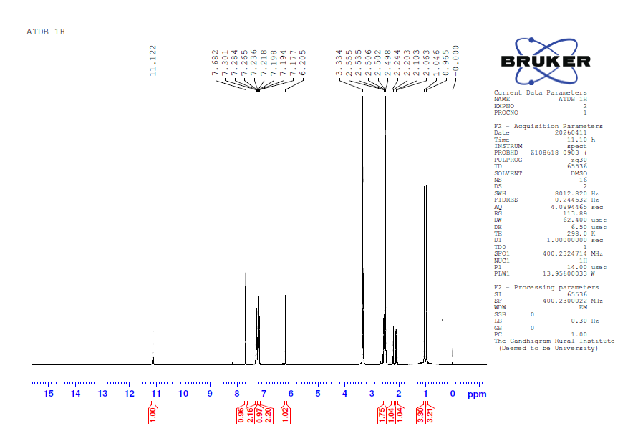¹H NMR spectrum of 6,6-dimethyl-9-phenyl-5,6,7,9-tetrahydro-[1,2,4]triazolo[5,1-b]quinazolin-8(4H)-one (4a)
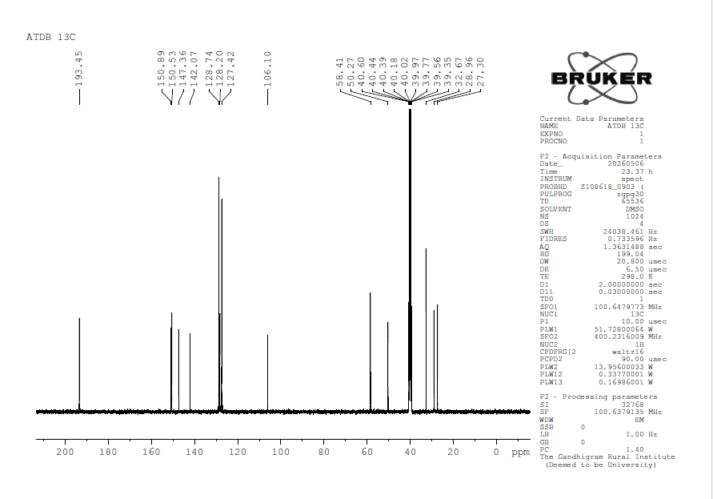
¹³C NMR spectrum of 6,6-dimethyl-9-phenyl-5,6,7,9-tetrahydro-[1,2,4]triazolo[5,1-b]quinazolin-8(4H)-one (4a)
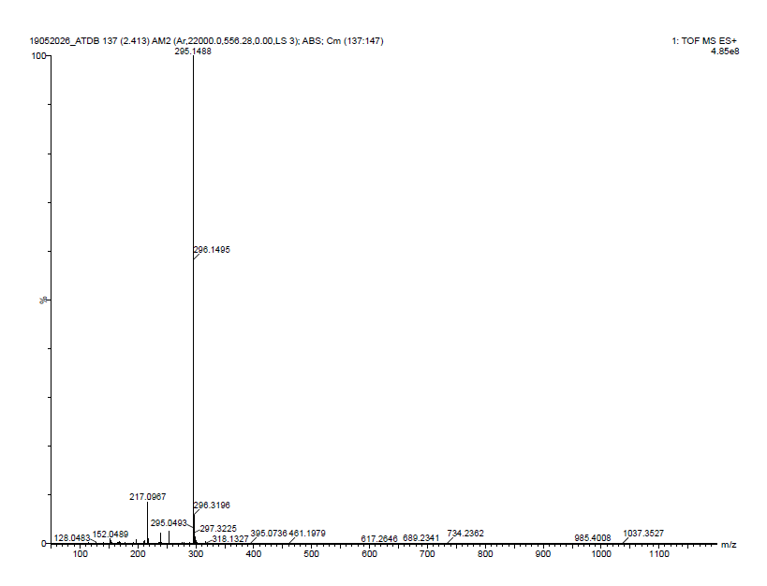
Mass spectrum of 6,6-dimethyl-9-phenyl-5,6,7,9-tetrahydro-[1,2,4]triazolo[5,1-b]quinazolin-8(4H)-one (4a)
IR Spectrum of 9-(4-fluorophenyl)-6,6-dimethyl-5,6,7,9-tetrahydro-[1,2,4]triazolo[5,1-b]quinazolin-8(4H)-one (4b)
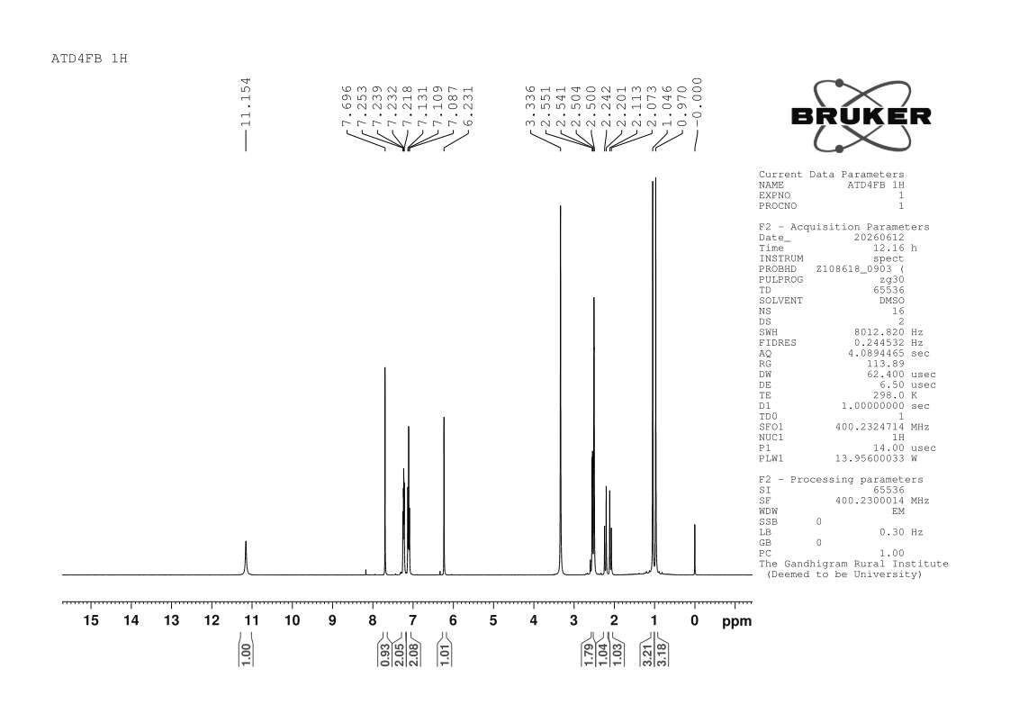
1H NMR Spectrum of 9-(4-fluorophenyl)-6,6-dimethyl-5,6,7,9-tetrahydro-[1,2,4]triazolo[5,1b]quinazolin-8(4H)-one
13C NMR Spectrum of 9-(4-fluorophenyl)-6,6-dimethyl-5,6,7,9-tetrahydro-[1,2,4]triazolo[5,1b]quinazolin-8(4H)-one

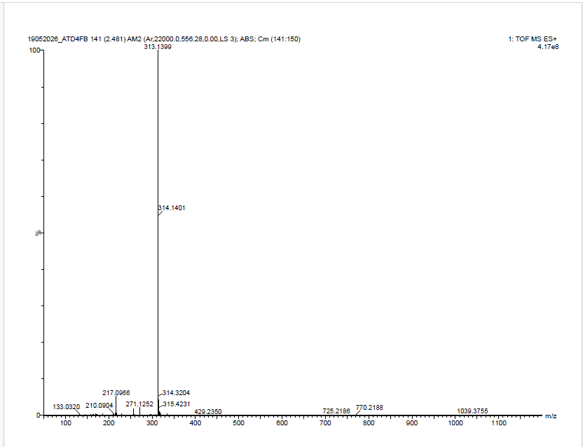
Mass spectrum of 9-(4-fluorophenyl)-6,6-dimethyl-5,6,7,9-tetrahydro-[1,2,4]triazolo[5,1b]quinazolin-8(4H)-one (4b)
IR Spectrum of 9-(4-chlorophenyl)-6,6-dimethyl-5,6,7,9-tetrahydro-[1,2,4]triazolo[5,1-b]quinazolin-8(4H)-one (4c)
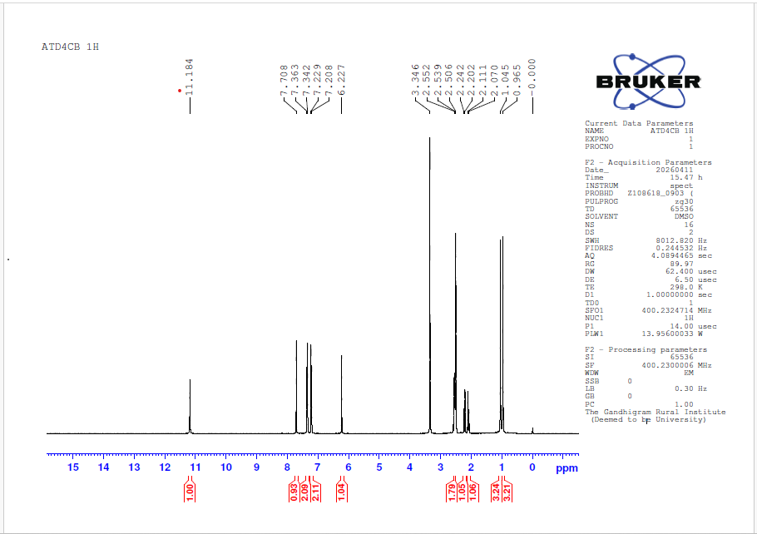
1H NMR Spectrum of 9-(4-chlorophenyl)-6,6-dimethyl-5,6,7,9-tetrahydro-[1,2,4]triazolo[5,1-b]quinazolin-8(4H)-one (4c)

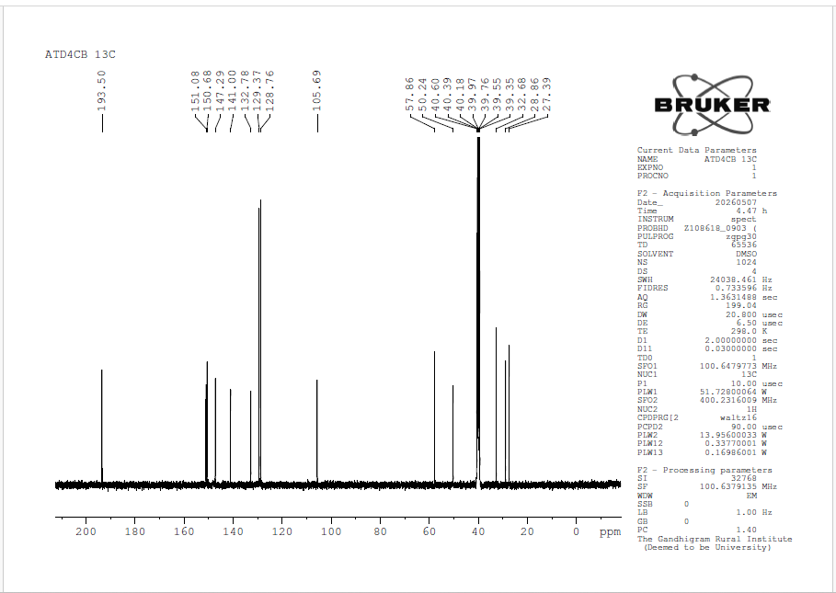
¹³ C NMR Spectrum of 9-(4-chlorophenyl)-6,6-dimethyl-5,6,7,9-tetrahydro-[1,2,4]triazolo[5,1-b]quinazolin-8(4H)-one (4c)
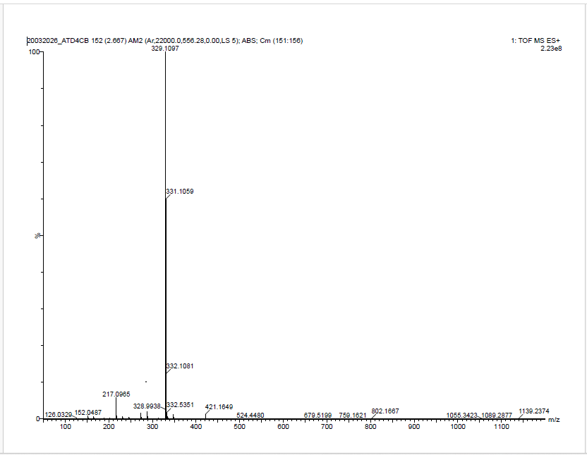
Mass Spectrum of 9-(4-chlorophenyl)-6,6-dimethyl-5,6,7,9-tetrahydro-[1,2,4]triazolo[5,1-b]quinazolin-8(4H)-one (4c)

IR Spectrum of 9-(2-chlorophenyl)-6,6-dimethyl-5,6,7,9-tetrahydro-[1,2,4]triazolo[5,1-b]quinazolin-8(4H)-one
¹H NMR Spectrum of 9-(2-chlorophenyl)-6,6-dimethyl-5,6,7,9-tetrahydro-[1,2,4]triazolo[5,1-b]quinazolin-8(4H)-one

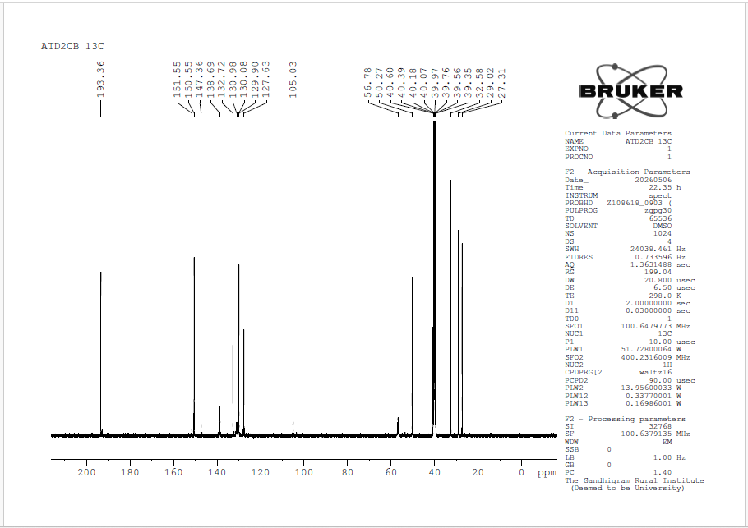
¹³C NMR Spectrum of 9-(2-chlorophenyl)-6,6-dimethyl-5,6,7,9-tetrahydro-[1,2,4]triazolo[5,1-b]quinazolin-8(4H)-one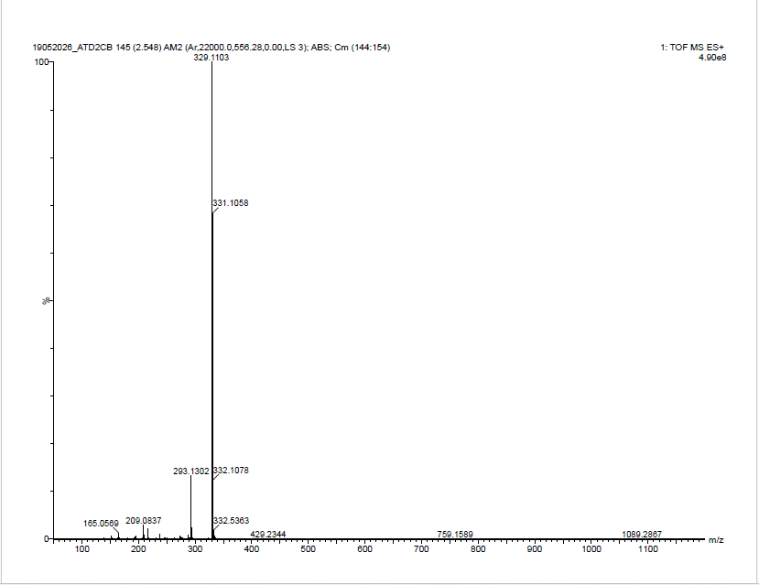
Mass Spectrum of 9-(2-chlorophenyl)-6,6-dimethyl-5,6,7,9-tetrahydro-[1,2,4]triazolo[5,1-b]quinazolin-8(4H)-one
IR Spectrum of 9-(4-bromophenyl)-6,6-dimethyl-5,6,7,9-tetrahydro-[1,2,4]triazolo[5,1-b]quinazolin-8(4H)-one
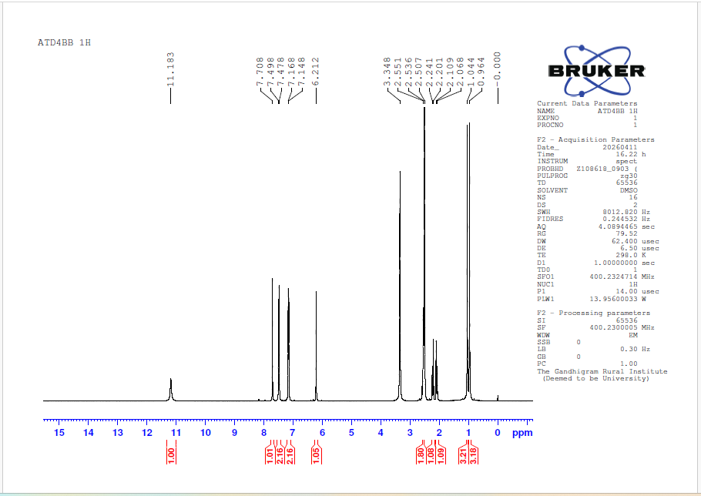
¹H NMR Spectrum of 9-(4-bromophenyl)-6,6-dimethyl-5,6,7,9-tetrahydro-[1,2,4]triazolo[5,1-b]quinazolin-8(4H)-one

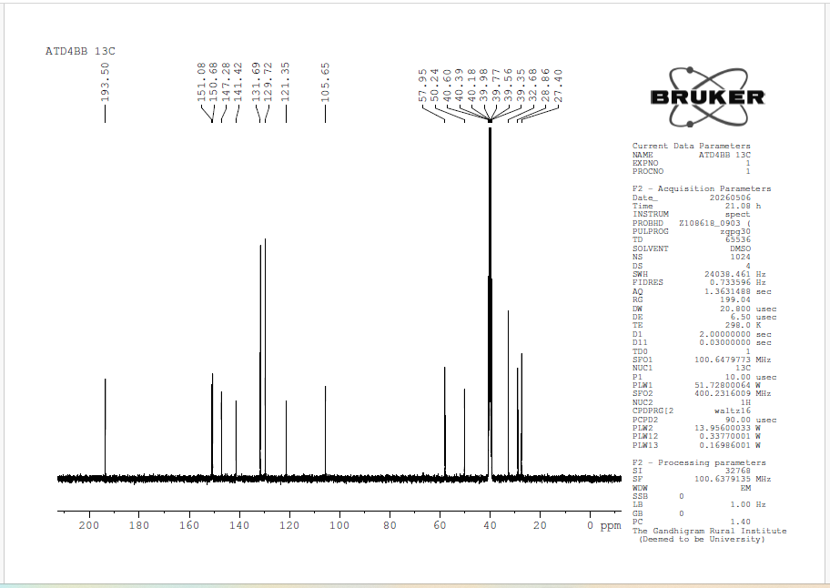
¹³C NMR Spectrum of 9-(4-bromophenyl)-6,6-dimethyl-5,6,7,9-tetrahydro-[1,2,4]triazolo[5,1-b]quinazolin-8(4H)-one
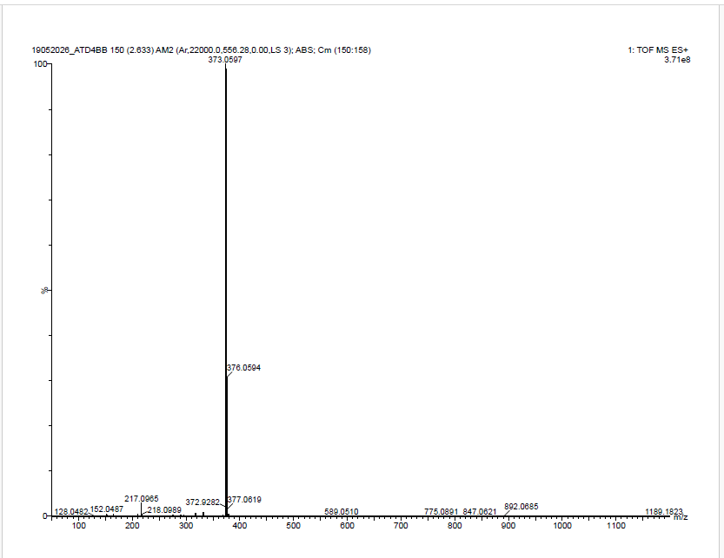
Mass Spectrum of 9-(4-bromophenyl)-6,6-dimethyl-5,6,7,9-tetrahydro-[1,2,4]triazolo[5,1b]quinazolin-8(4H)-one

IR Spectrum of 6,6-dimethyl-9-(p-tolyl)-5,6,7,9-tetrahydro-[1,2,4]triazolo[5,1-b]quinazolin-8(4H)-one
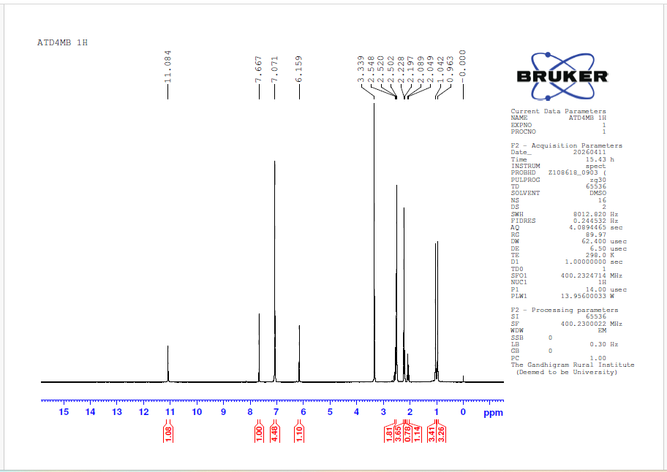
¹H NMR Spectrum of 6,6-dimethyl-9-(p-tolyl)-5,6,7,9-tetrahydro-[1,2,4]triazolo[5,1-b]quinazolin-8(4H)-one

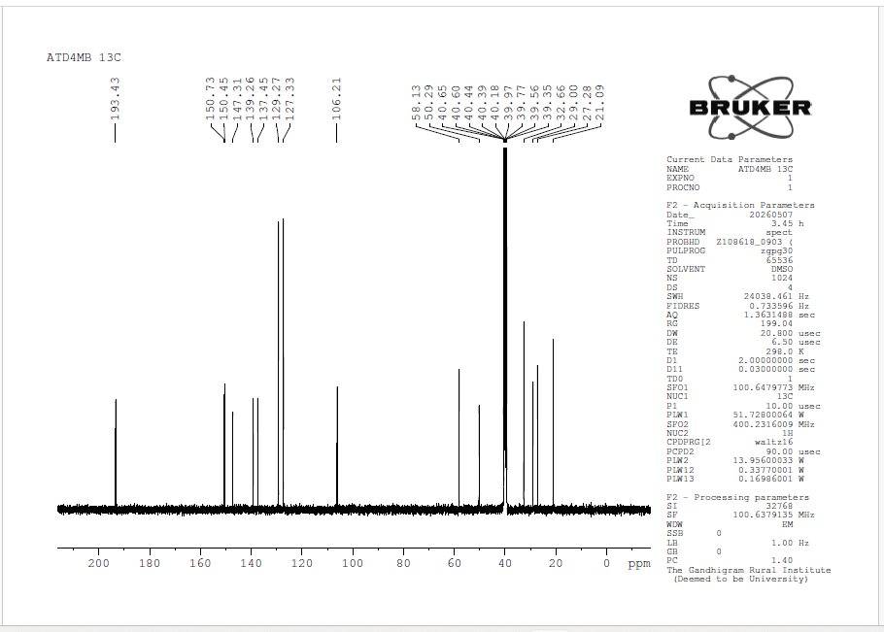
¹³C NMR Spectrum of 6,6-dimethyl-9-(p-tolyl)-5,6,7,9-tetrahydro-[1,2,4]triazolo[5,1-b]quinazolin-8(4H)-one
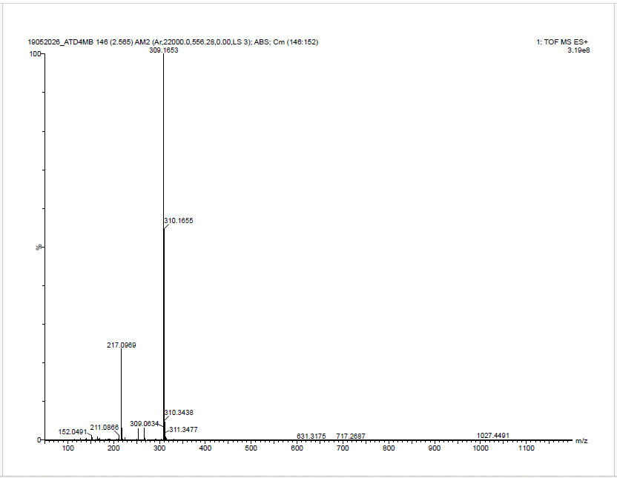
Mass Spectrum of 6,6-dimethyl-9-(p-tolyl)-5,6,7,9-tetrahydro-[1,2,4]triazolo[5,1-b]quinazolin-8(4H)-one
IR Spectrum of 9-(2,4-dimethylphenyl)-6,6-dimethyl-5,6,7,9-tetrahydro-[1,2,4]triazolo[5,1-b]quinazolin-8(4H)-one
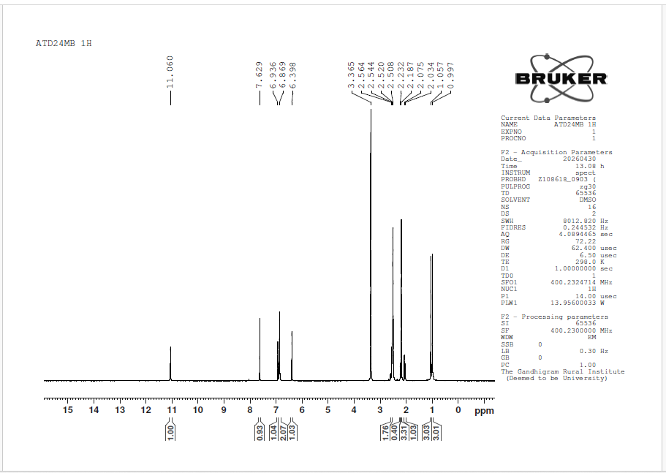
¹H NMR Spectrum of 9-(2,4-dimethylphenyl)-6,6-dimethyl-5,6,7,9-tetrahydro-[1,2,4]triazolo[5,1-b]quinazolin-8(4H)-one
¹³C NMR Spectrum of 9-(2,4-dimethylphenyl)-6,6-dimethyl-5,6,7,9-tetrahydro-[1,2,4]triazolo[5,1-b]quinazolin-8(4H)-one
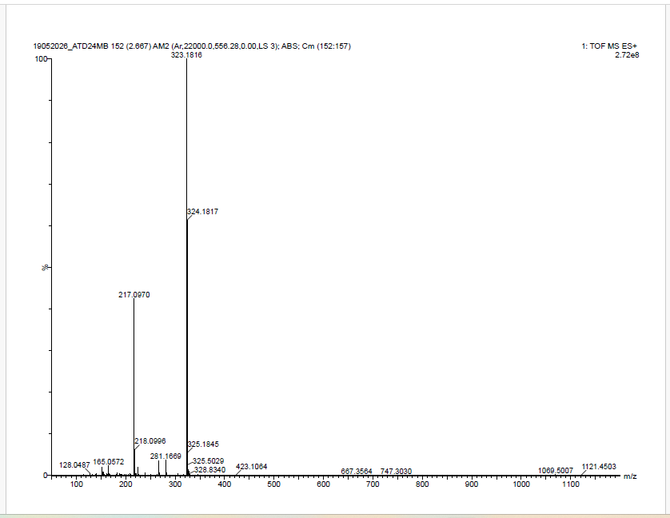
Mass Spectrum of 9-(2,4-dimethylphenyl)-6,6-dimethyl-5,6,7,9-tetrahydro-[1,2,4]triazolo[5,1-b]quinazolin-8(4H)-one
IR Spectrum of 9-(2,6-dimethylphenyl)-6,6-dimethyl-5,6,7,9-tetrahydro-[1,2,4]triazolo[5,1-b]quinazolin-8(4H)-one

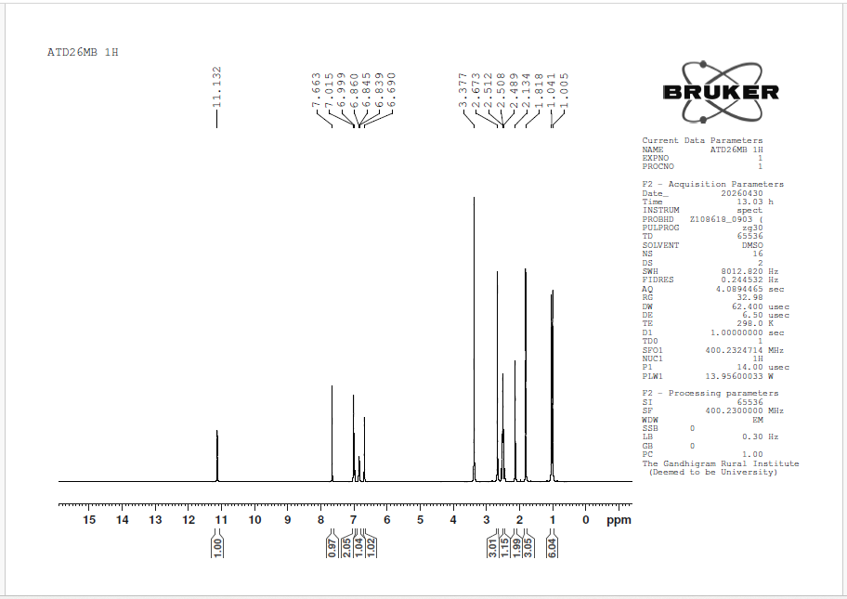
¹H NMR Spectrum of 9-(2,6-dimethylphenyl)-6,6-dimethyl-5,6,7,9-tetrahydro-[1,2,4]triazolo[5,1-b]quinazolin-8(4H)-one
¹³C NMR Spectrum of 9-(2,6-dimethylphenyl)-6,6-dimethyl-5,6,7,9-tetrahydro-[1,2,4]triazolo[5,1-b]quinazolin-8(4H)-one
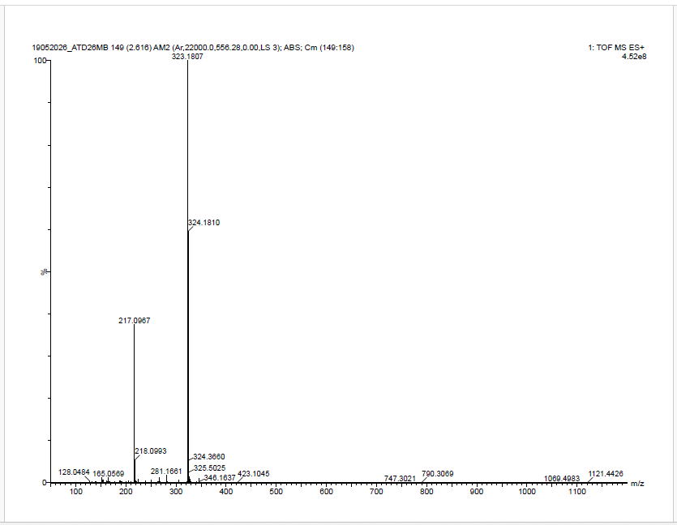
Mass Spectrum of 9-(2,6-dimethylphenyl)-6,6-dimethyl-5,6,7,9-tetrahydro-[1,2,4]triazolo[5,1-b]quinazolin-8(4H)-one
IR Spectrum of 9-(3,5-dimethylphenyl)-6,6-dimethyl-5,6,7,9-tetrahydro-[1,2,4]triazolo[5,1-b]quinazolin-8(4H)-one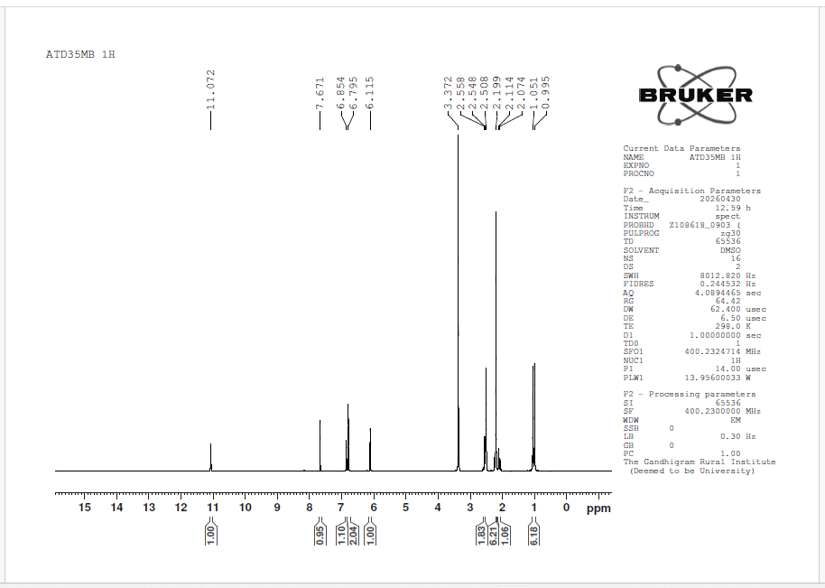
¹H NMR Spectrum of 9-(3,5-dimethylphenyl)-6,6-dimethyl-5,6,7,9-tetrahydro-[1,2,4]triazolo[5,1-b]quinazolin-8(4H)-one
¹³C NMR Spectrum of 9-(3,5-dimethylphenyl)-6,6-dimethyl-5,6,7,9-tetrahydro-[1,2,4]triazolo[5,1-b]quinazolin-8(4H)-one
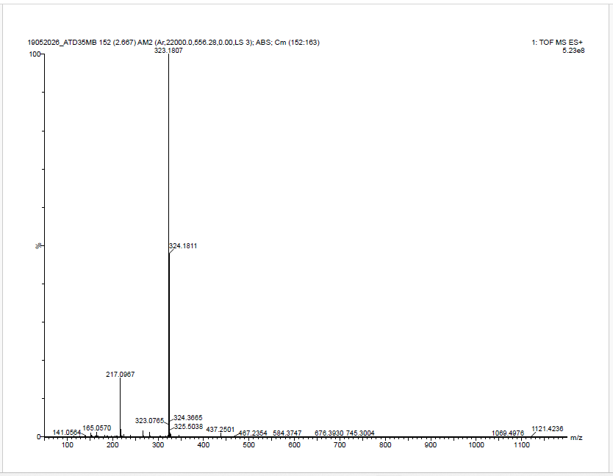
Mass Spectrum of 9-(3,5-dimethylphenyl)-6,6-dimethyl-5,6,7,9-tetrahydro-[1,2,4]triazolo[5,1-b]quinazolin-8(4H)-one
IR Spectrum of 9-(4-methoxyphenyl)-6,6-dimethyl-5,6,7,9-tetrahydro-[1,2,4]triazolo[5,1b]quinazolin-8(4H)-one
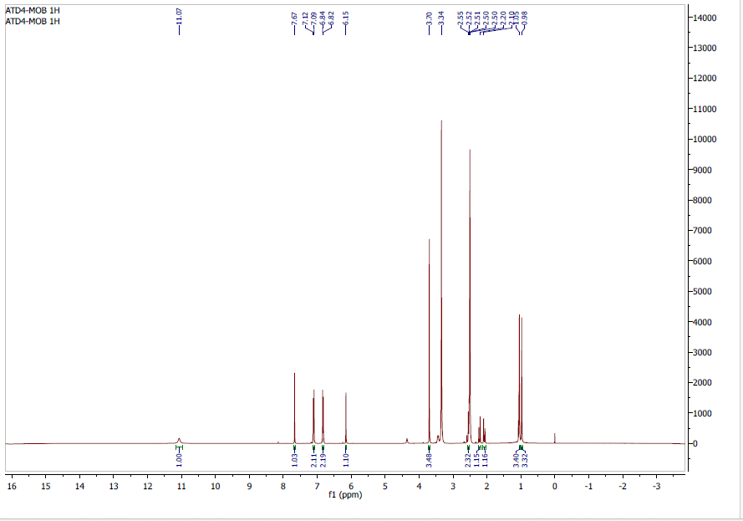
¹H NMR Spectrum of 9-(4-methoxyphenyl)-6,6-dimethyl-5,6,7,9-tetrahydro-[1,2,4]triazolo[5,1-b]quinazolin-8(4H)-one
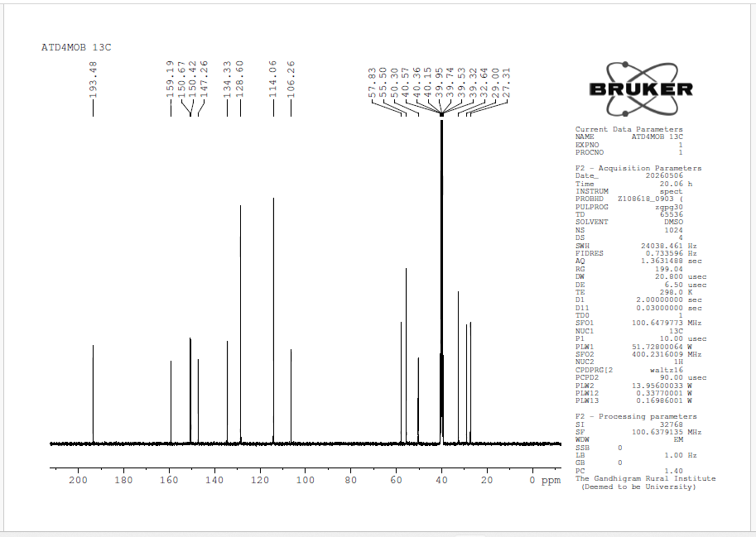
¹³C NMR Spectrum of 9-(4-methoxyphenyl)-6,6-dimethyl-5,6,7,9-tetrahydro-[1,2,4]triazolo[5,1-b]quinazolin-8(4H)-one
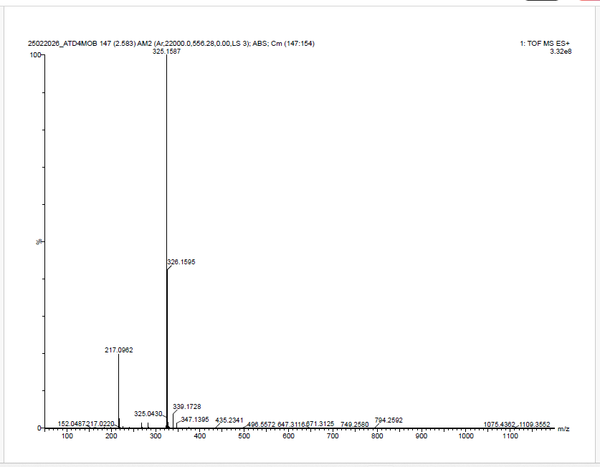
Mass Spectrum of 9-(4-methoxyphenyl)-6,6-dimethyl-5,6,7,9-tetrahydro-[1,2,4]triazolo[5,1-b]quinazolin-8(4H)-one
IR Spectrum of 9-(3,4,5-trimethoxyphenyl)-6,6-dimethyl-5,6,7,9-tetrahydro-[1,2,4]triazolo[5,1-b]quinazolin-8(4H)-one

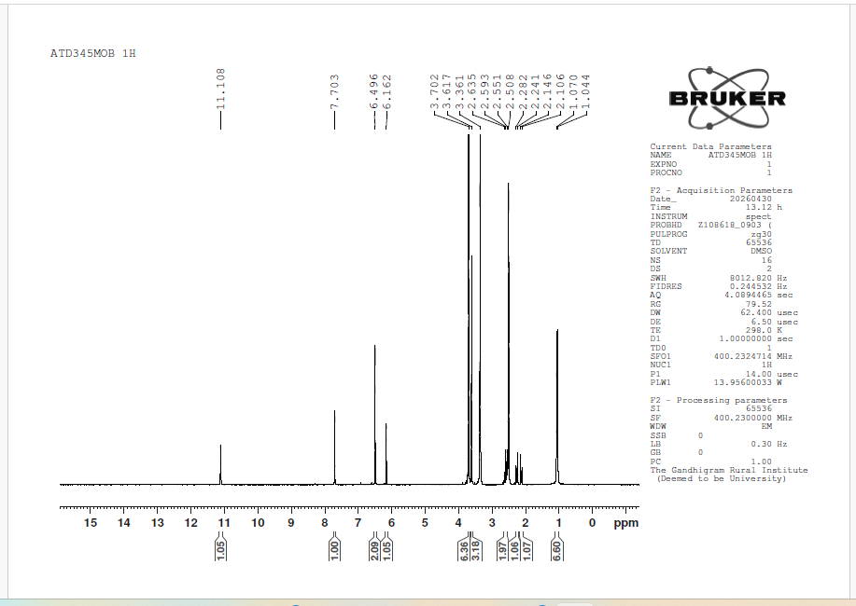
¹H NMR Spectrum of 9-(3,4,5-trimethoxyphenyl)-6,6-dimethyl-5,6,7,9-tetrahydro-[1,2,4]triazolo[5,1-b]quinazolin-8(4H)-one
¹³C NMR Spectrum of 9-(3,4,5-trimethoxyphenyl)-6,6-dimethyl-5,6,7,9-tetrahydro-[1,2,4]triazolo[5,1-b]quinazolin-8(4H)-one
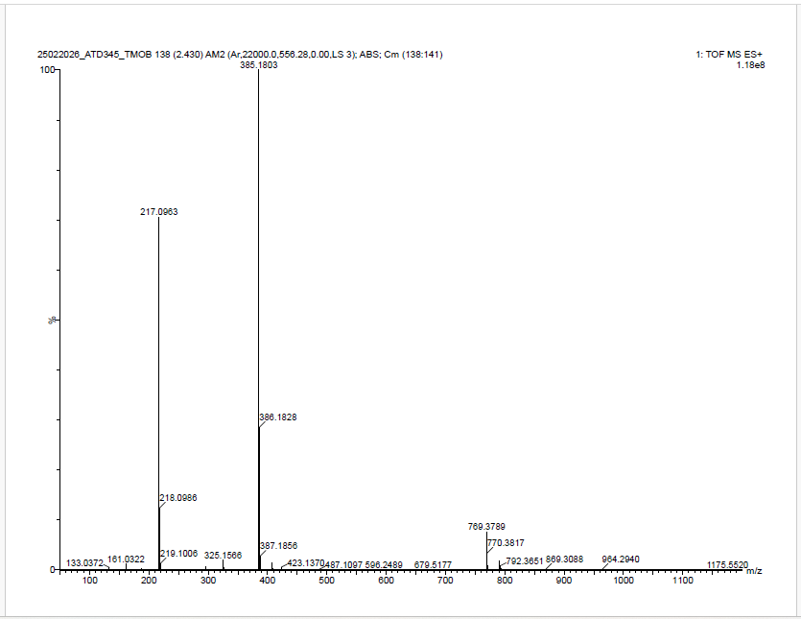
Mass Spectrum of 9-(3,4,5-trimethoxyphenyl)-6,6-dimethyl-5,6,7,9-tetrahydro-[1,2,4]triazolo[5,1-b]quinazolin-8(4H)-one

IR Spectrum of 6,6-dimethyl-9-(4-nitrophenyl)-5,6,7,9-tetrahydro-[1,2,4]triazolo[5,1-b]quinazolin-8(4H)-one
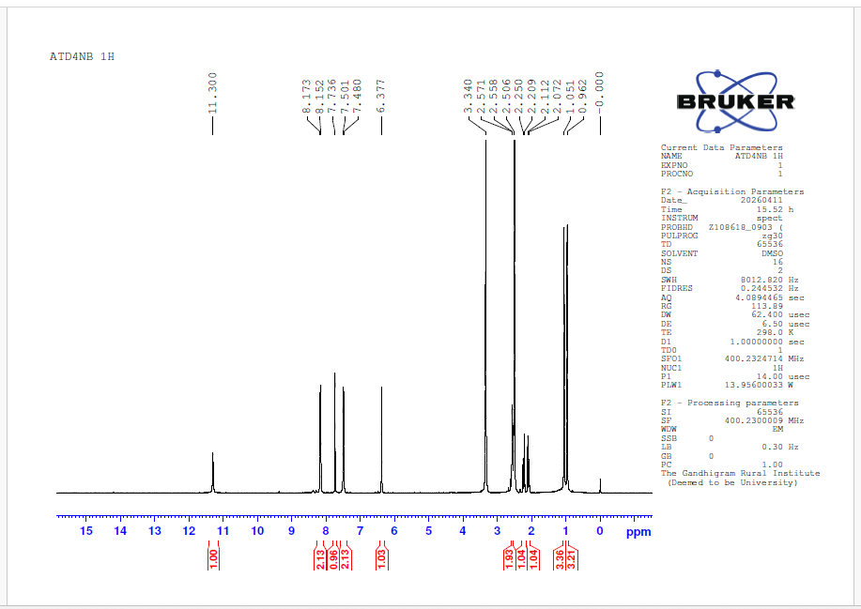
¹H NMR Spectrum of 6,6-dimethyl-9-(4-nitrophenyl)-5,6,7,9-tetrahydro-[1,2,4]triazolo[5,1-b]quinazolin-8(4H)-one

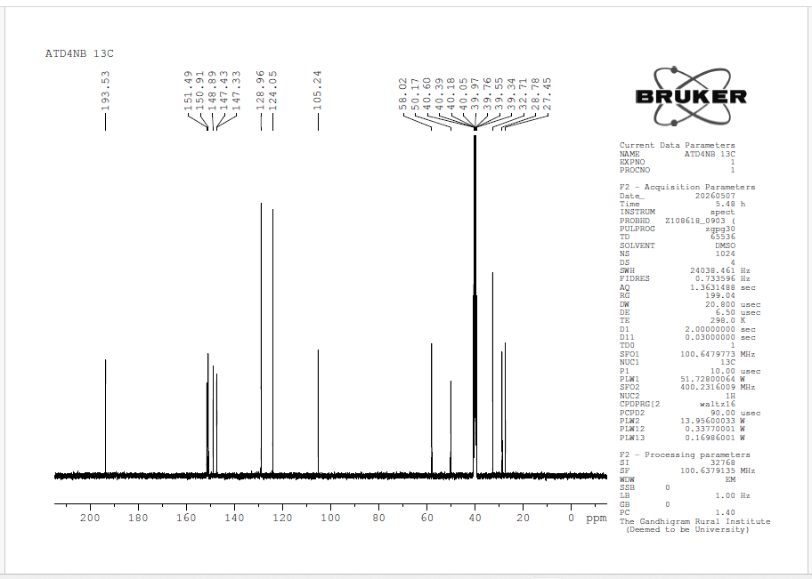
¹³C NMR Spectrum of 6,6-dimethyl-9-(4-nitrophenyl)-5,6,7,9-tetrahydro-[1,2,4]triazolo[5,1-b]quinazolin-8(4H)-one
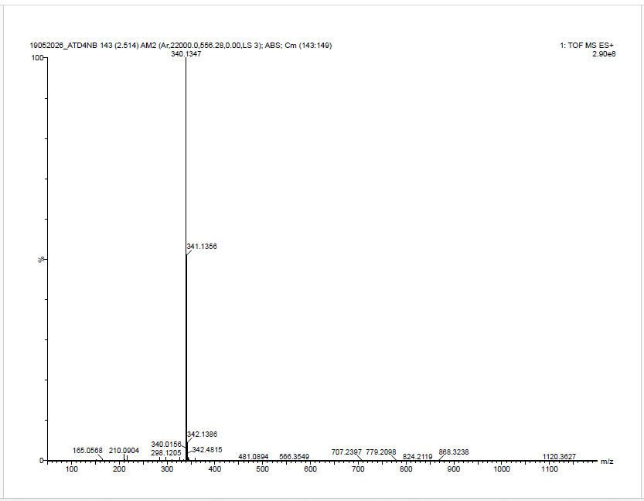
Mass Spectrum of 6,6-dimethyl-9-(4-nitrophenyl)-5,6,7,9-tetrahydro-[1,2,4]triazolo[5,1-b]quinazolin-8(4H)-one
IR Spectrum of 6,6-dimethyl-9-(3-nitrophenyl)-5,6,7,9-tetrahydro-[1,2,4]triazolo[5,1-b]quinazolin-8(4H)-one
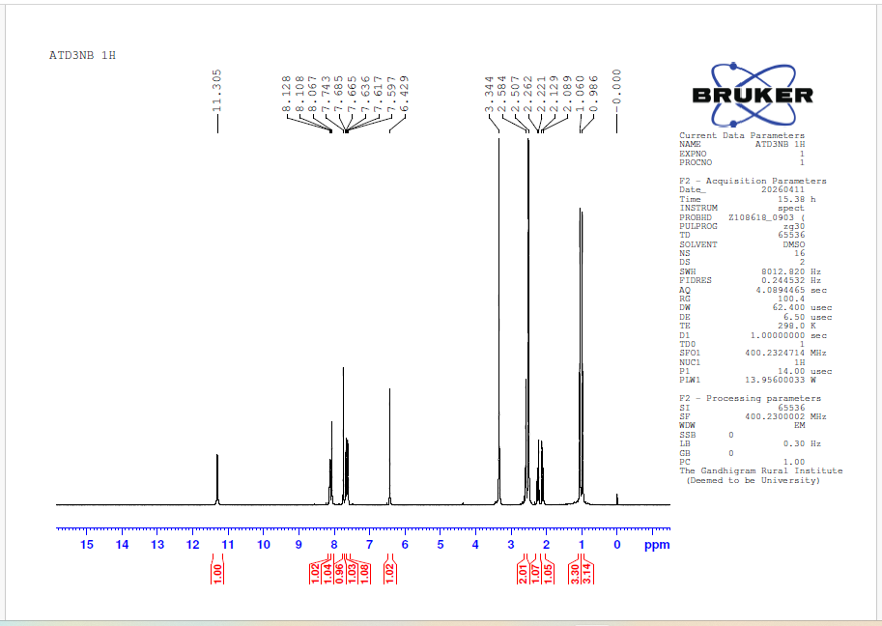
¹H NMR Spectrum of 6,6-dimethyl-9-(3-nitrophenyl)-5,6,7,9-tetrahydro-[1,2,4]triazolo[5,1-b]quinazolin-8(4H)-one
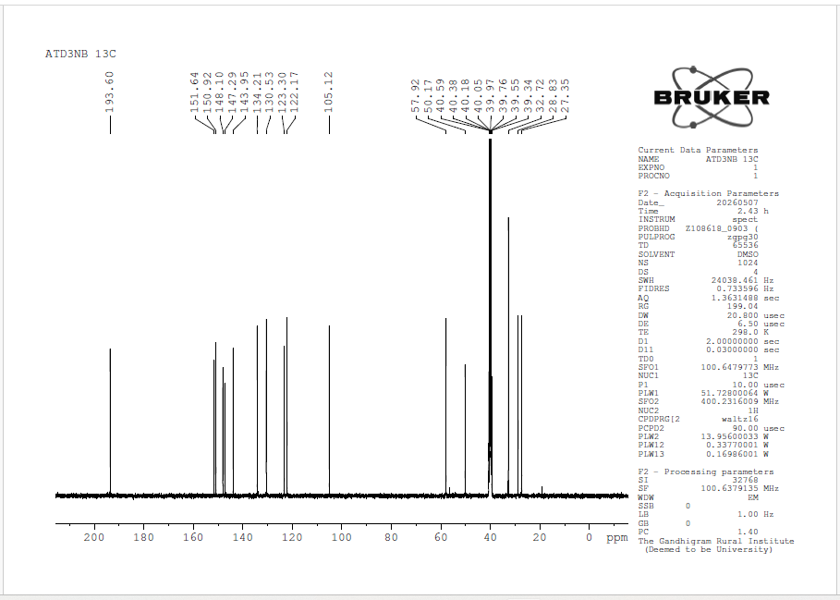
¹³C NMR Spectrum of 6,6-dimethyl-9-(3-nitrophenyl)-5,6,7,9-tetrahydro-[1,2,4]triazolo[5,1-b]quinazolin-8(4H)-one
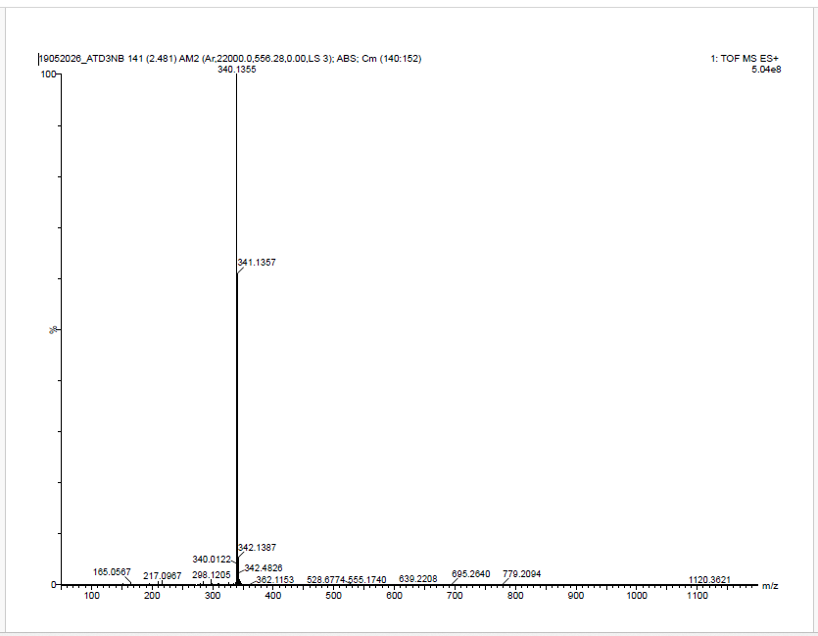
Mass Spectrum of 6,6-dimethyl-9-(3-nitrophenyl)-5,6,7,9-tetrahydro-[1,2,4]triazolo[5,1-b]quinazolin-8(4H)-one
IR Spectrum of 6,6-dimethyl-9-(2-nitrophenyl)-5,6,7,9-tetrahydro-[1,2,4]triazolo[5,1-b]quinazolin-8(4H)-one
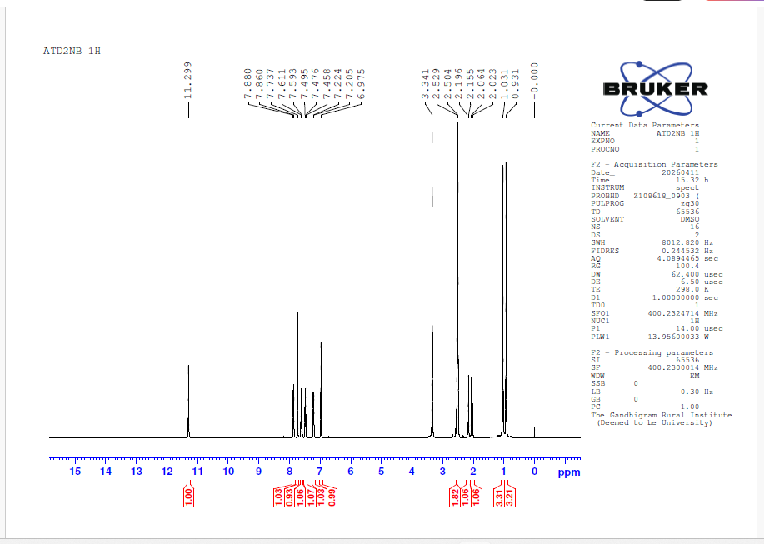
¹H NMR Spectrum of 6,6-dimethyl-9-(2-nitrophenyl)-5,6,7,9-tetrahydro-[1,2,4]triazolo[5,1-b]quinazolin-8(4H)-one
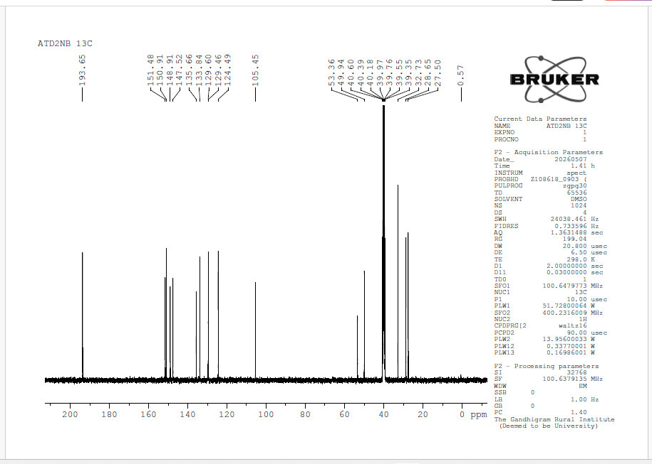
¹³C NMR Spectrum of 6,6-dimethyl-9-(2-nitrophenyl)-5,6,7,9-tetrahydro-[1,2,4]triazolo[5,1-b]quinazolin-8(4H)-one
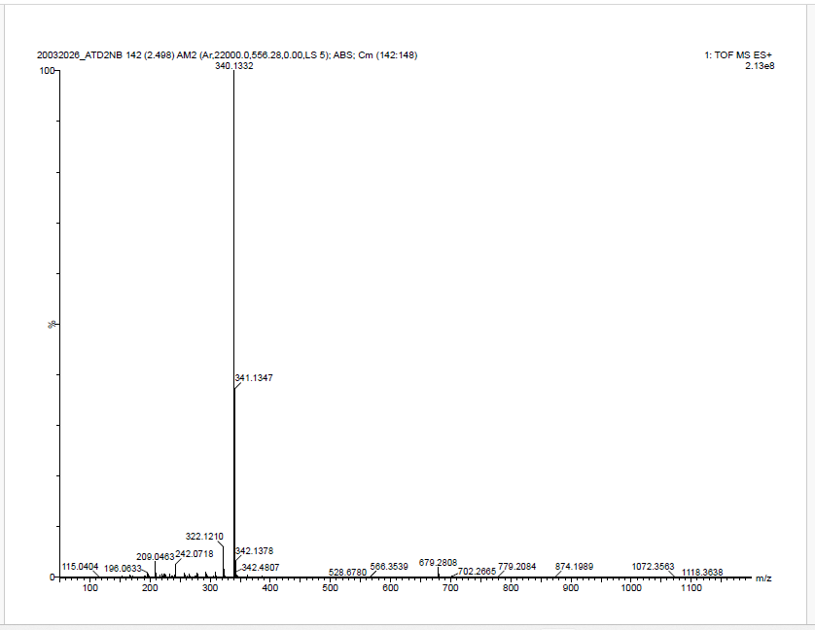
Mass Spectrum of 6,6-dimethyl-9-(2-nitrophenyl)-5,6,7,9-tetrahydro-[1,2,4]triazolo[5,1-b]quinazolin-8(4H)-one
IR Spectrum of 6,6-dimethyl-9-(naphthalen-1-yl)-5,6,7,9-tetrahydro-[1,2,4]triazolo[5,1-b]quinazolin-8(4H)-one (4o)
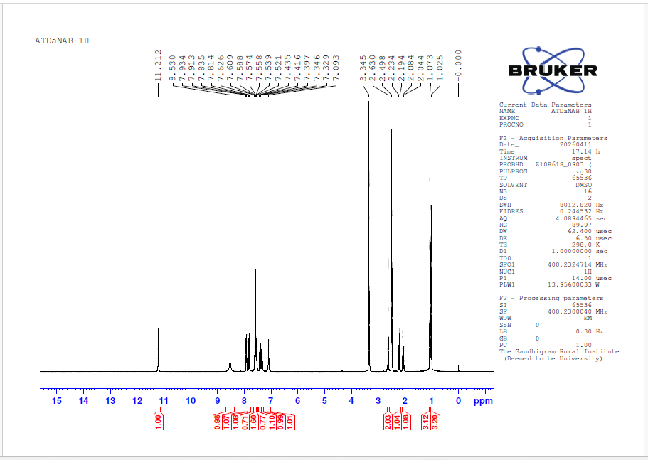
¹H NMR Spectrum of 6,6-dimethyl-9-(naphthalen-1-yl)-5,6,7,9-tetrahydro-[1,2,4]triazolo[5,1-b]quinazolin-8(4H)-one (4o)

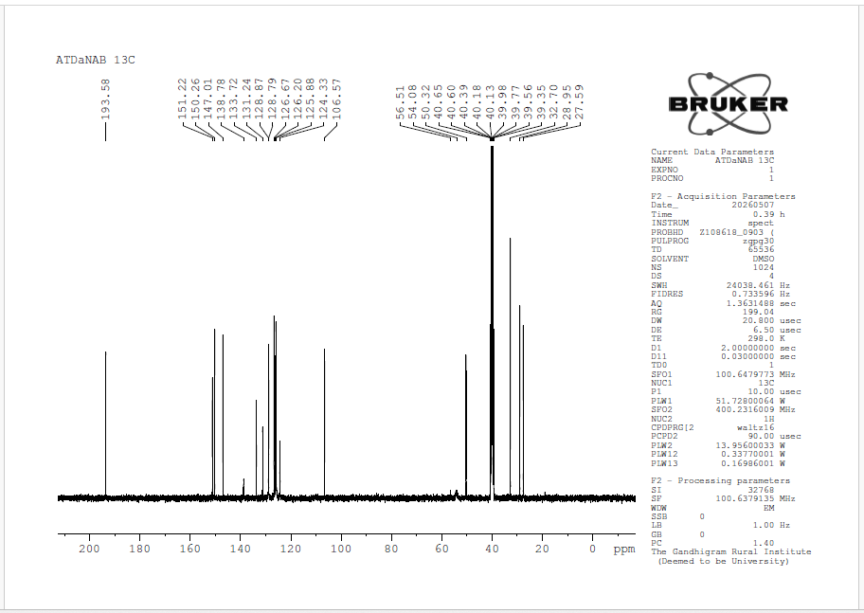
¹³C NMR Spectrum of 6,6-dimethyl-9-(naphthalen-1-yl)-5,6,7,9-tetrahydro-[1,2,4]triazolo[5,1-b]quinazolin-8(4H)-one (4o)
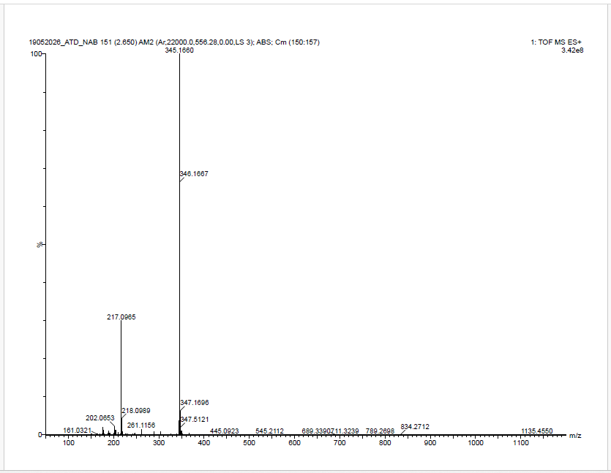
Mass Spectrum of 6,6-dimethyl-9-(naphthalen-1-yl)-5,6,7,9-tetrahydro-[1,2,4]triazolo[5,1-b]quinazolin-8(4H)-one (4o)

ANTI-INFLAMMATORY ACTIVITY
BSA denaturation technique
The synthesized compound and standard diclofenac sodium were screened for anti-inflammatory activity by using the inhibition of albumin denaturation technique with minor modification.^{4,5} The standard drug and compound were dissolved in minimum quantity of Dimethyl formamide (DMF) and diluted with phosphate buffer (0.2 M, PH 7.4). The final concentration of DMF in all solution was less than 2.5%. Test Solution (2.5 mL) containing different concentrations of the drug was mixed with 1 mL of 1 mM Bovine serum albumin solution in phosphate buffer and incubated at 37 °C in an incubator for 10 min. Denaturation was induced by keeping the reaction mixture at 70°C in a water bath for 10 min. After cooling, the turbidity was measured at 660 nm. Percentage of Inhibition of denaturation was calculated from control where no drug was added. The percentage inhibition of denaturation was calculated by using the following formula.
% of Inhibition = 100 x[ Ac-At /Ac]
At: Absorbance of test
Ac: Absorbance of control

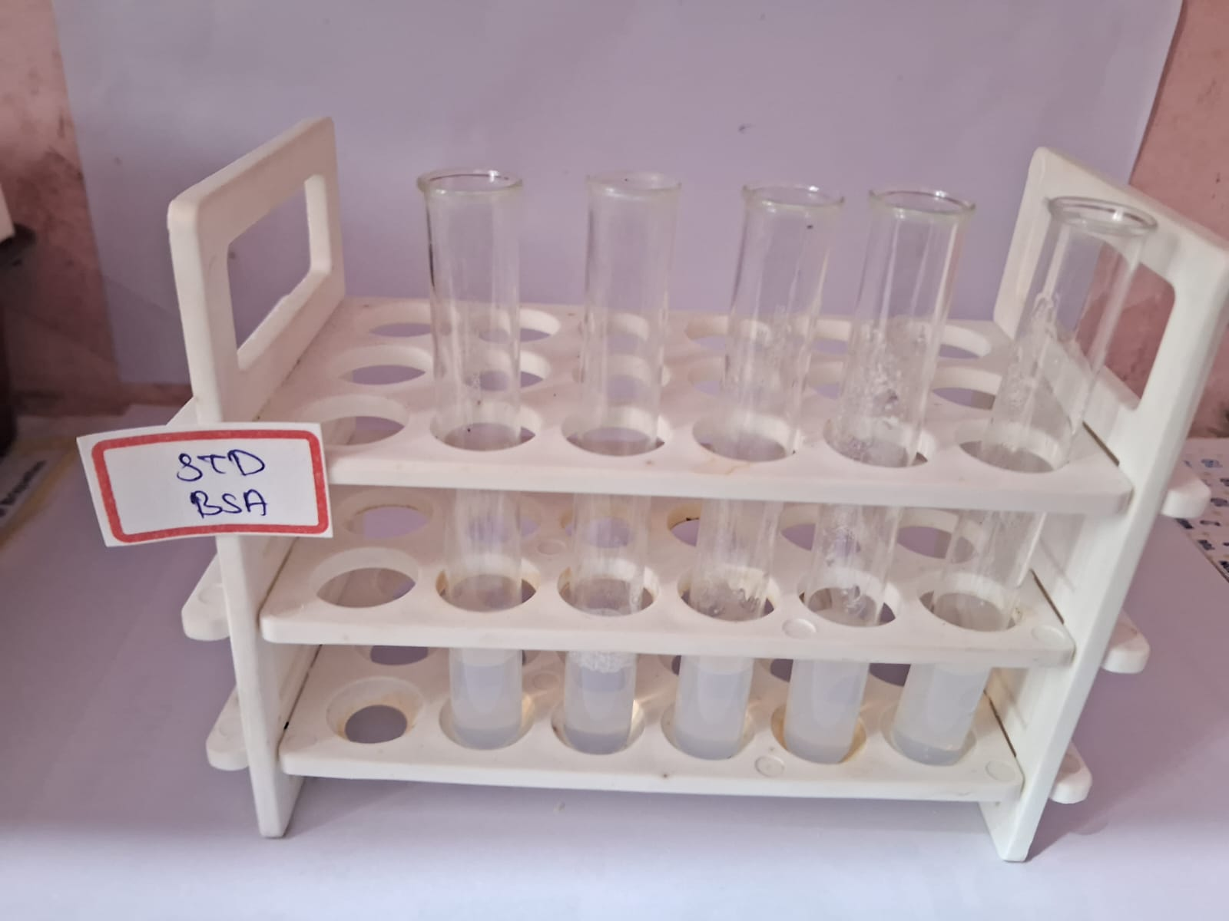
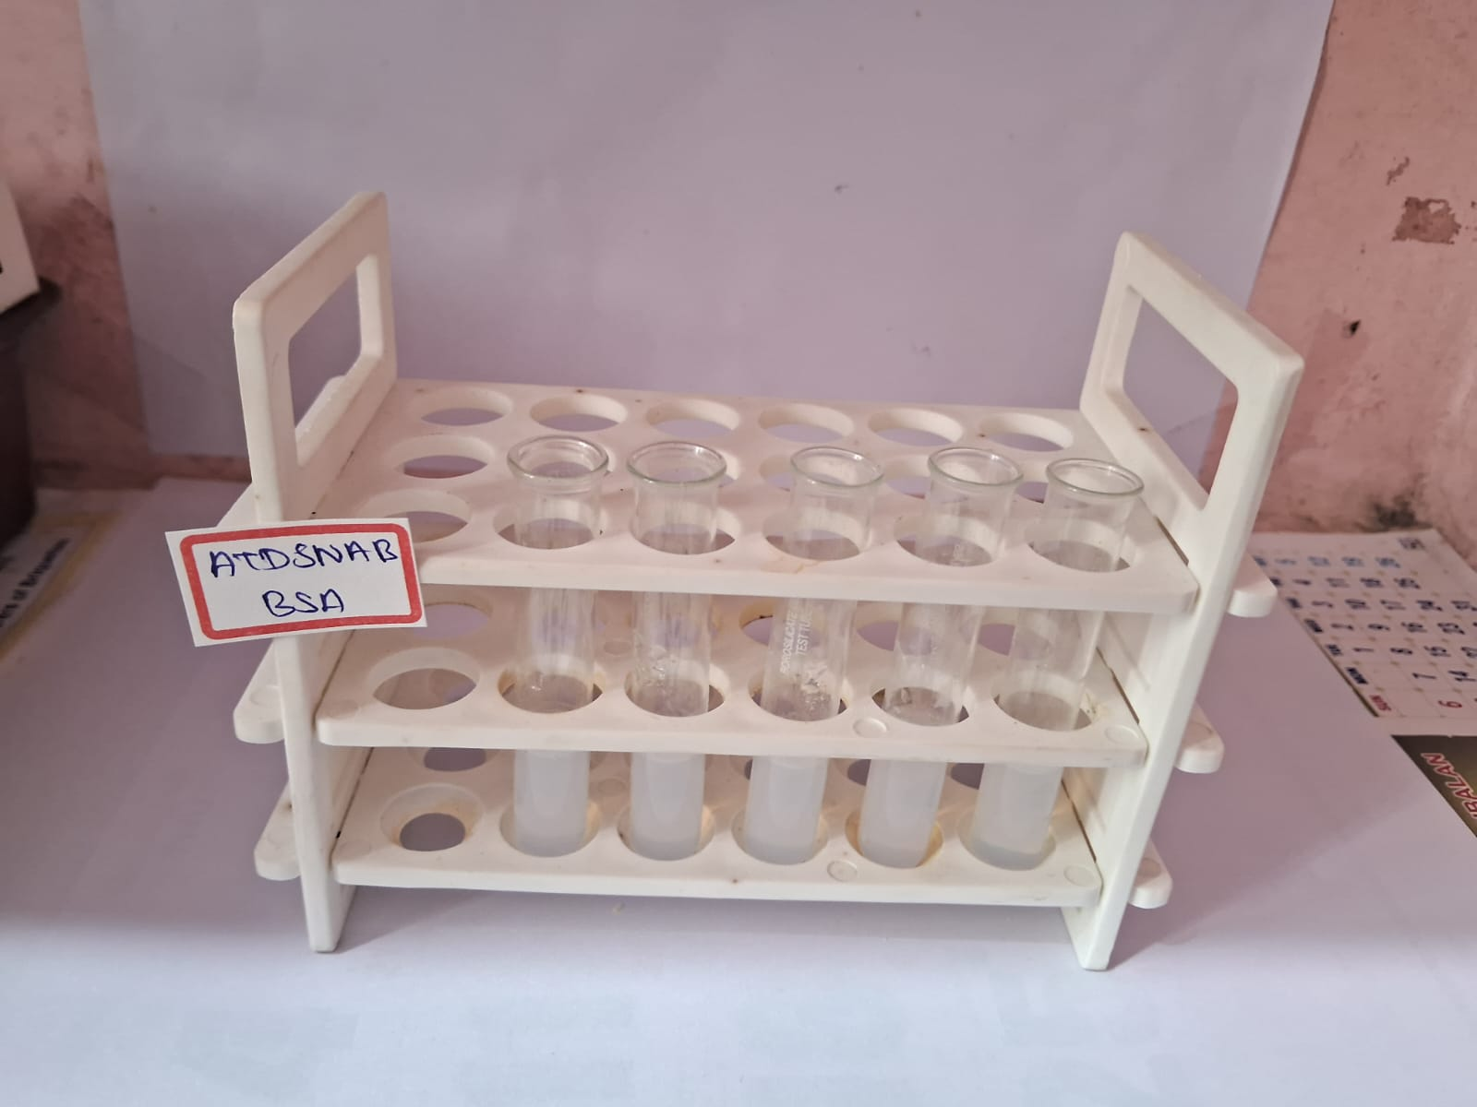
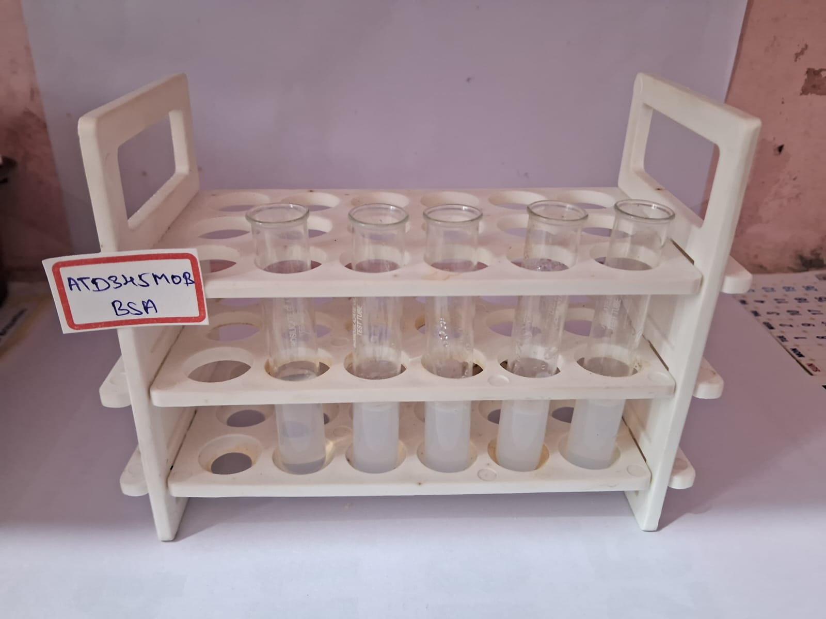
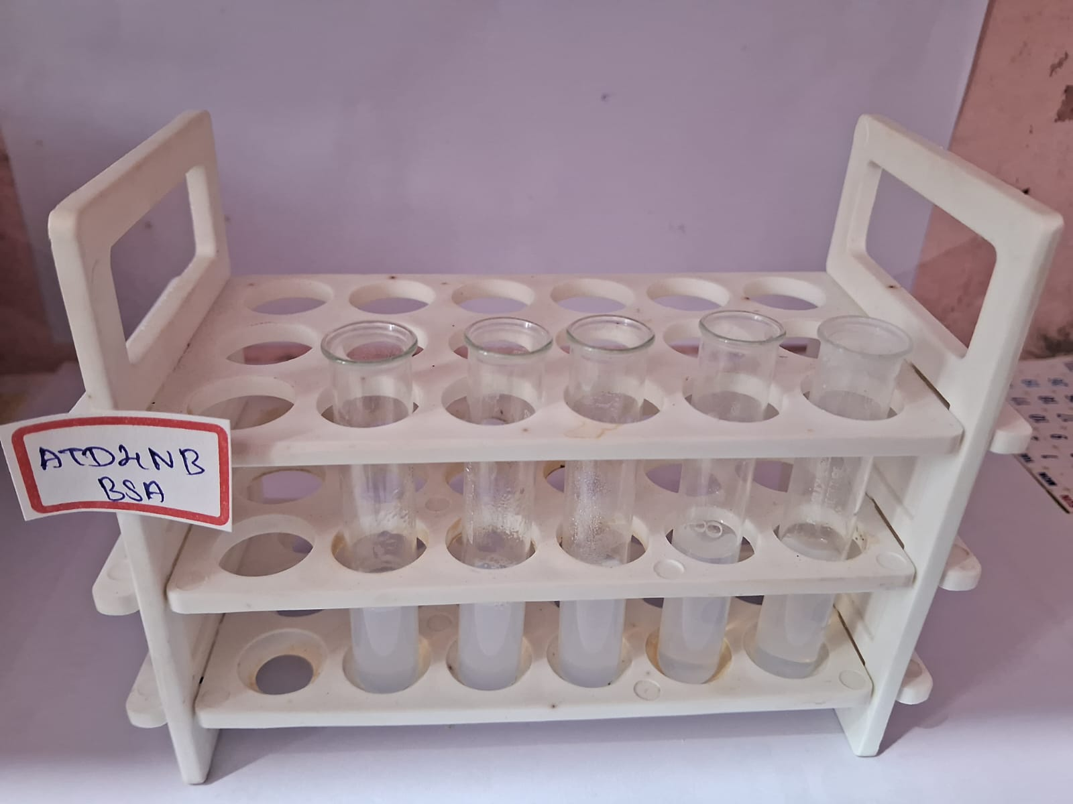

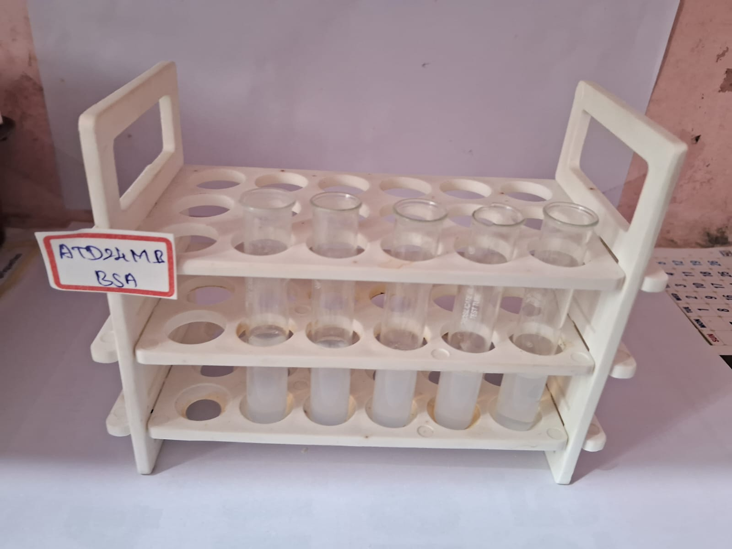
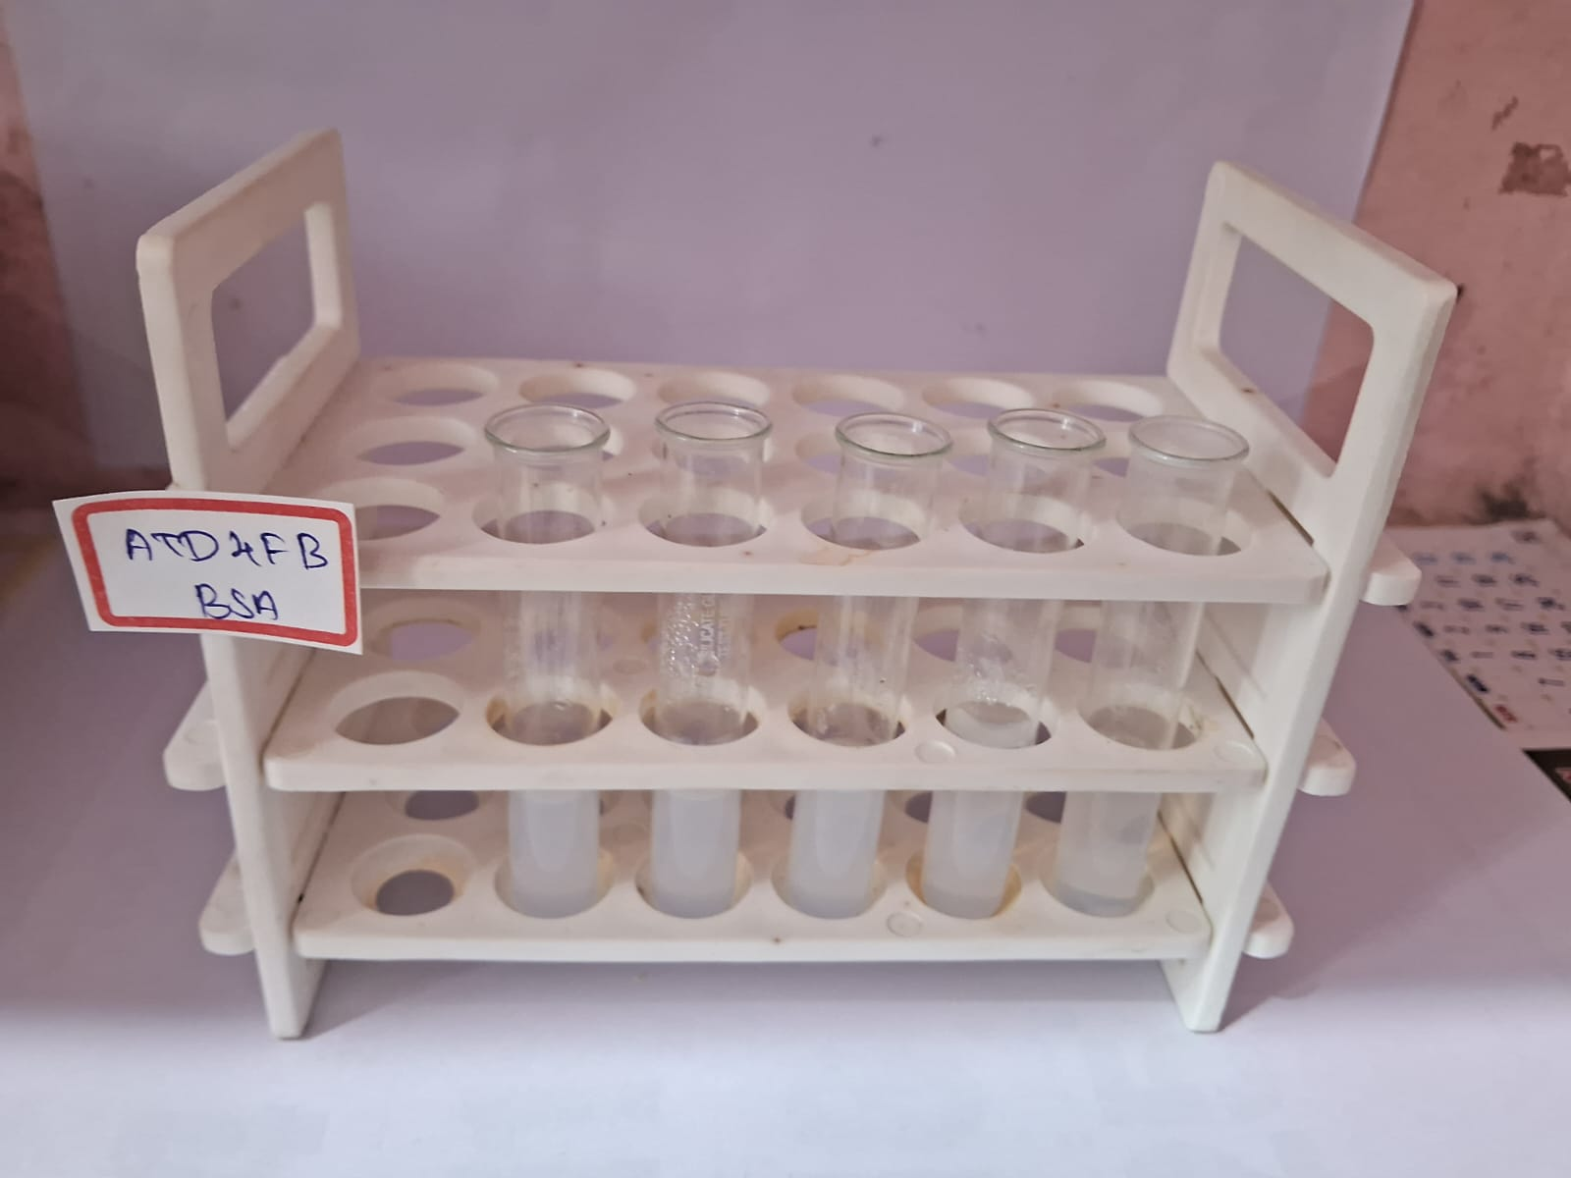

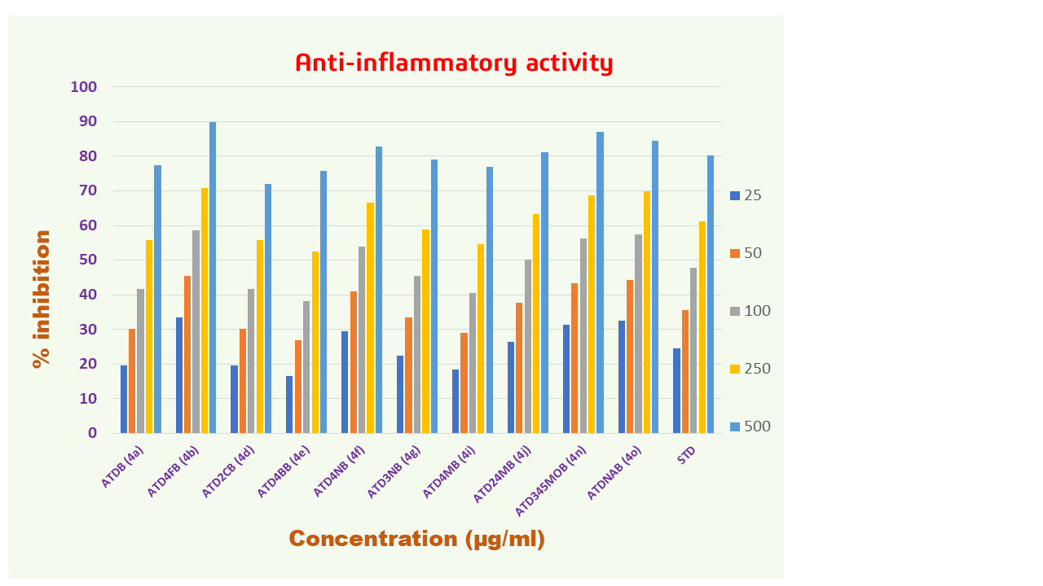

Table 3. Anti-inflammatory activity of 6,6-dimethyl-9-phenyl-5,6,7,9-tetrahydro-[1,2,4]triazolo[5,1-b]quinazolin-8(4H)-one derivatives
Conc  (µg/ml) | ATDB (4a) | ATD4FB (4b) | ATD2CB (4d) | ATD4BB (4e) | ATD4NB (4f) | ATD3NB (4g) | ATD4MB (4i) | ATD24MB (4j) | ATD345MOB (4n) | ATDNAB (4o) | STD  (Diclofenac)
25 | 19.48 | 33.46 | 19.48 | 16.43 | 29.44 | 22.45 | 18.44 | 26.47 | 31.45 | 32.49 | 24.46
50 | 30.11 | 45.50 | 30.11 | 26.77 | 41.04 | 33.38 | 29.00 | 37.77 | 43.27 | 44.39 | 35.58
100 | 41.78 | 58.66 | 41.78 | 38.14 | 53.83 | 45.35 | 40.52 | 50.26 | 56.28 | 57.47 | 47.81
250 | 55.69 | 70.93 | 55.69 | 52.42 | 66.62 | 58.96 | 54.65 | 63.35 | 68.77 | 69.89 | 61.16
500 | 77.40 | 89.89 | 71.97 | 75.76 | 82.83 | 79.03 | 76.88 | 81.19 | 86.99 | 84.46 | 80.12
IC₅₀ | 230.61 | 93.99 | 246.48 | 255.39 | 137.96 | 204.86 | 239.02 | 167.67 | 114.98 | 105.61 | 186.56

3D and 2D molecular docking interaction diagram of triazolo-quinazolinones derivatives
compound code | 3D Interaction | 2D Interaction
4a | 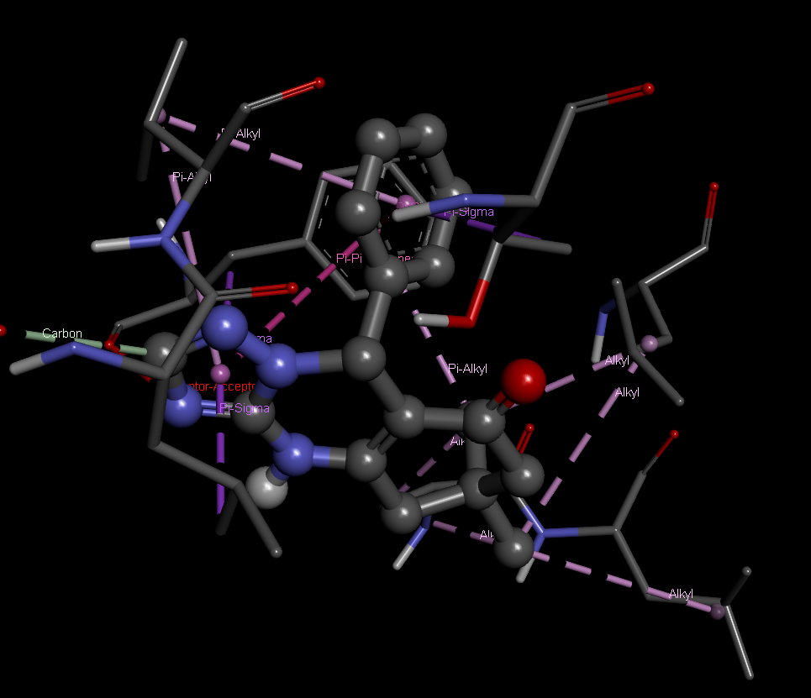 | 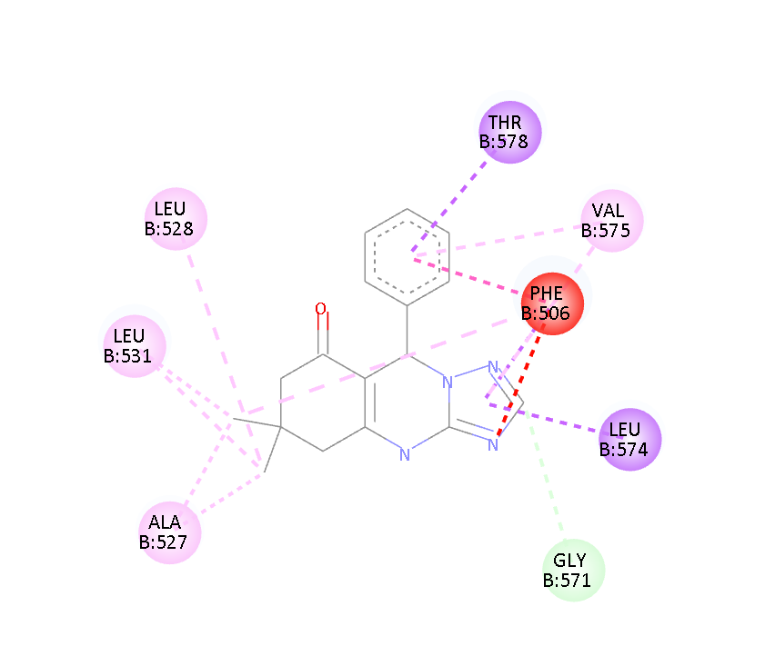
4b | 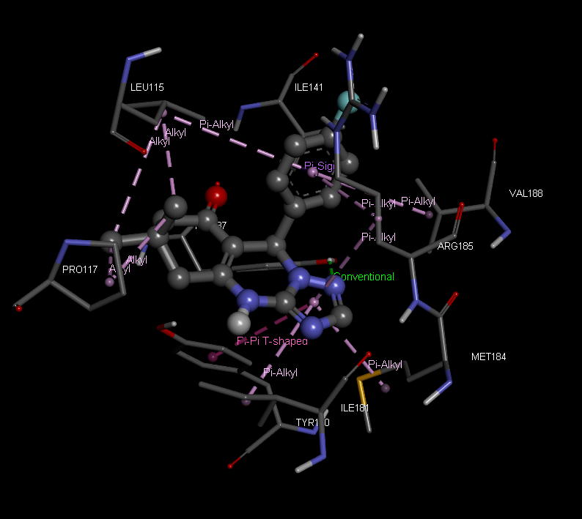 | 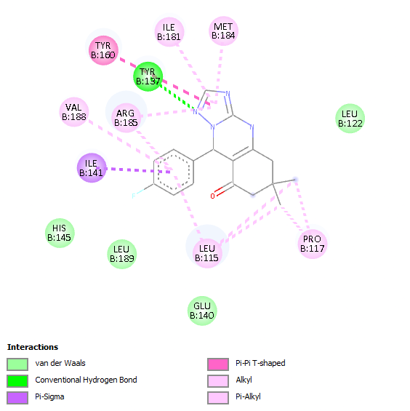
4c | 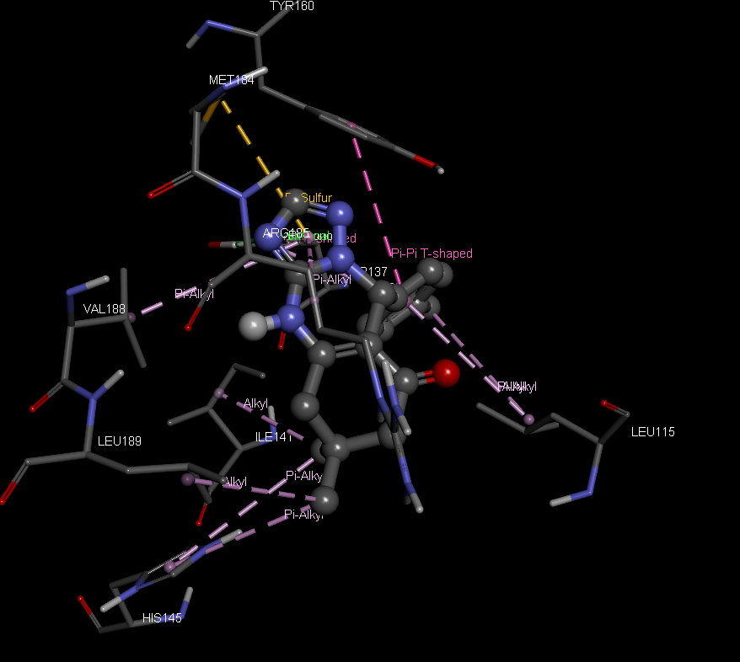 | 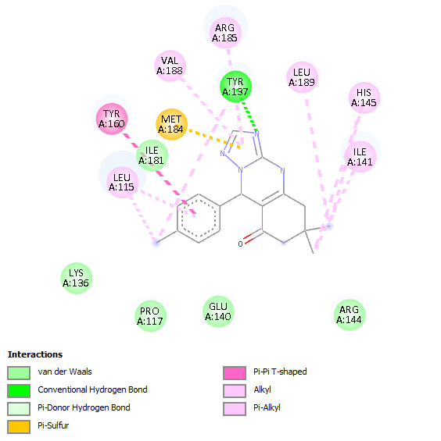
4d | 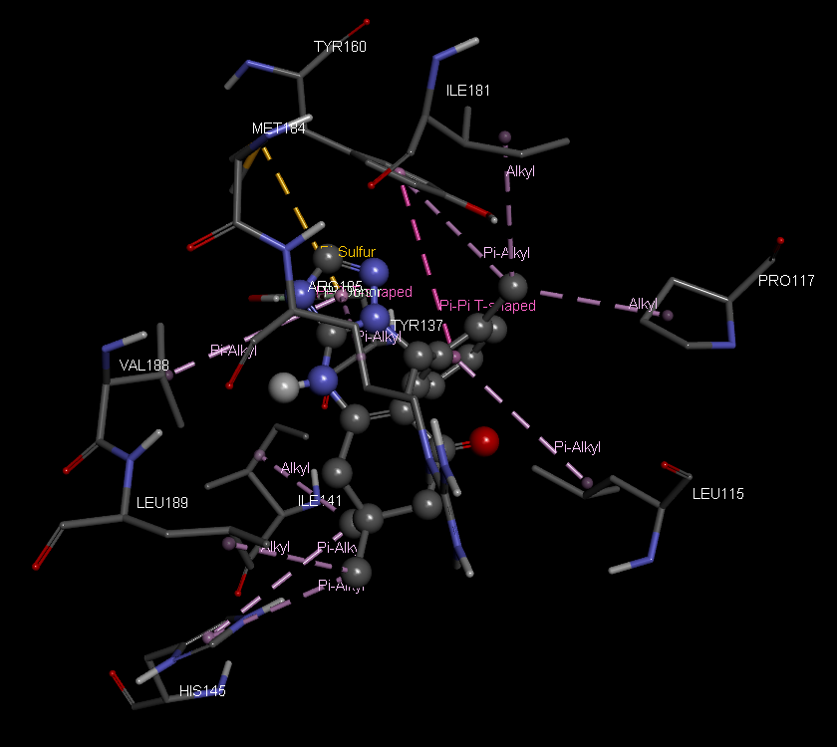 | 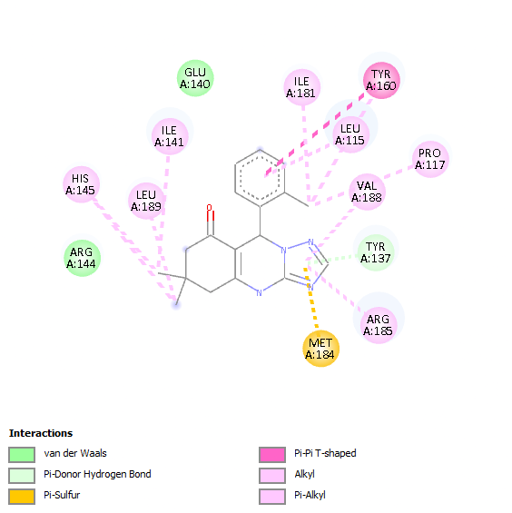
4e* | -- | --
4f | 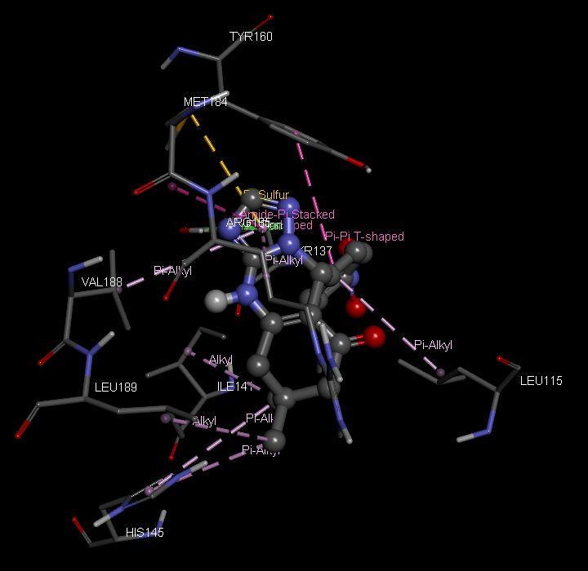 | 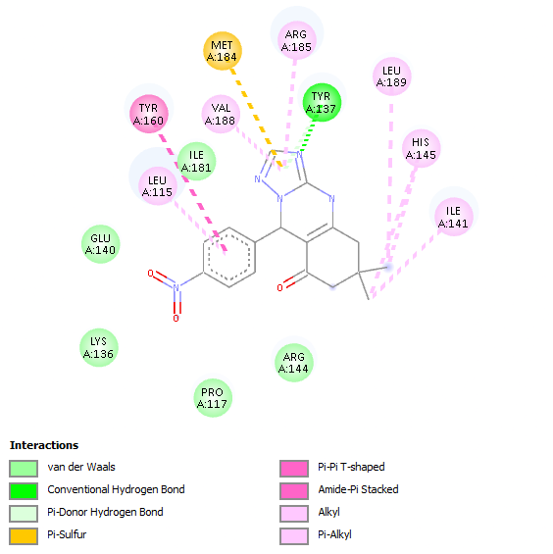
4g | 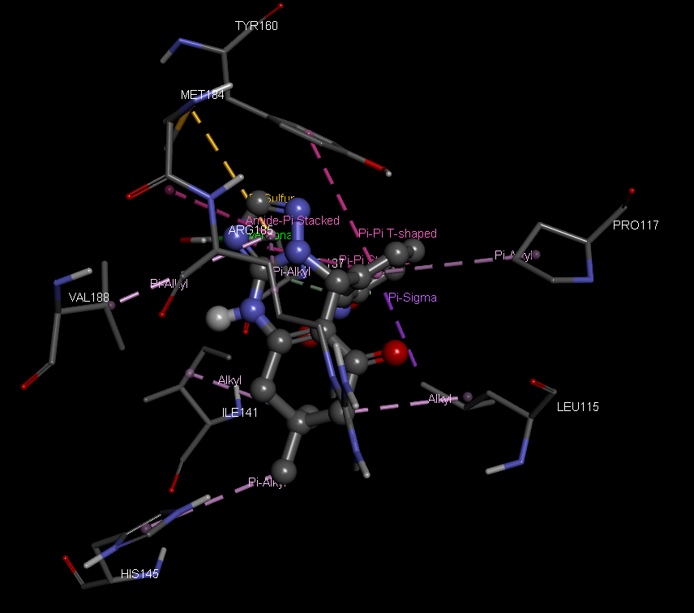 | 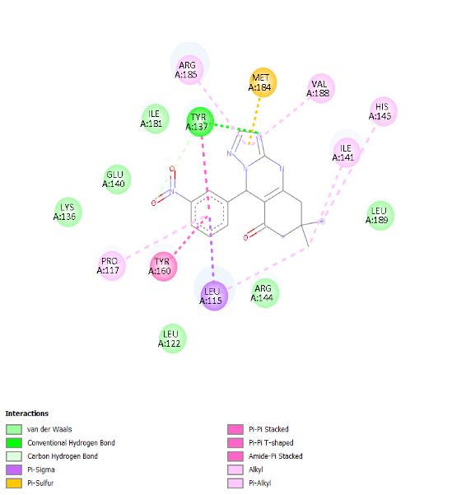
4h | 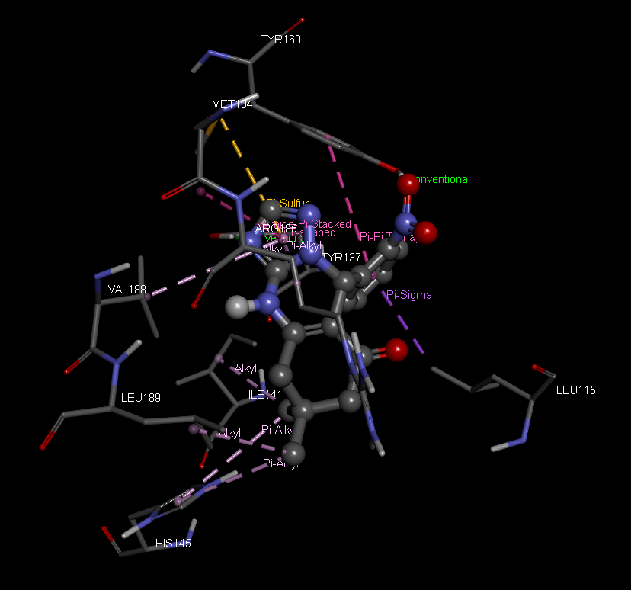 | 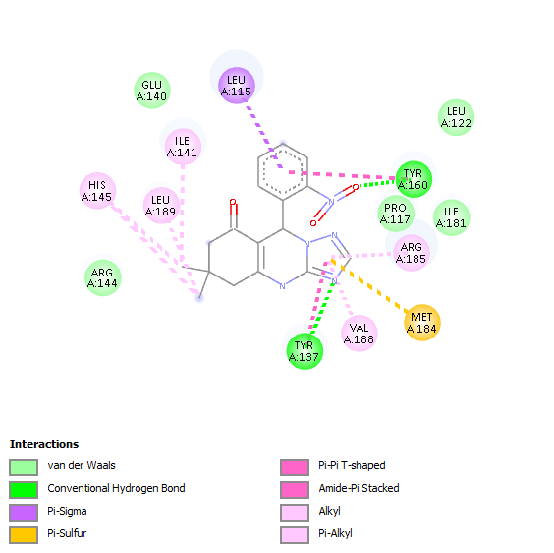
4i | 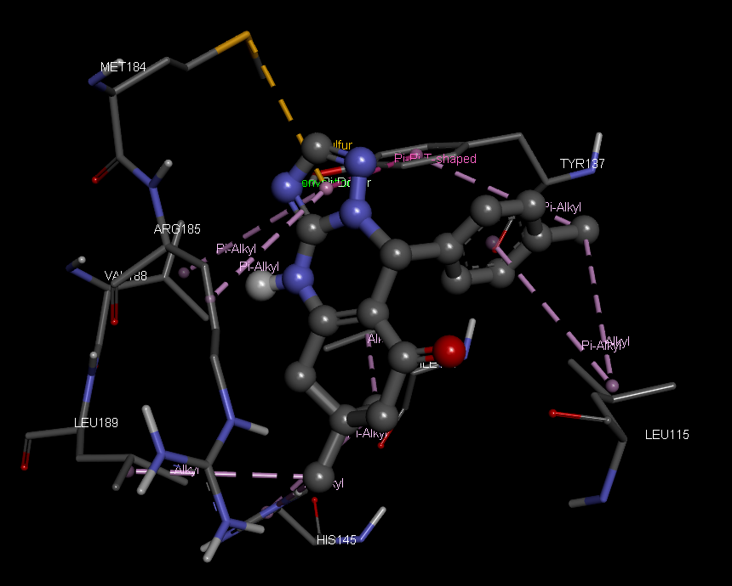 | 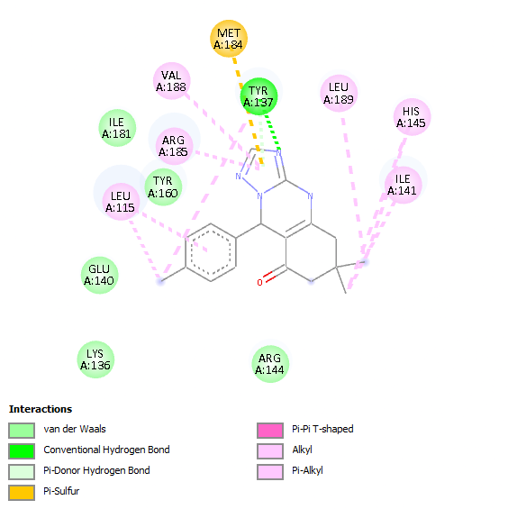
4j | 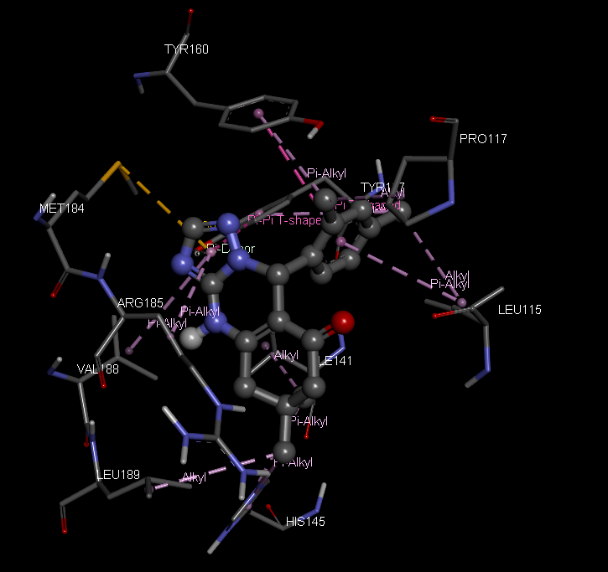 | 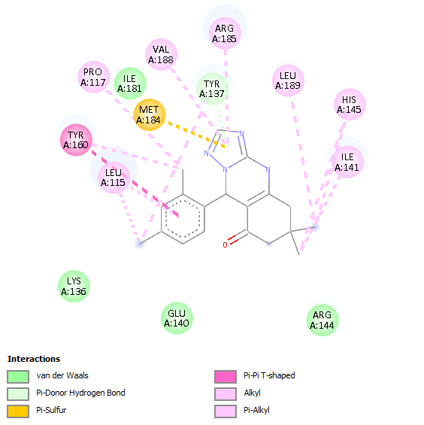
4k | 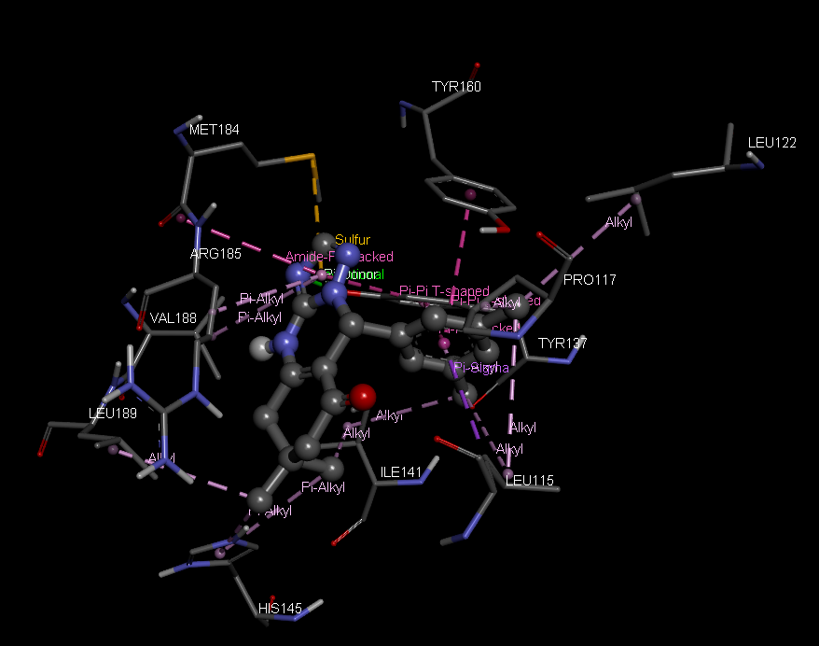 | 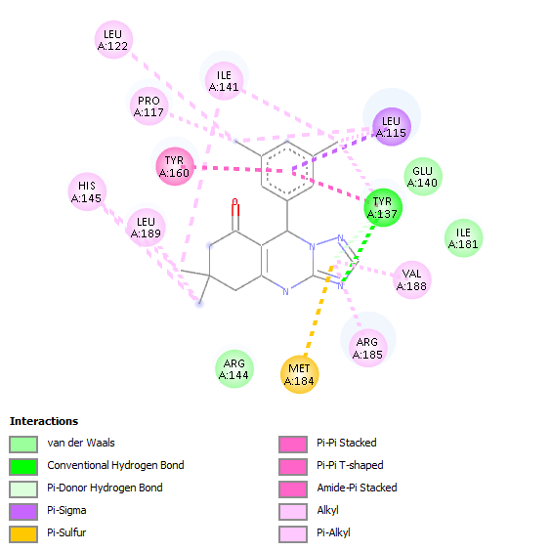
4l | 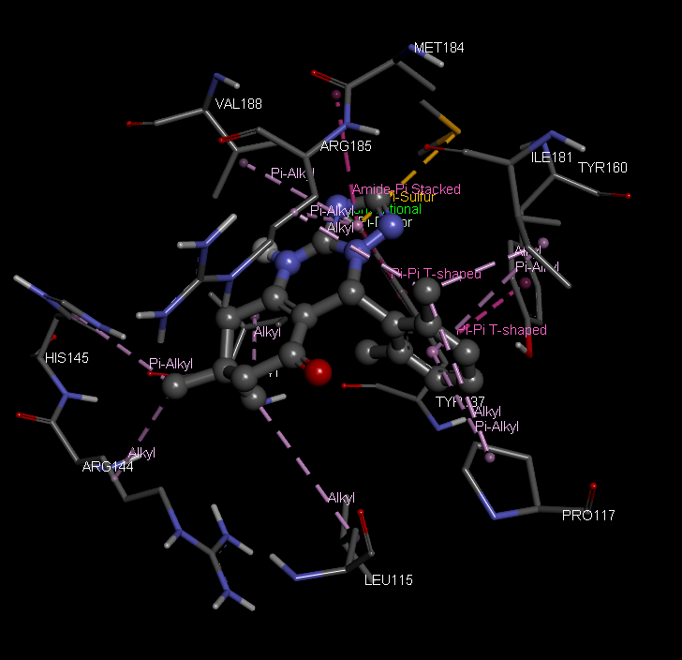 | 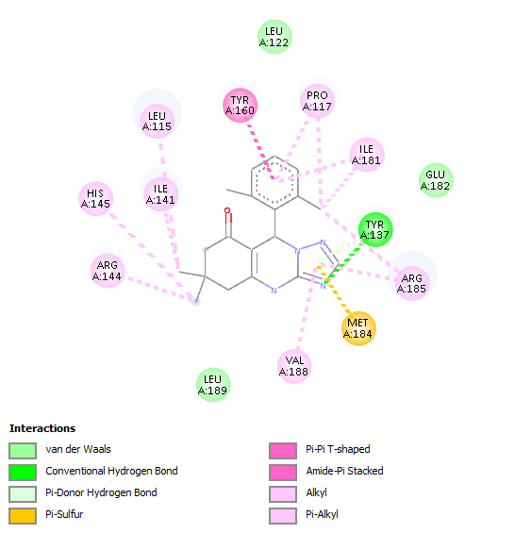
4m | 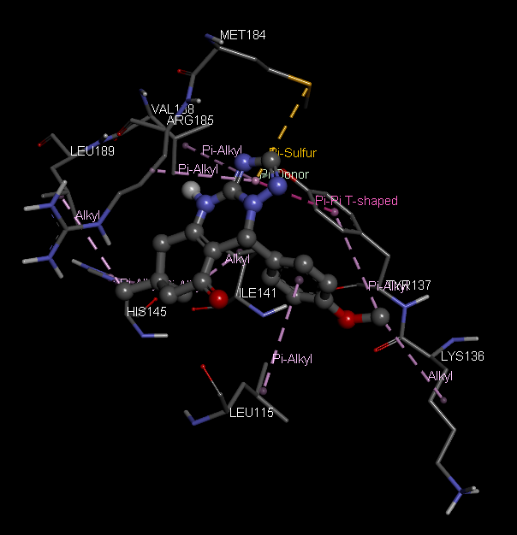 | 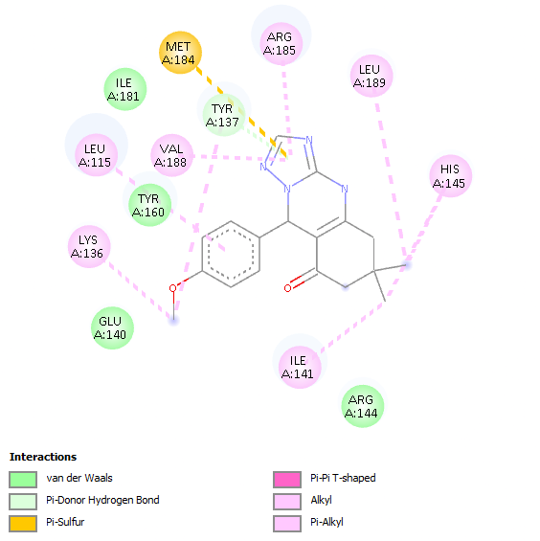
4n | 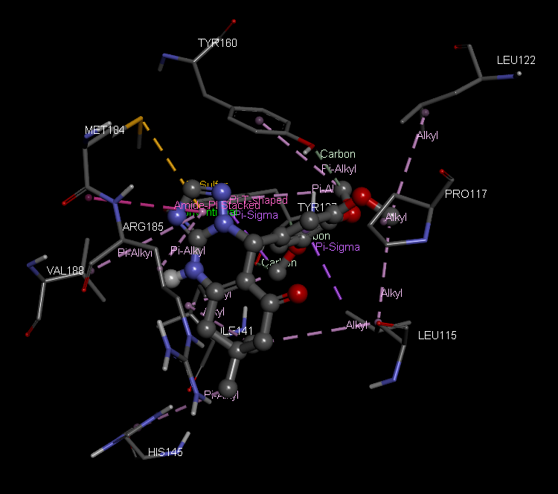 | 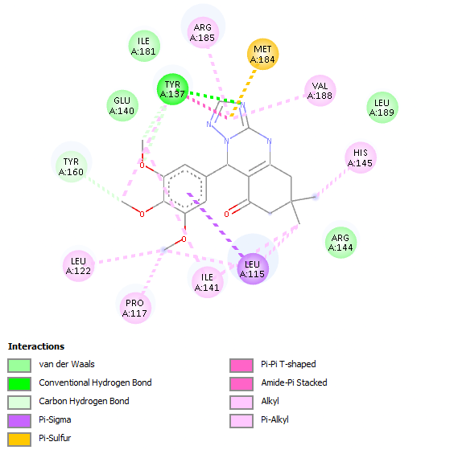
4o | 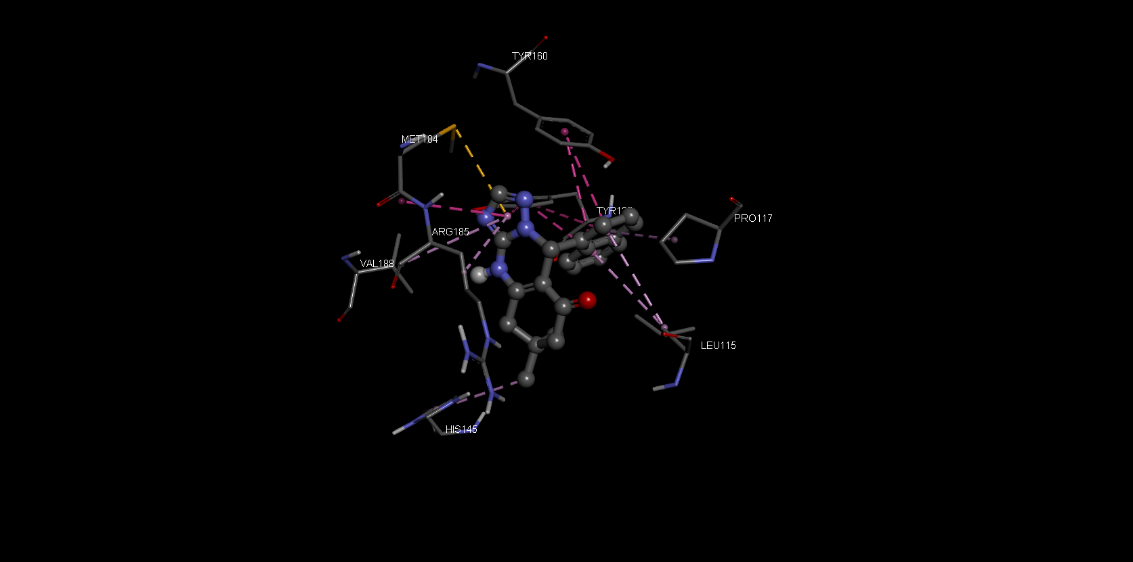 | 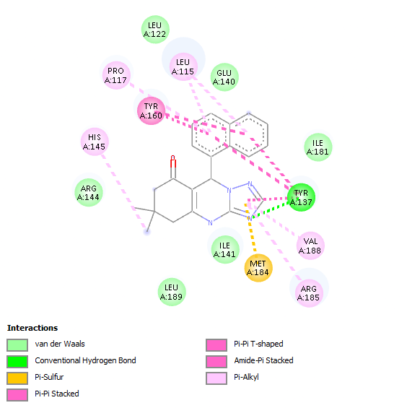
* not done

References
(1) Convergent and Efficient Synthesis of 1,2,4-Triazolo[5,1-b]Quinazolin-8-Ones Using Copper Incorporated Hydroxyapatite Encapsulated Kit-6 as a Recoverable Nanocatalyst. Indian J. Chem. 2023, 62 (8). https://doi.org/10.56042/ijc.v62i8.4776.
(2) Vibhute, S.; Jamale, D.; Undare, S.; Valekar, N.; Kolekar, G.; Anbhule, P. An Efficient, One-Pot Three Components Synthesis of [1,2,4] Triazoloquinazolinone Derivatives Using Anthranilic Acid as Green Catalyst. Res. Chem. Intermed. 2017, 43 (8), 4561–4574. https://doi.org/10.1007/s11164-017-2896-5.
(3) Heravi, M. M.; Derikvand, F.; Ranjbar, L. Sulfamic Acid–Catalyzed, Three-Component, One-Pot Synthesis of [1,2,4]Triazolo/Benzimidazolo Quinazolinone Derivatives. Synth. Commun. 2010, 40 (5), 677–685. https://doi.org/10.1080/00397910903009489.
(4) Elias, G.; Rao, M. N. Inhibition of Albumin Denaturation and Antiinflammatory Activity of Dehydrozingerone and Its Analogs. Indian J. Exp. Biol. 1988, 26 (7), 540–542.
(5) Chandra, S.; Chatterjee, P.; Dey, P.; Bhattacharya, S. Evaluation of in Vitro Anti-Inflammatory Activity of Coffee against the Denaturation of Protein. Asian Pac. J. Trop. Biomed. 2012, 2 (1), S178–S180. https://doi.org/10.1016/S2221-1691(12)60154-3.

