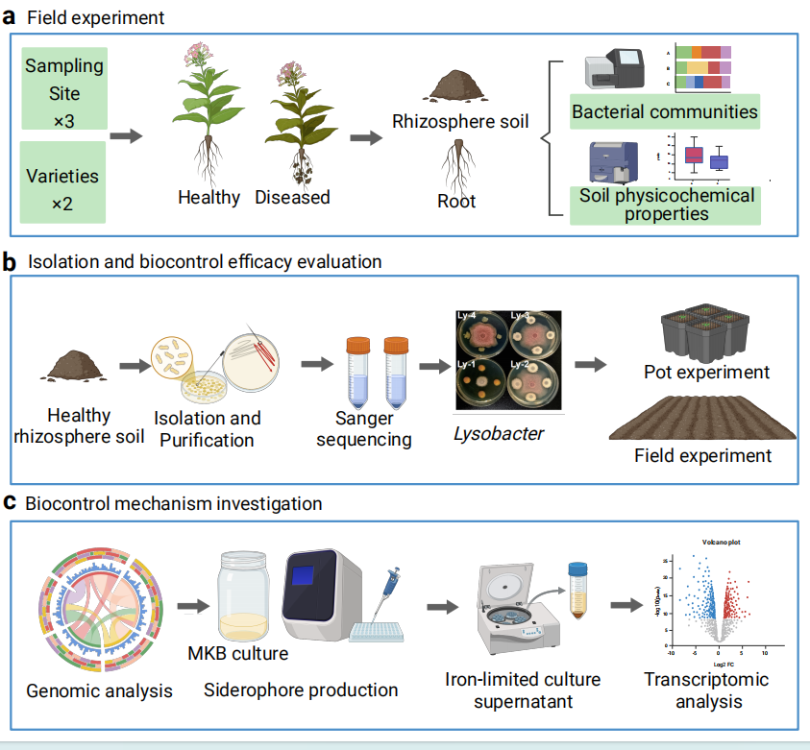
Fig. S1. The workflow for this study. a) Field experiment and microbiome profiling. Rhizosphere soil samples were collected from healthy and Fusarium root rot-diseased Salvia miltiorrhiza plants across three geographically distinct cultivation regions (FY, SJZ, and CD). Soil physicochemical properties were characterized, F. oxysporum abundance was quantified by qPCR, and bacterial community composition was profiled via 16S rRNA amplicon sequencing to identify health-associated core microbiota. b) Isolation and biocontrol efficacy evaluation. Bacterial strains were isolated from healthy rhizosphere soils, identified by Sanger sequencing, and screened for antagonistic activity against F. oxysporum. The candidate strain Lysobacter enzymogenes Ly-1 was selected for further evaluation of its biocontrol efficacy through greenhouse pot and field experiments. c) Biocontrol mechanism investigation. The complete genome of Ly-1 was sequenced and assembled to identify biocontrol-related gene clusters. Siderophore production was assessed under iron-limited MKB culture conditions, and the antifungal activity of iron-limited culture supernatants was tested. Transcriptomic analysis of Ly-1 under iron-limited versus iron-replete conditions, combined with volcano plot and KEGG enrichment analysis, revealed the molecular basis of siderophore-mediated iron competition and pathogen suppression.
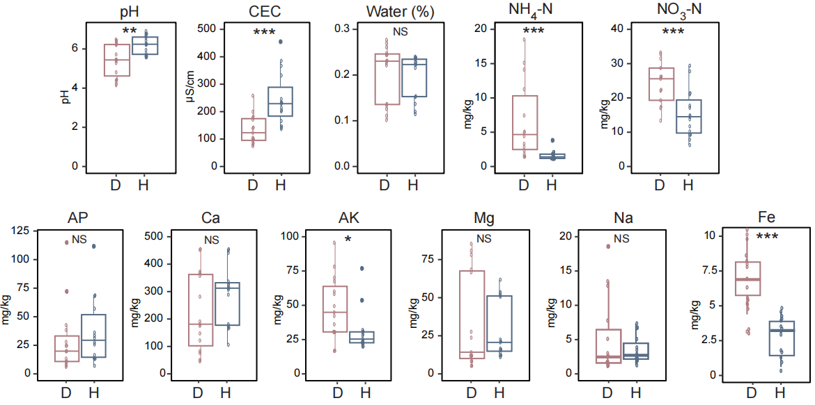
Fig. S2. Comparison of soil physicochemical properties in rhizosphere soils, with box plots demonstrating significantly higher pathogen abundance in diseased samples (ns no significant, *P < 0.05, **P < 0.01,***P < 0.001, Wilcoxon rank-sum test).
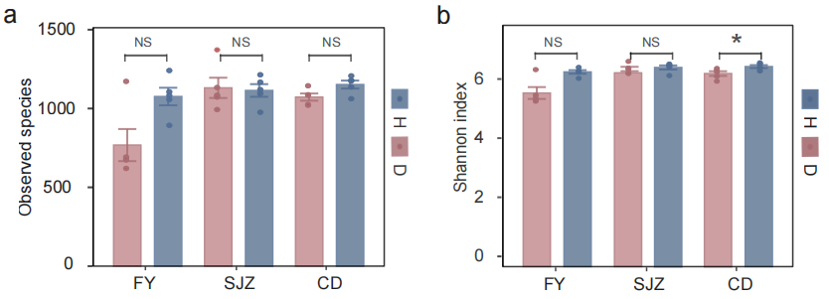
Fig. S3. Box plot of rhizosphere bacterial observed species (a) and shannon(b) index(ns no significant, *P < 0.05, Wilcoxon rank-sum test).
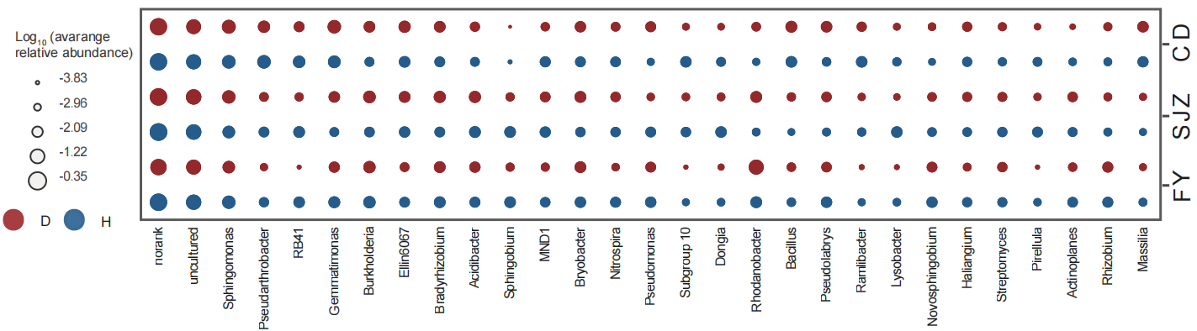
Fig. S4. The bubble chart displaying the log₁₀ fold change in the average relative abundance of core genera (29) from different groups.

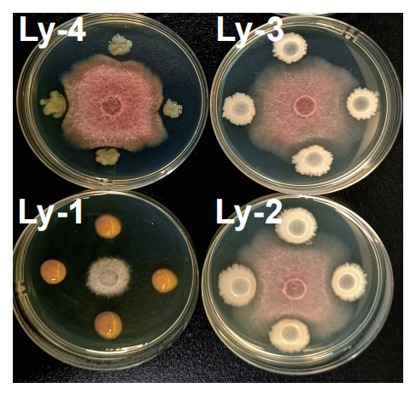
Fig. S5. Antagonistic activity demonstrated by co-culture assay on potato dextrose agar (PDA), showing inhibition zone mediated by Lysobacter Ly-1,Ly-2,Ly-3 and Ly-4.

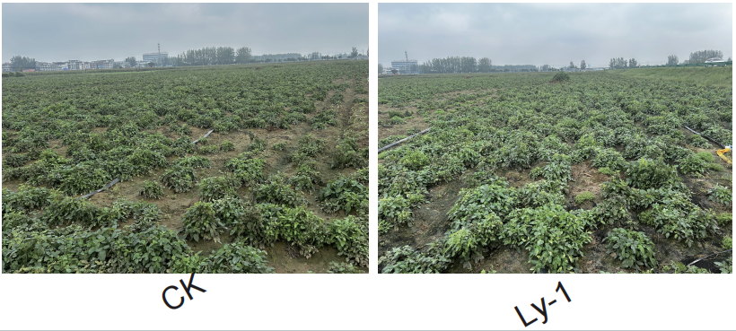
Fig. S6. Field test of the disease suppression and growth improvement activity of the Lysobacter Ly-1.
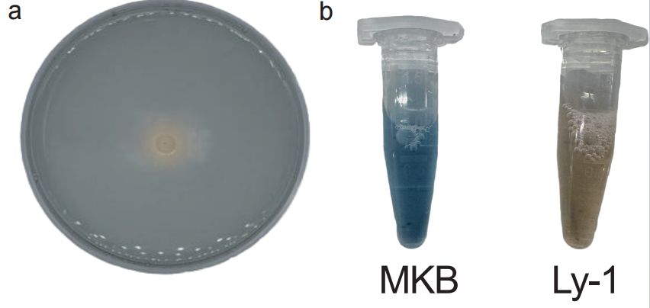
Fig. S7. Siderophore production by L. enzymogenes Ly-1 (a) yellow halos surrounding Ly-1 colonies on CAS agar plate after 4 d of incubation, indicating siderophore production (b) the cell-free supernatant of Ly-1 cultured in iron-limited MKB medium for 48 h was mixed with CAS detection solution, and the color changed from blue to light red, further confirming siderophore production
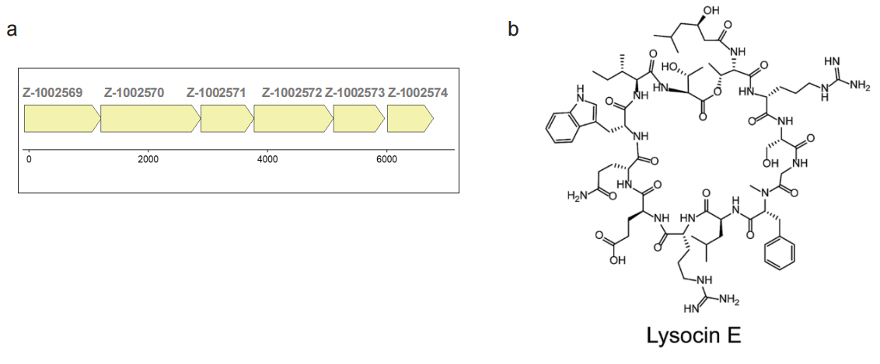
Fig. S8. Predicted biosynthetic gene cluster (a) and chemical planar structure (b) of Lysocin E.

