Supplemental Material
Early Blood Pressure Reduction for Intracerebral Hemorrhage: A Systematic Review And Meta-Analysis of Randomized Controlled Trials
Table of Contents
Supplemental Table 1. Search Strategy
Supplemental Table 2. Characteristics of included studies
Supplemental Table 3. Additional baseline characteristics of included studies
Supplemental Table 4. PRISMA 2020 Main Checklist
Supplemental Table 5. GRADE assessment
Supplemental Figure S1. Forest plot for poor functional outcome at 90 days. Pooled risk ratios (RR) with 95% confidence intervals (CI) using a random-effects model.
Supplemental Figure S2. Forest plot for 90-day mortality. Pooled risk ratios (RR) with 95% confidence intervals (CI) using a random-effects model.
Supplemental Figure S3. Forest plot for 7-day mortality. Pooled risk ratios (RR) with 95% confidence intervals (CI) using a random-effects model.
Supplemental Figure S4. Forest plot for hematoma expansion. Pooled risk ratios (RR) with 95% confidence intervals (CI) using a random-effects model.
Supplemental Figure S5. Forest plot for neurological deterioration. Pooled risk ratios (RR) with 95% confidence intervals (CI) using a random-effects model.
Supplemental Figure S6. Forest plot for serious adverse events. Pooled risk ratios (RR) with 95% confidence intervals (CI) using a random-effects model.
Supplemental Figure S7. Forest plot for shift in mRS score at 90 days stratified by timing. Pooled odds ratios (OR) with 95% confidence intervals (CI) using a random-effects model.
Supplemental Figure S8. Forest plot for poor functional outcome at 90 days stratified by timing. Pooled risk ratios (RR) with 95% confidence intervals (CI) using a random-effects model.
Supplemental Figure S9. Forest plot for good functional outcome at 90 days stratified by timing. Pooled risk ratios (RR) with 95% confidence intervals (CI) using a random-effects model.
Supplemental Figure S10. Forest plot for 90-day mortality stratified by timing. Pooled risk ratios (RR) with 95% confidence intervals (CI) using a random-effects model.
Supplemental Figure S11. Forest plot for hematoma expansion stratified by timing. Pooled risk ratios (RR) with 95% confidence intervals (CI) using a random-effects model.
Supplemental Figure S12. Forest plot for neurological deterioration stratified by timing. Pooled risk ratios (RR) with 95% confidence intervals (CI) using a random-effects model.
Supplemental Figure S13. Forest plot for serious adverse events stratified by timing. Pooled risk ratios (RR) with 95% confidence intervals (CI) using a random-effects model.
Supplemental Figure S14. Forest plot for shift in mRS at 90 days stratified by strategy of intervention. Pooled odds ratios (OR) with 95% confidence intervals (CI) using a random-effects model.
Supplemental Figure S15. Forest plot for poor functional outcome at 90 days stratified by strategy of intervention. Pooled risk ratios (RR) with 95% confidence intervals (CI) using a random-effects model.
Supplemental Figure S16. Forest plot for good functional outcome at 90 days stratified by strategy of intervention. Pooled risk ratios (RR) with 95% confidence intervals (CI) using a random-effects model.
Supplemental Figure S17. Forest plot for 90-day mortality stratified by strategy of intervention. Pooled risk ratios (RR) with 95% confidence intervals (CI) using a random-effects model.
Supplemental Figure S18. Forest plot for hematoma expansion stratified by strategy of intervention. Pooled risk ratios (RR) with 95% confidence intervals (CI) using a random-effects model.
Supplemental Figure S19. Forest plot for neurological deterioration at 90 days stratified by strategy of intervention. Pooled risk ratios (RR) with 95% confidence intervals (CI) using a random-effects model.
Supplemental Figure S20. Forest plot for serious adverse events at 90 days stratified by strategy of intervention. Pooled risk ratios (RR) with 95% confidence intervals (CI) using a random-effects model.
Supplemental Figure S21. Forest plot for shift in mRS at 90 days stratified by setting where BP lowering was initiated. Pooled odds ratios (OR) with 95% confidence intervals (CI) using a random-effects model.
Supplemental Figure S22. Forest plot for poor functional outcome at 90 days stratified by setting where BP lowering was initiated. Pooled risk ratios (RR) with 95% confidence intervals (CI) using a random-effects model.
Supplemental Figure S23. Forest plot for good functional outcome at 90 days stratified by setting where BP lowering was initiated. Pooled risk ratios (RR) with 95% confidence intervals (CI) using a random-effects model.
Supplemental Figure S24. Forest plot for 90-day mortality stratified by setting where BP lowering was initiated. Pooled risk ratios (RR) with 95% confidence intervals (CI) using a random-effects model.
Supplemental Figure S25. Forest plot for hematoma expansion stratified by setting where BP lowering was initiated. Pooled risk ratios (RR) with 95% confidence intervals (CI) using a random-effects model.
Supplemental Figure S26. Forest plot for neurological deterioration at 90 days stratified by setting where BP lowering was initiated. Pooled risk ratios (RR) with 95% confidence intervals (CI) using a random-effects model.
Supplemental Figure S27. Forest plot for serious adverse events at 90 days stratified by setting where BP lowering was initiated. Pooled risk ratios (RR) with 95% confidence intervals (CI) using a random-effects model.
Supplemental Figure S28. Leave-one-out sensitivity analysis for shift in mRS score at 90 days.
Supplemental Figure S29. Leave-one-out sensitivity analysis for poor functional outcome at 90 days.
Supplemental Figure S30. Leave-one-out sensitivity analysis for good functional outcome at 90 days.
Supplemental Figure S31. Leave-one-out sensitivity analysis for 90-day mortality.
Supplemental Figure S32. Leave-one-out sensitivity analysis for hematoma expansion.
Supplemental Figure S33. Leave-one-out sensitivity analysis for neurological deterioration.
Supplemental Figure S34. Leave-one-out sensitivity analysis for serious adverse events.
Supplemental Figure S35. Baujat plot for shift in mRS score at 90 days.
Supplemental Figure S36. Baujat plot for poor functional outcome at 90 days.
Supplemental Figure S37. Baujat plot for good functional outcome at 90 days.
Supplemental Figure S38. Baujat plot for 90-day mortality.
Supplemental Figure S39. Baujat plot for hematoma expansion.
Supplemental Figure S40. Baujat plot for neurological deterioration.
Supplemental Figure S41. Baujat plot for serious adverse events.
Supplemental Figure S42. Funnel plot for shift in mRS score at 90 days.
Supplemental Figure S43. Funnel plot for poor functional outcome at 90 days.
Supplemental Figure S44. Funnel plot for good functional outcome at 90 days.
Supplemental Figure S45. Funnel plot for 90-day mortality.
Supplemental Figure S46. Funnel plot for hematoma expansion.
Supplemental Figure S47. Funnel plot for neurological deterioration.
Supplemental Figure S48. Funnel plot for serious adverse events.

Supplemental Table 1. Search Strategy
Database | Strategy | Results
PUBMED | ("stroke" OR "cerebrovascular accident" OR "ischemic stroke" OR "hemorrhagic stroke" OR "intracerebral hemorrhage" OR "acute stroke")  AND  ("blood pressure reduction" OR "BP reduction" OR "antihypertensive therapy" OR "BP management" OR "BP control" OR "high blood pressure")  AND  ("early" OR "<6 hours" OR "<4 hours" OR "<6 hour" OR "<4 hour" OR "acute" OR "hyperacute" OR "hyper-acute" OR "ultraacute" OR "ultra-acute" OR "pre-hospital" OR prehospital OR ambulance OR paramedic)  AND  (randomized controlled trial[pt] OR controlled clinical trial[pt] OR clinical trials as topic[mesh:noexp] OR trial[ti] OR random*[tiab] OR placebo*[tiab]) | 464
Embase | (stroke OR 'cerebrovascular accident' OR 'ischemic stroke' OR 'hemorrhagic stroke' OR 'intracerebral hemorrhage' OR 'acute stroke')  AND  ('blood pressure reduction' OR 'bp reduction' OR 'antihypertensive therapy' OR 'bp management' OR 'bp control' OR 'high blood pressure’)  AND  (early OR acute OR hyperacute OR 'hyper acute' OR 'ultra acute' OR 'pre hospital' OR prehospital OR ambulance OR paramedic)  AND  ('controlled clinical trial'/exp OR random*:ti,ab OR placebo*:ti,ab OR trial:ti) AND  [embase]/lim | 1296
Cochrane Central | ("stroke" OR "cerebrovascular accident" OR "ischemic stroke" OR "hemorrhagic stroke" OR "intracerebral hemorrhage" OR "acute stroke")  AND  ("blood pressure reduction" OR "BP reduction" OR "antihypertensive therapy" OR "BP management" OR "BP control" OR "high blood pressure")  AND  ("early" OR "<6 hours" OR "<4 hours" OR "<6 hour" OR "<4 hour" OR "acute" OR "hyperacute" OR "hyper-acute" OR "ultraacute" OR "ultra-acute" OR "pre-hospital" OR prehospital OR ambulance OR paramedic) | 31
Google Scholar | allintitle: stroke prehospital OR ambulance OR early OR "blood pressure" AND (prehospital|ambulance|early) AND (blood pressure lowering|blood pressure control) | 183
Clinicaltrials.gov |  | 16

Supplemental Table 2. Characteristics of included studies
Database | Population | Intervention | Control
INTERACT-4 2024 | Adults (≥18 years) with spontaneous ICH confirmed by neuroimaging, identified within 2 hours of symptom onset in the prehospital setting, with SBP ≥150 mm Hg and a FAST score ≥2 including arm motor deficit. | Prehospital IV urapidil (25 mg bolus over 1 min, repeatable after 5 mins) initiated immediately post-randomization to target SBP 130–140 mm Hg within 30 mins, with cessation at 130 mm Hg. | Usual care with prehospital antihypertensive therapy reserved for SBP ≥220 mm Hg or DBP ≥110 mm Hg
MR-ASAP 2022 | Adults with spontaneous ICH confirmed by hospital neuroimaging, identified in the prehospital setting within 3 hours of symptom onset, with SBP ≥140 mm Hg and a FAST score of 2 or 3. | Prehospital initiation of open-label transdermal GTN patch (5 mg/day) immediately post-randomization, continued for 24 hrs during hospital admission (range 22–26 hrs) | Standard care alone, including admission to acute stroke unit upon stroke diagnosis, without GTN administration.
RIGHT-2 2019 | Adults with acute spontaneous ICH confirmed by neuroimaging within 4 hours of onset. | Paramedic assigned transdermal GTN 5 mg patch (Transiderm-Nitro 5), administered immediately post-randomization in the ambulance, continued daily for up to 3 days in-hospital, with application to shoulder or back and daily site rotation. | Similar-appearing sham dressing (DuoDERM hydrocolloid)
INTERACT-3 2023 | Adults with acute spontaneous ICH confirmed by imaging, presenting within 6 hours of symptom onset, with SBP ≥140 mm Hg. | Early intensive BP reduction¹ targeting SBP <140 mm Hg within 1 hour for up to 7 days or until discharge; cessation if SBP <130 mm Hg, combined with a care bundle including tight glucose control, pyrexia treatment, and warfarin reversal. | Usual care with standard BP management targeting SBP per local protocols, alongside routine clinical care without the intensive care bundle.
INTERACT-2 2013 | Adults with CT- or MRI-confirmed spontaneous intracerebral hemorrhage (ICH), presenting within 6 hours of symptom onset, with elevated systolic blood pressure (150–220 mm Hg), and no definite indication for or contraindication to antihypertensive treatment. Patients in deep coma (GCS 3–5), with massive hematoma or structural cerebral causes, or requiring early surgical evacuation were excluded. | Intensive BP lowering targeting SBP <140 mm Hg within 1 hour, maintained for 7 days or until discharge. Therapy initiated with IV and oral agents per local protocols, commonly ACE inhibitor plus diuretic unless contraindicated. | Guideline-based BP management with treatment initiated only if SBP >180 mm Hg; no lower target specified. Oral antihypertensives started within 7 days or at discharge for secondary prevention, typically ACE inhibitor plus diuretic unless contraindicated.
ATACH-2 2016 | Adults with supratentorial ICH (hematoma volume <60 cm³, GCS ≥5) presenting within 4.5 hours of symptom onset. | Stepped IV Nicardipine infusion initiated at 5 mg/hr, titrated by 2.5 mg/hr every 15 min to a maximum of 15 mg/hr targeting SBP 110–139 mm Hg within 24 hours post-randomization. If target unmet after 30 min at maximum dose, IV labetalol (or diltiazem/urapidil where unavailable) administered. | Guideline-based BP management targeting SBP 140–179 mm Hg within 24 hrs. Pre-randomization IV antihypertensives allowed to reduce SBP <180 mm Hg; exclusion if <140 mm Hg. Post-randomization, nicardipine titrated per protocol to maintain SBP 140–179 mm Hg.
INTERACT-1 2008 | Adults with CT-confirmed spontaneous ICH and elevated SBP ≥150 mm Hg within 6 hours of symptom onset. | Stepped IV antihypertensive therapy# targeting SBP 140 mm Hg within 1 hour, maintained for 7 days or until discharge; cessation if SBP <130 mm Hg. Oral ACE inhibitor plus diuretic recommended post-discharge for BP control. | Antihypertensive treatment targeting SBP of 180 mm Hg
ENOS-ICH 2013 | Adults presenting with spontaneous ICH, verified via neuroimaging, within a 6-hour window from the beginning of symptoms. | Initiation of transdermal GTN patch (5 mg daily) immediately following randomization, maintained over a 7-day period. | Routine clinical management and guideline-based BP control without the administration of glyceryl trinitrate.

Supplemental Table 3. Additional Baseline Characteristics
Study | Country | DM, % |  | HTN, % |  | HR, bpm |  | SBP, mmHg |  | mRs >2, %
 |  | I | C | I | C | I | C | I | C | I | C
INTERACT-4 2024 * | China | 18.4 | 16.3 | 72 | 69.8 | 83.8 (15.6) | 82.8 (15.4) | 178 (20) | 178 (22) | 1.9 | 0.7
MR-ASAP 2022 * | Netherlands | 18 | 23 | 52 | 63 | 85 (16) | 84 (18) | 175 [157-191] | 180 [161-195] * | 12 | 8
RIGHT-2 2019 | United Kingdom | 16 | 14 | 55 | 59 | 82 | 81 | 176 (26) | 176 (28) | 16 | 7
INTERACT-3 2023 | Multinational | 10.5 | 10.3 | 68.5 | 70.3 | NA | NA | 174.6 (28.2) | 174.5 (28.4) | 8.3 | 7.1
ATACH-2 2016 | Multinational | 18.4 | 16.6 | 82.2 | 76.4 | NA | NA | 200 (27.1) | 201.1 (26.9) | NA | NA
INTERACT-2 2013 | Multinational | 11.1 | 10.5 | 72.4 | 72.5 | NA | NA | 179 (17) | 179 (17) | NA | NA
INTERACT-1 2008 | Multinational | 10 | 6 | 74 | 74 | 79 (14) | 79 (15) | 180 (18) | 182 (19) | NA | NA
ENOS-ICH 2013 | Multinational | 11.1 | 10.3 | 77.8 | 69 | 75.4 (15.1) | 75.6 (12.4) | 172.1 (13.7) | 171.9 (17.3) | 0 | 0

Supplemental Table 4. PRISMA 2020 Main Checklist
TITLE
Title | 1 | Identify the report as a systematic review. | Page 1
ABSTRACT
Abstract | 2 | See the PRISMA 2020 for Abstracts checklist | Page 4-5
INTRODUCTION
Rationale | 3 | Describe the rationale for the review in the context of existing knowledge. | Page 6
Objectives | 4 | Provide an explicit statement of the objective(s) or question(s) the review addresses. | Page 6
METHODS
Eligibility criteria | 5 | Specify the inclusion and exclusion criteria for the review and how studies were grouped for the syntheses. | Page 8
Information sources | 6 | Specify all databases, registers, websites, organisations, reference lists and other sources searched or consulted to identify studies. Specify the date when each source was last searched or consulted. | Page 8
Search strategy | 7 | Present the full search strategies for all databases, registers and websites, including any filters and limits used. | SM
Selection process | 8 | Specify the methods used to decide whether a study met the inclusion criteria of the review, including how many reviewers screened each record and each report retrieved, whether they worked independently, and if applicable, details of automation tools used in the process. | Page 8
Data collection process | 9 | Specify the methods used to collect data from reports, including how many reviewers collected data from each report, whether they worked independently, any processes for obtaining or confirming data from study investigators, and if applicable, details of automation tools used in the process. | Page 8-9
Data items | 10a | List and define all outcomes for which data were sought. Specify whether all results that were compatible with each outcome domain in each study were sought (e.g. for all measures, time points, analyses), and if not, the methods used to decide which results to collect. | Page 9
 | 10b | List and define all other variables for which data were sought (e.g. participant and intervention characteristics, funding sources). Describe any assumptions made about any missing or unclear information. | Page 9
Study risk of bias assessment | 11 | Specify the methods used to assess risk of bias in the included studies, including details of the tool(s) used, how many reviewers assessed each study and whether they worked independently, and if applicable, details of automation tools used in the process. | Page 9
Effect measures | 12 | Specify for each outcome the effect measure(s) (e.g. risk ratio, mean difference) used in the synthesis or presentation of results. | Page 9
Synthesis methods | 13a | Describe the processes used to decide which studies were eligible for each synthesis (e.g. tabulating the study intervention characteristics and comparing against the planned groups for each synthesis (item 5)). | Page 9
 | 13b | Describe any methods required to prepare the data for presentation or synthesis, such as handling of missing summary statistics, or data conversions. | Page 9
 | 13c | Describe any methods used to tabulate or visually display results of individual studies and syntheses. | Page 9
 | 13d | Describe any methods used to synthesize results and provide a rationale for the choice(s). If meta-analysis was performed, describe the model(s), method(s) to identify the presence and extent of statistical heterogeneity, and software package(s) used. | Page 9
 | 13e | Describe any methods used to explore possible causes of heterogeneity among study results (e.g. subgroup analysis, meta-regression). | Page 10
 | 13f | Describe any sensitivity analyses conducted to assess robustness of the synthesized results. | Page 10
Reporting bias assessment | 14 | Describe any methods used to assess risk of bias due to missing results in a synthesis (arising from reporting biases). | NA
Certainty assessment | 15 | Describe any methods used to assess certainty (or confidence) in the body of evidence for an outcome. | Page 9
RESULTS
Study selection | 16a | Describe the results of the search and selection process, from the number of records identified in the search to the number of studies included in the review, ideally using a flow diagram. | Figure 1 and Page 10
 | 16b | Cite studies that might appear to meet the inclusion criteria, but which were excluded, and explain why they were excluded. | Figure 1
Study characteristics | 17 | Cite each included study and present its characteristics. | Table 1 and Supplemental Table 2
Risk of bias in studies | 18 | Present assessments of risk of bias for each included study. | Figure 4
Results of individual studies | 19 | For all outcomes, present, for each study: (a) summary statistics for each group (where appropriate) and (b) an effect estimate and its precision (e.g. confidence/credible interval), ideally using structured tables or plots. | Figure 2-3 and Supplementary Figures S1-S6
Results of syntheses | 20a | For each synthesis, briefly summarise the characteristics and risk of bias among contributing studies. | Page 10-13
 | 20b | Present results of all statistical syntheses conducted. If meta-analysis was done, present for each the summary estimate and its precision (e.g. confidence/credible interval) and measures of statistical heterogeneity. If comparing groups, describe the direction of the effect. | Figure 2-3 and Supplementary Figures S1-S48
 | 20c | Present results of all investigations of possible causes of heterogeneity among study results. | Page 12 and Supplementary Figures S7-S27, S35-S41
 | 20d | Present results of all sensitivity analyses conducted to assess the robustness of the synthesized results. | Page 13 and Supplementary Figures S28-S34
Reporting biases | 21 | Present assessments of risk of bias due to missing results (arising from reporting biases) for each synthesis assessed. | Page 13
Certainty of evidence | 22 | Present assessments of certainty (or confidence) in the body of evidence for each outcome assessed. | Page 13
DISCUSSION
Discussion | 23a | Provide a general interpretation of the results in the context of other evidence. | Page 13
 | 23b | Discuss any limitations of the evidence included in the review. | Page 18
 | 23c | Discuss any limitations of the review processes used. | Page 18
 | 23d | Discuss implications of the results for practice, policy, and future research. | Page 17-18
OTHER INFORMATION
Registration and protocol | 24a | Provide registration information for the review, including register name and registration number, or state that the review was not registered. | PROSPERO CRD42024563521 (Page 3)
 | 24b | Indicate where the review protocol can be accessed, or state that a protocol was not prepared. | PROSPERO CRD42024563521
 | 24c | Describe and explain any amendments to information provided at registration or in the protocol. | NA
Support | 25 | Describe sources of financial or non-financial support for the review, and the role of the funders or sponsors in the review. | Page 4
Competing interests | 26 | Declare any competing interests of review authors. | Page 4
Availability of data, code and other materials | 27 | Report which of the following are publicly available and where they can be found: template data collection forms; data extracted from included studies; data used for all analyses; analytic code; any other materials used in the review. | Page 4

Supplemental Table 5. GRADE Assessment
Certainty assessment |  |  |  |  |  |  | Summary of findings
Participants  (studies)  Follow-up | Risk of bias | Inconsistency | Indirectness | Imprecision | Publication bias | Overall certainty of evidence | Study event rates (%) |  | Relative effect  (95% CI) | Anticipated absolute effects
 |  |  |  |  |  |  | With Placebo | With EBPL | Relative effect  (95% CI) | Risk with Placebo | Risk difference with EBPL
90-day mRS shift
12168  (7 RCTs) | seriousª | serious^{b} | not serious | serious^{c} | none | ⨁◯◯◯  Very low^{a,b,c} | -/6388 | -/5780 | OR 0.90  (0.66 to 1.24) | -/6388 | 0 fewer per 1,000  (from 0 fewer to 0 fewer)
Poor functional outcome (mRS >2)
11639  (7 RCTs) | seriousª | serious^{b} | not serious | not serious | none | ⨁⨁◯◯  Low^{a,b} | 3560/6066 (58.7%) | 3072/5573 (55.1%) | RR 0.95  (0.90 to 1.00) | 3560/6066 (58.7%) | 29 fewer per 1,000  (from 59 fewer to 0 fewer)
Good functional outcome (mRS 0-2)
11944  (8 RCTs) | seriousª | serious^{b} | not serious | not serious | none | ⨁⨁◯◯  Low^{a,b} | 2571/6210 (41.4%) | 2579/5734 (45.0%) | RR 1.08  (1.03 to 1.14) | 2571/6210 (41.4%) | 33 more per 1,000  (from 12 more to 58 more)
90-day mortality
11902  (8 RCTs) | seriousª | serious^{b} | not serious | serious^{c} | none | ⨁◯◯◯  Very low^{a,b,c} | 1002/6173 (16.2%) | 805/5729 (14.1%) | RR 0.89  (0.77 to 1.03) | 1002/6173 (16.2%) | 18 fewer per 1,000  (from 37 fewer to 5 more)
Hematoma expansion
2992  (5 RCTs) | seriousª | serious^{b} | not serious | serious^{c} | none | ⨁◯◯◯  Very low^{a,b,c} | 345/1460 (23.6%) | 302/1532 (19.7%) | RR 0.81  (0.66 to 1.01) | 345/1460 (23.6%) | 45 fewer per 1,000  (from 80 fewer to 2 more)
Neurological deterioration
4916  (5 RCTs) | seriousª | not serious | not serious | serious^{c} | none | ⨁⨁◯◯  Low^{a,c} | 308/2463 (12.5%) | 320/2453 (13.0%) | RR 1.05  (0.87 to 1.27) | 308/2463 (12.5%) | 6 more per 1,000  (from 16 fewer to 34 more)
Serious adverse events
12635  (6 RCTs) | seriousª | serious^{b} | not serious | serious^{c} | none | ⨁◯◯◯  Very low^{a,b,c} | 1451/6589 (22.0%) | 1221/6046 (20.2%) | RR 0.98  (0.83 to 1.16) | 1451/6589 (22.0%) | 4 fewer per 1,000  (from 37 fewer to 35 more)

*The risk in the intervention group (and its 95% confidence interval) is based on the assumed risk in the comparison group and the relative effect of the intervention (and its 95% CI).
CI: confidence interval; MD: mean difference; OR: odds ratio
GRADE Working Group grades of evidence
High certainty: we are very confident that the true effect lies close to that of the estimate of the effect.
Moderate certainty: we are moderately confident in the effect estimate: the true effect is likely to be close to the estimate of the effect, but there is a possibility that it is substantially different.
Low certainty: our confidence in the effect estimate is limited: the true effect may be substantially different from the estimate of the effect.
Very low certainty: we have very little confidence in the effect estimate: the true effect is likely to be substantially different from the estimate of effect.

Explanations
a. all trials were at high risk of bias for deviations from the intended intervention, due to lack of blinding of clinicians to interventions
b. heterogeneity I2 values are high, mixing of intervention strategy
c. confidence interval, specifically prediction interval crosses 1

Figure S1. Forest plot for poor functional outcome at 90 days. Pooled risk ratios (RR) with 95% confidence intervals (CI) using a random-effects model.
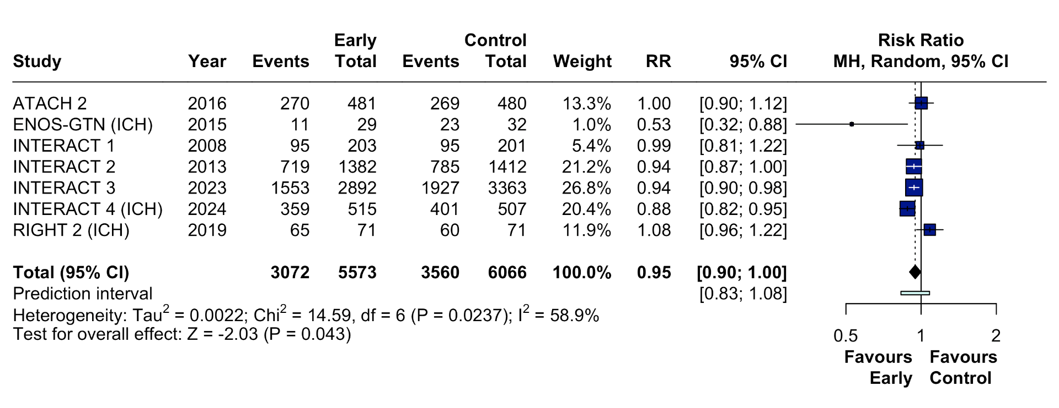

Figure S2. Forest plot for good functional outcome at 90 days. Pooled risk ratios (RR) with 95% confidence intervals (CI) using a random-effects model.
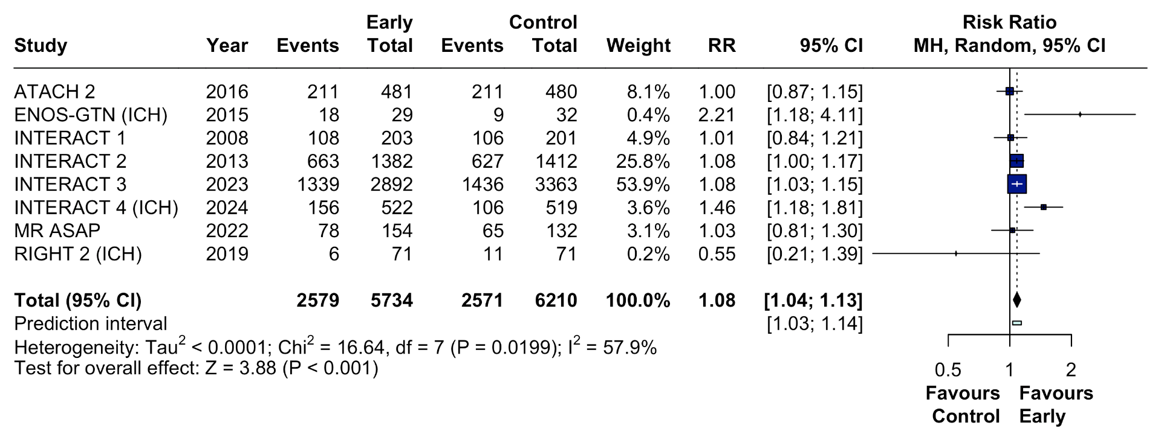

Figure S3. Forest plot for 90-day mortality. Pooled risk ratios (RR) with 95% confidence intervals (CI) using a random-effects model.
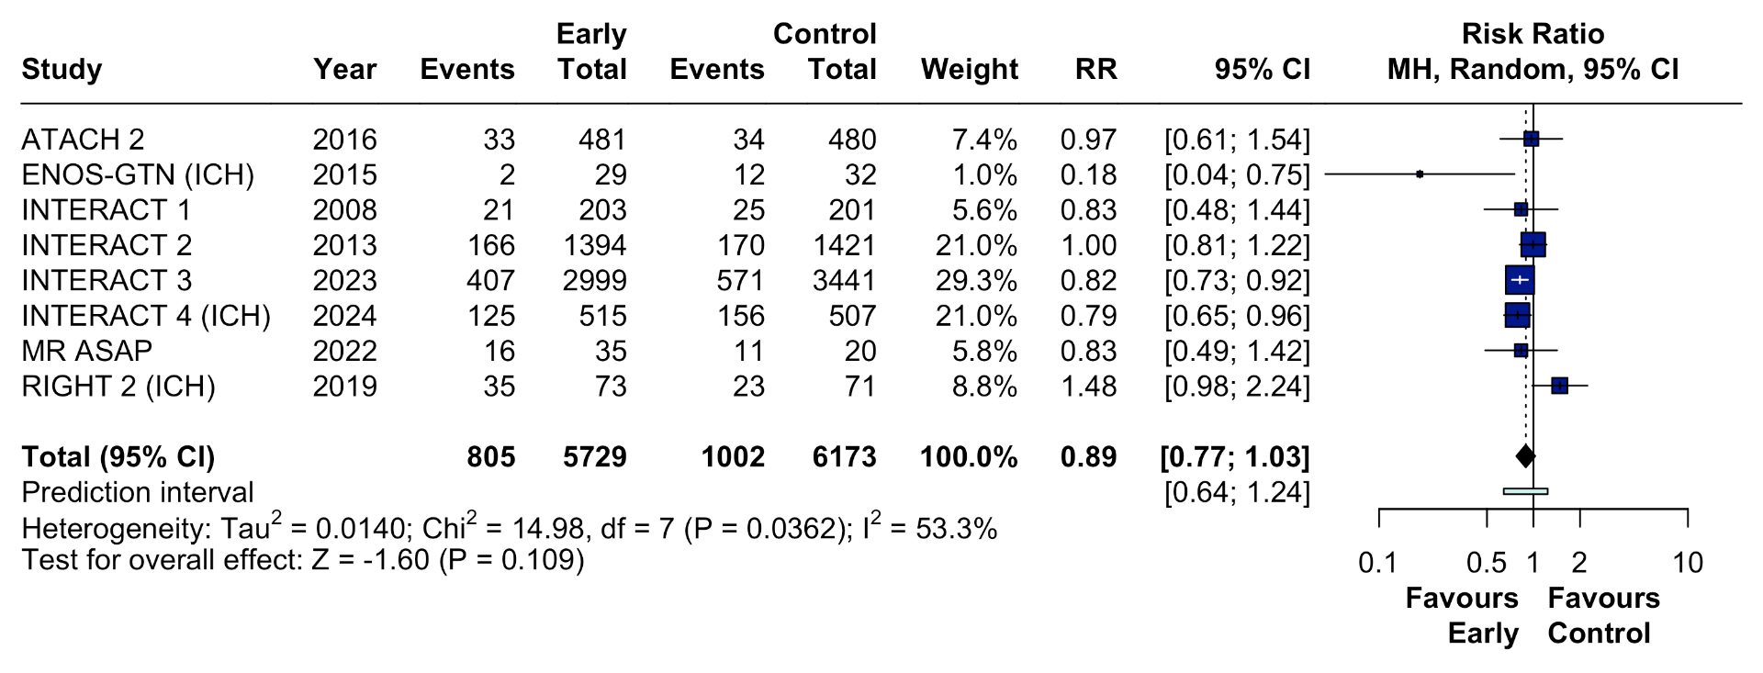

Figure S4. Forest plot for 7-day mortality. Pooled risk ratios (RR) with 95% confidence intervals (CI) using a random-effects model.
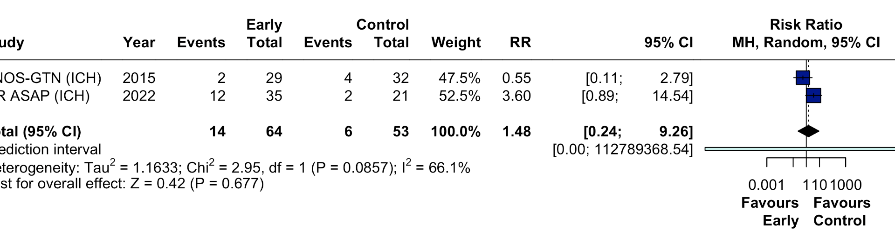

Figure S5. Forest plot for neurological deterioration. Pooled risk ratios (RR) with 95% confidence intervals (CI) using a random-effects model.
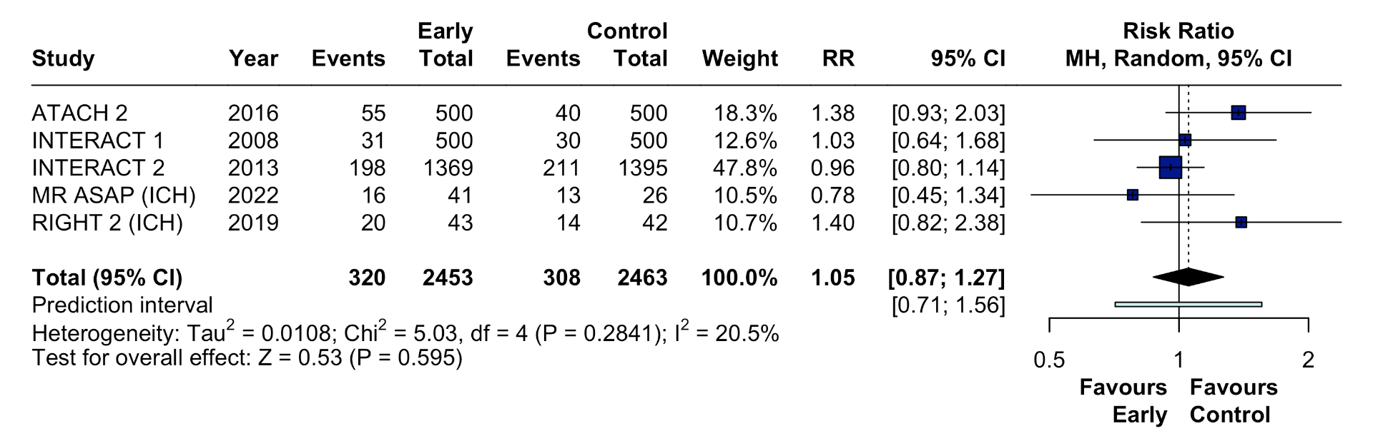
Figure S6. Forest plot for serious adverse events. Pooled risk ratios (RR) with 95% confidence intervals (CI) using a random-effects model.
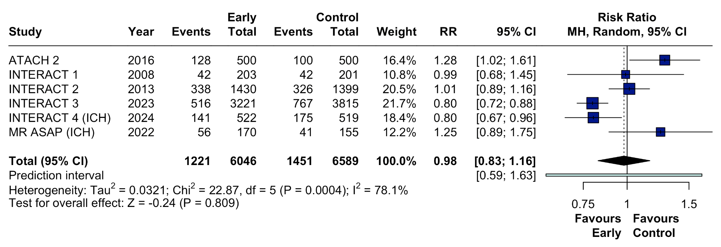

Figure S7. Forest plot for shift in mRS score at 90 days stratified by timing. Stratified analysis showing pooled odds ratios (OR) with 95% confidence intervals (CI) using a random-effects model.
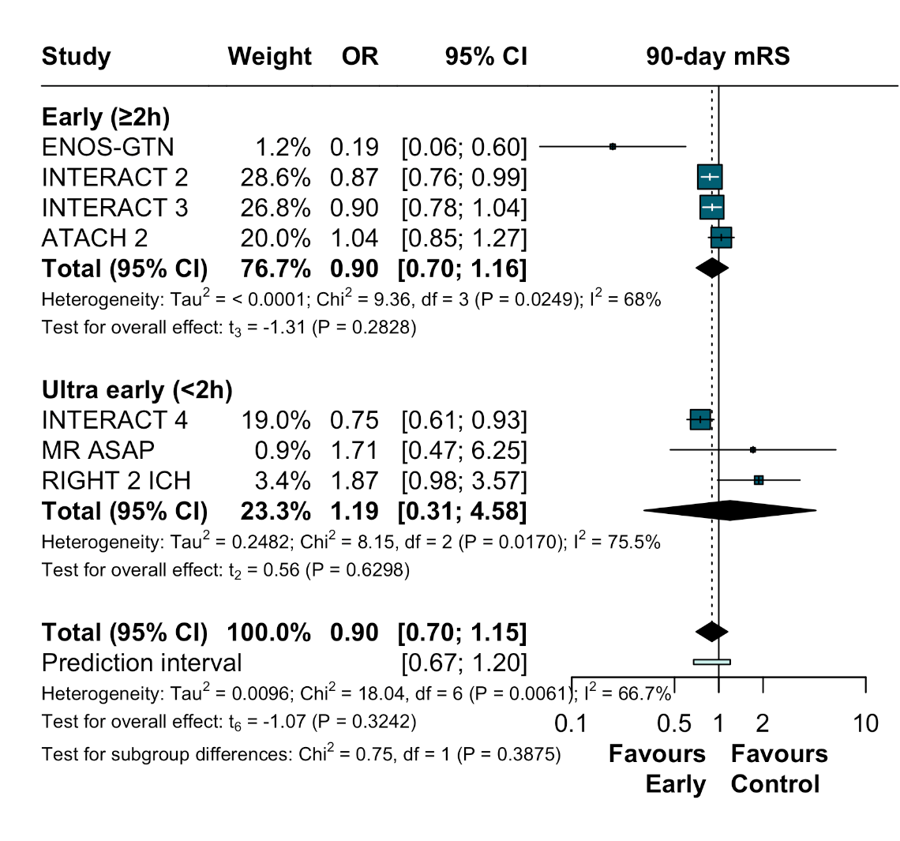

Figure S8. Forest plot for poor functional outcome at 90 days stratified by timing. Stratified analysis showing pooled risk ratios (RR) with 95% confidence intervals (CI) using a random-effects model.
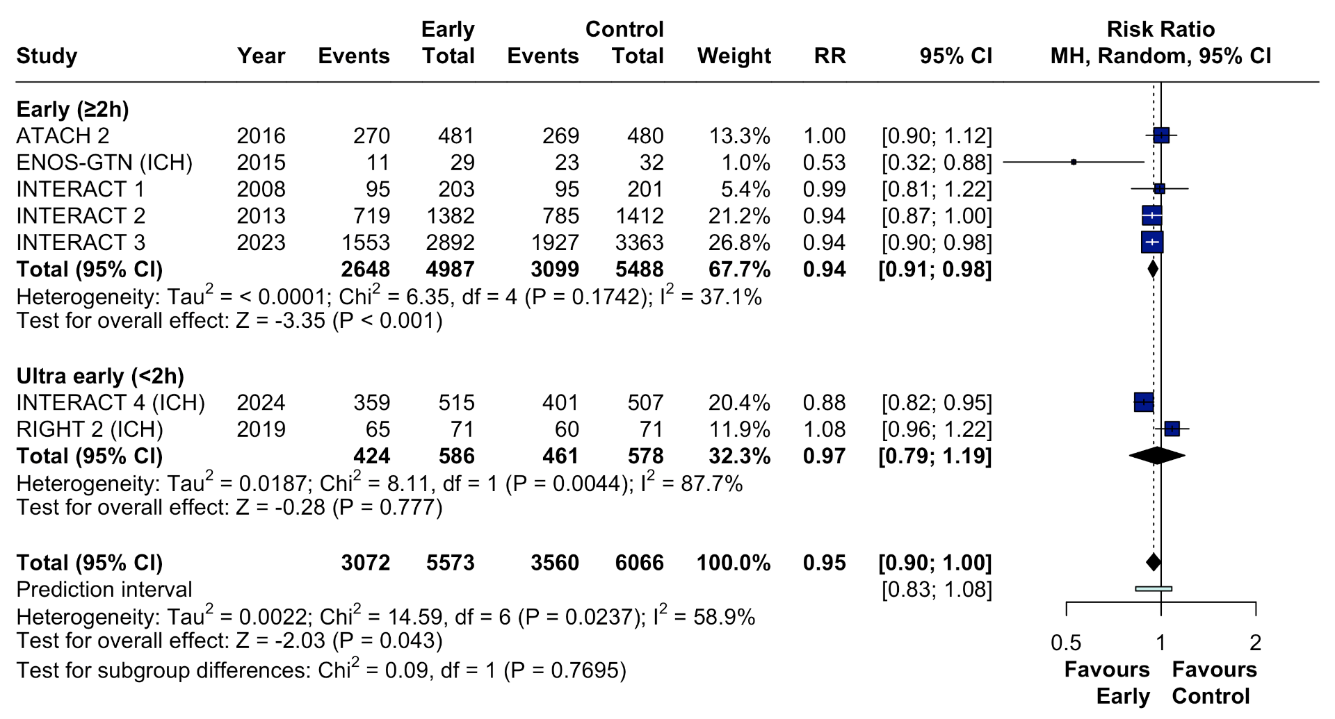
Figure S9. Forest plot for good functional outcome at 90 days stratified by timing. Stratified analysis showing pooled risk ratios (RR) with 95% confidence intervals (CI) using a random-effects model.
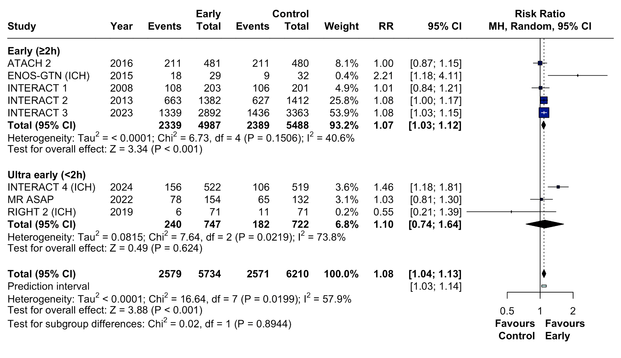
Figure S10. Forest plot for 90-day mortality stratified by timing. Stratified analysis showing pooled risk ratios (RR) with 95% confidence intervals (CI) using a random-effects model.
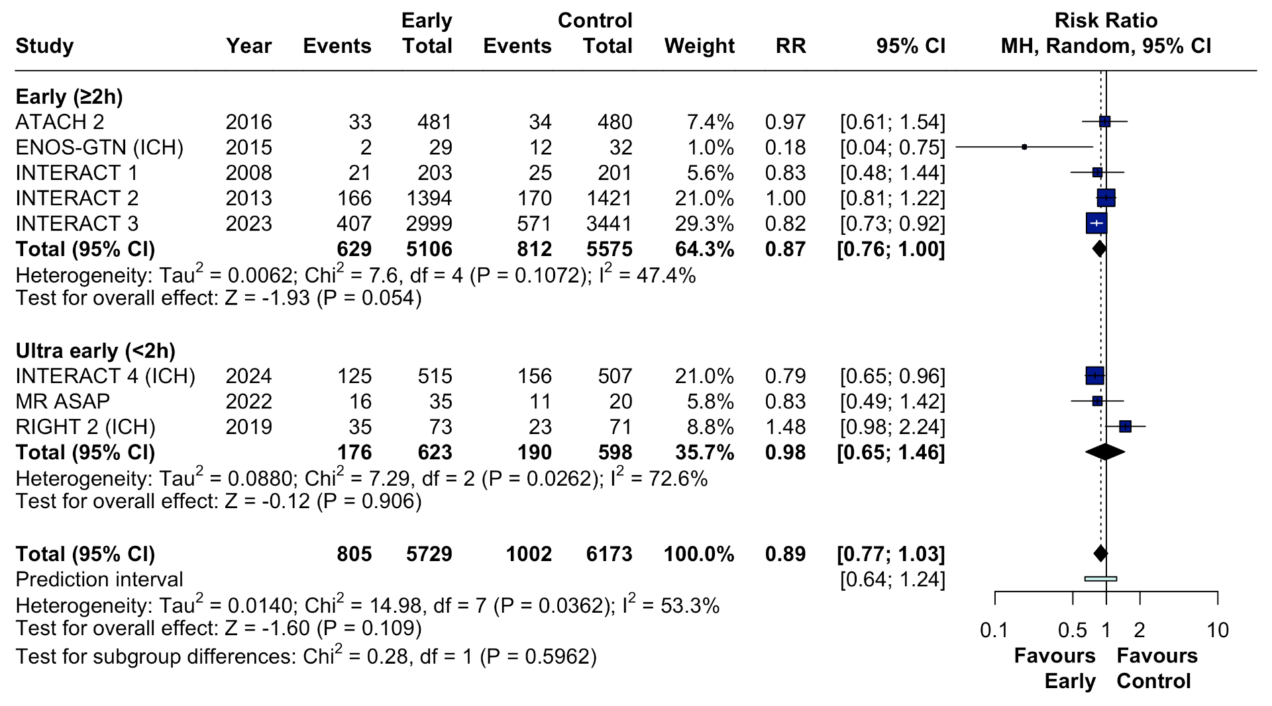

Figure S11. Forest plot for hematoma expansion stratified by timing. Stratified analysis showing pooled risk ratios (RR) with 95% confidence intervals (CI) using a random-effects model.
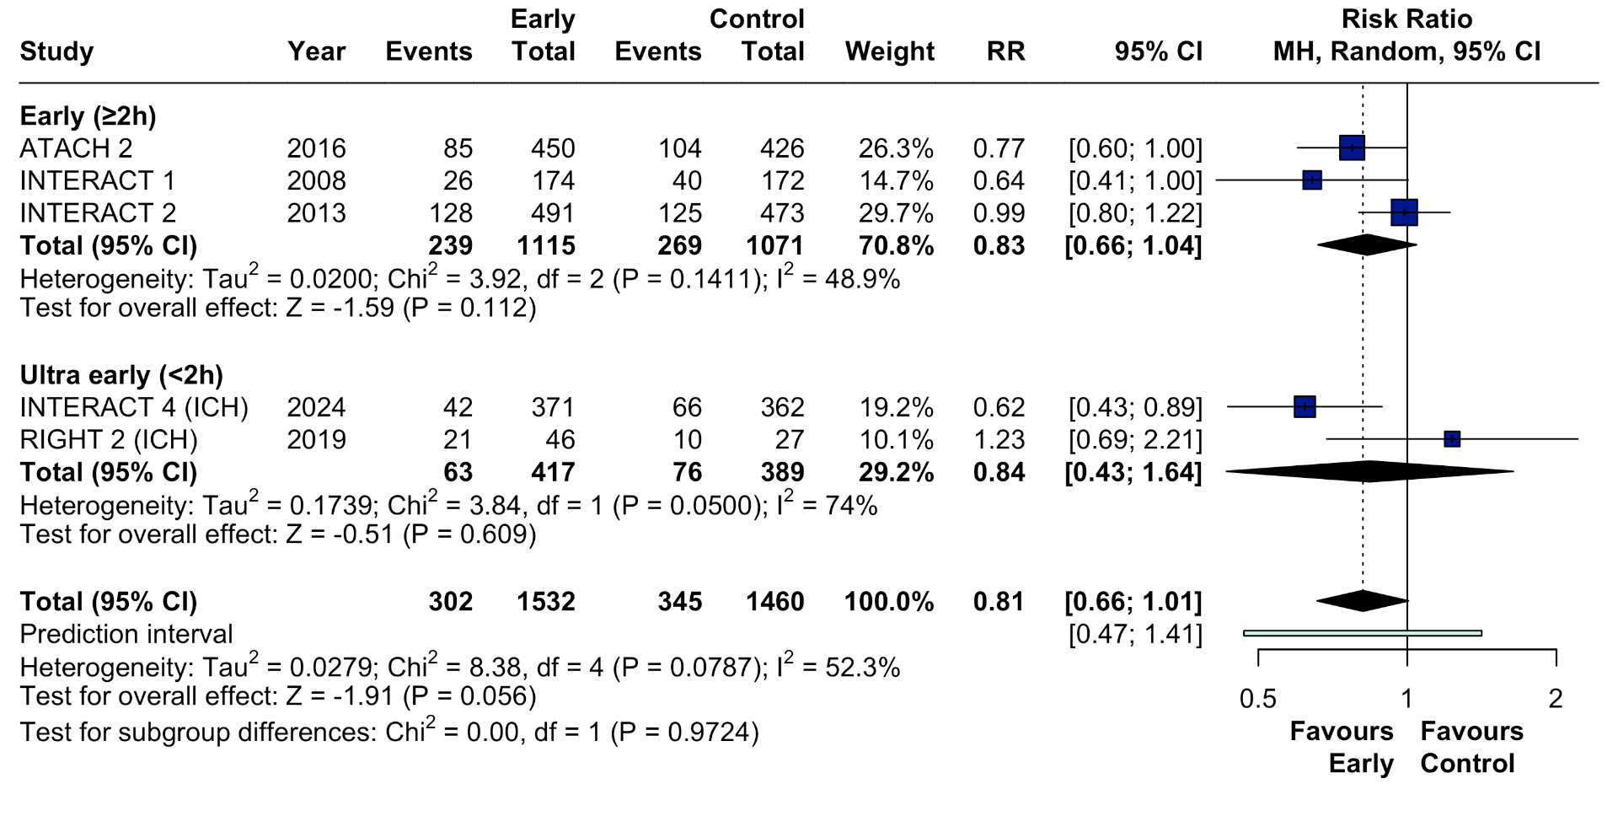

Figure S12. Forest plot for neurological deterioration stratified by timing. Stratified analysis showing pooled risk ratios (RR) with 95% confidence intervals (CI) using a random-effects model. 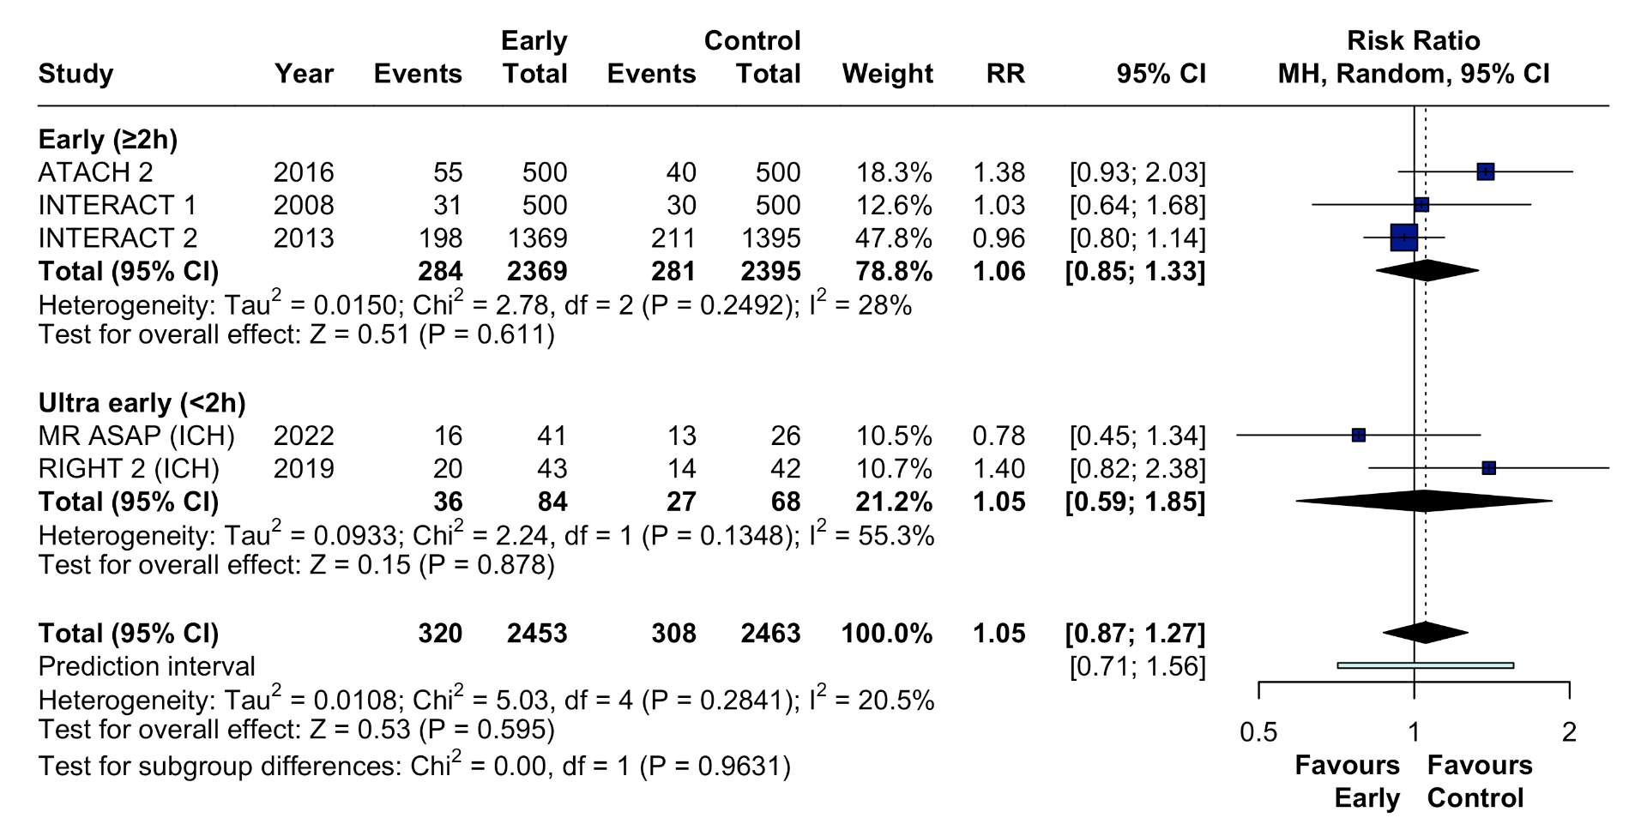

Figure S13. Forest plot for serious adverse events stratified by timing. Stratified analysis showing pooled risk ratios (RR) with 95% confidence intervals (CI) using a random-effects model.
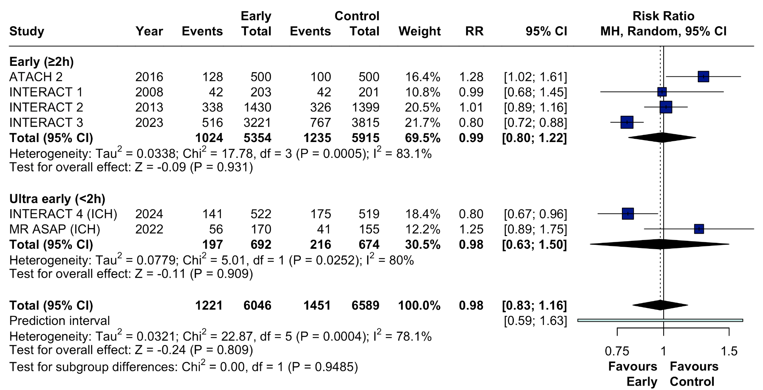
Figure S14. Forest plot for shift in mRS at 90 days stratified by strategy of intervention. Stratified analysis showing pooled odds ratios (OR) with 95% confidence intervals (CI) using a random-effects model.
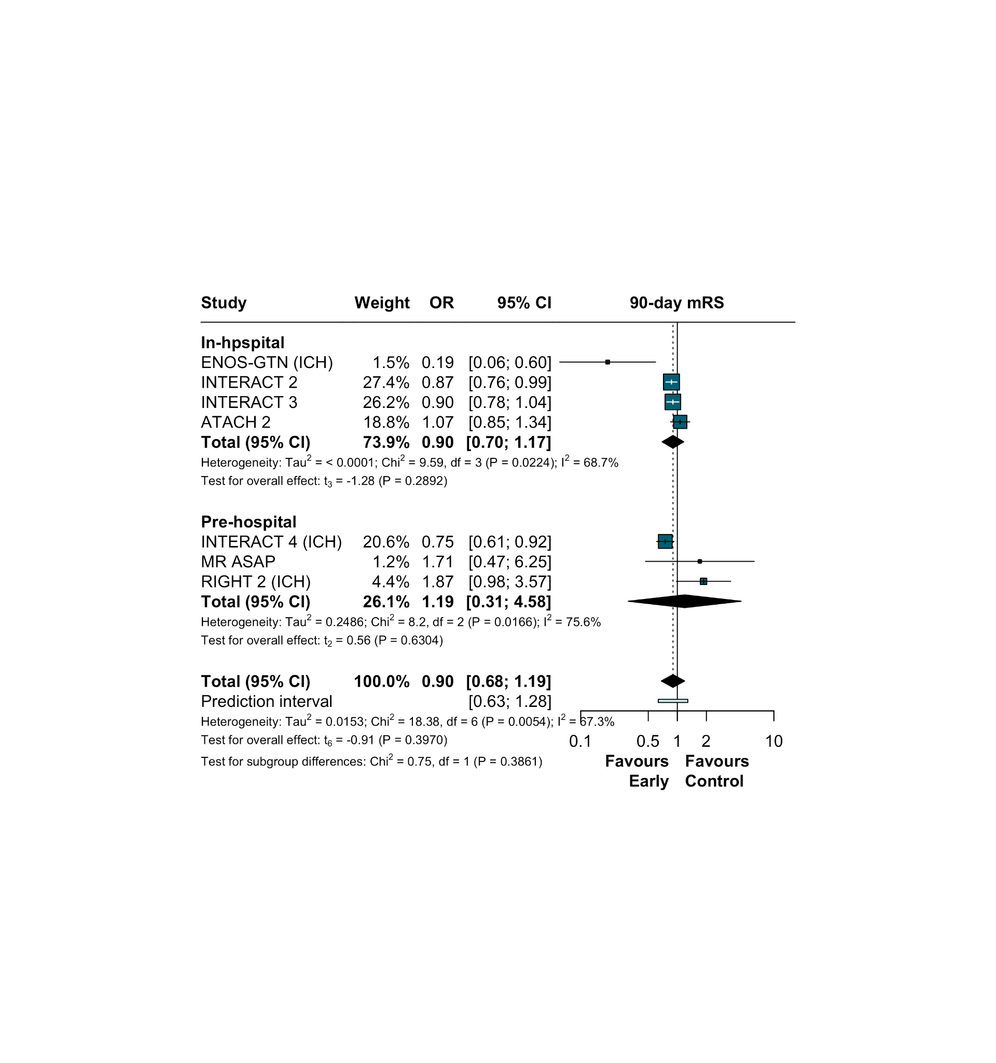
Figure S15. Forest plot for poor functional outcome at 90 days stratified by strategy of intervention. Pooled risk ratios (RR) with 95% confidence intervals (CI) using a random-effects model.

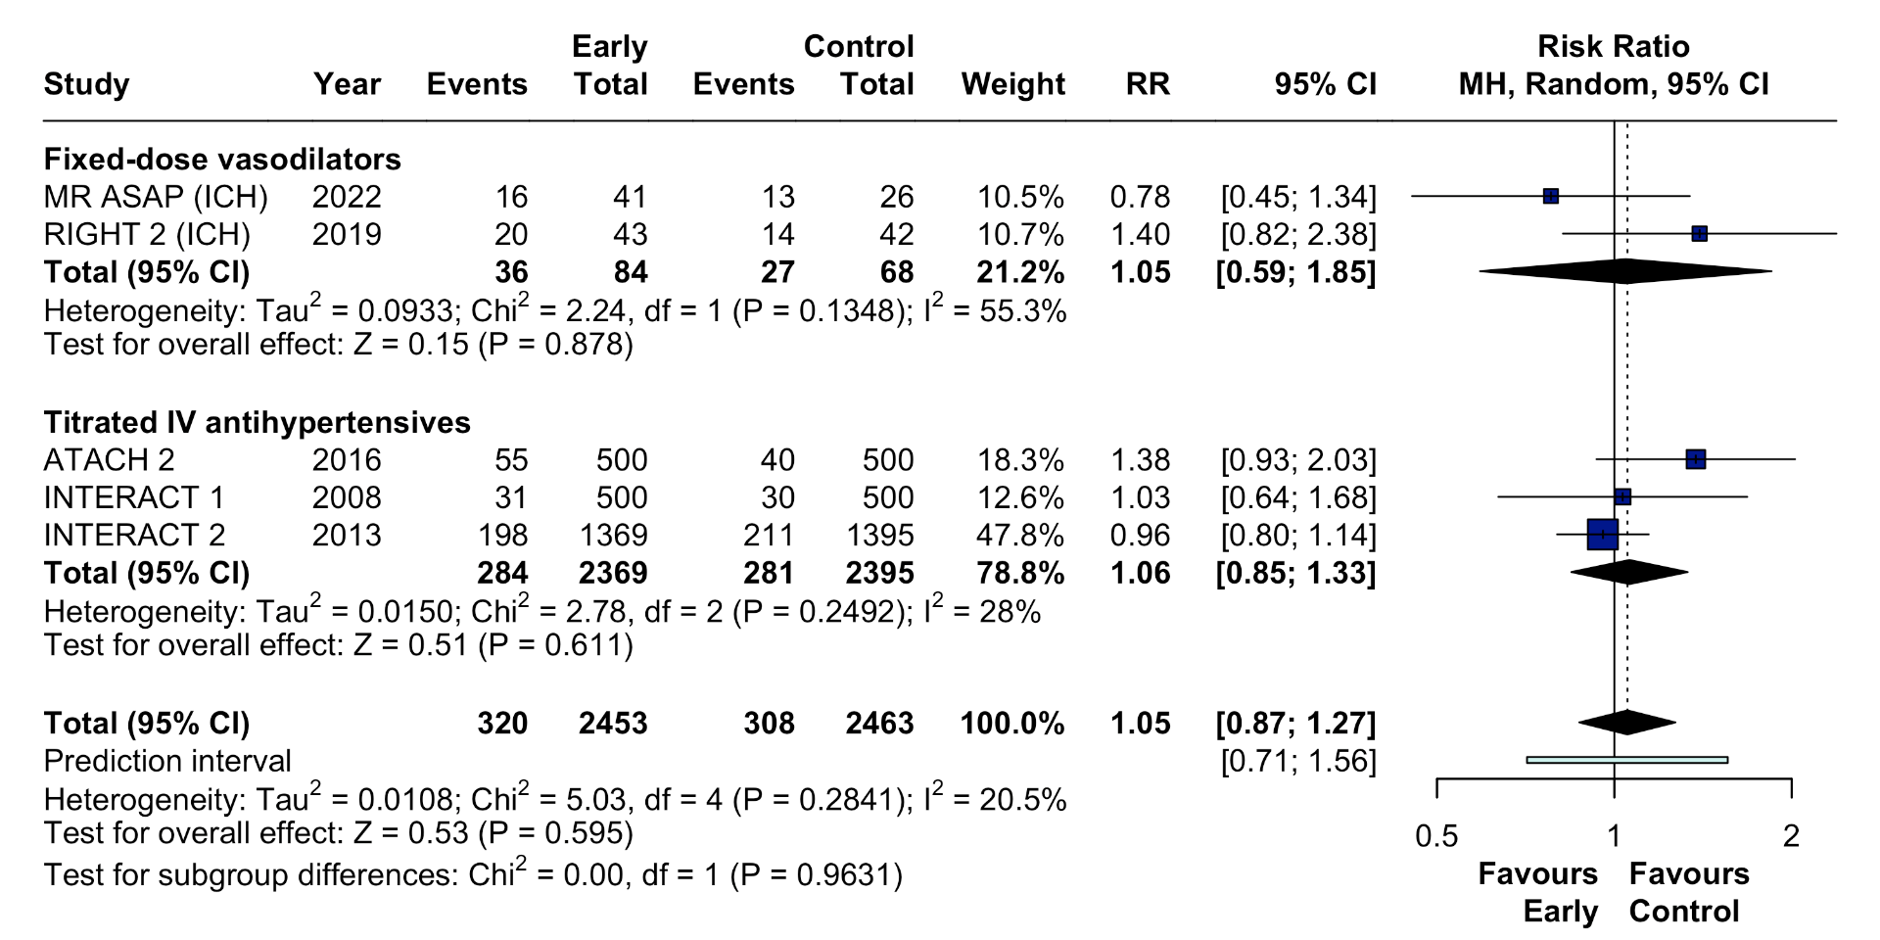

Figure S16. Forest plot for good functional outcome at 90 days stratified by strategy of intervention. Pooled risk ratios (RR) with 95% confidence intervals (CI) using a random-effects model.

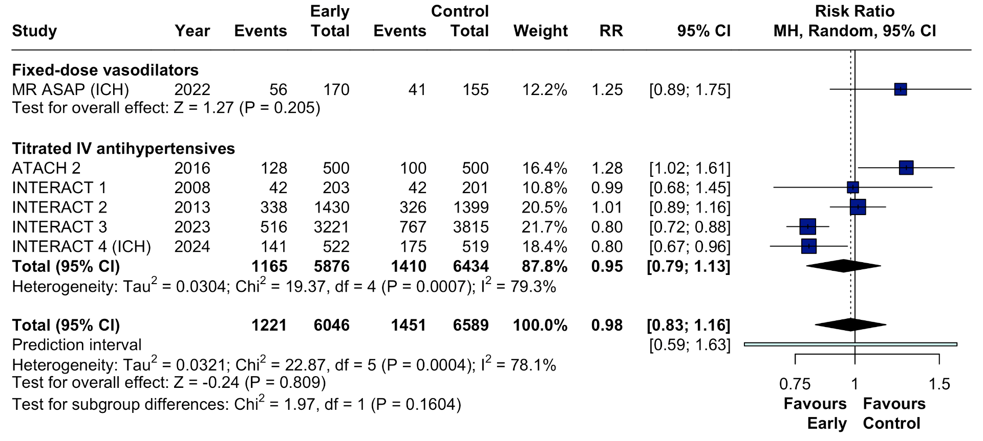

Supplemental Figure S17. Forest plot for 90-day mortality stratified by strategy of intervention. Pooled risk ratios (RR) with 95% confidence intervals (CI) using a random-effects model.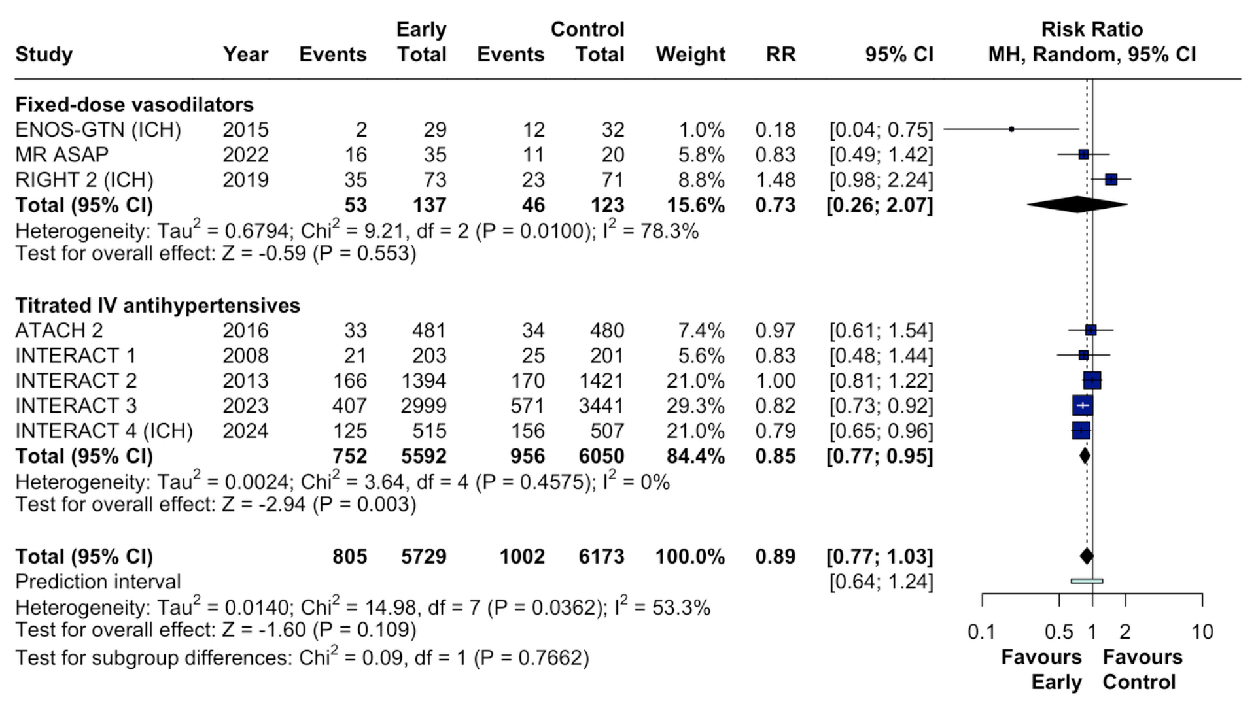

Supplemental Figure S18. Forest plot for hematoma expansion stratified by strategy of intervention. Pooled risk ratios (RR) with 95% confidence intervals (CI) using a random-effects model.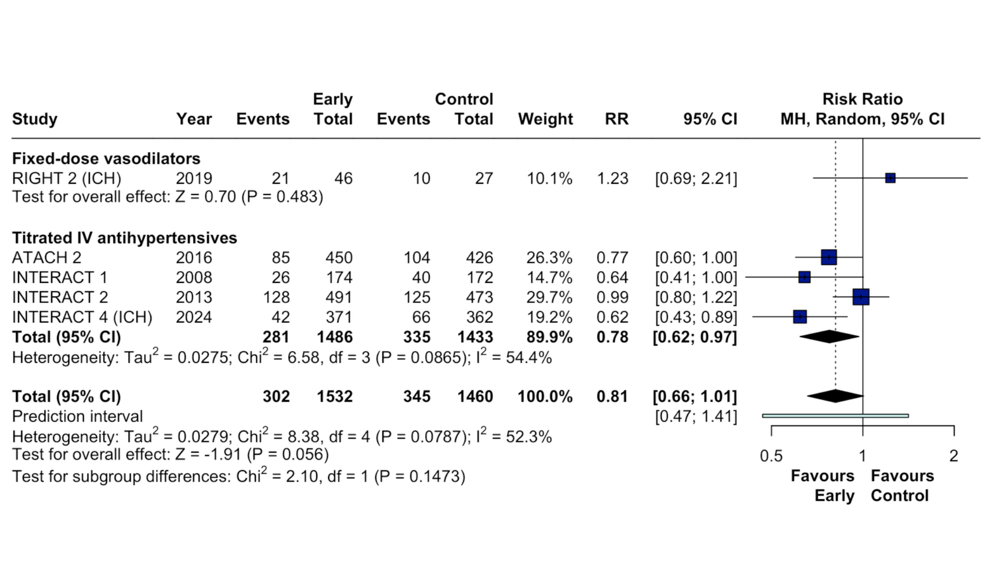

Supplemental Figure S19. Forest plot for neurological deterioration at 90 days stratified by strategy of intervention. Pooled risk ratios (RR) with 95% confidence intervals (CI) using a random-effects model.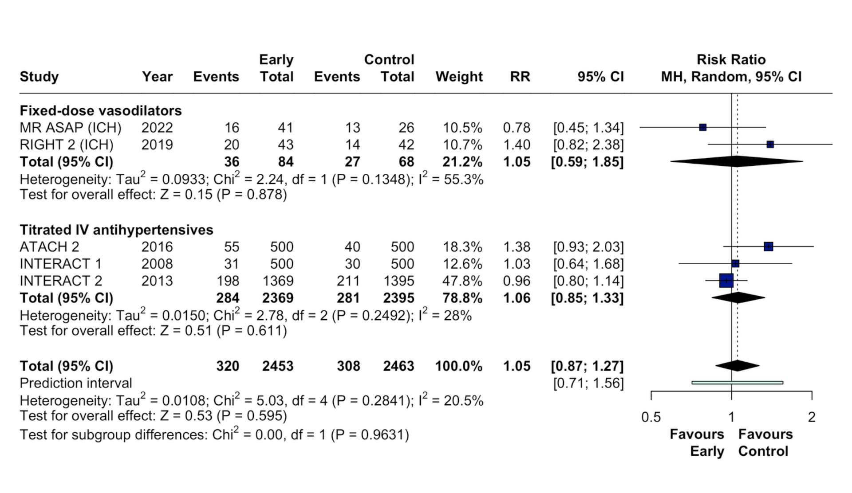

Supplemental Figure S20. Forest plot for serious adverse events at 90 days stratified by strategy of intervention. Pooled risk ratios (RR) with 95% confidence intervals (CI) using a random-effects model.
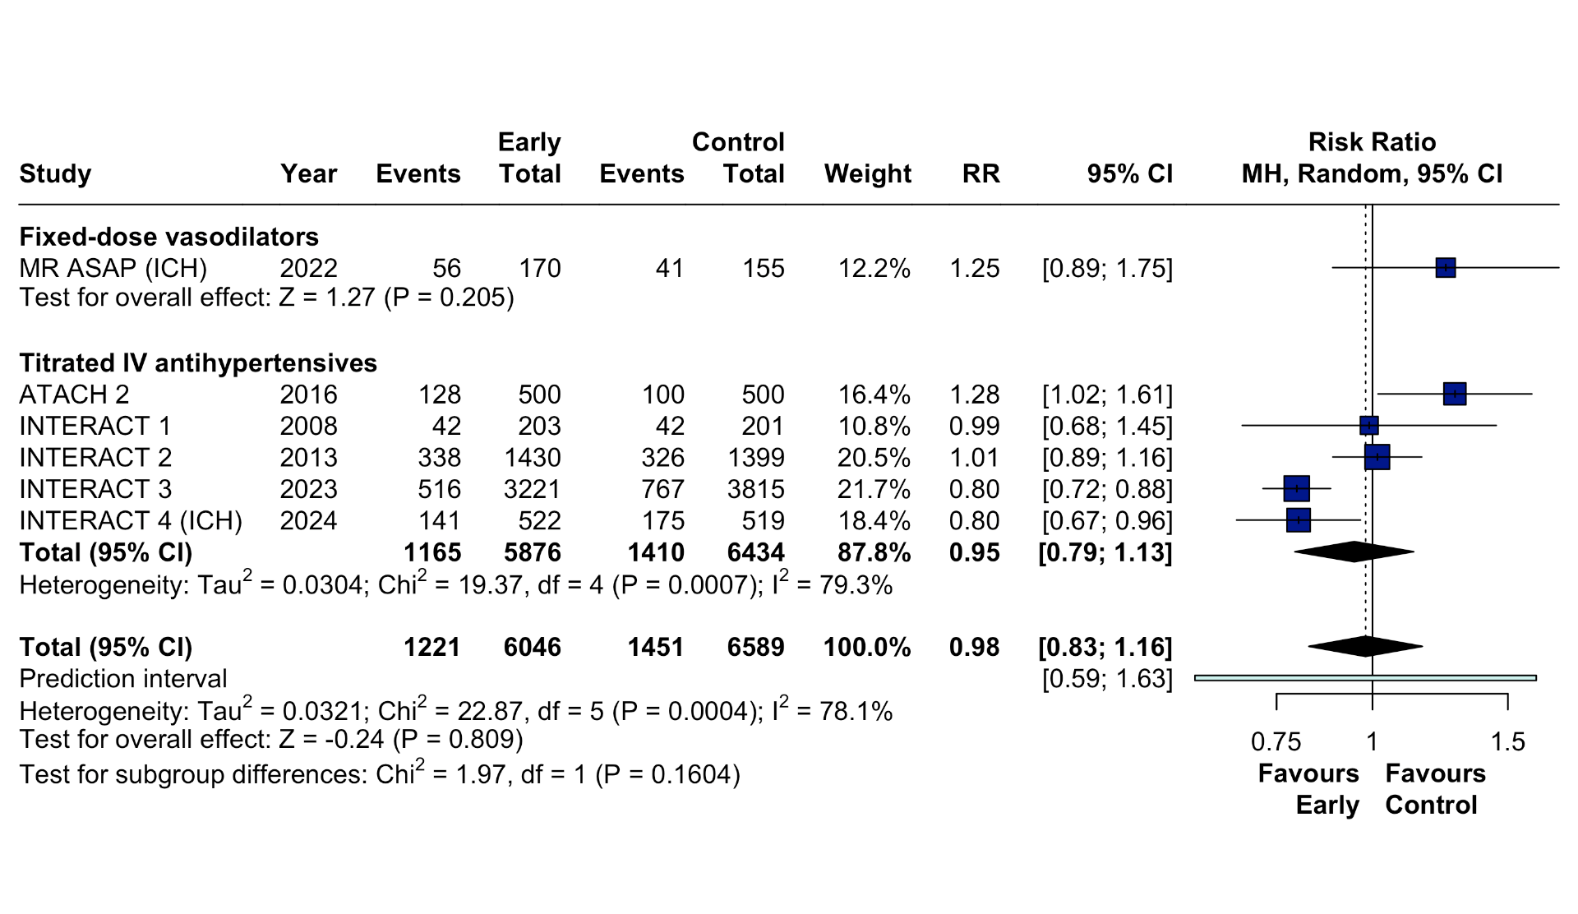
Supplemental Figure S21. Forest plot for shift in mRS at 90 days stratified by setting where BP lowering was initiated. Pooled odds ratios (OR) with 95% confidence intervals (CI) using a random-effects model.

Supplemental Figure S22. Forest plot for poor functional outcome at 90 days stratified by setting where BP lowering was initiated. Pooled risk ratios (RR) with 95% confidence intervals (CI) using a random-effects model.
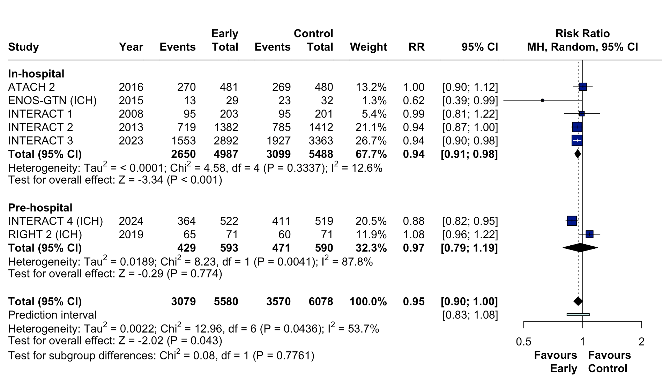
Supplemental Figure S23. Forest plot for good functional outcome at 90 days stratified by setting where BP lowering was initiated. Pooled risk ratios (RR) with 95% confidence intervals (CI) using a random-effects model.
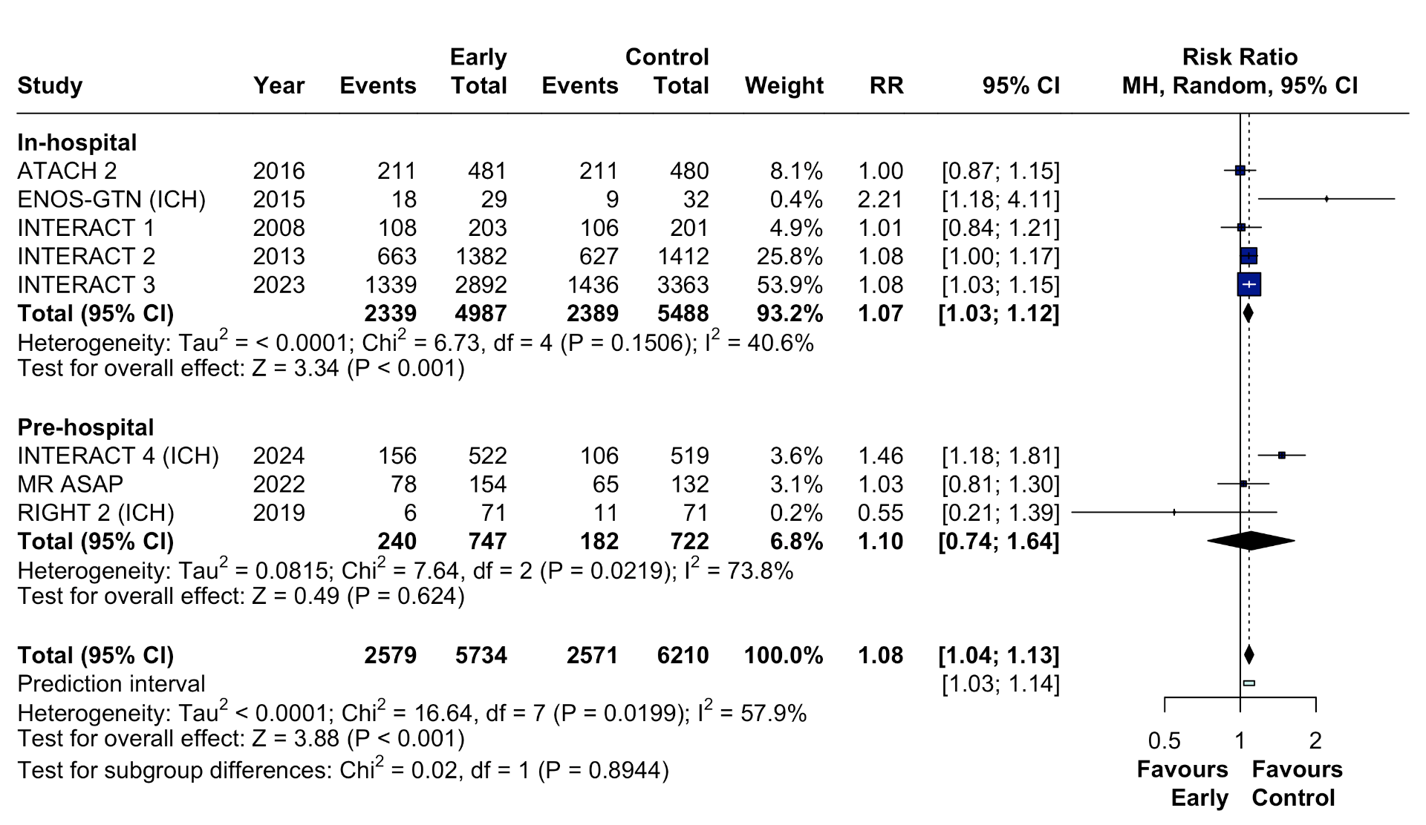
Supplemental Figure S24. Forest plot for 90-day mortality stratified by setting where BP lowering was initiated. Pooled risk ratios (RR) with 95% confidence intervals (CI) using a random-effects model.
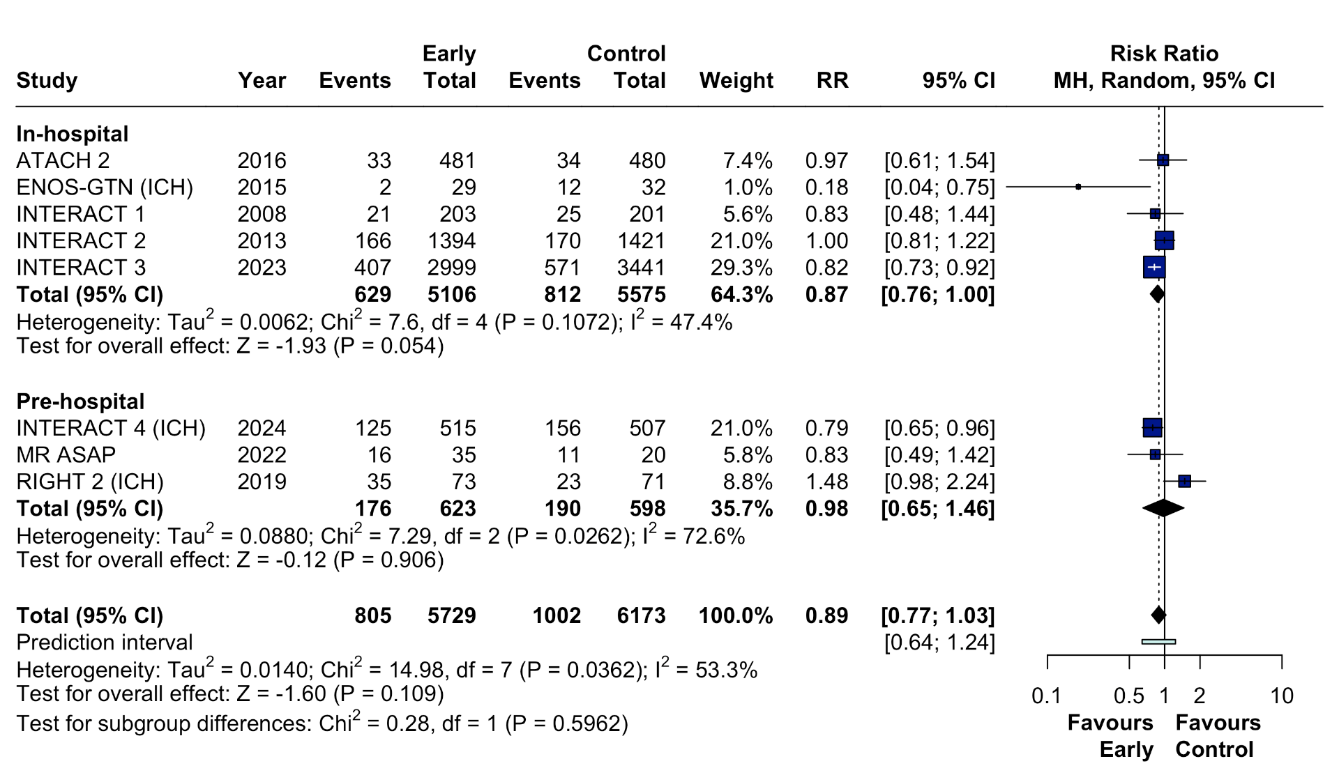
Supplemental Figure S25. Forest plot for hematoma expansion stratified by setting where BP lowering was initiated. Pooled risk ratios (RR) with 95% confidence intervals (CI) using a random-effects model.
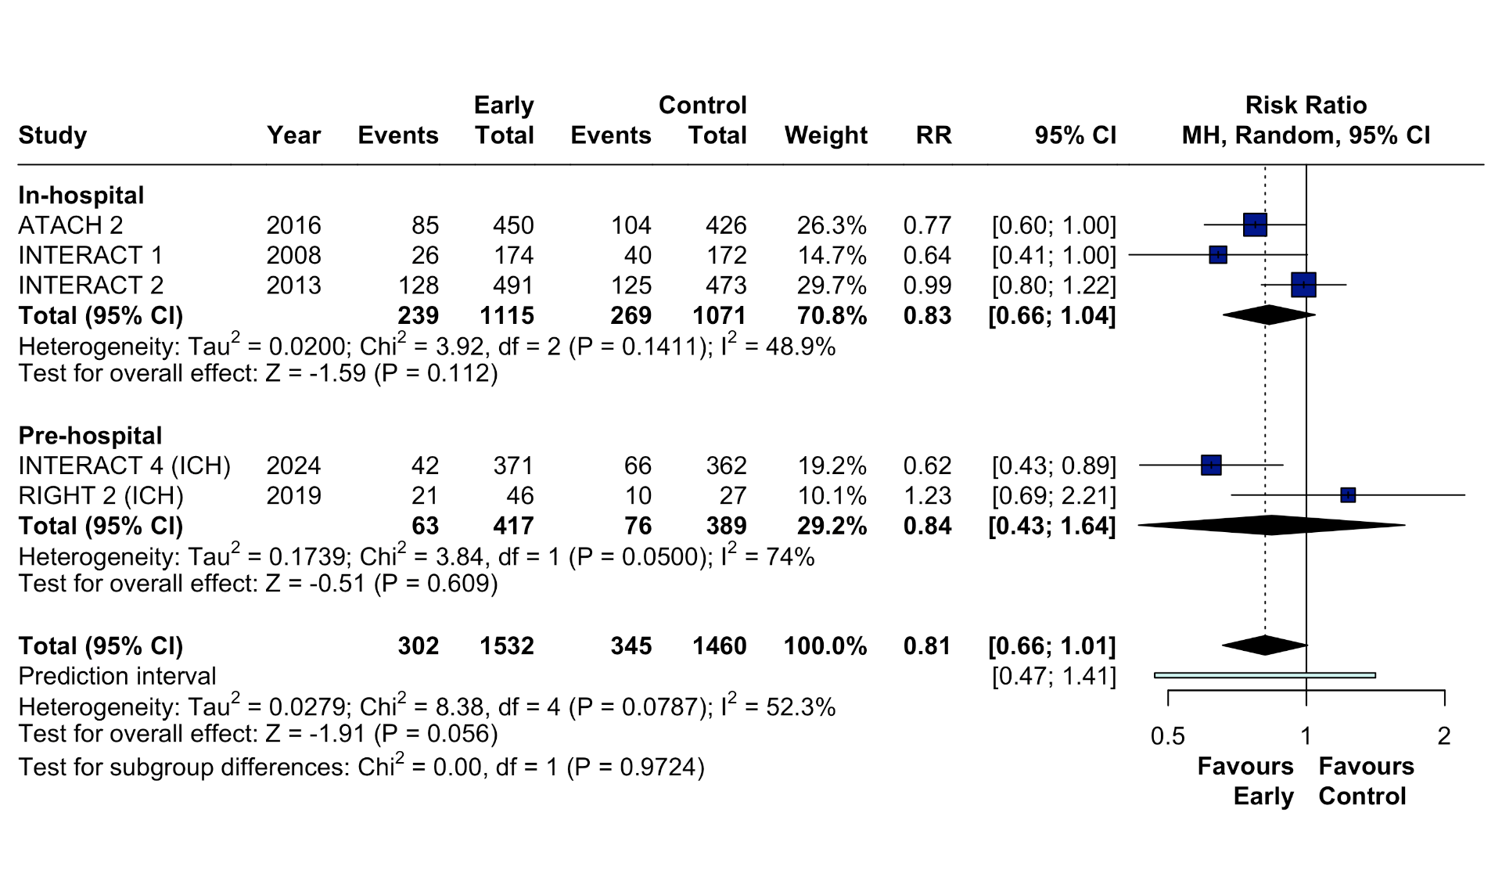
Supplemental Figure S26. Forest plot for neurological deterioration at 90 days stratified by setting where BP lowering was initiated. Pooled risk ratios (RR) with 95% confidence intervals (CI) using a random-effects model.
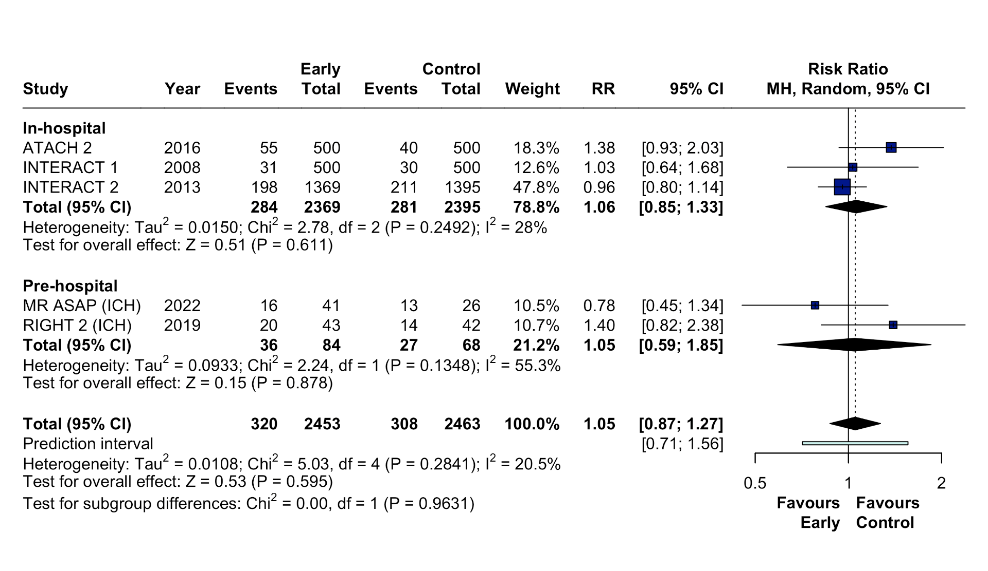
Supplemental Figure S27. Forest plot for serious adverse events at 90 days stratified by setting where BP lowering was initiated. Pooled risk ratios (RR) with 95% confidence intervals (CI) using a random-effects model.
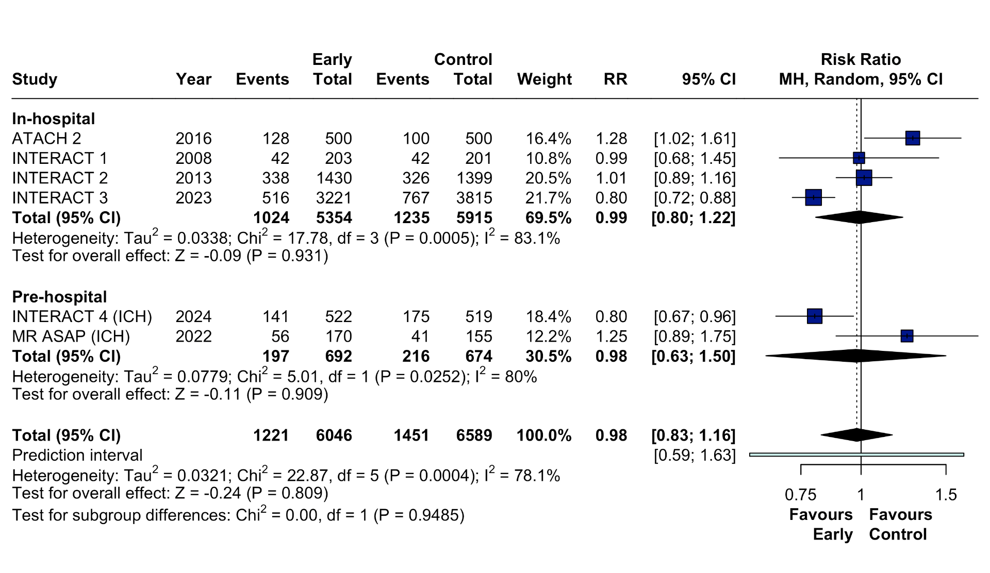

Figure S28. Leave-one-out sensitivity analysis for shift in mRS score at 90 days.
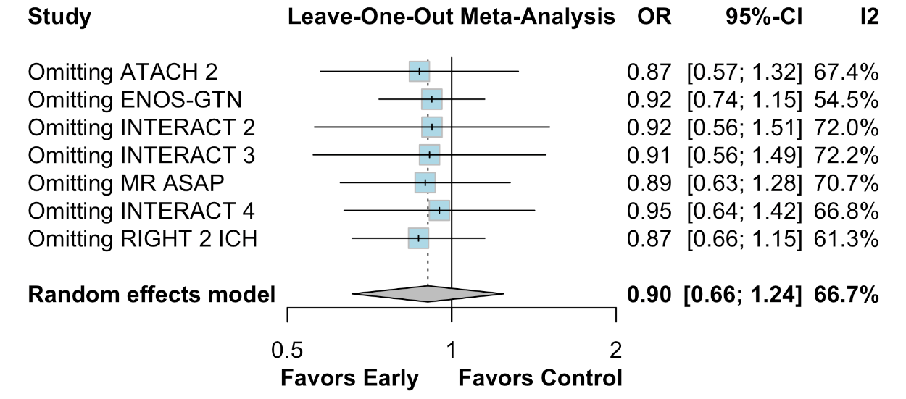
Figure S29. Leave-one-out sensitivity analysis for poor functional outcome at 90 days. 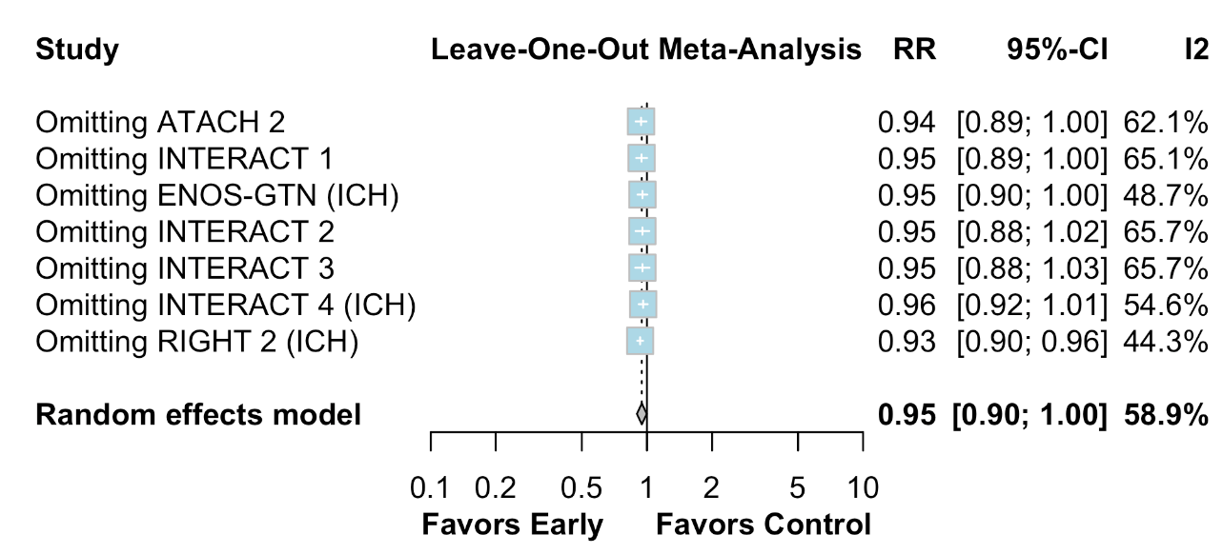

Figure S30. Leave-one-out sensitivity analysis for good functional outcome at 90 days.
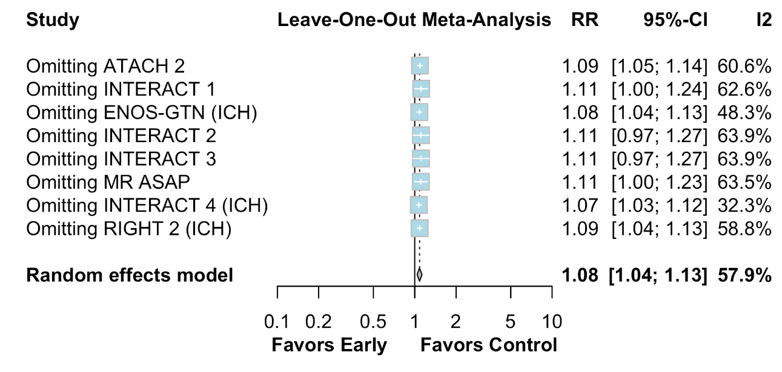
Figure S31. Leave-one-out sensitivity analysis for 90-day mortality.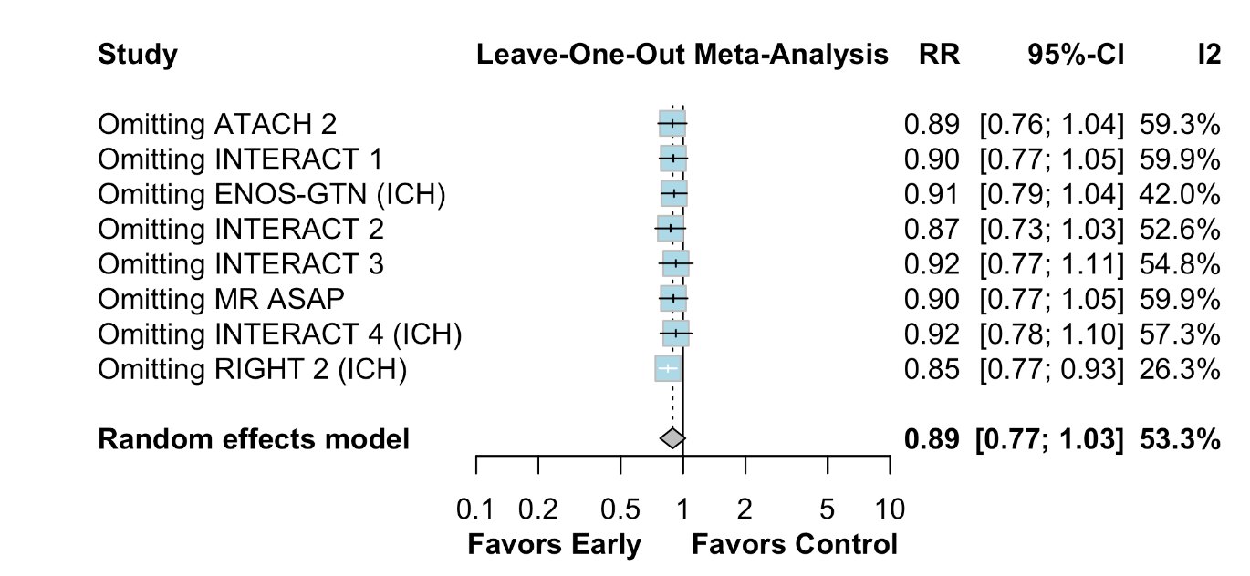
Figure S32. Leave-one-out sensitivity analysis for hematoma expansion.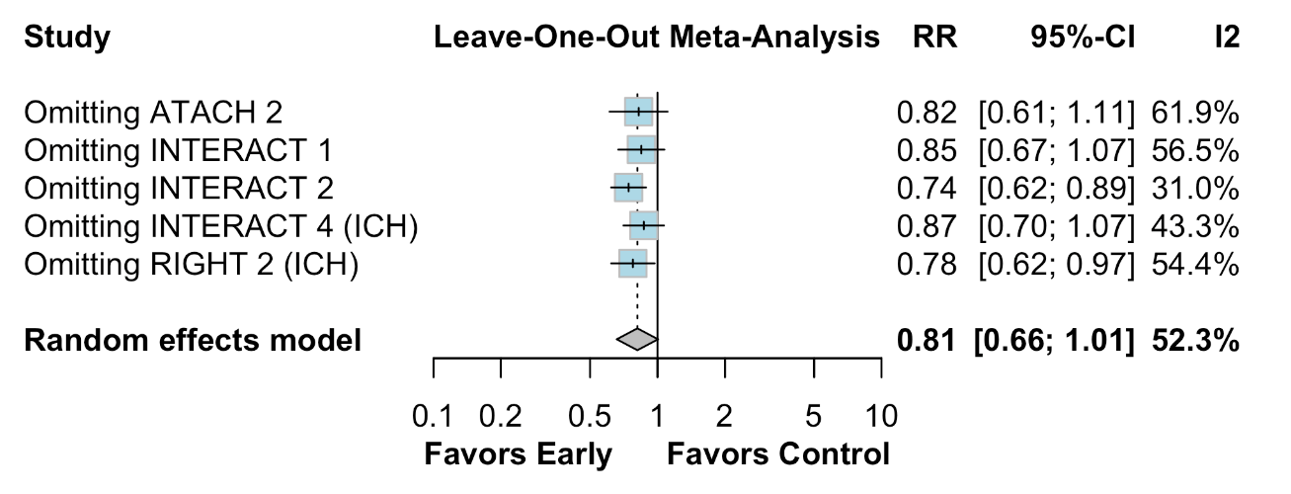

Figure S33. Leave-one-out sensitivity analysis for neurological deterioration.
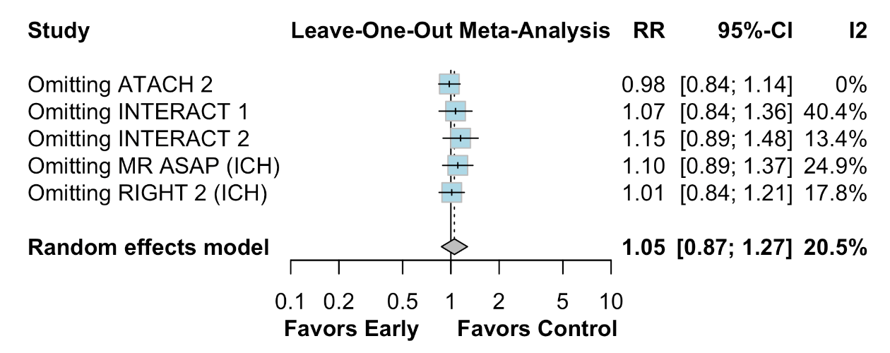
Figure S34. Leave-one-out sensitivity analysis for serious adverse events.
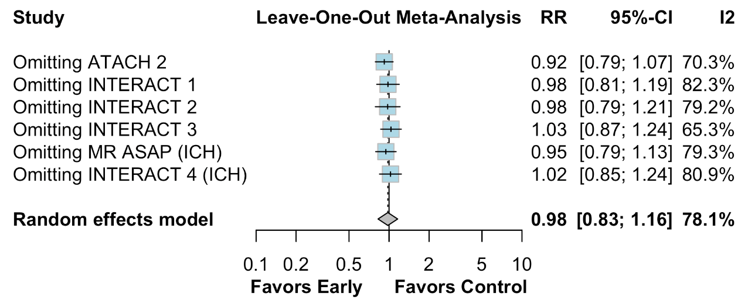

Figure S35. Baujat plot for shift in mRS score at 90 days.
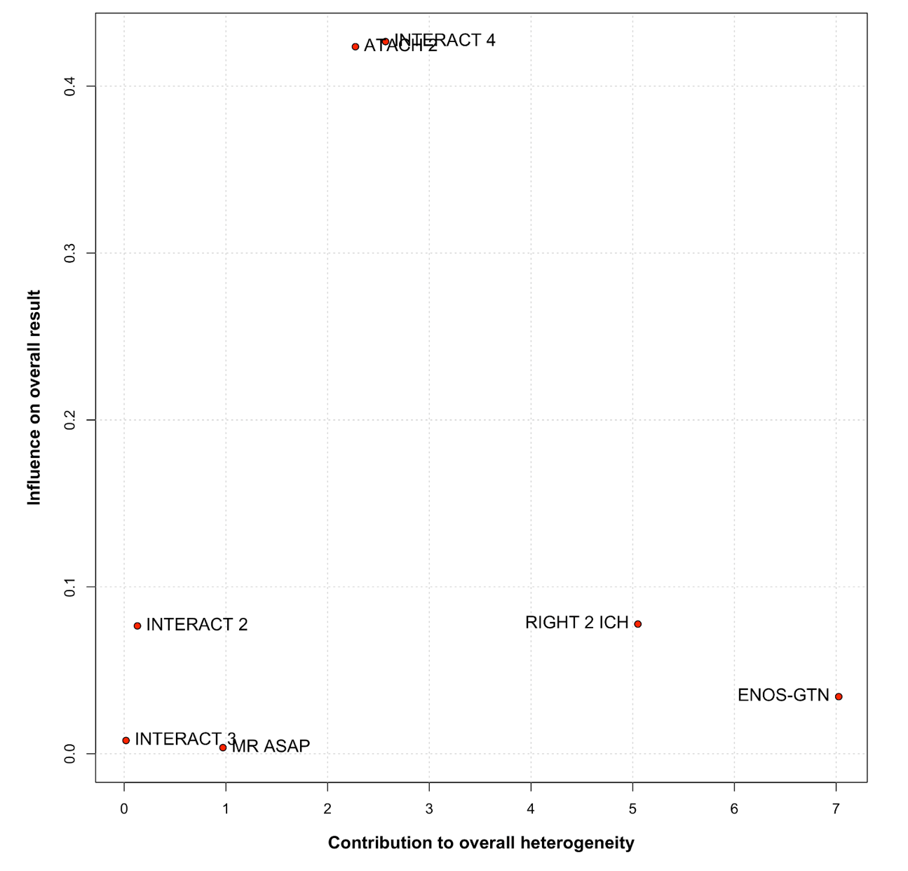
Figure S36. Baujat plot for poor functional outcome at 90 days.
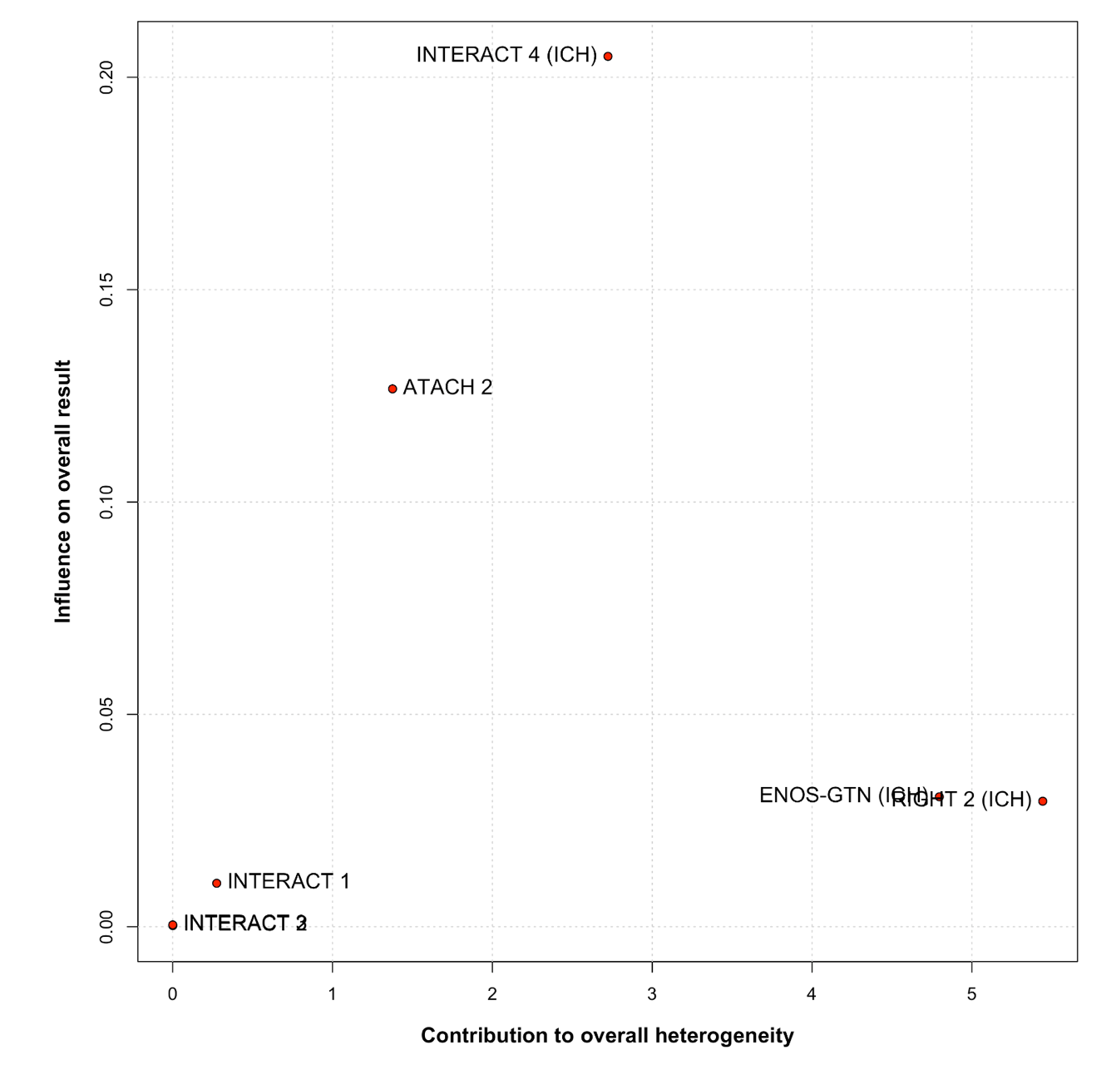
Figure S37. Baujat plot for good functional outcome at 90 days.
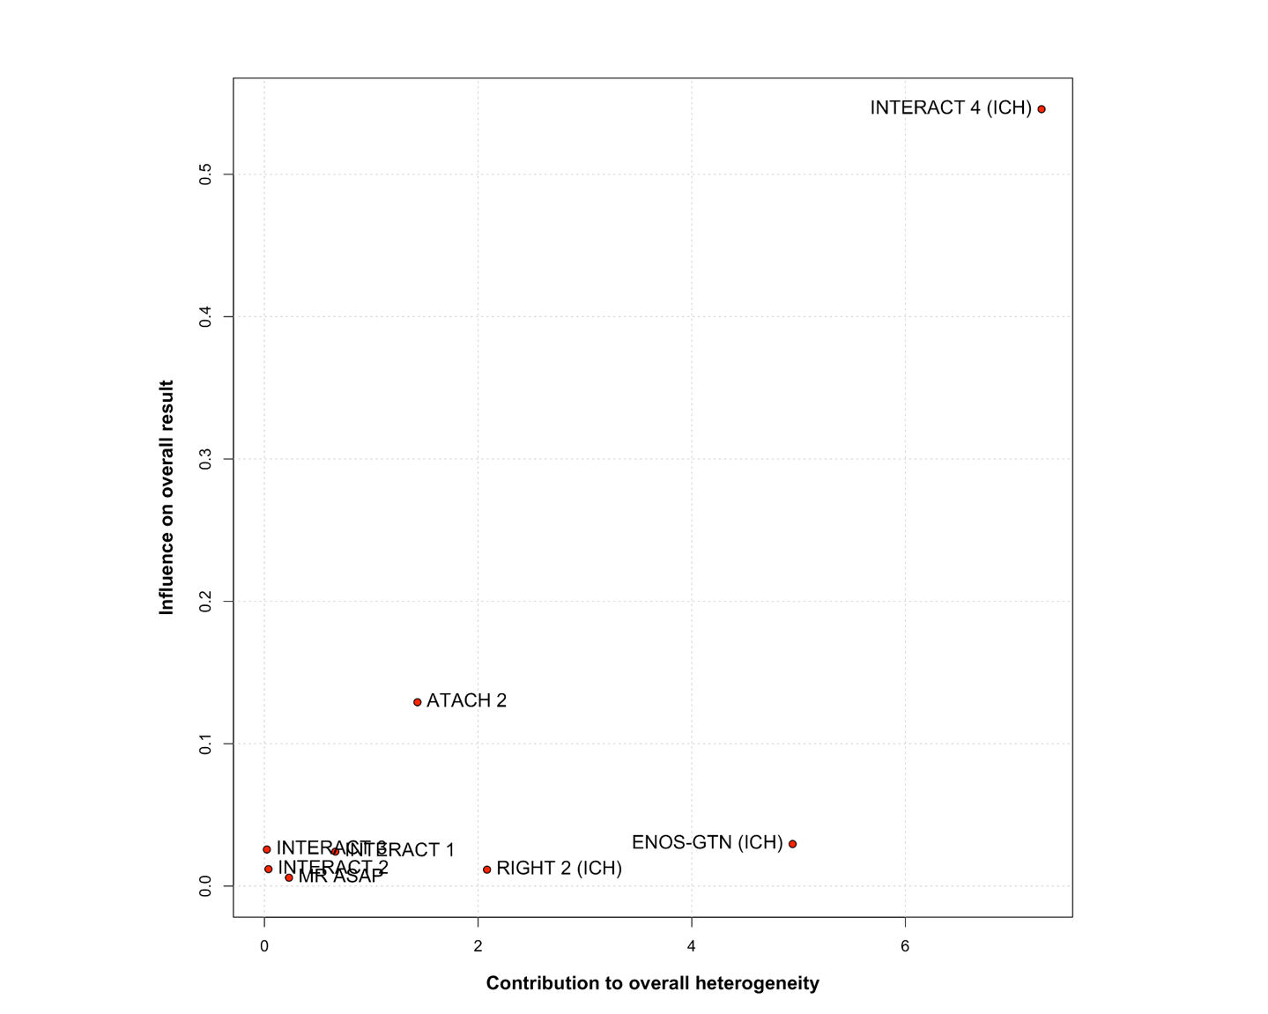

Figure S38. Baujat plot for 90-day mortality.
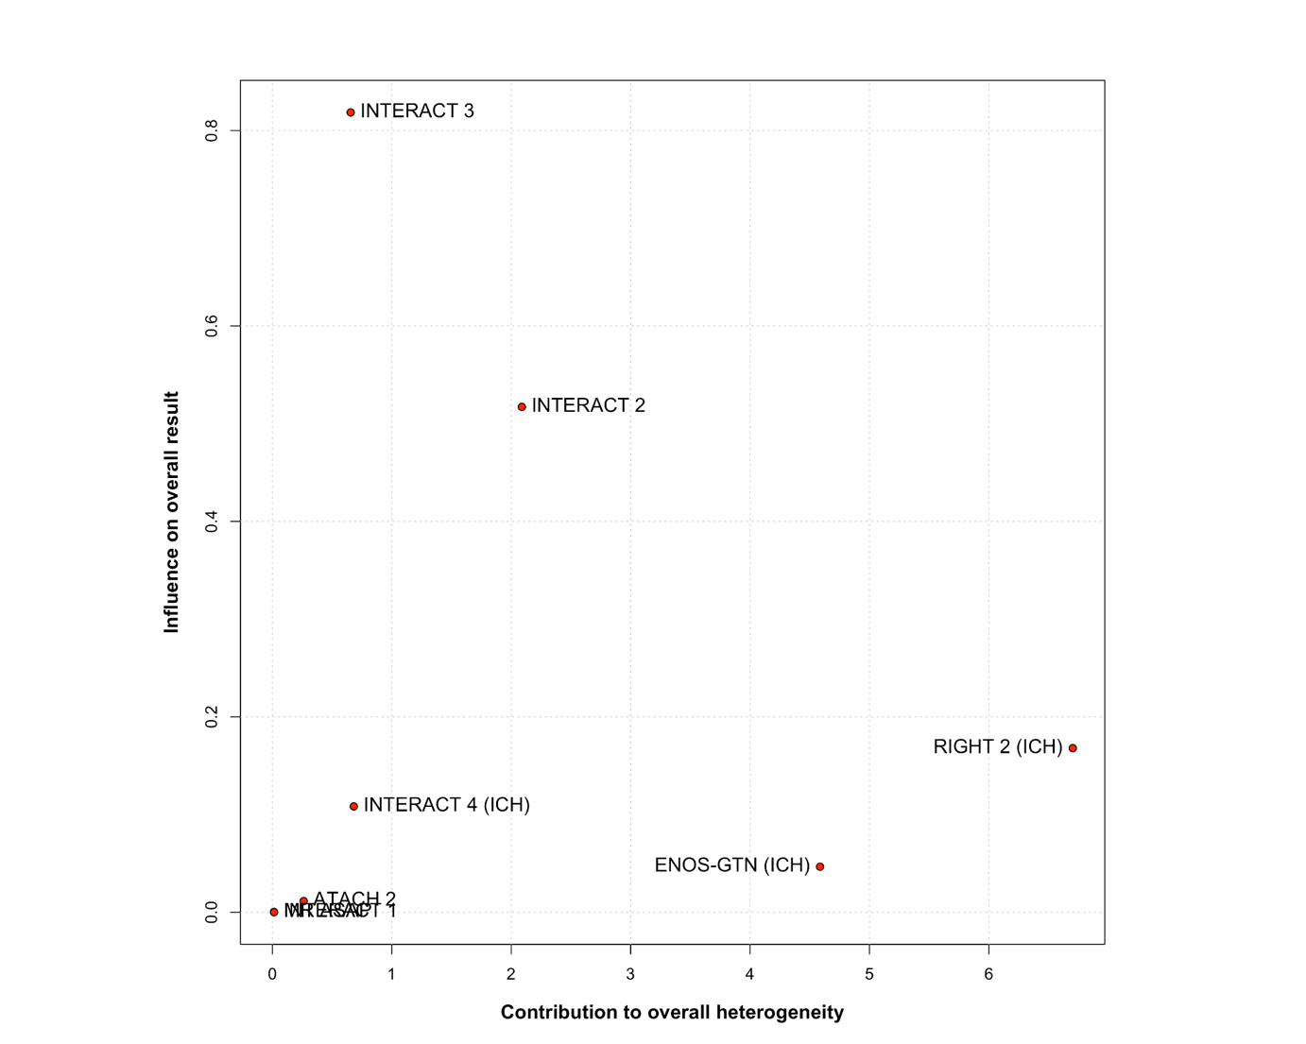

Figure S39. Baujat plot for hematoma expansion.
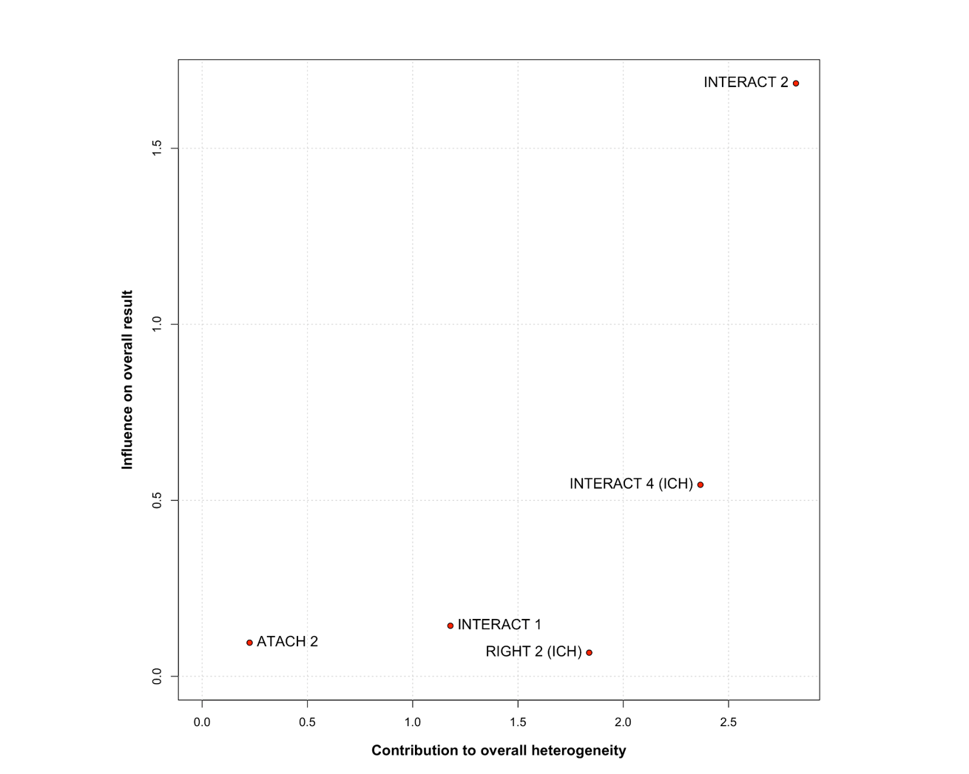

Figure S40. Baujat plot for neurological deterioration.
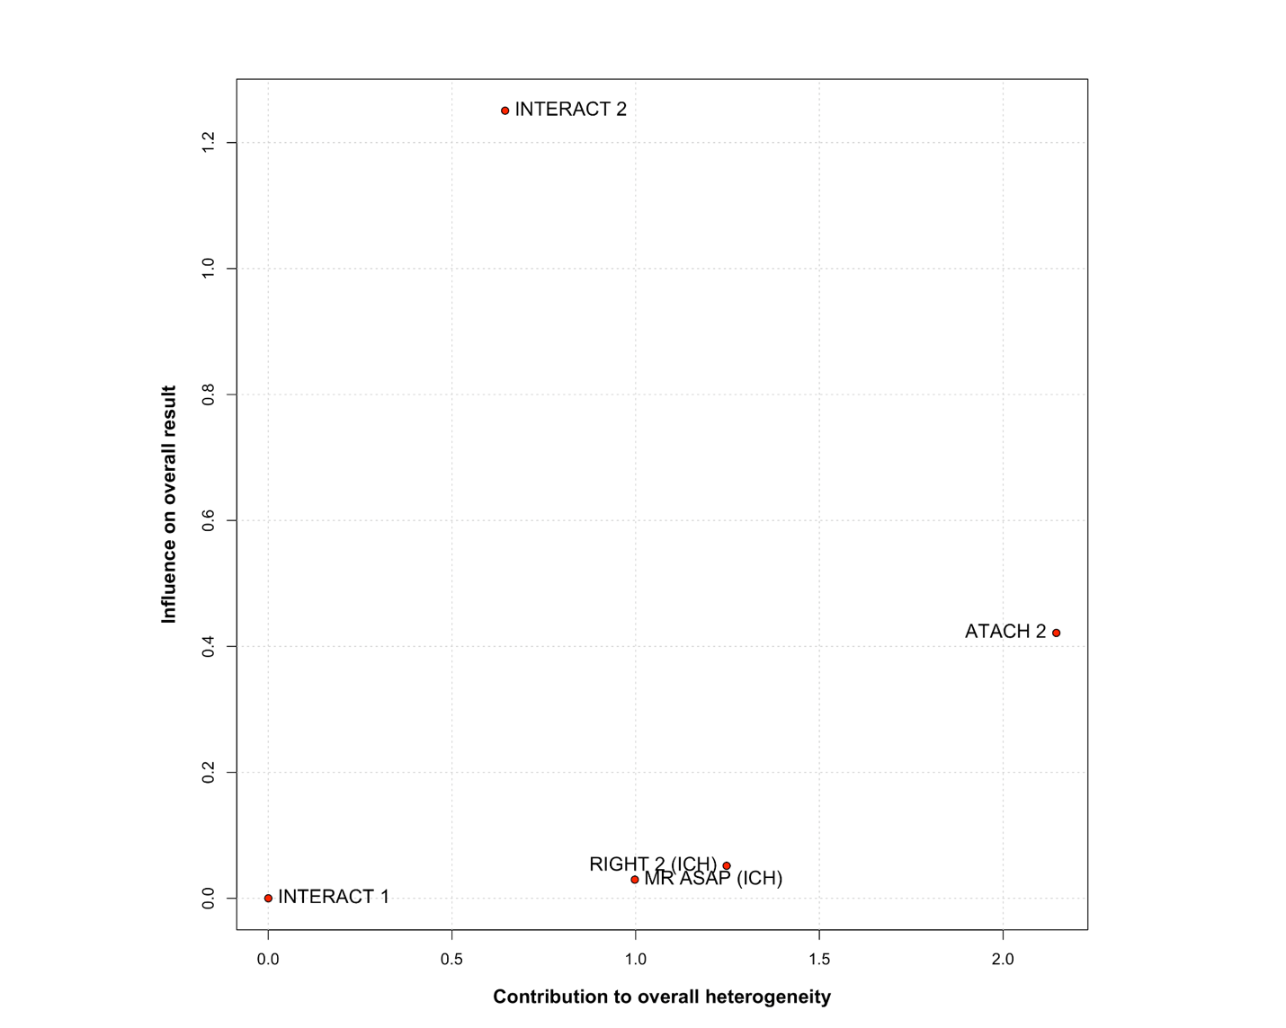

Figure S41. Baujat plot for serious adverse events.
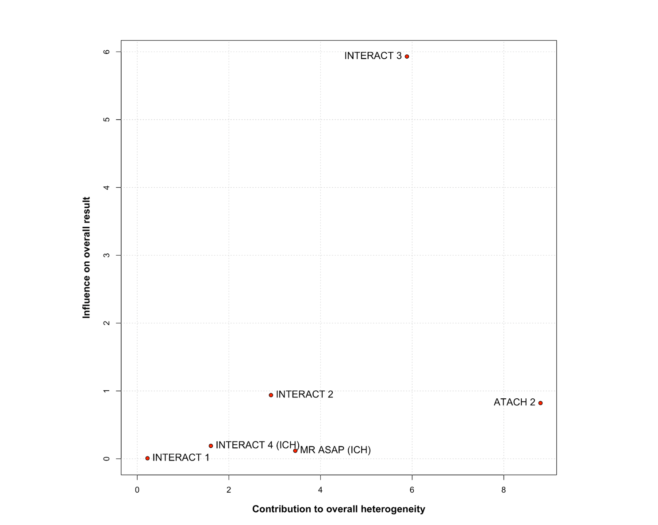

Figure S42. Funnel plot for shift in mRS score at 90 days.
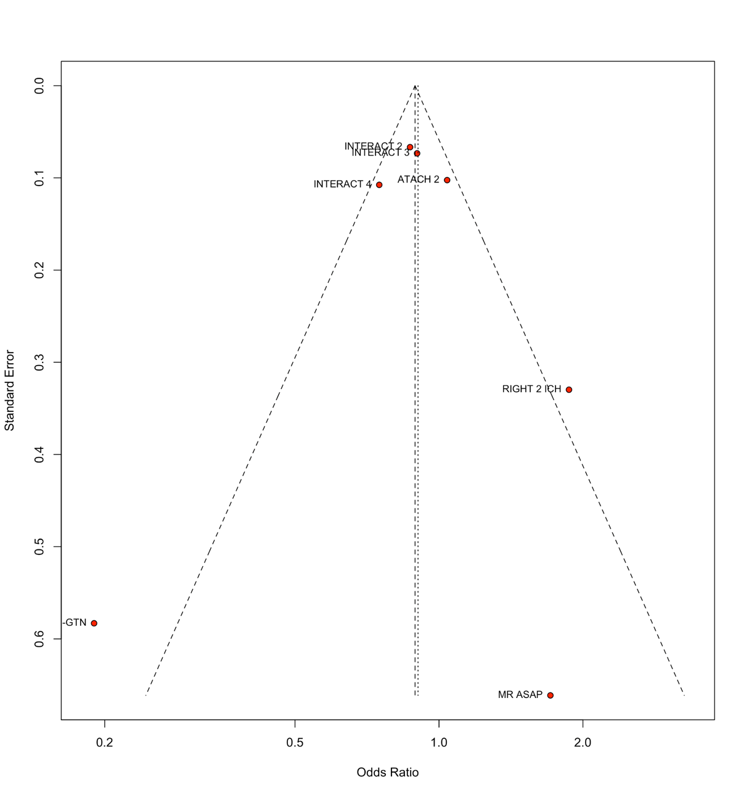
Figure S43. Funnel plot for poor functional outcome at 90 days.
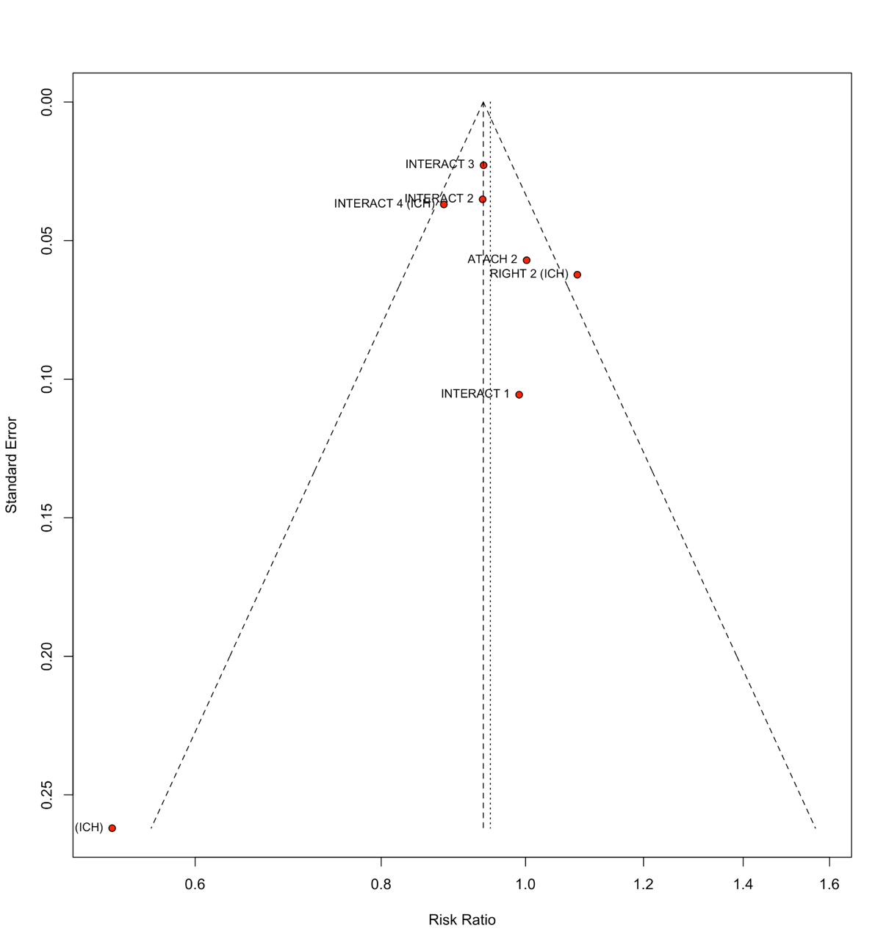
Figure S44. Funnel plot for good functional outcome at 90 days.
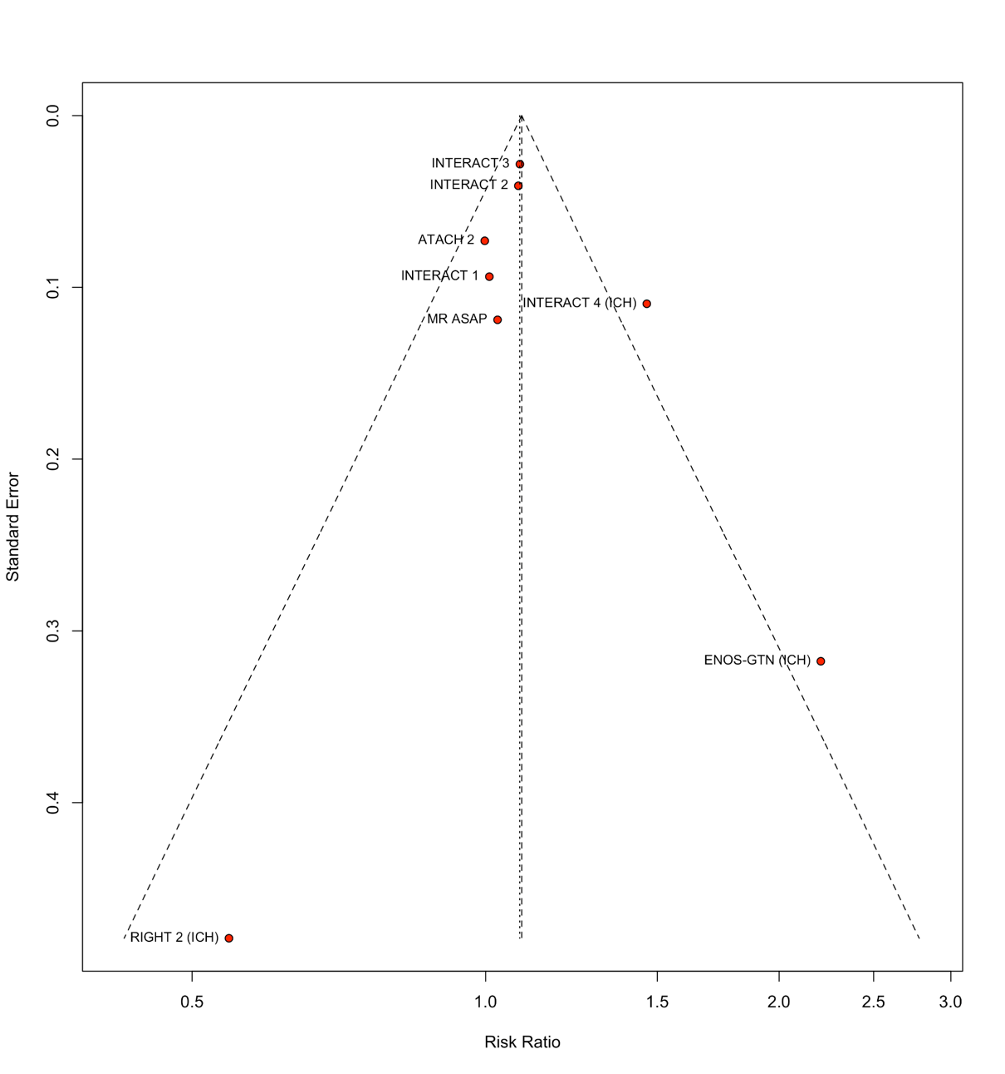
Figure S45. Funnel plot for 90-day mortality.
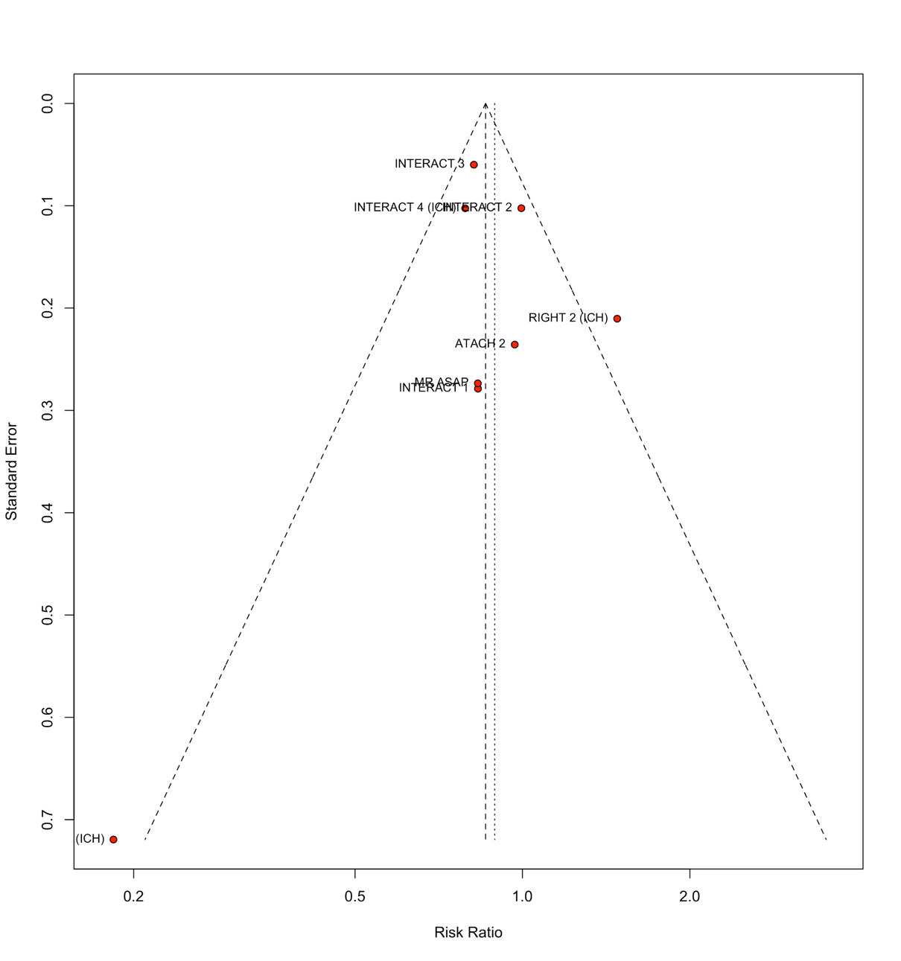
Figure S46. Funnel plot for hematoma expansion.
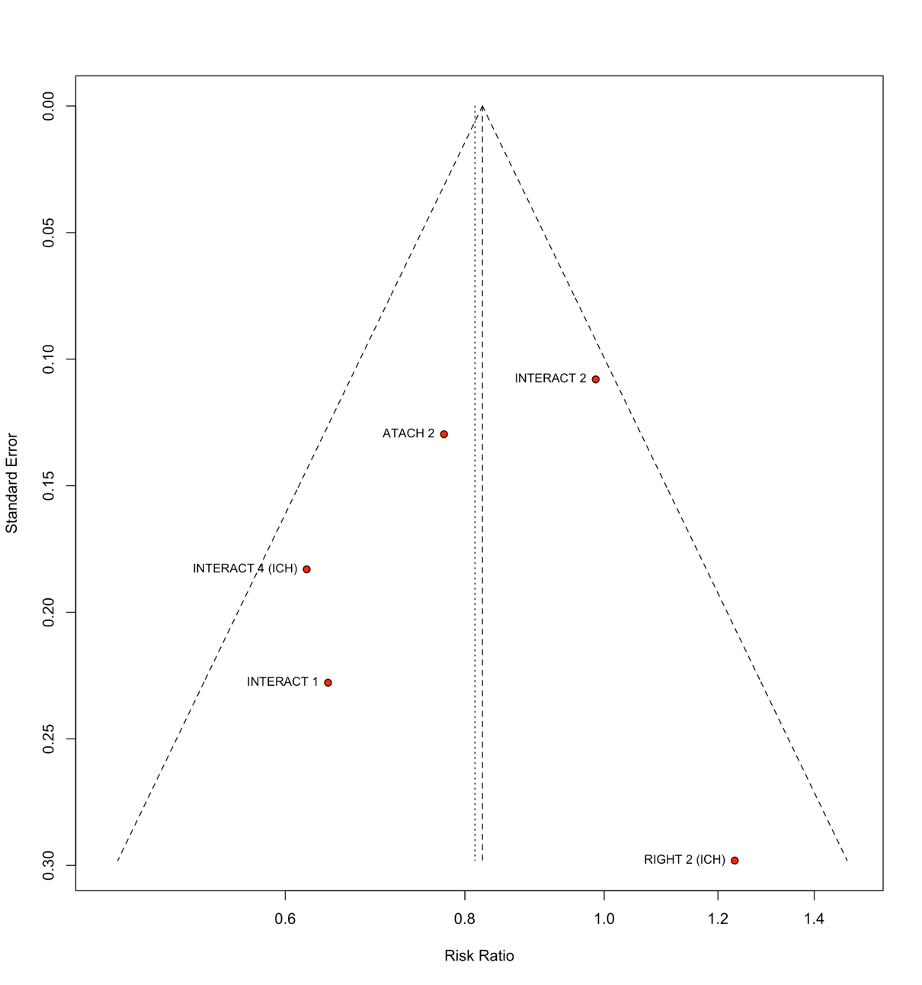
Figure S47. Funnel plot for neurological deterioration.
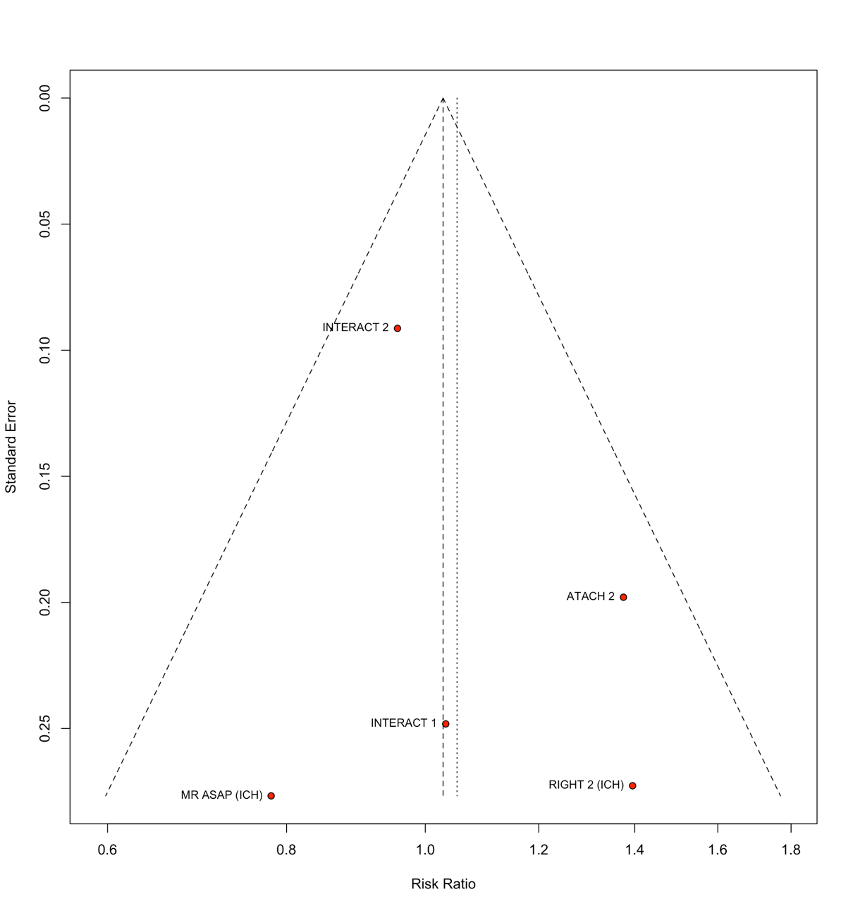
Figure S48. Funnel plot for serious adverse events.
