Supplementary Material

Supplementary Table 1. List of rumen bacterial strains included in this study with taxonomic classification and MALDI-TOF MS spectral counts.
Strain ID | Phylum | Class | Order | Family | Genus | Species | Spectra | Source
RB001 | p__Bacillota_A_368345 | c__Clostridia_258483 | o__Lachnospirales | f__Lachnospiraceae | g__Unclassified__f__Lachnospiraceae | s__Unclassified__f__Lachnospiraceae | 28 | IC
RB002 | p__Bacillota_A_368345 | c__Clostridia_258483 | o__Lachnospirales | f__Lachnospiraceae | g__Unclassified__f__Lachnospiraceae | s__Unclassified__f__Lachnospiraceae | 57 | IC
RB003 | p__Bacillota_A_368345 | c__Clostridia_258483 | o__Lachnospirales | f__Lachnospiraceae | g__Butyrivibrio_A_168226 | s__Unclassified__g__Butyrivibrio_A_168226 | 54 | IC
RB004 | p__Bacteroidota | c__Bacteroidia | o__Bacteroidales | f__Tannerellaceae | g__Massilibacteroides | s__Massilibacteroides_vaginae | 53 | IC
RB005 | p__Actinomycetota | c__Actinomycetes | o__Actinomycetales | f__Bifidobacteriaceae | g__Bifidobacterium_388775 | s__Unclassified__g__Bifidobacterium_388775 | 38 | IC
RB006 | p__Bacillota_I | c__Bacilli_A | o__Bacillales_B_306089 | f__Bacillaceae_H_294103 | g__Bacillus_P_294101 | s__Unclassified__g__Bacillus_P_294101 | 34 | IC
RB007 | p__Bacillota_A_368345 | c__Clostridia_258483 | o__Lachnospirales | f__Lachnospiraceae | g__Pseudobutyrivibrio | s__Pseudobutyrivibrio_xylanivorans | 25 | IC
RB008 | p__Bacillota_A_368345 | c__Clostridia_258483 | o__Lachnospirales | f__Lachnospiraceae | g__Pseudobutyrivibrio | s__Unclassified__g__Pseudobutyrivibrio | 62 | IC
RB009 | p__Actinomycetota | c__Actinomycetes | o__Actinomycetales | f__Actinomycetaceae | g__Actinomyces | s__Actinomyces_qiguomingii | 103 | IC
RB010 | p__Actinomycetota | c__Actinomycetes | o__Propionibacteriales | f__Propionibacteriaceae | g__Propionibacterium | s__Unclassified__g__Propionibacterium | 28 | IC
RB011 | p__Bacillota_A_368345 | c__Clostridia_258483 | o__Lachnospirales | f__Lachnospiraceae | g__Pseudobutyrivibrio | s__Pseudobutyrivibrio_xylanivorans | 68 | IC
RB012 | p__Pseudomonadota | c__Gammaproteobacteria | o__Enterobacterales_737866 | f__Enterobacteriaceae_A_725029 | g__Salmonella | s__Unclassified__g__Salmonella | 43 | IC
RB013 | p__Bacillota_A_368345 | c__Clostridia_258483 | o__Lachnospirales | f__Lachnospiraceae | g__Pseudobutyrivibrio | s__Pseudobutyrivibrio_xylanivorans | 31 | IC
RB014 | p__Actinomycetota | c__Actinomycetes | o__Actinomycetales | f__Bifidobacteriaceae | g__Bifidobacterium_388775 | s__Unclassified__g__Bifidobacterium_388775 | 59 | IC
RB015 | p__Actinomycetota | c__Actinomycetes | o__Actinomycetales | f__Bifidobacteriaceae | g__Bifidobacterium_388775 | s__Unclassified__g__Bifidobacterium_388775 | 26 | IC
RB016 | p__Actinomycetota | c__Coriobacteriia | o__Coriobacteriales | f__Atopobiaceae | g__Parafannyhessea | s__Unclassified__g__Parafannyhessea | 34 | IC
RB017 | p__Bacillota_I | c__Bacilli_A | o__Staphylococcales | f__Staphylococcaceae | g__Staphylococcus | s__Staphylococcus_epidermidis | 40 | IC
RB018 | p__Actinomycetota | c__Actinomycetes | o__Actinomycetales | f__Bifidobacteriaceae | g__Bifidobacterium_388775 | s__Bifidobacterium_globosum | 43 | IC
RB019 | p__Bacillota_A_368345 | c__Clostridia_258483 | o__Lachnospirales | f__Lachnospiraceae | g__Pseudobutyrivibrio | s__Pseudobutyrivibrio_xylanivorans | 32 | IC
RB020 | p__Bacillota_I | c__Bacilli_A | o__Lactobacillales | f__Streptococcaceae | g__Streptococcus | s__Unclassified__g__Streptococcus | 52 | IC
RB021 | p__Actinomycetota | c__Actinomycetes | o__Actinomycetales | f__Bifidobacteriaceae | g__Bifidobacterium_388775 | s__Bifidobacterium_globosum | 82 | IC
RB022 | p__Pseudomonadota | c__Gammaproteobacteria | o__Enterobacterales_737866 | f__Enterobacteriaceae_A_725029 | g__Escherichia | s__Unclassified__g__Escherichia | 36 | IC
RB023 | p__Bacillota_I | c__Bacilli_A | o__Lactobacillales | f__Streptococcaceae | g__Streptococcus | s__Streptococcus_infantarius | 41 | IC
RB024 | p__Bacillota_C | c__Negativicutes | o__Acidaminococcales | f__Acidaminococcaceae | g__Acidaminococcus | s__Acidaminococcus_fermentans | 41 | IC
RB025 | p__Bacillota_I | c__Bacilli_A | o__Bacillales_B_306089 | f__Bacillaceae_H_294103 | g__Bacillus_P_294101 | s__Bacillus_P_294101_licheniformis | 39 | IC
RB026 | p__Bacillota_I | c__Bacilli_A | o__Bacillales_B_306089 | f__Bacillaceae_H_294103 | g__Bacillus_P_294101 | s__Bacillus_P_294101_paralicheniformis | 36 | IC
RB027 | p__Pseudomonadota | c__Gammaproteobacteria | o__Enterobacterales_737866 | f__Enterobacteriaceae_A_725029 | g__Escherichia | s__Unclassified__g__Escherichia | 45 | IC
RB028 | p__Bacillota_I | c__Bacilli_A | o__Bacillales_B_306089 | f__Bacillaceae_H_294103 | g__Bacillus_P_294101 | s__Bacillus_P_294101_aerius | 35 | IC
RB029 | p__Bacillota_I | c__Bacilli_A | o__Bacillales_B_306089 | f__Bacillaceae_H_294103 | g__Bacillus_P_294101 | s__Bacillus_P_294101_sonorensis | 42 | IC
RB030 | p__Bacillota_I | c__Bacilli_A | o__Bacillales_D | f__Amphibacillaceae | g__Virgibacillus_E_287324 | s__Virgibacillus_E_287324_proomii | 46 | IC
RB031 | p__Bacillota_I | c__Bacilli_A | o__Bacillales_B_306089 | f__Bacillaceae_H_294103 | g__Bacillus_P_294101 | s__Bacillus_P_294101_licheniformis | 36 | IC
RB032 | p__Bacillota_A_368345 | c__Clostridia_258483 | o__Lachnospirales | f__Lachnospiraceae | g__Pseudobutyrivibrio | s__Pseudobutyrivibrio_ruminis_A | 32 | IC
RB033 | p__Bacillota_I | c__Bacilli_A | o__Bacillales_B_306089 | f__Bacillaceae_H_294103 | g__Bacillus_P_294101 | s__Bacillus_P_294101_haynesii | 34 | IC
RB034 | p__Bacillota_A_368345 | c__Clostridia_258483 | o__Lachnospirales | f__Lachnospiraceae | g__Pseudobutyrivibrio | s__Pseudobutyrivibrio_ruminis_A | 40 | IC
RB035 | p__Bacillota_I | c__Bacilli_A | o__Bacillales_D | f__Amphibacillaceae | g__Virgibacillus_E_287324 | s__Virgibacillus_E_287324_proomii | 33 | IC
RB036 | p__Bacillota_I | c__Bacilli_A | o__Bacillales_D | f__Amphibacillaceae | g__Virgibacillus_E_287324 | s__Virgibacillus_E_287324_proomii | 44 | IC
RB037 | p__Pseudomonadota | c__Gammaproteobacteria | o__Enterobacterales_737866 | f__Enterobacteriaceae_A_725029 | g__Escherichia | s__Escherichia_ruysiae | 55 | IC
RB038 | p__Pseudomonadota | c__Gammaproteobacteria | o__Enterobacterales_737866 | f__Enterobacteriaceae_A_725029 | g__Escherichia | s__Unclassified__g__Escherichia | 40 | IC
RB039 | p__Bacillota_A_368345 | c__Clostridia_258483 | o__Peptostreptococcales | f__Anaerovoracaceae | g__Baileyella | s__Unclassified__g__Baileyella | 23 | IC
RB040 | p__Bacillota_I | c__Bacilli_A | o__Lactobacillales | f__Streptococcaceae | g__Streptococcus | s__Unclassified__g__Streptococcus | 32 | IC
RB041 | p__Bacillota_I | c__Bacilli_A | o__Bacillales_D | f__Amphibacillaceae | g__Virgibacillus_E_287324 | s__Virgibacillus_E_287324_proomii | 14 | IC
RB042 | p__Bacillota_I | c__Bacilli_A | o__Bacillales_B_306089 | f__Bacillaceae_H_294103 | g__Bacillus_P_294101 | s__Unclassified__g__Bacillus_P_294101 | 90 | IC
RB043 | p__Bacillota_I | c__Bacilli_A | o__Bacillales_D | f__Amphibacillaceae | g__Virgibacillus_E_287324 | s__Virgibacillus_E_287324_proomii | 50 | IC
RB044 | p__Bacillota_I | c__Bacilli_A | o__Erysipelotrichales | f__Coprobacillaceae | g__Sharpea | s__Sharpea_azabuensis | 42 | IC
RB045 | p__Bacillota_I | c__Bacilli_A | o__Bacillales_D | f__Amphibacillaceae | g__Virgibacillus_E_287324 | s__Virgibacillus_E_287324_pantothenticus | 51 | IC
RB046 | p__Pseudomonadota | c__Gammaproteobacteria | o__Enterobacterales_737866 | f__Enterobacteriaceae_A_725029 | g__Escherichia | s__Escherichia_ruysiae | 43 | IC
RB047 | p__Bacillota_I | c__Bacilli_A | o__Bacillales_B_306089 | f__Bacillaceae_H_294103 | g__Bacillus_P_294101 | s__Bacillus_P_294101_aerius | 22 | IC
RB048 | p__Bacillota_A_368345 | c__Clostridia_258483 | o__Lachnospirales | f__Lachnospiraceae | g__Porcincola | s__Porcincola_intestinalis | 38 | IC
RB049 | p__Bacillota_I | c__Bacilli_A | o__Lactobacillales | f__Streptococcaceae | g__Streptococcus | s__Streptococcus_infantarius | 33 | IC
RB050 | p__Bacillota_I | c__Bacilli_A | o__Bacillales_B_306089 | f__Bacillaceae_H_294103 | g__Bacillus_P_294101 | s__Unclassified__g__Bacillus_P_294101 | 48 | IC
RB051 | p__Bacillota_I | c__Bacilli_A | o__Bacillales_B_306089 | f__Bacillaceae_H_294103 | g__Bacillus_P_294101 | s__Unclassified__g__Bacillus_P_294101 | 34 | IC
RB052 | p__Bacillota_I | c__Bacilli_A | o__Lactobacillales | f__Streptococcaceae | g__Streptococcus | s__Streptococcus_lutetiensis | 41 | IC
RB053 | p__Pseudomonadota | c__Gammaproteobacteria | o__Enterobacterales_737866 | f__Enterobacteriaceae_A_725029 | g__Escherichia | s__Escherichia_ruysiae | 38 | IC
RB054 | p__Bacillota_I | c__Bacilli_A | o__Lactobacillales | f__Streptococcaceae | g__Streptococcus | s__Unclassified__g__Streptococcus | 42 | IC
RB055 | p__Pseudomonadota | c__Gammaproteobacteria | o__Enterobacterales_737866 | f__Enterobacteriaceae_A_725029 | g__Escherichia | s__Unclassified__g__Escherichia | 58 | IC
RB056 | p__Bacillota_I | c__Bacilli_A | o__Bacillales_B_306089 | f__Bacillaceae_H_294103 | g__Bacillus_P_294101 | s__Bacillus_P_294101_aerius | 28 | IC
RB057 | p__Pseudomonadota | c__Gammaproteobacteria | o__Enterobacterales_737866 | f__Enterobacteriaceae_A_725029 | g__Escherichia | s__Unclassified__g__Escherichia | 50 | IC
RB058 | p__Bacillota_I | c__Bacilli_A | o__Erysipelotrichales | f__Coprobacillaceae | g__Sharpea | s__Sharpea_azabuensis | 43 | IC
RB059 | p__Bacillota_I | c__Bacilli_A | o__Bacillales_B_306089 | f__Bacillaceae_H_294103 | g__Bacillus_P_294101 | s__Unclassified__g__Bacillus_P_294101 | 46 | IC
RB060 | p__Bacillota_I | c__Bacilli_A | o__Bacillales_B_306089 | f__Bacillaceae_H_294103 | g__Bacillus_P_294101 | s__Bacillus_P_294101_aerius | 38 | IC
RB061 | p__Bacillota_I | c__Bacilli_A | o__Lactobacillales | f__Streptococcaceae | g__Streptococcus | s__Streptococcus_lutetiensis | 40 | IC
RB062 | p__Bacillota_I | c__Bacilli_A | o__Bacillales_B_306089 | f__Bacillaceae_H_294103 | g__Bacillus_P_294101 | s__Unclassified__g__Bacillus_P_294101 | 27 | IC
RB063 | p__Bacillota_I | c__Bacilli_A | o__Erysipelotrichales | f__Coprobacillaceae | g__Sharpea | s__Sharpea_azabuensis | 34 | IC
RB064 | p__Bacillota_I | c__Bacilli_A | o__Bacillales_B_306089 | f__Bacillaceae_H_294103 | g__Bacillus_P_294101 | s__Bacillus_P_294101_sonorensis | 39 | IC
RB065 | p__Pseudomonadota | c__Gammaproteobacteria | o__Enterobacterales_737866 | f__Enterobacteriaceae_A_725029 | g__Escherichia | s__Escherichia_ruysiae | 54 | IC
RB066 | p__Bacillota_I | c__Bacilli_A | o__Lactobacillales | f__Streptococcaceae | g__Streptococcus | s__Streptococcus_infantarius | 56 | IC
RB067 | p__Bacillota_I | c__Bacilli_A | o__Erysipelotrichales | f__Coprobacillaceae | g__Sharpea | s__Sharpea_azabuensis | 26 | IC
RB068 | p__Bacillota_I | c__Bacilli_A | o__Lactobacillales | f__Streptococcaceae | g__Streptococcus | s__Streptococcus_infantarius | 48 | IC
RB069 | p__Pseudomonadota | c__Gammaproteobacteria | o__Enterobacterales_737866 | f__Enterobacteriaceae_A_725029 | g__Escherichia | s__Escherichia_ruysiae | 55 | IC
RB070 | p__Bacillota_I | c__Bacilli_A | o__Bacillales_B_306089 | f__Bacillaceae_H_294103 | g__Bacillus_P_294101 | s__Bacillus_P_294101_aerius | 36 | IC
RB071 | p__Bacillota_I | c__Bacilli_A | o__Bacillales_D | f__Amphibacillaceae | g__Virgibacillus_E_287324 | s__Virgibacillus_E_287324_proomii | 58 | IC
RB072 | p__Bacillota_I | c__Bacilli_A | o__Bacillales_B_306089 | f__Bacillaceae_H_294103 | g__Bacillus_P_294101 | s__Bacillus_P_294101_licheniformis | 24 | IC
RB073 | p__Bacillota_I | c__Bacilli_A | o__Lactobacillales | f__Streptococcaceae | g__Streptococcus | s__Streptococcus_lutetiensis | 74 | IC
RB074 | p__Bacillota_I | c__Bacilli_A | o__Bacillales_B_306089 | f__Bacillaceae_H_294103 | g__Bacillus_P_294101 | s__Bacillus_P_294101_sonorensis | 45 | IC
RB075 | p__Pseudomonadota | c__Gammaproteobacteria | o__Enterobacterales_737866 | f__Enterobacteriaceae_A_725029 | g__Escherichia | s__Unclassified__g__Escherichia | 40 | IC
RB076 | p__Bacillota_I | c__Bacilli_A | o__Bacillales_B_306087 | f__Caldibacillaceae | g__Bacillus_J_295379 | s__Bacillus_J_295379_hisashii | 69 | IC
RB077 | p__Pseudomonadota | c__Gammaproteobacteria | o__Enterobacterales_737866 | f__Enterobacteriaceae_A_725029 | g__Escherichia | s__Escherichia_ruysiae | 59 | IC
RB078 | p__Bacillota_I | c__Bacilli_A | o__Bacillales_B_306089 | f__Bacillaceae_H_294103 | g__Bacillus_P_294101 | s__Bacillus_P_294101_aerius | 37 | IC
RB079 | p__Bacillota_I | c__Bacilli_A | o__Lactobacillales | f__Streptococcaceae | g__Streptococcus | s__Streptococcus_lutetiensis | 109 | IC
RB080 | p__Bacillota_I | c__Bacilli_A | o__Erysipelotrichales | f__Coprobacillaceae | g__Sharpea | s__Sharpea_azabuensis | 32 | IC
RB081 | p__Bacillota_I | c__Bacilli_A | o__Bacillales_B_306089 | f__Bacillaceae_H_294103 | g__Bacillus_P_294101 | s__Bacillus_P_294101_aerius | 22 | IC
RB082 | p__Bacillota_I | c__Bacilli_A | o__Lactobacillales | f__Streptococcaceae | g__Streptococcus | s__Streptococcus_lutetiensis | 57 | IC
RB083 | p__Pseudomonadota | c__Gammaproteobacteria | o__Enterobacterales_737866 | f__Enterobacteriaceae_A_725029 | g__Escherichia | s__Escherichia_ruysiae | 39 | IC
RB084 | p__Pseudomonadota | c__Gammaproteobacteria | o__Enterobacterales_737866 | f__Enterobacteriaceae_A_725029 | g__Escherichia | s__Escherichia_ruysiae | 38 | IC
RB085 | p__Pseudomonadota | c__Gammaproteobacteria | o__Enterobacterales_737866 | f__Enterobacteriaceae_A_725029 | g__Escherichia | s__Unclassified__g__Escherichia | 60 | IC
RB086 | p__Bacillota_I | c__Bacilli_A | o__Erysipelotrichales | f__Coprobacillaceae | g__Sharpea | s__Sharpea_azabuensis | 76 | IC
RB087 | p__Actinomycetota | c__Coriobacteriia | o__Coriobacteriales | f__Atopobiaceae | g__Parafannyhessea | s__Parafannyhessea_umbonata_A_405110 | 28 | IC
RB088 | p__Bacillota_I | c__Bacilli_A | o__Bacillales_B_306089 | f__Bacillaceae_H_294103 | g__Bacillus_P_294101 | s__Unclassified__g__Bacillus_P_294101 | 45 | IC
RB089 | p__Bacillota_I | c__Bacilli_A | o__Bacillales_B_306089 | f__Bacillaceae_H_294103 | g__Bacillus_P_294101 | s__Bacillus_P_294101_sonorensis | 40 | IC
RB090 | p__Bacillota_I | c__Bacilli_A | o__Lactobacillales | f__Streptococcaceae | g__Streptococcus | s__Streptococcus_lutetiensis | 43 | IC
RB091 | p__Actinomycetota | c__Coriobacteriia | o__Coriobacteriales | f__Atopobiaceae | g__Parafannyhessea | s__Parafannyhessea_umbonata_A_405110 | 31 | IC
RB092 | p__Bacillota_I | c__Bacilli_A | o__Bacillales_B_306089 | f__Bacillaceae_H_294103 | g__Bacillus_P_294101 | s__Bacillus_P_294101_aerius | 41 | IC
RB093 | p__Bacillota_I | c__Bacilli_A | o__Lactobacillales | f__Streptococcaceae | g__Streptococcus | s__Streptococcus_infantarius | 32 | IC
RB094 | p__Bacillota_I | c__Bacilli_A | o__Lactobacillales | f__Streptococcaceae | g__Streptococcus | s__Unclassified__g__Streptococcus | 40 | IC
RB095 | p__Actinomycetota | c__Actinomycetes | o__Actinomycetales | f__Bifidobacteriaceae | g__Bifidobacterium_388775 | s__Bifidobacterium_globosum | 36 | IC
RB096 | p__Pseudomonadota | c__Gammaproteobacteria | o__Enterobacterales_737866 | f__Enterobacteriaceae_A_725029 | g__Escherichia | s__Escherichia_ruysiae | 47 | IC
RB097 | p__Bacillota_I | c__Bacilli_A | o__Lactobacillales | f__Streptococcaceae | g__Streptococcus | s__Streptococcus_lutetiensis | 99 | IC
RB098 | p__Bacillota_I | c__Bacilli_A | o__Erysipelotrichales | f__Coprobacillaceae | g__Sharpea | s__Sharpea_azabuensis | 39 | IC
RB099 | p__Bacillota_I | c__Bacilli_A | o__Bacillales_B_306089 | f__Bacillaceae_H_294103 | g__Bacillus_P_294101 | s__Bacillus_P_294101_aerius | 27 | IC
RB100 | p__Bacillota_I | c__Bacilli_A | o__Lactobacillales | f__Streptococcaceae | g__Streptococcus | s__Unclassified__g__Streptococcus | 51 | IC
RB101 | p__Bacillota_I | c__Bacilli_A | o__Lactobacillales | f__Streptococcaceae | g__Streptococcus | s__Streptococcus_lutetiensis | 44 | IC
RB102 | p__Pseudomonadota | c__Gammaproteobacteria | o__Enterobacterales_737866 | f__Enterobacteriaceae_A_725029 | g__Escherichia | s__Unclassified__g__Escherichia | 39 | IC
RB103 | p__Actinomycetota | c__Coriobacteriia | o__Coriobacteriales | f__Atopobiaceae | g__Parafannyhessea | s__Parafannyhessea_umbonata_A_405110 | 28 | IC
RB104 | p__Bacillota_I | c__Bacilli_A | o__Lactobacillales | f__Streptococcaceae | g__Streptococcus | s__Streptococcus_lutetiensis | 88 | IC
RB105 | p__Pseudomonadota | c__Gammaproteobacteria | o__Enterobacterales_737866 | f__Enterobacteriaceae_A_725029 | g__Escherichia | s__Unclassified__g__Escherichia | 38 | IC
RB106 | p__Bacillota_I | c__Bacilli_A | o__Lactobacillales | f__Streptococcaceae | g__Streptococcus | s__Unclassified__g__Streptococcus | 58 | IC
RB107 | p__Actinomycetota | c__Coriobacteriia | o__Coriobacteriales | f__Atopobiaceae | g__Parafannyhessea | s__Parafannyhessea_umbonata_A_405110 | 21 | IC
RB108 | p__Bacillota_I | c__Bacilli_A | o__Bacillales_B_306087 | f__Caldibacillaceae | g__Bacillus_J_295379 | s__Bacillus_J_295379_hisashii | 41 | IC
RB109 | p__Bacillota_I | c__Bacilli_A | o__Lactobacillales | f__Streptococcaceae | g__Streptococcus | s__Streptococcus_lutetiensis | 24 | IC
RB110 | p__Pseudomonadota | c__Gammaproteobacteria | o__Enterobacterales_737866 | f__Enterobacteriaceae_A_725029 | g__Escherichia | s__Escherichia_albertii | 53 | IC
RB111 | p__Bacillota_I | c__Bacilli_A | o__Lactobacillales | f__Streptococcaceae | g__Streptococcus | s__Streptococcus_lutetiensis | 48 | IC
RB112 | p__Pseudomonadota | c__Gammaproteobacteria | o__Enterobacterales_737866 | f__Enterobacteriaceae_A_725029 | g__Escherichia | s__Unclassified__g__Escherichia | 42 | IC
RB113 | p__Bacillota_I | c__Bacilli_A | o__Bacillales_B_306089 | f__Bacillaceae_H_294103 | g__Bacillus_P_294101 | s__Bacillus_P_294101_aerius | 16 | IC
RB114 | p__Actinomycetota | c__Actinomycetes | o__Propionibacteriales | f__Propionibacteriaceae | g__Cutibacterium | s__Cutibacterium_avidum | 46 | IC
RB115 | p__Bacillota_I | c__Bacilli_A | o__Lactobacillales | f__Streptococcaceae | g__Streptococcus | s__Streptococcus_lutetiensis | 53 | IC
RB116 | p__Bacillota_I | c__Bacilli_A | o__Bacillales_B_306089 | f__Bacillaceae_H_294103 | g__Bacillus_P_294101 | s__Bacillus_P_294101_sonorensis | 33 | IC
RB117 | p__Pseudomonadota | c__Gammaproteobacteria | o__Enterobacterales_737866 | f__Enterobacteriaceae_A_725029 | g__Escherichia | s__Unclassified__g__Escherichia | 43 | IC
RB118 | p__Bacillota_I | c__Bacilli_A | o__Bacillales_B_306089 | f__Bacillaceae_H_294103 | g__Bacillus_P_294101 | s__Bacillus_P_294101_licheniformis | 38 | IC
RB119 | p__Actinomycetota | c__Actinomycetes | o__Actinomycetales | f__Bifidobacteriaceae | g__Bifidobacterium_388775 | s__Bifidobacterium_globosum | 38 | IC
RB120 | p__Bacillota_I | c__Bacilli_A | o__Bacillales_B_306089 | f__Bacillaceae_H_294103 | g__Bacillus_P_294101 | s__Bacillus_P_294101_sonorensis | 40 | IC
RB121 | p__Bacillota_I | c__Bacilli_A | o__Bacillales_B_306089 | f__Bacillaceae_H_294103 | g__Bacillus_P_294101 | s__Bacillus_P_294101_licheniformis | 22 | IC
RB122 | p__Pseudomonadota | c__Gammaproteobacteria | o__Enterobacterales_737866 | f__Enterobacteriaceae_A_725029 | g__Escherichia | s__Unclassified__g__Escherichia | 3 | IC
RB123 | p__Bacillota_I | c__Bacilli_A | o__Erysipelotrichales | f__Coprobacillaceae | g__Intestinibaculum | s__Intestinibaculum_porci | 2 | IC
RB124 | p__Pseudomonadota | c__Gammaproteobacteria | o__Enterobacterales_737866 | f__Enterobacteriaceae_A_732334 | g__Proteus | s__Proteus_mirabilis | 3 | IC
RB125 | p__Bacillota_I | c__Bacilli_A | o__Lactobacillales | f__Enterococcaceae | g__Enterococcus_B | s__Enterococcus_B_lactis | 6 | IC
RB126 | p__Bacillota_I | c__Bacilli_A | o__Lactobacillales | f__Enterococcaceae | g__Enterococcus_B | s__Enterococcus_B_lactis | 2 | IC
RB127 | p__Pseudomonadota | c__Gammaproteobacteria | o__Enterobacterales_737866 | f__Enterobacteriaceae_A_725029 | g__Escherichia | s__Unclassified__g__Escherichia | 2 | IC
RB128 | p__Bacillota_A_368345 | c__Clostridia_258483 | o__Lachnospirales | f__Lachnospiraceae | g__Unclassified__f__Lachnospiraceae | s__Unclassified__f__Lachnospiraceae | 2 | IC
RB129 | p__Pseudomonadota | c__Gammaproteobacteria | o__Enterobacterales_737866 | f__Enterobacteriaceae_A_732334 | g__Proteus | s__Proteus_mirabilis | 3 | IC
RB130 | p__Bacillota_A_368345 | c__Clostridia_258483 | o__Lachnospirales | f__Lachnospiraceae | g__Roseburia_C | s__Roseburia_C_amylophila | 1 | IC
RB131 | p__Bacillota_I | c__Bacilli_A | o__Erysipelotrichales | f__Coprobacillaceae | g__Sharpea | s__Sharpea_azabuensis | 1 | IC
RB132 | p__Bacillota_I | c__Bacilli_A | o__Erysipelotrichales | f__Coprobacillaceae | g__Sharpea | s__Sharpea_azabuensis | 1 | IC
RB133 | p__Bacillota_I | c__Bacilli_A | o__Erysipelotrichales | f__Coprobacillaceae | g__Sharpea | s__Sharpea_azabuensis | 1 | IC
RB134 | p__Bacillota_I | c__Bacilli_A | o__Erysipelotrichales | f__Coprobacillaceae | g__Sharpea | s__Sharpea_azabuensis | 1 | IC
RB135 | p__Bacillota_I | c__Bacilli_A | o__Erysipelotrichales | f__Coprobacillaceae | g__Sharpea | s__Sharpea_azabuensis | 1 | IC
RB136 | p__Bacillota_I | c__Bacilli_A | o__Erysipelotrichales | f__Coprobacillaceae | g__Sharpea | s__Sharpea_azabuensis | 1 | IC
RB137 | p__Bacillota_I | c__Bacilli_A | o__Erysipelotrichales | f__Coprobacillaceae | g__Sharpea | s__Sharpea_azabuensis | 1 | IC
RB138 | p__Bacillota_I | c__Bacilli_A | o__Erysipelotrichales | f__Coprobacillaceae | g__Sharpea | s__Sharpea_azabuensis | 1 | IC
RB139 | p__Bacillota_I | c__Bacilli_A | o__Erysipelotrichales | f__Coprobacillaceae | g__Sharpea | s__Sharpea_azabuensis | 1 | IC
RB140 | p__Bacillota_I | c__Bacilli_A | o__Bacillales_B_306089 | f__Bacillaceae_H_294103 | g__Bacillus_P_294101 | s__Bacillus_P_294101_aerius | 13 | IC
RB141 | p__Actinomycetota | c__Coriobacteriia | o__Coriobacteriales | f__Atopobiaceae | g__Parafannyhessea | s__Parafannyhessea_umbonata_A_405110 | 1 | IC
RB142 | p__Bacillota_I | c__Bacilli_A | o__Erysipelotrichales | f__Coprobacillaceae | g__Sharpea | s__Sharpea_azabuensis | 1 | IC
RB143 | p__Bacillota_I | c__Bacilli_A | o__Erysipelotrichales | f__Coprobacillaceae | g__Sharpea | s__Sharpea_azabuensis | 1 | IC
RB144 | p__Bacillota_I | c__Bacilli_A | o__Erysipelotrichales | f__Coprobacillaceae | g__Sharpea | s__Sharpea_azabuensis | 1 | IC
RB145 | p__Bacillota_I | c__Bacilli_A | o__Erysipelotrichales | f__Coprobacillaceae | g__Sharpea | s__Sharpea_azabuensis | 1 | IC
RB146 | p__Bacillota_I | c__Bacilli_A | o__Erysipelotrichales | f__Coprobacillaceae | g__Sharpea | s__Sharpea_azabuensis | 1 | IC
RB147 | p__Bacillota_I | c__Bacilli_A | o__Erysipelotrichales | f__Coprobacillaceae | g__Sharpea | s__Sharpea_azabuensis | 1 | IC
RB148 | p__Bacillota_I | c__Bacilli_A | o__Erysipelotrichales | f__Coprobacillaceae | g__Sharpea | s__Sharpea_azabuensis | 1 | IC
RB149 | p__Bacillota_I | c__Bacilli_A | o__Erysipelotrichales | f__Erysipelotrichaceae | g__Absicoccus | s__Absicoccus_porci | 22 | IC
RB150 | p__Bacillota_I | c__Bacilli_A | o__Erysipelotrichales | f__Erysipelotrichaceae | g__Absicoccus | s__Absicoccus_porci | 16 | IC
RB151 | p__Bacillota_I | c__Bacilli_A | o__Erysipelotrichales | f__Erysipelotrichaceae | g__Absicoccus | s__Absicoccus_porci | 28 | IC
RB152 | p__Bacillota_I | c__Bacilli_A | o__Erysipelotrichales | f__Coprobacillaceae | g__Sharpea | s__Sharpea_azabuensis | 1 | IC
RB153 | p__Bacillota_I | c__Bacilli_A | o__Erysipelotrichales | f__Coprobacillaceae | g__Sharpea | s__Sharpea_azabuensis | 1 | IC
RB154 | p__Bacillota_I | c__Bacilli_A | o__Erysipelotrichales | f__Coprobacillaceae | g__Sharpea | s__Sharpea_azabuensis | 1 | IC
RB155 | p__Bacillota_I | c__Bacilli_A | o__Erysipelotrichales | f__Coprobacillaceae | g__Sharpea | s__Sharpea_azabuensis | 1 | IC
RB156 | p__Bacillota_I | c__Bacilli_A | o__Erysipelotrichales | f__Coprobacillaceae | g__Sharpea | s__Sharpea_azabuensis | 1 | IC
RB157 | p__Bacillota_I | c__Bacilli_A | o__Erysipelotrichales | f__Coprobacillaceae | g__Sharpea | s__Sharpea_azabuensis | 1 | IC
RB158 | p__Bacillota_C | c__Negativicutes | o__Selenomonadales | f__Selenomonadaceae_42771 | g__Mitsuokella | s__Mitsuokella_jalaludinii | 28 | IC
RB159 | p__Bacillota_C | c__Negativicutes | o__Selenomonadales | f__Selenomonadaceae_42771 | g__Mitsuokella | s__Mitsuokella_jalaludinii | 26 | IC
RB160 | p__Bacillota_I | c__Bacilli_A | o__Erysipelotrichales | f__Coprobacillaceae | g__Sharpea | s__Unclassified__g__Sharpea | 1 | IC
RB161 | p__Bacillota_I | c__Bacilli_A | o__Erysipelotrichales | f__Coprobacillaceae | g__Sharpea | s__Sharpea_azabuensis | 1 | IC
RB162 | p__Bacillota_I | c__Bacilli_A | o__Erysipelotrichales | f__Coprobacillaceae | g__Sharpea | s__Sharpea_azabuensis | 1 | IC
RB163 | p__Bacillota_I | c__Bacilli_A | o__Erysipelotrichales | f__Coprobacillaceae | g__Sharpea | s__Sharpea_azabuensis | 1 | IC
RB164 | p__Bacillota_I | c__Bacilli_A | o__Erysipelotrichales | f__Coprobacillaceae | g__Sharpea | s__Sharpea_azabuensis | 2 | IC
RB165 | p__Bacillota_I | c__Bacilli_A | o__Erysipelotrichales | f__Coprobacillaceae | g__Sharpea | s__Sharpea_azabuensis | 1 | IC
RB166 | p__Bacillota_A_368345 | c__Clostridia_258483 | o__Lachnospirales | f__Lachnospiraceae | g__Roseburia_C | s__Roseburia_C_amylophila | 23 | IC
RB167 | p__Bacillota_A_368345 | c__Clostridia_258483 | o__Lachnospirales | f__Lachnospiraceae | g__Roseburia_C | s__Roseburia_C_amylophila | 18 | IC
RB168 | p__Bacillota_A_368345 | c__Clostridia_258483 | o__Peptostreptococcales | f__Anaerovoracaceae | g__Hornefia_231750 | s__Hornefia_butyriciproducens | 13 | IC
RB169 | p__Bacillota_I | c__Bacilli_A | o__Erysipelotrichales | f__Coprobacillaceae | g__Sharpea | s__Sharpea_azabuensis | 1 | IC
RB170 | p__Bacillota_A_368345 | c__Clostridia_258483 | o__Oscillospirales | f__Acutalibacteraceae | g__Unclassified__f__Acutalibacteraceae | s__Unclassified__f__Acutalibacteraceae | 24 | IC
RB171 | p__Bacillota_A_368345 | c__Clostridia_258483 | o__Oscillospirales | f__Acutalibacteraceae | g__Unclassified__f__Acutalibacteraceae | s__Unclassified__f__Acutalibacteraceae | 25 | IC
RB172 | p__Bacillota_I | c__Bacilli_A | o__Erysipelotrichales | f__Coprobacillaceae | g__Sharpea | s__Sharpea_azabuensis | 1 | IC
RB173 | p__Bacillota_I | c__Bacilli_A | o__Erysipelotrichales | f__Coprobacillaceae | g__Sharpea | s__Sharpea_azabuensis | 1 | IC
RB174 | p__Bacillota_I | c__Bacilli_A | o__Erysipelotrichales | f__Coprobacillaceae | g__Sharpea | s__Sharpea_azabuensis | 1 | IC
RB175 | p__Bacillota_I | c__Bacilli_A | o__Erysipelotrichales | f__Coprobacillaceae | g__Sharpea | s__Sharpea_azabuensis | 1 | IC
RB176 | p__Bacillota_A_368345 | c__Clostridia_258483 | o__Lachnospirales | f__Lachnospiraceae | g__Unclassified__f__Lachnospiraceae | s__Unclassified__f__Lachnospiraceae | 18 | IC
RB177 | p__Bacillota_A_368345 | c__Clostridia_258483 | o__Lachnospirales | f__Lachnospiraceae | g__Lachnospira | s__Lachnospira_eligens | 25 | IC
RB178 | p__Bacillota_A_368345 | c__Clostridia_258483 | o__Lachnospirales | f__Lachnospiraceae | g__Porcincola | s__Porcincola_intestinalis | 2 | IC
RB179 | p__Bacillota_I | c__Bacilli_A | o__Lactobacillales | f__Streptococcaceae | g__Streptococcus | s__Streptococcus_gallolyticus | 19 | IC
RB180 | p__Bacillota_I | c__Bacilli_A | o__Erysipelotrichales | f__Erysipelotrichaceae | g__Absicoccus | s__Absicoccus_porci | 17 | IC
RB181 | p__Bacillota_I | c__Bacilli_A | o__Erysipelotrichales | f__Erysipelotrichaceae | g__Absicoccus | s__Absicoccus_porci | 27 | IC
RB182 | p__Bacillota_I | c__Bacilli_A | o__Erysipelotrichales | f__Erysipelotrichaceae | g__Absicoccus | s__Absicoccus_porci | 30 | IC
RB183 | p__Bacillota_I | c__Bacilli_A | o__Erysipelotrichales | f__Coprobacillaceae | g__Sharpea | s__Sharpea_azabuensis | 1 | IC
RB184 | p__Bacillota_C | c__Negativicutes | o__Selenomonadales | f__Selenomonadaceae_42771 | g__Mitsuokella | s__Mitsuokella_jalaludinii | 27 | IC
RB185 | p__Bacillota_I | c__Bacilli_A | o__Erysipelotrichales | f__Coprobacillaceae | g__Unclassified__f__Coprobacillaceae | s__Unclassified__f__Coprobacillaceae | 29 | IC
RB186 | p__Bacillota_A_368345 | c__Clostridia_258483 | o__Lachnospirales | f__Lachnospiraceae | g__Oribacterium | s__Oribacterium_sp000513555 | 31 | IC
RB187 | p__Bacillota_I | c__Bacilli_A | o__Erysipelotrichales | f__Coprobacillaceae | g__Unclassified__f__Coprobacillaceae | s__Unclassified__f__Coprobacillaceae | 28 | IC
RB188 | p__Bacillota_I | c__Bacilli_A | o__Erysipelotrichales | f__Erysipelotrichaceae | g__Absicoccus | s__Absicoccus_porci | 32 | IC
RB189 | p__Bacillota_I | c__Bacilli_A | o__Erysipelotrichales | f__Coprobacillaceae | g__Unclassified__f__Coprobacillaceae | s__Unclassified__f__Coprobacillaceae | 28 | IC
RB190 | p__Bacillota_I | c__Bacilli_A | o__Erysipelotrichales | f__Erysipelotrichaceae | g__Absicoccus | s__Absicoccus_porci | 36 | IC
RB191 | p__Bacillota_I | c__Bacilli_A | o__Erysipelotrichales | f__Coprobacillaceae | g__Unclassified__f__Coprobacillaceae | s__Unclassified__f__Coprobacillaceae | 28 | IC
RB192 | p__Bacillota_I | c__Bacilli_A | o__Erysipelotrichales | f__Coprobacillaceae | g__Unclassified__f__Coprobacillaceae | s__Unclassified__f__Coprobacillaceae | 28 | IC
RB193 | p__Bacillota_I | c__Bacilli_A | o__Erysipelotrichales | f__Coprobacillaceae | g__Unclassified__f__Coprobacillaceae | s__Unclassified__f__Coprobacillaceae | 32 | IC
RB194 | p__Bacillota_I | c__Bacilli_A | o__Bacillales_B_306089 | f__Bacillaceae_H_294103 | g__Bacillus_P_294101 | s__Unclassified__g__Bacillus_P_294101 | 27 | IC
RB195 | p__Bacillota_I | c__Bacilli_A | o__Bacillales_B_306089 | f__Bacillaceae_H_294103 | g__Bacillus_P_294101 | s__Bacillus_P_294101_aerius | 29 | IC
RB196 | p__Bacillota_A_368345 | c__Clostridia_258483 | o__Peptostreptococcales | f__Anaerovoracaceae | g__Hornefia_231750 | s__Hornefia_butyriciproducens | 29 | IC
RB197 | p__Actinomycetota | c__Coriobacteriia | o__Coriobacteriales | f__Atopobiaceae | g__Olsenella_I | s__Unclassified__g__Olsenella_I | 30 | IC
RB198 | p__Bacillota_I | c__Bacilli_A | o__Erysipelotrichales | f__Erysipelotrichaceae | g__Unclassified__f__Erysipelotrichaceae | s__Unclassified__f__Erysipelotrichaceae | 33 | IC
RB199 | p__Bacillota_I | c__Bacilli_A | o__Erysipelotrichales | f__Erysipelotrichaceae | g__Unclassified__f__Erysipelotrichaceae | s__Unclassified__f__Erysipelotrichaceae | 32 | IC
RB200 | p__Bacillota_I | c__Bacilli_A | o__Erysipelotrichales | f__Erysipelotrichaceae | g__Unclassified__f__Erysipelotrichaceae | s__Unclassified__f__Erysipelotrichaceae | 24 | IC
RB201 | p__Fusobacteriota | c__Fusobacteriia | o__Fusobacteriales | f__Fusobacteriaceae | g__Fusobacterium_C | s__Fusobacterium_C_necrophorum | 21 | IC
RB202 | p__Fusobacteriota | c__Fusobacteriia | o__Fusobacteriales | f__Fusobacteriaceae | g__Fusobacterium_C | s__Fusobacterium_C_necrophorum | 30 | IC
RB203 | p__Bacillota_A_368345 | c__Clostridia_258483 | o__Lachnospirales | f__Lachnospiraceae | g__Unclassified__f__Lachnospiraceae | s__Unclassified__f__Lachnospiraceae | 28 | IC
RB204 | p__Actinomycetota | c__Coriobacteriia | o__Coriobacteriales | f__Atopobiaceae | g__Olsenella_G | s__Unclassified__g__Olsenella_G | 57 | IC
RB205 | p__Bacillota_A_368345 | c__Clostridia_258483 | o__Lachnospirales | f__Lachnospiraceae | g__Eubacterium_Q | s__Eubacterium_Q_ruminantium_A | 28 | IC
RB206 | p__Bacillota_A_368345 | c__Clostridia_258483 | o__Peptostreptococcales | f__Anaerovoracaceae | g__Eubacterium_T_231757 | s__Eubacterium_T_231757_pyruvativorans | 27 | IC
RB207 | p__Bacillota_A_368345 | c__Clostridia_258483 | o__Lachnospirales | f__Lachnospiraceae | g__Anaerocolumna | s__Anaerocolumna_aminovalerica | 28 | IC
RB208 | p__Bacillota_A_368345 | c__Clostridia_258483 | o__Lachnospirales | f__Lachnospiraceae | g__Anaerocolumna | s__Anaerocolumna_aminovalerica | 29 | IC
RB209 | p__Bacillota_A_368345 | c__Clostridia_258483 | o__Lachnospirales | f__Lachnospiraceae | g__Eubacterium_Q | s__Eubacterium_Q_sp000687975 | 32 | IC
RB210 | p__Bacteroidota | c__Bacteroidia | o__Bacteroidales | f__Marinifilaceae | g__Butyricimonas | s__Butyricimonas_faecihominis | 27 | IC
RB211 | p__Actinomycetota | c__Coriobacteriia | o__Coriobacteriales | f__Atopobiaceae | g__RUG721 | s__Unclassified__g__RUG721 | 27 | IC
RB212 | p__Bacillota_A_368345 | c__Clostridia_258483 | o__Peptostreptococcales | f__Anaerovoracaceae | g__Hornefia_231754 | s__Hornefia_sp000688015 | 28 | IC
RB213 | p__Bacillota_A_368345 | c__Clostridia_258483 | o__Lachnospirales | f__Lachnospiraceae | g__Unclassified__f__Lachnospiraceae | s__Unclassified__f__Lachnospiraceae | 28 | IC
RB214 | p__Bacillota_A_368345 | c__Clostridia_258483 | o__Lachnospirales | f__Lachnospiraceae | g__Anaerocolumna | s__Anaerocolumna_aminovalerica | 31 | IC
RB215 | p__Desulfobacterota_G_459543 | c__Desulfovibrionia | o__Desulfovibrionales | f__Desulfovibrionaceae | g__Desulfovibrio_446353 | s__Desulfovibrio_legallii | 8 | IC
RB216 | p__Bacillota_A_368345 | c__Clostridia_258483 | o__Clostridiales | f__Clostridiaceae_222000 | g__Clostridium_G | s__Clostridium_G_tetani | 28 | IC
RB217 | p__Bacillota_I | c__Bacilli_A | o__Bacillales_B_306087 | f__DSM-18226_301387 | g__Niallia_300228 | s__Niallia_taxi | 27 | IC
RB218 | p__Bacillota_I | c__Bacilli_A | o__Paenibacillales | f__Paenibacillaceae_367444 | g__Paenibacillus_A | s__Paenibacillus_A_barengoltzii | 28 | IC
RB219 | p__Fibrobacterota | c__Fibrobacteria | o__Fibrobacterales | f__Fibrobacteraceae | g__Fibrobacter_779683 | s__Fibrobacter_succinogenes | 82 | DSMZ
RB220 | p__Bacteroidota | c__Bacteroidia | o__Bacteroidales | f__Bacteroidaceae | g__Segatella | s__Segatella_bryantii | 89 | DSMZ
RB221 | p__Bacillota_A_368345 | c__Clostridia_258483 | o__Oscillospirales | f__Ruminococcaceae | g__Ruminococcus_C_59129 | s__Ruminococcus_C_59129_albus | 84 | DSMZ
RB222 | p__Bacillota_A_368345 | c__Clostridia_258483 | o__Oscillospirales | f__Ruminococcaceae | g__Ruminococcus_C_59129 | s__Ruminococcus_C_59129_flavefaciens_F | 83 | DSMZ
*IC = internal rumen bacterial isolate collection maintained within the co-authors

Supplementary Table 2. List of rumen archaea strains included in this study with taxonomic classification and MALDI-TOF MS spectral counts.
Strain_ID | Phylum | Class | Order | Family | Genus | Species | Spectra | Source
RA001 | p__Methanobacteriota_A_1229 | c__Methanobacteria | o__Methanobacteriales | f__Methanobacteriaceae | g__Methanobacterium_A | s__Methanobacterium_A_formicicum_A_1038 | 79 | DSMZ
RA002 | p__Thermoplasmatota | c__Thermoplasmata_1773 | o__Methanomassiliicoccales | f__Methanomassiliicoccaceae | g__Methanomassiliicoccus_A_1624 | s__Methanomassiliicoccus_luminyensis | 83 | DSMZ
RA003 | p__Halobacteriota | c__Methanomicrobia | o__Methanomicrobiales | f__Methanomicrobiaceae | g__Methanomicrobium | s__Methanomicrobium_mobile | 61 | DSMZ
RA004 | p__Methanobacteriota_A_1229 | c__Methanobacteria | o__Methanobacteriales | f__Methanobacteriaceae | g__Methanobrevibacter_B_1148 | s__Methanobrevibacter_B_1148_ruminantium | 77 | DSMZ
RA005 | p__Methanobacteriota_A_1229 | c__Methanobacteria | o__Methanobacteriales | f__Methanobacteriaceae | g__Methanobrevibacter_A | s__Methanobrevibacter_A_smithii_A | 81 | DSMZ
RA006 | p__Methanobacteriota_A_1229 | c__Methanobacteria | o__Methanobacteriales | f__Methanobacteriaceae | g__Methanobrevibacter_B_1147 | s__Methanobrevibacter_B_1147_wolinii | 81 | DSMZ

Supplementary Table 3. Effect of the custom rumen database on MALDI-TOF MS identification scores for bacterial isolates. Mean identification scores and standard deviations (SD) before and after database augmentation, mean score improvement (ΔScore), and the number of spectra and isolates per database coverage group.
Database coverage | Mean score before update ± SD | Mean score after update ± SD | ΔScore | Number of spectra | Number of isolates | Adjusted p-value | Significance level
Neither species nor genus present | 5.28 ± 0.77 | 8.70 ± 1.27 | 3.42 | 74 | 10 | <1e-04 | ****
Genus only present | 7.19 ± 2.01 | 9.31 ± 0.94 | 2.12 | 339 | 45 | <1e-04 | ****
Species present | 8.11 ± 1.84 | 9.32 ± 1.08 | 1.21 | 273 | 34 | <1e-04 | ****

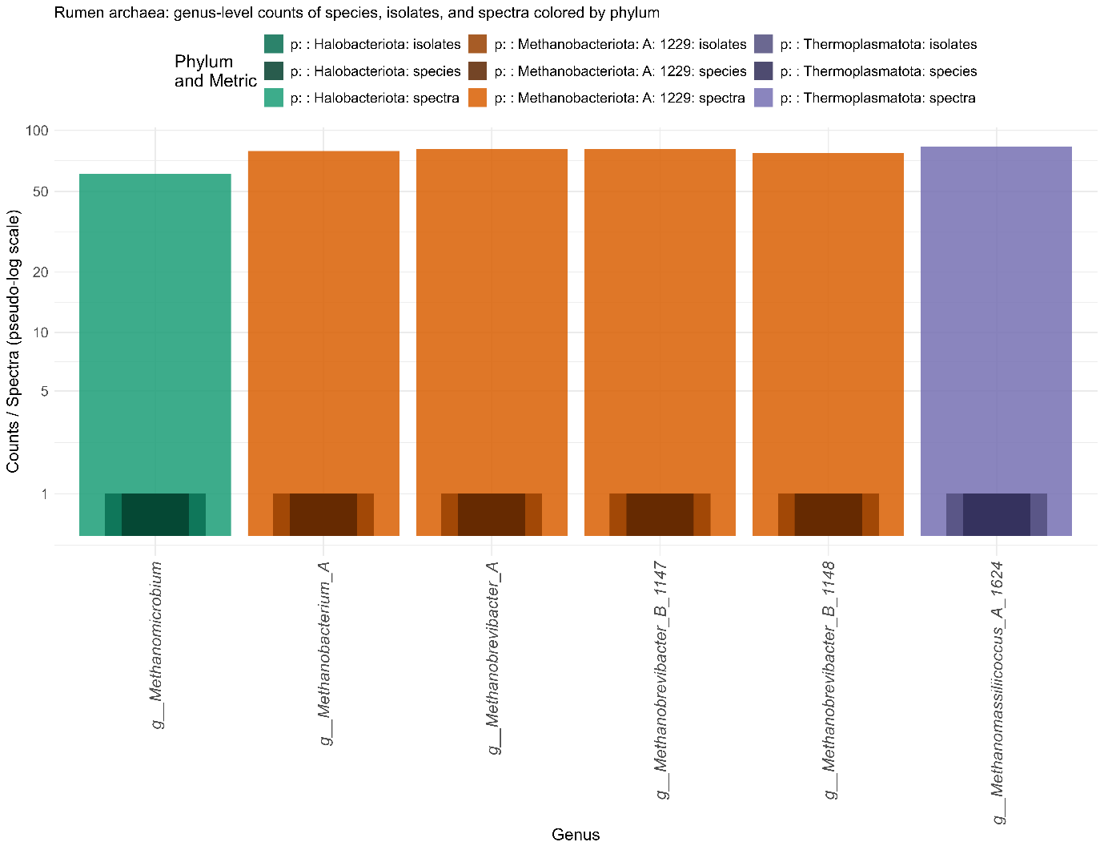
Supplementary Figure 1. Absolute counts of species, isolates, and spectra for each genus across archaeal phyla. Bars are layered with spectra at the back, isolates in the middle, and species in the front; darker shades indicate isolates and species relative to the spectra of the same phylum. Genera are coloured by phylum. A pseudo-logarithmic y-axis expands low counts while compressing high values, allowing all three types of data to be visualised simultaneously.

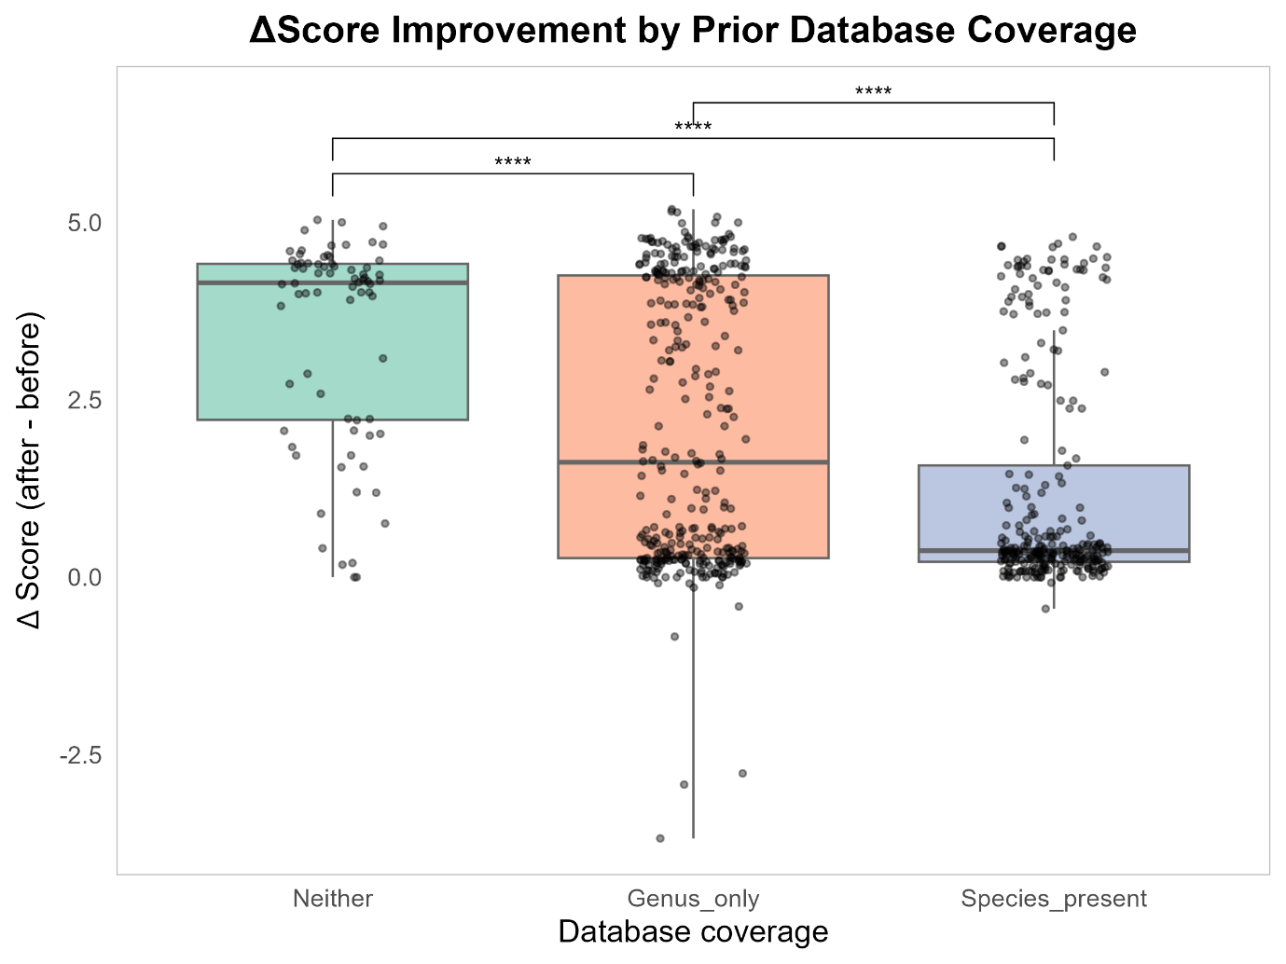
Supplementary Figure 2. Improvement in rumen bacteria MALDI-TOF MS identification scores by prior database coverage. Boxplots show the distribution of ΔScores (score after – score before) for isolates grouped by whether the genus and/or species were present in the original instrument database. Jittered points represent individual isolates. Isolates for which neither genus nor species was previously present (“Neither”) showed the largest median and mean improvements, followed by isolates with only the genus present (“Genus_only”), and then isolates with the species already present (“Species_present”). Statistical significance of pairwise comparisons from Dunn’s test (post-hoc to Kruskal–Wallis) is indicated above the boxes (**** p.adj < 0.001). This supplementary figure illustrates that the custom database had the greatest impact on previously underrepresented taxa, consistent with the overall improvement in identification scores.

Supplementary Table 4. Technical replicate-level summary for all methanogen species. Mean and standard deviation (SD) of scores before and after the database update, mean differences, and number of technical replicates for each biological replicate of each species.
species | rep | Mean before | SD before | Mean after | SD after | Mean diff | N tech reps
M. formicicum | Rep_1 | 7.175 | 0.665 | 9.748 | 0.033 | 2.573 | 26
M. formicicum | Rep_2 | 5.070 | 0.276 | 9.678 | 0.169 | 4.607 | 26
M. formicicum | Rep_3 | 4.946 | 0.211 | 9.621 | 0.226 | 4.675 | 25
M. formicicum | Val | 5.143 | 0.342 | 9.636 | 0.109 | 4.493 | 8
M. ruminantium | Rep_1 | 4.850 | 0.247 | 9.333 | 0.213 | 4.483 | 27
M. ruminantium | Rep_2 | 4.949 | 0.208 | 9.368 | 0.610 | 4.419 | 57
M. ruminantium | Rep_3 | 4.863 | 0.248 | 9.578 | 0.294 | 4.715 | 25
M. ruminantium | Val | 4.869 | 0.216 | 9.411 | 0.291 | 4.541 | 8
M. smithii | Rep_1 | 4.819 | 0.300 | 9.607 | 0.267 | 4.788 | 27
M. smithii | Rep_2 | 4.742 | 0.219 | 9.613 | 0.285 | 4.872 | 53
M. smithii | Rep_3 | 4.730 | 0.209 | 9.556 | 0.281 | 4.826 | 34
M. smithii | Val | 5.158 | 0.262 | 9.427 | 0.308 | 4.269 | 6
M. wolinii | Rep_1 | 4.911 | 0.195 | 9.744 | 0.085 | 4.834 | 27
M. wolinii | Rep_2 | 5.313 | 0.543 | 9.559 | 0.236 | 4.245 | 26
M. wolinii | Rep_3 | 5.428 | 0.748 | 9.341 | 0.214 | 3.913 | 29
M. wolinii | Val | 4.935 | 0.221 | 9.414 | 0.192 | 4.478 | 6
M. luminyensis | Rep_1 | 4.952 | 0.208 | 9.653 | 0.054 | 4.701 | 27
M. luminyensis | Rep_2 | 4.858 | 0.271 | 9.747 | 0.037 | 4.889 | 29
M. luminyensis | Rep_3 | 5.004 | 0.243 | 9.823 | 0.032 | 4.819 | 30
M. luminyensis | Val | 4.931 | 0.197 | 9.631 | 0.049 | 4.700 | 8
M. mobile | Rep_1 | 7.554 | 1.574 | 9.188 | 1.045 | 1.634 | 30
M. mobile | Rep_2 | 4.851 | 0.220 | 9.710 | 0.083 | 4.859 | 30
M. mobile | Rep_3 | 7.067 | 1.959 | 9.728 | 0.181 | 2.661 | 20
M. mobile | Val | 5.095 | 0.345 | 9.624 | 0.062 | 4.529 | 7

Supplementary Table 5. Misidentified rumen archaeal samples before database update. This table shows technical replicates of rumen archaeal samples that were misidentified as non-archaeal taxa prior to the database update. Columns indicate the archaeal species, the taxon to which it was misidentified (Match before), and the number of technical replicates (N tech reps) affected out of a total of 591 replicates. These data highlight the correction of misidentifications following the database update.
species | Match before | N tech reps (of total 591 reps)
M. formicicum | Aspergillus niger | 19
M. mobile | Rhodotorula mucilaginosa | 12
M. mobile | Enterococcus faecium | 11
M. formicicum | Aspergillus niger (Aspergillus usamii) | 6
M. mobile | Penicillium citrinum | 5
M. mobile | Candida guilliermondii (Pichia guilliermondii) | 3
M. wolinii | Candida parapsilosis | 2
M. wolinii | Penicillium citrinum | 2
M. mobile | Aspergillus tubingensis | 2
M. wolinii | Aspergillus niger (Aspergillus usamii) | 1
M. wolinii | Aspergillus niger | 1

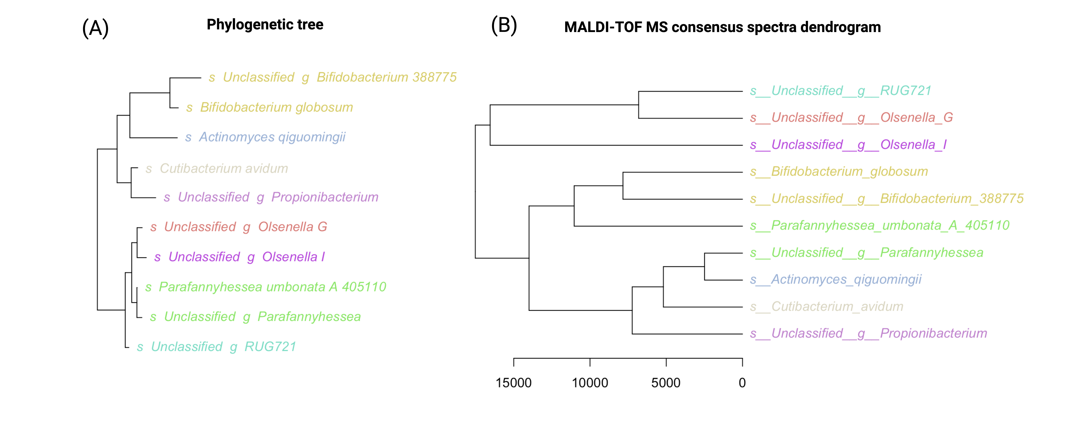
Supplementary Figure 3. Comparison of 16S rRNA gene phylogeny and MALDI-TOF MS spectral dendrogram for phylum Actinomycetota. (A) Phylogenetic tree based on the 16S rRNA gene sequences of species within the phylum. The tree has been collapsed at the species level. Tip labels are coloured by genus, using the same colour scheme as in panel (B). (B) Hierarchical clustering dendrogram of species based on consensus MALDI-TOF MS spectra. Distances were calculated using the Euclidean metric, and clustering used the average linkage method. Branch lengths are scaled proportionally to the calculated distances. Species labels are italicised and coloured by genus to match the 16S tree in panel (A).

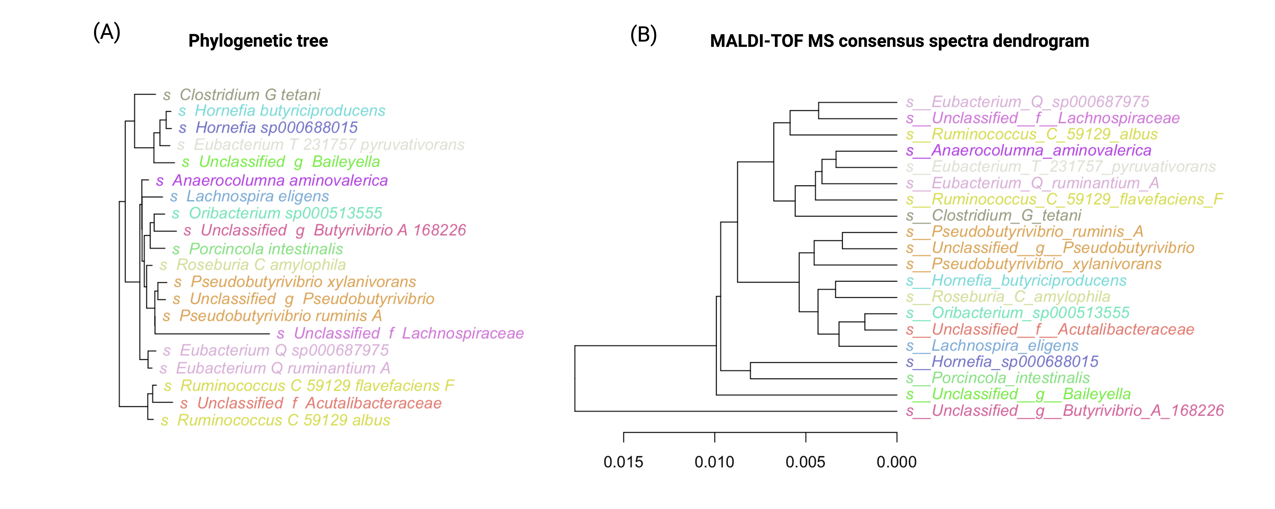
Supplementary Figure 4. Comparison of 16S rRNA gene phylogeny and MALDI-TOF MS spectral dendrogram for phylum Bacillota A 368345. (A) Phylogenetic tree based on the 16S rRNA gene sequences of species within the phylum. The tree has been collapsed at the species level. Tip labels are coloured by genus, using the same colour scheme as in panel (B). (B) Hierarchical clustering dendrogram of species based on consensus MALDI-TOF MS spectra. Distances were calculated using the Euclidean metric, and clustering used the average linkage method. Branch lengths are scaled proportionally to the calculated distances. Species labels are italicised and coloured by genus to match the 16S tree in panel (A).

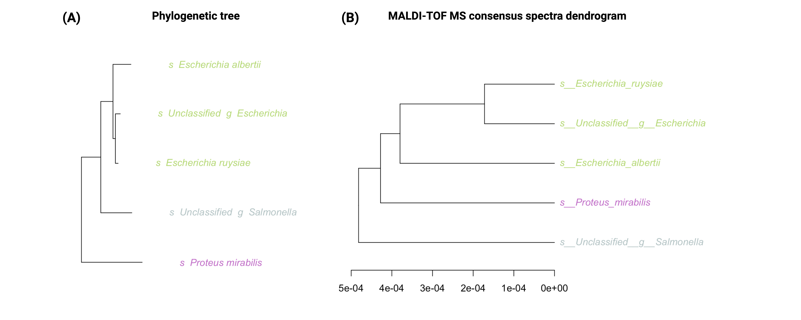
Supplementary Figure 5. Comparison of 16S rRNA gene phylogeny and MALDI-TOF MS spectral dendrogram for phylum Pseudomonadota. (A) Phylogenetic tree based on the 16S rRNA gene sequences of species within the phylum. The tree has been collapsed at the species level. Tip labels are coloured by genus, using the same colour scheme as in panel (B). (B) Hierarchical clustering dendrogram of species based on consensus MALDI-TOF MS spectra. Distances were calculated using the Euclidean metric, and clustering used the average linkage method. Branch lengths are scaled proportionally to the calculated distances. Species labels are italicised and coloured by genus to match the 16S tree in panel (A).

