Supplementary Materials

Extended Data Table 1: Baseline characteristics of the study population in the development and external test sets.
Characteristics | Development Set  (Center C, n=438 &  Center D, n=2580) | External Test Set-1 (Center A, n=466) | External Test Set-2 (Center B, n=559) | External Test Set-3 (Center E, n=672)
Demographics
Age, years | 56.8±23.5 | 54.0±22.2* | 67.4±18.5*** | 62.3±18.2***
Age group, n (%) | Ref. | *** | *** | ***
< 18 years | 362 (12.0%) | 53 (11.4%) | 22 (3.9%) | 36 (5.4%)
18-64 years | 1314 (43.5%) | 228 (48.9%) | 162 (29.0%) | 289 (43.0%)
65-79 years | 863 (28.6%) | 146 (31.3%) | 220 (39.4%) | 255 (37.9%)
≥ 80 years | 479 (15.9%) | 39 (8.4%) | 155 (27.7%) | 92 (13.7%)
Technical Parameters
CT Manufacturer, n (%)
GE | 439 (14.5%) | 466 (100.0%) | 559 (100.0%) | 672 (100.0%)
Siemens | 2579 (85.5%) | 0 (0.0%) | 0 (0.0%) | 0 (0.0%)
Head NCCT Subgroup | (n=1680) | (n=0) | (n=312) | (n=247)
Slice thickness, n (%) | Ref. | N/A | ns | ns
Thin layer (≤ 1.5mm) | 1678 (99.9%) | N/A | 312 (100.0%) | 246 (99.6%)
Thick layer (> 1.5mm) | 2 (0.1%) | N/A | 0 (0.0%) | 1 (0.4%)
Qualified (no defect), n (%) | 1320 (78.6%) | N/A | 80 (25.6%)*** | 198 (80.2%)
Sub-optimal (≥1 defect), n (%) | 360 (21.4%) | N/A | 232 (74.4%)*** | 49 (19.8%)
Isolated defect | 306 (18.2%) | N/A | 199 (63.8%)*** | 47 (19.0%)
Multiple defects (≥2) | 54 (3.2%) | N/A | 33 (10.6%)*** | 2 (0.8%)
Thorax NCCT Subgroup | (n=1338) | (n=466) | (n=247) | (n=425)
Slice thickness, n (%) | Ref. | *** | ns | ***
Thin layer (≤ 1.5mm) | 1338 (100.0%) | 439 (94.2%) | 247 (100.0%) | 341 (80.2%)
Thick layer (> 1.5mm) | 0 (0.0%) | 27 (5.8%) | 0 (0.0%) | 84 (19.8%)
Qualified (no defect), n (%) | 184 (13.8%) | 106 (22.7%)*** | 49 (19.8%)* | 38 (8.9%)*
Sub-optimal (≥1 defect), n (%) | 1154 (86.2%) | 360 (77.3%)*** | 198 (80.2%)* | 387 (91.1%)*
Isolated defect | 465 (34.8%) | 183 (39.3%) | 83 (33.6%) | 107 (25.2%)***
Multiple defects (≥2) | 689 (51.5%) | 177 (38.0%)*** | 115 (46.6%) | 280 (65.9%)***
Data are Mean±Std for continuous variables and n (%) for categorical variables. N/A = not applicable, ns = not significant (p ≥ 0.05). Asterisks (*) indicate statistical significance compared with the Development Set (Ref.): * p<0.05, ** p<0.01, *** p<0.001. Age, years was compared using independent-samples Student's t-test; all other categorical variables use χ² test.

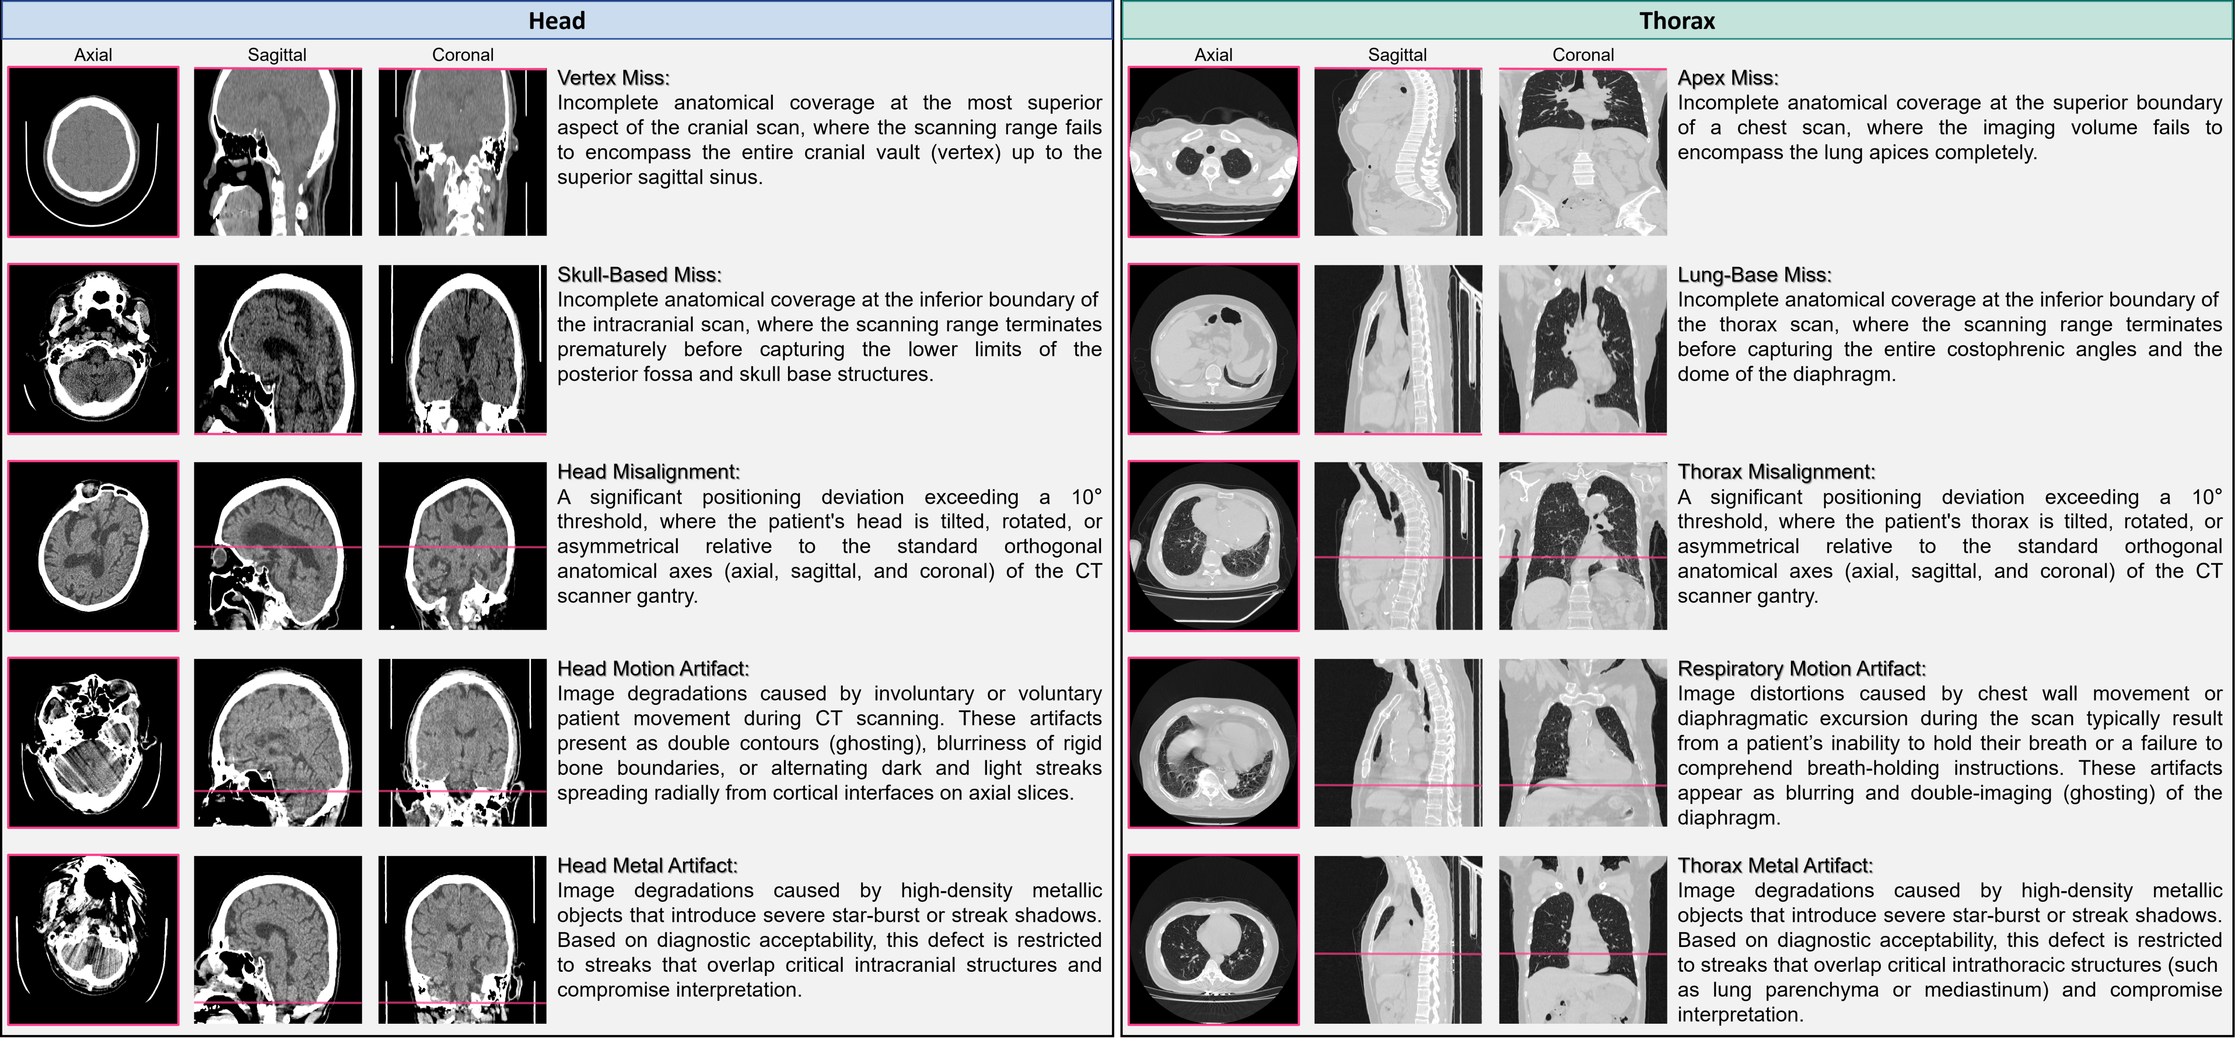
Extended Data Fig. 1: Detailed definitions and visual examples of various quality defects in this study.
Extended Data Table 2: The age distribution of all centers in the retrospective cohort.
Characteristics | Center A | Center B | Center C | Center D | Center E
Total. Number of Individuals | 466 | 559 | 438 | 2580 | 672
Total age distribution | 54.00±22.25 | 68.52±17.83 | 58.85±22.03 | 55.63±25.30 | 61.74±18.60
Incomplete Vertex Scan | N/A | N/A | 62.00±00.00 | N/A | 64.00±16.71
w/o Incomplete Vertex Scan | N/A | 68.52±17.83 | 58.83±22.08 | 55.63±25.30 | 59.57±21.42
Incomplete Skull-base Scan | N/A | N/A | N/A | 70.50±25.88 | 63.10±24.23
w/o Incomplete Skull-base Scan | N/A | 68.52±17.83 | 58.85±22.03 | 55.59±25.29 | 59.55±21.20
Head Misalignment | N/A | 68.84±25.44 | 68.12±14.39 | 56.82±26.89 | 61.61±26.07
w/o Head Misalignment | N/A | 68.50±17.27 | 58.50±22.21 | 55.45±25.05 | 59.28±20.16
Head Motion Artifact | N/A | 68.55±18.68 | 57.95±25.31 | 55.64±27.79 | 67.56±11.69
w/o Head Motion Artifact | N/A | 68.45±15.31 | 58.93±21.77 | 55.63±25.07 | 59.15±21.70
Head Metal Artifact | N/A | 75.14±9.93 | 58.57±25.14 | 62.58±24.07 | 66.78±18.30
w/o Head Metal Artifact | N/A | 68.04±18.19 | 58.89±21.58 | 55.39±25.31 | 59.43±21.38
Incomplete Apex Scan | 51.60±24.19 | 28.00±00.00 | N/A | 75.00±10.58 | N/A
w/o Incomplete Apex Scan | 54.06±22.23 | 66.97±17.92 | 53.43±22.88 | 59.26±20.25 | 63.78±15.90
Incomplete Lung-base Scan | 47.96±22.50 | 60.89±17.84 | 61.75±10.21 | 58.16±18.16 | 62.27±13.24
w/o Incomplete Lung-base Scan | 54.38±22.21 | 67.54±17.99 | 53.27±23.03 | 59.52±20.54 | 64.03±16.30
Thorax Misalignment | 52.27±23.61 | 74.31±18.86 | 63.16±24.32 | 74.52±16.64 | 68.93±13.83
w/o Thorax Misalignment | 54.24±22.08 | 65.57±17.66 | 51.79±22.28 | 57.81±19.94 | 59.89±16.27
Respiratory Motion Artifact | 52.16±22.02 | 71.96±16.74 | 55.69±23.53 | 64.40±19.32 | 67.36±13.74
w/o Respiratory Motion Artifact | 56.03±22.38 | 60.71±17.71 | 48.96±20.96 | 50.09±18.56 | 55.75±17.45
Thorax Metal Artifact | 52.54±23.37 | 69.09±16.26 | 57.87±19.26 | 64.28±16.61 | 64.07±14.88
w/o Thorax Metal Artifact | 55.52±20.97 | 63.82±19.85 | 45.48±26.55 | 51.14±22.90 | 63.33±17.40
Results are presented in Mean±Std. N/A = not applicable.

