Blood Research
Prognostic factors and an exploratory risk stratification model in newly diagnosed Pola-R-CHP-treated diffuse large B-cell lymphoma: A real-world retrospective cohort analysis

Yohei Sasaki^{a,b,}*, Shotaro Shimadaª, Hirotaro Sakaki, Ayano Shirai, Hidenori Hayashiª, Natsuki Kawamataª, Kazuki Nagaoª, Kai Kuroiwaª, Hinako Naritaª, Reiko Okamuraª, Megumi Watanukiª, Nana Araiª, Kouji Yanagisawaª, and Norimichi Hattoriª

* Corresponding Author: Yohei Sasaki
Division of Hematology, Department of Medicine, Showa Medical University School of Medicine, 1-5-8 Hatanodai, Shinagawa-Ku, Tokyo 142-8666, Japan
E-mail: ysasaki@med.showa-u.ac.jp

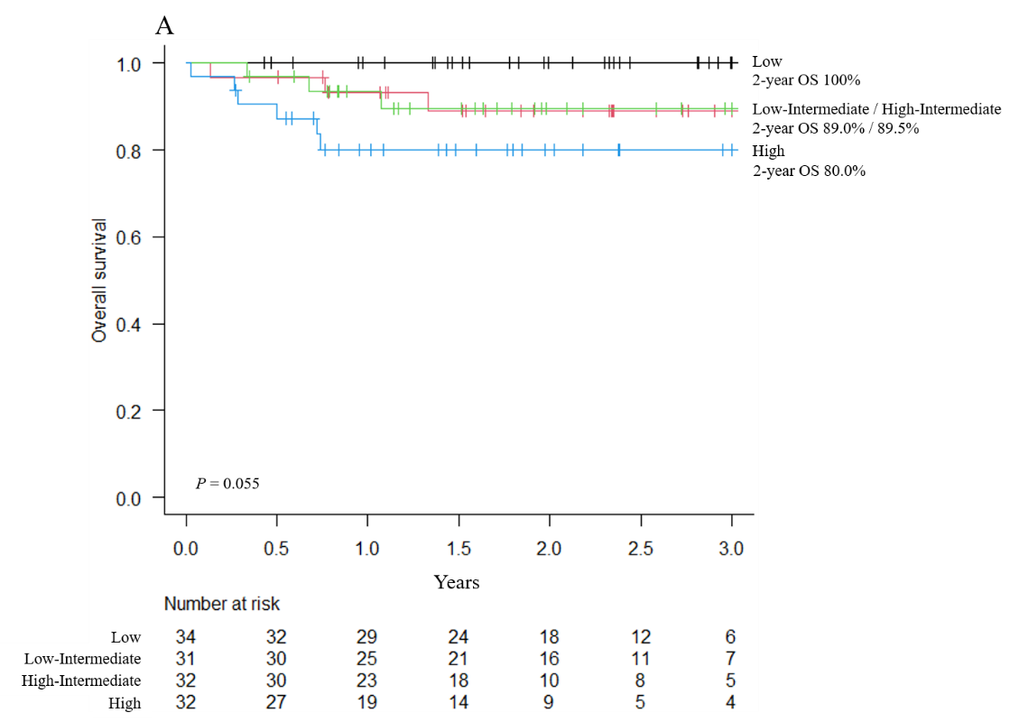
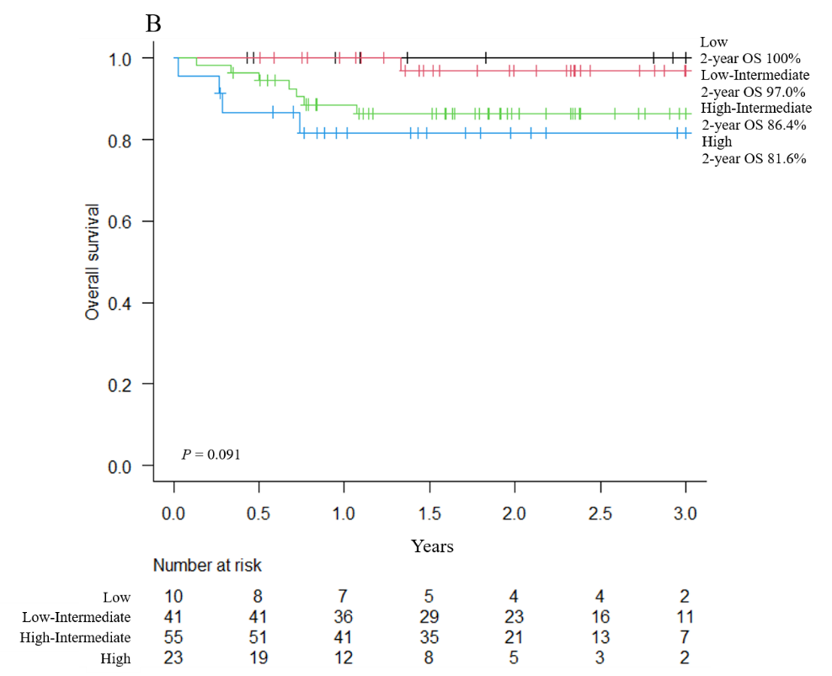
Supplementary Fig. 1 Kaplan–Meier curves showing overall survival (OS) in patients with diffuse large B-cell lymphoma treated with polatuzumab vedotin, rituximab, cyclophosphamide, doxorubicin, and prednisolone stratified according to the (A) International Prognostic Index and (B) National Comprehensive Cancer Network International Prognostic Index

