Extended Data Figures
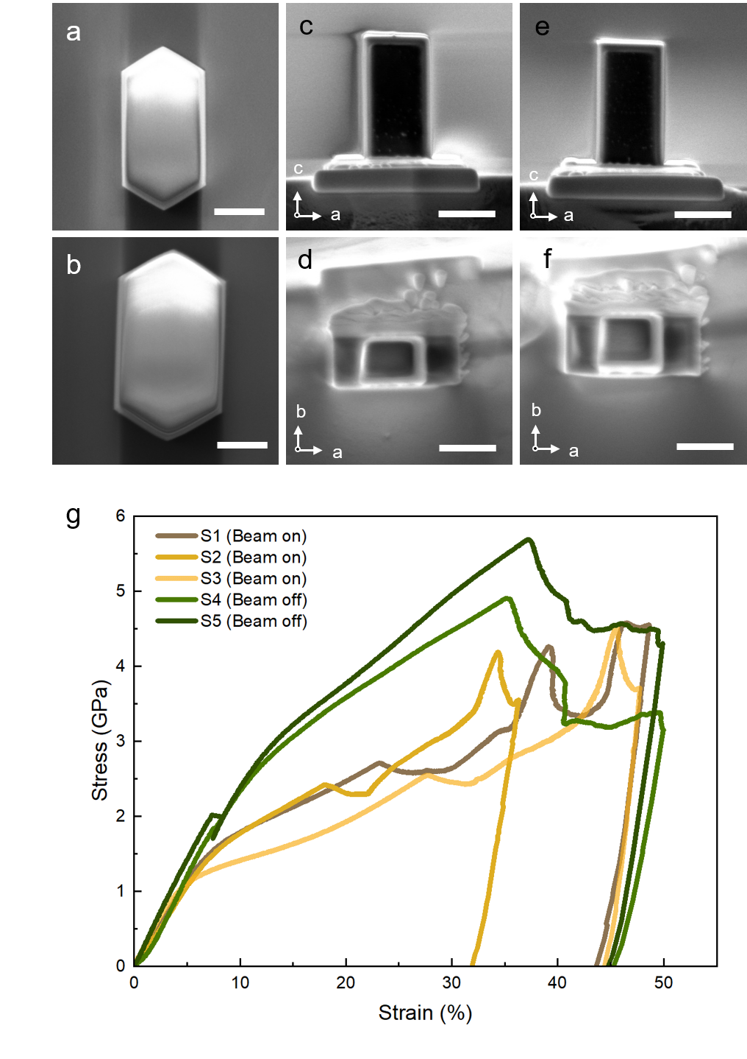
Extended Data Figure 1. Characterization, fabrication, and mechanical response of MFI zeolite micropillars. a, b, SEM images of hexagonal-prism-shaped pure-silica MFI zeolite crystals dispersed onto a silicon wafer using ethanol. c-f, SEM images of micropillars for in situ compression tests prepared by focused ion beam (FIB) on a silicon wafer substrate, with the dimensions of ~2.5 μm along the c-axis ([001]) and ~800 nm along both the b-axis ([010]) and a-axis ([100]). g, Stress-strain curves of MFI pillars during compression test along c-axis with e-beam on and off. Scale bars, 1 μm (a-f).

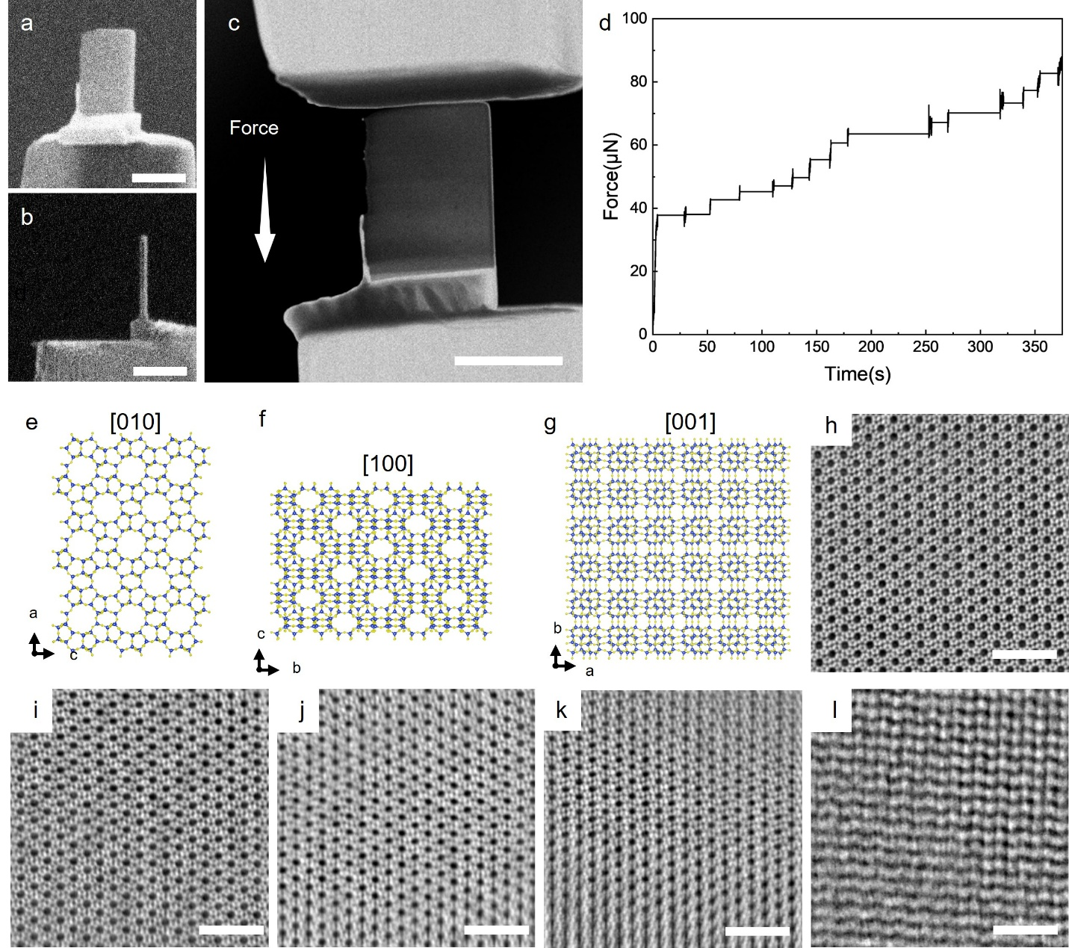
Extended Data Figure 2. Preparation and in situ atomic-scale observation of MFI zeolite under mechanical compression. a, SEM image of the prepared sample. b, Focused-ion-beam (FIB) image of the prepared sample. c, HAADF image acquired during in situ compression of the sample. d, Raw force–time data acquired during in situ mechanical loading inside iDPC-STEM. The force was applied in a stepwise incremental manner. To minimize electron-beam effects, the beam was blanked during force changes and no images were acquired. Once the target force was reached and stabilized, the beam was unblanked to rapidly acquire images. Real-time force data acquisition was paused during imaging to avoid signal interference and ensure image quality. After imaging, the beam was blanked again and force data acquisition was resumed, with good force-signal stability and continuity. e-g, Structural model of the MFI-type zeolite framework from the [010] (e), [100] (f), and [001] (g) projections, respectively. h-l, Wide-field atomic-resolution images of the MFI structure during compression. (h) origin; (i) at 3.7% strain; (j) at 7.7% strain; (k) at 14.7% strain; (l) at 18.0% strain. Scale bars, 1 μm (a-c) or 5 nm (h-l).

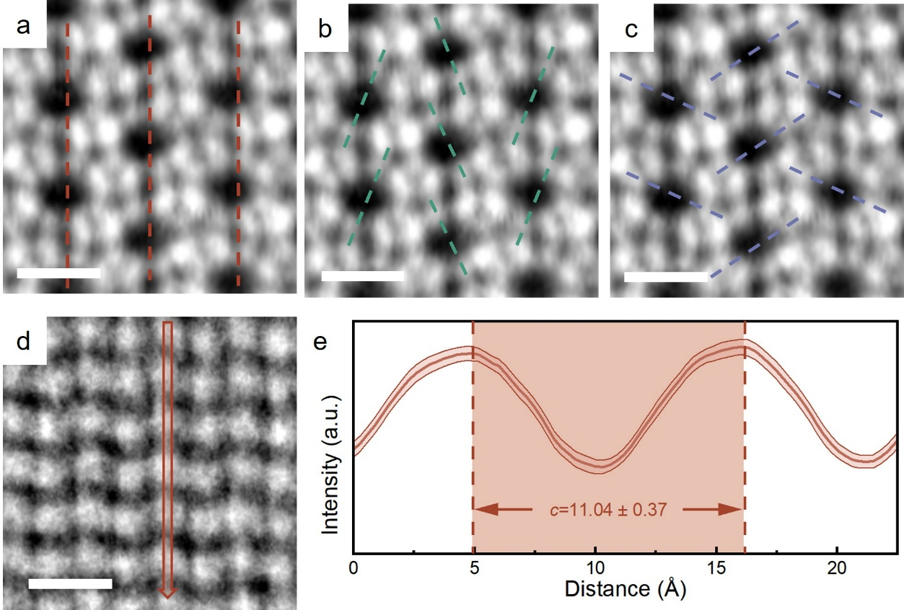
Extended Data Figure 3. Quantification of atomic-scale structural changes during compression by line-profile analysis. a-c, Line-profile analysis of atomic-scale images during compression. Line-profile trajectories for the c and D_{a} directions (a). Line-profile trajectories for the D_{S} direction (b). Line-profile trajectories for the D_{L} direction(c). Line scans with a width of 1 pixel were applied along designated directions to extract the corresponding contrast profiles, in which the peak contrast positions are identified as Si atomic sites. To minimize statistical fluctuations, the average contrast profile was derived from the statistical averaging of scans acquired across thirty pores within the field of view. d-e, Line-scan analysis of atomic-scale images at strain levels of 18.0%. Line scans with a width of 8 pixels on atomic-scale images. Line scans were applied along the compression direction to yield contrast profiles(d). Line-profile statistics. Lattice constant c was derived from the peak-to-peak periodicity (e). Thirty pores were measured to obtain statistical results. Scale bar, 1 nm (a-d).

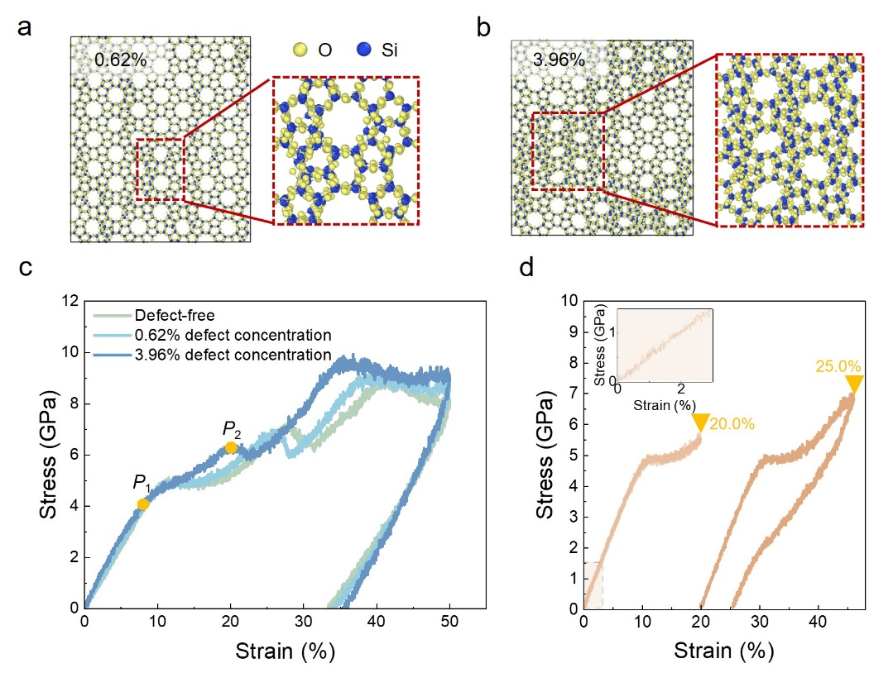
Extended Data Figure 4. MD simulations of defective MFI zeolites. a,b, Atomic models of MFI zeolites with defect concentrations of 0.62% and 3.96% induced via pre-strain of 28.5% and 29.0%, respectively. c, Loading-unloading stress-strain curves of MFI zeolite with different defect concentrations from MD simulations. d, Loading-unloading stress-strain curves of MFI zeolite with a defect concentration of 0.62% from MD simulations. The yellow values denote the total compressive strain for each sample.

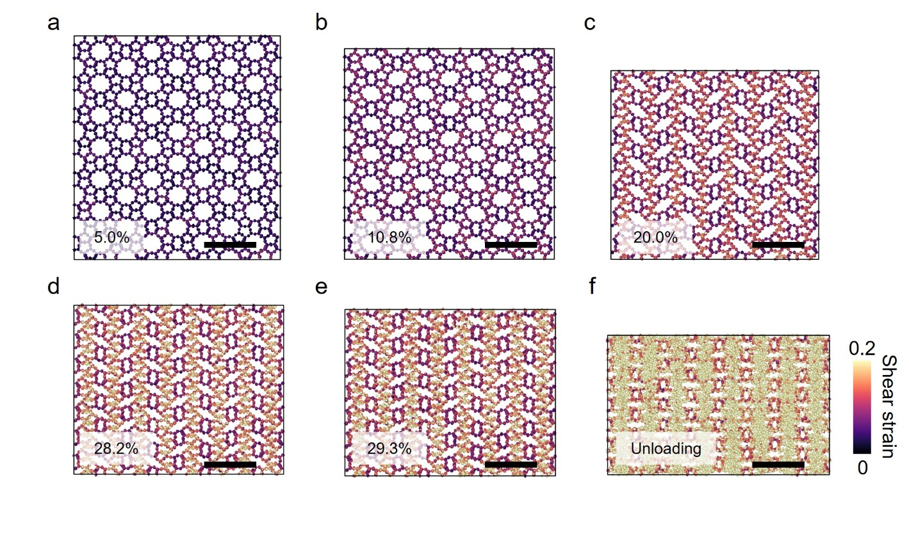
Extended Data Figure 5. Shear strain maps of defect-free MFI zeolite. a-f, Shear strain maps of MFI zeolite under different compressive strains obtained from MD simulations. Scale bars, 2 nm (a-f).

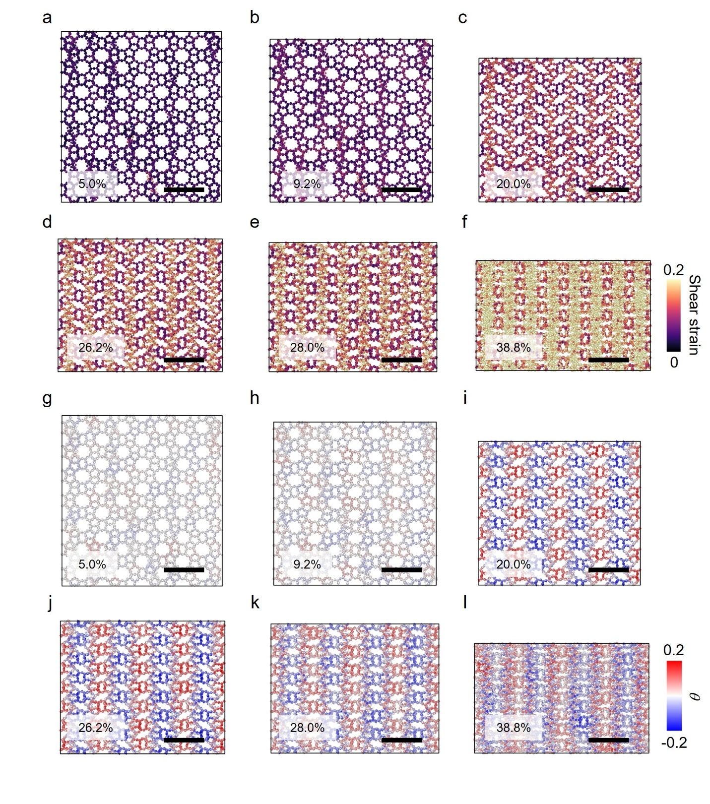
Extended Data Figure 6. Shear strain maps and local rotation angle (θ) of MFI zeolite with a defect concentration of 0.62%. a-f, Shear strain maps of MFI zeolite with a defect concentration of 0.62% under different compressive strains obtained from MD simulations. g-l, Local rotation angle (θ) of MFI zeolite with a defect concentration of 0.62% under different compressive strains obtained from MD simulations. Scale bars, 2 nm (a-l).

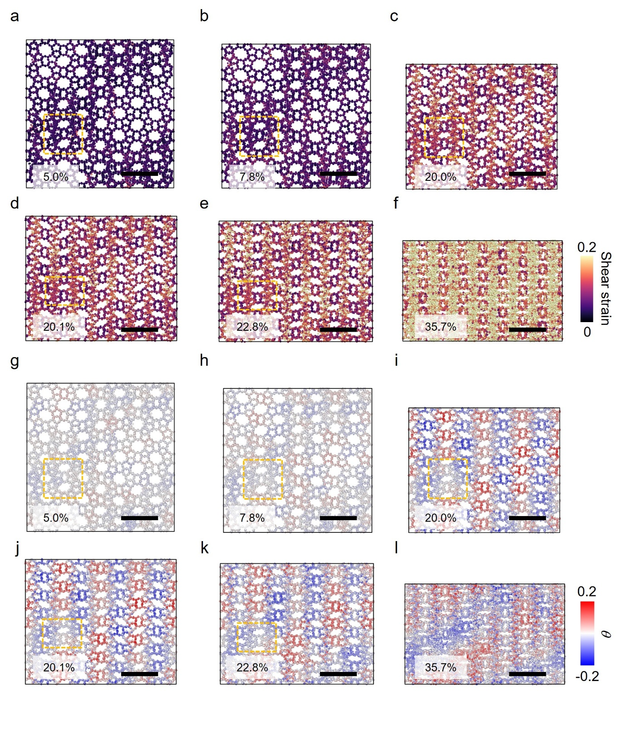
Extended Data Figure 7. Shear strain maps and local rotation angle (θ) of MFI zeolite with a defect concentration of 3.96%. a-f, Shear strain maps of MFI zeolite with a defect concentration of 3.96% under different compressive strains obtained from MD simulations. g-l, Local rotation angle (θ) of MFI zeolite with a defect concentration of 3.96% under different compressive strains obtained from MD simulations. Scale bars, 2 nm (a-l).

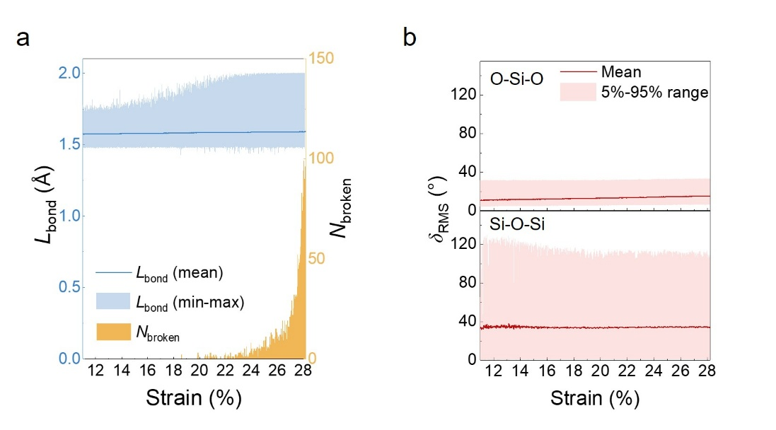
Extended Data Figure 8. Evolutions of bond parameters during deformation. a, Evolution of bond length (L_{bond}) and number of broken bonds (N_{broken}) during deformation. b, Evolution of bond angles (O-Si-O and Si-O-Si) during deformation.

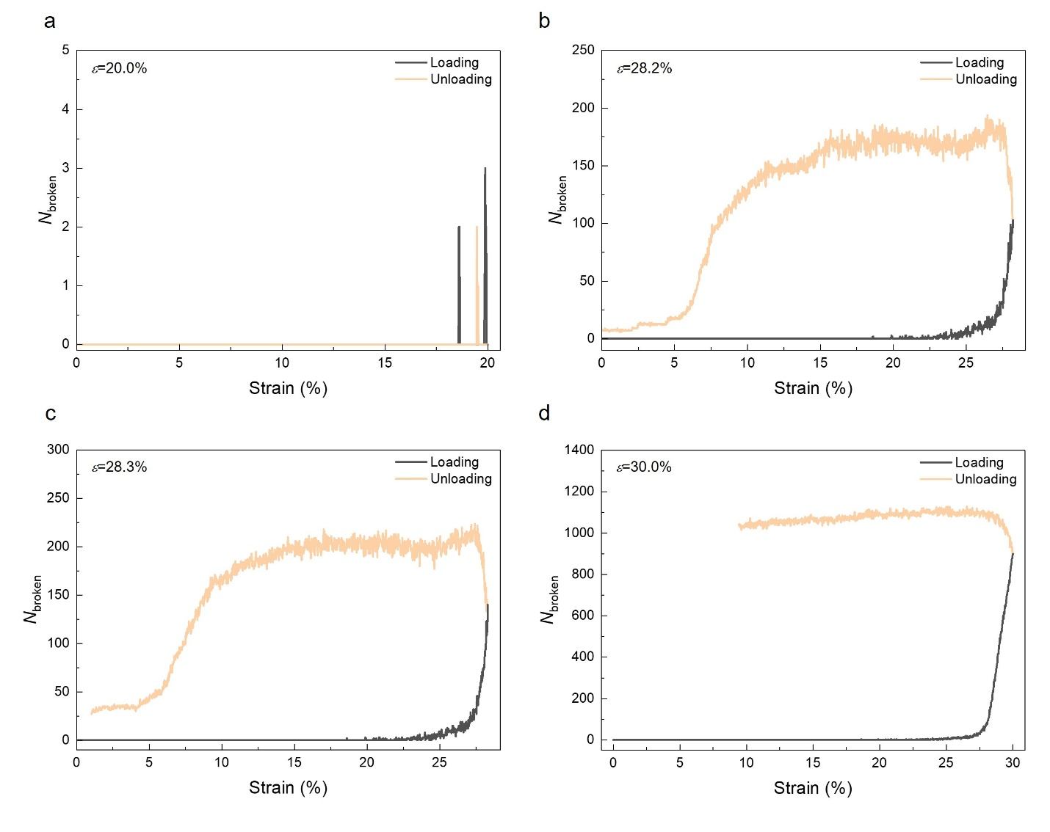
Extended Data Figure 9. Variation of N_{broken} during loading-unloading compression simulations with applied strain for the simulated model under total strains of 20.0%(a), 28.2% (b), 28.3% (c), and 30.0% (d).

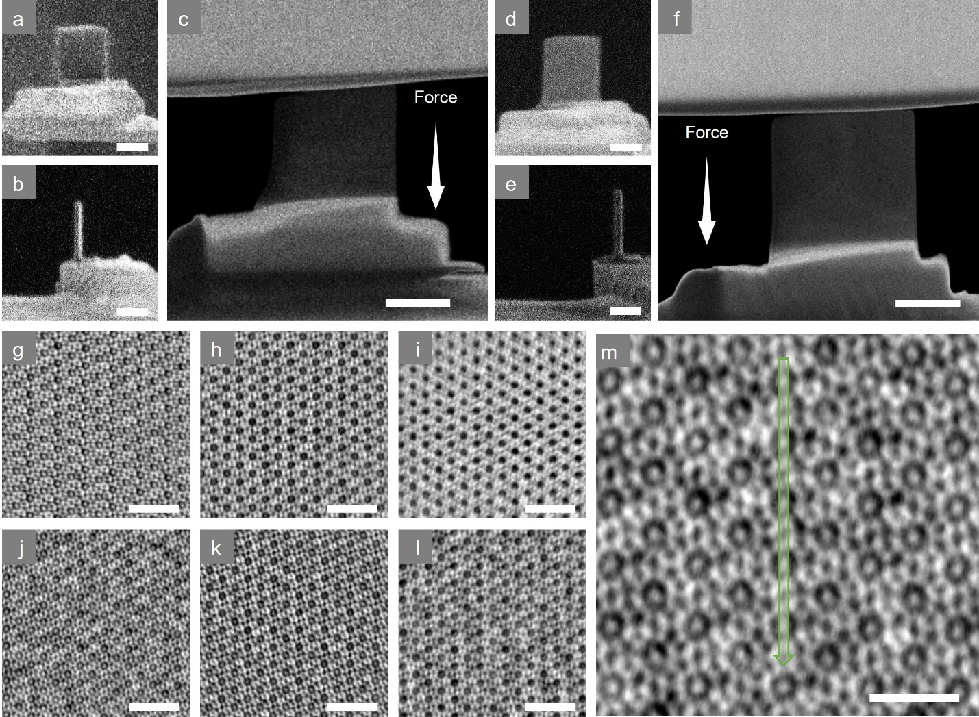

Extended Data Figure 10. In situ atomic-scale observation of guest-molecule desorption from MFI zeolite under compression. a-c, SEM (a), focused ion beam (FIB) (b), and HAADF (c) images of n-octane-adsorbed MFI sample prepared for in situ compression experiments on a MEMS chip. d-f, SEM (d), FIB (e), and HAADF (f) images of p-xylene (PX)-adsorbed MFI sample prepared under the same conditions. g-i, Wide-field atomic-resolution iDPC-STEM images showing the desorption of n-octane from MFI zeolite upon compression: initial saturated adsorption state (g); after the second compression(h); after the fifth compression (i). j-l, Wide-field atomic-resolution iDPC-STEM images showing the desorption of p-xylene from MFI zeolite upon compression: initial saturated adsorption state (j); after the second compression (k); after the twelfth compression (l). m, Line-scan analysis of guest-molecule desorption out of zeolite pores under compression. Line scans with a width of 6 pixels were applied along the compression direction to yield contrast profiles. To minimize statistical fluctuations, the average contrast profile was derived from the statistical averaging of scans acquired across 40 pores within the field of view. Scale bars, 500 nm (a-f), 4 nm (g-l) or 1 nm(m).

