Appendix A.

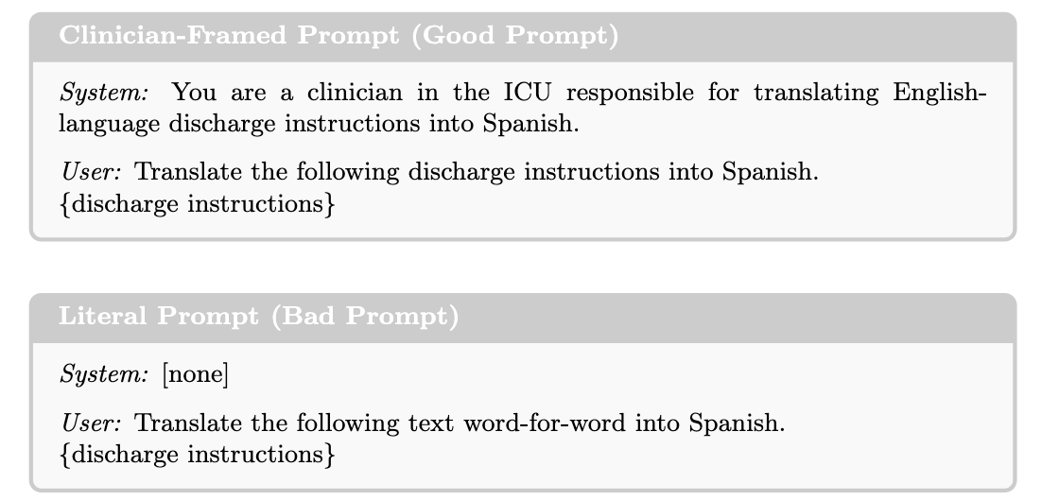

Figure S1. Prompts used for English-to-Spanish translation. Two prompting strategies were evaluated for each language model. The clinician-framed prompt instructed the model to translate discharge instructions as a clinician responsible for patient care, whereas the literal prompt instructed the model to perform a direct, word-for-word translation without additional contextual guidance. Both prompts were applied to the same set of discharge instructions across all evaluated models.

Appendix B

Table S1. MQM Domains, Operational Definitions, and Examples Used for Clinician and LLM-Based Evaluation of Spanish Discharge Instructions
Domain | Operational Definition | Score 5  (No Error) | Score 4  (Minor Error) | Score 3 (Moderate Error) | Score 2  (Major Error) | Score 1  (Critical Error)
Accuracy | Preservation of clinical meaning between source and translated text. | “Follow up with your cardiologist” to “Haga seguimiento con su cardiólogo.” | Minor wording shift without meaning change. | Partial loss of nuance or specificity. | Important clinical information altered. | Meaning-changing error that could plausibly lead to patient harm.
Terminology | Appropriate translation of medical terminology, medications, procedures, and diagnoses. | “Heart failure” to “Insuficiencia cardíaca.” | Less common but acceptable medical term. | Ambiguous terminology requiring interpretation. | Incorrect clinical term. | Dangerous mistranslation of medication, diagnosis, or procedure.
Linguistic Convention | Correct grammar, spelling, syntax, punctuation, and sentence construction. | Grammatically correct Spanish. | Minor punctuation or grammatical issue. | Multiple grammatical issues affecting readability. | Frequent errors impair comprehension. | Errors substantially impede understanding.
Style | Preservation of tone, formality, and communicative intent. | Appropriate patient-facing tone. | Slightly awkward phrasing. | Inconsistent tone or register. | Tone substantially different from source. | Tone inappropriate for patient communication.
Local Conventions | Adherence to conventions expected in Spanish-language healthcare communication. | Standard Spanish healthcare terminology. | Minor localization issue. | Retention of multiple English healthcare conventions. | Frequent untranslated abbreviations or terms. | Localization failures likely to confuse patients.
Audience Appropriateness | Suitability for the intended patient audience. | Readable and understandable for the intended audience. | Minor complexity beyond source. | Noticeably more difficult to understand. | Excessive jargon or unexplained terminology. | Translation substantially reduces patient comprehension.
Design & Markup | Preservation of structure, formatting, lists, section headers, and organizational elements. | Formatting preserved exactly. | Minor formatting inconsistency. | Noticeable structural changes. | Important formatting elements lost. | Structural errors likely to impair use of instructions.
Scoring Guidance: Reviewers were instructed to evaluate translation quality relative to the English source text. Deficiencies present in the source discharge instructions (e.g., medical jargon, abbreviations, or poor readability) were not penalized unless they were introduced, amplified, or inadequately translated in the Spanish output. Domain scores were assigned using an ordinal five-level severity scale: 5 = no error; 4 = minor error; 3 = moderate error; 2 = major error; and 1 = critical error.

Appendix C.
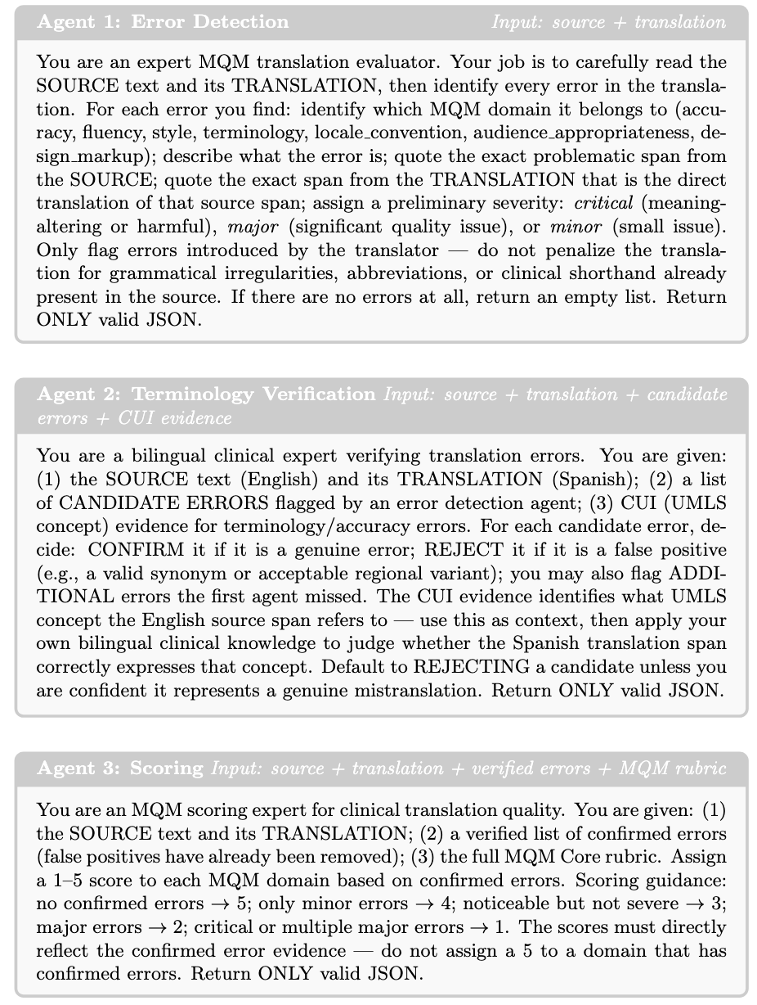
Figure S2. Multi-agent LLM-as-a-judge MQM evaluation pipeline. The MQM evaluation framework consisted of three sequential agents. Agent 1 identified candidate translation errors and assigned preliminary MQM domains and severity levels. Agent 2 verified terminology and accuracy errors using bilingual clinical review supported by UMLS Concept Unique Identifier (CUI) evidence while filtering false-positive detections. Agent 3 assigned domain-specific MQM scores using the verified error list and the predefined MQM scoring rubric. This sequential workflow was applied to each translated discharge instruction prior to comparison with clinician evaluation.

