Supplementary Material
Older Adults With Cardiovascular-Kidney-Metabolic Stage 2: Six-Year Risk Stratification Using NT-proBNP and TNFR1
Supplementary Tables
Supplementary Table 1. Candidate TNFR1 threshold.
Item | Value
Candidate TNFR1 threshold | 1906.7 pg/mL
Threshold percentile in NT-proBNP <125 subgroup | 83.0%
CVD/death risk below threshold | 13.5%
CVD/death risk above threshold | 27.5%
Adjusted HR above vs below threshold | 1.68 (1.37-2.05)
Bootstrap selected threshold, median (IQR) | 1906.7 (1887.4-1939.7) pg/mL
Bootstrap within 10% of candidate | 93.3%
Note. Candidate thresholds were evaluated among CKM stage-2 participants with NT-proBNP <125 pg/mL. CI, confidence interval; CVD, cardiovascular disease; HR, hazard ratio; IQR, interquartile range; TNFR1, tumor necrosis factor receptor 1.

Supplementary Table 2. Incremental model performance.
Outcome | Added TNFR1 term | N/events | Delta C-index | Delta AIC
Incident CVD | Continuous log TNFR1 | 4055/396 | +0.000 | +1.7
Incident CVD | Candidate threshold | 4055/396 | +0.004 | -2.2
Death | Continuous log TNFR1 | 4055/268 | +0.014 | -23.9
Death | Candidate threshold | 4055/268 | +0.018 | -22.7
CVD or death | Continuous log TNFR1 | 4055/645 | +0.004 | -10.7
CVD or death | Candidate threshold | 4055/645 | +0.011 | -22.1
Note. Delta values compare models with TNFR1 terms against the corresponding base model. AIC, Akaike information criterion; CVD, cardiovascular disease; TNFR1, tumor necrosis factor receptor 1.

Supplementary Table 3. Sensitivity and literature context.
Analysis | Outcome | Estimate | P value | Study/context | Overlap | Remaining difference
Survey-weighted low-NT threshold | Incident CVD | HR 1.29 (0.94-1.76) | 0.111
Survey-weighted low-NT threshold | Death | HR 2.56 (1.78-3.67) | <0.001
Survey-weighted low-NT threshold | CVD or death | HR 1.75 (1.39-2.19) | <0.001
Fine-Gray sequential group | Incident CVD | SHR 1.38 (1.09-1.75) | 0.008
Fine-Gray sequential group | Incident CVD | SHR 2.39 (2.02-2.82) | <0.001
Restricted cubic spline nonlinearity | Incident CVD | P-nonlinearity 0.167 | 0.167
Restricted cubic spline nonlinearity | Death | P-nonlinearity 0.105 | 0.105
Restricted cubic spline nonlinearity | CVD or death | P-nonlinearity 0.011 | 0.011
 |  |  |  | ARIC investigators, Circulation, 2026 | Strongly overlaps with CKM staging in older adults and subclinical cardiac structure/function. | Focuses on CKM stages and echocardiography/HF, not NT-proBNP-based risk refinement inside measured stage 2; outcome is HF rather than broad CVD/death.
 |  |  |  | European Heart Journal QCCO, 2026 | Very close to the idea that NT-proBNP adds value beyond PREVENT-type clinical risk. | Not framed around CKM stage 2; not HRS; focuses on ASCVD and PREVENT risk categories rather than measured CKM stage-2 concentration in older adults.
 |  |  |  | Diabetes Obesity and Metabolism, 2026 | Uses CKM stages 2-3 and PREVENT comparator to study residual risk. | Uses high-dimensional proteomics in UKB; not a simple clinical NT-proBNP rule; includes stage 3; not focused on CKM stage 2 containing most older adults.
 |  |  |  | Journal of Cardiac Failure, 2026 | Supports NT-proBNP as a marker of subclinical cardiac stress in community cohorts. | Heart-stress/pre-HF framework, not CKM stage-2 refinement; not HRS; not broad CVD/death as the primary framing.
 |  |  |  | Wang et al., New England Journal of Medicine, 2004 | Establishes natriuretic peptides as prognostic cardiovascular biomarkers. | Pre-CKM era; no CKM staging, no PREVENT comparator, no stage-2 refinement question.
 |  |  |  | Scientific Reports, 2026 | Same public-database CKM stage 0-3/CVD direction; uses routine metabolic index. | CHARLS, not HRS; metabolic/adiposity index, not NT-proBNP cardiac stress; not measured stage 2 overconcentration.
 |  |  |  | Cardiovascular Diabetology, 2026 | CKM stages 0-3 plus routine-derived marker prediction of CVD. | Metabolic/insulin-resistance markers; no NT-proBNP; no HRS; not focused on measured stage 2.
 |  |  |  | Cardiovascular Diabetology, 2026 | Very close to public-database CKM stage 0-3 + marker + prediction metrics style. | Inflammation/insulin-resistance/adiposity index; no cardiac-stress biomarker; not HRS; not measured stage-2 refinement.
Note. Sensitivity analyses include survey-weighted models, Fine-Gray competing-risk models, restricted cubic spline tests, and closest literature context. CKM, cardiovascular-kidney-metabolic; CVD, cardiovascular disease; SHR, subdistribution hazard ratio; TNFR1, tumor necrosis factor receptor 1.

Supplementary Figures
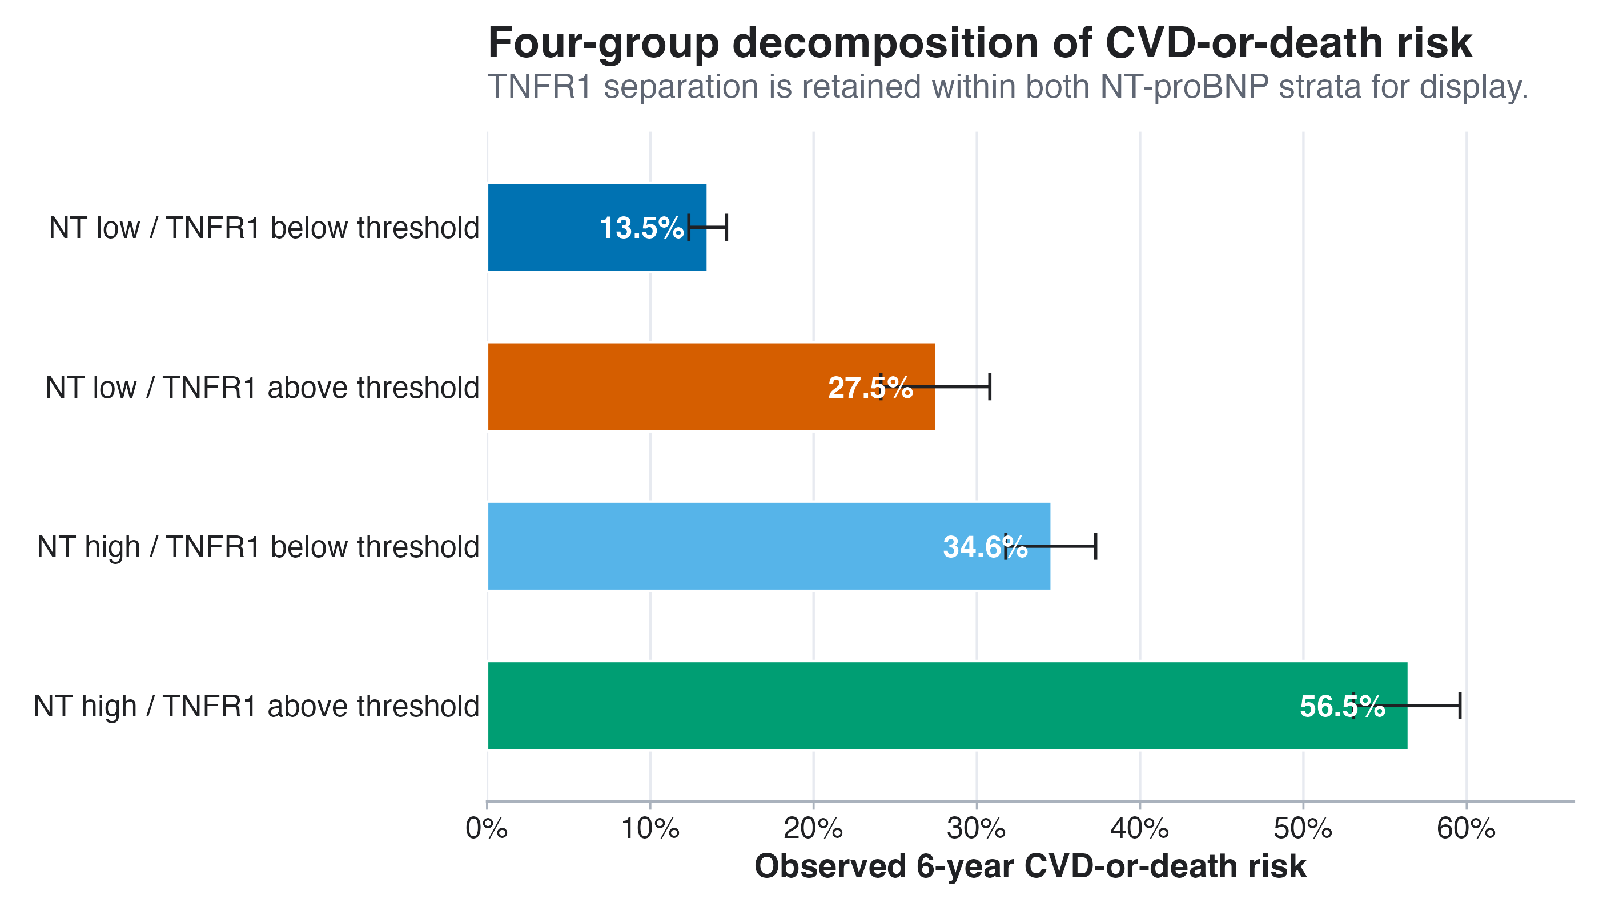
Supplementary Figure 1. Four-group CVD-or-death risk decomposition. TNFR1 separation is retained within both NT-proBNP strata for display only.

