Supplementary Information

Glyphosate-based herbicide affects reproductive performance and morphological traits across generations in freshwater cladocerans

Josiane Araujo da Silva¹, Sophia Vallerini², Bernardo dos Santos Vaz², Jenifer Silveira Moraes¹, Camila de Martinez Gaspar Martins¹

¹ Programa de Pós-graduação em Ciências Fisiológicas, Instituto de Ciências Biológicas, Universidade Federal do Rio Grande. Av, Itália km 8, 96203-900, Rio Grande, RS, Brazil.
² Instituto Federal de Educação, Ciência e Tecnologia Sul-rio-grandense, Campus Pelotas. Praça 20 de Setembro, 455, 96015-360, Pelotas, RS, Brazil.

Table S1: Percentage reduction in the offspring production relative to the control in D. magna after 21 days of exposure and C. dubia after 8 days of exposure across generations F0, F1, and F2.
Species | Generation | 30 µg/L | 65 µg/L | 100 µg/L
D. magna | F0 | 31.1 | 30.4 | 15.2
 | F1 | 6.7 | 14.9 | 5.1
 | F2 | 0 | 4.4 | 2.4
C. dubia | F0 | 7.4 | 26.5 | 32.1
 | F1 | 0 | 21.7 | 0
 | F2 | 13.4 | 16.6 | 15.0

Table S2: Mean initial and final physicochemical parameters for all exposure medium renewals in D. magna exposed for 21 days to 30, 65, and 100 µg/L glyphosate (Roundup Transorb R®). Data are presented as mean ± standard deviation.
 | Temperature (°C) |  | pH |  | Dissolved oxygen (mg/L)
 | initial | final | initial | final | initial | final
Control | 20,3 ± 0,4 | 20,1 ± 0,7 | 7,9 ± 0,1 | 8,1± 0,1 | 7,0 ± 0,5 | 6,4 ± 0,2
30 µg/L | 20,2 ± 0,5 | 20,0 ± 0,6 | 7,9 ± 0,1 | 8,1 ± 0,1 | 6,9 ± 0,4 | 6,3 ± 0,2
65 µg/L | 20,1 ± 0,5 | 19,9 ± 0,7 | 7,9 ± 0,1 | 8,2 ± 0,2 | 6,8 ± 0,5 | 6,2 ± 0,3
100 µg/L | 20,1 ± 0,6 | 19,8 ± 0,7 | 8,0 ± 0,2 | 8,2 ± 0,2 | 6,5 ± 0,7 | 5,9 ± 0,4

Table S3: Mean initial and final physicochemical parameters for all exposure medium renewals in C. dubia exposed for 8 days to 30, 65, and 100 µg/L glyphosate (Roundup Transorb R®). Data are presented as mean ± standard deviation.
 | Temperature (°C) |  | pH |  | Dissolved oxygen (mg/L)
 | initial | final | initial | final | initial | final
Control | 23,9 ± 0,2 | 24,9 ± 0,2 | 7,3 ± 0,2 | 7,2± 0,02 | 6,2 ± 0,6 | 5,7 ± 0,7
30 µg/L | 24,1 ± 0,2 | 24,8 ± 0,2 | 7,4 ± 0,05 | 7,3 ± 0,1 | 6,2 ± 0,6 | 5,9 ± 0,6
65 µg/L | 24,1 ± 0,2 | 24,6 ± 0,6 | 7,3 ± 0,1 | 7,3 ± 0,1 | 6,1 ± 0,5 | 5,7 ± 0,7
100 µg/L | 23,9 ± 0,2 | 24,7 ± 0,3 | 7,3 ± 0,1 | 7,3 ± 0,1 | 6,1 ± 0,3 | 5,4 ± 0,8

Table S4: Number of replicates (n) for each treatment group across generations (F0, F1, and F2) after 21 days of exposure for D. magna and 8 days of exposure for C. dubia, including the control and glyphosate treatments based on the formulated product.

Species | Generation | Control | 30 µg/L | 65 µg/L | 100 µg/L
D. magna | F0 | 14 | 12 | 12 | 14
 | F1 | 14 | 15 | 15 | 14
 | F2 | 14 | 14 | 14 | 13
C. dubia | F0 | 15 | 14 | 13 | 14
 | F1 | 12 | 14 | 10 | 13
 | F2 | 12 | 11 | 11 | 11

Figure S1: D. magna individual at 21 days of age. The red line indicates body length, the blue line body width, and the yellow line tail spine length.

Figure S2: C. dubia individual at 8 days of age. The red line indicates body length and the blue line body width.
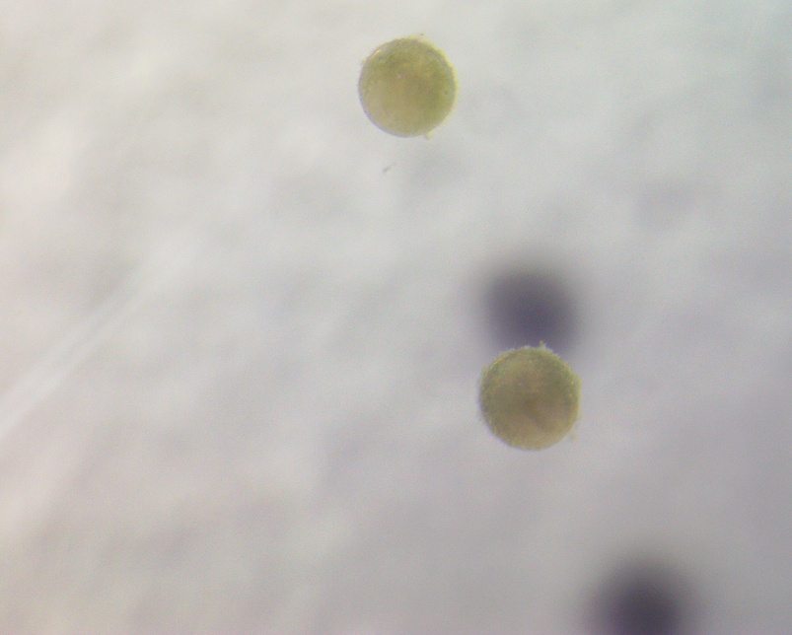
Figure S3: Aborted broods in F0 D. magna after 21 days of exposure to glyphosate at concentrations of 30, 65, and 100 µg/L.

