SUPPLEMENTARY MATERIAL

Oral Anticoagulation with or without Antiplatelet Therapy for Secondary Stroke Prevention in Patients with Atrial Fibrillation and Atherosclerosis: A Systematic Review and Meta-Analysis

TABLE OF CONTENTS

1. Supplementary Table S1. Details of the Search Strategy According to the Database
2. Supplementary Table S2. Definitions of vascular composite outcome and major bleeding in each included study.
3. Supplementary Table S3. Definitions of intra/extracranial arteries in each included study.
4. Supplementary Table S4. Detailed ROBINS-I Assessment
5. Supplementary Table S5. Detailed RoB 2.0 Assessment
6. Supplementary Figure S1. Sensitivity analysis for outcomes with moderate to high heterogeneity.

Supplementary Table S1. Details of the search strategy according to the database.

Database | Search strategy
PubMed | ("Atrial Fibrillation"[Mesh] OR "atrial fibrillation" OR AF OR NVAF)  AND  ("cerebral infarction" OR "brain infarction" OR "Ischemic Stroke"[Mesh] OR "Ischemic stroke" OR "Ischaemic Stroke" OR "cerebral accident" OR "cerebrovascular accident")  AND  (Atherosclerosis OR CAD OR CAOD OR "Coronary Artery Disease"[Mesh] OR "Carotid Artery Diseases"[Mesh] OR “carotid artery stenosis” OR "Carotid Stenosis"[Mesh] OR “intracranial artery stenosis” OR “intracranial arterial stenosis” OR “intracranial stenosis” OR “extracranial artery stenosis” OR “extracranial arterial stenosis” OR “extracranial stenosis” OR “ischemic heart disease” OR “peripheral artery disease” OR "Peripheral Arterial Disease"[Mesh] OR “steno-occlusion” OR “artery occlusion” OR “arterial occlusion”)  AND  (Antiplatelet OR antiplatelets OR "Platelet Aggregation Inhibitors"[Mesh] OR Aspirin OR AAS OR ticagrelor OR clopidogrel OR triflusal OR cilostazol)  AND  (Anticoagulant OR anticoagulants OR anticoagulation OR "Anticoagulants"[Mesh] OR OAC OR VKA OR DOAC OR Apixaban OR dabigatran OR rivaroxaban OR edoxaban)
Embase | ("atrial fibrillation" OR AF OR NVAF)  AND  ("cerebral infarction" OR "brain infarction" OR "Ischemic stroke" OR "Ischaemic Stroke" OR "cerebral accident" OR "cerebrovascular accident")  AND  (Atherosclerosis OR CAD OR CAOD OR “carotid artery stenosis” OR “Carotid Stenosis” OR “intracranial artery stenosis” OR “intracranial arterial stenosis” OR “intracranial stenosis” OR “extracranial artery stenosis” OR “extracranial arterial stenosis” OR “extracranial stenosis” OR “ischemic heart disease” OR “peripheral artery disease” OR “steno-occlusion” OR “artery occlusion” OR “arterial occlusion”)  AND  (Antiplatelet OR antiplatelets OR Aspirin OR AAS OR ticagrelor OR clopidogrel OR triflusal OR cilostazol)  AND  (Anticoagulant OR anticoagulants OR anticoagulation OR OAC OR VKA OR DOAC OR Apixaban OR dabigatran OR rivaroxaban OR edoxaban)
Cochrane | ("atrial fibrillation" OR AF OR NVAF)  AND  ("cerebral infarction" OR "brain infarction" OR "Ischemic stroke" OR "Ischaemic Stroke" OR "cerebral accident" OR "cerebrovascular accident")  AND  (Atherosclerosis OR CAD OR CAOD OR “carotid artery stenosis” OR “Carotid Stenosis” OR “intracranial artery stenosis” OR “intracranial arterial stenosis” OR "intracranial stenosis" OR “extracranial artery stenosis” OR “extracranial arterial stenosis” OR “extracranial stenosis” OR “ischemic heart disease” OR “peripheral artery disease” OR “steno-occlusion” OR “artery occlusion” OR “arterial occlusion”)  AND  (Antiplatelet OR antiplatelets OR Aspirin OR AAS OR ticagrelor OR clopidogrel OR triflusal OR cilostazol)  AND  (Anticoagulant OR anticoagulants OR anticoagulation OR OAC OR VKA OR DOAC OR Apixaban OR dabigatran OR rivaroxaban OR edoxaban)

Supplementary Table S2. Vascular composite outcome and major bleeding definitions of each included study.

Definitions of vascular composite outcome
Choi, 2019 | NA
Harrison, 2024 | NA
Heo, 2024 | All-composite: composite of all predetermined outcomes. Main outcomes encompassed all-cause mortality, cardiovascular death, ischemic stroke, hemorrhagic stroke, myocardial infarction and bleeding events.
Kim, 2020 | The primary outcome event was a composite of recurrent stroke (ischemic or hemorrhagic), myocardial infarction (MI), and all-cause mortality within 3 months of the index stroke.
Koyanagi, 2022 | The primary outcome was a composite of all-cause death, ISTH major bleeding events and ischemic events. Ischemic events included ischemic stroke, acute coronary syndrome, acute myocardial infarction, or systemic embolism.
McGrath, 2014 | The primary outcome was the composite of death or hospital readmission for recurrent IS, myocardial infarction (MI), or major bleeding.
Okazaki, 2025 | The primary outcome was a composite of ischemic cardiovascular events and ISTH major bleeding occurring within 2 years of randomization. Ischemic cardiovascular events included cardiovascular death, ischemic stroke, myocardial infarction, systemic embolism, and ischemic events requiring urgent revascularization.
Definitions of major bleeding
Choi, 2019 | NA
Harrison, 2024 | Major bleeding was defined based on ICD codes for intracranial, gastrointestinal, ocular, respiratory, genitourinary, and other systemic hemorrhages.
Heo, 2024 | NA
Kim, 2020 | NA
Koyanagi, 2022 | Major bleeding was defined according to ISTH criteria.
McGrath, 2014 | Major bleeding was defined based on ICD-10 codes for intracranial and gastrointestinal hemorrhages (including variceal and ulcer-related bleeding), as well as posthemorrhagic anemia.
Okazaki, 2025 | Major bleeding was defined according to ISTH criteria.
ISTH: International Society of Thrombosis and Hemostasis; ICD: International Classification of Diseases.

Supplementary Table S3. Definitions of intra/extracranial atherosclerosis in each included study.
Definitions of intracranial and extracranial atherosclerosis
Choi, 2019 | NA
Harrison, 2024 | Carotid artery disease was identified using ICD-10 codes (I63.03, I63.13, I63.23, I65.2), without specification of stenosis severity or imaging criteria.
Heo, 2024 | NA
Kim, 2020 | Patients with clinically significant large artery steno-occlusion (LASO) were included. LASO was defined as ≥50% stenosis or occlusion on CT or MR angiography, considered clinically significant when corresponding to acute ischemic lesions on brain imaging.
Koyanagi, 2022 | Intra-/extracranial artery stenosis was defined as >50% stenosis on vascular imaging (MRA, CTA, or DSA).
McGrath, 2014 | NA
Okazaki, 2025 | Subgroup analysis restricted to patients with intracranial or carotid stenosis (≥50% in diameter) was reported in the supplementary material (eFigure 1).
CRCS: Clinical Research Center for Stroke; CT: computed tomography; CTA: computed tomography angiography; DSA: digital subtraction angiography; ICD: International Classification of Diseases; MRA: magnetic resonance angiography; NHIRD: National Health Insurance Research Database; TOAST: Trial of Org 10172 in Acute Stroke Treatment.

Supplementary Table S4. Detailed ROBINS-I Risk of Bias Assessment.

Study | Confounding | Selection of Participants | Classification of Intervention | Deviations from Intended Interventions | Missing Data | Measurement of Outcomes | Selection of Reported Results | Overall Risk
Choi et al., 2019 | Serious – Residual confounding; D-dimer variability; unmeasured thrombotic conditions | Moderate | Baseline D-dimer measurement variability | Limited adherence verification | Laboratory variation | Clinical records | Low | Serious
Harrison et al., 2024 | PS matching; no NIHSS or stenosis severity | Multi-institutional EHR network | Exposure limited to first 6 weeks | Post-discharge therapy changes not captured | Outcomes outside network not captured | ICD-based definitions | Prespecified outcomes | Moderate
Heo et al., 2024 | IPTW applied; single-center limits covariate depth | Single-center cohort | Discharge-based classification | Adherence not fully assessable | Limited exposure tracking | Hospital record-based outcomes | No selective reporting detected | Moderate
Kim et al., 2020 | Registry; residual confounding | National Korean cohort | No dose/INR/NOAC detail | No adherence confirmation | Moderate | Moderate | Low | Moderate
Koyanagi et al., 2022 | No bleeding risk scores; limited stenosis stratification | Japanese registry cohort | Baseline treatment classification | No longitudinal verification | Small stenosis subgroup | Clinical endpoints without blinded adjudication | No reporting concerns | Moderate
McGrath et al., 2014 | Moderate – No post-discharge therapy tracking | Moderate – Stroke center cohort | Moderate – Discharge prescription only | No adherence/INR data | Moderate | Moderate | Low | Moderate

Supplementary Table S5. Detailed RoB 2.0 Assessment.

Study | Randomization Process | Deviations from Intended Interventions | Missing Outcome Data | Measurement of Outcomes | Selection of Reported Results | Overall Risk
Okazaki et al., 2025 | Appropriate allocation procedure | Open-label design; physician discretion in treatment selection | No major attrition | Blinded event adjudication | Prespecified outcomes | Some concerns

Supplementary Figure S1. Sensitivity analysis for (A) vascular composite outcome, (B) major bleeding, and (C) all-cause mortality.

A
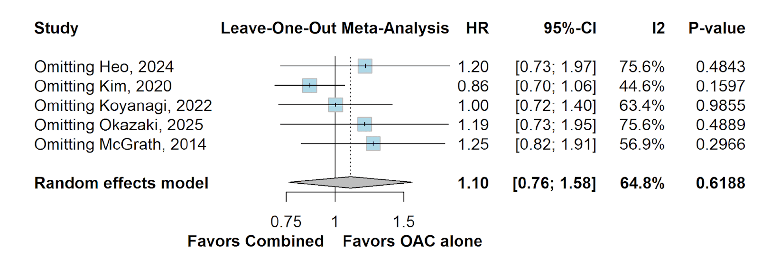
B
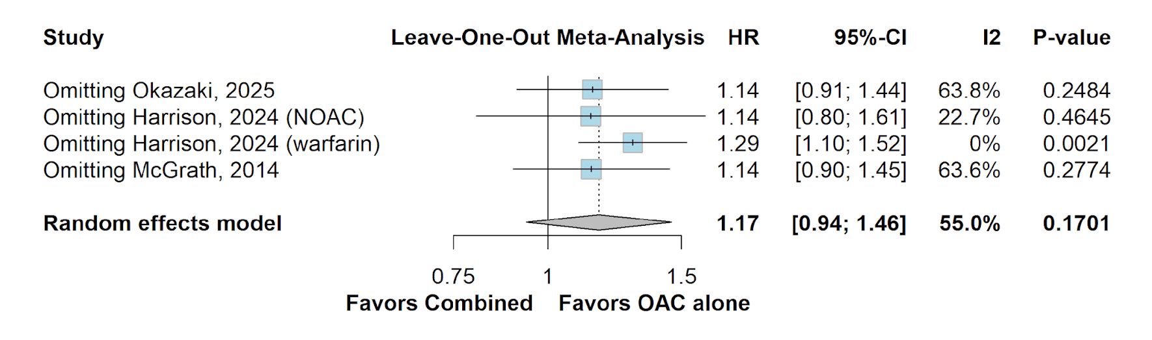
C
