scientific reports

Title: Menstrual cycle length trajectories and their health correlates across the reproductive lifespan

Makiko Mitsunami, Elizabeth Peebles, Boya Zhang, Brent A. Coull, Tamarra James-Todd,
Jorge E. Chavarro, Jaime E. Hart, Francine Laden, Shruthi Mahalingaiah
Corresponding author: Email: mmitsunami@hsph.harvard.edu

The PDF file includes:

Figures S1 to S4
Tables S1 to S3

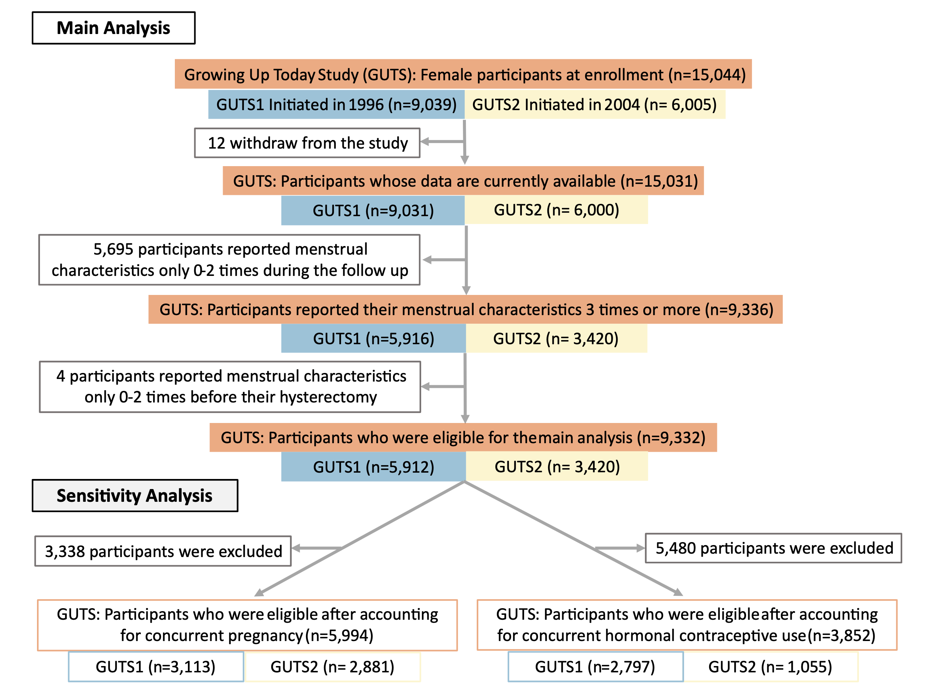 Figure S1. Participant flow chart for the analysis of menstrual cycle length trajectories across the reproductive lifespan in the United States-based Growing Up Today Study (GUTS)

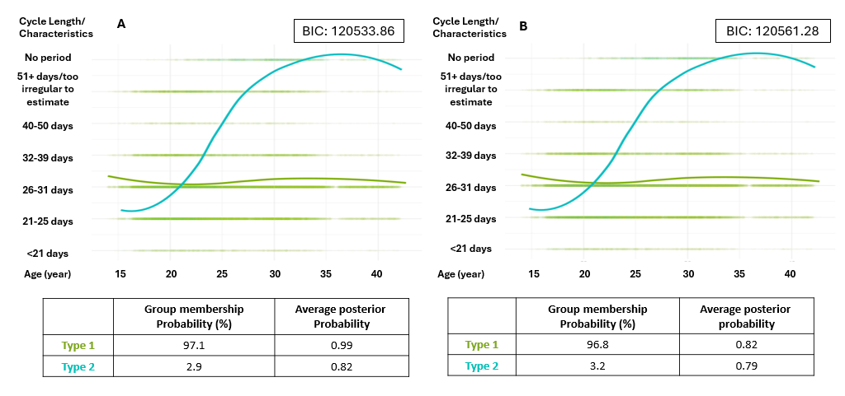
Figure S2. Latent class mixed models with two and three latent classes for self-reported categorical menstrual cycle lengths throughout the reproductive lifespan among participants in the Growing Up Today Study (GUTS) (1996-2023)
Those who reported their menstrual cycle length (MCL) for three or more questionnaires from 2008 to 2023 were included (Number of subjects: 9,332, Number of reports: 48,494). Panel A: Plot for two latent classes, Panel B: Plot for three latent classes. The plots illustrate the MCL distribution, colored to the assigned trajectory pattern, with overlayed with fitting curves based on the latent class with ordinal outcomes of menstrual characteristics. The fitted curves represent the estimated average MCL for each class at a given age. The different trajectories are categorized into Trajectory 1: “always regular”, Trajectory 2: “early long transition”. X-axis represents age (years) at menstrual cycle reports. The Bayesian Information Criterion (BIC) was calculated and displayed for each LCMM model.

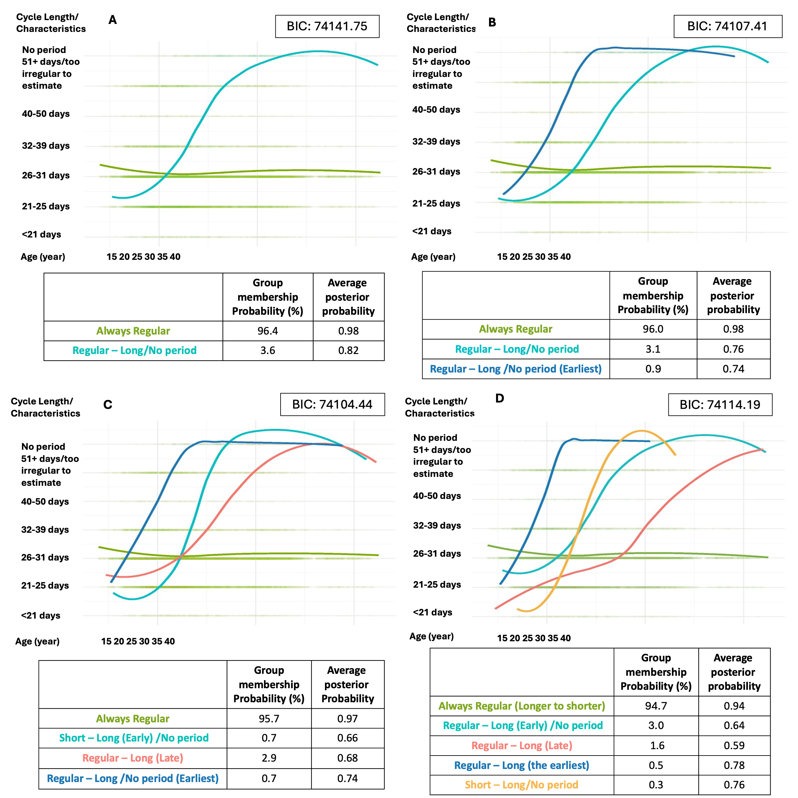

Figure S3. Sensitivity analyses for latent class analysis excluding cycles reported from estimated conception through post-pregnancy-related events (including delivery, miscarriage, abortion, and ectopic pregnancy outcomes) in the Growing Up Today Study (GUTS) (1996-2023)
After excluding menstrual cycle length (MCL) report with concurrent pregnancy-related outcomes, those who reported their menstrual cycle length for 3 or more questionnaires from 2008 to 2023 were included (Number of subjects: 5,994, Number of reports: 29,301). Panel A: Plot for 2 latent classes, Panel B: Plot for 3 latent classes, Panel C: Plot for 4 latent classes, Panel D: Plot for 5 latent classes. The plots illustrated the MCL distribution, colored to the assigned trajectory pattern, with overlayed fitting curves based on the latent class with ordinal outcomes of menstrual characteristics. X-axis represents age (years) at menstrual cycle length reports. The Bayesian Information Criterion (BIC) was calculated and displayed for each latent class mix model.

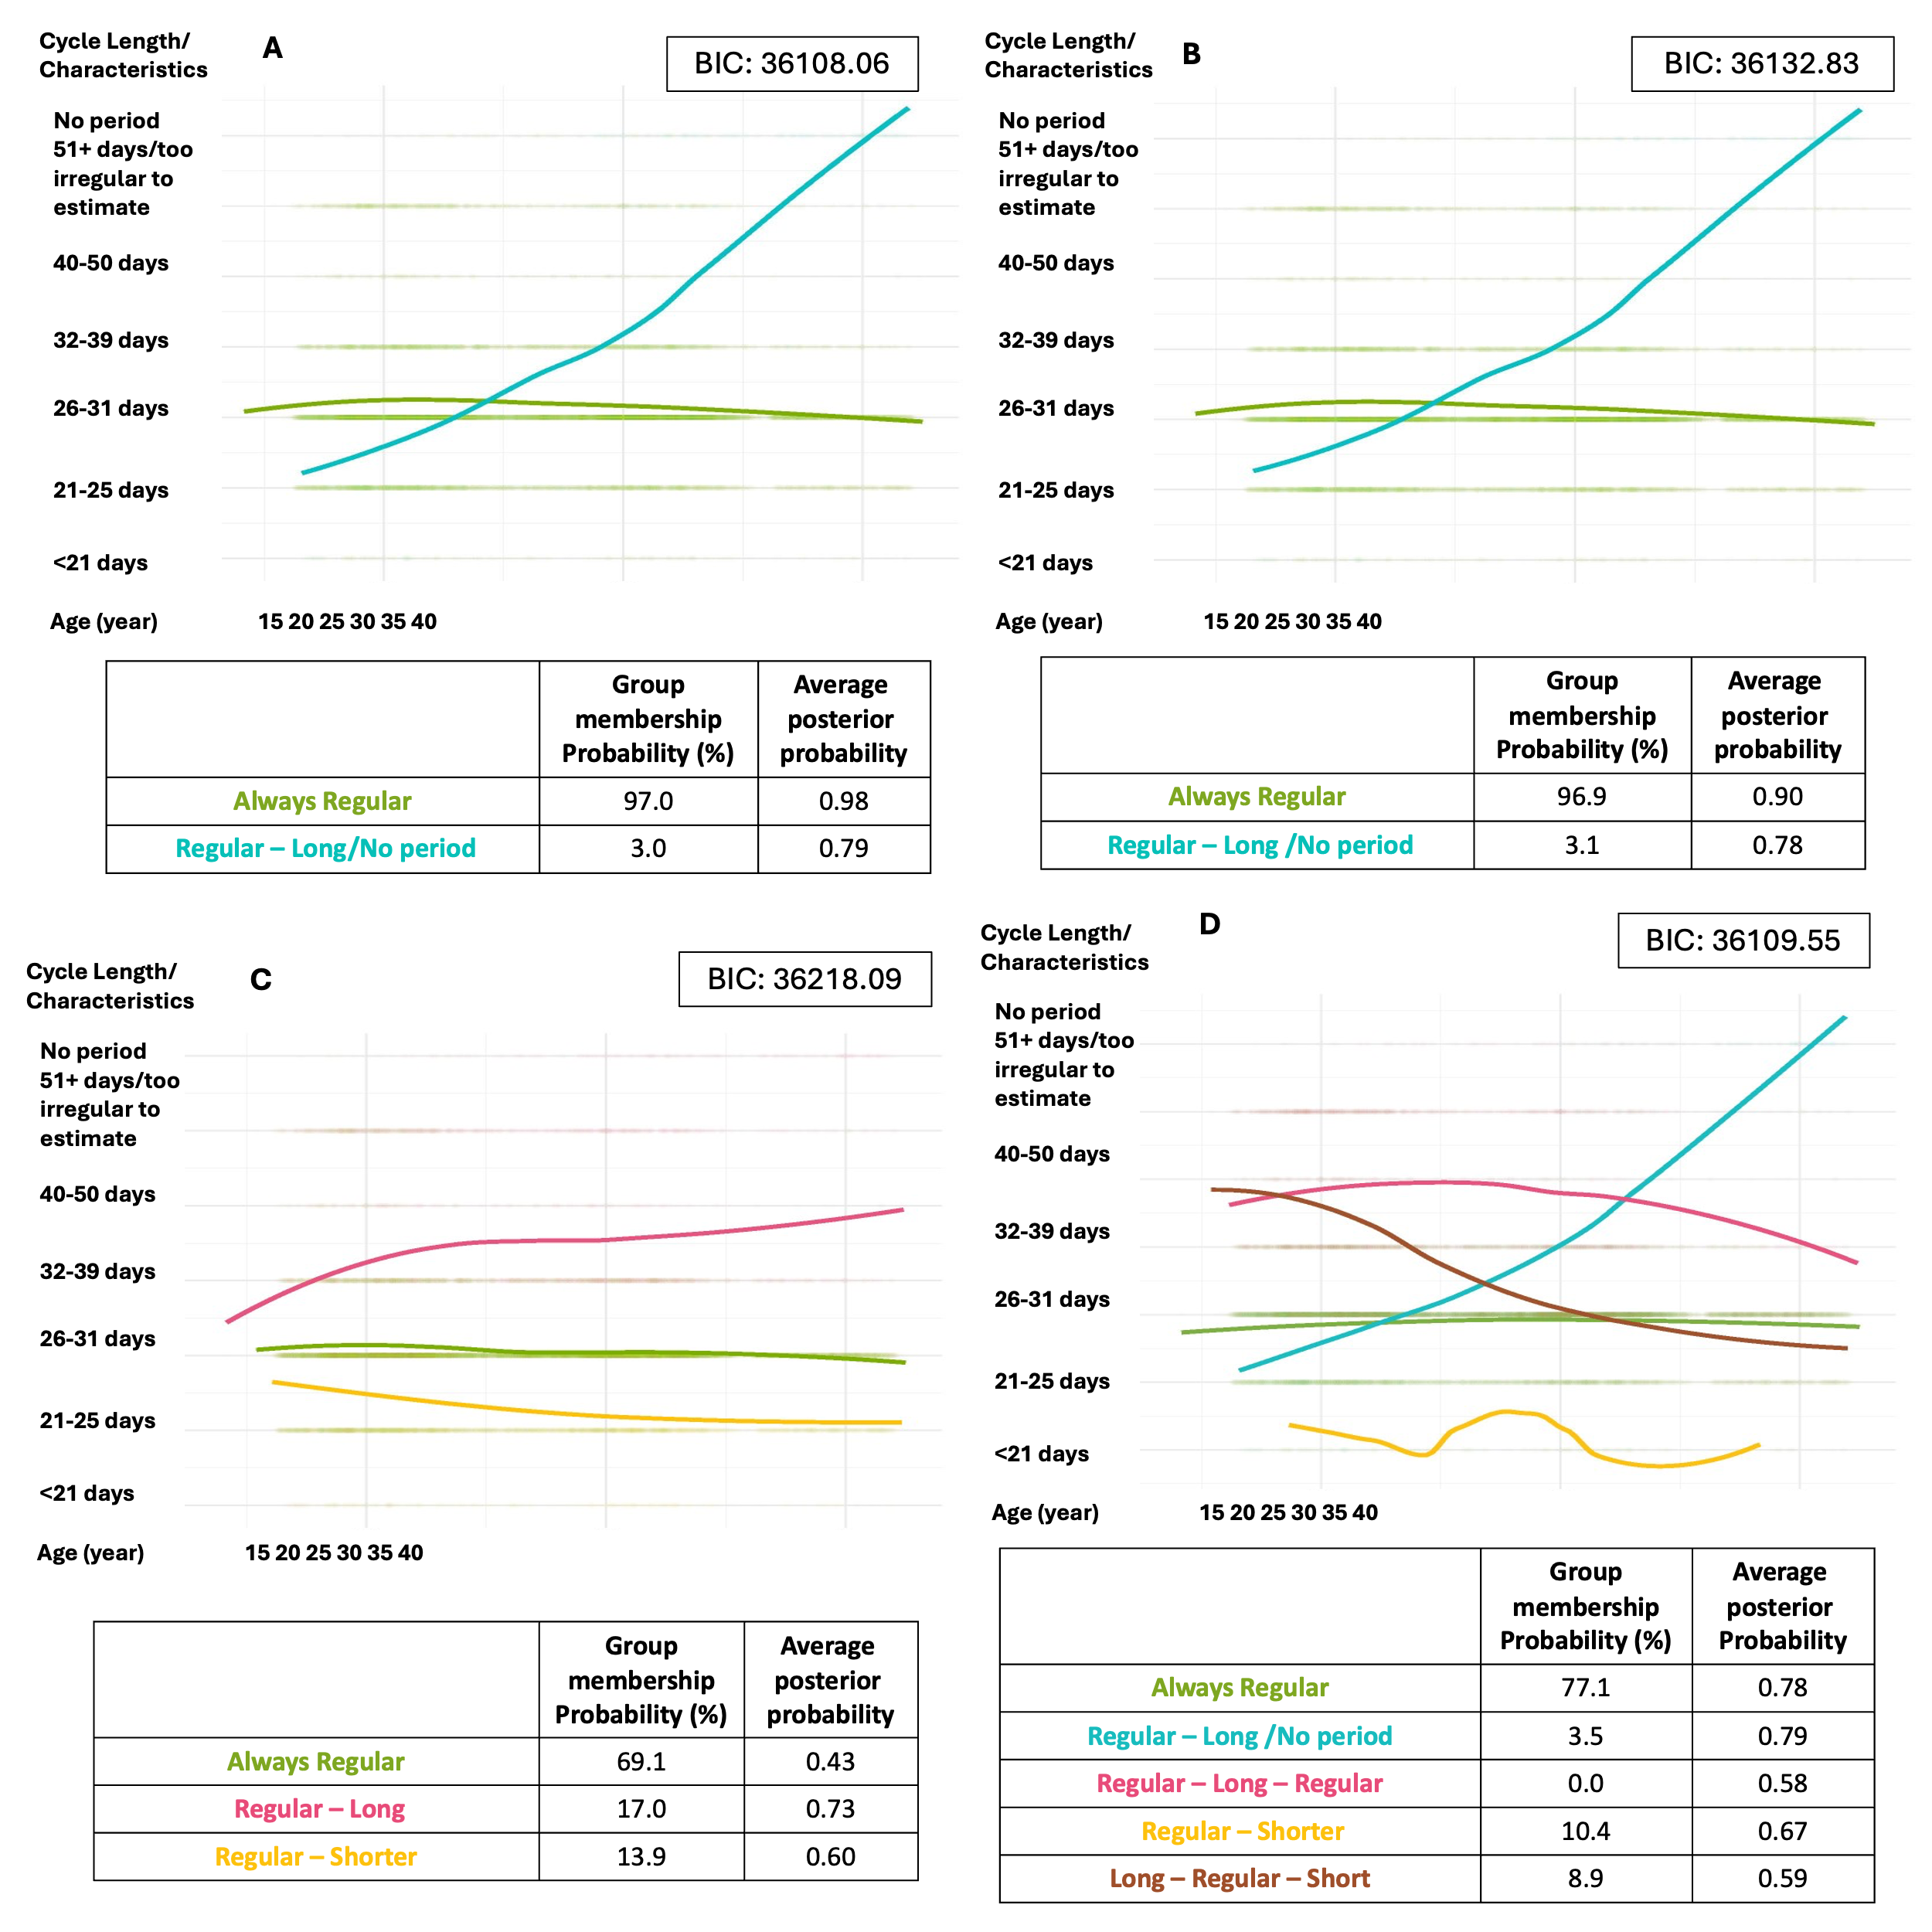

Figure S4. Sensitivity analyses for latent class analysis excluding cycles reported with concurrent hormonal contraceptive use in the Growing Up Today Study (GUTS) (1996-2023)
After excluding menstrual cycle length (MCL) report with concurrent hormonal contraceptive use, those who reported their menstrual cycle length for 3 or more questionnaires from 2008 to 2023 were included (Number of subjects: 3,852, Number of reports: 15,614). Panel A: Plot for 2 latent classes, Panel B: Plot for 3 latent classes, Panel C: Plot for 4 latent classes, Panel D: Plot for 5 latent classes. The plots illustrated the MCL distribution, colored to the assigned trajectory pattern, with overlayed fitting curves based on the latent class with ordinal outcomes of menstrual characteristics. X-axis represents age (years) at menstrual cycle length reports. The Bayesian Information Criterion (BIC) was calculated and displayed for each latent class mix model.

Table S1. Comparison of characteristics between participants included and excluded in creating a menstrual cycle classification in the Growing Up Today Study (GUTS) (1996-2023)^{a,b}
 | Included | Excluded | P-value
Participants (n) | 9,332 | 5,703
Age at baseline, mean ± SD | 12.2 ± 1.9 | 12.2 ± 1.9 | 0.16
Birth year, n (%) |  |  | <.0001
1980-1984 | 2,999 (32.1) | 1,586 (27.8)
1985-1989 | 4,070 (43.6) | 2,336 (41.0)
1990-1995 | 2,263 (24.3) | 1,777 (31.2)
Cohort, GUTS 1, n (%) | 5,912 (63.4) | 3,119 (54.7) | <.0001
Race and ethnicity, n (%) |  |  | 0.0004
Non-Hispanic white | 8,769 (94.8) | 5,315 (94.3)
Non-Hispanic black | 58 (0.6) | 57 (1.0)
Hispanic | 157 (1.7) | 132 (2.3)
Non-Hispanic Asian | 95 (1.0) | 36 (0.6)
Other | 170 (1.8) | 95 (1.7)
Age at menarche, mean ± SD | 12.8 ± 1.1 | 12.7 ± 1.1 | <.0001
Menstrual characteristics report (n) | 48,494 | 4,060
Total number of reports, median (IQR) | 5 (4, 6) | 0 (0, 1)
Abnormal length cycle^{c}, n (%) | 6,911 (14.3) | 593 (14.6) | 0.53
ªGUTS: Growing Up Today Study.
^{b}P-value was calculated by using the Kruskal-Wallis nonlinearity test for continuous variables, and chi-square test for categorical variables.
^{c}Abnormal length was defined as a reported menstrual cycle length of less than 21 days, more than 40 days, too irregular to estimate, or no period.

Table S2. Comparison of characteristics by suggestive categories of ovulatory disorder types Identified Through Menstrual Trajectory Patterns in the Growing Up Today Study (GUTS) (1996-2023)
 | Overall | Trajectory 1  “always regular” | Trajectory 2  “early long transition” | Trajectory 3  “late long transition” | Trajectory 4  “long to short transition” | p-value^{l}
n | 9,332 | 8,794 | 237 | 282 | 19
Variables Associated with Possible FHA
Childhood underweight^{b}, n (%) | 848 (9.1) | 795 (9.0) | 19 (8.0) | 32 (11.4) | 2 (10.5) | 0.54
Adulthood underweight^{c}, n (%) | 784 (8.4) | 731 (8.3) | 22 (9.3) | 26 (9.2) | 5 (26.3) | 0.04
High strenuous physical activity (>11hr/wk), n (%)^{d} | 306 (4.0) | 277 (3.9) | 12 (5.9) | 15 (5.9) | 2 (10.5) | 0.08
Possible functional hypothalamic amenorrhea^{e}, n (%) ^{d} | 302 (3.2) | 254 (2.9) | 27 (11.4) | 18 (6.4) | 3 (15.8) | <.0001
Variables Associated with Possible Endocrine Related Ovulation Disorders
Childhood obesity^{f}, n (%) | 781 (8.4) | 720 (8.2) | 21 (8.9) | 38 (13.5) | 2 (10.5) | 0.02
Adulthood obesity^{g}, n (%) | 2,432 (26.1) | 2,248 (25.6) | 76 (32.1) | 103 (36.5) | 5 (26.3) | <.0001
Low strenuous physical activity (<2hr/wk), n (%)^{d} | 3,317 (43.3) | 3,128 (43.5) | 73 (36.1) | 111 (43.5) | 5 (26.3) | 0.09
Hypothyroidism self-report, n (%) | 897 (9.6) | 818 (9.3) | 34 (14.4) | 43 (15.3) | 2 (10.5) | 0.0006
Hyperthyroidism self-report, n (%) | 75 (0.8) | 68 (0.8) | 2 (0.8) | 4 (1.4) | 1 (5.3) | 0.10
Hypertension self-report, n (%) | 717 (7.7) | 665 (7.6) | 18 (7.6) | 33 (11.7) | 1 (5.3) | 0.08
Diabetes Mellites self-report, n (%) | 158 (1.7) | 149 (1.7) | 5 (2.1) | 4 (1.4) | 0 (0) | 0.87
Hypercholesteremia self-report, n (%) | 1,326 (14.2) | 1,230 (14.0) | 31 (13.1) | 65 (23.1) | 0 (0) | <.0001
PCOS self-report, n (%) | 869 (9.3) | 787 (9.0) | 29 (12.2) | 52 (18.4) | 1 (5.3) | <.0001
Estimated age at PCOS diagnosis, mean ± SD | 23.9 ± 5.6 | 23.8 ± 5.6 | 22.4 ± 6.2 | 25.7 ± 5.4 | 26.6 | 0.05
Severe acne in adolescence^{h}, n (%)^{d} | 1,064 (11.8) | 987 (11.6) | 23 (10.1) | 49 (18.3) | 5 (26.3) | 0.001
Hirsutism^{i}, n (%)^{d} | 1,851 (22.0) | 1,740 (22.0) | 43 (18.9) | 60 (21.8) | 8 (42.1) | 0.12
PCOS traits^{j},n (%) | 3,105 (33.3) | 2,892 (32.9) | 71 (30.0) | 131 (46.5) | 11 (57.9) | <.0001
Maternal self-reported PCOS, n (%) | 803 (8.6) | 762 (8.7) | 13 (5.5) | 28 (9.9) | 0 (0) | 0.15
Hypergonadotropic Hypogonadism
NA^{k} | - | - | - | - | - | -
Anatomic Conditions
Fibroids self-report, n (%) | 170 (1.8) | 155 (1.8) | 5 (2.1) | 10 (3.6) | 0 (0) | 0.15
Gynecologic Conditions
Endometriosis self-report, n (%) | 551 (5.9) | 496 (5.6) | 16 (6.8) | 38 (13.5) | 1 (5.3) | <.0001

ªGUTS:Growing Up Today Study; PCOS: Polycystic ovary syndrome.
^{b} Childhood underweight is defined using the CDC BMI-for-age percentile, with underweight classified as less than the 5th percentile for individuals younger than 20 years old.
^{c}Adulthood underweight is defined as having a body mass index (BMI) of less than 18.5 for individuals aged 20 years and older.
^{d}Percentages were based on respondents only, excluding non-respondents.
^{e}Possible functional hypothalamic amenorrhea is defined as ever oligo-amenorrhea report between 2003 and 2023, underweight in childhood or adulthood, strenuous physical activity longer than 11hr/week, and not exhibiting PCOS traits, hypothyroidism or hyperthyroidism.
^{f}Childhood obesity is defined as obesity based on the International Obesity Task Force criteria for individuals younger than 20 years old.
^{g}Adulthood obesity is defined as having a body mass index (BMI) of 30 or greater for individuals aged 20 years and older.
^{h}Severe acne is defined as self-reported severe acne or oral contraceptive use due to acne under the age of 19.
^{i}Hirsutism is defined as simplified Ferriman-Gallyway score 4 or greater (Hair at upper abdomen, lower abdomen and chin)(48).
^{j}PCOS traits are defined as self-reported PCOS diagnosis, hirsutism, or adolescent severe acne.
^{k}We do not have any variables to discern hypergonadotropic and hypogonadism.
^{l}P-value was calculated by using the Kruskal-Wallis nonlinearity test for continuous variables, and chi-square test for categorical variables.

Table S3. Question items for menstrual cycle length in the Growing Up Today Study (GUTS) (1996-2023)
Year | Cohort | Question
2003 | GUTS1 | What is the current usual length of your menstrual cycle (interval from first day of period to first day of next period)?*
2005 | GUTS1 | What is the current interval from the first day of your period to the first day of your next period?*
2007 | GUTS1 | What is the current interval from the first day of your period to the first day of your next period?*
2008 | GUTS2 | What is the current interval from the first day of your period to the first day of your next period (when not pregnant, breast-feeding, or using birth control pills)?
2011 | GUTS2 | What is the current interval from the first day of your period to the first day of your next period (when not pregnant, breast-feeding, or using birth control pills)?
2013 | GUTS | What is the usual average length of your menstrual cycle (interval from first day of period to first day of next period)?
2015 | GUTS | What is the usual average length of your menstrual cycle (interval from first day of period to first day of next period)?
2016 | GUTS | What is the usual average length of your menstrual cycle (interval from first day of period to first day of next period)?
2023 | GUTS | What is the current usual length of your menstrual cycle (interval from the first day of period to the first day of next period)? Exclude the 6 months after pregnancy or while breastfeeding.
*The condition “when not pregnant, 6 breast-feeding or using birth control pills” applied only to menstrual cycle pattern but was adjacent to the menstrual cycle length question.

