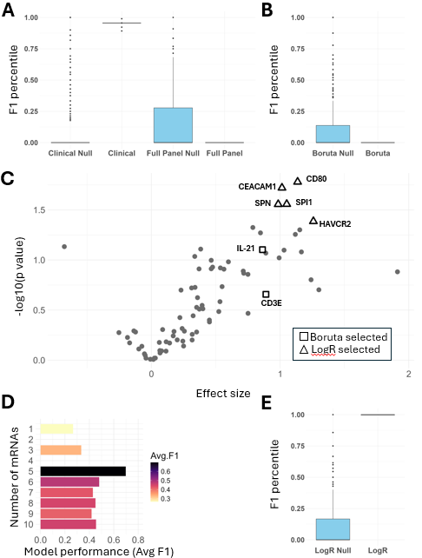

Figure S1: Baseline levels of CD80, CEACAM1, SPI1, SPN, and HAVCR2 identify metastatic patients likely to experience toxicity
(A) Percentiles of 25,000 random forest models which used datasets of permuted patient outcomes (blue) and 25 predictive models with unpermuted patient outcomes (red). Models utilize clinical characteristics (left), or all 79 transcripts in the OSU_Senescence panel (right). (B) Models as described in (A) based on the two mRNAs selected by the Boruta algorithm. (C) Logistic regression of OSU_Senescence transcripts by outcome. Position on x axis indicating higher expression in patients who would complete one year of ICI therapy (right) versus those that would experience a treatment disrupting toxicity (left). (D) Mean random forest model performance (25 runs) for predicting toxicity, with mRNAs sequentially incorporated according to increasing p-value (C). (E) Models as described in (A) using the five mRNAs identified in (C) (CD80, CEACAM1, SPI1, SPN, and HAVCR2).

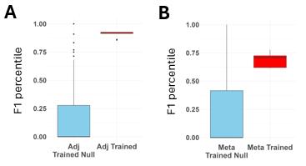

Figure S2: Cross adjuvant-metastatic models predicting toxicity have variable predictive ability.
(A-B) Percentiles of 25,000 random forest models which used datasets of permuted patient outcomes (blue) and 25 predictive models with unpermuted patient outcomes (red). Transcripts from patients that completed therapy or discontinued due to toxicities were utilized. (A) Models were trained on adjuvant discovery cohort and tested on metastatic validation cohort, with both limited to transcripts of TNFRSF18, VTCN1, CCR4, AHR, and TIGIT (B) trained on metastatic discovery cohort and tested on adjuvant validation cohort, with both limited to transcripts of CD80, CEACAM1, SPI1, SPN, and HAVCR2.

