Reassessing the Socioeconomic Spillover Effects of PEPFAR: Robustness Across Alternative Difference-in-Differences Methods

(Appendix for web publication)

Contents
Table A.1 List of PEPFAR countries, COP countries, and comparison countries 3
Table A.2 Estimation results for five outcomes from common DID 5
Table A.3 Estimation results for five outcomes from staggered DID 10
Figure A.1 Trends in five outcomes 15
Figure A.2 Testing the parallel trends assumption for five outcomes in common DID setting 18
Figure A.3 Testing the parallel trends assumption for five outcomes in staggered DID setting 21
Figure A.4 Honest DID estimation results 24
Figure A.5 Placebo test results 27

Table A.1 List of PEPFAR countries, COP countries, and comparison countries

  - PEPFAR countries
Afghanistan | Gambia, The | Niger
Albania | Georgia | Nigeria
Angola | Ghana | North Macedonia
Armenia | Guatemala | Pakistan
Bangladesh | Guinea | Papua New Guinea
Barbados | Guinea-Bissau | Peru
Belize | Guyana | Philippines
Benin | Haiti | Romania
Bolivia | Honduras | Russian Federation
Botswana | India | Rwanda
Brazil | Indonesia | Samoa
Burkina Faso | Jamaica | Sao Tome and Principe
Burundi | Jordan | Senegal
Cambodia | Kazakhstan | Seychelles
Cameroon | Kenya | Sierra Leone
Central African Republic | Kyrgyz Republic | South Africa
Chad | Lao PDR | Suriname
China | Lesotho | Tajikistan
Comoros | Liberia | Tanzania
Congo, Dem. Rep. | Madagascar | Thailand
Congo, Rep. | Malawi | Timor-Leste
Cote d'Ivoire | Mali | Togo
Djibouti | Mauritania | Trinidad and Tobago
Dominican Republic | Mexico | Turkmenistan
El Salvador | Moldova | Uganda
Eritrea | Mozambique | Ukraine
Estonia | Myanmar | Uzbekistan
Eswatini | Namibia | Vietnam
Ethiopia | Nepal | Zambia
Gabon | Nicaragua | Zimbabwe
1.2 COP countries
Angola | Guyana | Papua New Guinea
Botswana | Haiti | Rwanda
Burundi | India | South Africa
Cambodia | Indonesia | Tanzania
Cameroon | Kenya | Uganda
Congo, Dem. Rep. | Lesotho | Ukraine
Cote d'Ivoire | Malawi | Vietnam
Dominican Republic | Mozambique | Zambia
Eswatini | Myanmar | Zimbabwe
Ethiopia | Namibia | Papua New Guinea
Ghana | Nigeria
1.3 Comparison countries
Algeria | Hungary | Panama
American Samoa | Iran, Islamic Rep. | Paraguay
Antigua and Barbuda | Iraq | Poland
Argentina | Kiribati | Serbia and Montenegro
Azerbaijan | Korea, Dem. People’s Rep. | Serbia
Belarus | Kosovo | Slovak Republic
Bhutan | Latvia | Solomon Islands
Bosnia and Herzegovina | Lebanon | Somalia
Bulgaria | Libya | Sri Lanka
Cabo Verde | Lithuania | St. Kitts and Nevis
Chile | Malaysia | St. Lucia
Colombia | Maldives | St. Vincent and the Grenadines
Costa Rica | Marshall Islands | Syrian Arab Republic
Croatia | Mauritius | Tonga
Cuba | Mayotte | Tunisia
Czech Republic | Micronesia, Fed. Sts. | Turkey
Dominica | Mongolia | Tuvalu
Ecuador | Montenegro | Uruguay
Egypt, Arab Rep. | Morocco | Vanuatu
Equatorial Guinea | Nauru | Venezuela, RB
Algeria | Northern Mariana Islands | West Bank and Gaza
Fiji | Oman | Yemen, Rep.
Grenada | Palau

Table A.2 Estimation results for five outcomes from common DID

Panel (a). GDP per capita growth rate
Variables | All PEPFAR countries |  | COP countries
Variables | Unadjusted | Adjusted | Unadjusted | Adjusted
Time variable (=1 post-2004) | -0.287 | -0.112 | -0.287 | -0.125
 | (0.333) | (0.343) | (0.360) | (0.373)
Intervention (=1 if PEPFAR) | -1.977*** | -1.754*** | - | -
 | (0.317) | (0.389) | - | -
Intervention (=1 if COP) | - | - | -1.950*** | -2.100**
 | - | - | (0.444) | (0.796)
Interaction term (PEPFAR impact estimate) | 2.276*** | 2.072*** | - | -
 | (0.429) | (0.434) | - | -
Interaction term (COP impact estimate) | - | - | 2.623*** | 2.504***
 | - | - | (0.610) | (0.615)
Country income level (=1 if middle income) |  | 0.347 |  | 0.357
 |  | (0.393) |  | (0.581)
BL Population |  | 2.98e-09*** |  | 1.43e-09
 |  | (0.000) |  | (0.000)
BL Other donor health spending per capita |  | -0.00303 |  | -0.00265
 |  | (0.005) |  | (0.006)
BL Domestic health spending per capita |  | -0.00305*** |  | -0.00333**
 |  | (0.001) |  | (0.001)
BL GDP per capita |  | 0.000143*** |  | 0.000170***
 |  | (0.000) |  | (0.000)
BL HIV prevalence (% of population ages 15-49) |  | 0.00213 |  | -0.0477
 |  | (0.037) |  | (0.050)
BL Life expectancy at birth |  | -0.00705 |  | -0.0690
 |  | (0.032) |  | (0.051)
BL Urban population (%) |  | -0.0129 |  | -0.00524
 |  | (0.008) |  | (0.010)
BL School enrollment, secondary (% gross) |  | -0.0300*** |  | -0.0437***
 |  | (0.008) |  | (0.012)
BL Fertility rate (births per woman) |  | -0.712*** |  | -1.061***
 |  | (0.151) |  | (0.233)
Recipient of US HIV aid before 2004 (=1 if yes) |  | 0.0136 |  | 0.223
 |  | (0.270) |  | (0.535)
Constant | 2.875*** | 7.691** | 2.875*** | 13.50***
 | (0.247) | (2.515) | (0.268) | (4.097)
Adjusted R-squared | 0.015 | 0.035 | 0.009 | 0.025
Observations | 4192 | 3865 | 2576 | 2283
Standard errors in parentheses
*** p<0.001, ** p<0.01, * p<0.05
BL: Baseline variable in 2004

Panel (b). Female primary school disengagement
Variables | All PEPFAR countries |  | COP countries
Variables | Unadjusted | Adjusted | Unadjusted | Adjusted
Time variable (=1 post-2004) | -4.915*** | -4.551*** | -4.915*** | -4.113***
 | (1.365) | (0.928) | (1.019) | (0.835)
Intervention (=1 if PEPFAR) | 19.37*** | 5.895*** | - | -
 | (1.320) | (1.049) | - | -
Intervention (=1 if COP) | - | - | 18.31*** | 1.598
 | - | - | (1.250) | (1.735)
Interaction term (PEPFAR impact estimate) | -9.271*** | -9.185*** | - | -
 | (1.713) | (1.143) | - | -
Interaction term (COP impact estimate) | - | - | -11.60*** | -12.58***
 | - | - | (1.658) | (1.304)
Country income level (=1 if middle income) |  | 0.334 |  | 0.0606
 |  | (1.030) |  | (1.307)
BL Population |  | -4.55e-09* |  | -4.33e-09
 |  | (0.000) |  | (0.000)
BL Other donor health spending per capita |  | -0.0884*** |  | -0.0488*
 |  | (0.023) |  | (0.022)
BL Domestic health spending per capita |  | 0.00771*** |  | 0.000716
 |  | (0.002) |  | (0.002)
BL GDP per capita |  | 0.0000150 |  | 0.000317***
 |  | (0.000) |  | (0.000)
BL HIV prevalence (% of population ages 15-49) |  | -1.008*** |  | -0.747***
 |  | (0.092) |  | (0.106)
BL Life expectancy at birth |  | -0.770*** |  | -0.795***
 |  | (0.089) |  | (0.120)
BL Urban population (%) |  | -0.00774 |  | -0.0107
 |  | (0.021) |  | (0.025)
BL School enrollment, secondary (% gross) |  | -0.170*** |  | -0.125***
 |  | (0.022) |  | (0.028)
BL Fertility rate (births per woman) |  | 3.558*** |  | 2.725***
 |  | (0.388) |  | (0.520)
Recipient of US HIV aid before 2004 (=1 if yes) |  | -1.015 |  | 4.228***
 |  | (0.662) |  | (1.093)
Constant | 11.54*** | 68.15*** | 11.54*** | 67.94***
 | (1.053) | (6.647) | (0.785) | (9.077)
Adjusted R-squared | 0.220 | 0.669 | 0.291 | 0.609
Observations | 1669 | 1577 | 969 | 901
Standard errors in parentheses
*** p<0.001, ** p<0.01, * p<0.05
BL: Baseline variable in 2004

Panel (c). Male primary school disengagement
Variables | All PEPFAR countries |  | COP countries
Variables | Unadjusted | Adjusted | Unadjusted | Adjusted
Time variable (=1 post-2004) | -3.010** | -2.863*** | -3.010*** | -2.577***
 | (1.132) | (0.837) | (0.855) | (0.749)
Intervention (=1 if PEPFAR) | 17.10*** | 7.023*** | - | -
 | (1.094) | (0.945) | - | -
Intervention (=1 if COP) | - | - | 18.12*** | 5.782***
 | - | - | (1.049) | (1.557)
Interaction term (PEPFAR impact estimate) | -8.382*** | -7.962*** | - | -
 | (1.420) | (1.031) | - | -
Interaction term (COP impact estimate) | - | - | -12.34*** | -12.51***
 | - | - | (1.392) | (1.171)
Country income level (=1 if middle income) |  | -1.669 |  | -2.697*
 |  | (0.928) |  | (1.173)
BL Population |  | -6.56e-09*** |  | -7.41e-09**
 |  | (0.000) |  | (0.000)
BL Other donor health spending per capita |  | -0.0151 |  | 0.00248
 |  | (0.020) |  | (0.020)
BL Domestic health spending per capita |  | 0.00401* |  | -0.00226
 |  | (0.002) |  | (0.002)
BL GDP per capita |  | 0.000163* |  | 0.000460***
 |  | (0.000) |  | (0.000)
BL HIV prevalence (% of population ages 15-49) |  | -0.343*** |  | -0.317***
 |  | (0.083) |  | (0.095)
BL Life expectancy at birth |  | -0.319*** |  | -0.510***
 |  | (0.080) |  | (0.108)
BL Urban population (%) |  | 0.0137 |  | -0.0134
 |  | (0.019) |  | (0.022)
BL School enrollment, secondary (% gross) |  | -0.158*** |  | -0.100***
 |  | (0.020) |  | (0.025)
BL Fertility rate (births per woman) |  | 2.853*** |  | 1.584***
 |  | (0.350) |  | (0.467)
Recipient of US HIV aid before 2004 (=1 if yes) |  | -1.145 |  | 1.723
 |  | (0.596) |  | (0.981)
Constant | 9.054*** | 34.46*** | 9.054*** | 48.40***
 | (0.873) | (5.992) | (0.659) | (8.146)
Adjusted R-squared | 0.225 | 0.598 | 0.331 | 0.577
Observations | 1669 | 1577 | 969 | 901
Standard errors in parentheses
*** p<0.001, ** p<0.01, * p<0.05
BL: Baseline variable in 2004

Panel (d). Female employment rates
Variables | All PEPFAR countries |  | COP countries
Variables | Unadjusted | Adjusted | Unadjusted | Adjusted
Time variable (=1 post-2004) | 2.484** | 2.869*** | 2.484** | 2.869***
 | (0.858) | (0.805) | (0.840) | (0.695)
Intervention (=1 if PEPFAR) | 15.00*** | 2.084* | - | -
 | (0.790) | (0.885) | - | -
Intervention (=1 if COP) | - | - | 21.28*** | 15.88***
 | - | - | (1.006) | (1.416)
Interaction term (PEPFAR impact estimate) | -1.940 | -2.416* | - | -
 | (1.080) | (0.991) | - | -
Interaction term (COP impact estimate) | - | - | -2.846* | -3.313**
 | - | - | (1.374) | (1.102)
Country income level (=1 if middle income) |  | -2.579** |  | -12.65***
 |  | (0.865) |  | (1.022)
BL Population |  | -1.03e-08*** |  | -3.73e-08***
 |  | (0.000) |  | (0.000)
BL Other donor health spending per capita |  | 0.0579 |  | 0.523***
 |  | (0.042) |  | (0.048)
BL Domestic health spending per capita |  | 0.0148*** |  | 0.0207***
 |  | (0.002) |  | (0.002)
BL GDP per capita |  | -0.000435*** |  | -0.000603***
 |  | (0.000) |  | (0.000)
BL HIV prevalence (% of population ages 15-49) |  | -1.116*** |  | -0.955***
 |  | (0.086) |  | (0.094)
BL Life expectancy at birth |  | -1.149*** |  | -0.345***
 |  | (0.074) |  | (0.096)
BL Urban population (%) |  | -0.183*** |  | 0.0327
 |  | (0.018) |  | (0.021)
BL School enrollment, secondary (% gross) |  | -0.184*** |  | -0.240***
 |  | (0.019) |  | (0.022)
BL Fertility rate (births per woman) |  | -5.152*** |  | -3.346***
 |  | (0.344) |  | (0.438)
Recipient of US HIV aid before 2004 (=1 if yes) |  | 6.693*** |  | 0.373
 |  | (0.595) |  | (0.941)
Constant | 35.64*** | 156.7*** | 35.64*** | 93.83***
 | (0.628) | (5.680) | (0.615) | (7.539)
Adjusted R-squared | 0.147 | 0.334 | 0.265 | 0.543
Observations | 3948 | 3612 | 2324 | 2044
Standard errors in parentheses
*** p<0.001, ** p<0.01, * p<0.05
BL: Baseline variable in 2004

Panel (e). Male employment rates
Variables | All PEPFAR countries |  | COP countries
Variables | Unadjusted | Adjusted | Unadjusted | Adjusted
Time variable (=1 post-2004) | -0.444 | -0.220 | -0.444 | -0.220
 | (0.564) | (0.507) | (0.523) | (0.406)
Intervention (=1 if PEPFAR) | 4.497*** | -0.557 | - | -
 | (0.520) | (0.557) | - | -
Intervention (=1 if COP) | - | - | 5.645*** | 5.338***
 | - | - | (0.627) | (0.827)
Interaction term (PEPFAR impact estimate) | -1.389 | -1.657** | - | -
 | (0.710) | (0.625) | - | -
Interaction term (COP impact estimate) | - | - | -1.451 | -1.650*
 | - | - | (0.856) | (0.644)
Country income level (=1 if middle income) |  | -1.608** |  | -5.316***
 |  | (0.545) |  | (0.597)
BL Population |  | 4.36e-09*** |  | 2.05e-09
 |  | (0.000) |  | (0.000)
BL Other donor health spending per capita |  | -0.227*** |  | 0.0180
 |  | (0.026) |  | (0.028)
BL Domestic health spending per capita |  | -0.00976*** |  | -0.0136***
 |  | (0.001) |  | (0.001)
BL GDP per capita |  | 0.000208*** |  | 0.000294***
 |  | (0.000) |  | (0.000)
BL HIV prevalence (% of population ages 15-49) |  | 0.333*** |  | 0.517***
 |  | (0.054) |  | (0.055)
BL Life expectancy at birth |  | 0.826*** |  | 1.246***
 |  | (0.046) |  | (0.056)
BL Urban population (%) |  | -0.0392*** |  | 0.0196
 |  | (0.011) |  | (0.012)
BL School enrollment, secondary (% gross) |  | -0.213*** |  | -0.146***
 |  | (0.012) |  | (0.013)
BL Fertility rate (births per woman) |  | 1.224*** |  | 2.303***
 |  | (0.217) |  | (0.256)
Recipient of US HIV aid before 2004 (=1 if yes) |  | 3.739*** |  | 2.447***
 |  | (0.375) |  | (0.550)
Constant | 66.72*** | 28.96*** | 66.72*** | -8.904*
 | (0.413) | (3.578) | (0.383) | (4.405)
Adjusted R-squared | 0.031 | 0.314 | 0.055 | 0.460
Observations | 3948 | 3612 | 2324 | 2044
Standard errors in parentheses
*** p<0.001, ** p<0.01, * p<0.05
BL: Baseline variable in 2004

Table A.3 Estimation results for five outcomes from staggered DID

Panel (a). GDP per capita growth rate
Variables | All PEPFAR countries |  | COP countries
Variables | Unadjusted | Adjusted | Unadjusted | Adjusted
Intervention (=1 if PEPFAR) | -1.811*** | -1.413*** | - | -
 | (0.351) | (0.363) | - | -
Intervention (=1 if COP) | - | - | -1.961*** | -1.971*
 | - | - | (0.495) | (0.845)
Treatment (=1 for the years PEPFAR/COP starts and after) | 2.006*** | 1.726*** | 2.416*** | 2.305***
 | (0.381) | (0.385) | (0.548) | (0.550)
Country income level (=1 if middle income) |  | 0.416 |  | 0.343
 |  | (0.409) |  | (0.609)
BL Population |  | 3.04e-09*** |  | 1.45e-09*
 |  | (0.000) |  | (0.000)
BL Other donor health spending per capita |  | -0.00329 |  | -0.00260
 |  | (0.003) |  | (0.004)
BL Domestic health spending per capita |  | -0.00318** |  | -0.00351*
 |  | (0.001) |  | (0.002)
BL GDP per capita |  | 0.000143* |  | 0.000173*
 |  | (0.000) |  | (0.000)
BL HIV prevalence (% of population ages 15-49) |  | 0.00423 |  | -0.0441
 |  | (0.031) |  | (0.043)
BL Life expectancy at birth |  | -0.00258 |  | -0.0645
 |  | (0.032) |  | (0.058)
BL Urban population (%) |  | -0.0123 |  | -0.00421
 |  | (0.007) |  | (0.010)
BL School enrollment, secondary (% gross) |  | -0.0288** |  | -0.0435**
 |  | (0.009) |  | (0.014)
BL Fertility rate (births per woman) |  | -0.662*** |  | -1.045***
 |  | (0.165) |  | (0.224)
Recipient of US HIV aid before 2004 (=1 if yes) |  | -0.241 |  | 0.0339
 |  | (0.234) |  | (0.367)
Constant | 2.512*** | 6.433* | 3.015** | 13.30**
 | (0.762) | (2.724) | (1.023) | (4.793)
Adjusted R-squared | 0.054 | 0.079 | 0.039 | 0.059
Observations | 4192 | 3865 | 2576 | 2283
Standard errors in parentheses
*** p<0.001, ** p<0.01, * p<0.05
BL: Baseline variable in 2004

Panel (b). Female primary school disengagement
Variables | All PEPFAR countries |  | COP countries
Variables | Unadjusted | Adjusted | Unadjusted | Adjusted
Intervention (=1 if PEPFAR) | 19.10*** | 3.837*** | - | -
 | (1.398) | (0.941) | - | -
Intervention (=1 if COP) | - | - | 18.69*** | 0.735
 | - | - | (1.975) | (2.273)
Treatment (=1 for the years PEPFAR/COP starts and after) | -8.513*** | -6.693*** | -10.72*** | -11.04***
 | (1.619) | (0.929) | (2.175) | (1.533)
Country income level (=1 if middle income) |  | -0.368 |  | -0.747
 |  | (0.957) |  | (1.267)
BL Population |  | -5.60e-09*** |  | -3.71e-09*
 |  | (0.000) |  | (0.000)
BL Other donor health spending per capita |  | -0.0772** |  | -0.0352
 |  | (0.027) |  | (0.019)
BL Domestic health spending per capita |  | 0.00980*** |  | 0.00236
 |  | (0.002) |  | (0.002)
BL GDP per capita |  | -0.0000412 |  | 0.000296***
 |  | (0.000) |  | (0.000)
BL HIV prevalence (% of population ages 15-49) |  | -1.029*** |  | -0.774***
 |  | (0.098) |  | (0.101)
BL Life expectancy at birth |  | -0.771*** |  | -0.814***
 |  | (0.096) |  | (0.107)
BL Urban population (%) |  | -0.0183 |  | -0.0107
 |  | (0.020) |  | (0.020)
BL School enrollment, secondary (% gross) |  | -0.176*** |  | -0.138***
 |  | (0.021) |  | (0.031)
BL Fertility rate (births per woman) |  | 3.345*** |  | 2.382***
 |  | (0.406) |  | (0.627)
Recipient of US HIV aid before 2004 (=1 if yes) |  | 0.356 |  | 5.478***
 |  | (0.757) |  | (1.413)
Constant | 16.45*** | 75.68*** | 12.27*** | 74.82***
 | (3.801) | (7.686) | (3.372) | (9.508)
Adjusted R-squared | 0.238 | 0.690 | 0.292 | 0.622
Observations | 1669 | 1577 | 969 | 901
Standard errors in parentheses
*** p<0.001, ** p<0.01, * p<0.05
BL: Baseline variable in 2004

Panel (c). Male primary school disengagement
Variables | All PEPFAR countries |  | COP countries
Variables | Unadjusted | Adjusted | Unadjusted | Adjusted
Intervention (=1 if PEPFAR) | 16.41*** | 4.953*** | - | -
 | (1.134) | (0.793) | - | -
Intervention (=1 if COP) | - | - | 18.42*** | 4.695*
 | - | - | (1.660) | (1.945)
Treatment (=1 for the years PEPFAR/COP starts and after) | -6.989*** | -5.241*** | -11.29*** | -10.57***
 | (1.318) | (0.860) | (1.824) | (1.430)
Country income level (=1 if middle income) |  | -2.265* |  | -3.459**
 |  | (0.900) |  | (1.263)
BL Population |  | -7.27e-09*** |  | -6.71e-09***
 |  | (0.000) |  | (0.000)
BL Other donor health spending per capita |  | -0.00559 |  | 0.0167
 |  | (0.022) |  | (0.020)
BL Domestic health spending per capita |  | 0.00581*** |  | -0.000659
 |  | (0.002) |  | (0.002)
BL GDP per capita |  | 0.000116 |  | 0.000438***
 |  | (0.000) |  | (0.000)
BL HIV prevalence (% of population ages 15-49) |  | -0.360*** |  | -0.333***
 |  | (0.087) |  | (0.098)
BL Life expectancy at birth |  | -0.317*** |  | -0.520***
 |  | (0.083) |  | (0.112)
BL Urban population (%) |  | 0.00426 |  | -0.0134
 |  | (0.018) |  | (0.018)
BL School enrollment, secondary (% gross) |  | -0.163*** |  | -0.112***
 |  | (0.018) |  | (0.026)
BL Fertility rate (births per woman) |  | 2.679*** |  | 1.288*
 |  | (0.356) |  | (0.553)
Recipient of US HIV aid before 2004 (=1 if yes) |  | -0.0634 |  | 2.895**
 |  | (0.668) |  | (1.080)
Constant | 12.17*** | 39.16*** | 8.719** | 52.65***
 | (3.107) | (6.595) | (2.869) | (9.066)
Adjusted R-squared | 0.238 | 0.614 | 0.332 | 0.584
Observations | 1669 | 1577 | 969 | 901
Standard errors in parentheses
*** p<0.001, ** p<0.01, * p<0.05
BL: Baseline variable in 2004

Panel (d). Female employment rates
Variables | All PEPFAR countries |  | COP countries
Variables | Unadjusted | Adjusted | Unadjusted | Adjusted
Intervention (=1 if PEPFAR) | 13.52*** | 1.268 | - | -
 | (0.750) | (0.840) | - | -
Intervention (=1 if COP) | - | - | 21.49*** | 15.47***
 | - | - | (1.131) | (1.619)
Treatment (=1 for the years PEPFAR/COP starts and after) | 0.808 | -1.050 | -2.904* | -2.579*
 | (0.963) | (0.859) | (1.431) | (1.087)
Country income level (=1 if middle income) |  | -2.603** |  | -12.64***
 |  | (0.827) |  | (1.022)
BL Population |  | -1.03e-08*** |  | -3.72e-08***
 |  | (0.000) |  | (0.000)
BL Other donor health spending per capita |  | 0.0574 |  | 0.525***
 |  | (0.042) |  | (0.050)
BL Domestic health spending per capita |  | 0.0148*** |  | 0.0208***
 |  | (0.002) |  | (0.002)
BL GDP per capita |  | -0.000434*** |  | -0.000603***
 |  | (0.000) |  | (0.000)
BL HIV prevalence (% of population ages 15-49) |  | -1.114*** |  | -0.956***
 |  | (0.078) |  | (0.096)
BL Life expectancy at birth |  | -1.149*** |  | -0.348***
 |  | (0.066) |  | (0.095)
BL Urban population (%) |  | -0.183*** |  | 0.0327
 |  | (0.017) |  | (0.017)
BL School enrollment, secondary (% gross) |  | -0.185*** |  | -0.240***
 |  | (0.021) |  | (0.024)
BL Fertility rate (births per woman) |  | -5.169*** |  | -3.343***
 |  | (0.334) |  | (0.531)
Recipient of US HIV aid before 2004 (=1 if yes) |  | 6.844*** |  | 0.582
 |  | (0.700) |  | (1.134)
Constant | 36.75*** | 157.4*** | 35.84*** | 94.17***
 | (1.503) | (5.029) | (1.849) | (7.638)
Adjusted R-squared | 0.141 | 0.329 | 0.257 | 0.537
Observations | 3948 | 3612 | 2324 | 2044
Standard errors in parentheses
*** p<0.001, ** p<0.01, * p<0.05
BL: Baseline variable in 2004

Panel (e). Male employment rates
Variables | All PEPFAR countries |  | COP countries
Variables | Unadjusted | Adjusted | Unadjusted | Adjusted
Intervention (=1 if PEPFAR) | 3.256*** | -1.325* | - | -
 | (0.502) | (0.555) | - | -
Intervention (=1 if COP) | - | - | 5.584*** | 5.126***
 | - | - | (0.679) | (1.004)
Treatment (=1 for the years PEPFAR/COP starts and after) | 0.916 | -0.263 | -1.200 | -1.265
 | (0.662) | (0.569) | (0.897) | (0.665)
Country income level (=1 if middle income) |  | -1.614** |  | -5.311***
 |  | (0.539) |  | (0.524)
BL Population |  | 4.35e-09*** |  | 2.06e-09***
 |  | (0.000) |  | (0.000)
BL Other donor health spending per capita |  | -0.227*** |  | 0.0186
 |  | (0.025) |  | (0.025)
BL Domestic health spending per capita |  | -0.00976*** |  | -0.0136***
 |  | (0.001) |  | (0.001)
BL GDP per capita |  | 0.000208*** |  | 0.000294***
 |  | (0.000) |  | (0.000)
BL HIV prevalence (% of population ages 15-49) |  | 0.333*** |  | 0.517***
 |  | (0.046) |  | (0.052)
BL Life expectancy at birth |  | 0.826*** |  | 1.245***
 |  | (0.040) |  | (0.052)
BL Urban population (%) |  | -0.0391*** |  | 0.0196*
 |  | (0.011) |  | (0.010)
BL School enrollment, secondary (% gross) |  | -0.213*** |  | -0.146***
 |  | (0.015) |  | (0.013)
BL Fertility rate (births per woman) |  | 1.219*** |  | 2.305***
 |  | (0.244) |  | (0.289)
Recipient of US HIV aid before 2004 (=1 if yes) |  | 3.777*** |  | 2.549***
 |  | (0.409) |  | (0.720)
Constant | 69.41*** | 31.37*** | 68.88*** | -6.615
 | (0.894) | (3.382) | (0.999) | (4.278)
Adjusted R-squared | 0.030 | 0.313 | 0.051 | 0.460
Observations | 3948 | 3612 | 2324 | 2044
Standard errors in parentheses
*** p<0.001, ** p<0.01, * p<0.05
BL: Baseline variable in 2004

Figure A.1 Trends in five outcomes

Panel (a). Trends in GDP per capita growth rate
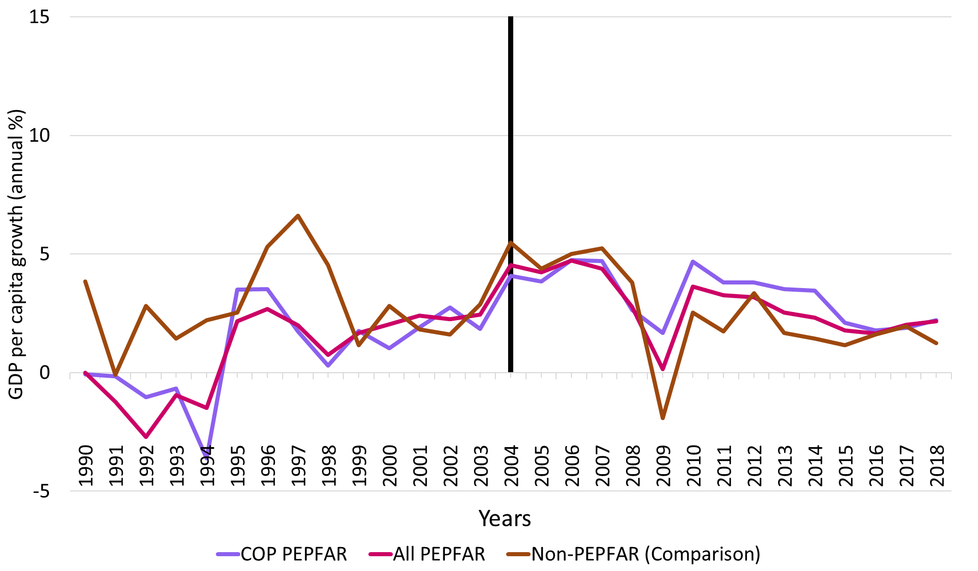
Source: Authors’ tabulations
Notes: Vertical line indicates the formal year of initiation of the PEPFAR program; COP=Country Operational Plans; GDP=gross domestic product; PEPFAR= US President's Emergency Plan for AIDS Relief.

Panel (b). Trends in female primary school disengagement
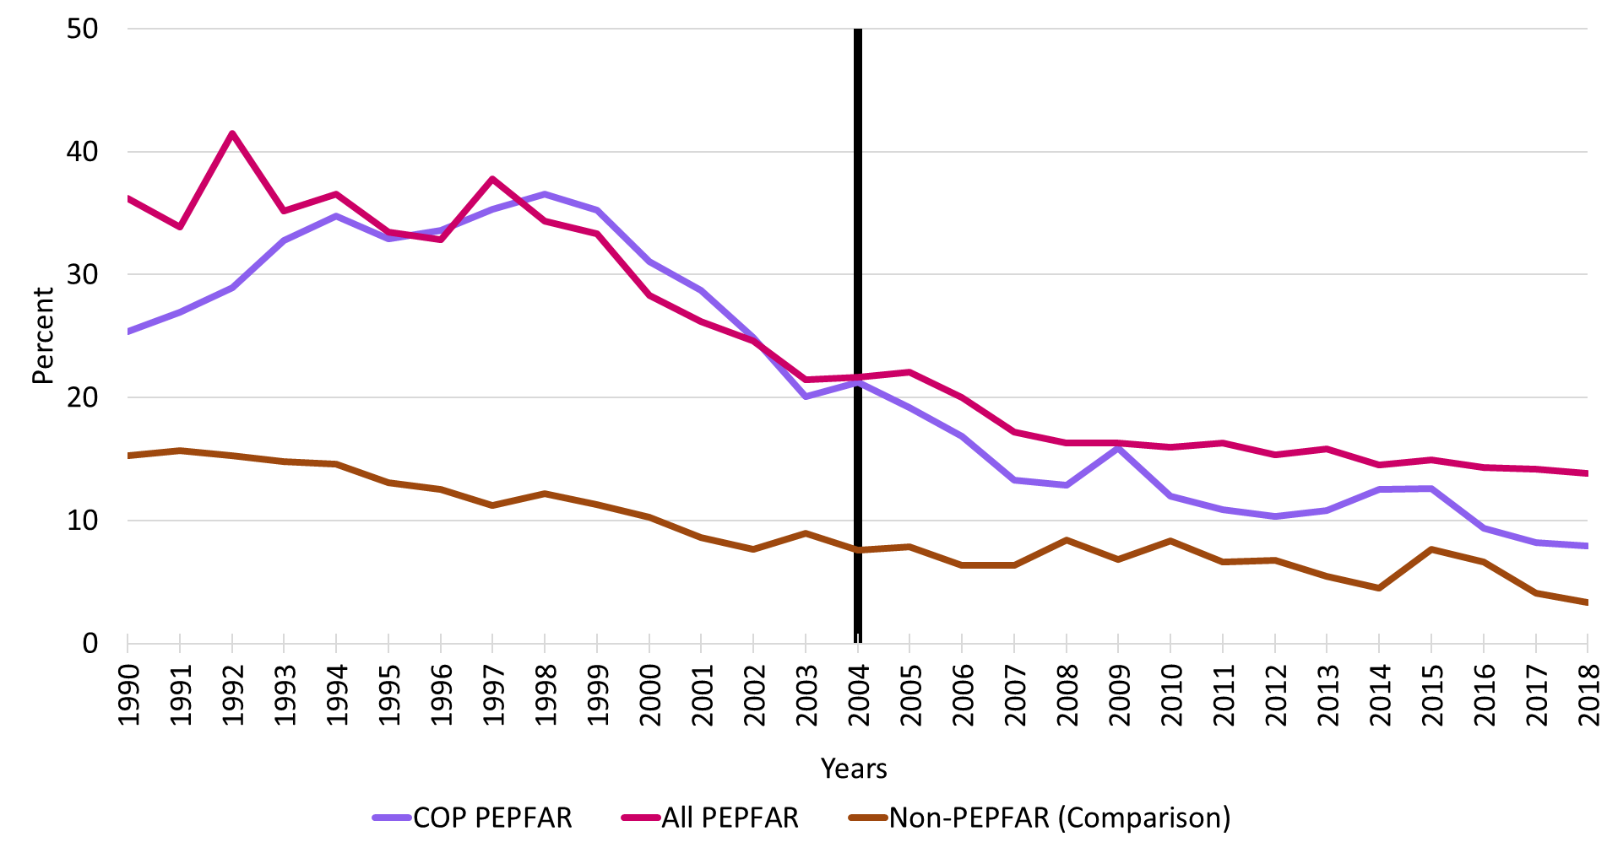
Source: Authors’ tabulations
Notes: Vertical line indicates the formal year of initiation of the PEPFAR program; COP=Country Operational Plans; PEPFAR= US President's Emergency Plan for AIDS Relief.

Panel (c). Trends in male primary school disengagement
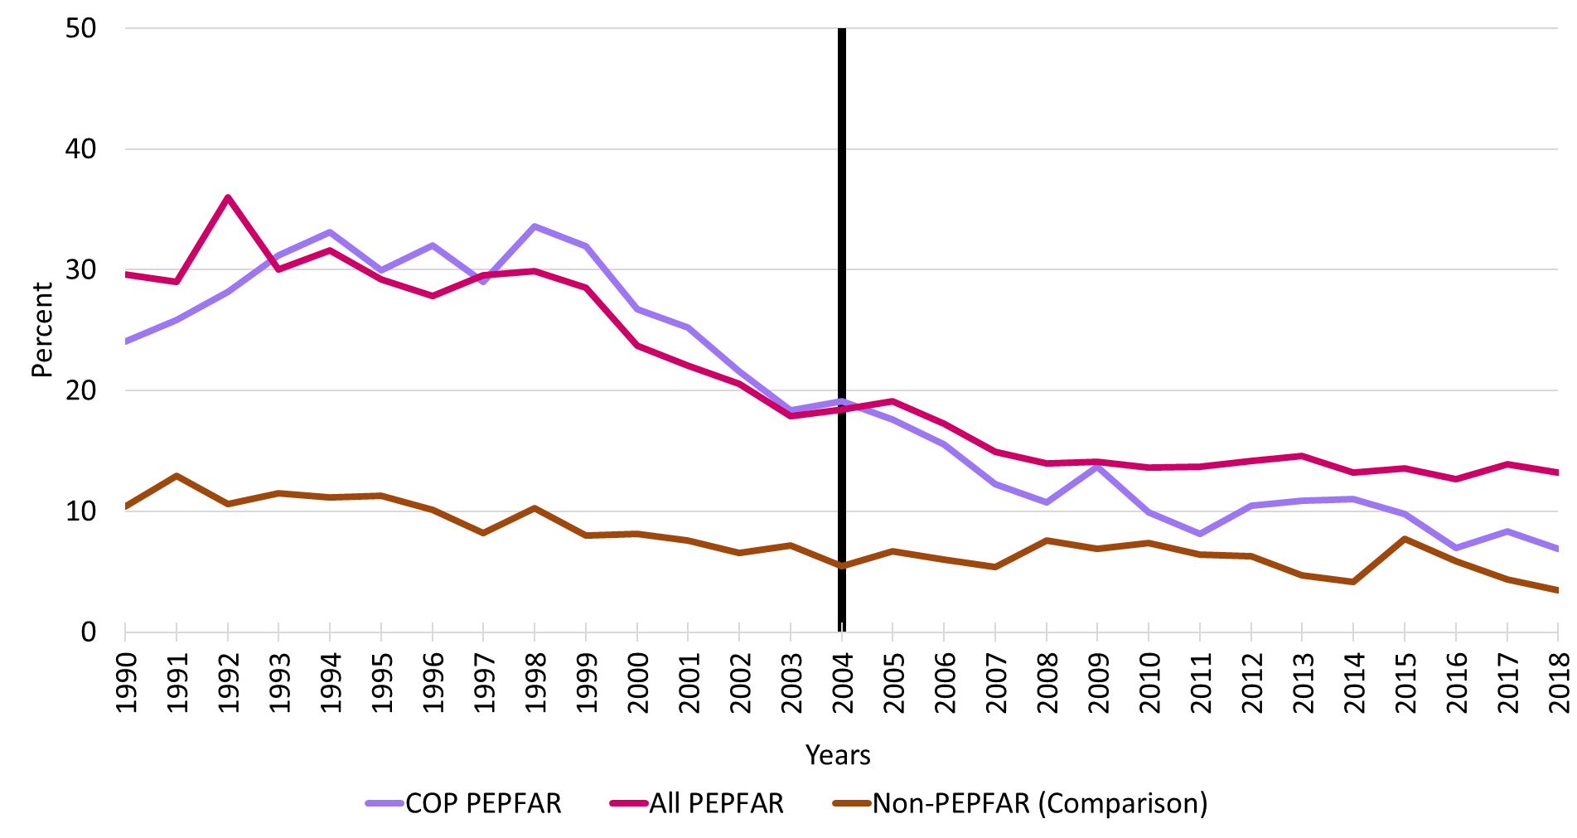
Source: Authors’ tabulations
Notes: Vertical line indicates the formal year of initiation of the PEPFAR program; COP=Country Operational Plans; PEPFAR= US President's Emergency Plan for AIDS Relief.

Panel (d). Trends in female employment rates
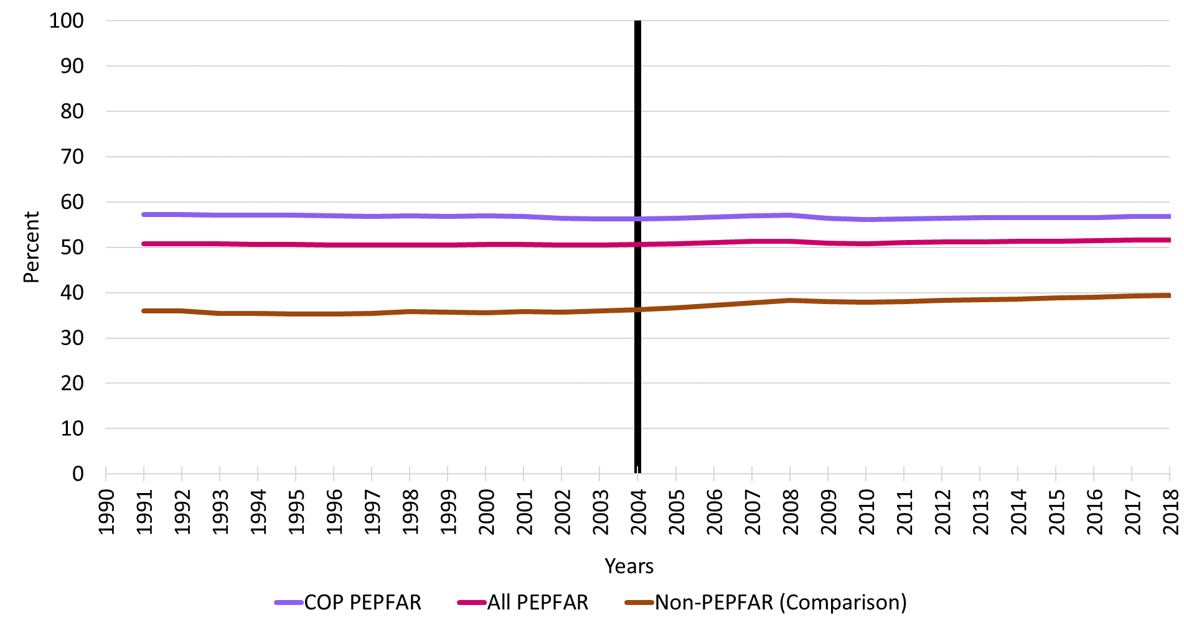
Source: Authors’ tabulations
Notes: Vertical line indicates the formal year of initiation of the PEPFAR program; COP=Country Operational Plans; PEPFAR= US President's Emergency Plan for AIDS Relief.

Panel (e). Trends in male employment rates
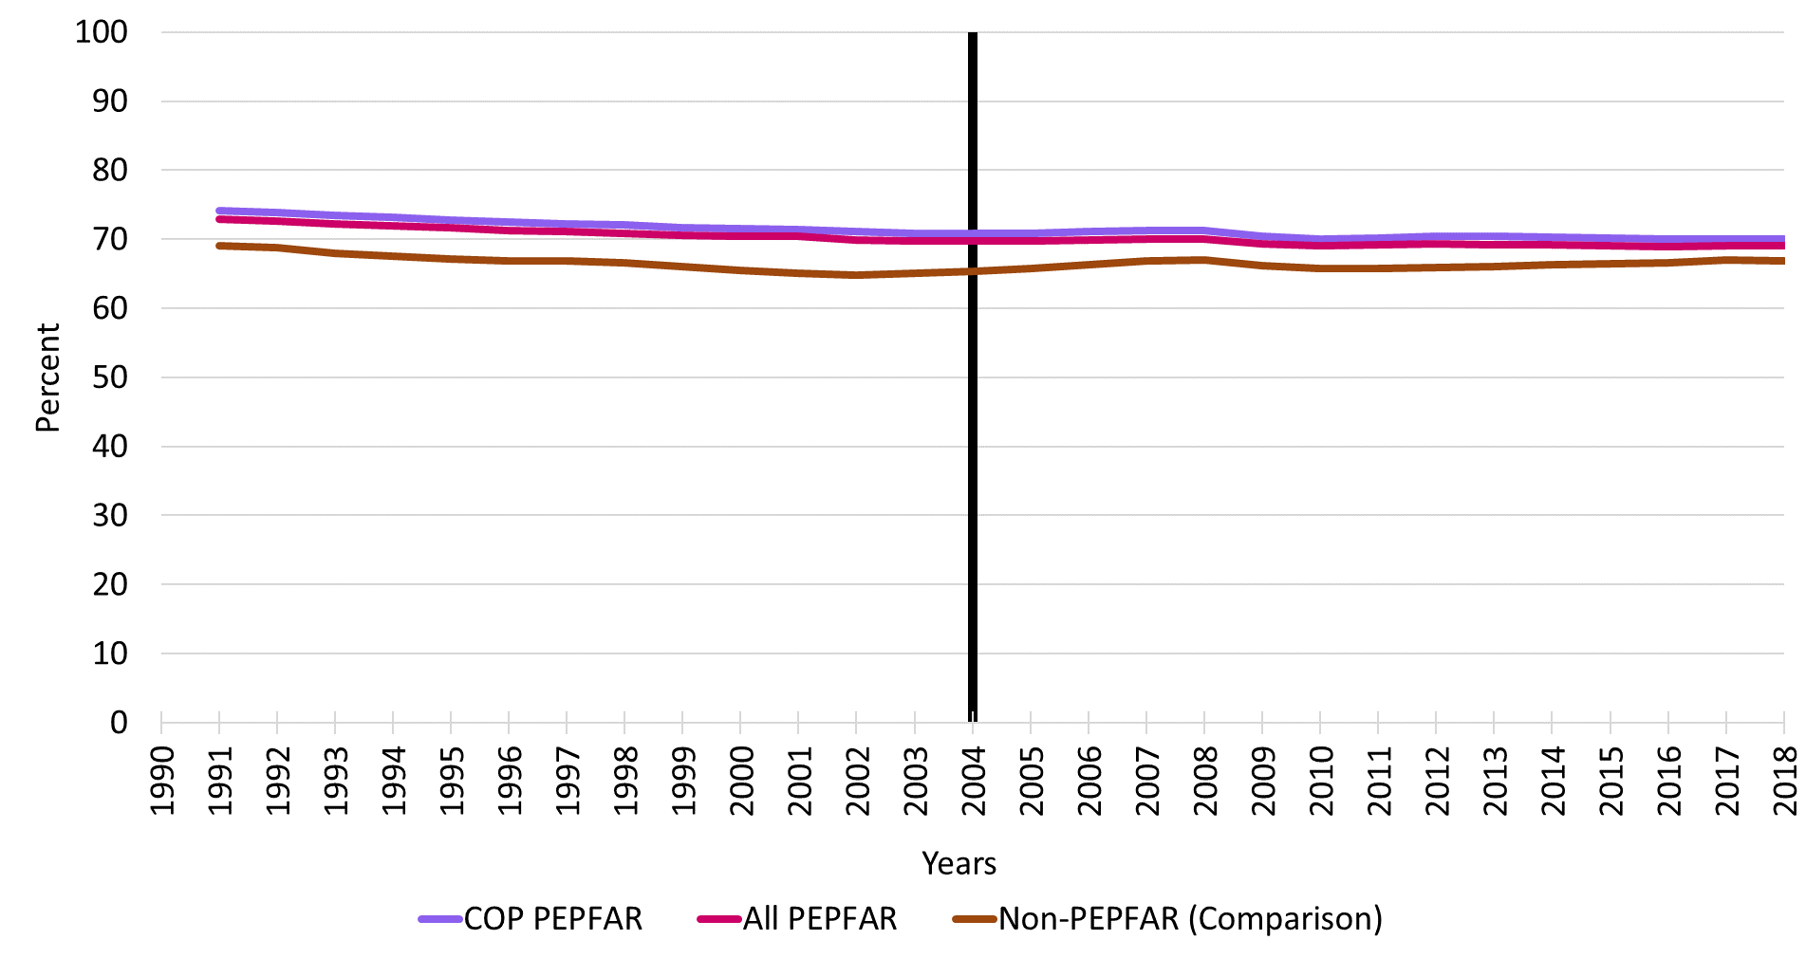
Source: Authors’ tabulations
Notes: Vertical line indicates the formal year of initiation of the PEPFAR program; COP=Country Operational Plans; PEPFAR= US President's Emergency Plan for AIDS Relief.

Figure A.2 Testing the parallel trends assumption for five outcomes in common DID setting

Panel (a). GDP per capita growth rate

Panel (b). Female primary school disengagement

Panel (c). Male primary school disengagement

Panel (d). Female employment rate

Panel (e). Male employment rate

Figure A.3 Testing the parallel trends assumption for five outcomes in staggered DID setting

Panel (a). GDP per capita growth rate

Panel (b). Female primary school disengagement

Panel (c). Male primary school disengagement

Panel (d). Female employment rate

Panel (e). Male employment rate

Figure A.4 Honest DID estimation results

Panel (a). GDP per capita growth rate

Panel (b). Female primary school disengagement

Panel (c). Male primary school disengagement

Panel (d). Female employment rate

Panel (e). Male employment rate

Figure A.5 Placebo test results

Panel (a). GDP per capita growth rate

Panel (b). Female primary school disengagement

Panel (c). Male primary school disengagement

Panel (d). Female employment rate

Panel (e). Male employment rate

