Supplementary Information
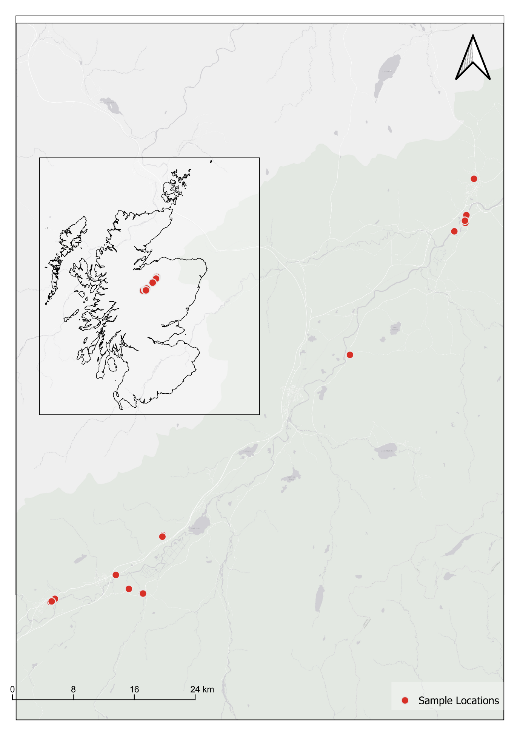
Fig.S 1. Locations of the Andrena marginata nest aggregations (n = 31) sampled in August 2022 in the Spey valley, Cairngorms National Park, Scotland (OS grid squares NN60, NN68 and NN80). Points denote sampled aggregations; some points overlap at this scale. Inset shows the location of the study area within Scotland. Projection British National Grid (EPSG:27700). Contains Ordnance Survey data © Crown copyright and database right (2026), and OpenStreetMap contributor data.
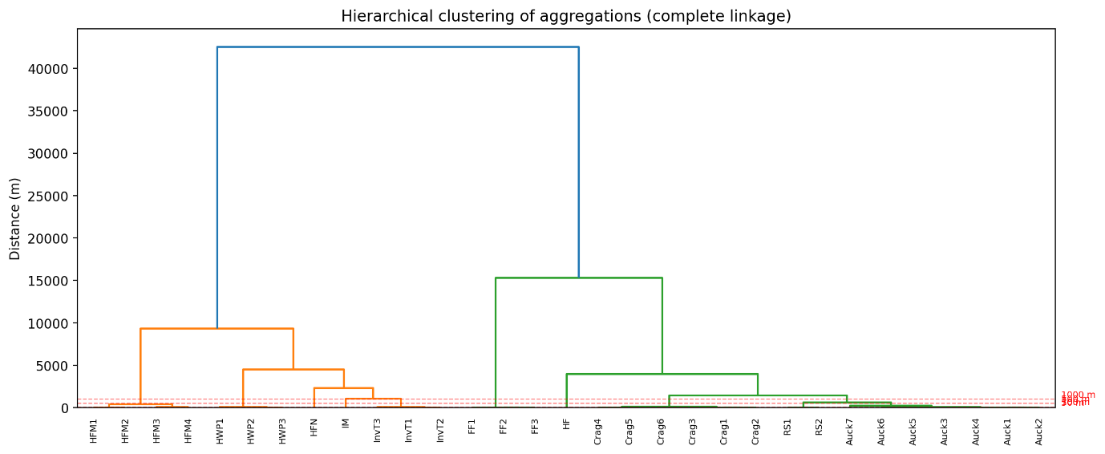
Fig.S 2. Complete-linkage hierarchical clustering dendrogram of the sampled A. marginata nest aggregations, based on pairwise Euclidean distances between aggregation centroids. Leaf labels give site codes; branch height gives the merge distance in metres. Red dashed lines mark the merging thresholds evaluated in the sensitivity analysis (2, 5, 10, 20, 50, 100, 500 and 1000 m), all of which fall close to the horizontal axis relative to the overall spread of the data, reflecting that most aggregations are separated by kilometres rather than metres. The maximum merge height of approximately 42.5 km corresponds to the full extent of the sampled area.

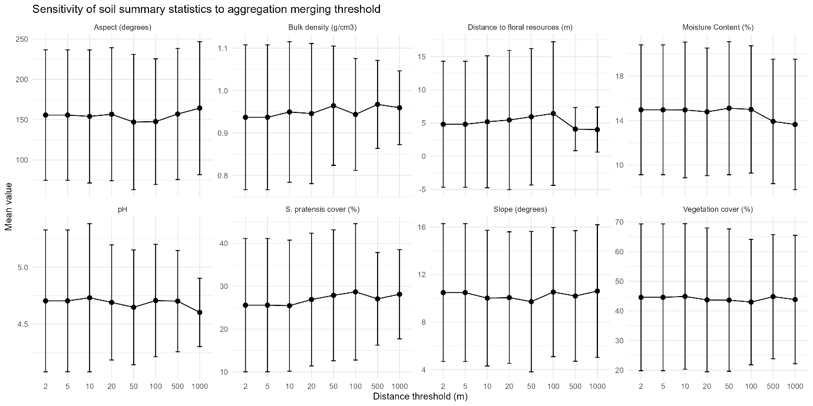
Fig.S 3. Sensitivity of soil and microhabitat summary statistics to the distance threshold used to define separate nest aggregations. Aggregations were merged by complete-linkage hierarchical clustering at thresholds of 2 to 1000 m and variable means recalculated within the resulting clusters. Points give the mean and error bars give ± 2 standard deviations across clusters. The number of clusters falls from 31 at 2 m to 17 at 50 m and 9 at 1000 m. All soil variable means change by less than 8% at 50 m and less than 3% at 1000 m relative to baseline. Distance to floral resources is the only variable to shift appreciably, driven by a single outlying aggregation (42.0 m from the nearest Succisa pratensis).

