Supplementary Information

Figure S1. Computational models of the MOR–D₁R heterotetramer constructed to investigate alternative G protein arrangements. (a) In the first model, both G proteins (Gi coupled to MOR and Gs coupled to D₁R) were positioned on the outer protomers of the complex. (b) In the second model, the MOR-associated Gi protein occupied the outer protomer and the D₁R-associated Gs protein was positioned on the inner protomer. (c) In the third model, the MOR-associated Gi protein occupied the inner protomer, while the D₁R-associated Gs protein was positioned on the outer protomer. The stability of the complexes was analyzed via root-mean-square deviations (RMSD) during unbiased 1 μs MD simulations (right panels). Low RMSD values indicate that the protein is stable in the complex. As expected, the G proteins exhibited higher RMSD values than the receptor protomers, primarily due to the intrinsic flexibility of the α-helical domain of the Gα subunit.
Figure S2. Proposed mechanism by which naloxone-bound MOR mediates cross-antagonism of its partner D₁R. (a) Distance the C_{a} atom of K235^{5.39} and either the carbonyl group (O=C) at the C6 position of the morphinan scaffold in naloxone or the hydroxyl group (HO-C) at the corresponding position in morphine during three independent 1-μs unbiased MD simulations. Rotational flexibility of TM5 during the simulations show that naloxone provides increased stability. (b) Dynamical cross-correlation matrix (DCCM) for the naloxone bound-system, with axes representing MOR protomer residues in Ballesteros-Weinstein numbering (upper left). Correlated motion is observed between the upper regions of TM5 and ECL2 and the upper regions of TM4. Values range from -1 (fully anticorrelated, dark blue) to +1 (fully correlated, dark red). (c) Schematic representation of the shortest allosteric path derived from the mean network obtained from the DCCM, shown on the dimer structure. Edges (lines) and nodes (spheres) represent network connections and residues along the path, respectively. The start is K235^{5.39} in MOR and the end is R121^{3.50} in D₁R. No allosteric path was detected in the apo receptor system. (d) Contact frequency difference at the MOR-D₁R interface between naloxone-bound and apo receptor systems. Positive values indicate increased contact frequency upon naloxone binding. (e) Allosteric signal strength expressed as conductance (1/weight) for naloxone-bound and apo receptor systems across replicates, showing higher conductance in the naloxone system. Dynamic network modeling was performed using the Python package NetworkX. In this graph-based approach, residues act as nodes connected by edges if they maintain physical proximity (<7.5Å). The efficiency of mechanical transmission across these edges was weighted based on the DCCM of the trajectories, meaning that highly correlated atomic motions translate to high allosteric conductance (low transmission resistance). The DCCM reveals that there is a correlated motion between the upper regions of TM5, ECL2 and TM4 in the MOR protomer. By computing the shortest allosteric path, we traced the continuous flow of this mechanical signal from the naloxone binding site to the conserved (D/E)RY motif at the D₁R protomer. The energetic favorability of this signal transmission is supported by the significantly higher allosteric conductance observed in the naloxone-bound state than in the apo receptor.

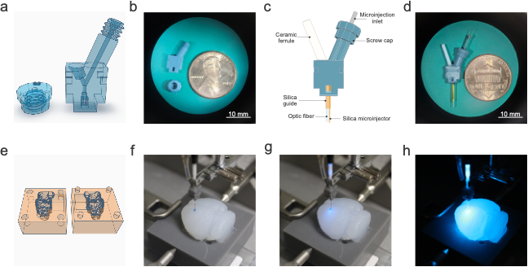
Figure S3. Custom-made photo-fluidic probes and agarose brain phantom. (a) 3D model of the core and cap of the probe. (b) 3D-printed cap and core of the probe. (c) Schematic representation of the photo-fluidic probe. (d) Final photo-fluidic probe after all components were secured together, including the photometry probe and the microinjector. (e) 3D model of the mold for preparing a 4% agarose brain phantom. Images of the agarose brain phantom during Evans blue dye microinfusion (f), dye microinfusion with fiber photometry (g), and fiber photometry with room lights turned off (h).

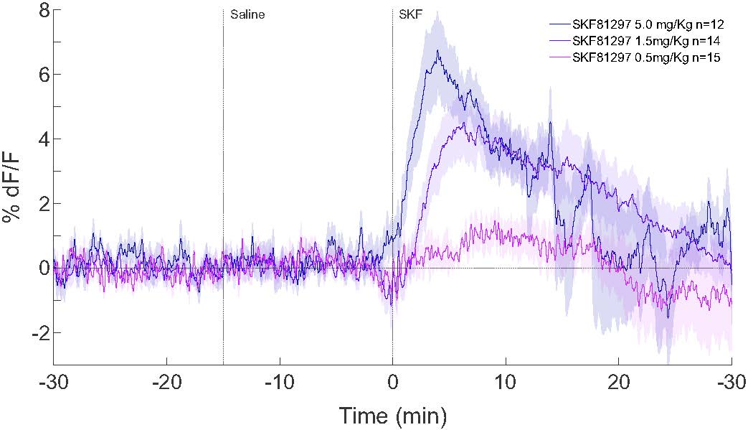
Figure S4. Dose-response curve of SKF 81297 (SKF) on cAMP levels in the mouse dorsal striatum. Striatal cAMP levels were evaluated in vivo using fiber photometry with the cADDis biosensor. Animals were injected with saline and, 15 minutes later, with one of three doses of SKF (0.5, 1.5, or 5.0 mg/kg). The vertical dotted lines indicate the timing of injections. The horizontal dotted line represents the baseline fluorescence normalized to zero percent.

 | K_{DB1} |  | K_{DB2} |  | K_{DAB} |  | D_{CB}
 | Log (M) | nM | Log (M) | nM | Log (M) | nM | D_{CB}
EM1 | -8.93 | 1.18  (0.89-1.58) | -5.68 | 2104  (1597-2774) | -8.30 | 5.04  (3.51-7.23) | -2.65
EM1 + SKF | -9.09 | 0.81  (0.75-0.87) | -6.26* | 548  (406-740) | -8.38 | 4.15  (3.61-4.78) | -2.23
EM1 + SCH | -8.87 | 1.36  (1.05-1.76) | -5.91 | 1222  (724-2063) | -8.13 | 7.37  (5.26-10.32) | -2.35

Table S1. Parameter values obtained by fitting data from competition experiments of the antagonist [³H]-naloxone binding to MOR vs. the agonist endomorphin-1 to the dimer receptor model. Values are expressed as log (K_{D}) and mean (confidence interval 95%) from 4 independent experiments performed in triplicate. The radioligand (A) affinity was K_{DA1} = 1.5 nM. K_{DB1} and K_{DB2} are, respectively, the equilibrium dissociation constants of the first and second binding of competitor (B) endomorphin-1 (EM1) to the dimer. K_{DAB} is the hybrid equilibrium dissociation constant of B binding to a receptor dimer semioccupied by A ([³H]-naloxone). D_{CB} is the dimer cooperativity index for the binding of ligand B (see Methods). Statistical analysis was performed using repeated measures one-way ANOVA followed by Dunnett’s multiple comparisons post hoc test (*p < 0.05 vs. EM1).

