Life's Essential 8 Health Behaviors and All-Cause Mortality Across CKM Stages: Accounting for Construct Overlap in NHANES 2005–2014
Yang Zhang1,2†; Yanyuan Wu3†; Hongxi Zhang1,2*; Xiaochen Liu1,2*
1 Third Clinical College, Liaoning University of Traditional Chinese Medicine, Shenyang, Liaoning, China
2 Third Affiliated Hospital, Liaoning University of Traditional Chinese Medicine, Shenyang, Liaoning, China
3 Zhejiang Cancer Hospital, Hangzhou Institute of Medicine (HIM), Chinese Academy of Sciences, Hangzhou, Zhejiang 310022, China
†Yang Zhang and Yanyuan Wu contributed equally and share first authorship; *Hongxi Zhang and Xiaochen Liu share corresponding authorship. Correspondence: Xiaochen Liu (liuxiaochen@cmu.edu.cn); Hongxi Zhang (zhanghongxi999@sina.com)

Supplementary Information
This Supplementary Information contains four supplementary figures and nine supplementary tables.

Supplementary Figures
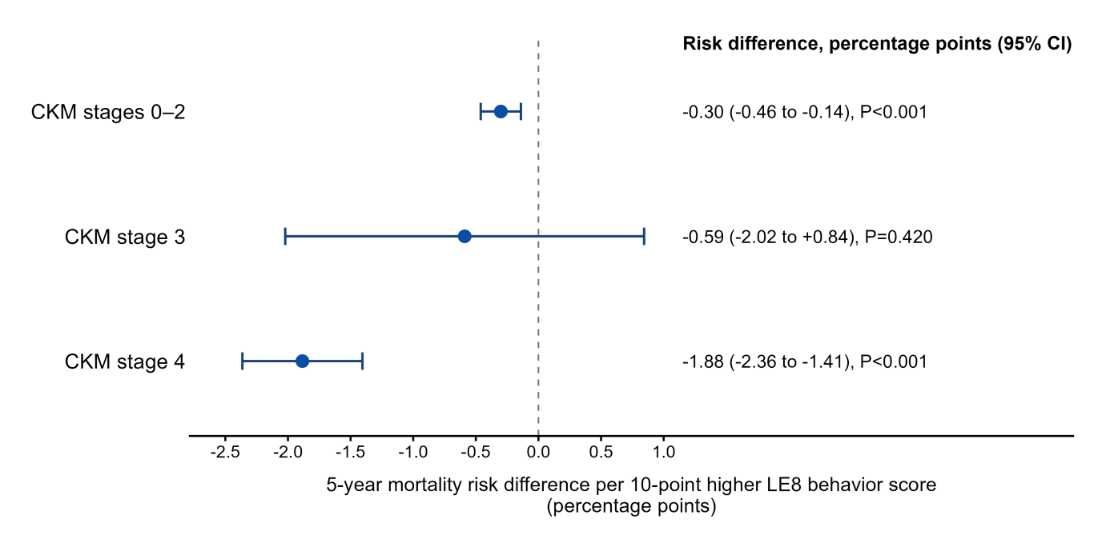

Supplementary Figure S1. Standardized 5-year mortality risk difference associated with a 10-point higher health behavior score. The analysis included 5,949 participants with 893 deaths. Within each CKM stage group, the health behavior score was increased by 10 points and truncated at 100, then compared with the observed-score scenario. Points and intervals represent covariate-marginally standardized 5-year mortality risk differences and 95% CIs; uncertainty was estimated using 500 Rao–Wu complex survey bootstrap replicates with complete model refitting. The dashed line indicates a risk difference of zero.
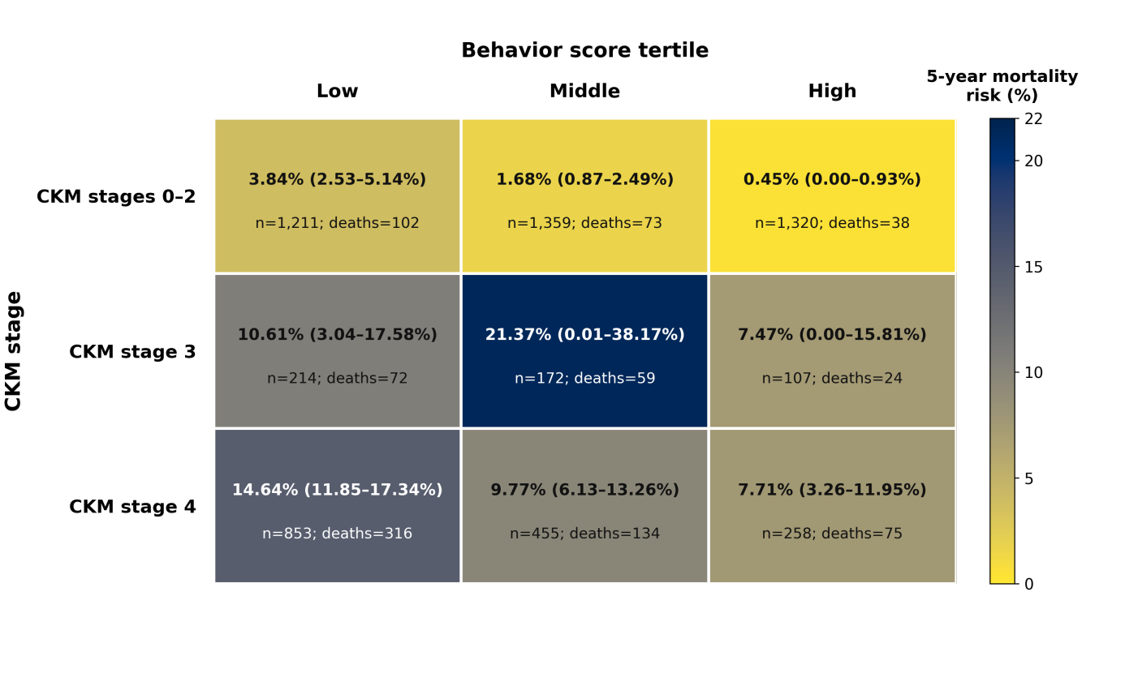

Supplementary Figure S2. Five-year mortality risk across combinations of CKM stage group and health behavior score tertile. The figure shows nine cells formed by CKM stage group and behavior-score tertile among 5,949 participants, with the sample size, number of deaths, and descriptive 5-year cumulative mortality risk for each cell. This analysis was not used for confirmatory between-group comparisons; some cells in CKM stage 3 had small sample sizes and wide intervals.
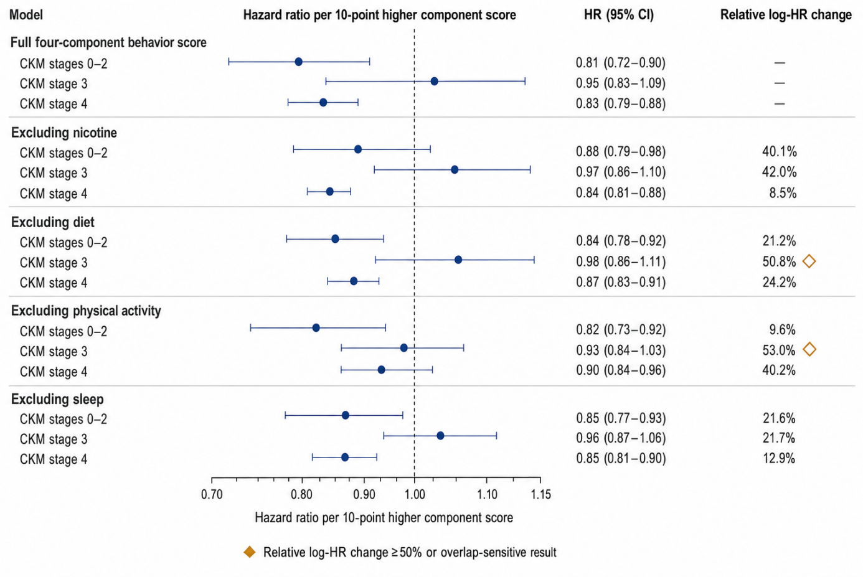

Supplementary Figure S3. Construct-overlap sensitivity analysis with leave-one-component-out scores. The figure shows adjusted HRs and 95% CIs per 10-point higher score for the complete four-component health behavior score and scores obtained after removing diet, physical activity, nicotine exposure, or sleep in turn across the three CKM stage groups. The primary analytic sample included 5,949 participants. Leave-one-component-out models included participants for whom the corresponding score could be constructed and all primary adjustment covariates were complete, and used the same complex survey-weighted Cox model as the primary analysis. The vertical line indicates HR=1.
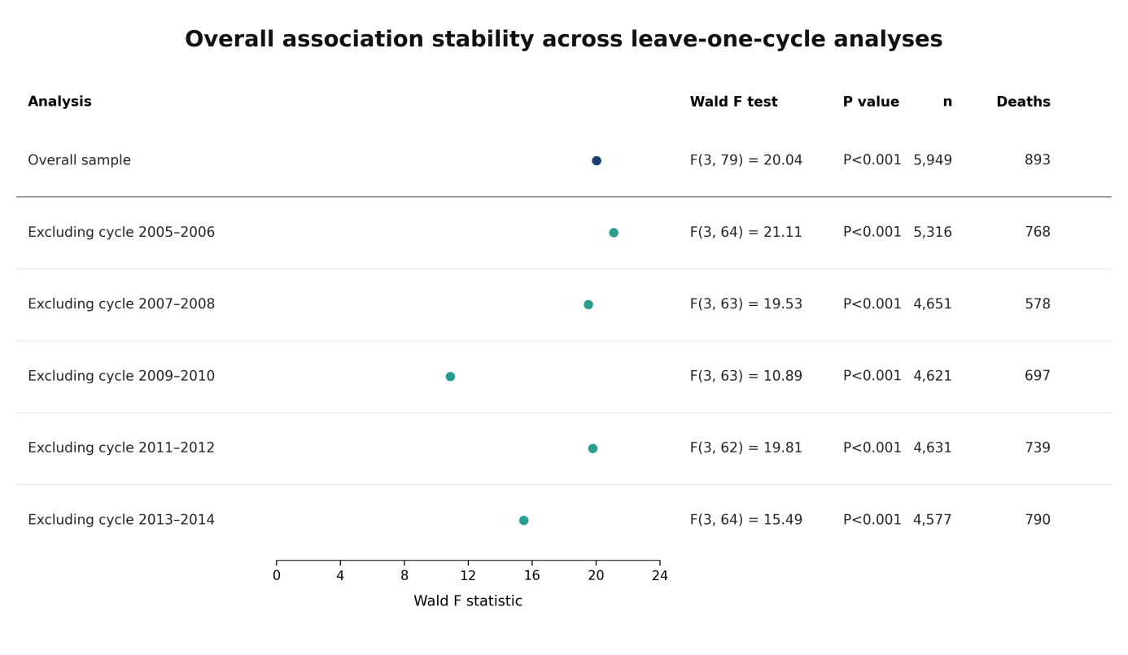
Supplementary Figure S4. Stability of the global association after omitting each NHANES survey cycle. The figure shows results for the overall sample (5,949 participants and 893 deaths) and after omitting one survey cycle at a time for the 3-degree-of-freedom Wald test that the three stage-specific slopes in the complex survey-weighted Cox model were jointly equal to zero. Weights were rescaled across the four remaining cycles in each subset. This analysis evaluated sensitivity of the findings to any single survey cycle.

Supplementary Tables
Supplementary Table S1. Participant screening and sample flow
Screening step | Unweighted participants | Deaths
Initial demographic sample | 50,965 | 4,109
Age 30–79 years | 21,532 | 2,628
Eligible mortality follow-up | 20,826 | 2,506
Complex survey design variables available | 17,347 | 2,076
CKM stage and four-component behavior score available | 6,418 | 950
Final complete-case analytic sample | 5,949 | 893
Note: Participant counts are unweighted; deaths are the numbers with a mortality outcome at the corresponding screening step.
Supplementary Table S2. Standardized 5-year mortality risk differences and descriptive risks in the nine-cell analysis
CKM stage group/behavior level | Measure | Estimate | 95% CI | P value | Stratum sample size/deaths
CKM stages 0–2 | 5-year risk difference (percentage points) | −0.300 | −0.461 to −0.140 | <0.001 | 3,890/213
CKM stage 3 | 5-year risk difference (percentage points) | −0.589 | −2.022 to 0.844 | 0.420 | 493/155
CKM stage 4 | 5-year risk difference (percentage points) | −1.885 | −2.364 to −1.405 | <0.001 | 1,566/525
CKM stages 0–2, low tertile | 5-year mortality risk (%) | 3.84 | 2.53–5.14 | — | 1211/102
CKM stages 0–2, middle tertile | 5-year mortality risk (%) | 1.68 | 0.87–2.49 | — | 1359/73
CKM stages 0–2, high tertile | 5-year mortality risk (%) | 0.45 | 0.00–0.93 | — | 1320/38
CKM stage 3, low tertile | 5-year mortality risk (%) | 10.61 | 3.04–17.58 | — | 214/72
CKM stage 3, middle tertile | 5-year mortality risk (%) | 21.37 | 0.01–38.17 | — | 172/59
CKM stage 3, high tertile | 5-year mortality risk (%) | 7.47 | 0.00–15.81 | — | 107/24
CKM stage 4, low tertile | 5-year mortality risk (%) | 14.64 | 11.85–17.34 | — | 853/316
CKM stage 4, middle tertile | 5-year mortality risk (%) | 9.77 | 6.13–13.26 | — | 455/134
CKM stage 4, high tertile | 5-year mortality risk (%) | 7.71 | 3.26–11.95 | — | 258/75
Note: The risk difference is the absolute change associated with increasing the behavior score by 10 points within the same CKM stage group relative to the observed-score scenario. Risks in the nine-cell analysis are descriptive only.
Supplementary Table S3. Key sensitivity analysis results
Sensitivity analysis | CKM stage group | Effect estimate/statistic | 95% CI | P value | Holm-adjusted P value | Relative change in log HR | Sensitive to construct overlap
Restricted cubic spline nonlinearity test | Overall | F=9.23 | — | <0.001 | — | — | —
Excluding nicotine | CKM stages 0–2 | HR 0.880 | 0.790–0.980 | 0.020 | 0.040 | 40.1% | No
Excluding nicotine | CKM stage 3 | HR 0.972 | 0.856–1.103 | 0.659 | 0.659 | 42.0% | No
Excluding nicotine | CKM stage 4 | HR 0.844 | 0.806–0.884 | <0.001 | <0.001 | 8.5% | No
Excluding diet | CKM stages 0–2 | HR 0.845 | 0.776–0.919 | <0.001 | <0.001 | 21.2% | No
Excluding diet | CKM stage 3 | HR 0.976 | 0.861–1.107 | 0.706 | 0.706 | 50.8% | Yes
Excluding diet | CKM stage 4 | HR 0.869 | 0.833–0.907 | <0.001 | <0.001 | 24.2% | No
Excluding physical activity | CKM stages 0–2 | HR 0.824 | 0.735–0.924 | <0.001 | 0.003 | 9.6% | No
Excluding physical activity | CKM stage 3 | HR 0.928 | 0.837–1.028 | 0.152 | 0.152 | 53.0% | Yes
Excluding physical activity | CKM stage 4 | HR 0.895 | 0.838–0.956 | <0.001 | 0.003 | 40.2% | No
Excluding sleep | CKM stages 0–2 | HR 0.846 | 0.771–0.927 | <0.001 | <0.001 | 21.6% | No
Excluding sleep | CKM stage 3 | HR 0.962 | 0.870–1.065 | 0.456 | 0.456 | 21.7% | No
Excluding sleep | CKM stage 4 | HR 0.851 | 0.807–0.897 | <0.001 | <0.001 | 12.9% | No
Multiple imputation | CKM stages 0–2 | HR 0.802 | 0.721–0.893 | <0.001 | <0.001 | — | —
Multiple imputation | CKM stage 3 | HR 0.948 | 0.839–1.072 | 0.392 | 0.392 | — | —
Multiple imputation | CKM stage 4 | HR 0.827 | 0.785–0.871 | <0.001 | <0.001 | — | —
Inverse-probability missingness weighting | CKM stages 0–2 | HR 0.807 | 0.725–0.898 | <0.001 | <0.001 | — | —
Inverse-probability missingness weighting | CKM stage 3 | HR 0.952 | 0.837–1.084 | 0.460 | 0.460 | — | —
Inverse-probability missingness weighting | CKM stage 4 | HR 0.830 | 0.787–0.876 | <0.001 | <0.001 | — | —
Missing-not-at-random (MNAR) δ stress test | CKM stages 0–2 | HR 0.801 | 0.719–0.892 | <0.001 | <0.001 | — | —
Missing-not-at-random (MNAR) δ stress test | CKM stage 3 | HR 0.944 | 0.835–1.067 | 0.357 | 0.357 | — | —
Missing-not-at-random (MNAR) δ stress test | CKM stage 4 | HR 0.824 | 0.783–0.868 | <0.001 | <0.001 | — | —
Attained-age time scale | CKM stages 0–2 | HR 0.804 | 0.724–0.894 | <0.001 | <0.001 | — | —
Attained-age time scale | CKM stage 3 | HR 0.936 | 0.823–1.064 | 0.311 | 0.311 | — | —
Attained-age time scale | CKM stage 4 | HR 0.821 | 0.777–0.867 | <0.001 | <0.001 | — | —
Note: A result was flagged as sensitive to construct overlap when the relative change in log HR was ≥50% or the direction of effect reversed. Sensitivity analyses do not replace the primary test.
Supplementary Table S4. Missing-data and complete-case selection diagnostics
Measure | Value | Status | Interpretation | Notes
Eligible before primary covariate screening | 6,418 | Observed | CKM stage, four behaviors, mortality follow-up, and survey design variables available | Entered completeness screening for primary adjustment covariates
Complete cases in the primary analysis | 5,949 | Observed | Primary adjustment covariates complete | Primary Cox model sample
Excluded because primary adjustment covariates were missing | 469 (7.3%) | Observed | 6,418−5,949 | Complete-case selection proportion
Stabilized complete-case weight, 1st percentile | 0.946 | Estimated | Assesses selection due to missing primary adjustment covariates | Close to 1
Stabilized complete-case weight, 5th percentile | 0.953 | Estimated | Assesses selection due to missing primary adjustment covariates | Close to 1
Stabilized complete-case weight, median | 0.989 | Estimated | Assesses selection due to missing primary adjustment covariates | Close to 1
Stabilized complete-case weight, 95th percentile | 1.089 | Estimated | Assesses selection due to missing primary adjustment covariates | Close to 1
Stabilized complete-case weight, 99th percentile | 1.140 | Estimated | Assesses selection due to missing primary adjustment covariates | Close to 1
Upstream joint-constructibility weighting (prespecified) | 44,547 | Withdrawn before outcome modeling | WTDR2D was zero or unavailable outside the frozen target population and could not represent the upstream population | No effect estimate was produced; not interpreted as a negative or robustness result
Note: Stabilized complete-case weights were used to assess complete-case selection arising from missing primary adjustment covariates. The prespecified upstream joint-constructibility weighting analysis was withdrawn before outcome modeling because the frozen 2-day dietary weight (WTDR2D) was zero or unavailable outside the 2-day dietary target population and could not represent the upstream population. The value 44,547 is the number excluded before entry into the frozen target population. This analysis produced no effect estimate and is not interpreted as a negative result or as robustness evidence.
Supplementary Table S5. Model assumptions, cycle robustness, and reverse-causation analyses
Analysis | CKM stage group | Effect estimate/statistic | 95% CI | P value | Model sample size/deaths | Variance method/description
Leave-one-cycle-out: exclude 2005–2006 | Overall | F=21.11 | — | 1.27×10⁻⁹ | 5316/768 | Complex survey linearization (cycle weights rescaled)
Leave-one-cycle-out: exclude 2007–2008 | Overall | F=19.53 | — | 4.57×10⁻⁹ | 4651/578 | Complex survey linearization (cycle weights rescaled)
Leave-one-cycle-out: exclude 2009–2010 | Overall | F=10.89 | — | 7.44×10⁻⁶ | 4621/697 | Complex survey linearization (cycle weights rescaled)
Leave-one-cycle-out: exclude 2011–2012 | Overall | F=19.81 | — | 4.04×10⁻⁹ | 4631/739 | Complex survey linearization (cycle weights rescaled)
Leave-one-cycle-out: exclude 2013–2014 | Overall | F=15.49 | — | 1.11×10⁻⁷ | 4577/790 | Complex survey linearization (cycle weights rescaled)
Cross-cycle harmonization of physical activity | Overall | F=20.04 | — | 9.36×10⁻¹⁰ | 5,949/893 | Complex survey linearization
Secondhand-smoke definition: 2005–2012 | Overall | F=16.81 | — | 3.67×10⁻⁸ | 4577/790 | Complex survey linearization
Secondhand-smoke definition: 2013–2014 | Overall | F=7.46 | — | 0.00277 | 1372/103 | Complex survey linearization
5-year restricted mean survival time | CKM stages 0–2 | Mean difference, 0.0068 years | Not reported | Not reported | 3,890/213 | Exploratory standardized point estimate; no interval or P-value inference
5-year restricted mean survival time | CKM stage 3 | Mean difference, 0.0140 years | Not reported | Not reported | 493/155 | Exploratory standardized point estimate; no interval or P-value inference
5-year restricted mean survival time | CKM stage 4 | Mean difference, 0.0453 years | Not reported | Not reported | 1,566/525 | Exploratory standardized point estimate; no interval or P-value inference
Excluding deaths within 2 years of baseline | Overall | F=18.15 | — | 4.71×10⁻⁹ | 5826/770 | Complex survey linearization
Excluding deaths within 2 years of baseline | CKM stages 0–2 | HR 0.801 | 0.714–0.899 | 0.000164 | 5826/770 | Complex survey linearization
Excluding deaths within 2 years of baseline | CKM stage 3 | HR 0.966 | 0.837–1.114 | 0.630 | 5826/770 | Complex survey linearization
Excluding deaths within 2 years of baseline | CKM stage 4 | HR 0.836 | 0.789–0.885 | 1.02×10⁻⁹ | 5826/770 | Complex survey linearization
Alternative eGFR/CKM rules | Overall | F=20.04 | — | 9.36×10⁻¹⁰ | 5,949/893 | Complex survey linearization
Alternative eGFR/CKM rules | CKM stages 0–2 | HR 0.807 | 0.724–0.900 | 0.000107 | 5,949/893 | Complex survey linearization
Alternative eGFR/CKM rules | CKM stage 3 | HR 0.952 | 0.835–1.086 | 0.463 | 5,949/893 | Complex survey linearization
Alternative eGFR/CKM rules | CKM stage 4 | HR 0.831 | 0.787–0.877 | 1.57×10⁻¹¹ | 5,949/893 | Complex survey linearization
Attained-age time scale | Overall | F=20.74 | — | 5.22×10⁻¹⁰ | 5,949/893 | Complex survey linearization
Attained-age time scale | CKM stages 0–2 | HR 0.804 | 0.724–0.894 | 5.48×10⁻⁵ | 5,949/893 | Complex survey linearization
Attained-age time scale | CKM stage 3 | HR 0.936 | 0.823–1.064 | 0.311 | 5,949/893 | Complex survey linearization
Attained-age time scale | CKM stage 4 | HR 0.821 | 0.777–0.867 | 2.26×10⁻¹² | 5,949/893 | Complex survey linearization
Proportional hazards diagnostics | Overall | χ²=46.69 (22 df) | — | 0.00161 | 5,949/893 | Global Schoenfeld residual test; complete results are shown in Supplementary Table S9
Note: F denotes the design-adjusted Wald statistic. In leave-one-cycle-out analyses, weights were rescaled across the four remaining survey cycles. Proportional hazards diagnostics used Schoenfeld residual tests. For 5-year restricted mean survival time, only standardized point estimates are reported; because the available variance implementation did not fully incorporate uncertainty from model-parameter estimation and the complex survey design, confidence intervals and P values are not reported, and no confirmatory conclusion is based on this analysis.
Supplementary Table S6. Validation of the staging algorithm, variable construction, and variance estimation
Validation category | Validation item | Prespecified criterion | Observed result | Conclusion | Description
Staging algorithm | 2021 CKD-EPI boundary values | Absolute error from reference values ≤5×10⁻⁴ | 68.633497, 91.691479, 119.244575 | Passed | Race-free equation used for primary staging
Staging algorithm | 2009 CKD-EPI sensitivity equation | Absolute error from reference values ≤5×10⁻⁴ | 65.637623, 87.369677, 101.261456 | Passed | Used in the alternative-staging sensitivity analysis
Staging algorithm | UACR threshold, PREVENT staging threshold, and official example | UACR=30 mg/g; PREVENT staging threshold=0.20; official S25 example prediction=0.147 | UACR=30 mg/g; PREVENT threshold=0.20; S25 example=0.147 | Passed | 0.147 is an algorithm-validation output, not the CKM stage 3 threshold
Variable construction | Ranges of scores, stages, and risk | Scores 0–100, stages 0–4, risk 0–1, and nonmissing | All scores were within 0–100; CKM stages were 0–4; PREVENT ranged from 0.001 to 0.581 | Passed | Nonmissing counts varied according to variable-construction requirements
Variance validation | Linearization-variance simulation for the primary Cox model | 100% success rate; coverage 0.925–0.975; SE ratio 0.80–1.25 | 100% success rate; coverage 0.943–0.950; SE ratio 0.979–1.028 | Passed | Included scenarios with null effects, heterogeneous slopes, and sparse stage 4 data
Variance validation | Rao–Wu resampling for 5-year risk differences | 500 complete refits; coverage 0.925–0.975; SE ratio 0.80–1.25 | 100% success rate; coverage 0.948–0.960; SE ratio 0.997–1.000 | Passed | CKM stages 0–2, stage 3, and stage 4
Variance validation | Resampling for differences between health behavior and total LE8 score slopes | 500 synchronized resamples; coverage 0.925–0.975; SE ratio 0.80–1.25 | 100% success rate; coverage 0.946–0.966; SE ratio 0.990–1.000 | Passed | Three CKM stage groups
Note: The staging algorithm, variable ranges, and complex survey variance methods were validated against prespecified standards. Only summary results suitable for scientific interpretation are reported.
Supplementary Table S7. Operational definitions, thresholds, and priorities for CKM stages 0–4
Stage/group | Operational definition | Thresholds and inputs | Priority and missing-data handling
CKM stage 4 | Clinical cardiovascular disease | Any self-reported coronary heart disease, myocardial infarction, angina, heart failure, or stroke | Highest priority; classified as stage 4 when any criterion was met
CKM stage 3 | No clinical cardiovascular disease; at least one stage 1 or stage 2 criterion; and PREVENT 10-year total CVD risk ≥0.20 | PREVENT base model on a 0–1 scale for ages 30–79 years; inputs: age, sex, SBP, antihypertensive treatment, total cholesterol, HDL, statin treatment, diabetes, current smoking, eGFR, and BMI | Evaluated only among participants without stage 4; if a required input was missing, stage 3 was unknown and was not automatically reassigned to stage 2
CKM stage 2 | Hypertension, diabetes, or chronic kidney disease | Hypertension: mean SBP ≥130 mmHg, DBP ≥80 mmHg, or antihypertensive treatment; diabetes: self-report, medication use, HbA1c ≥6.5%, or FPG ≥126 mg/dL; CKD: eGFR <60 mL/min/1.73 m² or UACR ≥30 mg/g | Classified when stage 3–4 criteria were not met
CKM stage 1 | Overweight/central obesity or prediabetes | BMI ≥25 kg/m²; waist circumference ≥102 cm in men or ≥88 cm in women; or, without diabetes, HbA1c 5.7%–6.4% or FPG 100–125 mg/dL | Classified when stage 2–4 criteria were not met
CKM stage 0 | No stage 1–4 criteria met | No metabolic, kidney, or clinical cardiovascular trigger listed above | Lowest stage
Primary analysis groups | Stages 0–2, stage 3, and stage 4 | Stage 0 had only nine deaths; the prespecified minimum was 20 deaths per primary stratum | Grouping does not imply clinical homogeneity across stages 0, 1, and 2
Note: Participants were classified according to the highest stage whose criteria they met; clinical cardiovascular disease took priority as stage 4. Because NHANES lacks subclinical imaging data, stage 3 was identified only through the high-risk PREVENT pathway. When a required PREVENT input was missing, stage 3 status was recorded as unknown and was not automatically reassigned to stage 2.
Supplementary Table S8. Construction and scoring rules for the four LE8 health behavior components
Component | Construction and variables | 0–100 scoring rule | Completeness and cross-cycle handling
Diet | Two-day DR1/DR2 records were linked to cycle-specific daily FPED totals by SEQN and cycle; arithmetic means of 2-day FPED equivalents and nutrients, including energy, sodium, and fatty acids, were calculated before scoring the 13 HEI-2015 components | HEI-2015 total score used directly (0–100) | Required DR1DRSTZ=1, DR2DRSTZ=1, and WTDR2D>0; energy ≤0, linkage failure, or an invalid denominator was treated as missing, with no substitution of a 1-day score
Physical activity | Moderate-intensity-equivalent minutes/week=moderate-intensity minutes+2×vigorous-intensity minutes; calculated from activity-level PAQIAF records in 2005–2006 and from GPAQ in 2007–2014 | 0→0; 1–29→20; 30–59→40; 60–89→60; 90–119→80; 120–149→90; ≥150→100 | GPAQ days were restricted to 0–7 and minutes to 0–960; out-of-range values were set to missing; both questionnaires were harmonized to the same weekly-minute scale
Nicotine exposure | Current smoking status and years since cessation among former smokers | Current smoking 0; cessation <1 year 25; cessation 1 to <5 years 50; cessation ≥5 years 75; never smoking 100 | The primary score across five cycles did not deduct points for secondhand smoke; secondhand smoke was evaluated in cycle-specific sensitivity analyses
Sleep | Usual nightly sleep duration (h/night) | <4→0; 4 to <5→20; 5 to <6→40; 6 to <7→70; 7 to <9→100; 9 to <10→90; ≥10→40 | Valid range 0–24 h; out-of-range values were set to missing
Composite scores | Health behavior score=equally weighted mean of diet, physical activity, nicotine exposure, and sleep; health factor score=equally weighted mean of BMI, non-HDL cholesterol, blood glucose, and blood pressure; total LE8=equally weighted mean of all eight components | All component and composite scores were restricted to 0–100 | The primary behavior score required all four components; the common sample for comparison with total LE8 required all eight components and the primary adjustment set to be complete
Note: When all four behavior components were complete, their equally weighted mean yielded the health behavior score on a 0–100 scale. The score excluding nicotine was the mean of diet, physical activity, and sleep; each leave-one-component-out score was the mean of the remaining three behavior components.
Supplementary Table S9. Schoenfeld residual proportional hazards diagnostics for the primary Cox model
Model term | χ² | Degrees of freedom | P value
Health behavior score | 10.8703 | 1 | 0.000977
CKM stage group | 2.3434 | 2 | 0.3098
Age spline term 1 | 6.1710 | 1 | 0.0130
Age spline term 2 | 1.1625 | 1 | 0.2809
Age spline term 3 | 15.4896 | 1 | 8.30×10⁻⁵
Sex | 0.0048 | 1 | 0.9445
Race and ethnicity | 9.0455 | 4 | 0.0600
Educational attainment | 4.3856 | 4 | 0.3563
Family income-to-poverty ratio | 0.4432 | 1 | 0.5056
NHANES survey cycle | 5.6756 | 4 | 0.2247
Health behavior score×CKM stage group | 5.9273 | 2 | 0.0516
Global test | 46.6907 | 22 | 0.00161
Note: Statistics were obtained from survival::cox.zph(primary_model$fit). The global P value of 0.00161 was below the prespecified trigger threshold of 0.01; therefore, the exploratory 5-year restricted mean survival time analysis was initiated. This analysis does not replace the primary complex survey-weighted Cox analysis.

