Self-organized Ag-Sb lamellae redirect cracks in all-solid-state Li metal batteries
Cheng Xu,¹ Shiyao Lin,² Bharat Pant,³ Ye Cao,³ Jiwei Wang,¹ Han Su,⁴ Hua Zhou,⁵ Luxi Li,⁵ Xianhui Zhao,⁶ Ercan Cakmak,⁶ Longqing Chen,⁷ Chunsheng Wang,*^{,4} Hongli Zhu*^{,1}

¹Department of Mechanical and Industrial Engineering, Northeastern University, Boston, MA 02115, USA
²Department of Mechanical and Aerospace Engineering, University of Texas at Arlington, Arlington, TX 76019, United States
³Department of Materials Science and Engineering, University of Texas at Arlington, Arlington, TX 76019, United States
⁴Department of Chemical and Biomolecular Engineering, University of Maryland, College Park, MD 20740, USA
⁵X-ray Science Division, Advanced Photon Source, Argonne National Laboratory, Lemont, IL 60439, USA.
⁶Oak Ridge National Laboratory, Oak Ridge, TN 37830, USA
⁷Department of Materials Science and Engineering, The Pennsylvania State University, University Park, Pennsylvania 16802, USA
Corresponding authors: h.zhu@neu.edu; cswang@umd.edu

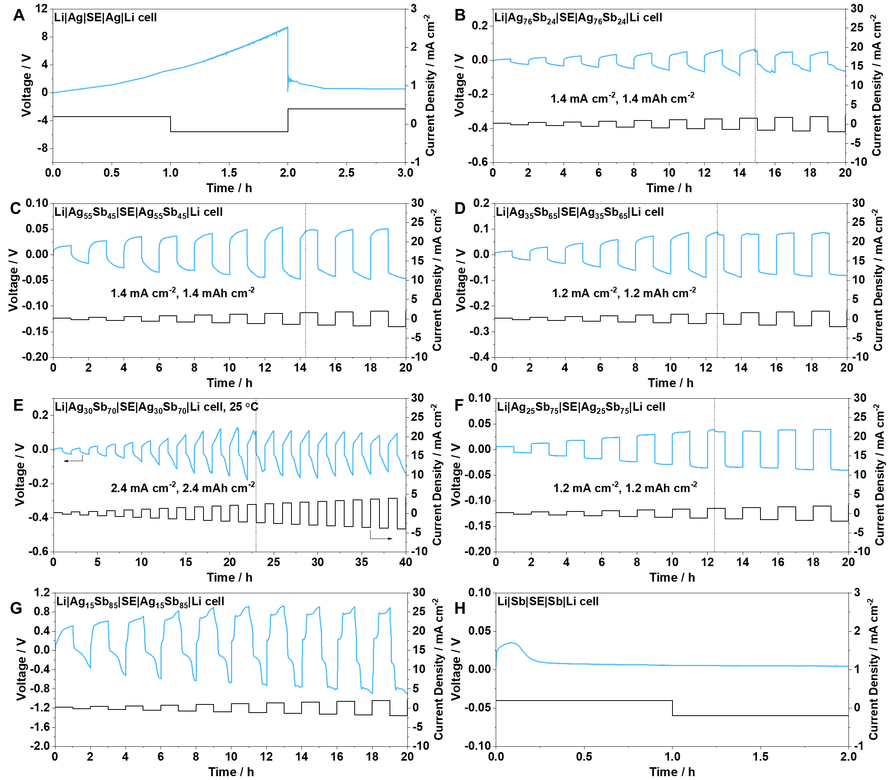
Supplementary Fig. S1. Critical current density of Li|Ag_{x}Sb_{y}||SE||Ag_{x}Sb_{y}|Li symmetric cells at 25 °C. (A) Ag. (B) Ag₇₆Sb₂₄. (C) Ag₅₅Sb₄₅. (D) Ag₃₅Sb₆₅. (E) Ag₃₀Sb₇₀. (F) Ag₂₅Sb₇₅. (G) Ag₁₅Sb₈₅. (H) Sb. The cells were standing at 80 °C overnight before testing at 25 °C.
It is important to note that the observed polarization is sensitive to the interlayer thickness. A reduction in the mass loading of the Ag and Sb powders leads to a thinner interlayer and a lower overpotential. Consequently, the relatively large polarization observed in Fig. 1A, H is attributed to the comparatively thick interlayer used in these measurements.

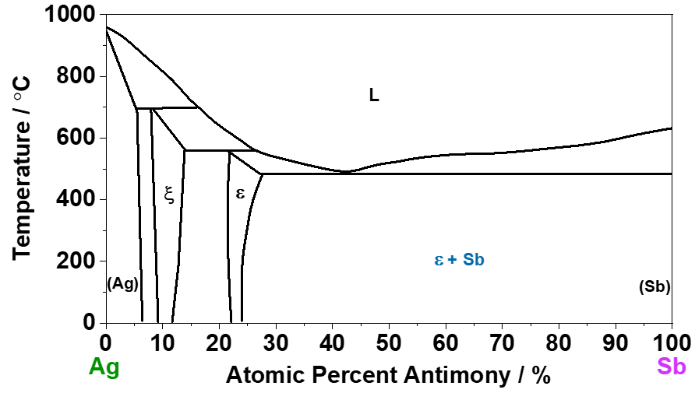
Supplementary Fig. S2. Phase diagram of Ag-Sb.¹

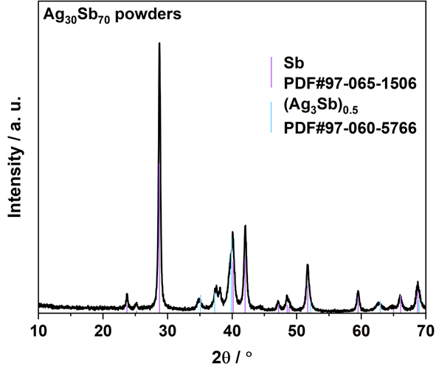
Supplementary Fig. S3. XRD patterns of Ag₃₀Sb₇₀ powders.

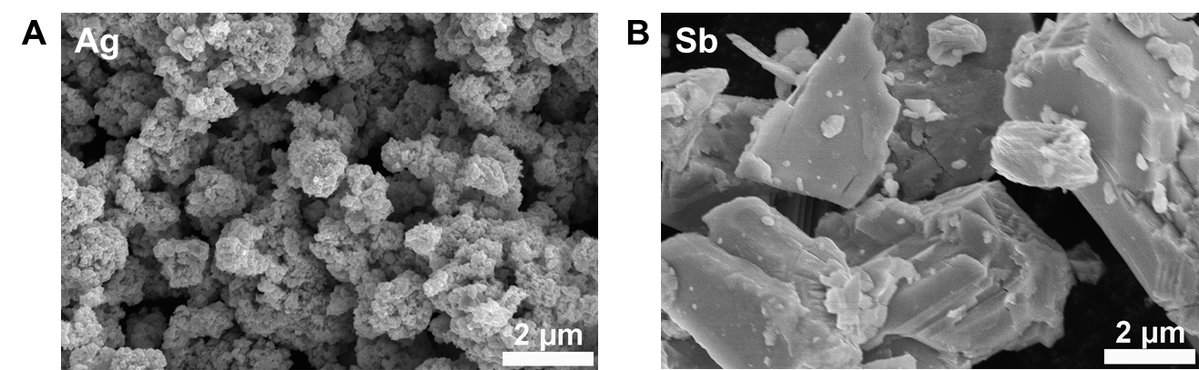
Supplementary Fig. S4. SEM images of the (A) Ag powders, and (B) Sb powders.

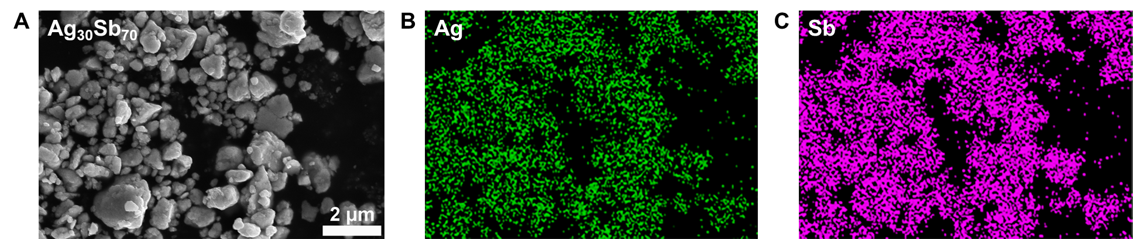
Supplementary Fig. S5. (A) SEM images of the Ag₃₀Sb₇₀ powders, and corresponding EDS mapping of (B) Ag and (C) Sb.

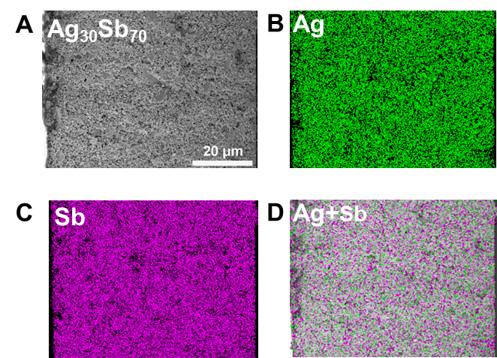
Supplementary Fig. S6. Cross-sectional SEM image of (A) the individual Ag₃₀Sb₇₀ pellet, and corresponding EDS mapping of (B) Ag, (C) Sb, and (D) the overlay of Ag and Sb.

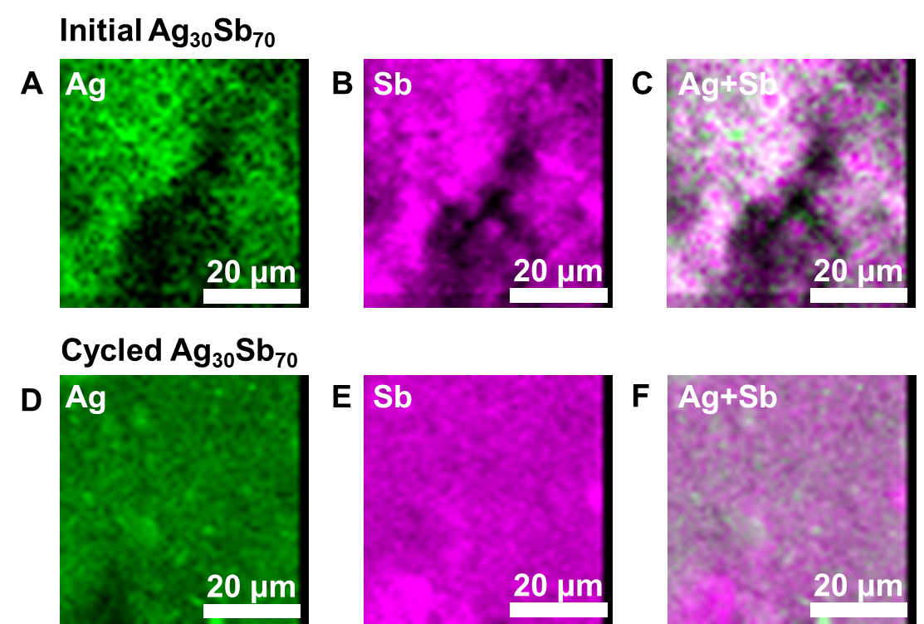
Supplementary Fig. S7. XRF mapping of the surface (not cross-section) of the (A-C) initial Ag₃₀Sb₇₀ interlayer and the (D-F) cycled (5 cycles) Ag₃₀Sb₇₀ interlayer collected from Li|Ag₃₀Sb₇₀||SE||Ag₃₀Sb₇₀|Li symmetric cells. Fluorescence signals of (A, D) Ag, (B, E) Sb, and (C, F) the overlay of Ag and Sb.

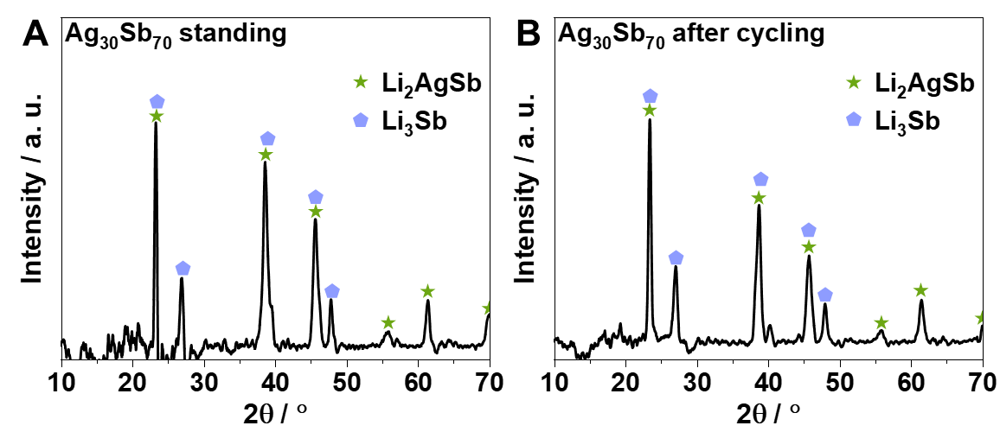
Supplementary Fig. S8. XRD patterns of the Ag₃₀Sb₇₀ interlayer collected from the Li|Ag₃₀Sb₇₀||SE||Ag₃₀Sb₇₀|Li symmetric cell (A) before cycling and (B) after cycling.
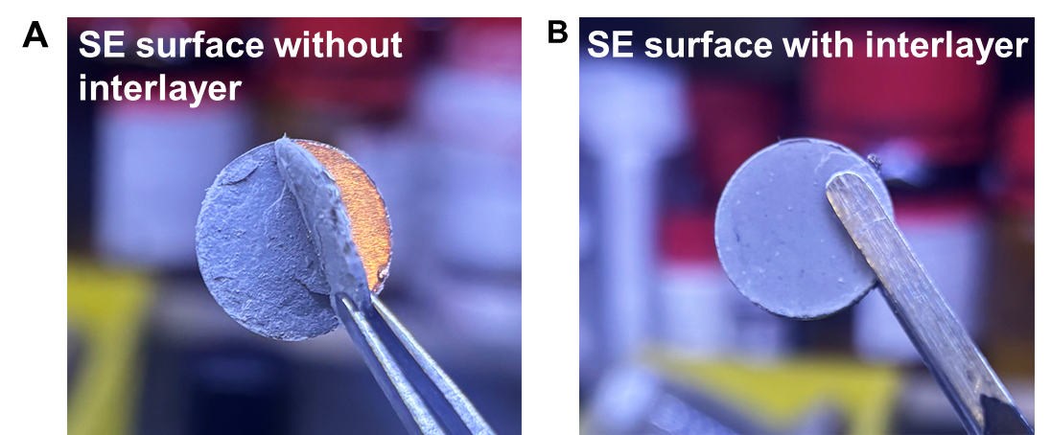
Supplementary Fig. S9. Digital photographs of the SE surface form the cycled (A) Li||SE||Li and (B) Li|Ag₃₀Sb₇₀||SE||Ag₃₀Sb₇₀|Li symmetric cells.

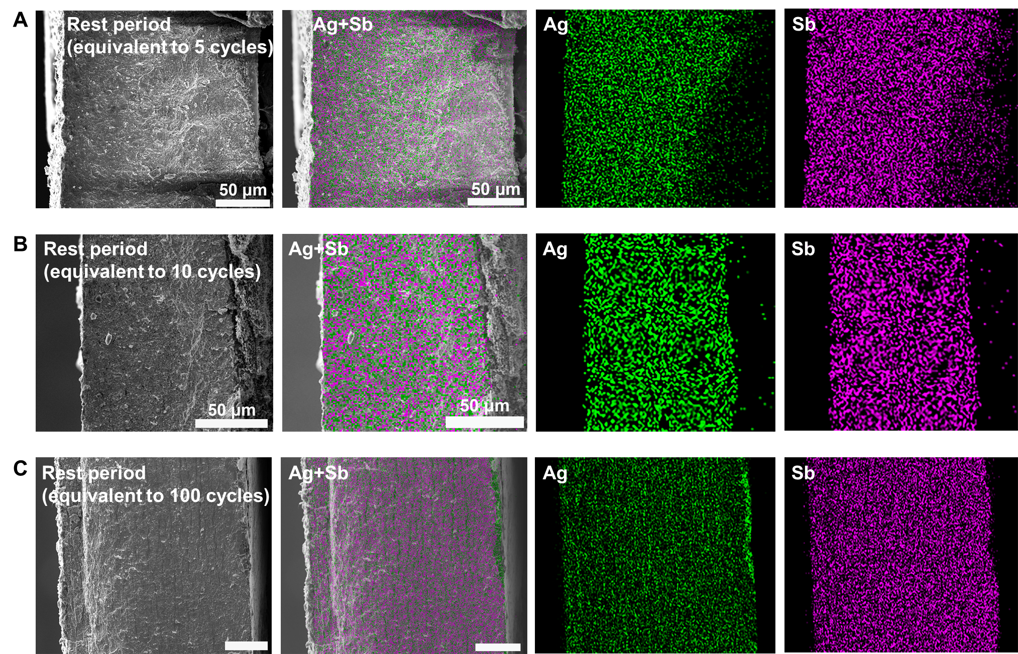
Supplementary Fig. S10. Cross-sectional SEM image and EDS mappings of Ag₃₀Sb₇₀ interlayer collected from the Li|Ag₃₀Sb₇₀||SE||Ag₃₀Sb₇₀|Li symmetric cell after resting for durations equivalent to (A) 5 cycles, (B) 10 cycles, and (C) 100 cycles.

Notably, the Ag₃₀Sb₇₀ sample recovered from the Li|Ag₃₀Sb₇₀||SE||Ag₃₀Sb₇₀|Li symmetric cell also exhibits slight lamellar separation after resting for more than one week, consistent with the phase-field simulation results shown in Fig. 1F. This observation suggests that Li self-diffusion, activated by residual stress and temperature, continues to drive the formation and evolution of the lamellar phases.

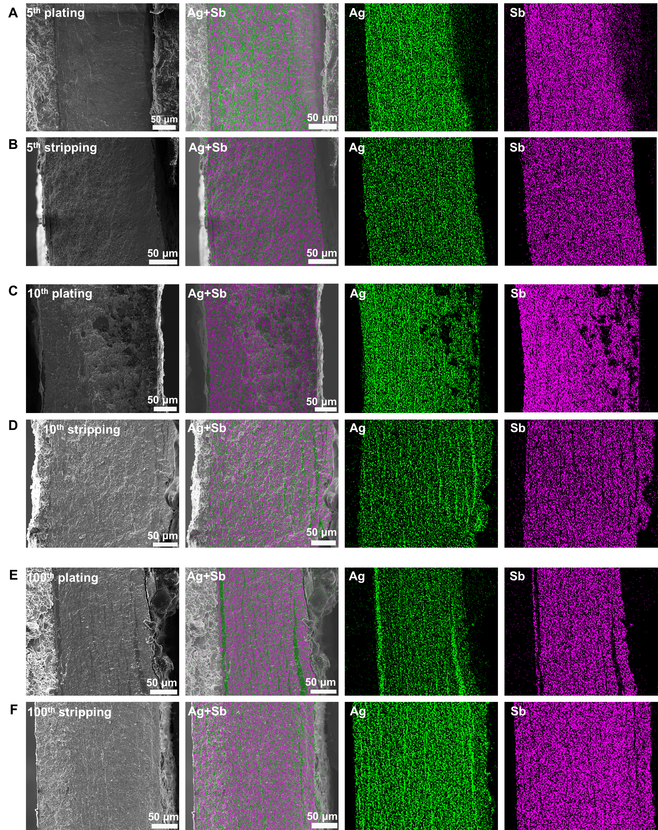
Supplementary Fig. S11. Cross-sectional SEM images and EDS mappings of Ag₃₀Sb₇₀ interlayer collected from the Li|Ag₃₀Sb₇₀||SE||Ag₃₀Sb₇₀|Li symmetric cell at the stripping and plating state after (A, B) 5 cycles, (C, D) 10 cycles, and (E, F) 100 cycles.

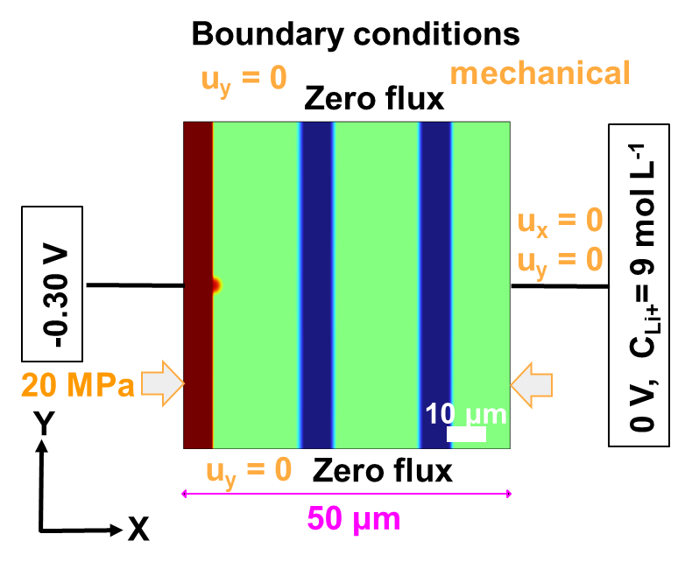
Supplementary Fig. S12. Schematic illustration showing boundary condition for phase-field modeling.

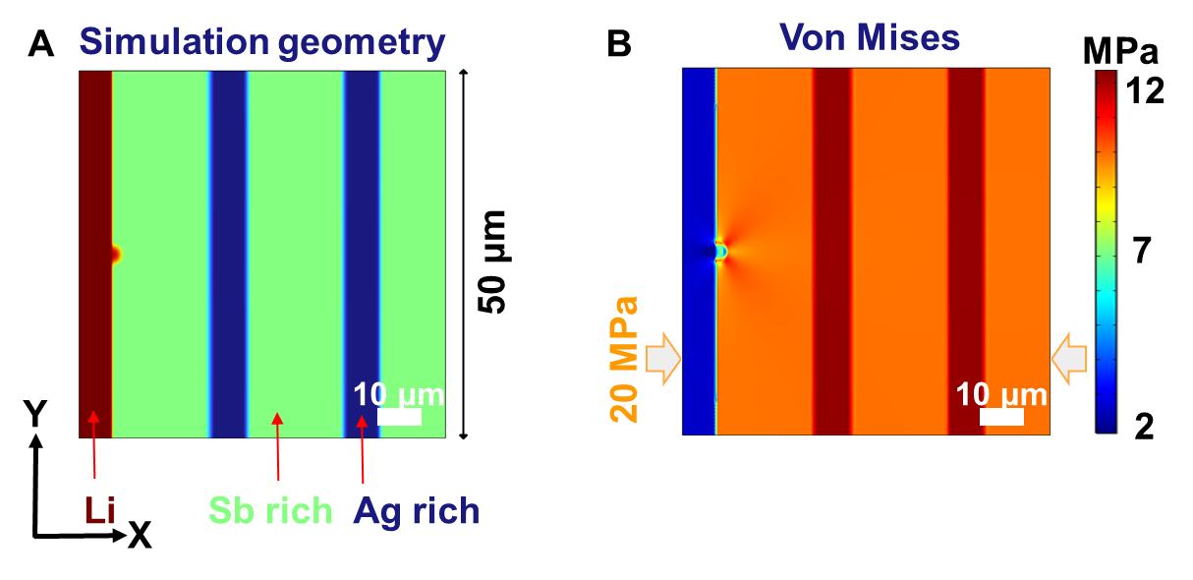
Supplementary Fig. S13. Phase-field simulation results showing (A) simulation geometry and (B) von mises stress distribution.

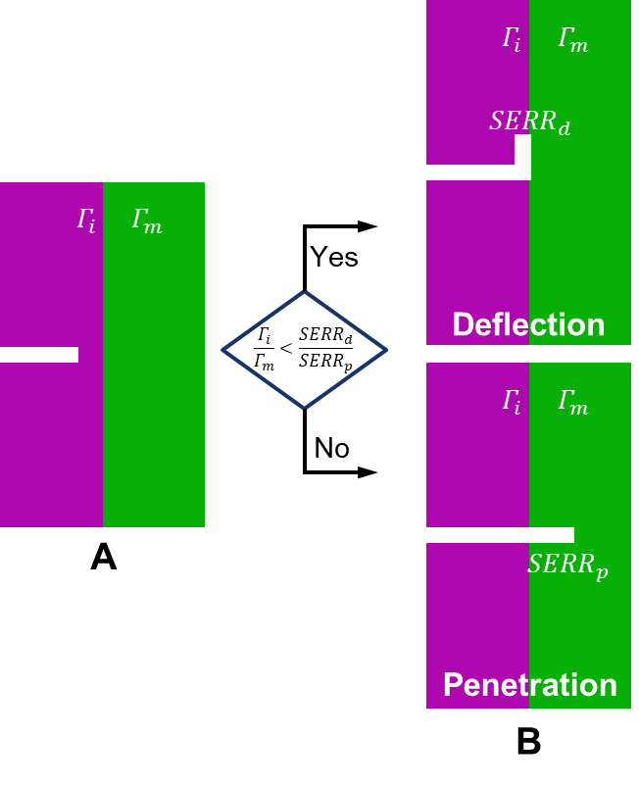
Supplementary Fig. S14. The crack deflection mechanism and criterion in a bi-material system.² (A) before the crack reaching the interface and (B) the crack either deflects or penetrates to the phase on the other side of the interface. ${SERR}_{d}$ and ${SERR}_{p}$ are the the strain energy release rate vlaues at the crack tip in the defelction and penetratin case. $Γ_{i}$ and $Γ_{m}$ are the fracture toughness values of the interface and the material phase on the other side of the interface.

A crack deflects when the condition $\frac{Γ_{i}}{Γ_{m}}<\frac{{SERR}_{d}}{{SERR}_{p}}$ is satisfied,² where $Γ_{i}$ and $Γ_{m}$ are the fracture toughness values of the interface and the material on the other side of the interface, as shown in Supplementary Fig. 15. Computational parameter study further indicate that the cohesive strengths of the interface ${\hat{σ}}_{i}$ and the material after the interface ${\hat{σ}}_{m}$ also play a critical role in determining whether a crack deflects or penetrates.³ In general, smaller $\frac{Γ_{i}}{Γ_{m}}$ and $\frac{{\hat{σ}}_{i}}{{\hat{σ}}_{ m}}$ values facilitate crack deflection.³ Here, $\frac{Γ_{i}}{Γ_{m}}=$0.0005 and $\frac{{\hat{σ}}_{i}}{{\hat{σ}}_{ m}}=0.073$, both are small and therefore drive the deflection of crack along the interface between the Ag-rich and Sb-rich phases, as seen in Fig. 3D.

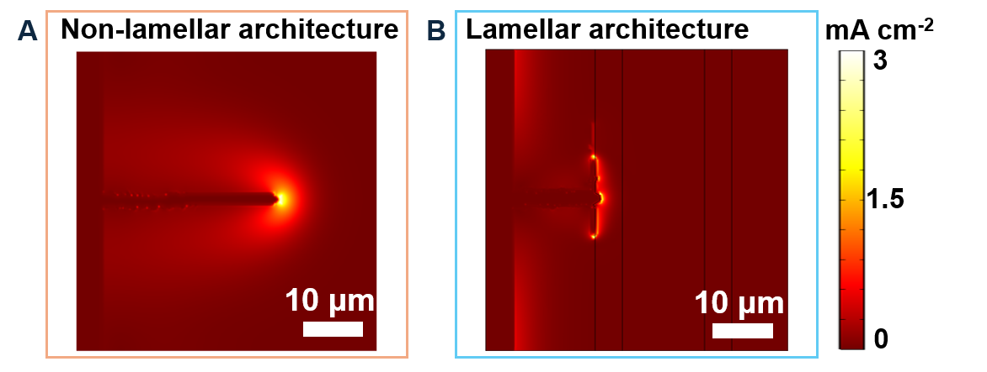
Supplementary Fig. S15. Phase-field simulation showing the evolution of Li⁺ flux at the local current density of the (A) non-lamellar architecture and (B) lamellar architecture.

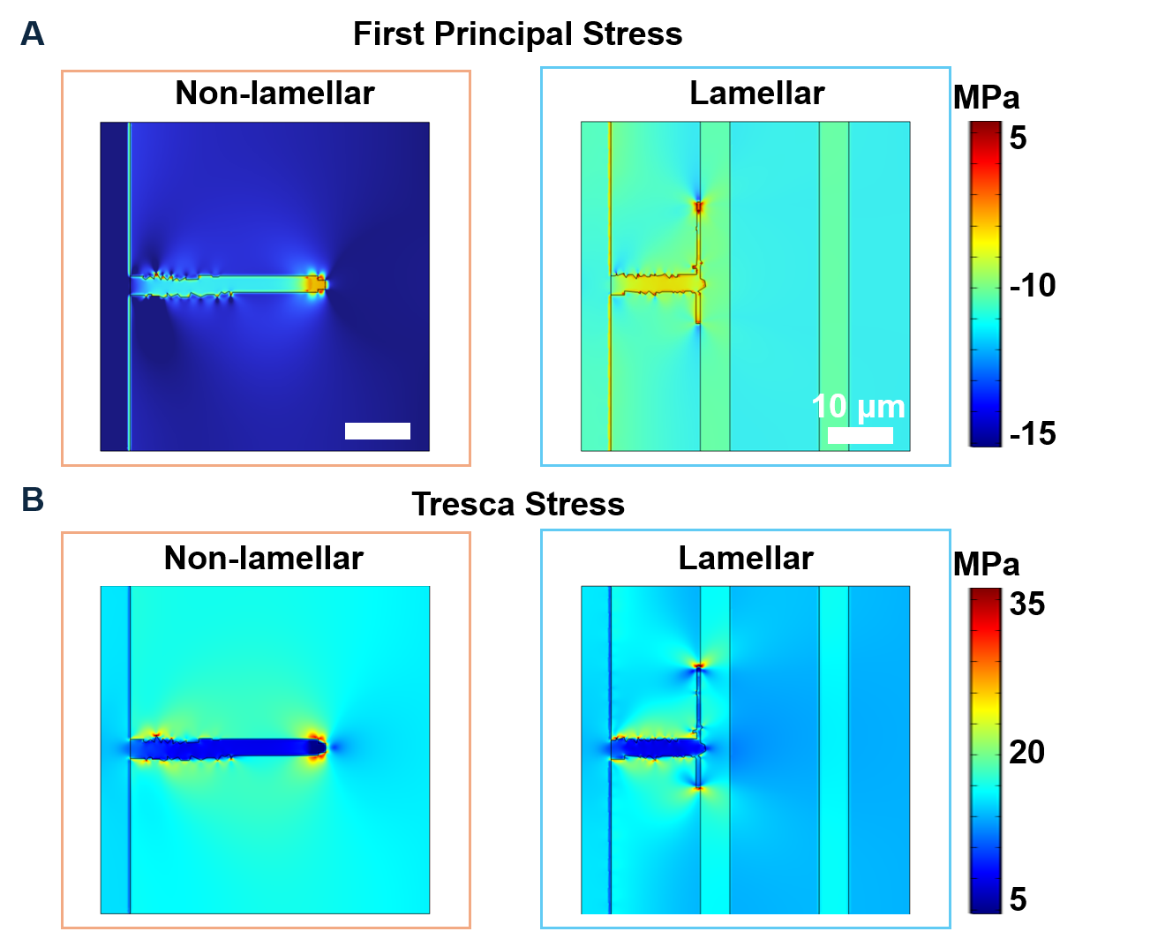
Supplementary Fig. S16. (A) First principal stress. (B) Tresca stress in both structures.

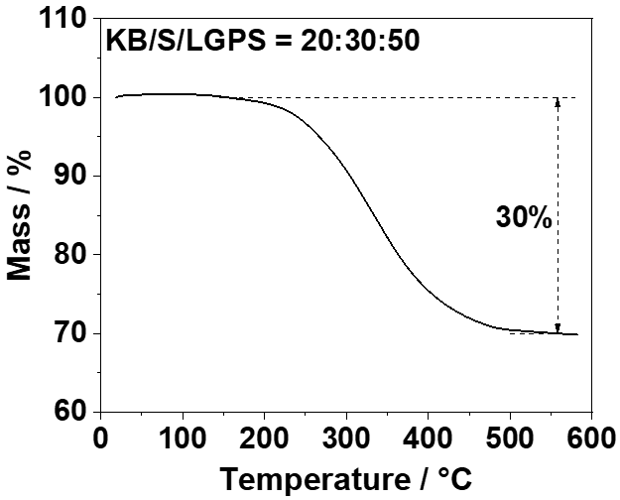
Supplementary Fig. S17. TGA curve of the S (KB/S/LGPS) cathode composite within the temperature range of 25-600 °C.

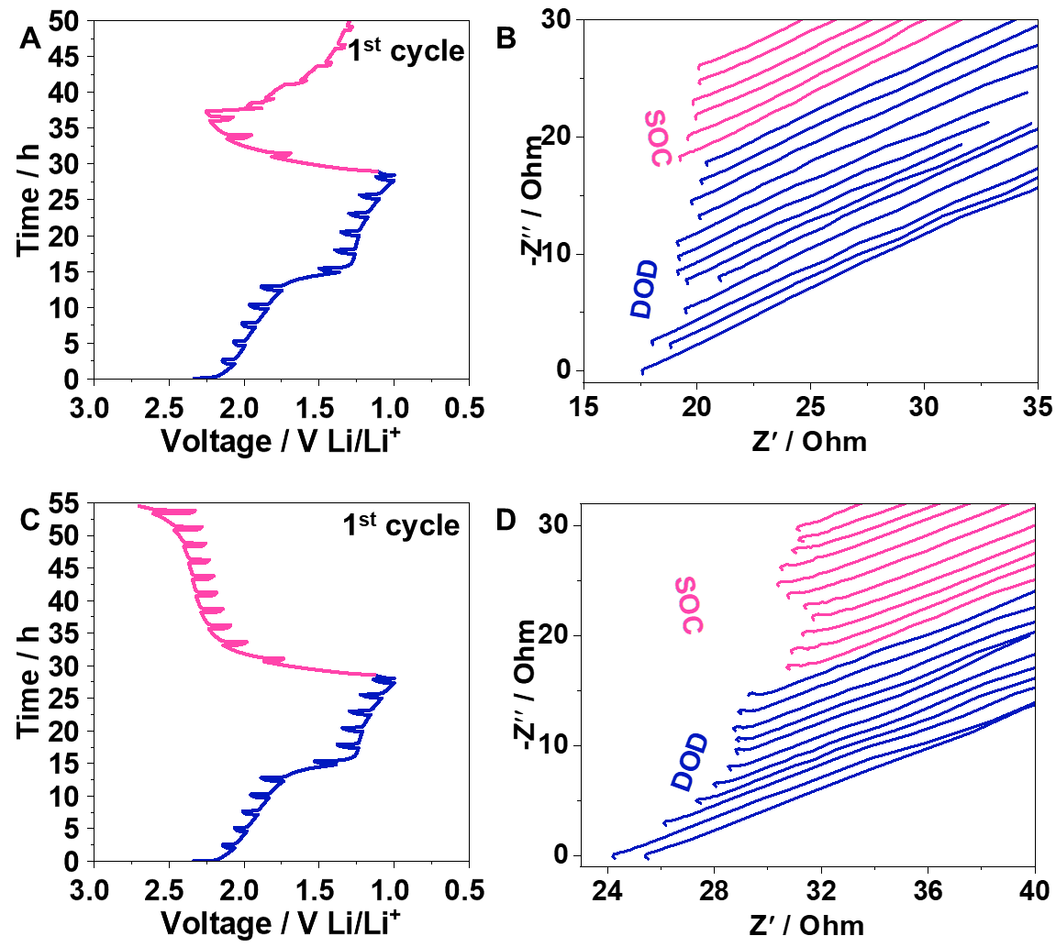
Supplementary Fig. S18. Dis-/charge profiles of ASSLMSBs (A) without and (C) with the Ag₃₀Sb₇₀ interlayer during the EIS measurement. Nyquist plots (B) without and (D) with the Ag₃₀Sb₇₀ interlayer at different SoC and DoD.

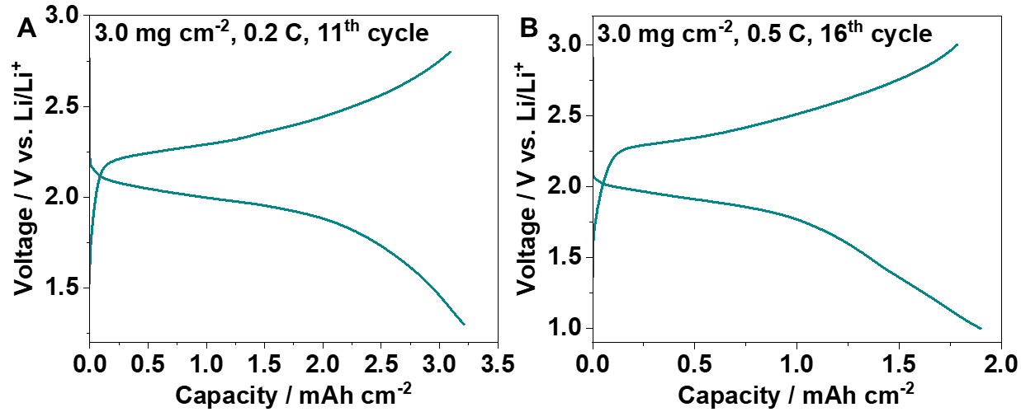
Supplementary Fig. S19. Rate performance of ASSLMSBs (Li|Ag₃₀Sb₇₀||SE||S) at 60 °C. Dis-/charge profiles at (A) 0.2 C in the 11th cycle and (B) 0.5 C in the 16th cycle. The sulfur mass loading is 3.0 mg cm⁻².

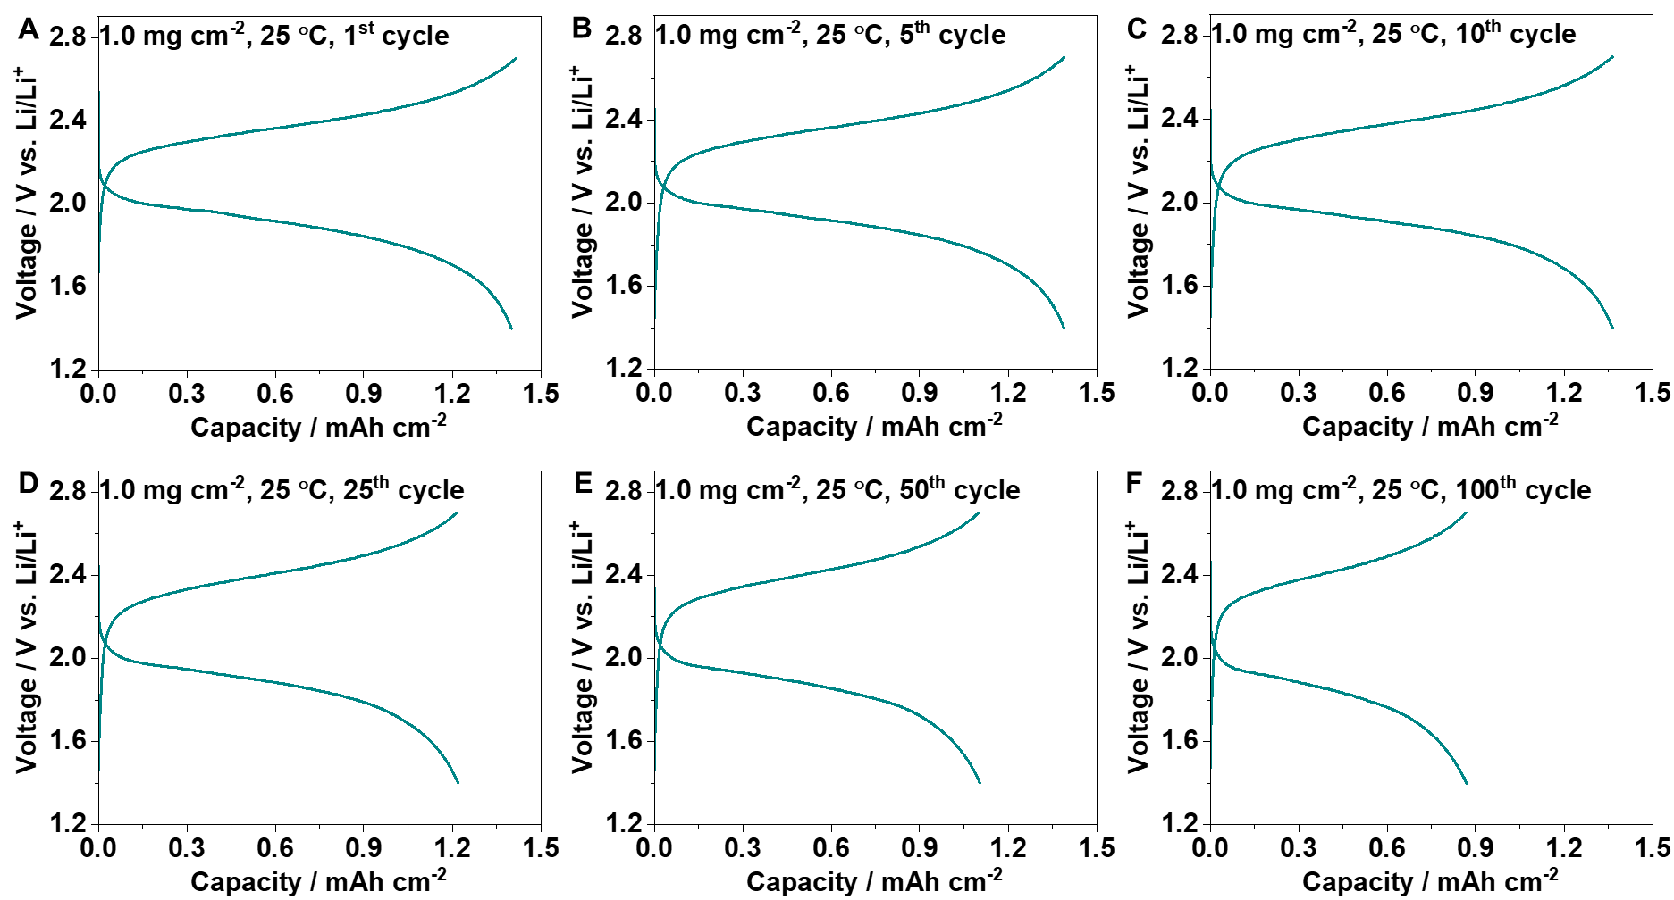
Supplementary Fig. S20. Dis-/charge profiles of Li|Ag₃₀Sb₇₀||SE||S cell at 0.1 C and 25 °C. (A) 1st, (B) 5th, (C) 10th, (D) 25th, (E) 50th and (F) 100th cycle. The sulfur mass loading is 1.0 mg cm⁻².

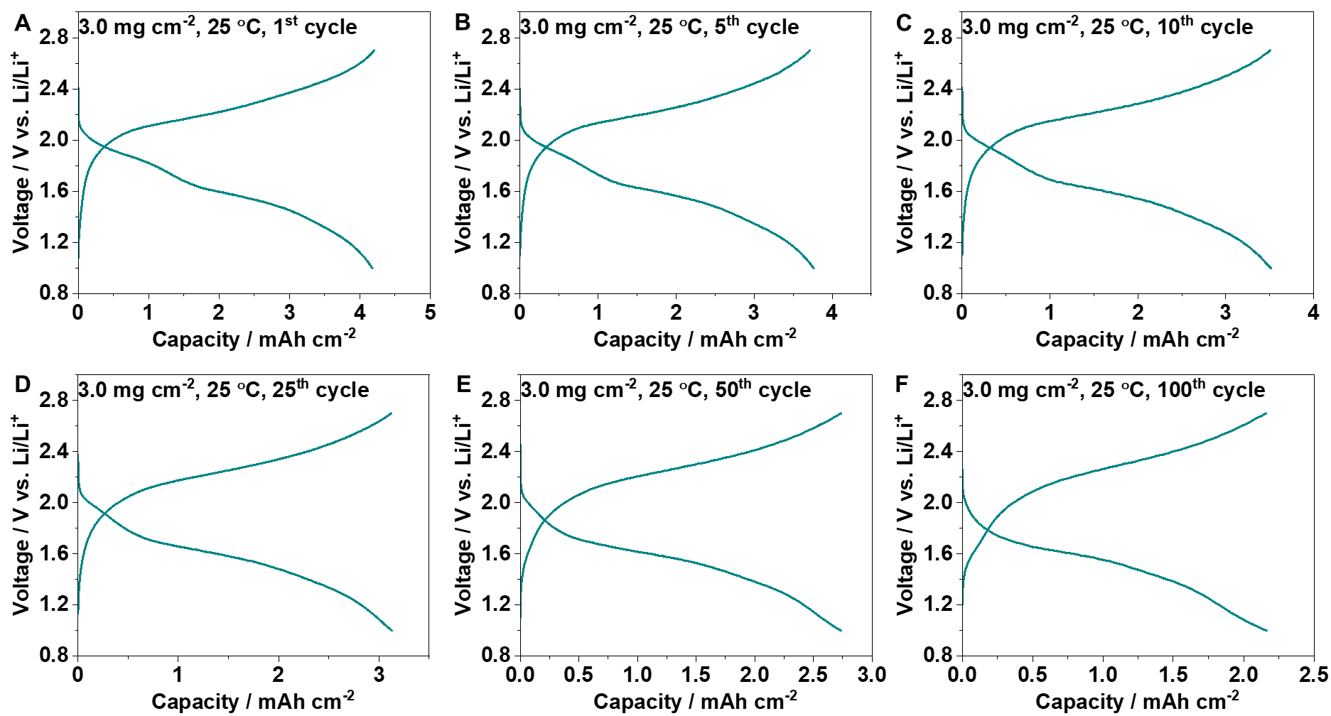
Supplementary Fig. S21. Dis-/charge profiles of Li|Ag₃₀Sb₇₀||SE||S cell at 0.1 C and 25 °C. (A) 1st, (B) 5th, (C) 10th, (D) 25th, (E) 50th and (F) 100th cycle. The sulfur mass loading is 3.0 mg cm⁻².

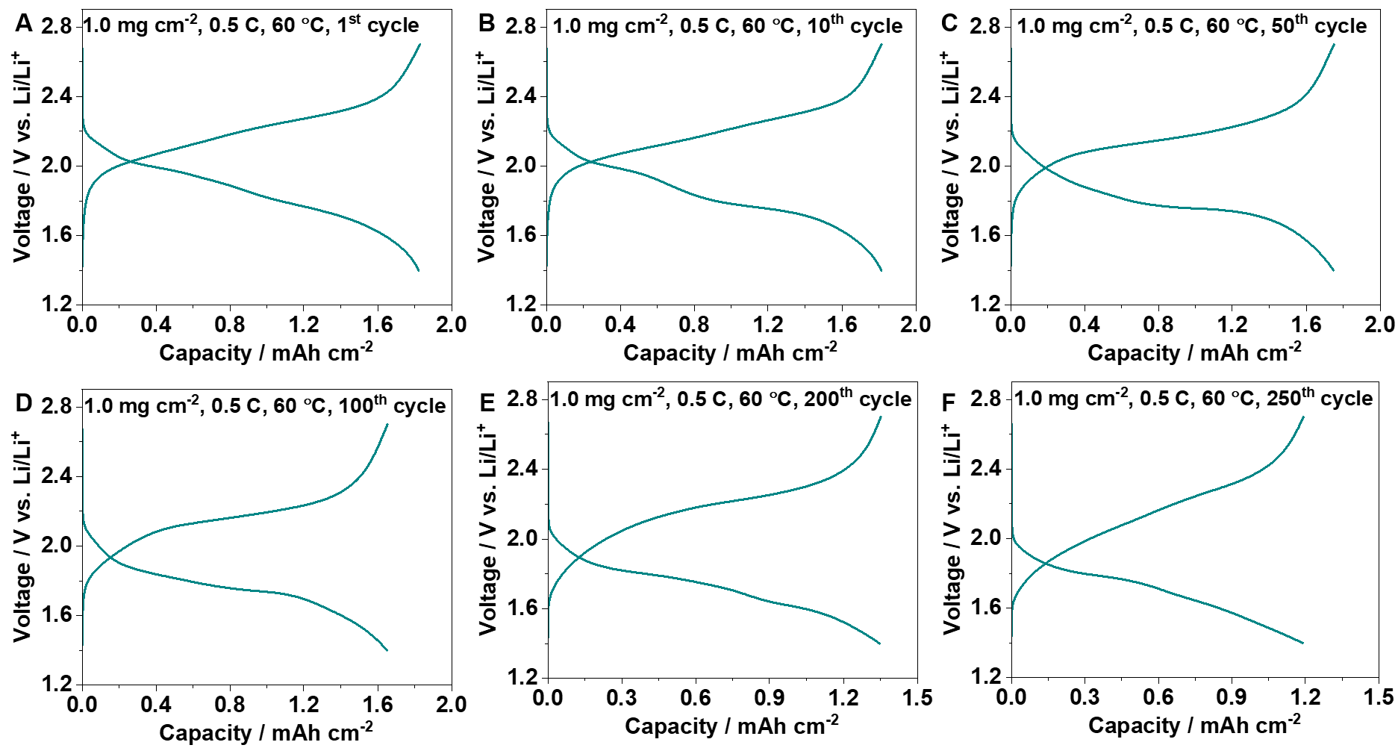
Supplementary Fig. S22. Dis-/charge profiles of Li|Ag₃₀Sb₇₀||SE||S cell at 0.5 C and 60 °C. (A) 1st, (B) 10th, (C) 50th, (D) 100th, (E) 200th and (F) 250th cycle. The sulfur mass loading is 1.0 mg cm⁻².

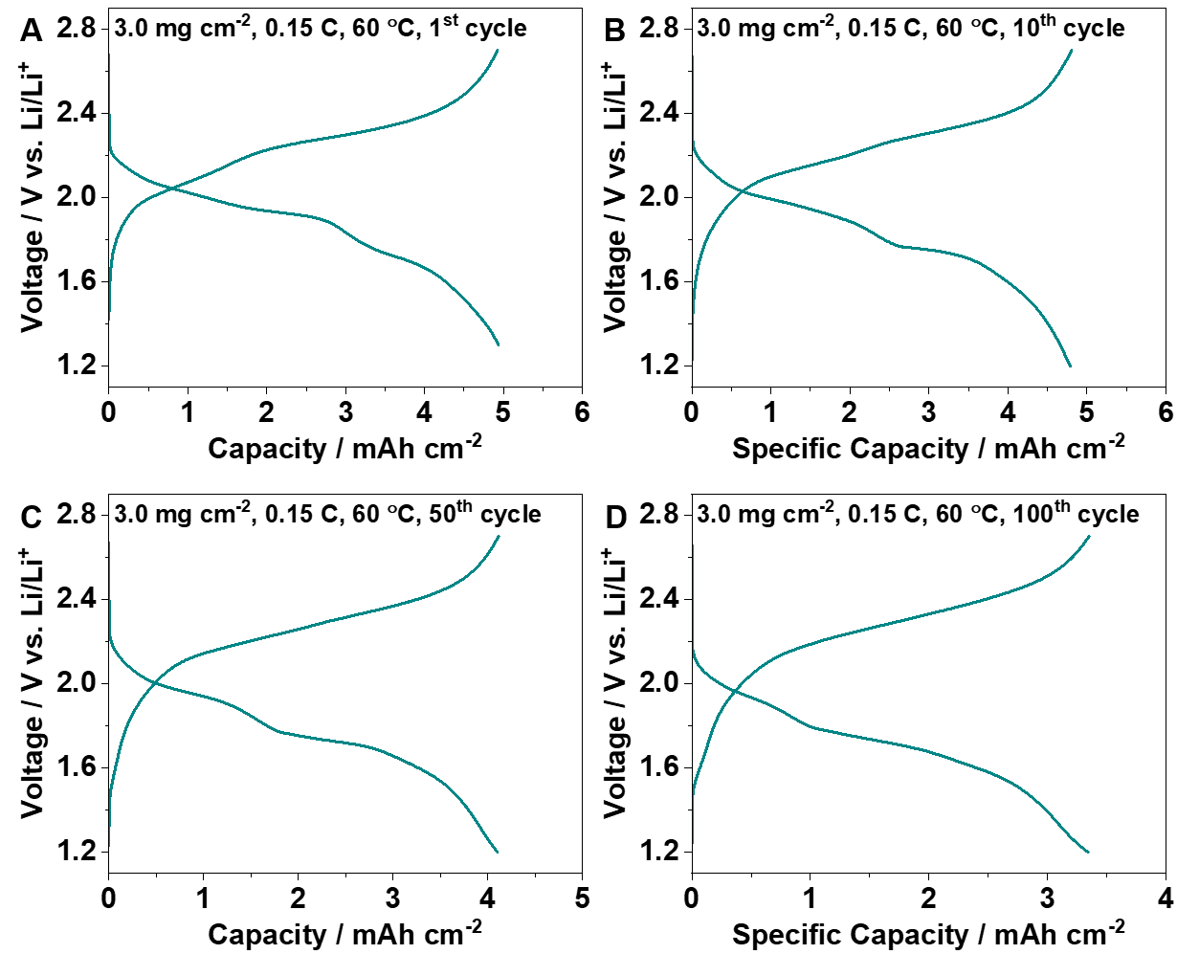
Supplementary Fig. S23. Dis-/charge profiles of Li|Ag₃₀Sb₇₀||SE||S cell at 0.15 C and 60 °C. (A) 1st, (B) 10th, (C) 50th, and (D) 100thcycle. The sulfur mass loading is 3.0 mg cm⁻².

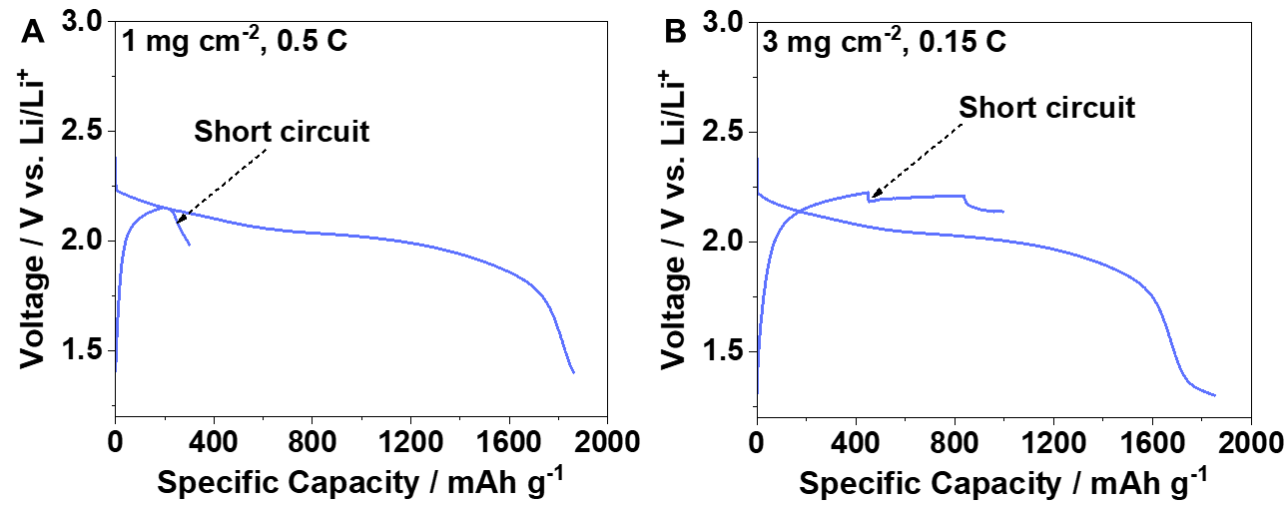
Supplementary Fig. S24. Dis-/charge curve of Li||SE||S cells. (A) With a sulfur mass loading of 1.0 mg cm⁻² at 0.5 C under 60 °C. (B) With a sulfur mass loading of 3.0 mg cm⁻² at 0.15 C under 60 °C.

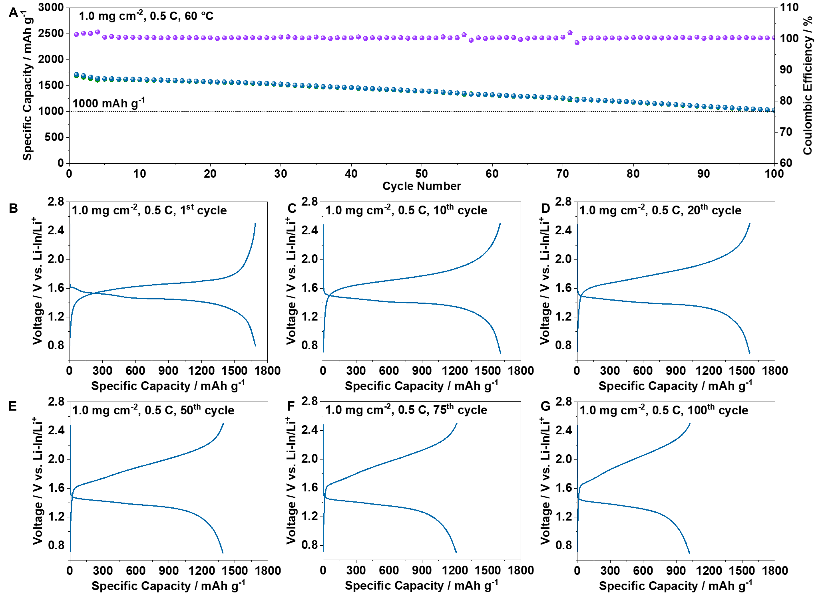
Supplementary Fig. S25. Electrochemical performance of all-solid-state Lithium batteries with sulfur cathodes and Li-In anode (Li-In||SE||KB/S/LGPS) at 0.5 C and 60 °C. (A) Dis-/charge specific capacity and coulombic efficiency, and corresponding voltage profiles at (B) 1st, (C) 10th, (D) 20th, (E) 50th, (F) 75th, and (G)100th cycle. The sulfur mass loading is 1.0 mg cm⁻².

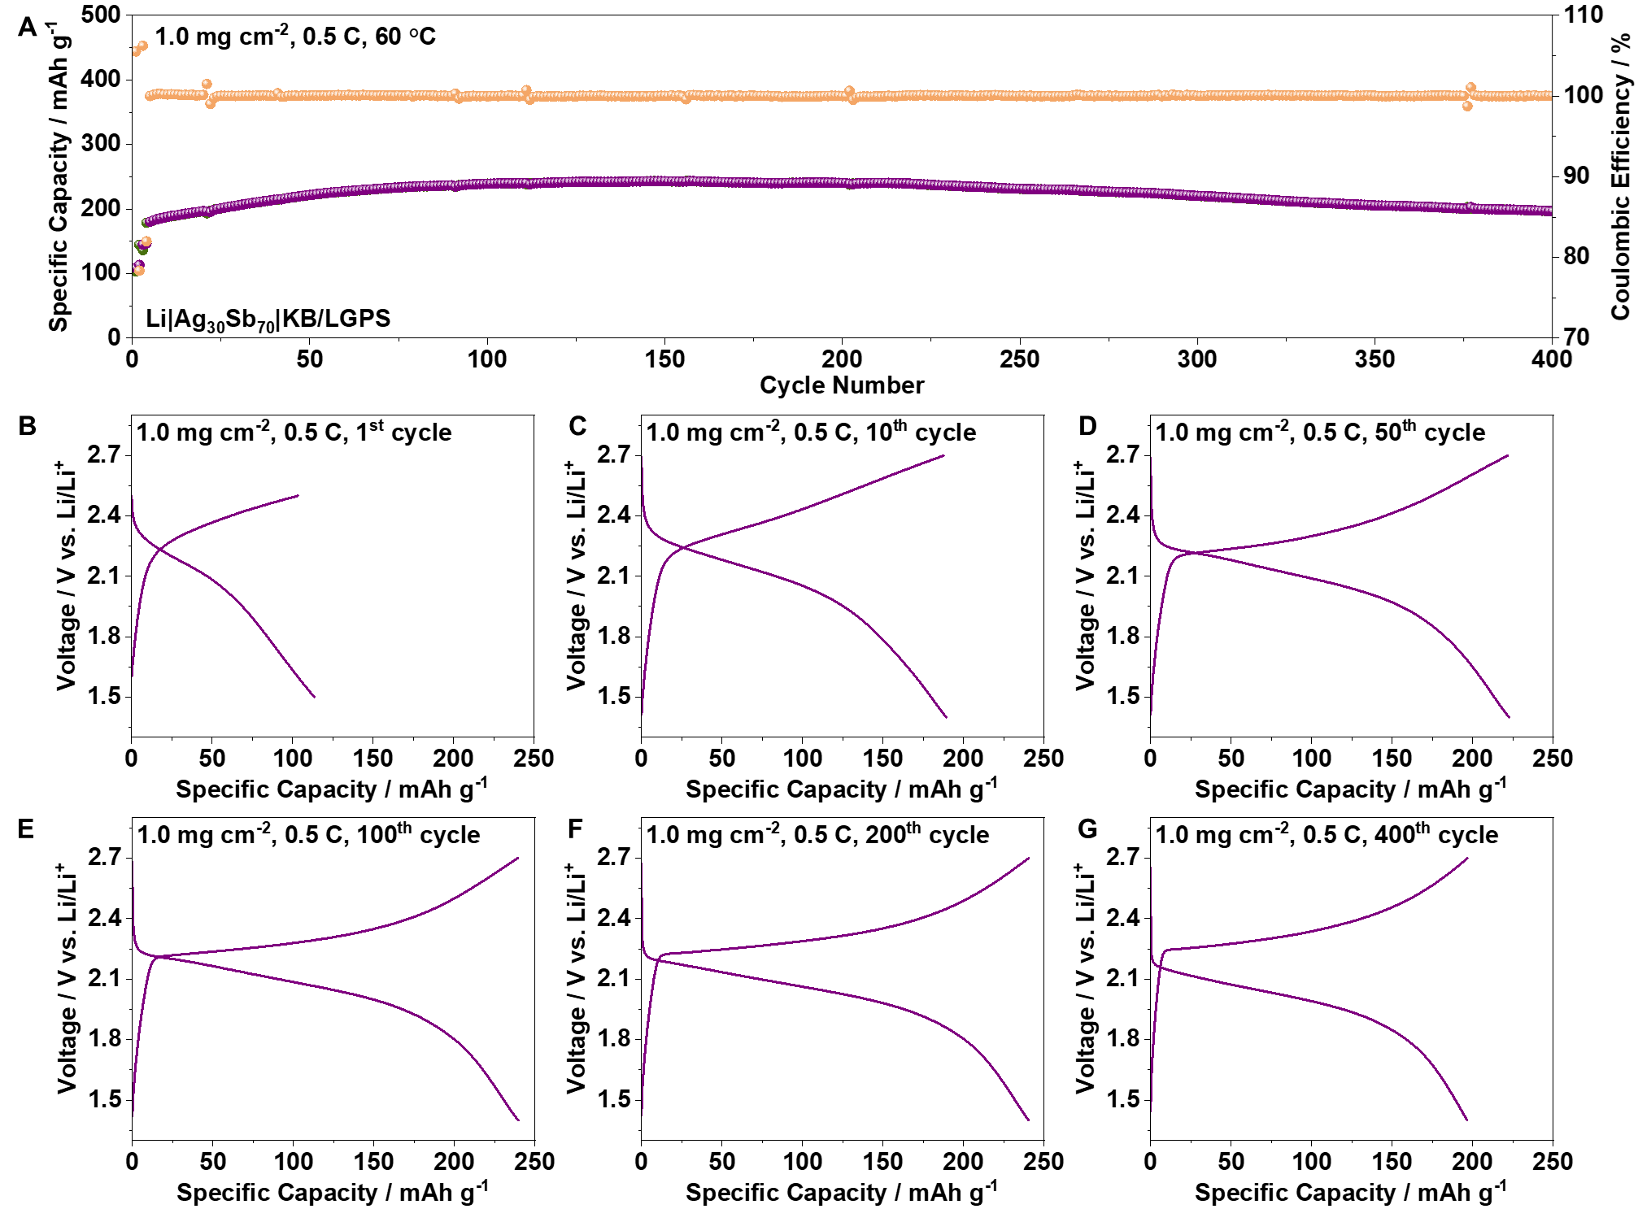
Supplementary Fig. S26. Electrochemical performance of all-solid-state Li metal battery with KB/LGPS cathode (Li|Ag₃₀Sb₇₀||SE||KB/LGPS) at 0.5 C and 60 °C. (A) Dis-/charge specific capacity and coulombic efficiency, and corresponding voltage profiles at (B) 1st, (C) 10th, (D) 50th, (E) 100th, (F) 200th, and (G) 400th cycle. The LGPS mass loading is 1.0 mg cm⁻².

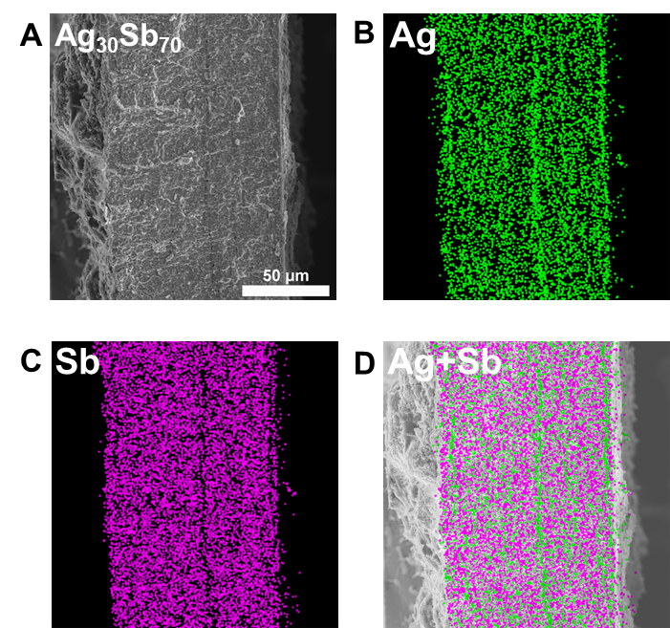
Supplementary Fig. S27. (A) Cross-sectional SEM image of thinner Ag₃₀Sb₇₀ interlayer collected from the cycled Li|Ag₃₀Sb₇₀||SE||Ag₃₀Sb₇₀|Li symmetric cell, and corresponding EDS mapping of (B) Ag, (C) Sb, and (D) the overlay of Ag and Sb.

Supplementary Table 1. Performance comparison of sulfide-based all-solid-state lithium-sulfur batteries
No. | Anode | Electrolyte | S Cathode | S Mass loading / mg cm⁻² | Performance | Testing pressure / Mpa | Ref.
1 | Li-In | Li₆PS₅Cl | S:LPSCl:KB | 2.0 | 3 mAh cm⁻² for 450 cycles | 70 | ⁴
 |  |  |  | 3.0 | 5-6 mAh cm⁻² for 450 cycles | 70 | ⁴
2 | Li | SP/LPSCl/LPS | S_{9.3}I:LPS:VGCF | 1.12 | 800 mAh g⁻¹ for 400 cycles | 30 | ⁵
 |  |  |  | 3.91 | 50 cycles at 100 °C | 30 | ⁵
3 | Li-In | LBPSIGSEs | S:KB:LBPSI | 1.1 | 0.9 mAh cm⁻² for 25 k cycles | 64 | ⁶
4 | Li-In | LPSBI | S:C:MIEC20 | 2.025 | 930 mAh g⁻¹ for 1000 cycles | 55 | ⁷
5 | Li-In | LPSCl_{1.5} | S:CNG:LPSCl_{1.5} | 1.7 | 990 mAh g⁻¹ for 53 cycles | 50 | ⁸
 |  |  |  | 3.4 | 2.1 mAh cm⁻² for 235 cycles | 50 | ⁸
6 | Li-In | Li₁₀GeP₂S₁₂ | S:CNT:Li₁₀GeP₂S₁₂ | 0.65 | 980 mAh g⁻¹ for 1500 cycles | 150 | ⁹
7 | Li-In | LPB | S:KB:LPB | 2.57 | 2.58 mAh cm⁻² for 800 cycles | 55 | ¹⁰
8 | Li-In | Li₁₀GeP₂S₁₂ | S:CNT:Li₁₀GeP₂S₁₂ | 1.3 | 1138 mAh g⁻¹ for 200 cycles | 60 | ¹¹
9 | Li-In | Li₁₀GeP₂S₁₂ | MCS-S-Co:CNT:LGPS | 1.0 | 850 mAh g⁻¹ for 1400 cycles | 127 | ¹²
 |  |  |  | 3.0 | 800 mAh g⁻¹ for 100 cycles | 127 | ¹²
10 | Li-In | Li_{5.5}PS_{4.5}Cl_{1.5} | S:LPSCl:KB | 1.8 | 1249 mAh g⁻¹ for 200 cycles | 70 | ¹³
10 | Li | Li_{5.5}PS_{4.5}Cl_{1.5} | S:LPSCl:KB | 4.4 | 5.7 mA h cm⁻¹ for 25 cycles | 16 | ¹³
11 | Li | Lamellar interfaces  /LPSCl | S:KB:Li₁₀GeP₂S₁₂ | 1.0 | Initial 1.40 mAh cm⁻² and 0.89 mAh cm⁻² for 100 cycles | 20 | This work
 |  |  |  |  | Initial 1.75 mAh cm⁻² and 70% retention for 250 cycles | 20 | This work
 |  |  |  | 3.0 | Initial 4.18 mAh cm⁻² and 2.16 mAh cm⁻² for 100 cycles | 20 | This work
 |  |  |  |  | Initial 4.91 mAh cm⁻² and 70% retention for 100 cycles | 20 | This work
 |  |  |  |  | C-rates: 5.39 mAh cm⁻² | 20 | This work

Recent progress in all-solid-state lithium-sulfur batteries has primarily focused on advancing the sulfur cathode, with Li–In commonly adopted as the anode to circumvent Li dendrite challenges. However, the low redox potential of sulfur and its associated volume expansion impose severe interfacial challenges on the lithium metal anode, which has received comparatively less attention (Supplementary Table 1). As a result, Li dendrite growth remains a critical bottleneck limiting the practical deployment of lithium–sulfur batteries. In this context, we directly address the interfacial instability at the lithium metal anode by constructing lamellar interfaces that regulate crack evolution, thereby suppressing dendrite propagation and enabling stable operation of all-solid-state lithium metal sulfur batteries.
1. Manasijević, D. et al. Microstructure evaluation and thermal properties of Ag–Sb alloys. Journal of Physics and Chemistry of Solids 169, (2022).
2. Het, M.-Y. & Hutchinson, W. CRACK DEFLECTION AT AN INTERFACE BETWEEN DISSIMILAR ELASTIC MATERIALS. Inl. J. Solids SlruClures 25, 1053–1067 (1989).
3. Parmigiani, J. P. & Thouless, M. D. The roles of toughness and cohesive strength on crack deflection at interfaces. J. Mech. Phys. Solids 54, 266–287 (2006).
4. Lee, J. et al. Halide segregation to boost all-solid-state lithium-chalcogen batteries. Science. 388, 724–729 (2025).
5. Zhou, J. et al. Healable and conductive sulfur iodide for solid-state Li–S batteries. Nature 627, 301–305 (2024).
6. Song, H. et al. All-solid-state Li-S batteries with fast solid-solid sulfur reaction. Nature 637, 846–853 (2025).
7. Wang, D. et al. Overcoming the conversion reaction limitation at three-phase interfaces using mixed conductors towards energy-dense solid-state Li–S batteries. Nat. Mater. 24, 243–251 (2025).
8. Yu, Z., Singh, B., Yu, Y. & Nazar, L. F. Suppressing argyrodite oxidation by tuning the host structure for high-areal-capacity all-solid-state lithium–sulfur batteries. Nat. Mater. 24, 1082–1090 (2025).
9. Kim, J. T. et al. Manipulating Li2S2/Li2S mixed discharge products of all-solid-state lithium sulfur batteries for improved cycle life. Nat. Commun. 14, 6404 (2023).
10. Wang, D. et al. Realizing high-capacity all-solid-state lithium-sulfur batteries using a low-density inorganic solid-state electrolyte. Nat. Commun. 14, 1895 (2023).
11. Hou, L. P. et al. Improved interfacial electronic contacts powering high sulfur utilization in all-solid-state lithium–sulfur batteries. Energy Storage Mater. 25, 436–442 (2020).
12. Cao, Y. et al. Integrating solid interfaces for catalysis in all-solid-state lithium-sulfur batteries. Energy Environ. Sci. 18, 3795–3806 (2025).
13. Jarrold, G. & Manthiram, A. Delineating the Intricate Impact of Carbon in All-solid-state Lithium-Sulfur Batteries. Adv. Energy Mater. 15, e02557 (2025).

