SUPPLEMENTARY MATERIAL
MORPHOLOGICAL SCREENING AS A LOW-COST AFLATOXIN SURVEILLANCE TOOL FOR MAIZE IN GHANA

TABLE

Table S1: Open market maize samples fungal contamination survey data
No. | Market Location | Region | AEZ | Total Fungal Growth (%) | Presumptive Aflatoxigenic Growth (%)
White Maize
1 | Adenta Market | Greater Accra | Coastal | 47.619 | 4.762
2 | Dome Market | Greater Accra | Coastal | 66.667 | 28.571
3 | Takoradi | Western | Coastal | 66.667 | 0.000
4 | Mankessim | Central | Coastal | 71.429 | 19.048
5 | Winneba | Central | Coastal | 61.905 | 19.048
6 | Assin Fosu | Central | Forest | 42.857 | 0.000
7 | Kumasi Asokore | Ashanti | Forest | 95.238 | 85.714
8 | Suame | Ashanti | Forest | 57.143 | 14.286
9 | Bantama | Ashanti | Forest | 71.429 | 33.333
10 | Obuasi | Ashanti | Forest | 80.952 | 9.524
11 | Konongo | Ashanti | Forest | 61.905 | 28.571
12 | Asuofua | Ashanti | Forest | 71.429 | 38.095
13 | Koforidua | Eastern | Forest | 80.952 | 28.571
14 | Nkawkaw | Eastern | Forest | 90.476 | 4.762
15 | Kpong | Eastern | Forest | 71.429 | 19.048
16 | Ho | Volta | Forest | 95.238 | 0.000
17 | Hohoe | Volta | Forest | 47.619 | 9.524
18 | Asankragua | Western | Forest | 80.952 | 0.000
19 | Dormaa Ahenkro | Bono | Transition | 100.000 | 33.333
20 | Sunyani | Bono | Transition | 71.429 | 33.333
21 | Kintampo Old Market | Bono East | Transition | 95.238 | 0.000
22 | Kintampo New Market | Bono East | Transition | 100.000 | 57.143
23 | Yendi | Northern | Savannah | 66.667 | 33.333
24 | Damongo | Savannah | Savannah | 90.476 | 9.524
25 | Bole | Savannah | Savannah | 85.714 | 14.286
26 | Bamboi | Savannah | Savannah | 61.905 | 19.048
27 | Navrongo | Upper East | Savannah | 47.619 | 23.810
28 | Wa Old Market | Upper West | Savannah | 85.714 | 4.762
29 | Wa New Market | Upper West | Savannah | 100.000 | 14.286
30 | Wa Fadama Market | Upper West | Savannah | 80.952 | 4.762
31 | Wa Farmer | Upper West | Savannah | 95.238 | 4.762
32 | Nalerigu | North East | Savannah | 61.905 | 4.762
33 | Dodi Papase (germ.) | Oti | Transition | 61.905 | 33.333
34 | Dodi Papase (non-g.) | Oti | Transition | 61.905 | 4.762
35 | Nkwanta | Oti | Savannah | 57.143 | 0.000
Yellow maize
36 | Adenta Market | Greater Accra | Coastal | 52.381 | 38.095
37 | Dome Market | Greater Accra | Coastal | 100.000 | 33.333
38 | Takoradi | Western | Coastal | 80.952 | 14.286
39 | Mankessim | Central | Coastal | 90.476 | 9.524
40 | Winneba | Central | Coastal | 85.714 | 23.810
41 | Assin Fosu | Central | Forest | 80.952 | 9.524
42 | Kumasi Asokore | Ashanti | Forest | 80.952 | 57.143
43 | Suame | Ashanti | Forest | 71.429 | 23.810
44 | Bantama | Ashanti | Forest | 95.238 | 43.651
45 | Obuasi | Ashanti | Forest | 85.714 | 33.333
46 | Koforidua | Eastern | Forest | 66.667 | 38.095
47 | Begoro | Eastern | Forest | 95.238 | 52.381
48 | Nkawkaw | Eastern | Forest | 61.905 | 14.286
49 | Ho | Volta | Forest | 85.714 | 23.810
50 | Hohoe | Volta | Forest | 95.238 | 9.524
51 | Tarkwa | Western | Forest | 100.000 | 19.048
52 | Asankragua | Western | Forest | 95.238 | 4.762
53 | Dormaa Ahenkro | Bono | Transition | 100.000 | 14.286
54 | Kintampo Old Market | Bono East | Transition | 80.952 | 19.048
55 | Kintampo New Market | Bono East | Transition | 57.143 | 0.000
56 | Tamale | Northern | Savannah | 55.556 | 9.524
57 | Damongo | Savannah | Savannah | 33.333 | 0.000
58 | Bole | Savannah | Savannah | 80.952 | 19.048
59 | Navrongo | Upper East | Savannah | 85.714 | 38.095
60 | Wa Old Market | Upper West | Savannah | 80.952 | 9.524
61 | Wa New Market | Upper West | Savannah | 76.190 | 4.762
62 | Wa Fadama Market | Upper West | Savannah | 78.571 | 4.762
63 | Nalerigu | North East | Savannah | 100.000 | 0.000
64 | Nkwanta | Oti | Savannah | 85.714 | 14.286

FIGURES
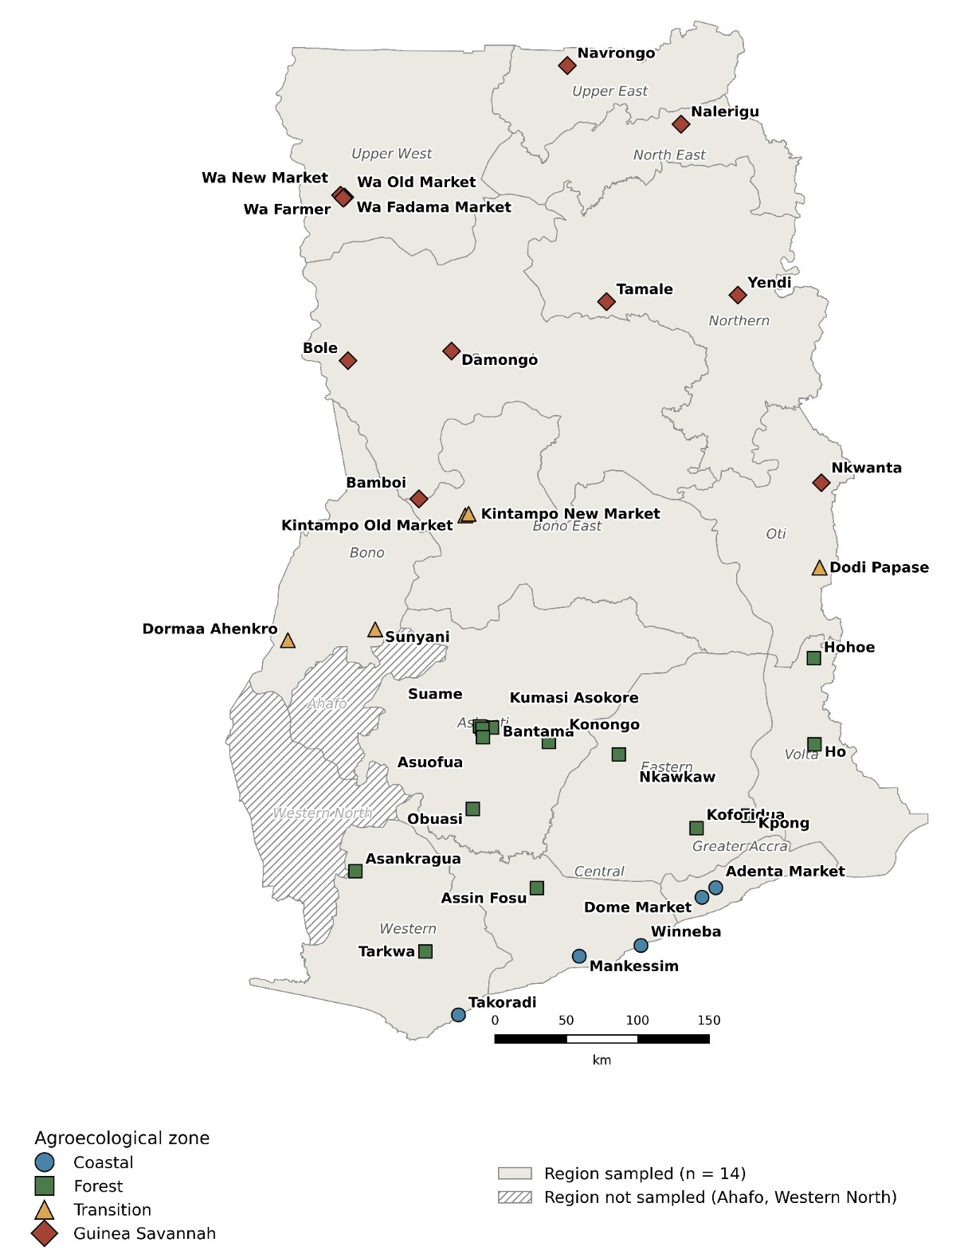

Figure S1. Geographic distribution of open-market maize sampling sites across Ghana. Markers indicate sampling towns, coloured by agroecological zone (Coastal Savannah, Moist Semi-Deciduous Forest, Forest-Savannah Transition, Guinea Savannah); some towns include more than one market sampled. Shaded regions denote the 14 administrative regions included in the survey; Ahafo and Western North (hatched) were excluded due to logistical constraints.

Figure S2. Total filamentous fungal growth in white maize (blue bars) and yellow maize (orange bars) across the four agroecological zones of Ghana. Values represent zone-level mean percentages of plated grains (21 grains per sample, 7 per DRBC plate, 3 replicate plates per sample) exhibiting any visible filamentous fungal colony after 7 days incubation at 25 ± 1°C. Coastal, n white = 6 market locations, n yellow = 6; Savannah, n white = 13, n yellow = 9; Transition, n white = 4, n yellow = 3; Forest, n white = 12, n yellow = 11.

Figure S3. Presumptive aflatoxigenic (green) fungal growth in white maize (blue bars) and yellow maize (orange bars) across the four agroecological zones of Ghana. . Values represent zone-level mean percentages of plated grains (21 grains per sample, 7 per DRBC plate, 3 replicate plates per sample) exhibiting any visible filamentous fungal colony after 7 days incubation at 25 ± 1°C. Coastal, n white = 6 market locations, n yellow = 6; Savannah, n white = 13, n yellow = 9; Transition, n white = 4, n yellow = 3; Forest, n white = 12, n yellow = 11.

