Supplementary Table S1: Sensitivity analysis excluding participants with documented prior EBOV vaccination

Outcome | Primary analysis  (n = 40) | Excluding participants with documented EBOV vaccine  (n = 38)
BDBV seropositive | 22/40 (55.0%; 95% CI: 38.7, 70.4) | 21/38 (55.3%; 95% CI: 38.5, 71.0)
EBOV-Mayinga seropositive | 23/40 (57.5%; 95% CI: 41.0, 72.6) | 21/38 (55.3%; 95% CI: 38.5, 71.0)
SUDV-Gulu seropositive | 5/40 (12.5%; 95% CI: 4.7, 27.6) | 4/38 (10.5%; 95% CI: 3.4, 25.7)
SUDV-Boniface seropositive | 3/40 (7.5%; 95% CI: 2.0, 21.5) | 2/38 (5.3%; 95% CI: 0.9, 19.1)
BDBV+ and EBOV-Mayinga+ | 20/40 (50.0%; 95% CI:35.2, 64.8) | 19/38 (50.0%; 95% CI: 34.8, 65.2)
BDBV+ and any other + strain | 20/40 (50.0%; 95% CI: 35.2, 64.8) | 19/38 (50.0%; 95% CI: 34.8, 65.2)
All four strains + | 3/40 (7.5%; 95% CI: 2.0, 21.5) | 2/38 (5.3%; 95% CI: 0.92, 19.1)
Comparison of glycoprotein-specific seropositivity and recognition profiles in the full cohort of 40 PCR-confirmed BDBV survivors and after exclusion of the two participants with documented prior receipt of an EBOV glycoprotein-based vaccine (n = 38). Seropositivity was defined as background-subtracted test-sample OD₄₅₀ ≥0.4295. The threshold was calculated as four times the mean raw blank-well OD₄₅₀ (mean=0.1074) and applied to background-subtracted test-sample values according to the predefined primary analytical procedure. Heterologous recognition was defined as seropositivity to at least one of EBOV-Mayinga, SUDV-Gulu or SUDV-Boniface glycoproteins. Values are n/N (%) with exact 95% binomial confidence intervals.

Supplementary Table S2. Sensitivity analysis of BDBV seropositivity classification using alternative negative-reference panels
Negative reference panel | n | Median OD₄₅₀  (IQR) | Mean  (SD) | Cut-off  (Mean + 2SD) | Seropositive survivors
Combined negative-reference panel | 200 | 0.095  (0.073, 0.135) | 0.136  (0.176) | 0.488 | 22/40 (55.0%)
Healthy controls, EV | 42 | 0.078  (0.063, 0.103) | 0.134  (0.234) | 0.602 | 18/40 (45.0%)
Healthy controls, Protocol B00 | 39 | 0.116  (0.096, 0.138) | 0.174  (0.256) | 0.686 | 16/40 (40.0%)
 | 50 | 0.075  (0.050, 0.098) | 0.096  (0.087) | 0.270 | 25/40 (62.5%)
  Healthy controls, Protocol E
General population, Protocol L | 40 | 0.111  (0.082, 0.162) | 0.135  (0.079) | 0.293 | 25/40 (62.5%)
Unexposed individuals from northen Uganda | 29 | 0.102  (0.093, 0.139) | 0.159  (0.154) | 0.466 | 22/40 (55.0%)
Combined healthy controls | 121 | 0.100  (0.078, 0.139) | 0.147  (0.205) | 0.556 | 20/40 (50.0%)

Biological negative-reference specimens represented a broad biological and geographical range of individuals with no known or documented filovirus infection. For each reference panel, a BDBV-specific threshold was calculated as the mean background-subtracted donor-level OD₄₅₀ + 2SD and applied to BDBV OD₄₅₀ values from the 40 survivors. The combined negative-reference panel comprised healthy controls from EV (n=42), Protocol B00 (n=39) and Protocol L (n=40), Protocol E specimens (n=50), and unexposed uninfected participants from northern Uganda (n=29). The combined healthy-control panel comprised EV, Protocol B00 and Protocol L (n=121). This analysis was restricted to BDBV glycoprotein and was independent of the common assay-derived threshold used in the primary four-antigen analysis. Values are median (IQR), mean (SD), threshold (mean + 2SD) and n/N (%), as indicated.
Supplementary Figures
Supplementary Figure S1. Cohort derivation and participant flow
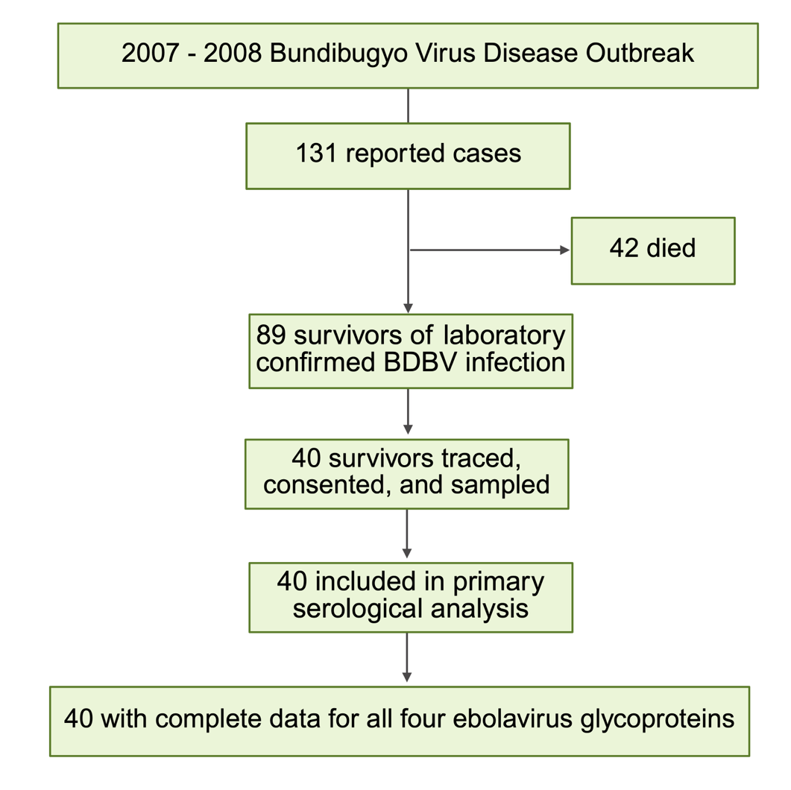
Flow diagram showing derivation of the study cohort from the 2007–2008 Bundibugyo virus disease outbreak in Uganda. Of 131 reported cases, 42 died and 89 survived laboratory-confirmed BDBV infection. Forty survivors were traced, consented, and sampled 16–17 years after infection. All 40 participants had complete glycoprotein-specific IgG measurements against all four ebolavirus glycoproteins evaluated (BDBV, EBOV-Mayinga, SUDV-Gulu, and SUDV-Boniface).

Supplementary Figure S2: Inter-operator performance of the internal IgG reference standard across ELISA runs
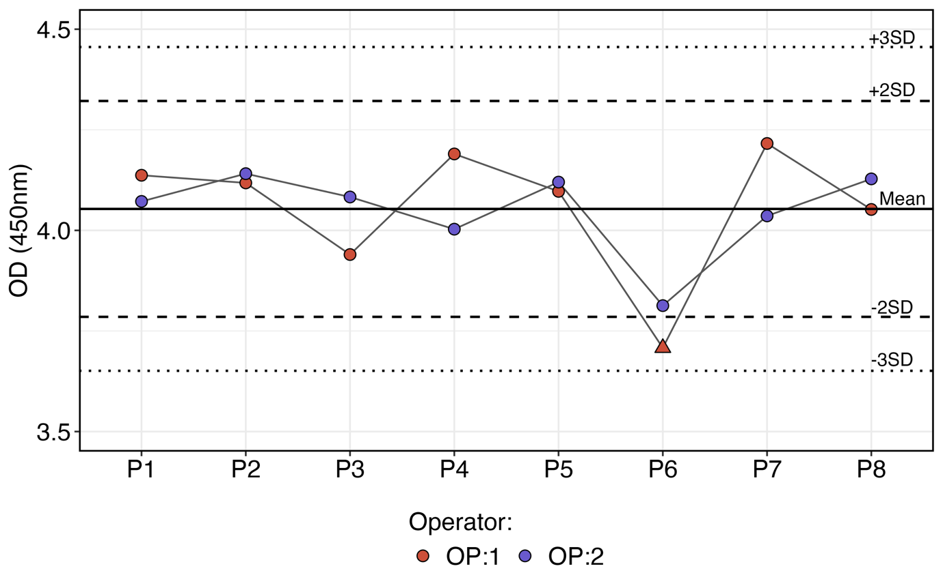
Levey–Jennings plot of the internal STD1 IgG reference standard across ELISA analytical runs performed by two operators (OP1 and OP2). Points represent the mean OD₄₅₀ of triplicate STD1 wells for each analytical run; the solid horizontal line indicates the overall mean, and dashed lines indicate the mean ±2 SD warning limits and mean ±3 SD acceptance limits. Fifteen of 16 measurements (93.8%) fell within the mean ±2 SD warning limits, and all 16 measurements (100%) fell within the mean ±3 SD acceptance limits.

Supplementary Figure S3: Distribution of BDBV glycoprotein-specific IgG responses in the biological negative-reference panel
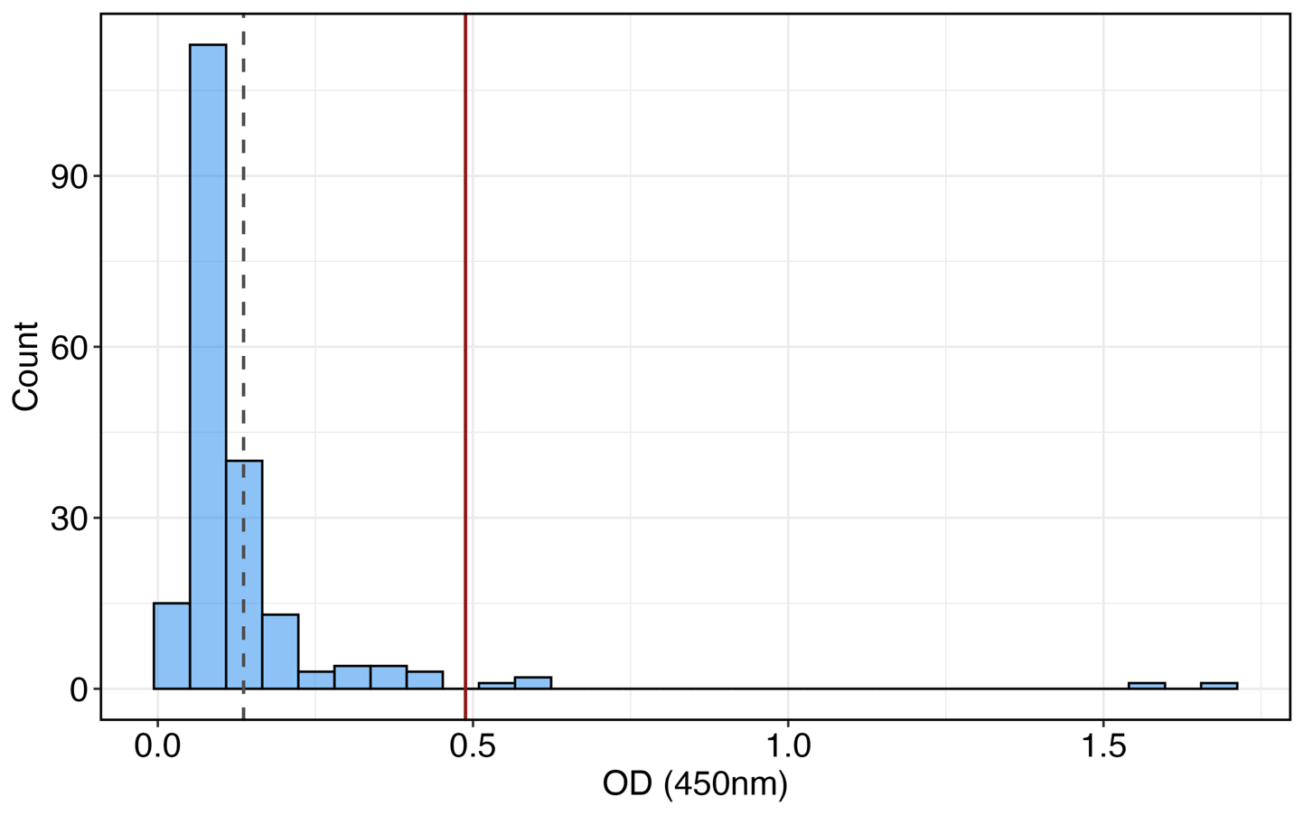
Distribution of background-subtracted BDBV glycoprotein-specific OD₄₅₀ responses among 200 biological negative-reference specimens with no known or documented filovirus infection. The combined reference panel comprised healthy controls from EV (n=42), Protocol B00 (n=39), Protocol L (n=40) and Protocol E (n=50), and unexposed uninfected participants from northern Uganda (n=29). The mean background-subtracted OD₄₅₀ was 0.136 (SD, 0.176), yielding a BDBV-specific threshold of 0.488, calculated as the mean + 2 SD. The horizontal lines indicate the mean and derived threshold, as specified in the figure.
Supplementary Figure S4. Sensitivity analysis of the BDBV–SUDV-Gulu association after exclusion of a high SUDV-Gulu response
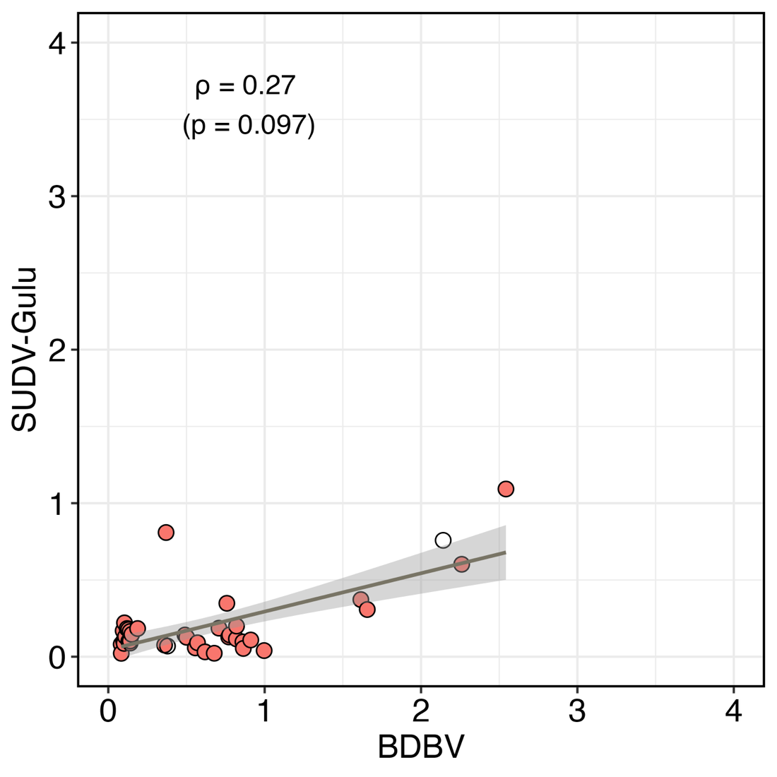
Scatter plot showing sensitivity analysis of the association between background-subtracted BDBV and SUDV-Gulu glycoprotein-specific OD₄₅₀ responses after exclusion of the participant with the highest SUDV-Gulu response. The sensitivity analysis included 39 participants and yielded Spearman ρ=0.27 and two-sided P=0.097. Each point represents one participant; the line and shaded band represent the fitted linear trend and 95% confidence interval, respectively. The excluded participant was retained in the primary analysis of all 40 participants.
Supplementary Figure S5: Inter-operator reproducibility of endpoint titres
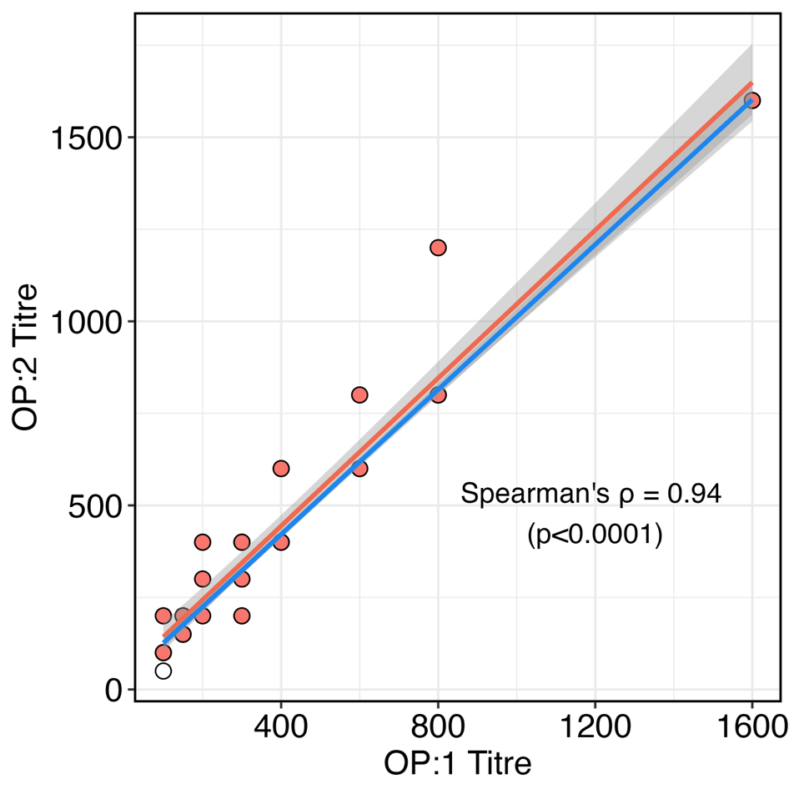
Scatter plot comparison of independently determined endpoint antibody titres generated by two operators for BDBV and EBOV-Mayinga glycoprotein-specific IgG responses. Each point represents paired endpoint-titre measurements from the same participant and glycoprotein obtained independently by the two operators. Inter-operator endpoint titres were strongly correlated (Spearman ρ=0.94, two-sided P<0.0001). The line and shaded band represent the fitted trend and 95% confidence interval, respectively.

