Supplementary files

Table S1. Results of sensitivity analysis (DiD, SC, SDiD)

Model | ATT | Std. Error | t | P>t | [95 % Conf. | Interval]
TotalCost – DiD | 45,000 | 40,700 | 1.11 | 0.269 | -34,800 | 125,000
TotalCost – SC | -138,000 | 99,300 | -1.38 | 0.166 | -332,000 | 57,100
TotalCost – SDiD | 37,300 | 38,300 | 0.97 | 0.330 | -37,700 | 112,000
ACSC – DiD | 0.05899 | 0.23165 | 0.25 | 0.799 | -0.39503 | 0.51301
ACSC – SC | 0.97844 | 0.54422 | 1.80 | 0.072 | -0.08821 | 2.04510
ACSC – SDiD | 0.10972 | 0.24213 | 0.45 | 0.650 | -0.36484 | 0.58428
Difference-in-Differences, Synthetic control, Synthetic Control Difference-in-Differences. Confidence intervals are based on placebo permutation inference. Pre-treatment period: second semester of 2015–2016. Treatment assigned in 2017.

Figure S1. Unit-specific weights SDiD, outcome total costs.

Figure S2. Unit-specific weights SDiD, outcome ACSC.

Figure S3. Total costs result in severity groups (SDiD).
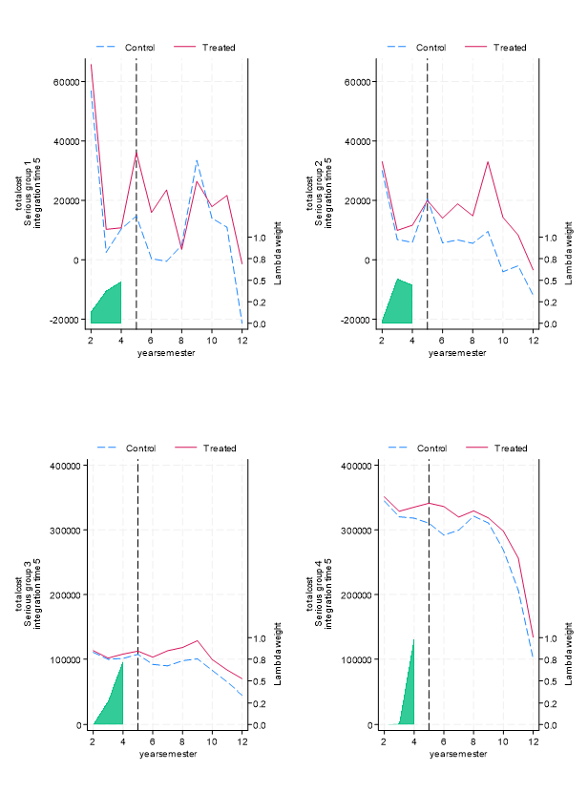

Figure S4. ACSC results in severity groups (SDiD).

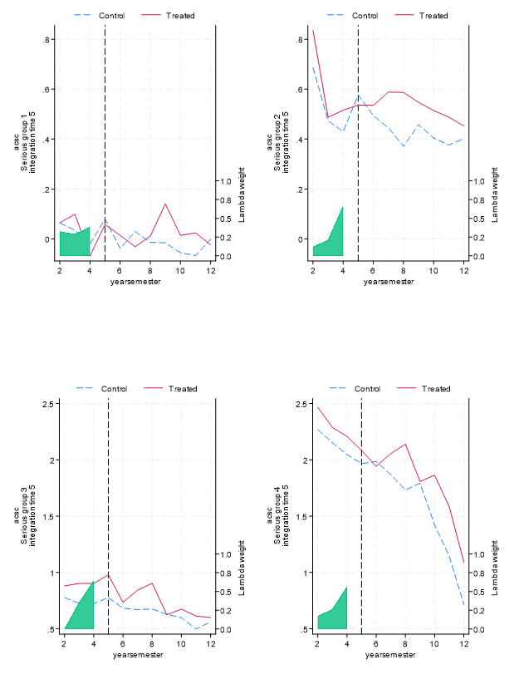

Figure S5. Primary and secondary care results (SDiD).

Figure S6. Mortality results (SDiD).

Figure S7. Mean cost/per patient (SDiD).

