Supplementary Information

Spatial Benchmarking of Four Spatially Explicit Models for Groundwater Potential Mapping in Cheongju, South Korea

Sooyeon Han and Saro Lee

Contents: Figures S1-S4 and Tables S1-S9

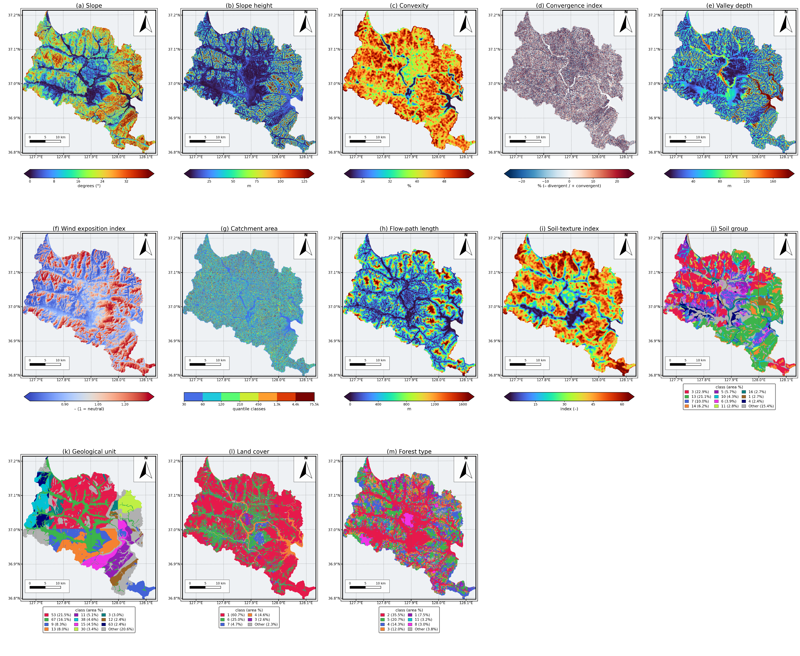
Fig. S1 Spatial distributions of the 13 retained conditioning factors. Continuous-panel color bars report mapped units or index values; categorical panels use source-map class codes and show class-area percentages

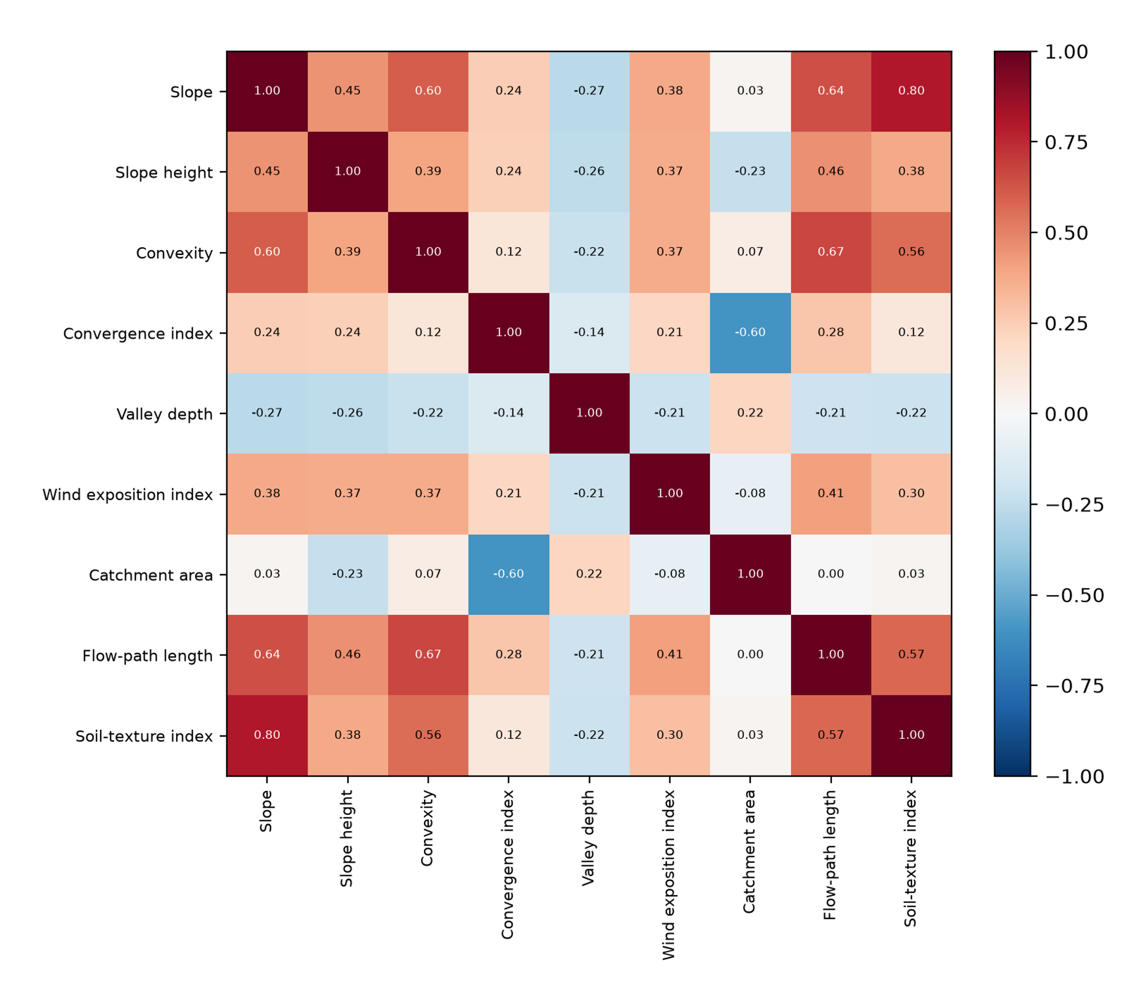
Fig. S2 Spearman rank-correlation matrix for the nine retained continuous factors

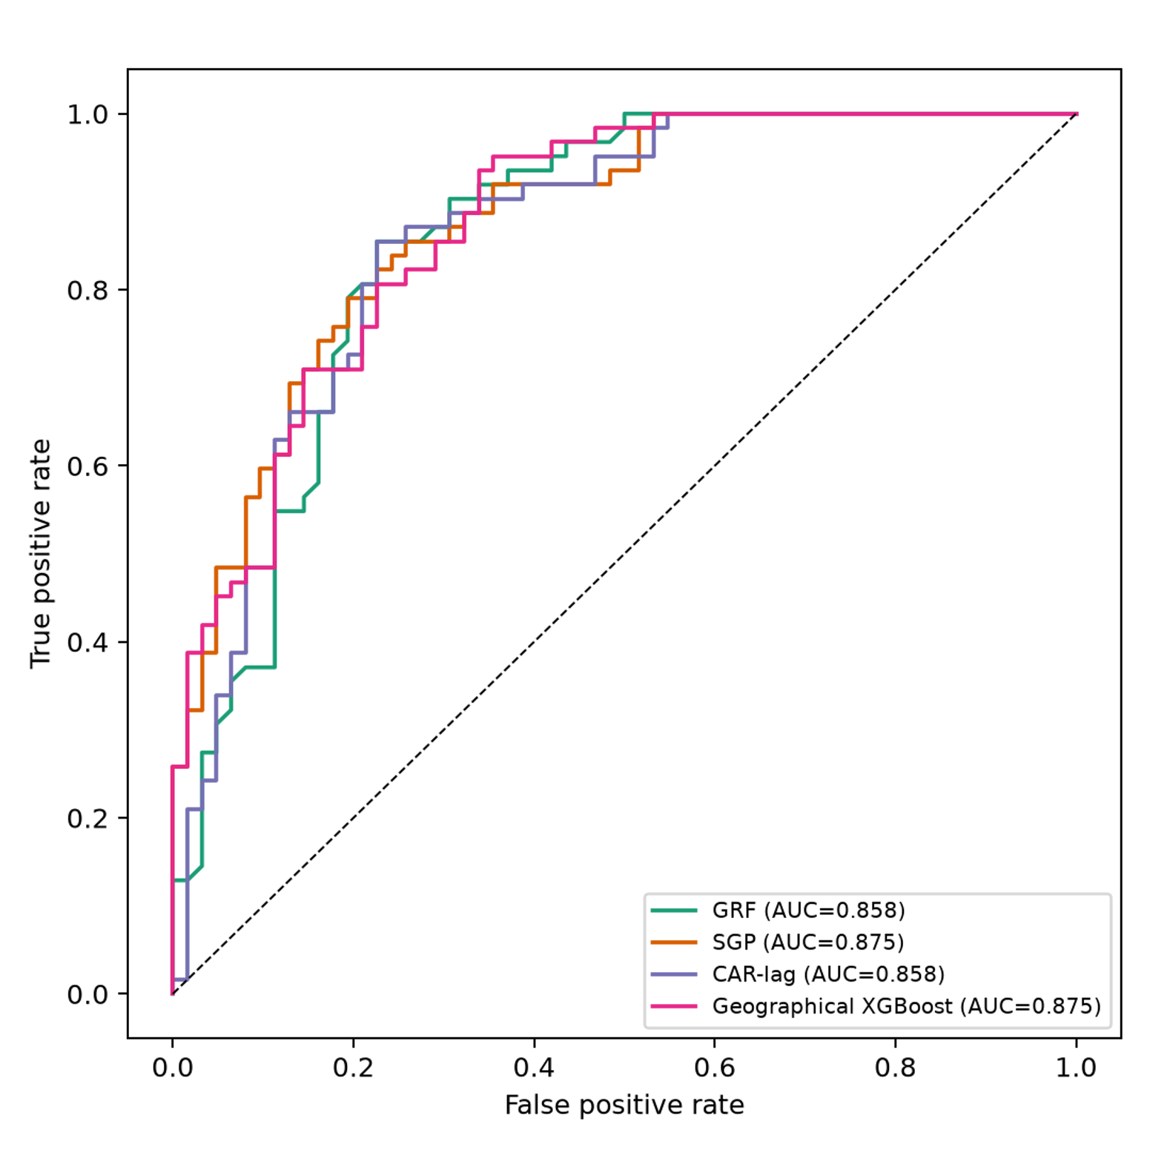
Fig. S3 Receiver operating characteristic curves for the common 124-point secondary hold-out set

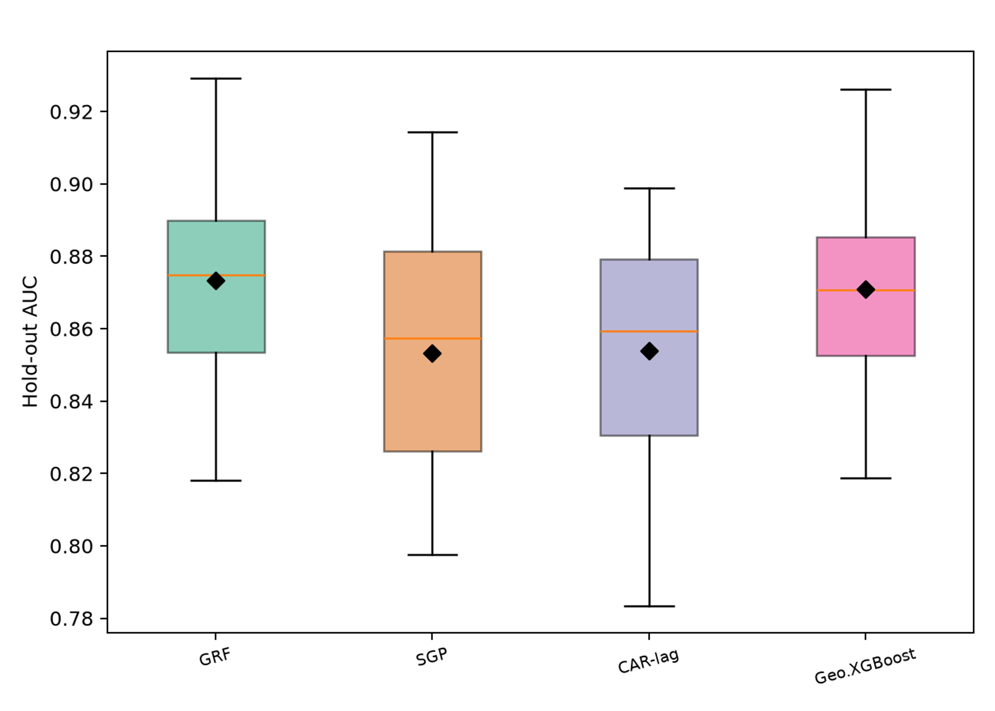
Fig. S4 Hold-out AUC distributions across 15 combined design realizations. Diamonds indicate means

Table S1 Conditioning factors retained for modeling
No. | Factor | Thematic block | Data type (classes)
1 | Slope | Terrain | Continuous
2 | Slope height | Terrain | Continuous
3 | Convexity | Terrain | Continuous
4 | Convergence index | Terrain | Continuous
5 | Valley depth | Terrain | Continuous
6 | Wind exposition index | Terrain | Continuous
7 | Catchment area | Hydrology | Continuous
8 | Flow-path length | Hydrology | Continuous
9 | Soil-texture index | Soil | Continuous
10 | Geological unit | Geology | Categorical (12)
11 | Soil group | Soil | Categorical (12)
12 | Land cover | Land and vegetation | Categorical (6)
13 | Forest type | Land and vegetation | Categorical (8)

Table S2 Spatial-block geometry, sample composition, and fold contiguity
Fold | Blocks | n | Positive | Background | Rook components | Queen components | Block indices
Fold 0 | 7 | 54 | 14 | 40 | 1 | 1 | 19, 24, 25, 26, 30, 31, 32
Fold 1 | 6 | 36 | 17 | 19 | 1 | 1 | 4, 5, 10, 11, 16, 17
Fold 2 | 5 | 69 | 44 | 25 | 1 | 1 | 13, 14, 15, 20, 21
Fold 3 | 5 | 69 | 43 | 26 | 1 | 1 | 2, 3, 7, 8, 9
Fold 4 | 7 | 62 | 27 | 35 | 1 | 1 | 22, 23, 27, 28, 29, 33, 34
Total | 30 | 290 | 145 | 145 | - | - | 30 occupied of 36

Table S3 SHAP explainer, reference data, evaluation sample, and seed for each model
Model | Explained object | Explainer | Background/reference data | Evaluation sample | Seed
GRF | Global random-forest surrogate, 300 trees | TreeExplainer, tree-path-dependent | No external background; training coverage stored in tree structure | 124 hold-out points | 42
Coord-XGBoost | Fitted XGBoost on design matrix plus two standardized coordinate columns | TreeExplainer, tree-path-dependent | No external background; training coverage stored in tree structure | 124 hold-out points | 42
kNN-lag | Fitted L2 logistic regression on design matrix plus kNN label lag | LinearExplainer | 290 development rows of augmented matrix | 124 hold-out points | 42
SGP | Positive-class score of fitted Gaussian-process classifier | KernelExplainer, 120 coalitions | 40 development rows drawn with seed 42 | First 60 hold-out points | 42

Table S4 Recorded geometry of the main background sample and the 15 combined design realizations
Diagnostic | Main analysis (seed 42) | 15 realizations (seeds 1000-1014)
Number of background points | 207 | 207 per realization
Sampling frame | Continuous coordinates inside boundary polygon | 1,090,365 valid 30 m cells
Drawn with replacement | No (continuous rejection sampling) | Yes
Coincident or repeated locations | 0 | 0 of 3,105 draws
Background points sharing one 30 m cell | 0 | 0
Minimum background separation | 66.7 m | 30.0 m (one cell)
Median background separation | 975.2 m | Not reported
Minimum well-to-background distance | 79.9 m | 61.6 m
Exclusion radius from wells | > 60 m | > 60 m
Boundary/valid-data mask | Administrative boundary and valid factor stack | Valid-data extent
Water-body mask | No | No

Table S5 Fold-specific AUC under the common five-fold spatial partition
Model | Fold 0 | Fold 1 | Fold 2 | Fold 3 | Fold 4 | Mean ± SD | Pooled OOF AUC
GRF | 0.894 | 0.864 | 0.816 | 0.857 | 0.923 | 0.871 ± 0.040 | 0.873
SGP | 0.857 | 0.808 | 0.797 | 0.852 | 0.933 | 0.850 ± 0.054 | 0.855
kNN-lag | 0.846 | 0.858 | 0.785 | 0.851 | 0.929 | 0.854 ± 0.051 | 0.858
Coord-XGBoost | 0.877 | 0.858 | 0.792 | 0.831 | 0.892 | 0.850 ± 0.040 | 0.852

Table S6 Threshold-dependent secondary hold-out metrics. Values are conditional on the balanced case-background sample; background rejection is not specificity to regional dry wells
Model | Sensitivity at 0.5 | Background rejection at 0.5 | F1 at 0.5 | Accuracy at 0.5 | Youden threshold | Sensitivity at J | Background rejection at J | Accuracy at J
GRF | 0.855 | 0.742 | 0.809 | 0.798 | 0.560 | 0.855 | 0.774 | 0.815
SGP | 0.887 | 0.677 | 0.803 | 0.782 | 0.592 | 0.855 | 0.742 | 0.798
kNN-lag | 0.887 | 0.677 | 0.803 | 0.782 | 0.610 | 0.855 | 0.774 | 0.815
Coord-XGBoost | 0.839 | 0.710 | 0.788 | 0.774 | 0.194 | 0.952 | 0.645 | 0.798

Table S7 Pairwise DeLong tests for secondary hold-out AUC. Upper triangle: z statistics; lower triangle: two-sided p values
 | GRF | SGP | kNN-lag | Coord-XGBoost
GRF | - | z = -0.841 | z = 0.000 | z = -0.956
SGP | p = 0.400 | - | z = -1.045 | z = -0.027
kNN-lag | p = 1.000 | p = 0.296 | - | z = -0.734
Coord-XGBoost | p = 0.339 | p = 0.979 | p = 0.463 | -

Table S8 Exploratory equivalence and power results for the widest-separated secondary hold-out AUC pair. TOST two one-sided tests, SE standard error
Quantity | Value
Pair | SGP (0.8754) vs GRF (0.8582)
Observed difference, d | 0.01717
DeLong SE of difference | 0.02041
DeLong z; two-sided p | 0.841; 0.400
TOST p, margin 0.05 | 0.0538 (equivalence not established at 5%)
TOST p, margin 0.10 | 2.46 × 10⁻⁵ (exploratory equivalence at this margin)
Power to detect ΔAUC = 0.03 | 0.312
Sample-size multiplier for 80% power | 3.64 (approximately 450 evaluation points)

Table S9 Hold-out AUC across 15 combined background-sampling, re-splitting, and re-standardization realizations. CV coefficient of variation
Model | Mean AUC | SD | Minimum | Maximum | CV (%)
GRF | 0.873 | 0.031 | 0.818 | 0.929 | 3.58
Coord-XGBoost | 0.871 | 0.029 | 0.819 | 0.926 | 3.32
kNN-lag | 0.854 | 0.034 | 0.783 | 0.899 | 3.93
SGP | 0.853 | 0.036 | 0.798 | 0.914 | 4.25

