Supplementary Information

Vegetation management saved 7,000 tonnes of soil carbon losses in one of the UK’s highest severity peatland fires

Sarah J. Baker*^{1,2}, Romy C. Franz Bodenham*², Kerryn Little³, Stefan H. Doerr¹, Nicholas Kettridge³ and Claire M. Belcher²

¹ Centre for Wildfire Research, Swansea University, Singleton Park, Swansea, SA2 8PP, Wales, UK
² WildFIRE Lab, University of Exeter, Hatherley Laboratories, Prince of Wales Road, EX4 4PS, Exeter, UK
³ School of Geography, Earth and Environmental Sciences, University of Birmingham, B15 2TT, Birmingham, UK

Fig. S1. Field Images of part of the burned area at Langdale Moor A) example view showing variability in areas burned. B) high severity area showing loss of peat converted to mineral ash C) example of depth of peat loss in high severity areas, D) Moderate severity area showing exposed root and some patches of mineral ash, E) example of depth of peat loss in moderate severity areas F) low severity, surface burned, with char remaining, no-little peat consumption.

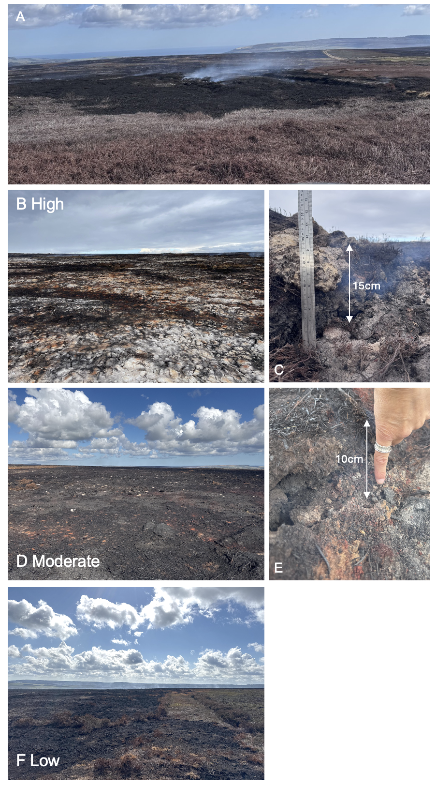
Fig. S2. Transect walked in the field illustrating location of and depth of peat loss measured (Source: Esri World Imagery basemap (Sources: Esri, DigitalGlobe, GeoEye, i-cubed, USDA FSA, USGS, AEX, Getmapping, Aerogrid, IGN, IGP, swisstopo, and the GIS User Community).⁴⁹

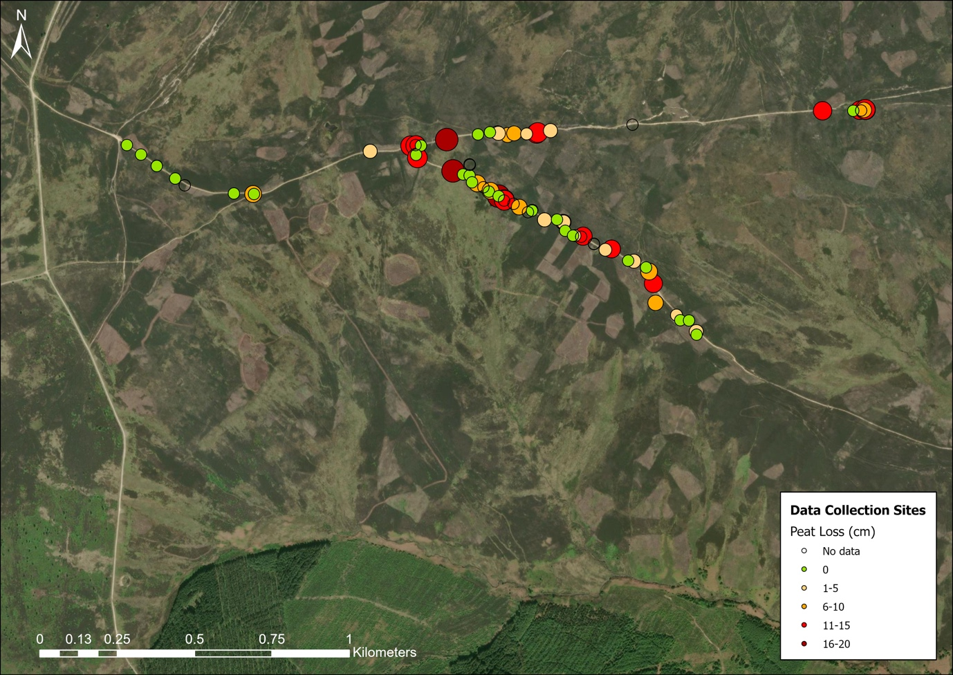

Fig. S3 Boxplot illustrating depth of peat loss measured for each burn severity category.

Table S1: : Parameters for Sentinel-2 satellite images.

Sensor | Acquisition date | Cloud cover (%) | Band Name | Central Wavelength | Spatial resolution (m)
Sentinel-2 | 13/05/2025 | 3.502746 | B08 | 0.842 | 10
Sentinel-2 | 13/05/2025 | 3.502746 | B12 | 2.190 | 20
Sentinel-2 | 05/09/2025 | 28.056756 | B08 | 0.842 | 10
Sentinel-2 | 05/09/2025 | 28.056756 | B12 | 2.190 | 20
Sentinel-2 | 22/09/2025 | 2.615983 | B08 | 0.842 | 10
Sentinel-2 | 22/09/2025 | 2.615983 | B12 | 2.190 | 20

Comparing peat soil carbon bulk density
Due to sampling of peat soil not being possible due to the risk of unexploded ordinance, we evaluated carbon emissions using three sources of carbon bulk density to determine the potential loss of SOC from the burning of the underlying peat layers.

The first carbon bulk density values were taken from SoilGrids 2.0⁴⁷. Here, we took the organic carbon density (hg/m³) values for soil depths of 0-5cm and 5-15 cm, sampling at each 10 m sample point across the burn scar. These values were then converted to kg/m³ and allocated accordingly.

The second was using a carbon bulk density of 62.59 kgm⁻³ presented as a national average for England in ref ¹⁶. This was allocated across the burn site for areas that overlay peat.
The third carbon bulk density values were taken by sampling mean estimates of topsoil (0-15 cm) carbon density from ref ⁴⁸) at 10 m resolution across the burn site to calculate SOC lost at each 10 m sample point. Carbon density values here were produced through a combination of measurements of carbon from soil that was collected across 2614 locations from 591, 1 km² squares across Great Britain. These were then extrapolated to a national level using statistical analysis using a combination of habitat type and soil parent material (see ref ⁴⁸ for more information).

Table S2: Results from varying carbon bulk densities for carbon emission estimates

Burn severity | Peat burn depth allocation | C emissions using SoilGrids 2.0⁴⁷ (tC) | C emissions using ref ¹⁶ (tC) | C emissions using ref ⁴⁸ (tC)
Unburned | 0 cm | 0 | 0 | 0
Low | 0 cm | 0 | 0 | 0
Moderate | 5 cm | 18,254 | 19,755 | 18,989
High | 13 cm | 6,931 | 9,039 | 8,447

Fig. S4: Variation in soil moisture in the top 5 cm taken from the Soil Moisture Active Passive Satellite (SMAP) of the Langdale moor burn scar. These present as long-term monthly means (LTM) taken between 2015 and 2024 and compared to the 2025 monthly mean soil moisture. Volumetric soil moisture (m³/m³).

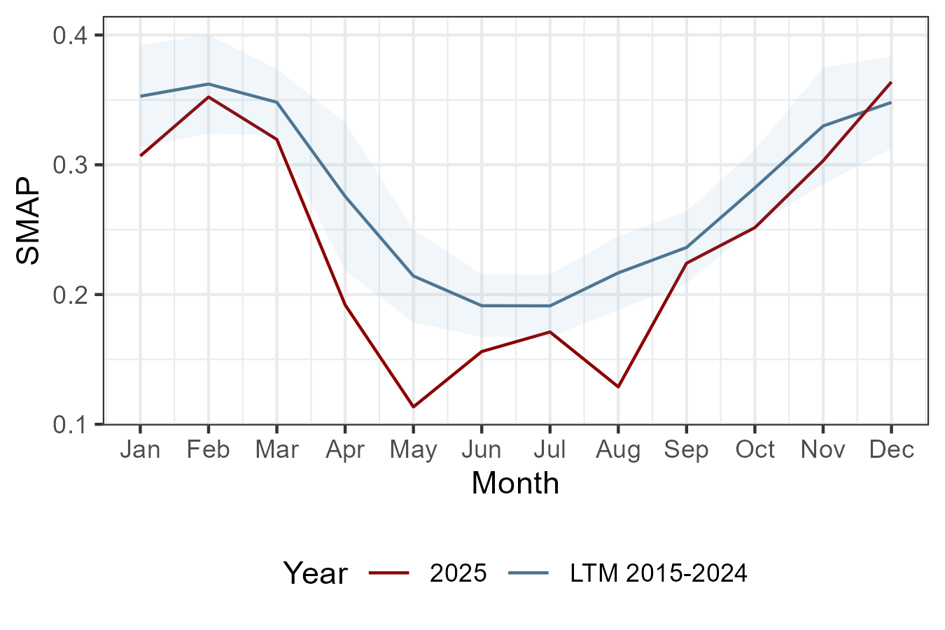
Volumetric soil moisture (m³/m³)

