SUPPLEMENTARY MATERIAL

Supplementary Methods S1

Calculation of Anthropometric and Metabolic Indices
Height Measurement
Height measurement was performed using a wall-mounted stadiometer (TEMBEKO 035×040 device, Istanbul, Turkey). Participants took off their shoes and stood with their backs, hips, and heels against the device's vertical surface. The measurement was taken after the participant took a deep breath to make sure they were standing up straight. The procedures were carried out in accordance with standardized anthropometric assessment protocols (19).
Weight Measurement
A portable scale with a balance mechanism that was regularly calibrated was used to measure body weight. Participants were measured while dressed in light clothing and barefoot. Before the measurement, all heavy items, like keys, accessories, and metal objects, were taken away. Participants were told to stand in the middle of the weighing platform with their heels at the back edge, their heads facing forward, and their arms hanging down at their sides. According to standard survey procedures (19), measurements were taken to the nearest 0.1 kg. To find BMI, we divided body weight in kilograms by height in meters squared (kg/m²). BMI was used both as a descriptive anthropometric parameter and as an inclusion criterion for obesity (BMI ≥30 kg/m²).
Body Shape Index (ABSI)
To evaluate central fat distribution independently of body size, ABSI was computed using the methodology suggested by Krakauer and Krakauer (12). ABSI lessens the confusing effect of body size by making waist circumference the same for height and BMI. Using the following formula, it was figured out:
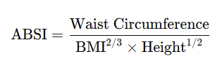

The waist circumference (centimeters) was measured at the midpoint between the lower margin of the last palpable rib and the top of the iliac crest, using a nonstretchable tape positioned horizontally, at the end of a normal expiration (19). The height in meters, and the BMI in kg/m². ABSI was incorporated as an indicator of abdominal adiposity, independent of total body mass.

Waist-to-Height Ratio (WHtR)
The WHtR was found by dividing the waist circumference by the height:
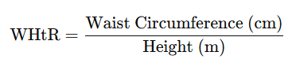

Both measurements were given in meters. WHtR was utilized as a measure of central adiposity in relation to height (11).

Body Roundness Index (BRI)
Body Roundness Index (BRI) was calculated according to the geometrical model described by Thomas et al. (13). BRI is based on an elliptical body shape model that uses waist circumference and height to get a better estimate of total and visceral fat than BMI alone. BRI takes into account body shape and the amount of fat in the middle of the body, which makes it easier to guess where fat is stored in the body than BMI does.
The following formula was used to figure out BRI:
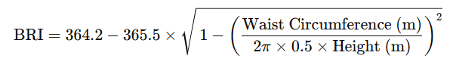

where waist circumference (WC) and height were given in meters. The authors' original algorithm was used to calculate the BRI values.

Weight-Adjusted Waist Index (WWI)
The weight-adjusted waist index (WWI) was computed by dividing waist circumference by the square root of body weight (14):
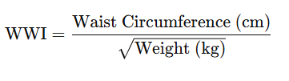

WWI was incorporated as an indicator of abdominal adiposity, minimally affected by total body mass.

Triglyceride–Glucose Index (TyG)
We figured out the triglyceride–glucose (TyG) index, which is a stand-in for insulin resistance, by

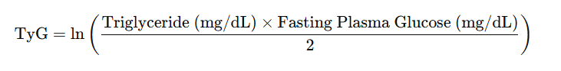

with triglycerides and fasting glucose measured in mg/dL (20).

Conicity Index (CI)
According to the model proposed by Valdez (21), the Conicity Index (CI) was calculated to measure central adiposity without taking body size into account:
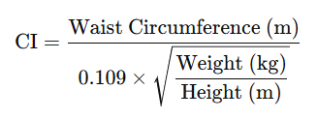
The waist circumference and height were given in meters, and the body weight was given in kilograms. CI was included as a geometric indicator of fat buildup in the abdomen.

Cardiometabolic Index (CMI)
The Cardiometabolic Index (CMI) was determined by multiplying the waist-to-height ratio by the triglyceride-to-high-density lipoprotein cholesterol ratio (22):
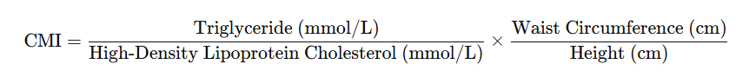
CMI served as a composite indicator denoting both visceral adiposity and dyslipidemia.

Atherogenic Index of Plasma (AIP)
We found the Atherogenic Index of Plasma (AIP) by taking the base-10 logarithm of the ratio of triglycerides to HDL-cholesterol (23):
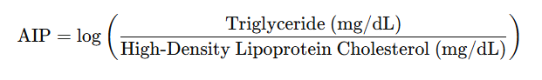

Triglyceride and HDL-cholesterol levels were measured in mmol/L. AIP was included as a sign of an atherogenic lipid profile.

