Materials and Methods

Ethical approval

Animal maintenance and conduction of all the experiments were performed in the animal facility of the Laboratory of Chronobiology and Aging and the Laboratory for Reproductive Endocrinology and Signaling, Department of Biology and Ecology, Faculty of Sciences, University of Novi Sad, Serbia. Experiments were performed and conducted following the European Convention for the Protection of Vertebrate Animals used for Scientific Purposes (Council of Europe No. 123, Strasbourg, 1985) and NIH Guide for the Use and Care of Laboratory Animals (NIH Publications, No. 80 23, revised, 7th ed., 1996). All the experiments and protocols were approved by the Committee on Animal Care, University of Novi Sad (statement No. 01-201/3), operating under the rules of the National Council for Animal Welfare and following statements of National Law for Animal Welfare (copyright March 2009). Experiments were in adherence to the ARRIVE guidelines.

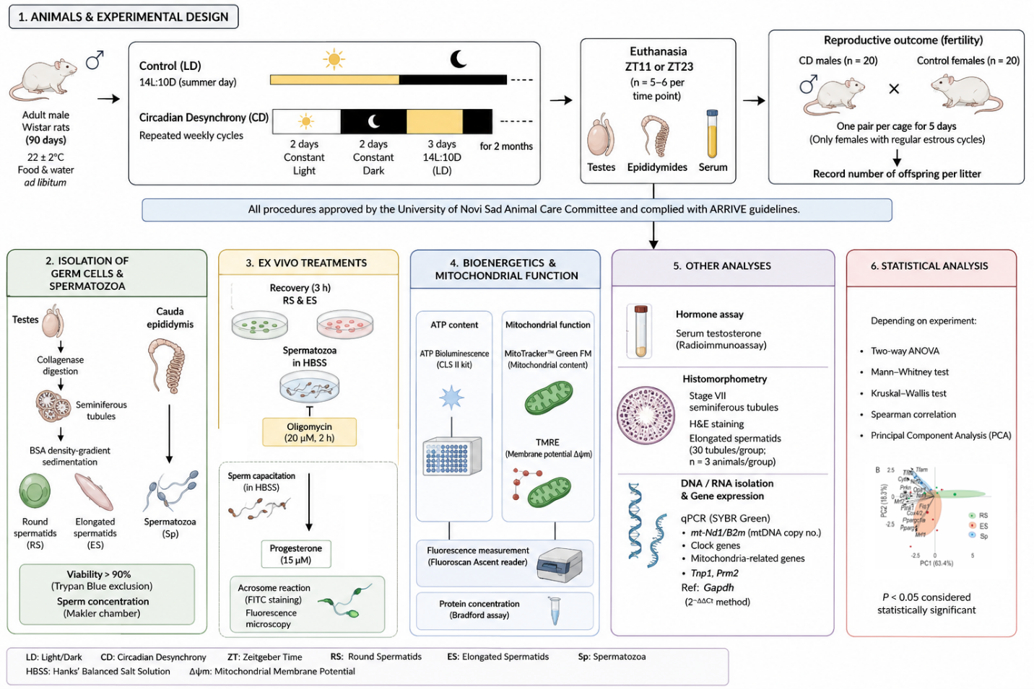

2.2. In Vivo Experiments

Experiments were carried out on male adult Rattus norvegicus specimens of the Wistar, bred and raised in the animal facility of the Faculty of Sciences, University of Novi Sad (Novi Sad, Serbia). The animals were grown in controlled environmental conditions (22 ± 2°C; 14 h light–10 h dark cycle, lights on at 7:00 AM; provided with commercially balanced food and water ad libitum). At the 90th postnatal day (P90), for in vivo observations and recordings, rats were randomly divided into different light regime groups, the experimental with disturbed and control group (LD) with regular light cycles (14 h light and 10 h dark, summer day). For two months, the experimental group (CD) was exposed to two days of constant light, followed by two days of continuous darkness, and three days of 14 h light and 10 h dark. The control group was held under the LD regime throughout the treatment. After two months in the regime, during the second day of the light period, animals were decapitated at specific zeitgeber times (ZT), in other words at different time points for 24 h (indicated for each experimental group, 5–6 rats per time point): ZT11 (06:00 pm.- onset of active phase) and ZT23 (06:00 am.). Trunk blood was assembled for testosterone measurement. Testes and caudal epididymis were collected and used for specific germ cell type isolation to further analyze impact of circadian disturbance on different testes compartments. From isolated testes interstitial and seminiferous tubules tissues were seperated to purify elongated and round spermatids, while spermatozoa were obtained directly from epididymis. No masking was used during group allocation, data collection, or data analysis. Previous results from our group obtained on the rat model showed that the size of the group of 5 rats was sufficient to calculate hormone parameters of the diurnal rhythm (Baburski et al., 2016, 2019). The sample size was also checked by Power Analysis using G Power software (Heinrich Heine University Düsseldorf, Germany, https://download.cnet.com/G-Power/3000-2054_4-1064 7044.html) according to previous results.

To assess reproductive outcome, CD males (n = 20) were individually housed with age-matched control females (n = 20; one pair per cage) for 7 days. Only females exhibiting regular estrous cycles were included. The number of offspring per litter was recorded after parturition.

Detection of An Animal’s Voluntary Activity

To analyze the voluntary activity of the rats, an important parameter for indicating circadian disturbance, the rats from both light regime groups were placed in individual cages with a running wheel system. The system automatically recorded the total number of wheel turns performed by each animal at 6-minute intervals. The activity pattern was monitored from P90 to P150 (Travicic et al, 2023; Pavlovic et al, 2002).

Histomorphometrical analyses
The right testis of each animal was fixed in Davidson’s fixative for 24 h and transferred to neutral buffered formalin (pH = 7.4) for storage. Later, they were dehydrated in growing ethanol concentrations (70%, 80%, 96%, 100%) and molded into paraffin blocks. The paraffin blocks were cut into 4 μm-thick sections with a rotary microtome (Leica, Wetzlar, Germany) and stained with a standard hematoxylin-eosin stain. For each group, testes from three animals in both the LD and CD groups were analyzed (n = 3 per group). From each animal, three testis sections were examined, and within these, ten seminiferous tubule cross-sections corresponding to stage VII of spermatogenesis were identified, yielding 30 tubules per group. The number of elongated spermatids was counted in each of these stage VII tubules.

Seminiferous Tubules Isolation

The detailed protocol for isolation of seminiferous tubules from interstitial content was previously described by our research group (Travicic et al, 2023). Briefly, following the dissection of rat’s abdominal region, testes were decapsulated, tunica albuginea removed, the main blood vessel carefully pulled out with forceps from the rest of testicular tissue, and as such, whole testicular content was placed on ice, in 50 ml conical tubes containing 0.25 mg/ml collagenase (Type IA, from Clostridium histolyticum, Sigma, St. Louis, MO, USA); 1.5%-BSA (Bovine Serum Albumin, Sigma, St. Louise, MO, USA); 20 mM HEPES-M199 (4-(2-hydroxyethyl)-1-piperazineethanesulfonic acid- Medium 199 containing Earle’s salt and L-glutamine, Sigma, St. Louise, MO, USA). Enzymatic disaggregation of testicular tissue was performed in shaking-water bath (15 min/34°C/ 140 cycles/min). At the end of the enzymatic reaction, 45 ml of cold M199-0.1% BSA medium was added into each sample tube to stop collagenase. Disaggregated testicular tissue was filtrated through Mesh № 100 (Sigma, St. Louis, MO, USA), separating seminiferous tubules from interstitial content, the tubules left on the mesh surface, while the interstitium flew through. Seminiferous tubules were transferred to 15 mL conical tubes, washed with 1xPBS buffer, then centrifuged at 500 x g/7 min/RT. This step was repeated three times to fully wash tubules from medium and was stored for further analysis.

Spermatocytes and spermatids fractional isolation from seminiferous tubules

Spermatocytes and spermatids isolation from seminiferous tubules was done according to the modified method for enrichment of pachytene spermatocytes and spermatids by Da Ros et al. (2019). This specified method was developed as a simplified protocol, following principles underlying the STA-PUT velocity sedimentation method for separation of spermatogenic cell types described by Bryant et al. (2013), which requires only standard laboratory equipment. This protocol is referred to as modified density gradient for round spermatids (MDR), since it works particularly well for enriching round spermatids along with two more abundant cell populations of rodent testes, pachytene spermatocytes and elongating spermatids. Living cells are allowed to sediment through a manually prepared discontinuous BSA (Sigma, St. Louise, MO, USA) density gradient inside a standard 50 mL tube under the Earth's gravitational field. Larger cells move faster through the gradient, which separates different populations of germ cells. After sedimentation, enriched fractions of the three cell types are manually collected. The protocol also describes a sequential digestion method with collagenase IV and trypsin. Sequential digestions combined with bicarbonate buffer, like Krebs solution, have been shown to greatly enhance the separation and viability of the germ cells (Romrell et al. 1976).
As described above, after testes collagenase (Type IA, Sigma, St. Louis, MO, USA) disaggregation and dissociated interstitial cells were filtered through Mesh № 100 (Sigma Aldrich, St Louis, MO) resulting stromal content separation from the seminiferous tubules. The seminiferous tubules were transffered from meshes into a 50 mL conical tubes containing 40 mL of freshly prepared 1x Krebs buffer solution (following manual Da Ros et al, 2019), pre- warmed at 34 °C, allowing the tubules to sediment (~1 min) at room temperature (RT), and supernatant was removed. This step was repeated twice in order to wash seminiferous tubules from remaining DMEM/F12 medium (Sigma, St. Louis, MO, USA). Afterwards, 25 mL of fresh prepared trypsin solution (trypsin from porcine pancreas, Sigma Aldrich, St Louis, MO) was added to each tube and incubated in a shaking water bath oscillating at 120 cycles/min, for 15min at 34◦C. Once the solution became cloudy and only small pieces of tubules remained visible, the tubes were placed on ice. To avoid overdigestion and cell lysis, trypsin was removed by immediate centrifugation and subsequent washing with cold 1x Krebs buffer. More specifically, digested solution was filtered through a 40 μm cell strainer (BD Falcon, Franklin Lakes, NJ, USA) into a new 50 mL conical tube on ice and centrifuged at 600 x g for 5 min at 4 °C to precipitate the cells. By carefully pouring out, supernatant was removed and the cell pellet resuspended in the remaining 1x Krebs solution. Subsequently, 40 mL of cold 1x Krebs buffer was added to the resuspended cells, these steps were repeated twice to completely stop trypsin digestion. Following the enzymatic reaction, 1 mL of 0.5% BSA-1x Krebs buffer was added to the cell pellet and aspirated with a cut pipette tip to get a homogeneous cell suspension. Finally, 3 mL of 0.5% BSA-1x Krebs solution was added to the suspension, and germ cells were again filtrated through a 40 μm cell strainer (BD Falcon, Franklin Lakes, NJ, USA) for additional purification and single cell- dissociation. Afterwards, it immediately proceeded with the separation of germ cells through the discontinuous BSA gradient. Cell suspension was loaded on the top of the BSA gradient without disturbing the layers. The three different concentrations of BSA gradient fractions were previously prepared with 1x Krebs according to MDR protocol (Da Ros et al. 2019): 0.50%, 1% and 2%. After mounting single-cell suspension, the 50 mL tubes with BSA gradient were placed on ice to let the cells sediment through the gradient for 1.5 h. When cell sedimentation is done, each BSA gradient fraction should contain one dominating germ cell population: 0.50% with elongating spermatids (ES), 1% with dominating round spermatids (RS) and 2% with pachytene spermatocytes (PSpc). This was verified during protocol accommodation process, analyzing cell fractions on microscopic slides with DAPI fluorescent microscopy to estimate which particular germ cell type is enriched for each fraction. Since different cell types can be recognized by their characteristic nuclear morphology. The round spermatid nucleus is small (6−7 μm in diameter) and round, which in rodents is characterized by a single, round heterochromatin structure called the chromocente. Nuclei of elongating spermatids have a typical elongated shape and reduced nuclear size due to chromatin condensation. Pachytene spermatocyte nuclei are much larger (diameter more than 10 μm) and more irregular in shape, with areas of densely packed chromatin distributed throughout. Finally, when cell sedimentation period ended on the BSA gradient, enriched germ cell fractions were harvested from each BSA gradient layer, individually, ~5 mL fractions in separate 1.5 mL tubes for each sample, starting from the top of the BSA gradient. Afterwards, the germ cell fractions were counted on Neuber chamber with Trypan Blue Exclusion test, cell viability was greater than 90%. Cells were divided for further applications, centrifuged at 600 x g for 10 min at 4 °C, supernatant was discarded and germ cell pellet stored at -70 °C.

Isolation, capacitation and acrosome reaction of spermatozoa

Spermatozoa were isolated directly from rat's caudal epididymis. Alongside testes removal, epididymis was taken as well and placed in a petri dish, filled with modified Hanks' Balanced Salt Solution (HBSS, Sigma Aldrich, St Louis, MO), isolation and preservation for spermatozoa medium (1 % M199 in HBSS with 20 mM HEPES and 5 % BSA). The epididymis was thoroughly punctuated with a needle and incubated for 10 min/37 ◦C to release spermatozoa into HBSS. When incubation period ended, spermatozoa were collected, centrifuged 700 × g/5 min, and resuspended in adequate medium. Makler counting chamber was used to identify the number of isolated spermatozoa, counted in three different fields.
Further, to determine the functionality of the spermatozoa after the treatment, following capacitation process, acrosome reaction was initiated in vitro. Approximately 1.5 × 10⁵ spermatozoa were incubated with Whitten’s Media (100 mM NaCl, 4.7 mM KCl, 1.2 mM KH₂PO₄, 1.2 mM MgSO₄, 5.5 mM glucose, 1 mM pyruvate, 4.8 mM lactate, 20 mM HEPES) supplemented with the 10 mg/mL BSA and 20 mM NaHCO₃ for 1h, at 37 ◦C. When capacitation period ended, spermatozoa were divided into two groups for each specimen: treated with/without progesterone (15 μM) for 30 min/37 ◦C to activate the acrosome reaction. Finally, spermatozoa were fixed with fixation solution (20 mM Na₂HPO₄, 150 mM NaCl, 7.5% formaldehyde) for 20 min and centrifuged 12,000 × g/1 min. The cell pellet was washed with 100 mM ammonium acetate (pH 9). Fixed spermatozoa were smeared on microscopic slides, air-dried, followed by staining with FITC dye (Fluorescein 5(6)-isothiocyanate, Sigma Aldrich, St Louis, MO) and DAPI (Mounting Medium with DAPI - Aqueous, Fluoroshield, Abcam, CBC, UK) according to manufacturer's protocol. After staining process, analyzing the microscopy slides under a fluorescence microscope Zeiss Axio Imager (MicroImaging GmbH Axio Imager, Carl Zeiss, OKO, GER) was performed to estimate which number of spermatozoa went under acrosome reaction).

ATP and Mitochondrial Membrane Potential (ΔΨ) Determination

The level of ATP was performed using the ATP Bioluminescence CLS II kit (Roche Diagnostics, Mannheim, Germany), following the protocol recommended by the manufacturer. Spermatozoa (10⁶/mL) and spermatids (10⁶/mL) were resuspended in boiling water and Tris-EDTA (Tris-Ethylenediaminetetraacetic acid, 1:9), incubated for 3 min/ 100 ◦C, and centrifuged 900 × g/1 min. The resulting supernatant was used for ATP level detection, while the pellet was further used for the Bradford protein analysis. Luciferase reagent was mixed with standard/sample (1:1) to measure luminescence by luminometar (Biosystems/Fluoroscan, Ascent, FL, USA). Mitochondrial abundance and mitochondrial membrane potential (ΔΨ) were determined by MitoTracker dye (MitoTracker™ Green FM Dye, Invitrogen™, Thermo Fisher Scientific, Waltham MA, USA) and TMRE (Tetramethylrhodamine, Sigma Aldrich, St Louis, MO), respectively, staining for 20 min/34°C/5% CO₂ were applied with subsequent fluorescence reading (Fluoroscan, Ascent, FL, USA). The excitation wavelength used for each test was 485 and 550 nm while emission wavelengths were 510 and 590 nm respectively; after staining, cells were washed with 0.1% BSA-PBS and used for protein quantification by Bradford method.

Testosterone Measurements

Testosterone level was measured in serum using radioimmunoassay (RIA). Androgens detected in serum by RIA were referred to as testosterone + dihydrotestosterone (T + DHT) because the Anti-testosterone serum No. 250 Anti-testosterone-11-BSA, used in this study showed 100% crossreactivity with DHT. All samples were measured in duplicate in one assay (sensitivity: 6 pg/tube; intra-assay coefficient of variation: 5–8%; inter-assay coefficient of variation: 7.5%). Testosterone was from New England Nuclear (Brisel, Belgium).

Ex Vivo Experiments

Both types of spermatides cells, round (RS) and elongated (ES) spertmatides, were obtained by plating 3 x 10⁶ cells in DMEM/F12, Petri dish (55 mm) and placed in a CO₂ incubator at 34°C for 3 h to get recovered and attached to dish surface. After attaching period 10% FBS (Fetal Bovine Serum, Sigma Aldrich, St Louis, MO) has been added to each (Kavarthapu et al, 2015). Spermatozoa 5 x 10⁶/ mL were resuspended with HBSS vehicle in 1.5 mL tubes, since attaching to plastic surfaces is at low rate. To compare cell’s mitochondria bioenergetic capacity between different gamete stages, spermatids and spermatozoa, among different specimen’s groups (Control/Experimental) were respectively treated with oligomycin (20 µM, Sigma, St. Louise, MO, USA). Oligomycin is allowed to examine which portion in ATP synthesis is predominantly affected, glycolytic or OXPHOS ATP production, since itself is used as synthase inhibitor. After 2h, cell medium and cells were collected and stored until analysis.

Genomic DNA isolation, total RNA purification, RT-PCR, and qRT-PCR analysis

Genomic DNA from spermatides and spermatozoa was purified using NucleoSpin Tissue, Mini kit for DNA from cells and tissue (Macherey-Nagel, Dueren, Germany) to estimate the Mt-Nd1/B2m ratio, used for mtDNA copies determination. Total RNA from spermatozoa, spermatides were isolated using GenElute™ Mammalian Total RNA Miniprep Kit (Sigma, St. Louise, MO, USA) following the manufacturer’s protocol. The kit is designed to minimize co-purification of proteins and other contaminants, so the isolated RNA sample does not necessarily contain significant amounts of ribonucleoprotein complexes. While RNA from seminiferous tubules, as whole tissue, was obtained using EXTRAsol reagent (BLIRT S.A., Poland), adhering to the instruction provided by the manufacturer. DNA and RNA quality was measured and validated using BioSpec-nano (Shimadzu Biotech, Kyoto, Japan), followed by DNAse I treatment of the isolated RNA (New England Biolabs, Ipswich, Massachusetts, USA). cDNA synthesis was performed using a HighCapacity kit (Thermo Fisher Scientific, Waltham, MA, USA) according to the manufacturer’s instructions. Quantification of relative gene expression was performed by real-time PCR (qRT-PCR- quantitative real-time polymerase chain reaction) reaction with SYBR Green technology (Applied Biosystems/Thermo Fisher Scientific, Massachusetts, USA) on RealPlex Mastercycler (Eppendorf Master Cycler Real- Plex, Hamburg, Germany), with standard reaction conditions (50°C/2 min, 95°C/10 min; 40 cycles, each 95°C/15 s, and then 60°C/1 min). The transcription of Gapdh was used as an endogenous control to correct the variations in cDNA between the samples. Each sample was run in triplicate for each experiment group, for each cell type. The reaction was performed in the presence of 2.5 ng cDNA and specific primer’s sequences used for qRT-PCR analysis and GenBank accession codes are provided in (Suppl. Tabl 1). Alone primers were synthetized from Invitrogen (Waltham, MA, USA). Melting curve analyses were performed to verify the amplification specificity. The relative quantification of gene expression was analyzed from the measured threshold cycles (Ct) by using the 2_ΔΔCt method.

Statistical Analysis

For in vivo studies the results represent group mean _ standard error of the mean (SEM) values of individual variations from 5 rats per group. For ex vivo measurements data represents mean _ SEM from three to five independent replicates.

Statistical analysis was performed using GraphPad Prism 8. The rats' voluntary activity data is represented as activity in the final week of the experiment, where statistical significance between control and experimental groups, was determined using the Kruskal-Wallis ANOVA test.

Mann-Whitney test was used for comparation between two groups for the Mt-Nd1/B2m ratio (n=5), the MitoTracker assay (mitochondrial content), TMRE measurements (mitochondrial membrane potential (ΔΨ)), ATP measurements (mitochondrial energetic function), at both time points for each germ cell type, along with graphical data represented as Whisker box plot, where dots represent individual values (n = 3-6, at two-time points).

Serum testosterone levels and the expression patterns of genes are important for germ cell maturation (Tnp1 and Prm2) in seminiferous tubules, as well in separated germ cell types, round (RS) elongated (ES) spermatides were presented also as Whisker box plots, where dots represent individual values (n = 3-6, at two-time points). Statistical significance was determined using the Kruskal-Wallis ANOVA test.

The relative expression of clock genes and mitochondria-related genes (MRG) in RS, ES and spermatozoa were presented as a Whisker box plot (n=4-5 per group), as deviations from the corresponding control values, at ZT11 and ZT23.
The acrosome reaction is presented as % of acrosome-reacted spermatozoa isolated from control and experimental rats (n=5-9). Statistical significance was determined with two-way ANOVA.

For all statistical analyses, statistical significance was set at p < 0.05.

Principal Component Analysis (PCA) of the clock and mitochondria-related gene expression under control and circadian desynchrony in round spermatids, elongated spermatids, and spermatozoa was done with dudi. PCA() function implemented in "ade4" package (Dray and Dufour, 2007) on scaled and centered data matrix, within the R environment. We decided to retain the first two PC based on eigenvalues and cumulative variation. In support of such a decision, we performed Horn’s parallel analysis for a PCA with the "paran" package, to adjust for finite sample bias in retaining components (Dinno, 2018). Biplots visualization were done with "factoextra" package (Kassambara, Mundt, 2021). Datasets for PCA were prepared by calculating the deviation from control values at ZT11, representing the baseline condition. The PCA score plot for the first two principal components (PCs) is derived from the clock gene expression data across all three cell types under control conditions (A). The PCA score plot for the first two PCs of mitochondria-related gene expression in the same cell types under control conditions, while PCA score plot using data obtained from rats under circadian desynchrony conditions were calculated as deviations from the corresponding control values. PC1 and PC2 represent the first two principal components, indicating the percentage of total variation explained by each component (variable loadings detailed in Supplemental Tables 2 & 3).

Supplemental Table 1. The primer sequences used for RQPCR analysis.

Gene | Access bank code | Primer sequence
B2m | NM_012512.2 | F: 5’-GCGTGGGACGAGCATCAGGG -3’  R: 5’-CTCATCACCACCCCGGGGACT -3’
Bmal1 | NM_024362.2 | F:5'-AAGAGGCGTCGGGACAAAAT-3'  R:5'- TTCCGGGACATCGCATTG-3'
Clock | NM_021856.1 | F:5'-ACAGCCCCACTGTACAATACGA-3'  R:5'- TGCGGCATACTGGATGGAAT-3'
Cry1 | NM_198750.2 | F:5'-ACCATCCGCTGCGTGTACAT-3'  R:5'-AGCAAAAATCGCCACCTGTT-3'
Cry2 | NM_133405.1 | F:5'-TTCCCAAGGCTTTTCAAGGA-3'  R:5'-TCCCGTTCTTTCCCAAAGG-3'
CytC | NM_012839 | F:5'-GCAAGCATAAGACTGGACCAAA-3'  R:5'-TTGTTGGCATCTGTGTAAGAGAATC-3'
Drp1 | NM_053655.3 | F: 5’-AGGTTGCCCGTGACAAATGA-3’  R: 5’-CACAGGCATCAGCAAAGTCG-3’
Fis1 | NM_001105919.1 | F: 5’-ACGCCTGCCGTTACTTCTTC-3’  R: 5’-GCAACCCTGCAATCCTTCAC-3’
Gapdh | NM_017008 | F: 5'-TGCCAAGTATGATGACATCAAGAAG-3'  R: 5'-AGCCCAGGATGCCCTTTAGT-3'
Mfn1 | NM_138976.1 | F: 5'-CCTTGTACATCGATTCCTGGGTTC-3'  R: 5'-CCTGGGCTGCATTATCTGGTG-3'
Mfn2 | NM_130894.4 | F: 5'-TCAAGCGCCAGTTTGTGGAG-3'  R: 5'-CACAGATGAGCAAATGTCCCAGA-3'
Nr1d1  (Reverba) | NM_001113422.1 | F:5'-GAGCATCCAGCAGAACATCCA-3'  R:5'-TTGCGATTGATACGGACAATG-3'
Nr1d2 (Reverbb) | NM_147210.1 | F:5'-GAACGAGAATTGCTCCATCATG-3'  R:5'-CGACATTCCCACGGACAGA-3'
Nrf1 | NM_001100708 | F: 5'-GACCATCCAGACGACGCAAGCA-3'  R: 5'-ATGGGCGGCAGCTTCACTGTT-3'
Opa1 | NM_133585.3 | F: 5'-AAAAGCCCTTCCCAGTTCAGA-3'  R: 5'-TACCCGCAGTGAAGAAATCCTT-3'
Per1 | NM_001034125.1 | F:5'-CCTGCACACCCAGAAGGAA-3'  R:5'- GAGGTGTCAAGCCCACGAA-3'
Per2 | NM_031678.1 | F:5'-GGAAGGAGGCCCAGACGTA-3'  R:5'- TGGGTCCATTTCGTTAGAAACA-3'
Pink1 | NM_001106694.1 | F: 5’-CAAGCAAGTGTCTGACCCAC-3’  R: 5’-GCTTCATACACAGCGGCATT-3’
Ppargc1a | NM_031347 | F: 5'-AGCCGTAGGCCCAGGTATGACA-3'  R: 5'-TGCTTGGCCCTTTCAGACTCCC-3'
Prkn | NM_020093.1 | F: 5’-CTTCCAGCTCAAGGAAGTGG-3’  R: 5’-CAGAGGCATTTGTTTCGTGA-3’
Rora | NM_001106834.1 | F:5'-GAAGAACCACCGAGAAGATGGA-3'  R:5'-CGTCCGCATAGGGCTCTTAA-3'
Rorb | NM_001270958.1 | F:5'-CAGGAACCGTTGCCAACAC-3'  R:5'-GGACATCCTCCCAAACTTCACA-3'
Tfam | NM_031326 | F: 5'-TATAGTCGTCGGCCCGAGGGAT-3'  R: 5'-AAGGCTGACAGGCGAGGGTATG-3'
Tnp1 | NM_017056.2 | F: 5'-AACGGGGCGATGATGCAAG-3'  R: 5'-TGCTGCCTGGTGTAGTTTGA-3'
Prm2 | NM_012873.1 | F: 5'-GGCTTCACAGGATCCACAAGA-3'  R: 5'-ATAGTGCCACCTGCATTTCCT-3'
Primers were designed by using NCBI Gene bank primer blast (https://www.ncbi.nlm.nih.gov/tools/primer-blast/). F - forward, R - reverse.

Supplemental Table 2. Variables loadings of relative gene expression from principal component analysis. In this and the following Tables data calculated in PC are obtained by 2^ (-∆∆CT) method normalized on LD ZT11. PC-principal component.
PC1;PC2;PC3
Rev.erba; -0.0000171; 0.562991841; -0.113051091
Rev.erbb; -0.406479373; -0.005519338; -0.241307955
Clock; -0.428935442; 0.034742508; -0.12031105
Bmal; -0.234222119; 0.398799275; 0.231417242
Per1; -0.273781988; -0.358429717; -0.076450928
Per2; -0.378737531; -0.235907394; 0.028280102
Cry1; -0.42171649; 0.148499636; 0.049809938
Cry2; -0.428634296; 0.036197299; -0.070721313
Rora; 0.126314901; -0.018667565; -0.912130981
Rorb; -0.001611564; 0.561183389; -0.12186576
Supplemental Table 3. Variables loadings of relative gene expression from principal component analysis. In this and the following Tables data calculated in PC are obtained by 2^ (-∆∆CT) method normalized on LD ZT11. PC-principal component.
PC1;PC2;PC3
Tfam; -0.231795731; 0.367073612; -0.219365305
Tfeb; -0.255945812; 0.345772267; 0.105146274
Nrf1; -0.24936977; 0.013585534; 0.436914234
Nrf2; -0.284367102; 0.243172695; -0.154030959
Mfn1; -0.194243374; -0.46511446; 0.102492197
Mfn2; -0.291590835; -0.068883973; 0.2523785
Opa1; -0.308246169; 0.057993878; -0.091831906
Fis1; -0.142787869; -0.07934835; 0.603825187
Drp1; -0.299865935; -0.032198132; -0.203052802
Pink1; -0.316282741; -0.108950701; 0.068127118
Prkn; -0.311333596; 0.070268994; -0.134367348
Cytc; -0.286024989; 0.247773817; 0.133103732
Ppargc1a; -0.189451886; -0.40934525; -0.200600206
Pparg; -0.197559496; -0.443986489; -0.107944881
Cox4/2; -0.236511616; -0.108263364; -0.381353581

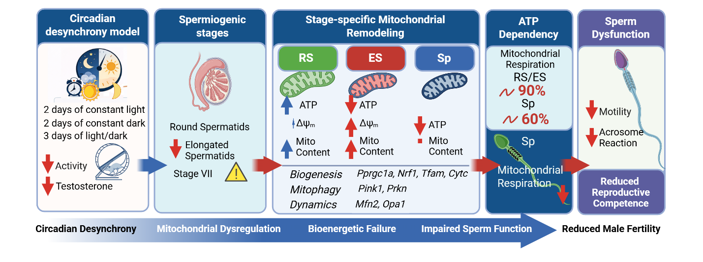
Graphical abstract. Circadian desynchrony disrupts mitochondrial bioenergetics, dynamics, and quality control in a stage-specific manner during spermiogenesis. This leads to a transition from compensatory mitochondrial activation in round spermatids to energetic insufficiency in elongated spermatids and metabolic reprogramming in spermatozoa, ultimately impairing sperm function and reducing male reproductive potential.
References
Pavlovicn M.V., Marinkovic, D.Z., Andric, S.A., Kostic, T.S. (2022). The cost of circadian desynchrony on Leydig cell function. Sci Rep,12, 15520. doi: 10.1038/s41598-022-19889-9.
Travicic, D.Z., Pavlovic, M.V., Medar, M.LJ., Becin, A., Cetnik ,M., Lalosevic, D., Andric, S.A., Kostic, T.S. (2023) Circadian desynchrony disturbs the function of rat spermatozoa. Eur J Cell Biol, 102, 151323. doi: 10.1016/j.ejcb.2023.151323.
Da Ros, M., Lehtiniemi, T., Olotu, O., Meikar, O., & Kotaja, N. (2019). Enrichment of Pachytene Spermatocytes and Spermatids from Mouse Testes Using Standard Laboratory Equipment. Journal of Visualized Experiments, 151, e60271. https://doi.org/10.3791/60271
Bryant, J. M., Meyer-Ficca, M. L., Dang, V. M., Berger, S. L., & Meyer, R. G. (2013). Separation of spermatogenic cell types using STA-PUT velocity sedimentation. Journal of Visualized Experiments, 80, e50648. https://doi.org/10.3791/50648
Romrell, L. J., Bellvé, A. R., & Fawcett, D. W. (1976). Separation of mouse spermatogenic cells by sedimentation velocity: A morphological characterization. Developmental Biology, 49(1), 119–131. https://doi.org/10.1016/0012-1606(76)90262-1
Kavarthapu R, Dufau ML. Germ cell nuclear factor (GCNF/RTR) regulates transcription of gonadotropin-regulated testicular RNA helicase (GRTH/DDX25) in testicular germ cells: The androgen connection. Mol Endocrinol. 2015;29:1792-1804. doi:10.1210/me.2015-1198.
Dray, S., & Dufour, A.-B. (2007). The ade4 package: Implementing the duality diagram for ecologists. Journal of Statistical Software, 22(4), 1–20. https://doi.org/10.18637/jss.v022.i04
Dinno, A. (2018). paran: Horn's Test of Principal Components/Factors (R package, Version 1.5.2). https://CRAN.R-project.org/package=paran
Kassambara, A., & Mundt, F. (2020). factoextra: Extract and Visualize the Results of Multivariate Data Analyses (R package, Version 1.0.7). https://CRAN.R-project.org/package=factoextra

