Supplementary Material

Ancient genomics reveals lost giant chaffinch ecomorphs in the Azores

Juan Carlos Illera^{1,*}, B. Karina Montero^{1,2,3}, Juan Carlos Rando⁴, Josep Antoni Alcover⁵, Carles Lalueza-Fox^{6,7}, Martin Irestedt^{8,9}, Carmen N. Hernández-Flores¹⁰, Erik Sandertun¹¹, Bezawit Tesfa¹¹, Jens Hering¹², Mark Ravinet¹¹ & Pere Bover^{13,14*}

¹Biodiversity Research Institute (CSIC-Oviedo University-Principality of Asturias), University of Oviedo, Campus of Mieres, E-33006 Mieres, Asturias, Spain.
E-mail: jcillera@csic.es
https://orcid.org/0000-0002-4389-0264

²Centre de Synthèse et d’Analyse sur la Biodiversité, Fondation pour la Recherche sur la Biodiversité, Montpellier 34000, France.

³Center for Evolutionary and Functional Ecology (CEFE), Centre National de la Recherche Scientifique (CNRS), Montpellier 34000, France.

⁴Departamento de Biología Animal, Universidad de La Laguna (ULL), E-38206 La Laguna, Tenerife, Canary Islands, Spain.

⁵Institut Mediterrani d'Estudis Avançats (CSIC-UIB, Center of Excellence María de Maeztu), Ctra. Valldemossa km 7.5, 07122 Palma, Balearic Islands, Spain.

⁶ Institute of Evolutionary Biology (UPF-CSIC), PRBB, Barcelona, Spain.

⁷ Natural Sciences Museum of Barcelona, Barcelona, Spain.

⁸Department of Bioinformatics and Genetics, Swedish Museum of Natural History, Stockholm, Sweden.

⁹Department of Zoology, Stockholm University, Stockholm, Sweden.

¹⁰Department of Mathematics, University of Las Palmas de Gran Canaria, 35018 Las Palmas de Gran Canaria, Spain.

¹¹Centre for Ecological and Evolutionary Synthesis, Department of Biosciences, University of Oslo, Oslo 0316, Norway.

¹²German Ornithological Society, Limbach-Oberfrohna, Germany.

¹³Fundación Agencia Aragonesa para la Investigación y el Desarrollo (ARAID), Zaragoza 50018, Spain.

¹⁴Instituto Universitario de Investigación en Ciencias Ambientales de Aragón (IUCA)-Grupo Aragosaurus, Universidad de Zaragoza, Zaragoza 50009, Spain.

* Authors for correspondence: Juan Carlos Illera (jcillera@csic.es) & Pere Bover (pbover@unizar.es)
Material and Methods

2.3.1. Ancient DNA extraction

All ancient DNA laboratory tasks, including sample preparation, DNA extraction, and library construction, were carried out in the IUCA and IBE paleogenomic laboratories. All bones were lightly wiped with 0.5% bleach, washed in 2 ml of ultrapure water for 10 minutes, and then in 2 ml of 80% ethanol for another 10 minutes. After air-drying, the bones were UV-irradiated on each side for 15 minutes and then mechanically pulverized in a 2 ml screw-cap tube using sterile tweezers. The final amount of bone powder for each sample is listed in S-Table 1.
Bone powder was initially pre-digested at room temperature under constant rotation for one hour in 1 ml of 0.5 M EDTA (pH 8.0). The samples were then digested using approximately 1 ml of digestion buffer (900 μl of 0.5 M EDTA, pH 8.0, plus 20 μl of Proteinase K at 20 mg/ml) for 20–24 hours at 55°C. DNA was extracted from the bone powder following the silica suspension method described by Brotherton et al. (2013), using 13 ml of a modified PB buffer (Qiagen) [13.6 ml PB buffer, 420 μl of 3 M sodium acetate, and 7 μl of Tween-20 (Bover et al. 2019), based on Dabney et al. (2013)] and 100 μl of silica suspension. The extraction was followed by three washes: the first with 1 ml of the remaining binding buffer, and the subsequent two with 80% ethanol. Final elution was performed in 100 μl of TLE buffer.
Double-stranded libraries (DSLs) were constructed following the protocol of Meyer and Kircher (2010), with modifications from Llamas et al. (2016), specifically, the addition of internal 7-bp barcodes on both ends of the molecules and the use of a partial uracil-DNA glycosylase (UDG) repair treatment (Rohland et al. 2015). After a round of amplification using Platinum Taq HiFi DNA polymerase (Invitrogen), the libraries were purified and quantified. Three samples from Graciosa (227, 228 and 229) and three from Pico (232, 233 and 234) did not furnish results in the library amplification step being consequently discarded for further analysis. Pooled libraries were sequenced on Illumina HiSeq X or NovaSeq X (flow cell 10B) platforms (paired-end, 2 × 150 bp).
The quality of the raw sequencing data was assessed using FastQC v0.11.2 (http://www.bioinformatics.babraham.ac.uk/projects/fastqc). Sequencing reads (read 1 and read 2) for each sample were obtained after demultiplexing with Sabre v1.0 (https://github.com/najoshi/sabre), based on the internal barcode sequences. Adapter sequences were then trimmed using AdapterRemoval v2.3.0 (Schubert et al. 2016), applying parameters commonly used in ancient DNA data filtering: mismatch rate of 0.1, minimum Phred quality of 4, quality base of 33, trimming of ambiguous bases (N), trimming of bases with quality scores equal to or below the minimum threshold, and collapsing (merging) of paired reads overlapping by at least 11 bp. The number of collapsed reads per sample is reported in S-Table 1.
2.3.2 Modern DNA
Individual F112 from Faial (Azores) carried an unexpected mitochondrial genome that was nearly identical to European mitogenomes. In contrast, its nuclear genome grouped unambiguously with Azorean chaffinches (Fringilla moreletti), revealing marked mitonuclear discordance. To validate this result, DNA was re-extracted from the same sample and the genome re-sequenced at 35× coverage using a NovaSeq X Plus Series platform (PE150). Reads were processed using the same pipeline described in the main text, and the mitochondrial genome was reconstructed following the same procedure applied to all modern samples.
The reanalysis recovered the same mitochondrial sequence, differing only in the resolution of a few indels, thereby confirming the authenticity of this unexpected mitogenome.
2.5.1. Genetic diversity and phylogenetic inference
2.5.2. Nuclear analyses
2.5.2.1. Gene flow
To assess evidence of gene flow among Fringilla lineages we calculated Patterson’s D statistics (ABBA-BABA tests) (Green et al., 2010; Durand et al., 2011) implemented in Dsuite v0.5 (Malinsky et al., 2021) using “Dsuite Dtrios” function. D sratistics estimates the presence of excess of derived allele sharing among a given 4 taxon topology; (((P1,P2),P3),Outgroup) where P3 shares excess derived alleles with P2 more than expected under incomplete lineage sorting alone. A significantly non zero D value is taken as evidence that gene flow has taken place. We calculated D statistics on the whole genome nuclear SNP datasets comprising of 213 individuals assigned to 13 populations. We tested all possible trios that fit the relationship ((P1,P2),P3) in our nuclear phylogeny (Fig. 6) among the 13 Fringilla populations with F. montifrigilla fixed as the outgroup. This finally resulted in a total of 286 combinations (S2, Table 2). Statistical significance was assessed using block jackknife Z-scores using the default setting of 20 jackknife blocks, where signals with Z>3 considered as significant. For each test, the corresponding f₄ ratio was also calculated, as a related statistics that provides estimates of the proportion of excess alleles shared between P2 and P3 (Reich et al., 2009). Because a single gene flow event in an ancestral lineage can lead to multiple significant D and f₄ ratio values among descendant taxa, individual tests are not always straightforward to interpret in isolation, especially when there are large numbers of tests performed (Malinsky et al., 2018). This is owning to the non-independence of tests among taxa that share branches on a tree where shared ancestry can produce correlated signals across multiple tests (Martin et., 2013). Thus, to address the large number of tests and presence of multiple correlated signals we calculated f-branch statistic (Malinsky et al., 2018) implemented in Dsuite using “Dsuite fbranch” function. f-branch utilizes a given phylogenetic tree to summarize the correlated f₄ signals and estimates a branch specific excess allele sharing signal. This helps to identify whether internal or terminal branches are most likely involved in introgression allowing for a relative timing of gene flow to be inferred (Malinsky et al.2018, 2021). We used the maximum likelihood nuclear tree (Fig. 5) as the input phylogeny combined with our f₄ results (S-Table 2) to calculate f-branch. The resulting matrix was then visualized as heatmap (Fig. 6)

References
Bover, P., Llamas, B., Mitchell, K.J., Thomson, V.A., Alcover, J.A., Lalueza-Fox, C., Cooper, A., and Pons, J. (2019). Unraveling the phylogenetic relationships of the extinct bovid Myotragus balearicus Bate 1909 from the Balearic Islands. Quaternary Science Reviews, 215:185–195.
Brotherton, P., Haak, W., Templeton, J., Brandt, G., Soubrier, J., Adler, C.J., Richards, S.M., Der Sarkissian, C., Ganslmeier, R., Friederich, S., Dresely, V., van Oven, M., Kenyon, R., Van der Hoek, M.B., Korlach, J., Luong, K., Ho, S.Y.W., Quintana-Murci, L., Behar, D.M., Meller, H., Alt, K.W., Cooper, A., and The Genographic Consortium. (2013). Neolithic mitochondrial haplogroup H genomes and the genetic origin of Europeans. Nature Communications, 4:1764.
Dabney, J., Knapp, M., Glocke, I., Gansauge, M.T., Weihmann, A., Nickel, B., Valdiosera, C., García, N., Pääbo, S., Arsuaga, J.L., and Meyer, M. (2013). Complete mitochondrial genome sequence of a Middle Pleistocene cave bear reconstructed from ultrashort DNA fragments. Proceedings of the National Academy of Science U.S.A., 110:15758e15763.
Durand, E. Y., Patterson, N., Reich, D. & Slatkin, M. (2011). Testing for ancient admixture between closely related populations. Molecular Biology and Evolution, 28: 2239-2252.
Green, R. E. et al., (2010). A Draft Sequence of the Neandertal Genome. Science, 328: 710-722.
Llamas, B., Fehren-Schmitz, L., Valverde, G., Soubrier, J., et al. (2016). Ancient mitocondrial DNA provides high-resolution time scale of the peopling of the Americas. Science Advances, 2: e1501385.
Malinsky, M., Matschiner, M. & Svardal, H. (2021). Dsuite — fast D-statistics and related admixture evidence from VCF files. Molecular Ecology Resources, 21: 584–595.
Malinsky, M., Svardal, H., Tyers, A. M., Miska, E. A., Genner, M. J., Turner, G. F., & Durbin, R. (2018). Whole genome sequences of Malawi cichlids reveal multiple radiations interconnected by gene flow. Nature Ecology & Evolution, 2: 1940–1955.
Martin, S. H., Dasmahapatra, K. K., Nadeau, N. J., Salazar, C., Walters, J. R., Simpson, F., Blaxter, M., Manica, A., Mallet, J., & Jiggins, C. D. (2013). Genome-wide evidence for speciation with gene flow in Heliconius butterflies. Genome research, 23(11): 1817–1828.
Meyer, M. & Kircher, M. (2010). Illumina sequencing library preparation for highly multiplexed target capture and sequencing. Cold Spring Harbor Protocols, 6:1–10.
Reich, D., Thangaraj, K., Patterson, N., Price, A. L. & Singh, L. (2009). Reconstructing Indian Population History. Nature, 461: 489–494.
Rohland, N., Harney, E., Mallick, S., Nordenfelt, S., and Reich, D. 2015. Partial uracil–DNA–glycosylase treatment for screening of ancient DNA. Philosophical Transactions of the Royal Society B Biological Sciences, 370:20130624.
Schubert, M., Lindgreen, S., and Orlando, L. 2016. AdapterRemoval v2: rapid adapter trimming, identification, and read merging. BMC Research Notes, 12:88.

S-Table 1. Metadata for extant and extinct Fringilla individuals included in this study.
S-Table 1 is available in https://doi.org/10.5281/zenodo.21834896
S-Table 2. Sheet 1 includes all morphological trait measurements of extant and extinct Fringilla individuals included in this study. Sheet 2 provides the calculated values for the ABBA-BABA topologies.
S-Table 2 is available in https://doi.org/10.5281/zenodo.21834896

S-Table 3. Mean values (± SE) for cranial and postcranial traits (mm). The sample size is shown in brackets. Variation (%): variation between extinct and extant individuals. Positive mean values (in black) represent differences between extinct (bigger) and extant (smaller) individuals, meanwhile negative mean values (in red) represent differences between extinct (smaller) and extant (bigger) individuals. N.a.: not applicable.
Morphological traits | Extinct Graciosa | Modern Graciosa | Variation (%) | Extinct Pico | Modern Pico | Variation (%)
1_Maxilla length | 18.69 ± 0.97 (2) | 15.27 ± 0.14 (5) | 22.40 | 17.51 ± 0.23 (5) | 15.35 ± 0.26 (6) | 14.10
2_Maxilla width | 8.53 ± 0.31 (2) | 7.15 ± 0.06 (5) | 19.30 | 7.55 ± 0.21 (5) | 7.16 ± 0.09 (6) | 5.50
3_Maxilla height | 7.43 ± 0.42 (2) | 5.18 ± 0.02 (5) | 43.40 | 5.77 ± 0.18 (4) | 5.49 ± 0.07 (6) | 5.00
4_Interorbital width | 5.60 ± 0.13 (2) | 4.62 ± 0.11 (5) | 21.20 | 4.60 ± 0.20 (6) | 4.50 ± 0.11 (6) | 2.30
5_Cranium width | 17.64 ± 0.21 (2) | 15.07 ± 0.14 (5) | 17.10 | 15.95 ± 0.25 (5) | 15.33 ± 0.08 (6) | 4.10
6_Cranium length | 37.50 ± 1.40 (2) | 31.79 ± 0.12 (5) | 18.00 | 36.53 ± 0.46 (4) | 32.26 ± 0.28 (6) | 13.20
7_Cranium height | 13.75 ± 0.17 (2) | 12.79 ± 0.11 (5) | 7.50 | 13.39 ± 0.47 (2) | 13.08 ± 0.14 (6) | 2.30
8_Mandibule length | 29.96 ± 0.67 (6) | 25.30 ± 0.10 (5) | 18.40 | 28.54 ± 0.44 (5) | 25.24 ± 0.32 (6) | 13.10
9_Symphysis length | 12.06 ± 0.35 (6) | 9.05 ± 0.12 (5) | 33.30 | 11.23 ± 0.24 (5) | 9.22 ± 0.21 (6) | 21.80
10_Mandible width | 17.88 ± 0.43 (6) | 14.59 ± 0.08 (5) | 22.60 | 16.38 ± 0.23 (5) | 14.86 ± 0.32 (6) | 10.20
11_Articular end width | 6.12 ± 0.12 (6) | 4.78 ± 0.01 (5) | 28.00 | 5.28 ± 0.14 (7) | 4.86 ± 0.19 (6) | 8.70
12_Mandible height | 7.07 ± 0.20 (6) | 4.82 ± 0.08 (5) | 46.60 | 5.83 ± 0.14 (7) | 4.83 ± 0.07 (6) | 20.70
13_Scapula length | N.a. | 20.30 ± 0.43 (3) | N.a. | 19.50 ± 0.34 (6) | 19.88 ± 0.14 (5) | -1.90
14_Coracoid length_1 | 17.64 ± 0.68 (4) | 17.47 ± 0.07 (5) | 1.00 | 17.56 ± 0.20 (7) | 17.06 ± 0.33 (5) | 2.90
15_Coracoid length_2 | 16.82 ± 0.68 (4) | 16.81 ± 0.07 (5) | 0.10 | 16.83 ± 0.18 (7) | 16.71 ± 0.16 (5) | 0.70
16_Humerus length | 19.56 ± 0.28 (10) | 19.45 ± 0.12 (5) | 0.60 | 19.17 ± 0.20 (9) | 19.19 ± 0.12 (6) | -0.10
17_Ulna length | 23.41 ± 0.29 (11) | 23.57 ± 0.22 (5) | -0.70 | 22.73 ± 0.45 (7) | 23.33 ± 0.23 (6) | -2.60
18_Carpometacarpus length | 11.46 (1) | 12.52 ± 0.18 (5) | -9.20 | 12.14 ± 0.17 (7) | 12.92 ± 0.16 (5) | -6.40
19_Femur length | 19.79 ± 0.19 (15) | 18.03 ± 0.19 (5) | 9.80 | 19.45 ± 0.32 (3) | 18.02 ± 0.14 (6) | 7.90
20_Tibiotarsus length | 34.11 ± 0.44 (10) | 31.32 ± 0.32 (4) | 8.90 | 34.35 ± 0.91 (3) | 31.53 ± 0.28 (6) | 8.90
21_Tarsometatarsus length | 24.36 ± 0.29 (9) | 21.52 ± 0.36 (4) | 13.20 | 24.14 ± 0.20 (7) | 21.66 ± 0.32 (6) | 11.50

S-Table 4. Genetic diversity statistics obtained from the whole mitochondrion. Sample sizes (N) and diversity estimates for the study populations and species of the common chaffinch species complex. Hap: number of haplotypes. Haplotype (HD) and nucleotide (𝜋) diversities are given with their standard deviations (SD). P: Pico. G: Graciosa. Theta 1: per sequence. Theta 2: per site

Species | Populations | N | Hap | HD | SD | 𝜋 | SD | Theta 1 | Theta 2 | Tajima's D | Fu's F | R2
Fringilla moreletti | Extinct (P & G) | 7 | 6 | 0.925 | 0.009 | 0.0025 | 0.0007 | 44.4898 | 0.00308 | -1.0904 | 2.3540 | 0.1846
Fringilla moreletti | Extant (P & G) | 22 | 16 | 0.974 | 0.019 | 0.0024 | 0.0003 | 25.5120 | 0.00166 | 1.7615 | 1.7570 | 0.1253
Fringilla moreletti | Azores | 89 | 42 | 0.941 | 0.014 | 0.0038 | 0.0010 | 151.9700 | 0.01188 | -2.3663 | 4.0660 | 0.0939
Fringilla maderensis | Madeira | 13 | 12 | 0.987 | 0.035 | 0.0012 | 0.0003 | 25.4580 | 0.00162 | -1.2894 | -1.6800 | 0.1484
Fringilla canariensis | Canary Islands | 55 | 42 | 0.987 | 0.007 | 0.0070 | 0.0003 | 53.1100 | 0.00554 | 0.9370 | -0.5010 | 0.1027
Fringilla coelebs | Europe | 14 | 14 | 1.000 | 0.027 | 0.0023 | 0.0001 | 31.4450 | 0.00357 | -1.5427 | -3.6600 | 0.1421
Fringilla spodiogenys | North Africa | 21 | 20 | 0.995 | 0.016 | 0.0142 | 0.0018 | 135.9190 | 0.00980 | 1.8515 | 1.0350 | 0.1268

S-Fig. 1. Cranial and postcranial skeletal elements of Fringilla specimens included in the morphometric analysis conducted in this study. (1) Maxilla length; (2) Maxilla width; (3) Maxilla height; (4) Interorbital width; (5) Cranium width; (6) Cranium length; (7) Cranium height; (8) Mandible length; (9) Symphysis length; (10) Mandible width; (11) Articular end width; (12) Mandible height; (13) Scapula length; (14) Coracoid length; (15) Humerus length; (16) Ulna length; (17) Carpometacarpus length; (18) Femur length; (19) Tibiotarsus length; (20) Tarsus metatarsus length.

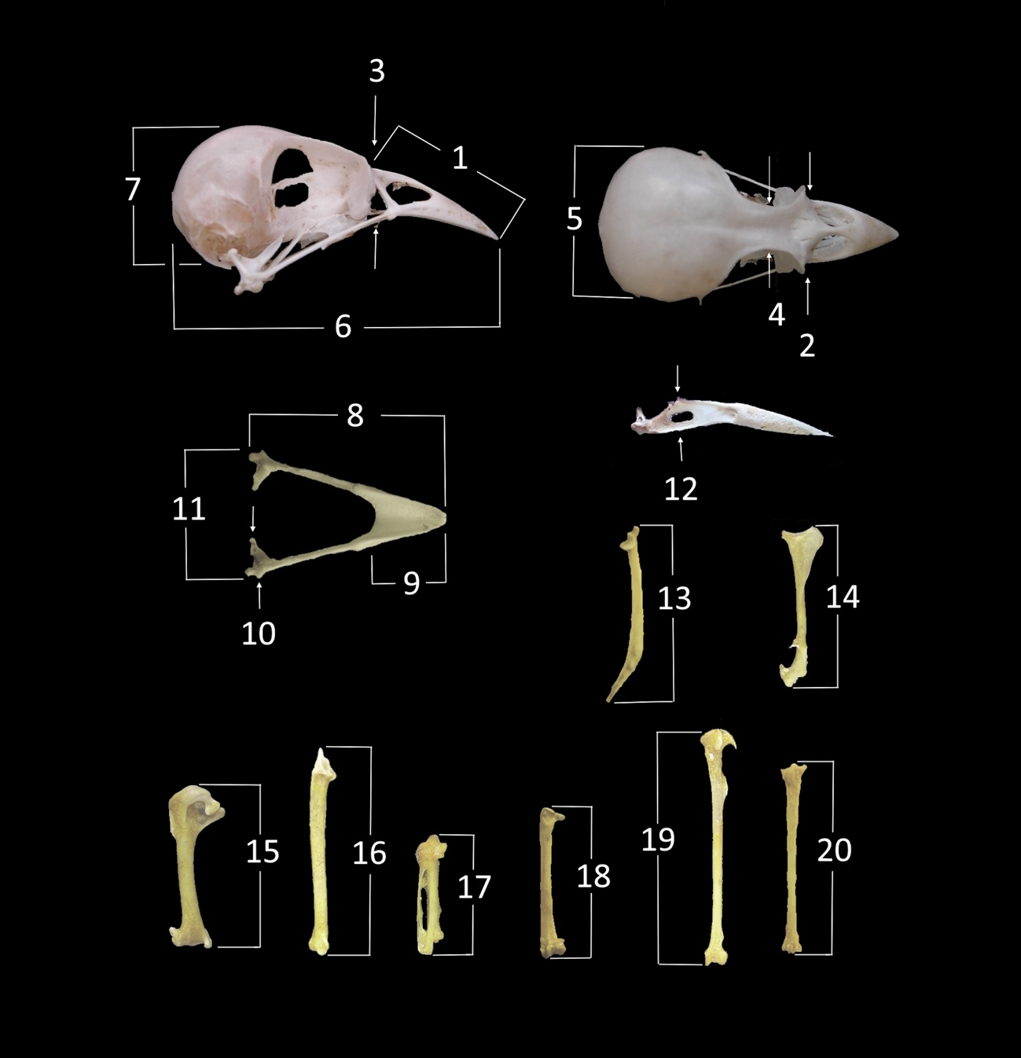

Supplementary Fig. 2. Empirical support based on the difference in BIC relative to the best model for normal mixture models on the mandible dataset assuming 1–9 distinct morphological groups.

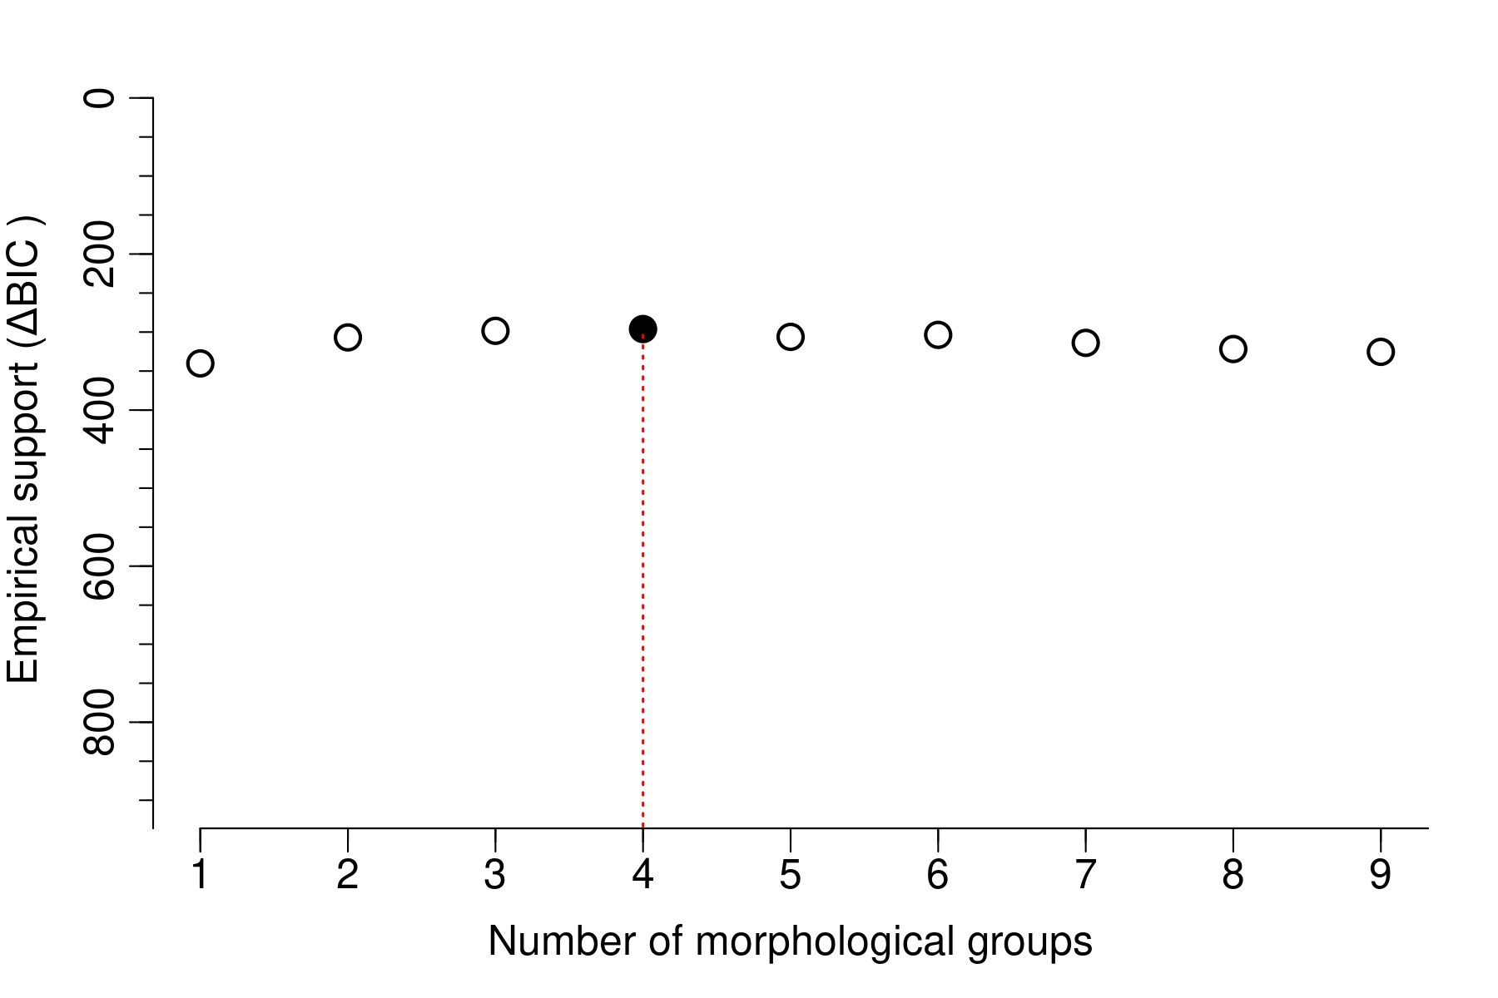

Supplementary Fig. 3. Empirical support based on the difference in BIC relative to the best model for normal mixture models on the skull dataset assuming 1–9 distinct morphological groups.

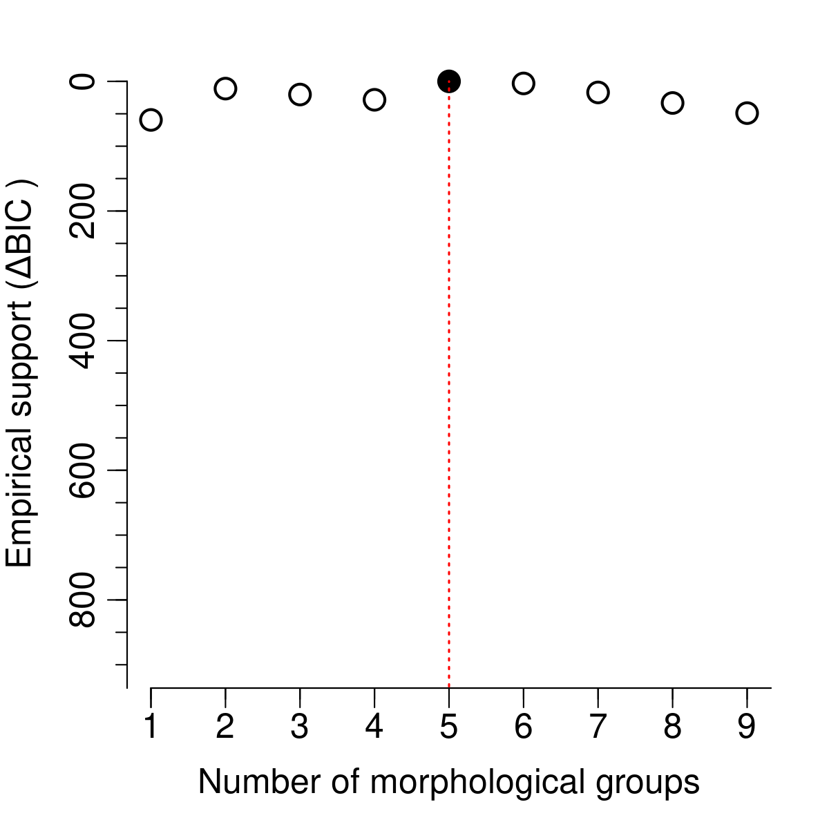

Supplementary Fig. 4. MapDamage report of the BWA mapping of Azorean extinct chaffinches to the mitochondrial genome reference. Only damage patterns for those samples furnishing > 500 unique reads mapped are depicted. The top four panels of each sample show the frequency of purines and pyrimidines just before and after the reads, respectively. The mid two panels show accumulation of 5’ C-to-T (red) and 3’ G-to-A (blue) misincorporations. The bottom panels show the fragment size distribution of mapped reads. The patterns displayed agree with those typically observed for ancient samples using Double-Stranded Libraries (partial uracile-DNA-glycosylase treated, samples 224A, 226A, 230A, 231A, 235A, 236A and 455A), and Single-Stranded libraries (samples F1IG and F3IG).

Supplementary Fig. 5. Bayesian (MrBayes) and Maximum Likelihood (IQ-TREE) phylogenetic inferences based on whole mitochondrial genomes from modern and fossil (red) Fringilla. All major nodes (•) received maximal support in both Bayesian and Maximum Likelihood (ML) analyses, except for the Macaronesian nodes (node A and B), which received 99% ML bootstrap support. The mitochondrial genome of one Azorean chaffinch (F112, purple) grouped within the European common chaffinch clade, although its nuclear genome clustered with the Azorean lineage (see S-Fig. 6). EH: El Hierro. LP: La Palma. LG: La Gomera. TF: Tenerife. GC: Gran Canaria.
