Supplemental Files
Supplemental Figures 3
Figure S1. The definition of perimenopause 3
Figure S2. Directed acyclic graph (DAG) of the association between BMI with T2DM 3
Figure S3. Multiple Imputation Convergence Plot (n=1325) 4
Figure S4. Proportional Hazards Assumption (continuous BMI, n=1325) 5
Figure S5. Restricted cubic spline curves for association between continuous BMI and T2DM (n=1325) 7
Figure S6. Proportional Hazards Assumption (categorical BMI, n=1325) 8
Figure S7. Kaplan–Meier survival analyses of categorical BMI and T2DM (n=1325) 10
Figure S8. Kaplan–Meier survival analyses of binary BMI and T2DM (n=1325) 10
Figure S9. Proportional Hazards Assumption (binary BMI, Model 4, n=1325) 11
Figure S10. Cox association between binary BMI and T2DM (binary BMI, n=1325) 11
Figure S11. Proportional Hazards Assumption (BMI change patterns, n=579) 12
Figure S12. Proportional Hazards Assumption (Relative BMI Change, n=579) 14
Figure S13. Cox association between relative BMI Change and the risk of T2DM (n=579) 16
Figure S14. Proportional Hazards Assumption(continuous BMI, underweight individuals excluded, n=1290) 17
Figure S15. Restricted cubic spline curves for association between BMI and T2DM (Underweight individuals excluded, n=1290) 19
Figure S16. Cox association between continuous BMI and T2DM (Underweight individuals excluded, n=1290) 19
Figure S17. Kaplan–Meier survival analyses of categorical BMI and T2DM (Underweight individuals excluded, n=1290) 20
Figure S18. Proportional Hazards Assumption(BMI change patterns, Underweight individuals excluded, n=552) 20
Figure S19. Cox association between relative BMI Change and the risk of T2DM (Underweight individuals excluded, n=552) 23
Figure S20. Restricted cubic spline curves for association between BMI and T2DM (Physical activity excluded, n=1325) 24
Figure S21. Cox association between continuous BMI and T2DM (Physical activity excluded, n=1325) 24
Figure S22. Cox association between relative BMI Change and the risk of T2DM (Physical activity excluded, n=579) 25
Supplemental Tables 26
Table S1. Missing Values and Proportions for Variables in baseline BMI (n=1325) 26
Table S2. Comparison of Accelerated Failure Time (AFT) models under alternative parametric distributional assumptions 26
Table S3. Missing Values and Proportions for Variables in the BMI change pattern subsample (n=579) 27
Table S4. Accelerated failure time model for time to T2DM (Log-normal distribution, underweight individuals excluded, n=1290) 27
Table S5. Accelerated failure time model for time to T2DM (Log-normal distribution, Physical activity excluded, n=1325) 28

Supplemental Figures
Figure S1. The definition of perimenopause
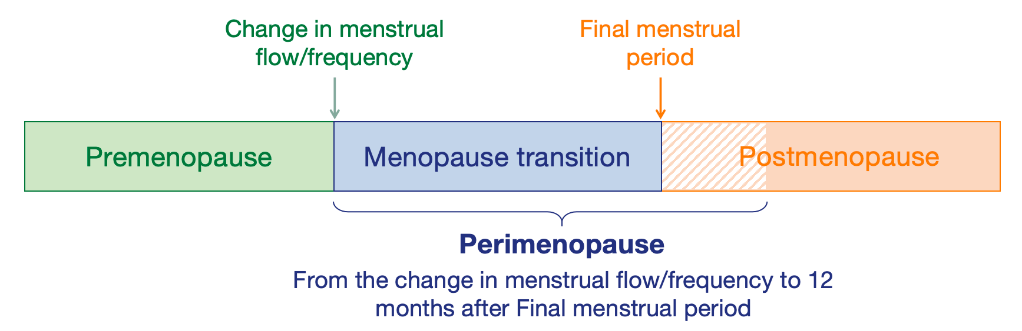

Figure S2. Directed acyclic graph (DAG) of the association between BMI with T2DM
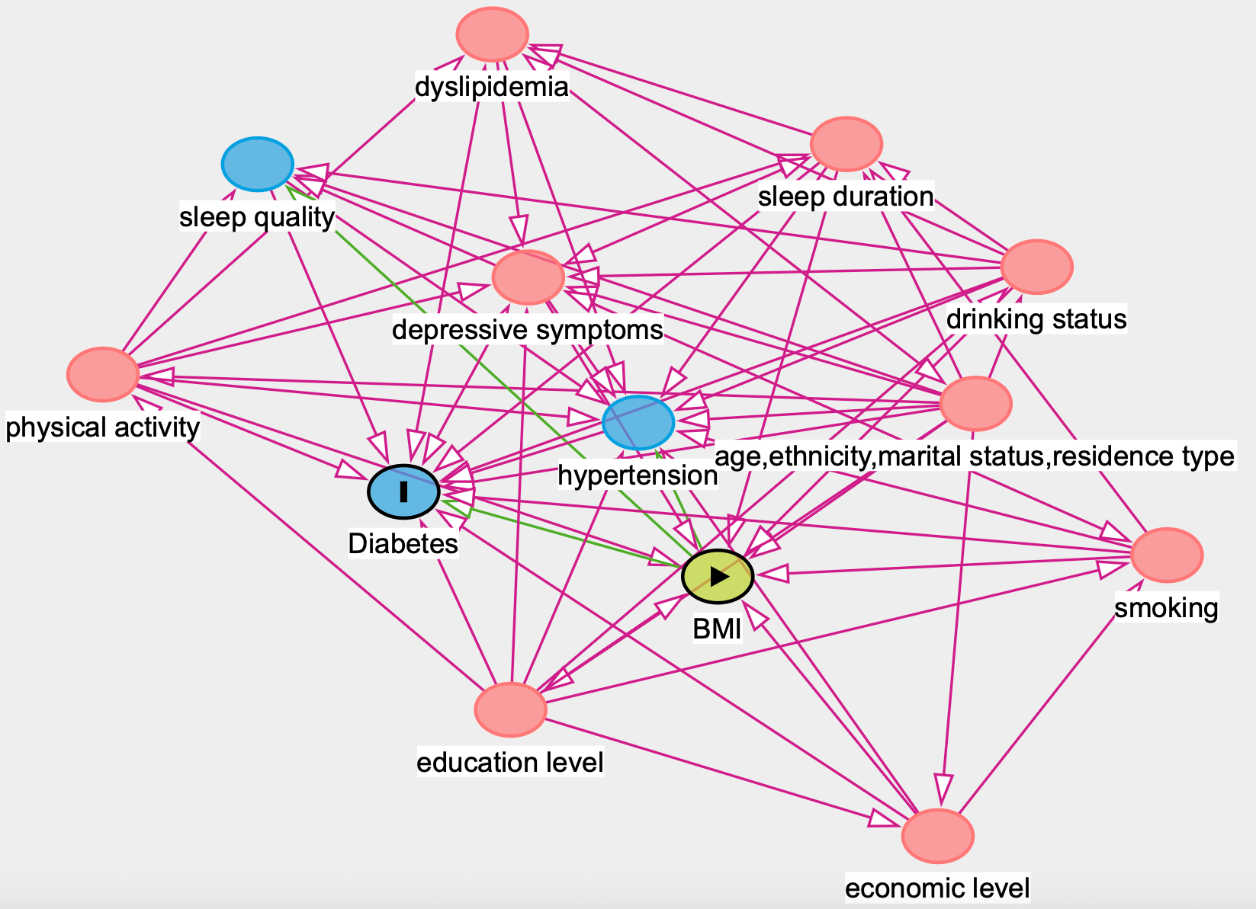
Notes. The variable in green and with the “►” symbol inside the rectangle was the exposure variable; the in blue and with the letter “I” inside the rectangle was the outcome variables; variables in blue are the antecedents of the outcome variable; and those in red are antecedents of the outcome and exposure variable, with dyslipidemia serving as the mediator.

Figure S3. Multiple Imputation Convergence Plot (n=1325)
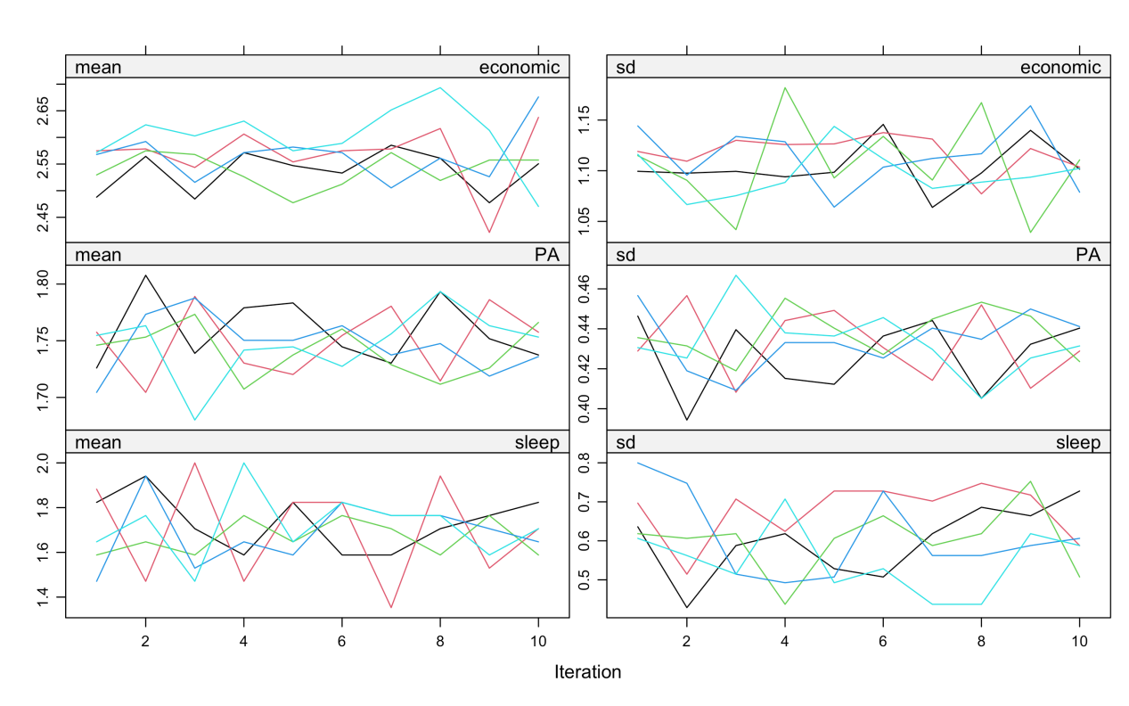
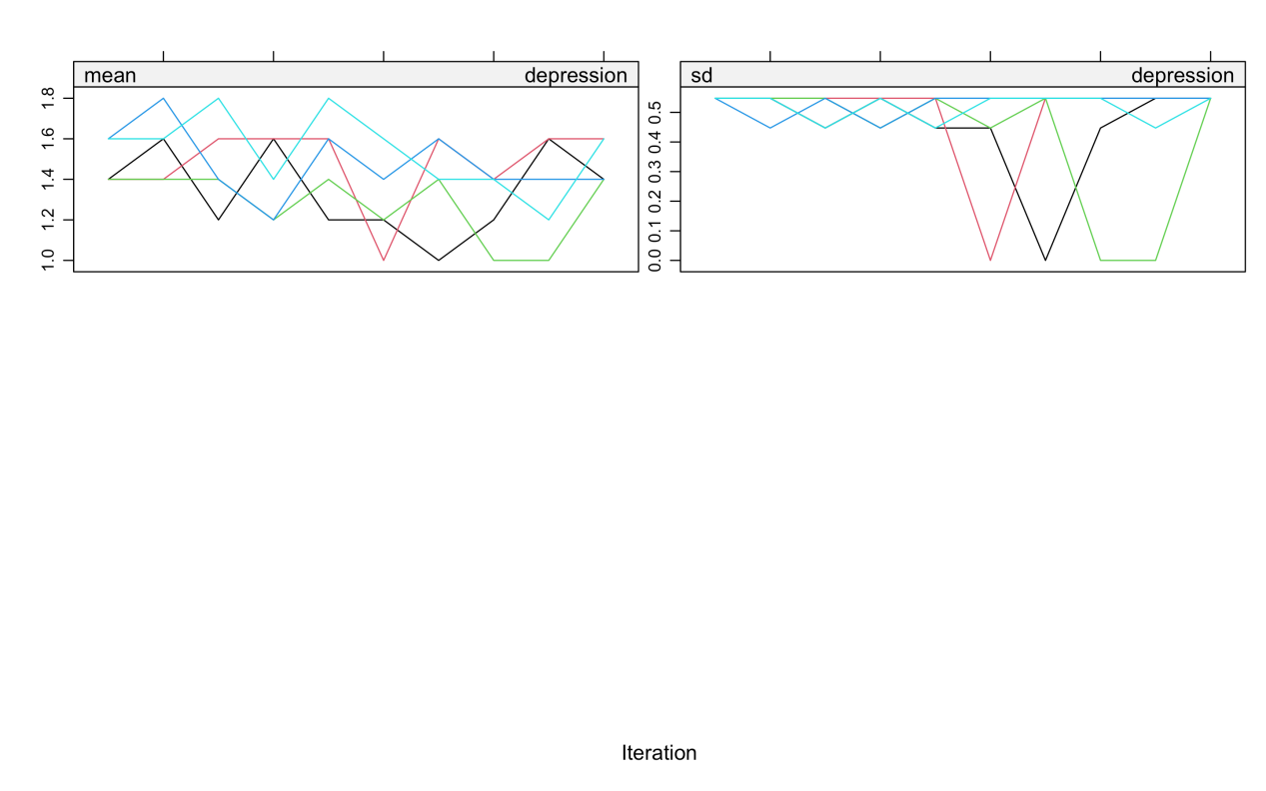

Figure S4. Proportional Hazards Assumption (continuous BMI, n=1325)
Model 1
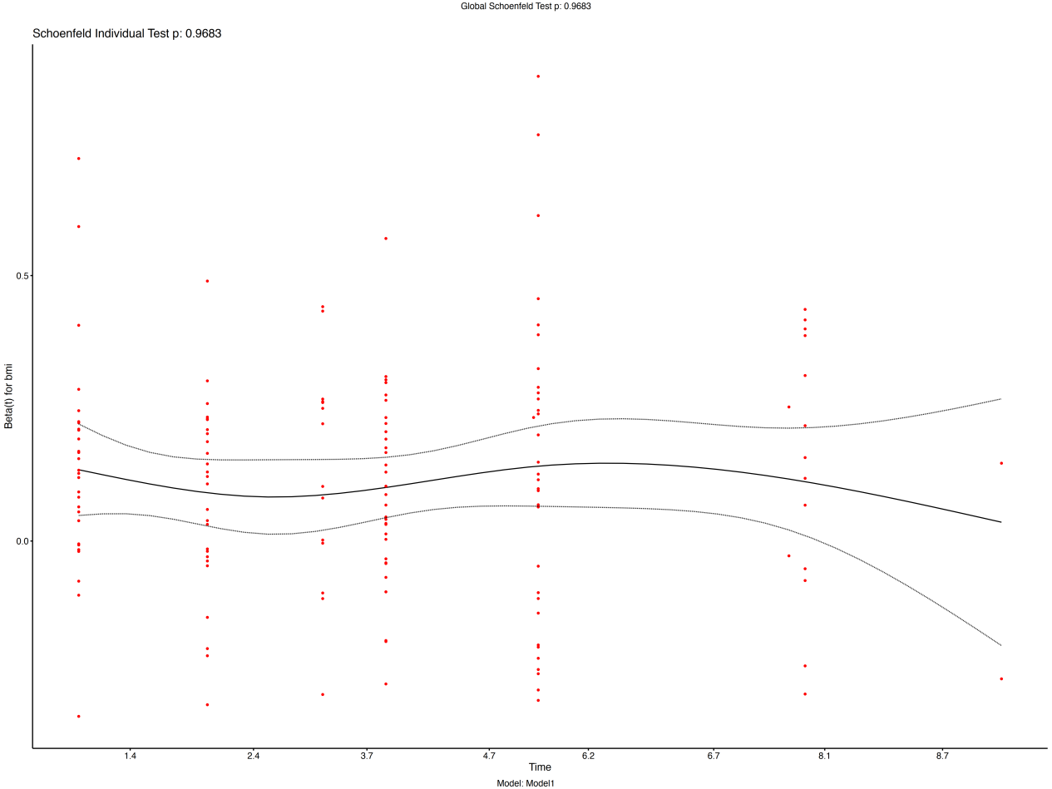
Model 2
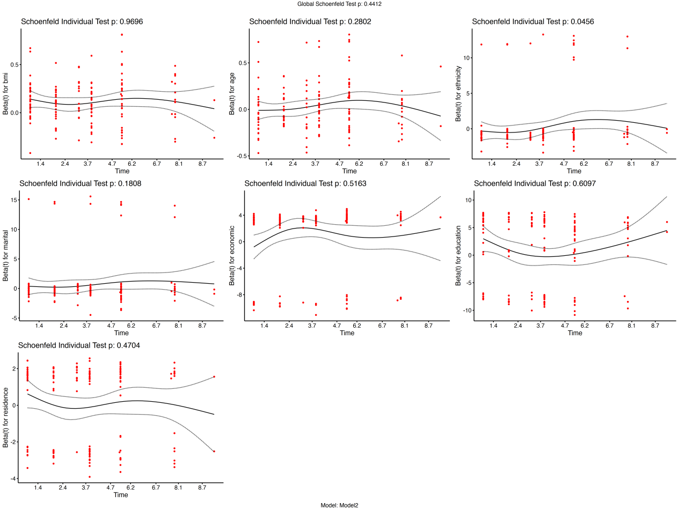
Model 3
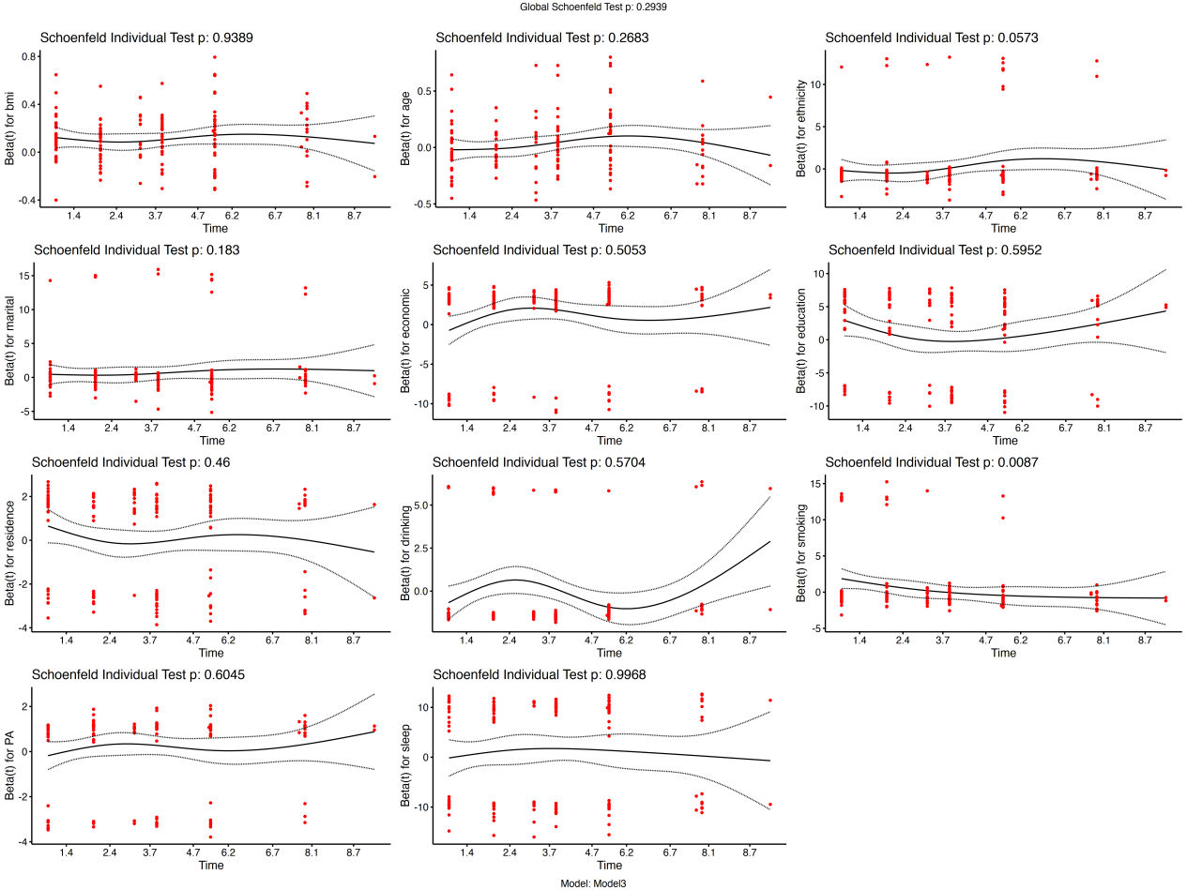

Model 4
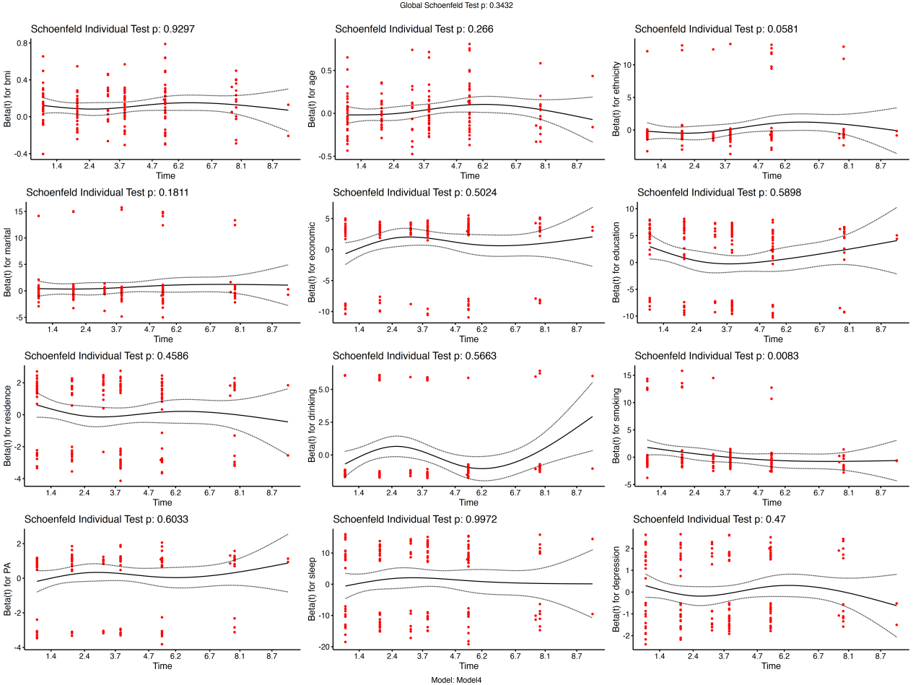
Figure S5. Restricted cubic spline curves for association between continuous BMI and T2DM (n=1325)
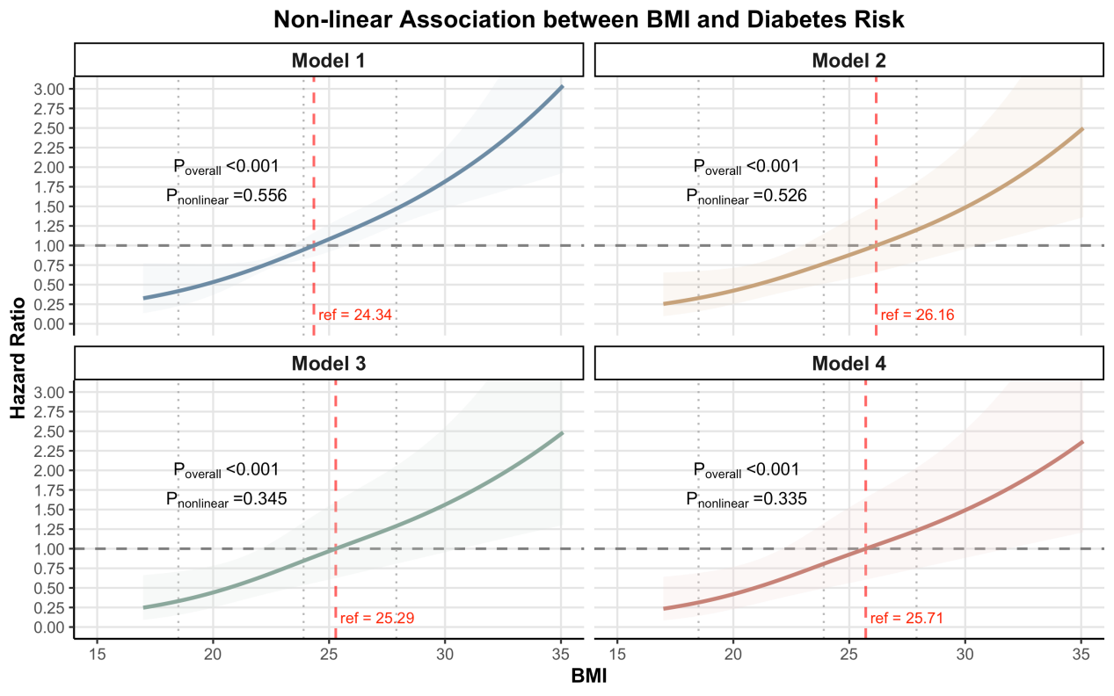
Notes. Model 1 represented the crude model without adjustment for any variables. Model 2 adjusted sociodemographic factors, including age, ethnicity, economic level, education level, marital status, and residence type. Model 3 further adjusted for behavioral and lifestyle factors—specifically smoking status, drinking status, physical activity and sleep duration. Model 4 further incorporated depressive symptoms.

Figure S6. Proportional Hazards Assumption (categorical BMI, n=1325)
Model 1
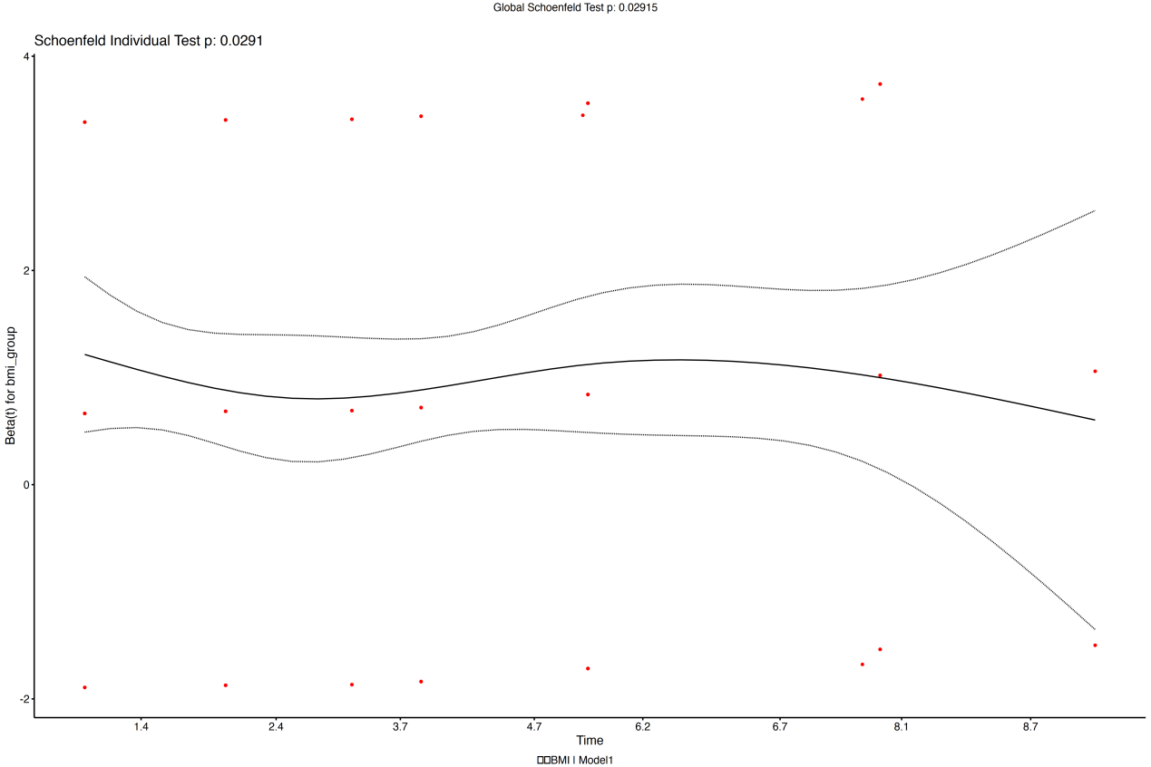

Model 2
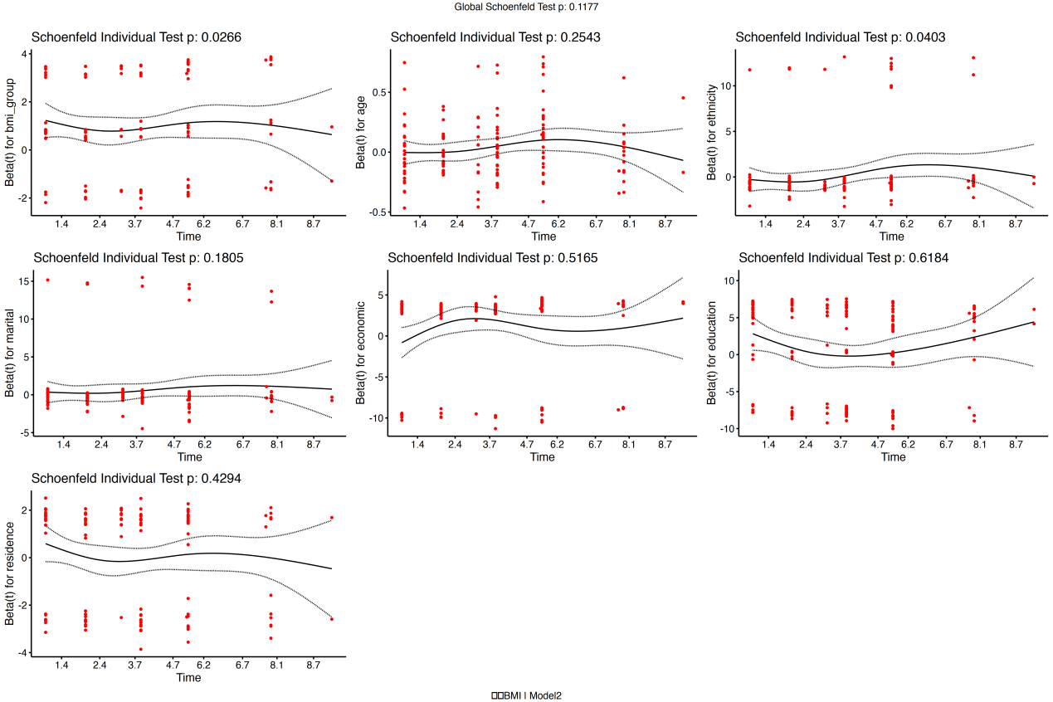

Model 3
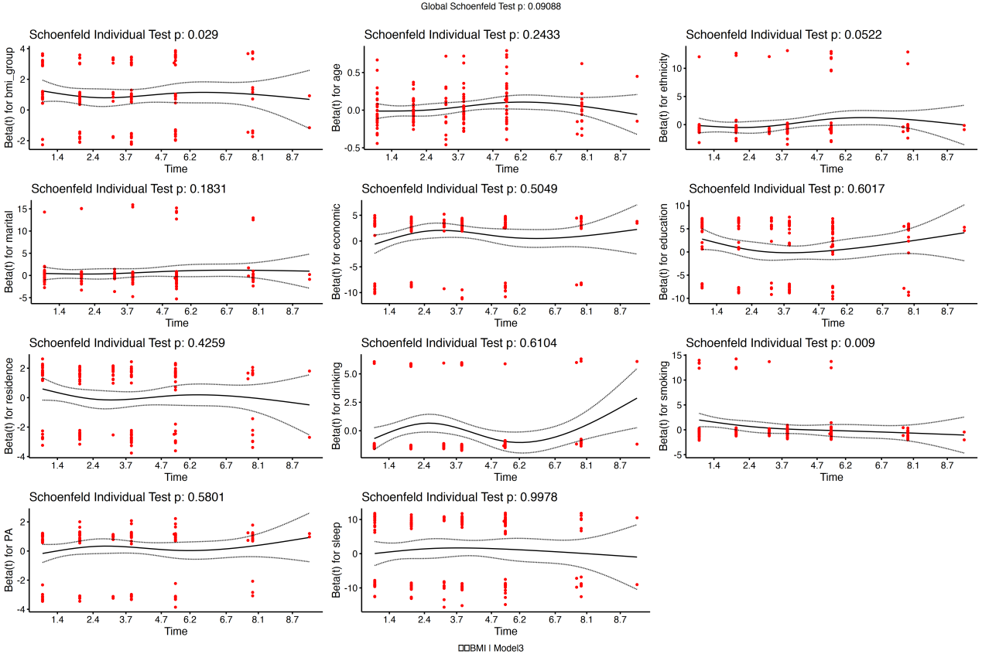

Model 4
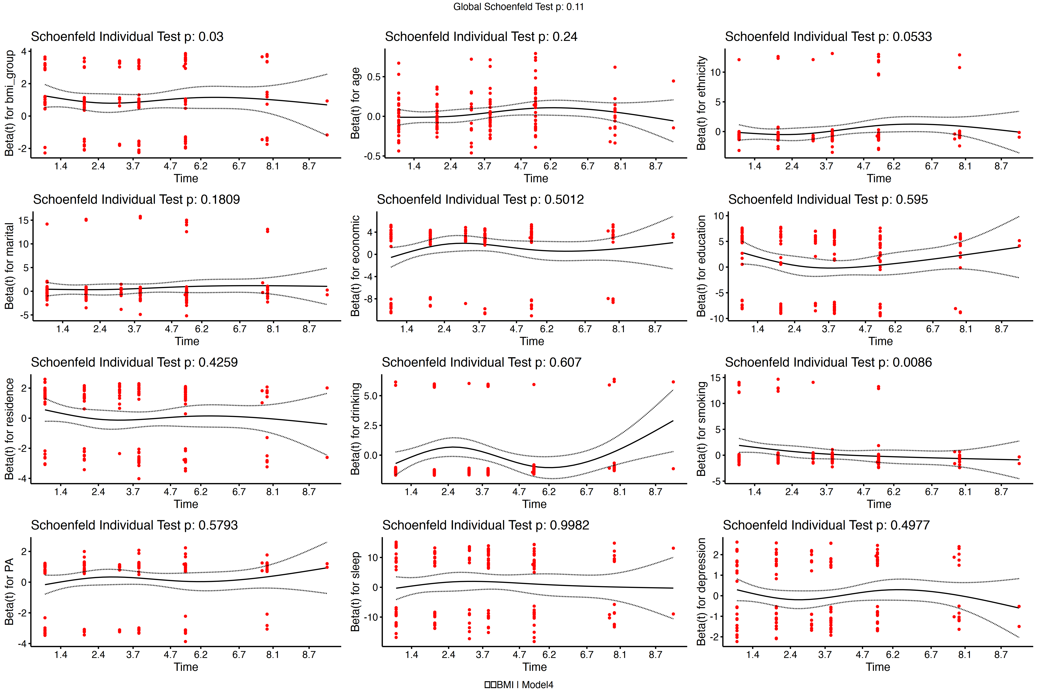

Figure S7. Kaplan–Meier survival analyses of categorical BMI and T2DM (n=1325)
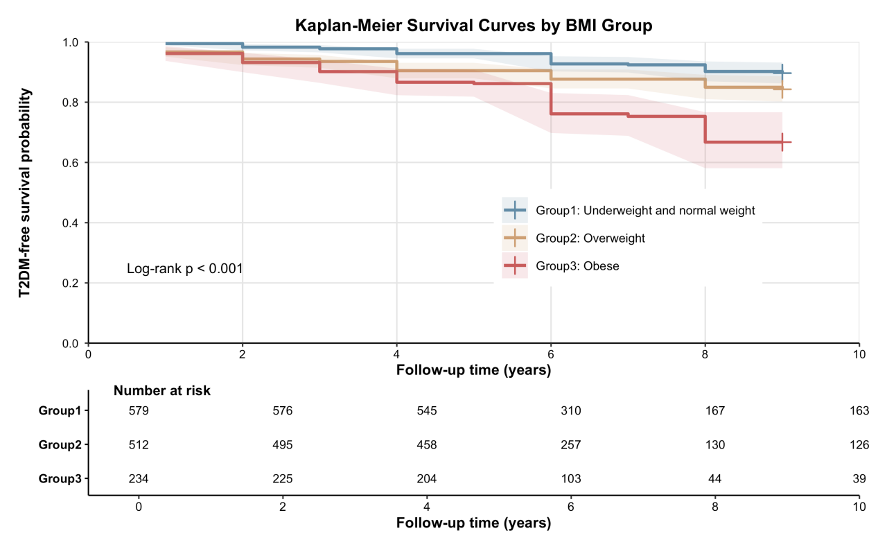

Figure S8. Kaplan–Meier survival analyses of binary BMI and T2DM (n=1325)
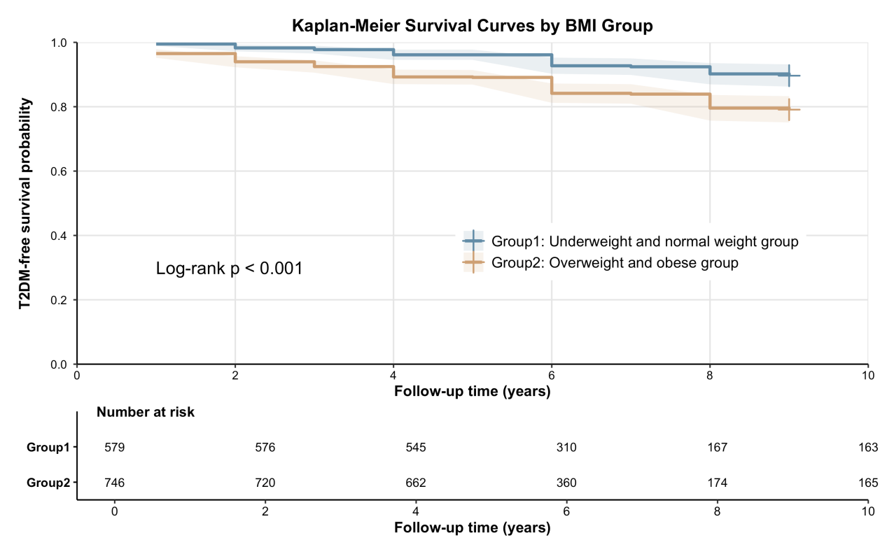

Figure S9. Proportional Hazards Assumption (binary BMI, Model 4, n=1325)

Figure S10. Cox association between binary BMI and T2DM (binary BMI, n=1325)
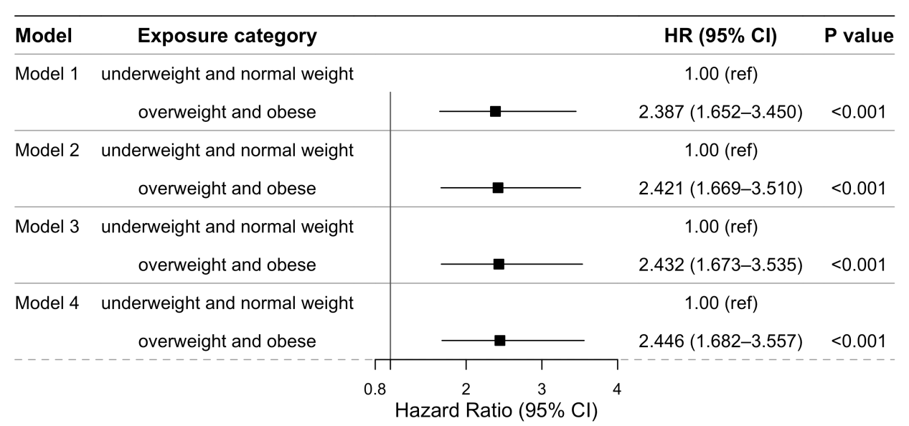
Notes. Model 1 represented the crude model without adjustment for any variables. Model 2 adjusted sociodemographic factors, including age, ethnicity, economic level, education level, marital status, and residence type. Model 3 further adjusted for behavioral and lifestyle factors—specifically smoking status, drinking status, physical activity and sleep duration. Model 4 further incorporated depressive symptoms.

Figure S11. Proportional Hazards Assumption (BMI change patterns, n=579)
Model 1
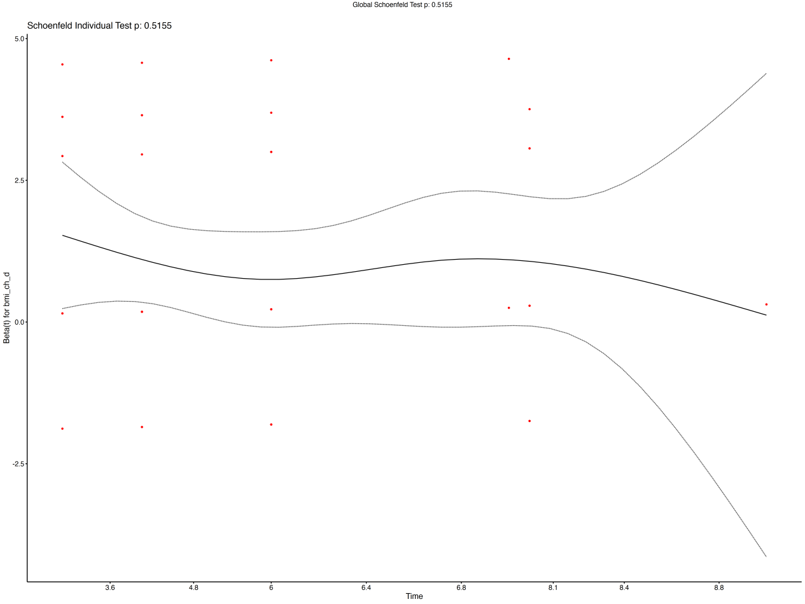

Model 2
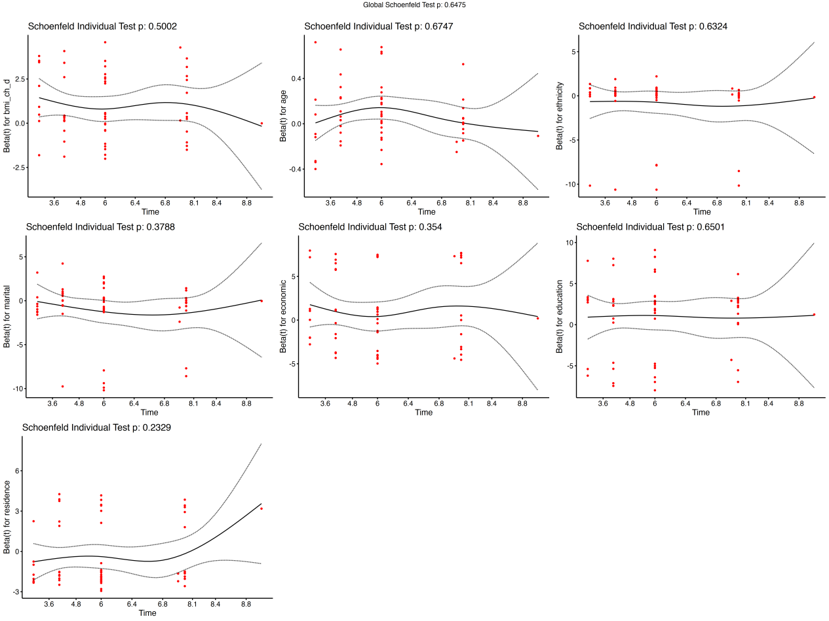
Model 3
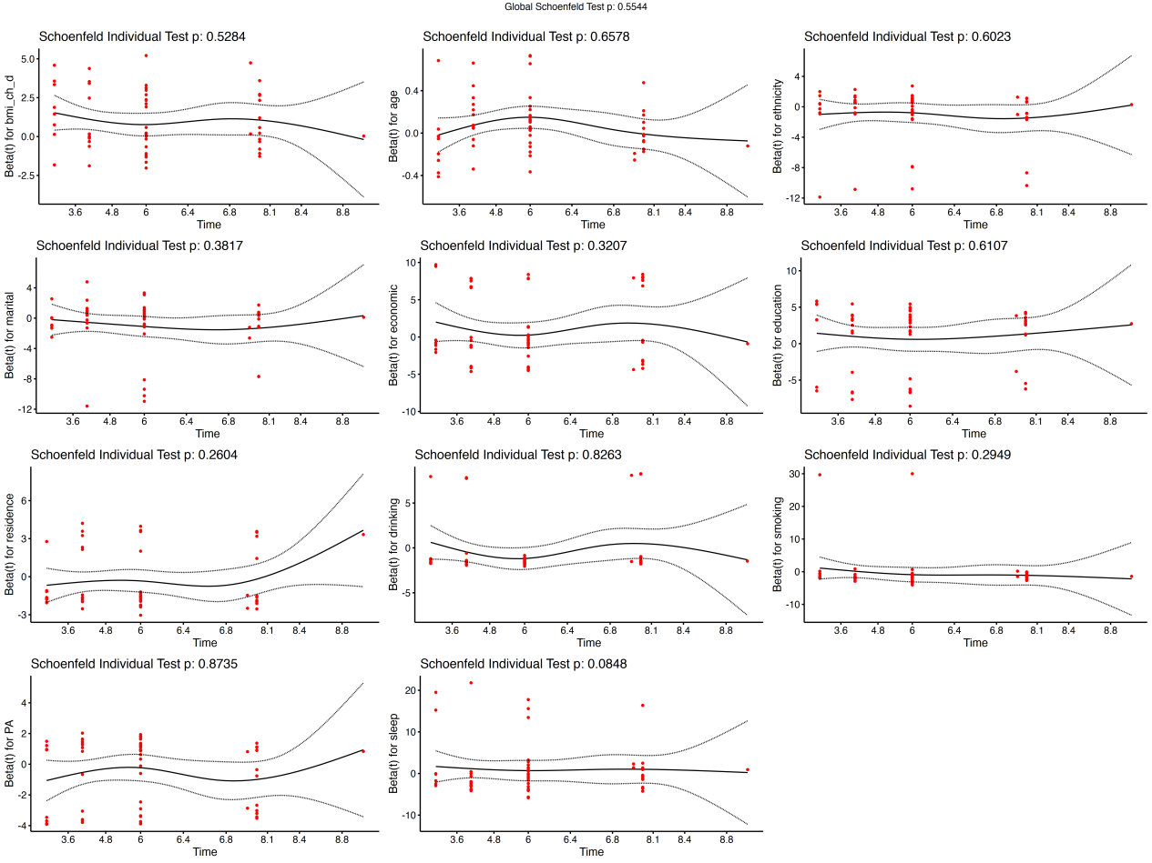

Model 4
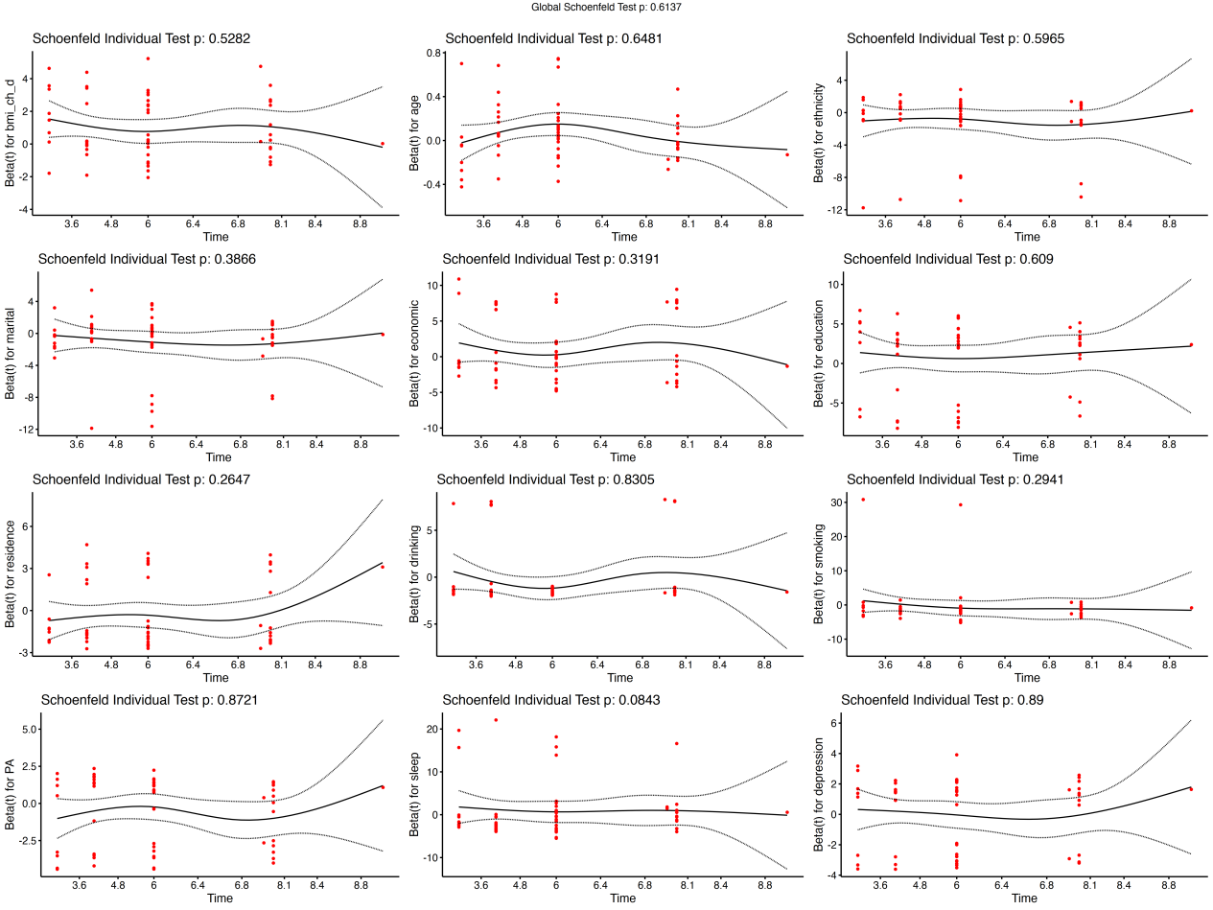

Figure S12. Proportional Hazards Assumption (Relative BMI Change, n=579)
Model 1
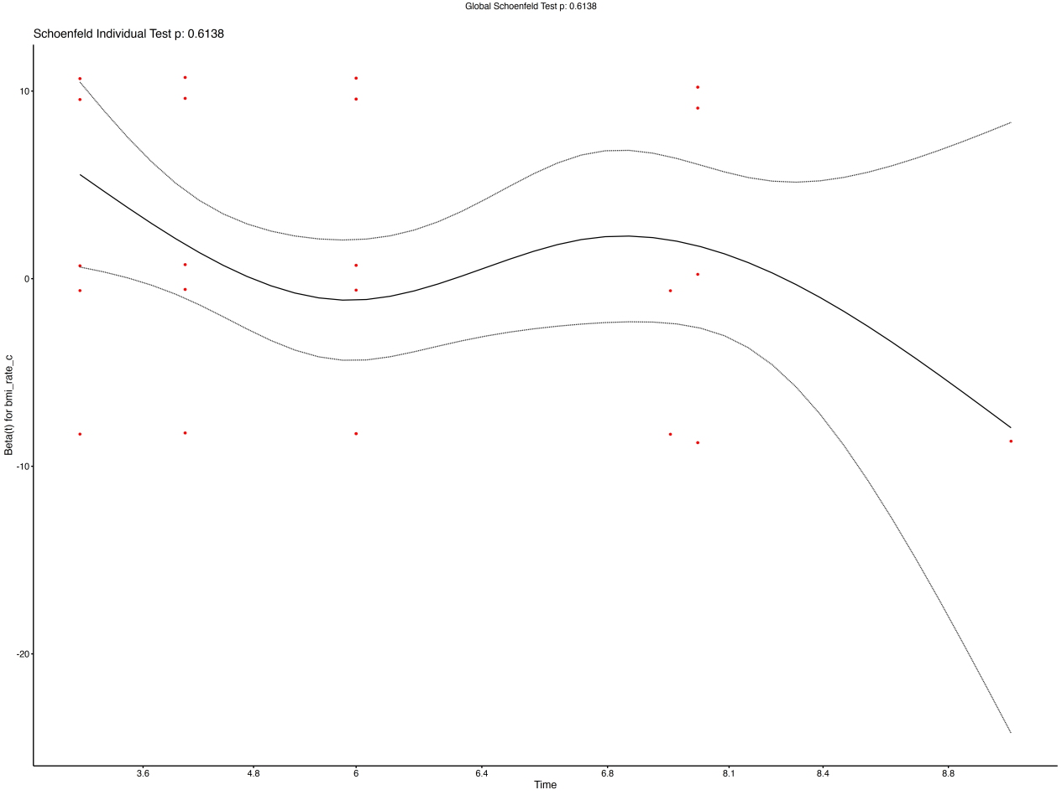

Model 2
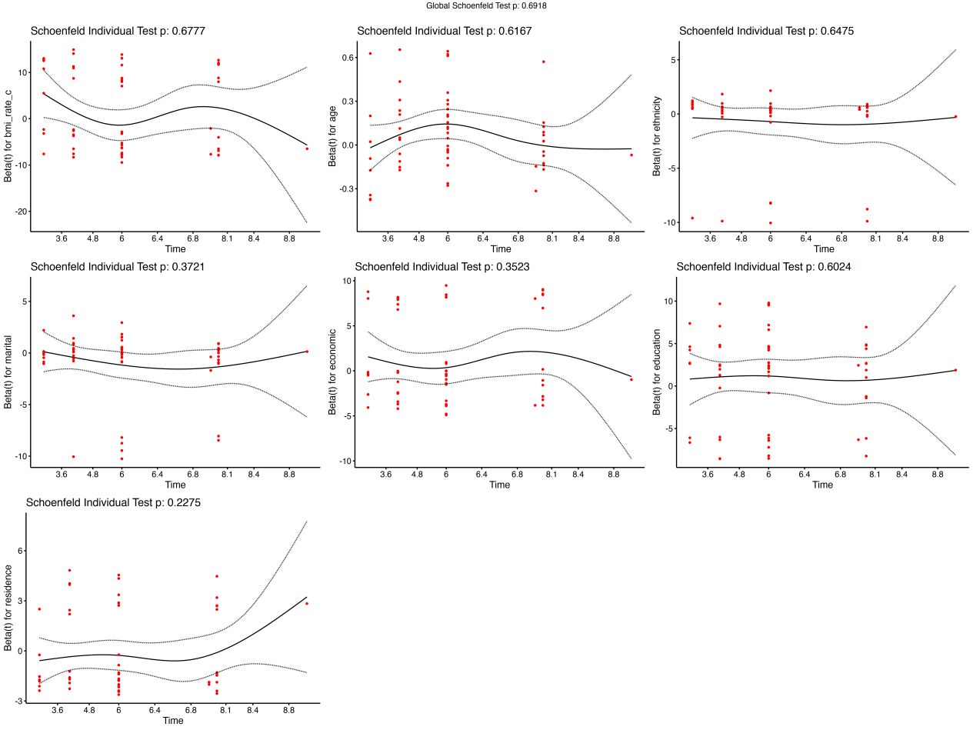
Model 3
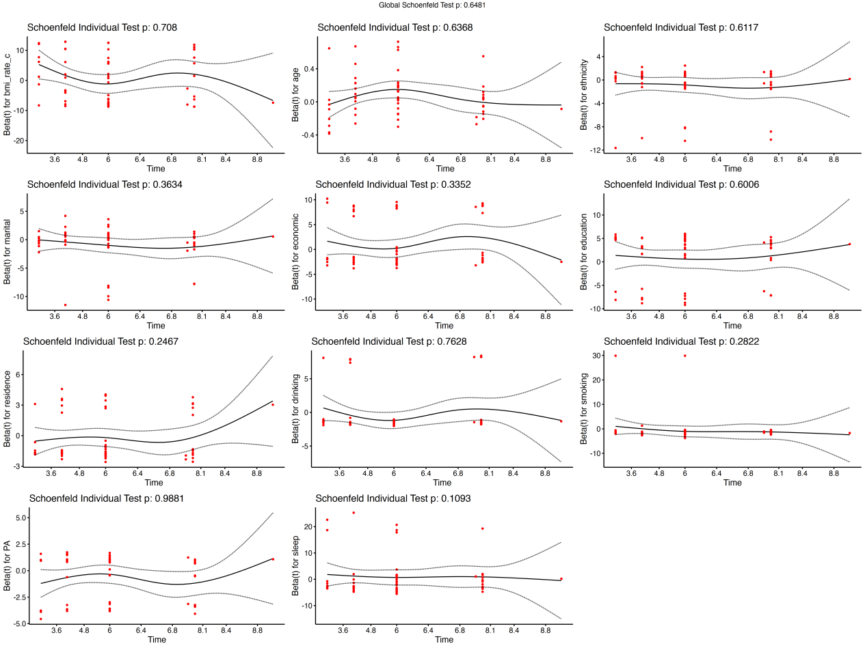

Model 4
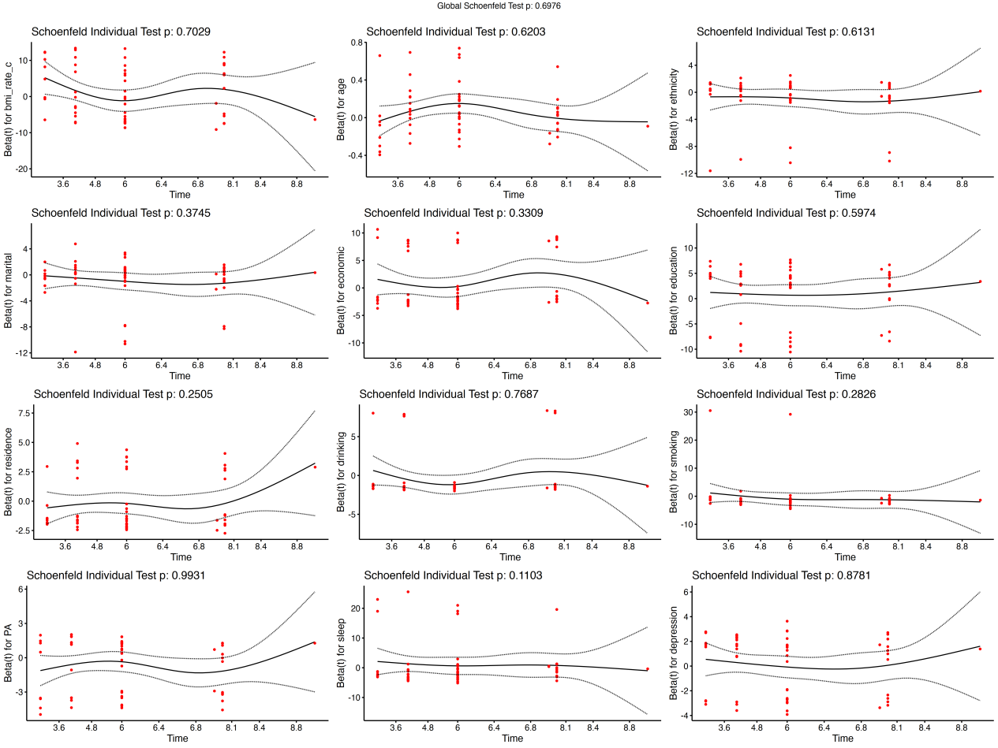

Figure S13. Cox association between relative BMI Change and the risk of T2DM (n=579)
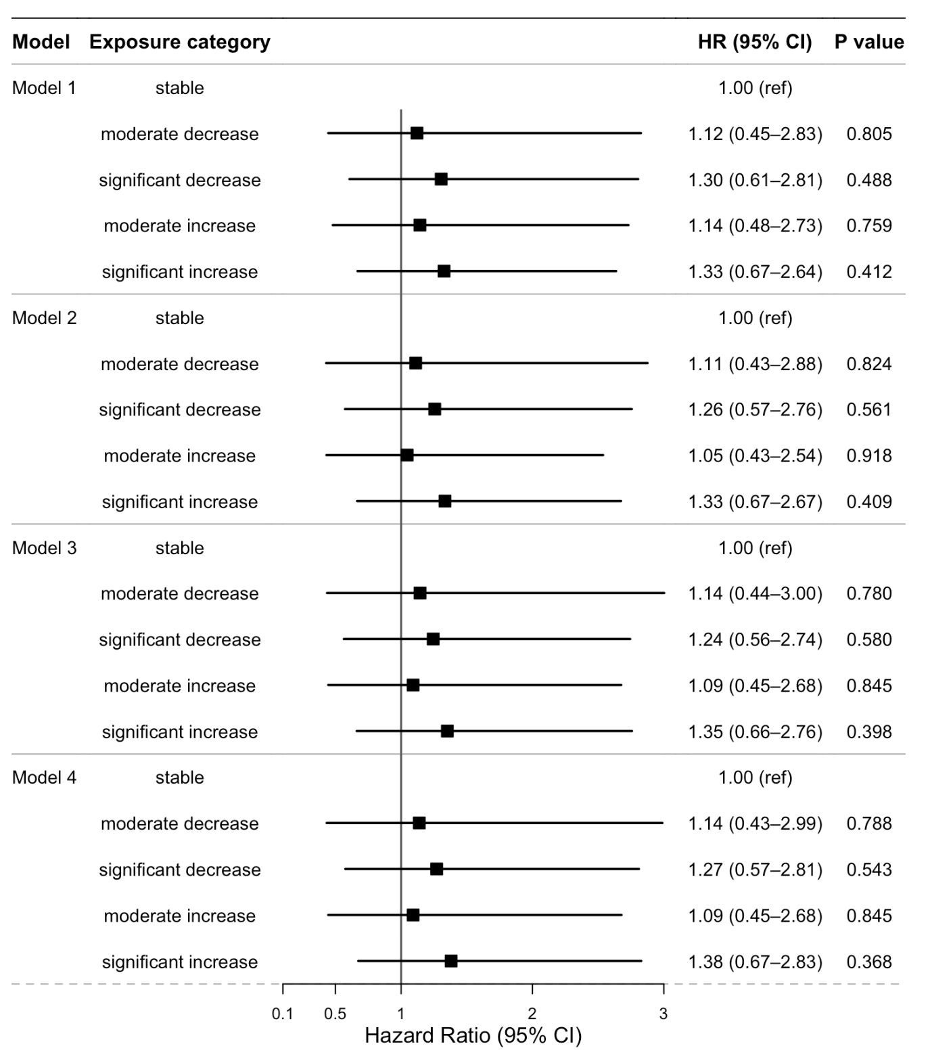
Notes. Model 1 represented the crude model without adjustment for any variables. Model 2 adjusted sociodemographic factors, including age, ethnicity, economic level, education level, marital status, and residence type. Model 3 further adjusted for behavioral and lifestyle factors—specifically smoking status, drinking status, physical activity and sleep duration. Model 4 further incorporated depressive symptoms.

Figure S14. Proportional Hazards Assumption(continuous BMI, underweight individuals excluded, n=1290)
Model 1
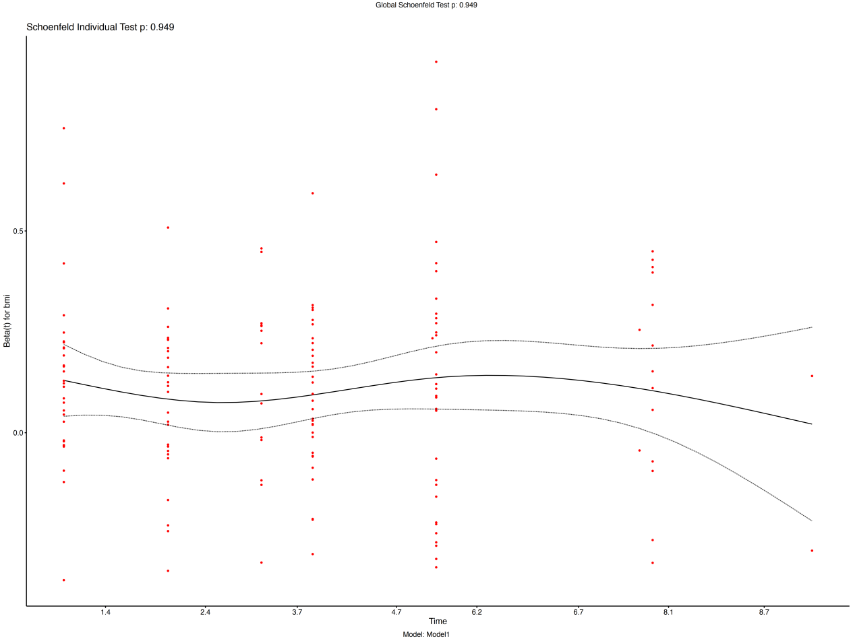
Model 2
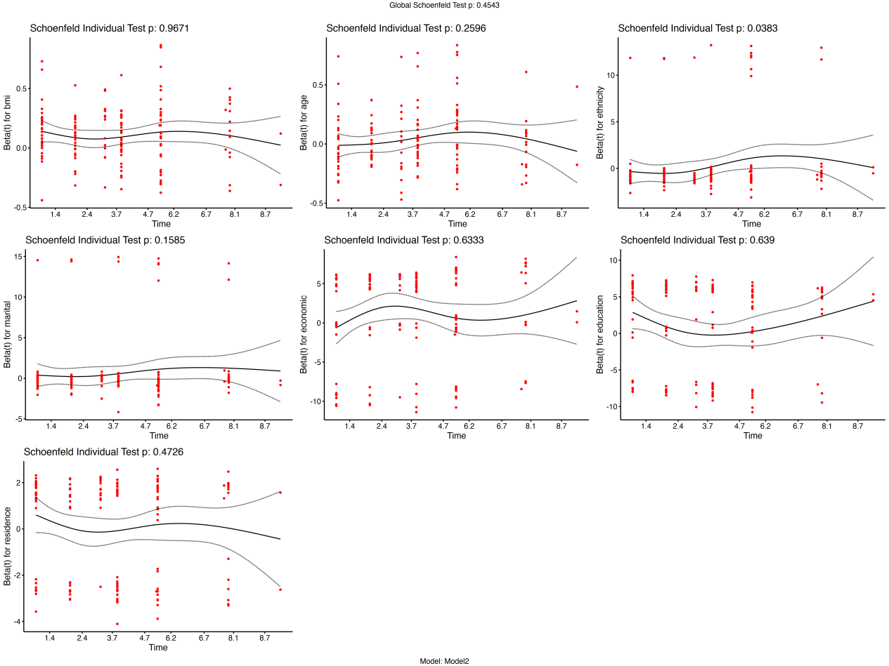
Model 3
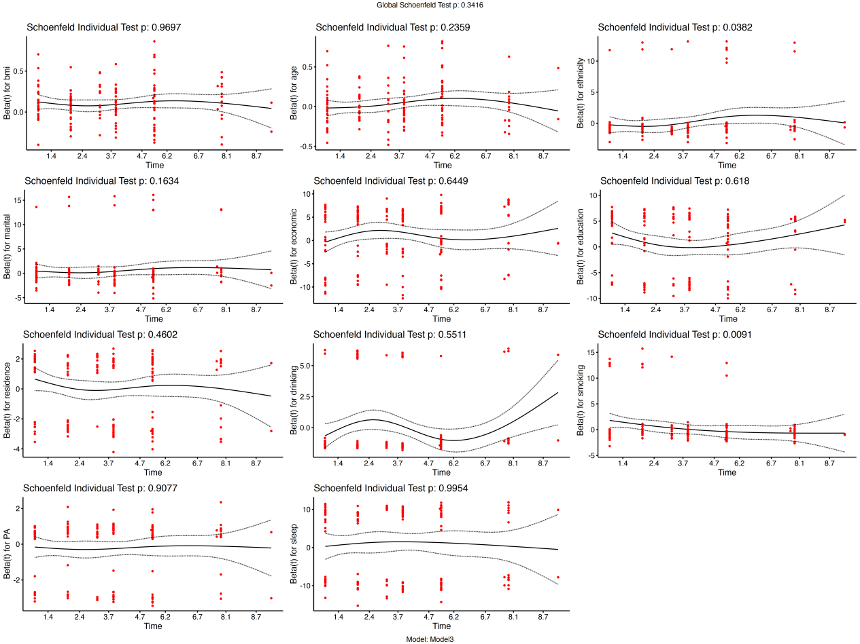

Model 4
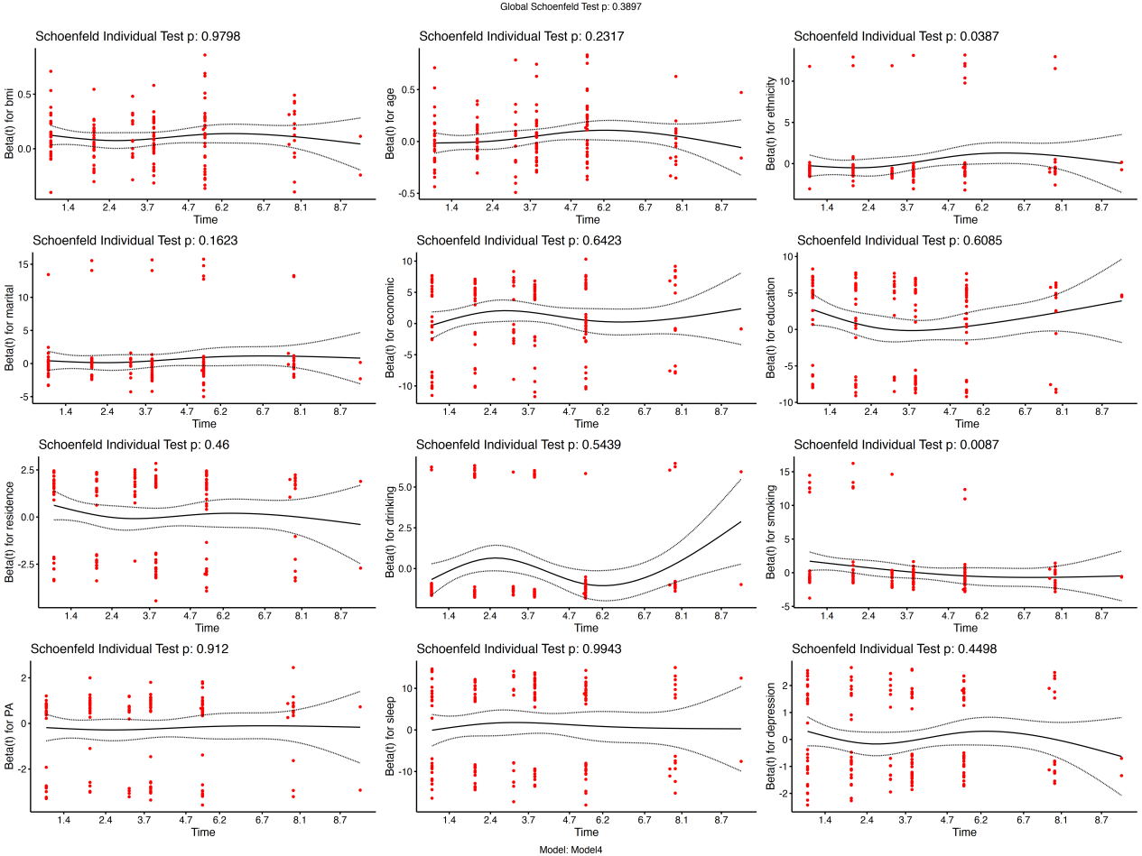

Figure S15. Restricted cubic spline curves for association between BMI and T2DM (Underweight individuals excluded, n=1290)
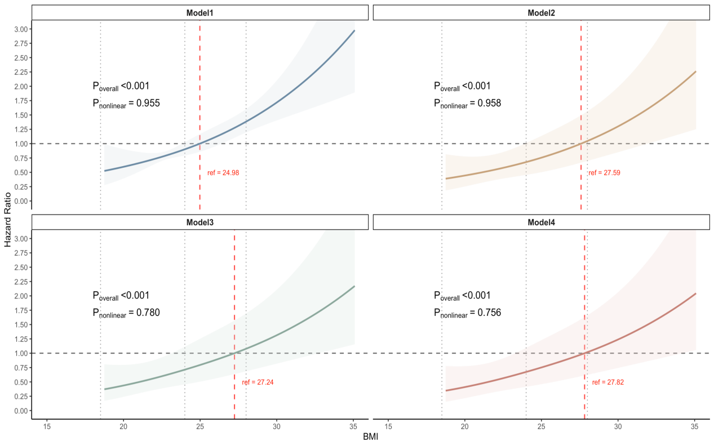
Notes. Model 1 represented the crude model without adjustment for any variables. Model 2 adjusted sociodemographic factors, including age, ethnicity, economic level, education level, marital status, and residence type. Model 3 further adjusted for behavioral and lifestyle factors—specifically smoking status, drinking status, physical activity and sleep duration. Model 4 further incorporated depressive symptoms.

Figure S16. Cox association between continuous BMI and T2DM (Underweight individuals excluded, n=1290)
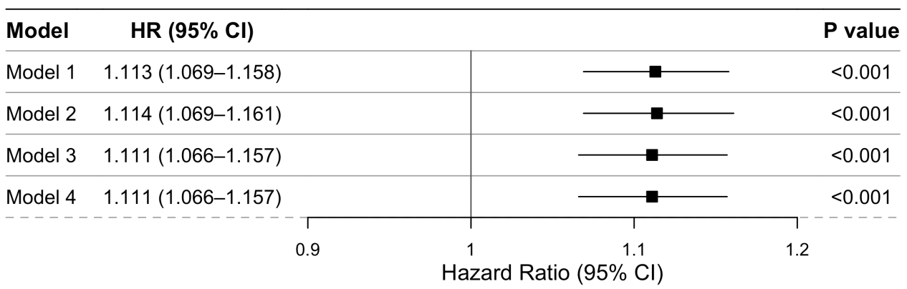
Notes. Model 1 represented the crude model without adjustment for any variables. Model 2 adjusted sociodemographic factors, including age, ethnicity, economic level, education level, marital status, and residence type. Model 3 further adjusted for behavioral and lifestyle factors—specifically smoking status, drinking status, physical activity and sleep duration. Model 4 further incorporated depressive symptoms.
Figure S17. Kaplan–Meier survival analyses of categorical BMI and T2DM (Underweight individuals excluded, n=1290)
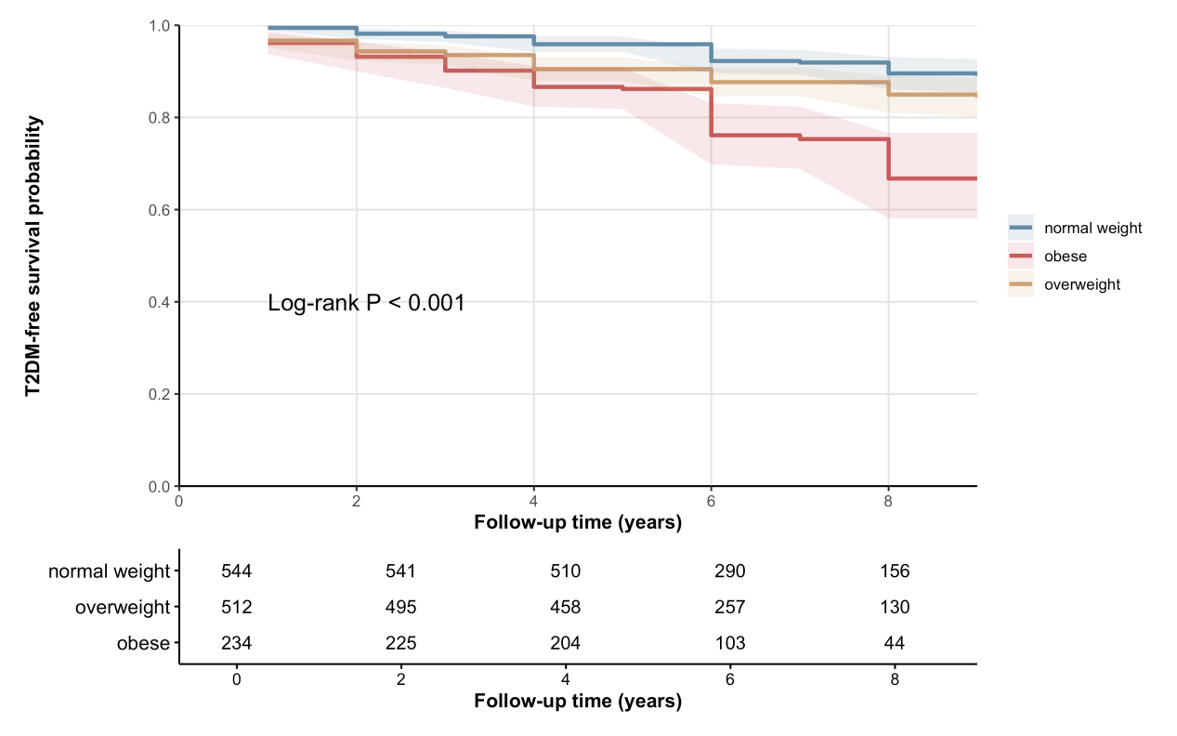

Figure S18. Proportional Hazards Assumption(BMI change patterns, Underweight individuals excluded, n=552)
Model 1
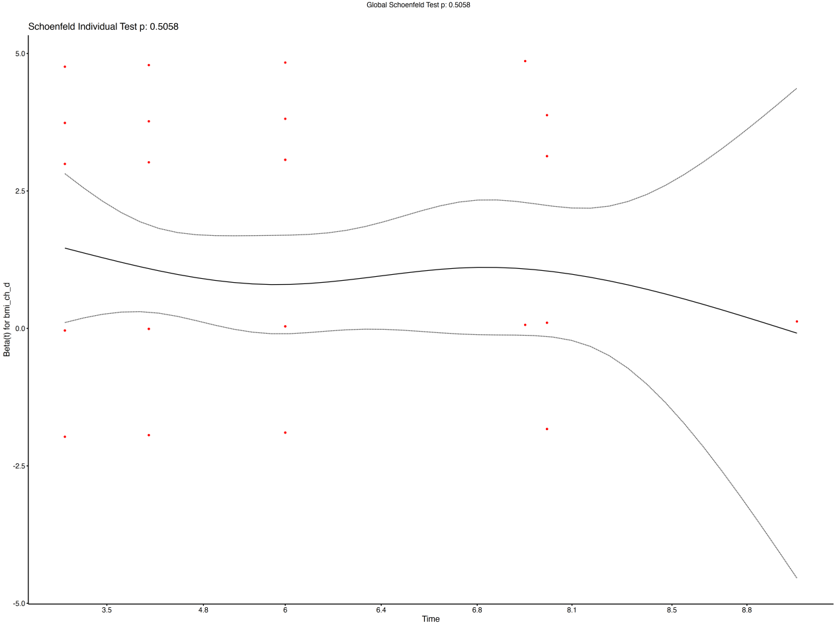
Model 2
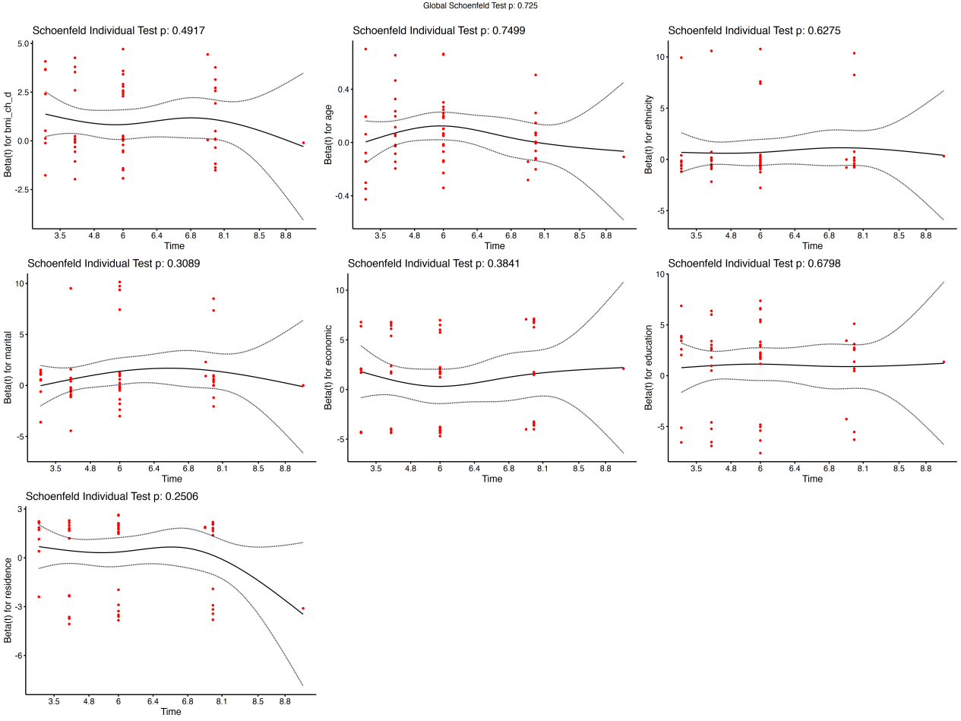

Model 3
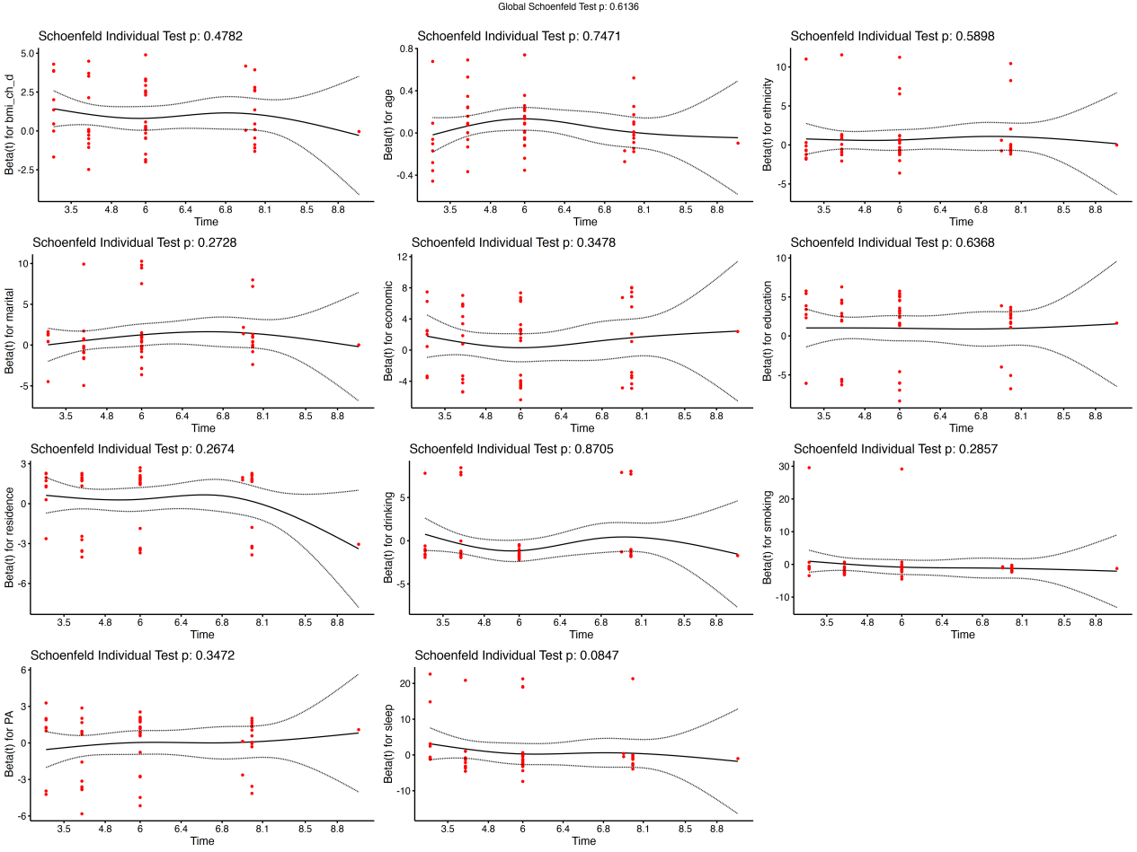

Model 4
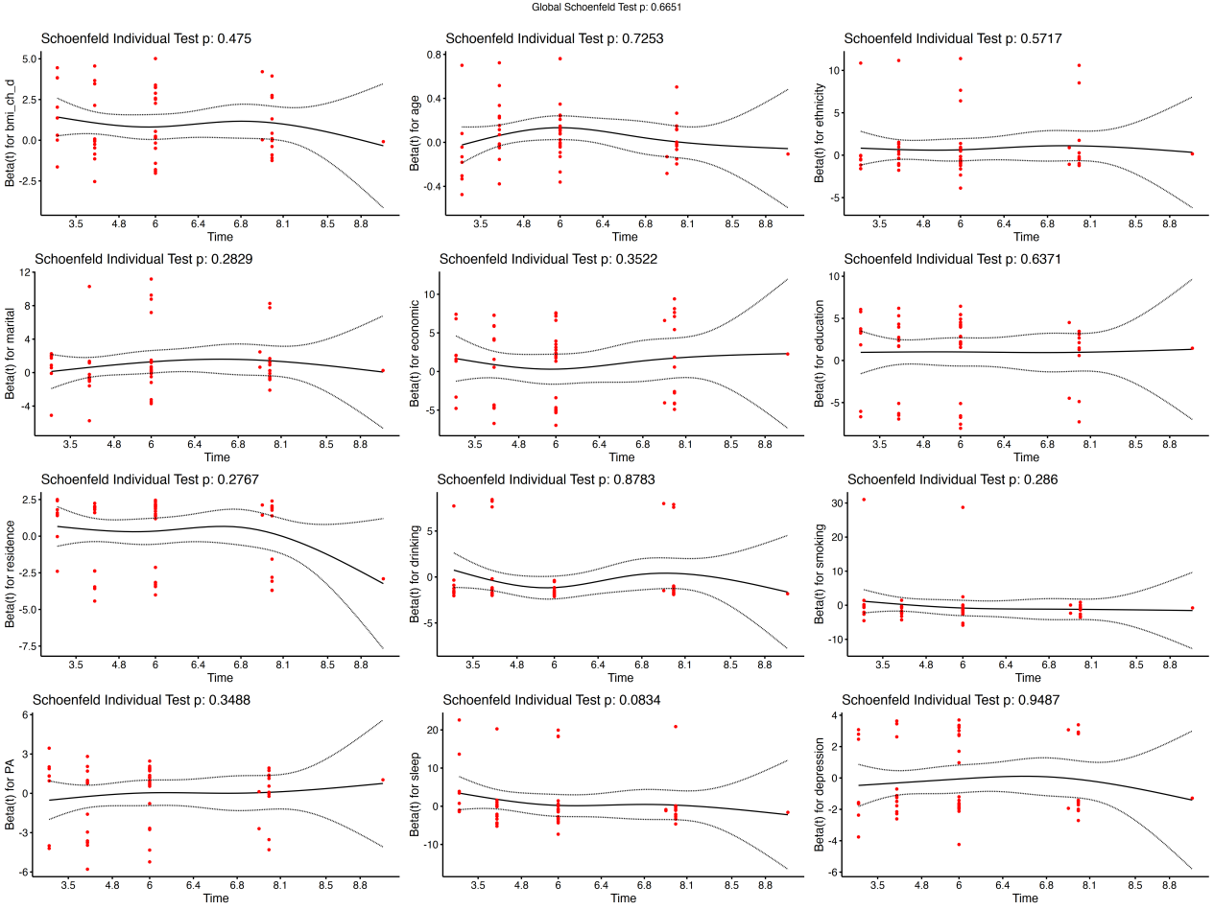

Figure S19. Cox association between relative BMI Change and the risk of T2DM (Underweight individuals excluded, n=552)
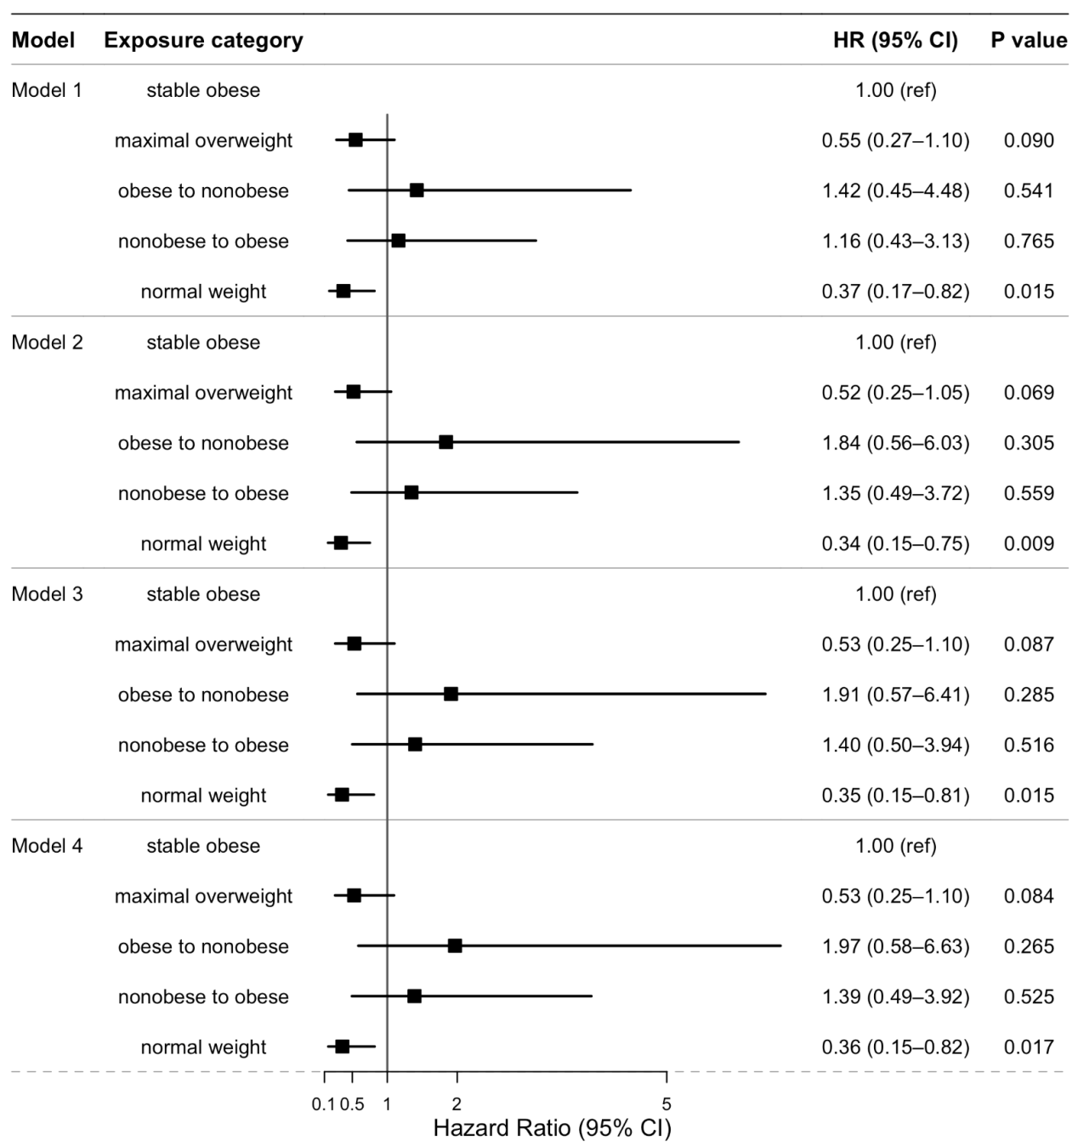

Notes. Model 1 represented the crude model without adjustment for any variables. Model 2 adjusted sociodemographic factors, including age, ethnicity, economic level, education level, marital status, and residence type. Model 3 further adjusted for behavioral and lifestyle factors—specifically smoking status, drinking status, physical activity and sleep duration. Model 4 further incorporated depressive symptoms.

Figure S20. Restricted cubic spline curves for association between BMI and T2DM (Physical activity excluded, n=1325)
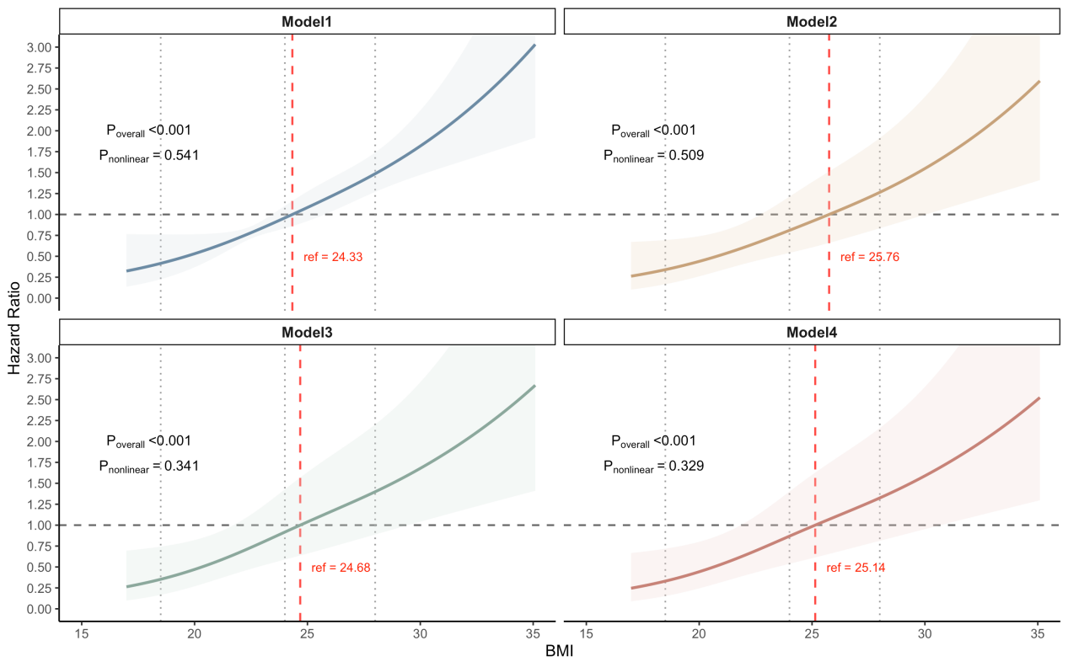
Notes. Model 1 represented the crude model without adjustment for any variables. Model 2 adjusted sociodemographic factors, including age, ethnicity, economic level, education level, marital status, and residence type. Model 3 further adjusted for behavioral and lifestyle factors—specifically smoking status, drinking status and sleep duration. Model 4 further incorporated depressive symptoms.

Figure S21. Cox association between continuous BMI and T2DM (Physical activity excluded, n=1325)
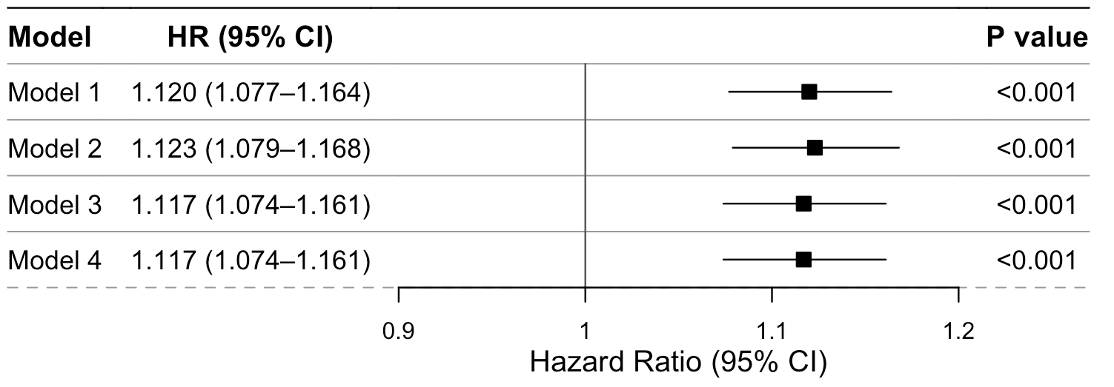
Notes. Model 1 represented the crude model without adjustment for any variables. Model 2 adjusted sociodemographic factors, including age, ethnicity, economic level, education level, marital status, and residence type. Model 3 further adjusted for behavioral and lifestyle factors—specifically smoking status, drinking status and sleep duration. Model 4 further incorporated depressive symptoms.

Figure S22. Cox association between relative BMI Change and the risk of T2DM (Physical activity excluded, n=579)
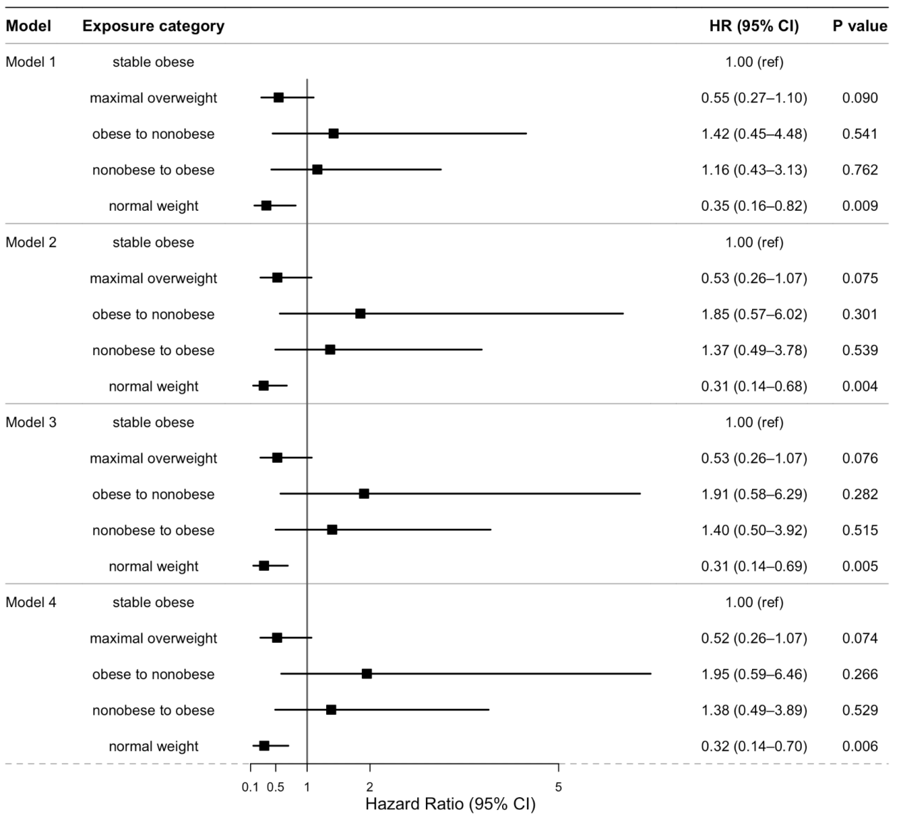
Notes. Model 1 represented the crude model without adjustment for any variables. Model 2 adjusted sociodemographic factors, including age, ethnicity, economic level, education level, marital status, and residence type. Model 3 further adjusted for behavioral and lifestyle factors—specifically smoking status, drinking status and sleep duration. Model 4 further incorporated depressive symptoms.

Supplemental Tables
Table S1. Missing Values and Proportions for Variables in baseline BMI (n=1325)
variable type | variable name | population | missing values | proportion of missingness
Independent variable | bmi | 1325 | 0
Independent variable | bmi_c | 1325 | 0
Dependent variable | time_month | 1325 | 0
Dependent variable | event | 1325 | 0
Sociodemographic characteristics | age | 1325 | 0
Sociodemographic characteristics | ethnicit | 1325 | 0
Sociodemographic characteristics | marital status | 1325 | 0
Sociodemographic characteristics | economic status | 1325 | 287 | 21.66%
Sociodemographic characteristics | educational leve | 1325 | 0
Sociodemographic characteristics | residence type | 1325 | 0
Behavioral and lifestyle factors | smoking status | 1325 | 0
Behavioral and lifestyle factors | drinking status | 1325 | 0
Behavioral and lifestyle factors | physical activity | 1325 | 697 | 52.60%
Behavioral and lifestyle factors | sleep duration | 1325 | 17 | 1.28%
Health status | depressive symptoms | 1325 | 5 | 0.38%

Table S2. Comparison of Accelerated Failure Time (AFT) models under alternative parametric distributional assumptions
data distribution | AIC | BIC | Rank(AIC) | Rank(BIC)
Log-normal | 1487.11 | 1492.30 | 1 | 1
Log-logistic | 1492.43 | 1497.62 | 2 | 2
Weibull | 1493.03 | 1498.22 | 3 | 3
Exponential | 1502.74 | 1507.93 | 4 | 4
Notes. AIC: Akaike Information Criterion, BIC: Bayesian Information Criterion

Table S3. Missing Values and Proportions for Variables in the BMI change pattern subsample (n=579)
variable type | variable name | population | missing values | proportion of missingness
Independent variable | bmi | 579 | 0
Independent variable | bmi_c | 579 | 0
Dependent variable | time_month | 579 | 0
Dependent variable | event | 579 | 0
Sociodemographic characteristics | age | 579 | 0
Sociodemographic characteristics | ethnicit | 579 | 0
Sociodemographic characteristics | marital status | 579 | 0
Sociodemographic characteristics | economic status | 579 | 97 | 16.75%
Sociodemographic characteristics | educational leve | 579 | 0
Sociodemographic characteristics | residence type | 579 | 0
Behavioral and lifestyle factors | smoking status | 579 | 0
Behavioral and lifestyle factors | drinking status | 579 | 0
Behavioral and lifestyle factors | physical activity | 579 | 312 | 53.89%
Behavioral and lifestyle factors | sleep duration | 579 | 9 | 1.55%
Health status | depressive symptoms | 579 | 1 | 0.17%

Table S4. Accelerated failure time model for time to T2DM (Log-normal distribution, underweight individuals excluded, n=1290)
Model | BMI  ref: underweight/normal weight | TR (95% CI) | P value
Model 1 | overweight | 0.586 (0.423-0.811) | <0.001
Model 1 | obeses | 0.356 (0.244-0.520) | <0.001
Model 2 | overweight | 0.571 (0.411-0.794) | <0.001
Model 2 | obeses | 0.346 (0.235-0.508) | <0.001
Model 3 | overweight | 0.577 (0.416-0.799) | <0.001
Model 3 | obeses | 0.353 (0.240-0.517) | <0.001
Model 4 | overweight | 0.575 (0.414-0.798) | <0.001
Model 4 | obeses | 0.353 (0.247-0.505) | <0.001
Notes. Model 1 represented the crude model without adjustment for any variables. Model 2 adjusted sociodemographic factors, including age, ethnicity, economic level, education level, marital status, and residence type. Model 3 further adjusted for behavioral and lifestyle factors—specifically smoking status, drinking status, physical activity and sleep duration. Model 4 further incorporated depressive symptoms.

Table S5. Accelerated failure time model for time to T2DM (Log-normal distribution, Physical activity excluded, n=1325)
Model | BMI  ref: underweight/normal weight | TR (95% CI) | P value
Model 1 | overweight | 0.586 (0.423-0.811) | <0.001
Model 1 | obeses | 0.356 (0.244-0.520) | <0.001
Model 2 | overweight | 0.573 (0.412-0.797) | <0.001
Model 2 | obeses | 0.344 (0.234-0.505) | <0.001
Model 3 | overweight | 0.577 (0.416-0.800) | <0.001
Model 3 | obeses | 0.351 (0.239-0.513) | <0.001
Model 4 | overweight | 0.576 (0.414-0.799) | <0.001
Model 4 | obeses | 0.351 (0.247-0.500) | <0.001
Notes. Model 1 represented the crude model without adjustment for any variables. Model 2 adjusted sociodemographic factors, including age, ethnicity, economic level, education level, marital status, and residence type. Model 3 further adjusted for behavioral and lifestyle factors—specifically smoking status, drinking status and sleep duration. Model 4 further incorporated depressive symptom.

