Supplementary Information
for
Source-dependent epoxide depletion in graphene oxide induced by
soft X-rays and low-energy electron irradiation

E. Faella ^{1, a}, D. Capista ², L. Camilli ³, L. Lozzi ¹ and M. Passacantando ^{1, a}
¹ Department of Physical and Chemical Sciences, University of L’Aquila, via Vetoio, L’Aquila, 67100, Italy
² IHP, Im Technologiepark 25, 15236 Frankfurt (Oder), Germany
³ Dipartimento di Fisica, University of Rome “Tor Vergata”, via della Ricerca Scientifica 1, 00133, Rome, Italy

SI.1 Effective density estimated from XRD-derived interlayer spacing
The effective density of the graphene oxide (GO) films was estimated from the interlayer distance extracted from X-ray diffraction (XRD). This approach was used to provide a structural density for absorbed-dose calculations in the near-surface region probed by XPS. It should be regarded as an effective lamellar density, not as a direct bulk-density measurement.
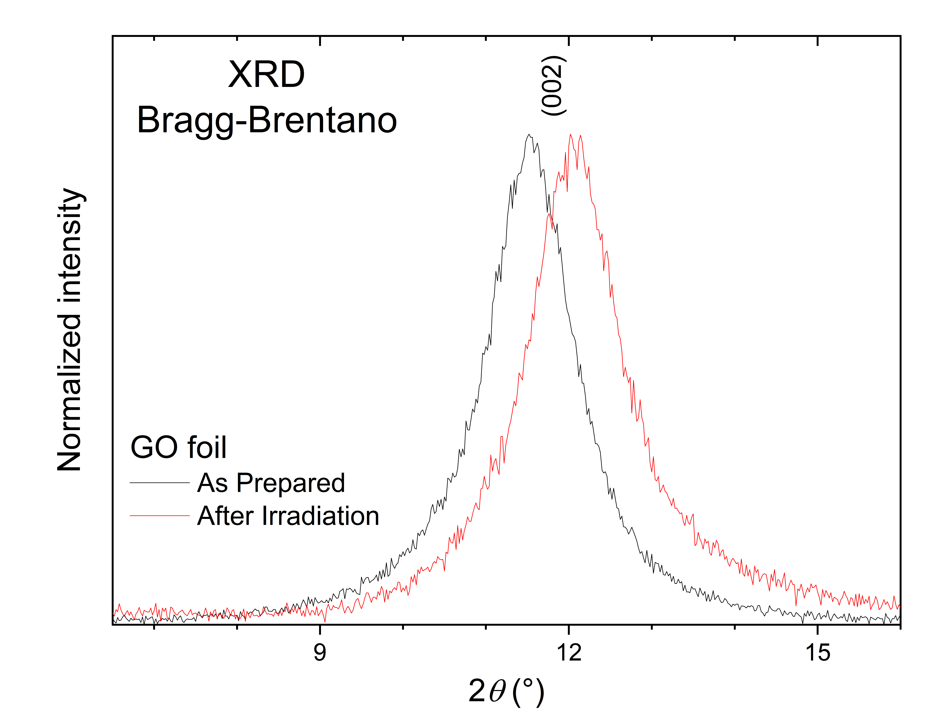
Figure S1. XRD patterns of the GO sheet before (black curve) and after (red curve) irradiation. The shift of the (002) reflection toward higher 2θ after irradiation indicates a decrease in the interlayer distance $d_{002}$, consistent with partial reduction/dehydration.
The position of the GO (002) reflection was used to calculate the interlayer distance through Bragg's law:
$$\begin{aligned}d_{002}=\frac{λ}{2\sin{θ}}\#\left(S1\right)\end{aligned}$$
where λ = 0.15406 nm for Cu Kα radiation and θ is half of the measured 2θ peak position obtained from XRD measurements of pristine and irradiated GO (Fig. S1).
The density was then estimated using the empirical relationship between mass density and interlayer distance extracted from fitting previously published data for GO few-layer films [S1]:
$$\begin{aligned}ρ=0.63+1.67e^{\left(\frac{0.33-d_{002}}{0.28}\right)}\#(S2)\end{aligned}$$
where $d_{002}$ is expressed in nm and ρ in g cm⁻³. The relation was used here only as a density estimate for the dose calculation. The slight shift of the GO peak toward higher 2θ after irradiation (Figure S1) indicates a decrease of $d_{002}$ and, correspondingly, a small increase in the estimated effective density (Figure S2).
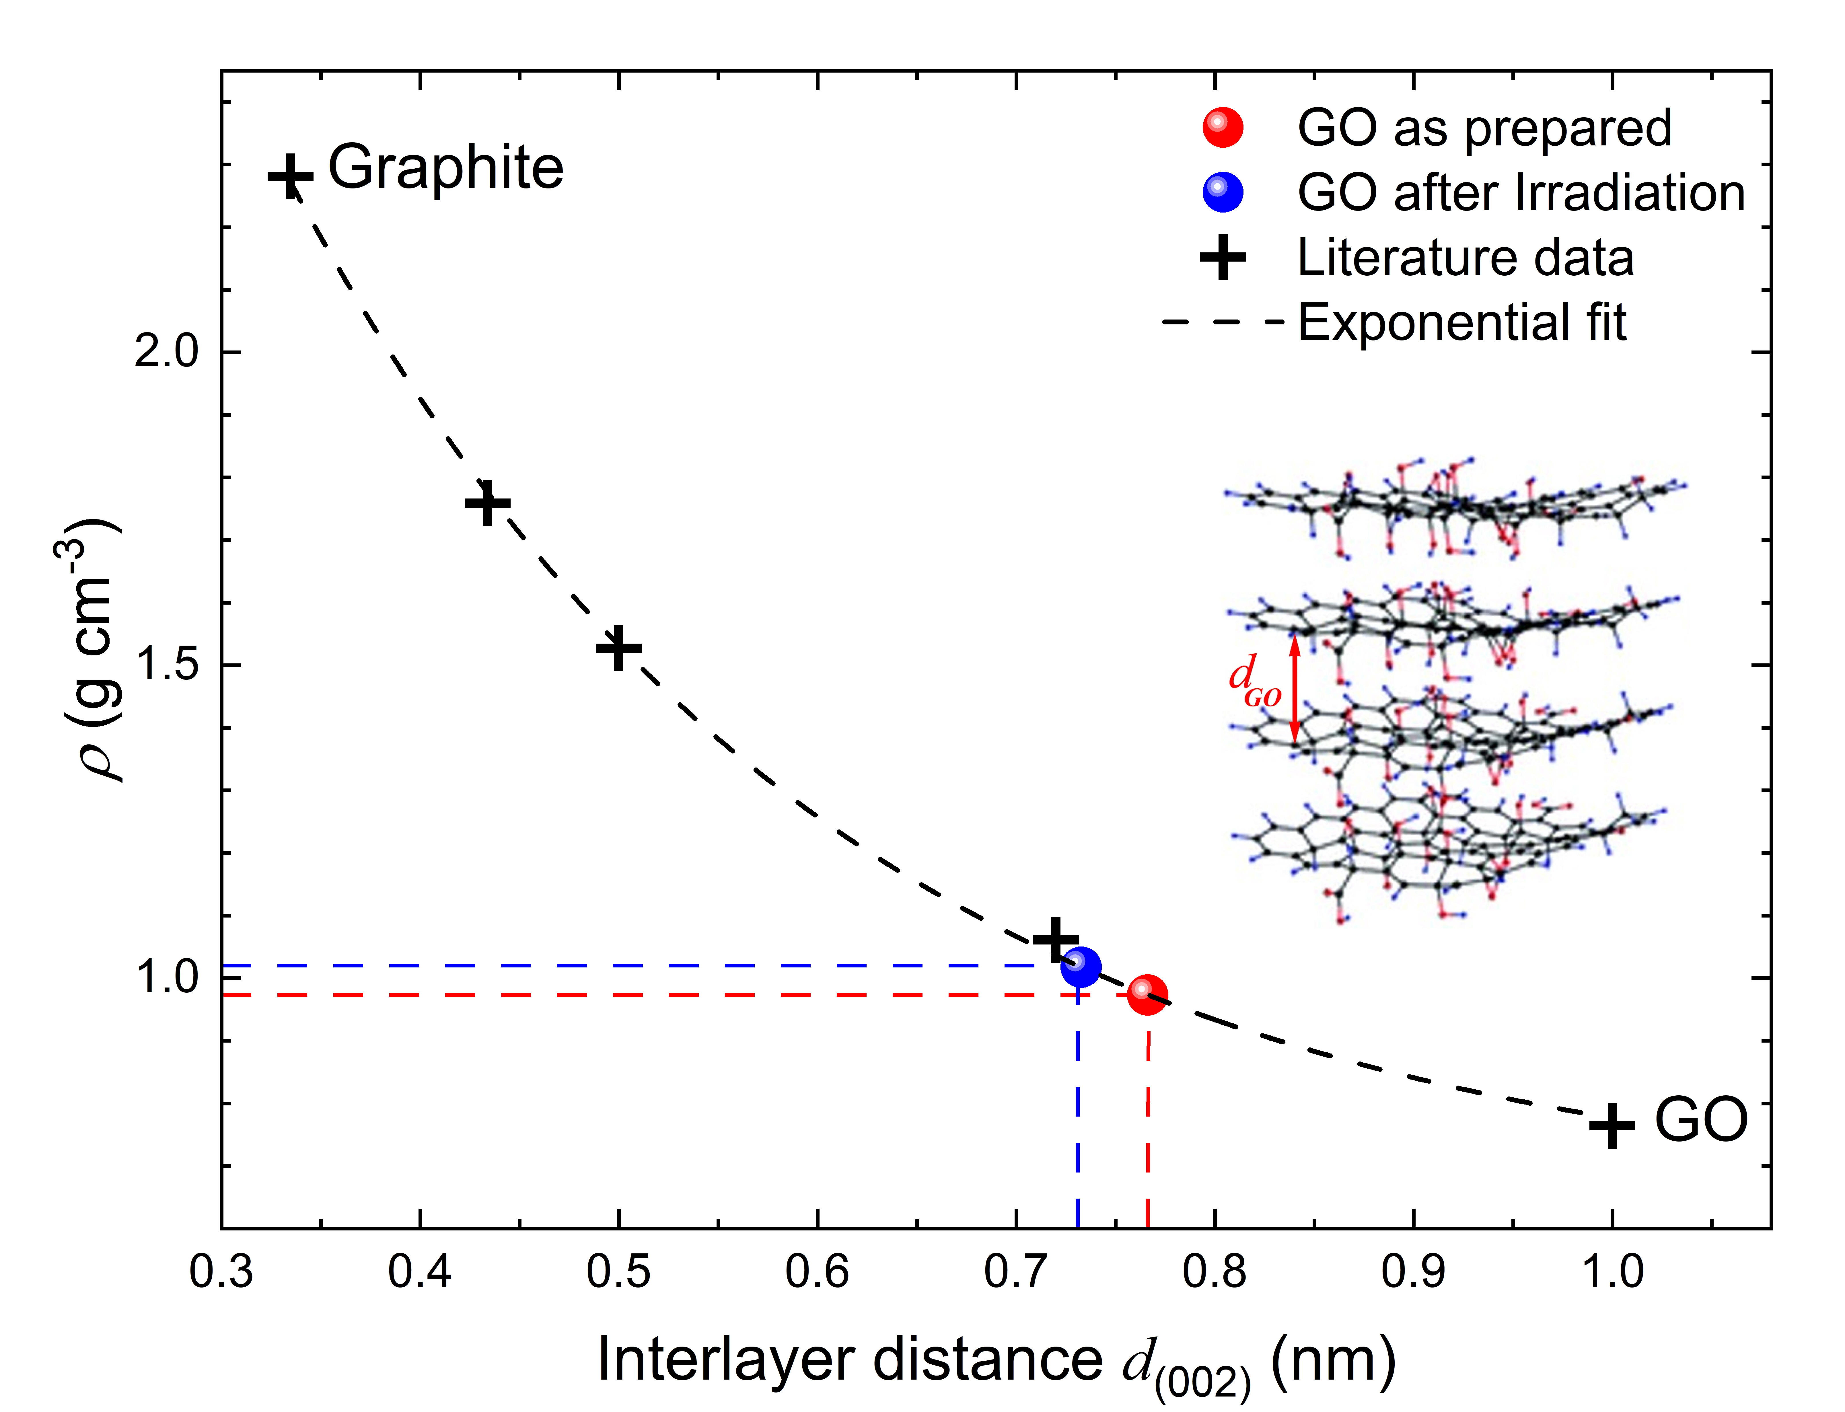
Figure S2. Relationship between the GO structural density ρ and the interlayer distance $d_{002}$. Black cross symbols represent literature data extracted from Jiménez Riobóo et al. [S1]. The dashed black line represents the exponential fit to the literature data given by Eq. (S2). The red and blue symbols indicate the GO sheet before and after irradiation, respectively.
Because the effective mass density of GO is strongly related to the interlayer spacing and stacking state, the $d_{002}$ values extracted from the GO (002) XRD reflection were converted into structural density values using the empirical exponential fit reported in Fig. S2. These density values were then used as input parameters for the absorbed-dose calculation. Table S1 summarizes the calculated $d_{002}$ spacings and the corresponding estimated densities.
Table S1. Density estimation from the XRD-derived interlayer spacing.
Sample | 2θ GO peak (deg) | d₀₀₂ (nm) | Estimated ρ (g cm⁻³)
GO as prepared | 11.54 | 0.766 | 0.973
GO after irradiation | 12.07 | 0.733 | 1.017

SI.2 XPS fitting procedure and irradiation-time evolution
Under the experimental configuration described in the Materials and methods section of the main manuscript, the irradiation-induced evolution of GO was monitored through the C 1s and O 1s core-level spectra as a function of exposure time. Regardless of the radiation source, after each irradiation step, high-resolution C 1s and O 1s core level spectra were acquired at a pass energy of 23 eV, corresponding to an overall experimental energy resolution of approximately 0.75 eV. After subtraction of a Shirley background, the spectra were fitted using Voigt line shapes. The C 1s peak was decomposed into graphitic C-C/C=C (284.8 eV), hydroxyl C-OH (285.9 eV), epoxide C-O-C (286.9 eV), carbonyl C=O (288.2 eV), and carboxyl O-C=O (289.3 eV) components, together with a π-π* shake-up contribution at 291.1 eV. The O 1s peak was fitted with three components assigned to carbonyl/carboxyl oxygen (530.4 eV), epoxide oxygen (532.0 eV), and hydroxyl-related oxygen (533.4 eV).
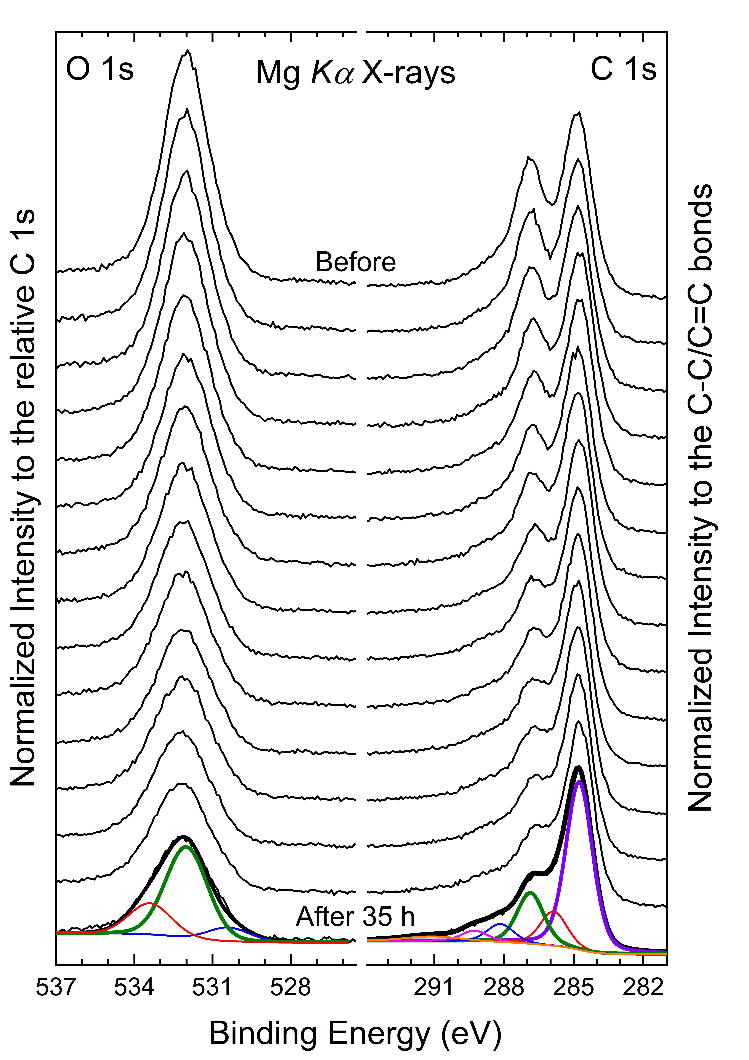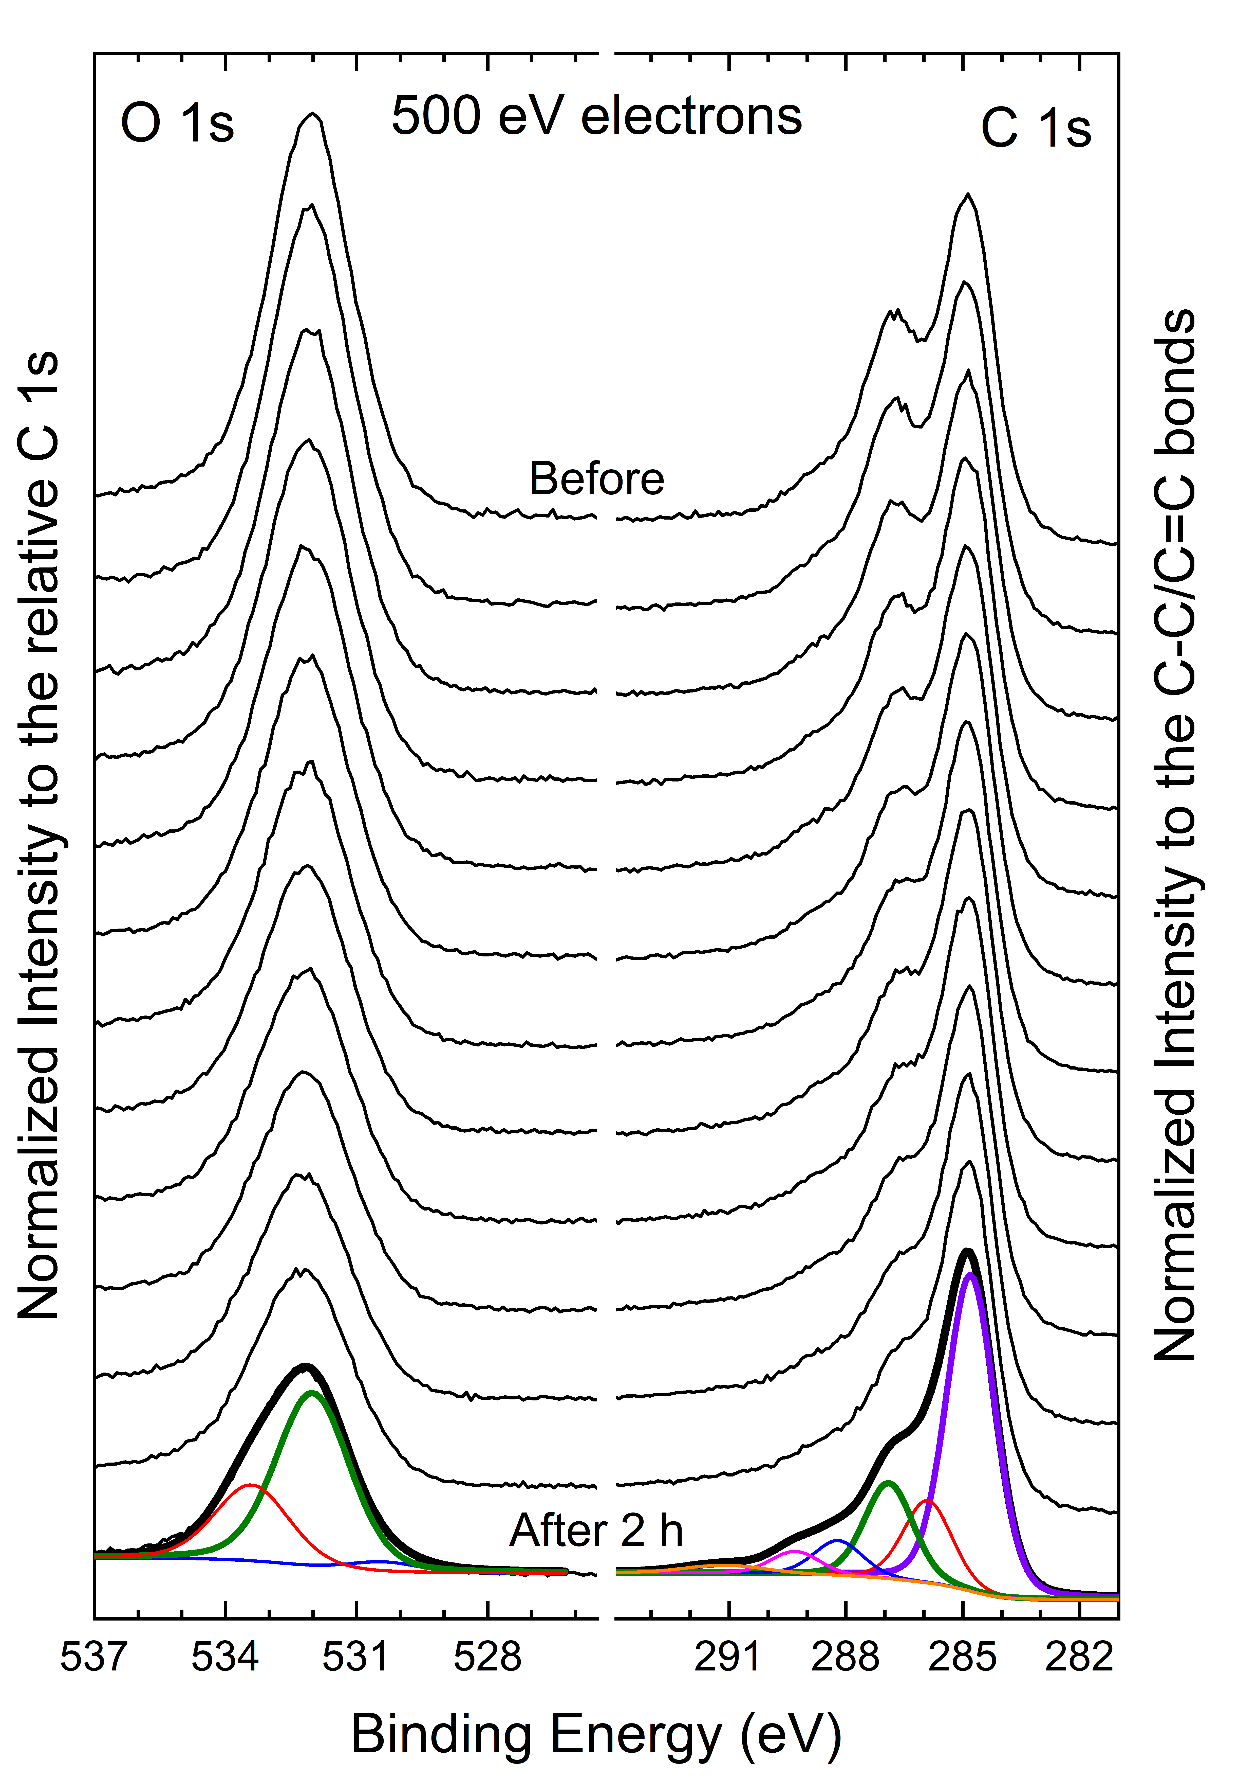
Figure S3. Irradiation-time evolution of the O 1s and C 1s XPS spectra of GO upon Mg Kα X-ray irradiation (left) and 500 eV electron irradiation (right). The C 1s spectra are normalized to the graphitic C-C/C=C component, and the O 1s spectra are normalized to the corresponding C 1s signal. The O 1s fits comprise hydroxyl-related oxygen (533.4 eV, red), epoxide oxygen (532.0 eV, green), and carbonyl/carboxyl oxygen (530.4 eV, blue). The C 1s fits comprise C-C/C=C (284.8 eV, violet), C-OH (285.9 eV, red), C-O-C (286.9 eV, green), C=O (288.2 eV, blue), O-C=O (289.3 eV, magenta), and the π-π* shake-up contribution (291.1 eV, orange).
To ensure a consistent comparison among irradiation steps and between the two radiation sources, the component assignments, relative binding-energy separations, and full widths at half maximum were constrained within each spectral series. The C 1s component intensities were expressed relative to the total fitted C 1s area for the compositional trends reported in Figure 3 of the main manuscript. For the epoxide-depletion yield, the C-O-C area was additionally normalized to the graphitic C-C/C=C component, as defined in Eq. (3) of the main manuscript. The O 1s spectra were used as an independent qualitative check of the chemical evolution inferred from the C 1s fits.
Figure S3 shows a consistent irradiation-induced evolution for both radiation sources. The epoxide-related C-O-C contribution decreases markedly in the C 1s spectra, while the graphitic C-C/C=C component increases. The O 1s spectra independently show a pronounced loss of the epoxide-oxygen contribution and a reduction of the overall oxygen signal relative to C 1s. The hydroxyl-related contribution exhibits a moderate relative increase, whereas the carbonyl and carboxyl components remain nearly unchanged within the investigated exposure range. These trends support a chemically selective reduction pathway dominated by epoxide depletion rather than uniform removal of all oxygen-containing groups. The component areas extracted from the complete C 1s irradiation series are reported as a function of absorbed dose in Figure 3 of the main manuscript and form the basis of the epoxide-depletion analysis in Figure 4.
SI.3 Estimation of the local absorbed dose
This Supplementary Note reports the calculation used to estimate the local absorbed dose delivered to the XPS-sensitive depth of the GO sheet under Mg Kα soft X-ray or 500 eV electron irradiation. The purpose of this estimate is to provide a common physical basis for comparing the chemical response induced by the two different radiation sources. It is not intended as a source-independent calibration of the GO response. All numerical values are derived from the experimental input parameters reported in the main manuscript and the dose-calculation dataset.
SI.3.1 Absorbed-dose framework
The absorbed dose, $D$, was calculated as the ratio between the energy absorbed by the GO film and the mass of the irradiated volume:
$$\begin{aligned}D=\frac{E_{abs}}{m}\#\left(S3\right)\end{aligned}$$
The corresponding dose rate was calculated as:
$$\begin{aligned}\dot{D}=\frac{P_{abs}}{m}\#\left(S4\right)\end{aligned}$$
where $E_{abs}$, $P_{abs}$ and $m$ are the absorbed energy, the absorbed power and the mass of the GO sheet considering the XPS-sensitivity depth of about 10 nm.
The irradiated mass was calculated as:
$$\begin{aligned}m=ρS_{eff}d\#\left(S5\right)\end{aligned}$$
where $ρ$ is the GO density, $S_{eff}$ is the effective irradiated footprint area on the sample surface, and $d$ is the assumed XPS-sensitivity depth (10 nm). The GO density used in the calculation was: $ρ=0.973 g cm^{-3}$ as determined in the SI.1 section.
For normal-incidence X-ray irradiation, as in our experiments, the effective surface area was taken as:
$$\begin{aligned}S_{eff,X}=S_{X}\#\left(S6\right)\end{aligned}$$
For electron irradiation, given the incidence angle $θ=45°$ with respect to the sample surface in our experiments, the effective footprint area was calculated as:
$$\begin{aligned}S_{eff,e}=\frac{S_{e}}{\sin{45°}}\#\left(S7\right)\end{aligned}$$
This correction assumes that the reported electron spot area is the beam cross-section perpendicular to the beam direction; the corresponding footprint on the sample surface is therefore larger by a factor of 1/sin 45°.
SI.3.2 Soft X-ray dose estimation
The soft X-ray source was treated as an Mg Kα photon beam with photon energy:
$$E_{ph}=1253.6 eV$$
Table S2. Input parameters for Mg Kα Soft X-ray irradiation experiments. ^{(†)}Assuming a soft X-ray photon energy corresponding to the Mg Kα line ($E_{ph}=1253.6$ eV), the absorption at a GO depth of 10 nm was determined using the CXRO code [S2], resulting in $A_{GO}=1.33×{10}^{-3}$.
Parameter | Symbol | Value
Photon energy | $$E_{ph}$$ | 1253.6 eV
Photon flux density | $$Φ$$ | $5.21×{10}^{12}$ photons cm⁻² s⁻¹
Irradiated area | $$S_{X}$$ | 1 cm²
Absorbed fraction in GO | $$A_{GO}$$ | $$1.33×{10}^{-3}$$
Irradiation time | $$t_{X}$$ | 35 h
XPS-sensitive depth | $$d$$ | 10 nm
GO density | $$ρ$$ | 0.973 g cm⁻³
The absorbed X-ray power was calculated from the incident photon flux, the irradiated area, the photon energy and the absorbed fraction of the GO layer according to the formula:
$$\begin{aligned}P_{abs,X}=ΦS_{X}E_{ph}A_{GO}\#\left(S8\right)\end{aligned}$$
where $Φ$ is the photon flux density, $S_{X}$ the irradiated area, $E_{ph}$ the photon energy expressed in joule, and $A_{GO}$ the absorbed fraction of the incident photon energy in GO.
Using these values, the absorbed X-ray power was:
$$P_{abs,X}=1.39×{10}^{-6} Js^{-1}$$
For an irradiation time of 35 h, the absorbed energy was:
$$E_{abs,X}=P_{abs,X}∙t_{X}=1.75×{10}^{-1} J$$
The mass of the irradiated 10 nm-GO layer that corresponds to the XPS-sensitivity depth, Eq. $\left(S5\right)$, was:
$$m_{X}=ρS_{eff,X}d=9.73×{10}^{-10} kg$$
Therefore, the absorbed dose, Eq. $\left(S3\right)$, was:
$$D_{X}=\frac{1.75×{10}^{-1}}{9.73×{10}^{-10}}=1.80×{10}^{8} Gy$$
and the dose rate, Eq. $\left(S4\right)$, was:
$${\dot{D}}_{X}=\frac{1.39×{10}^{-6}}{9.73×{10}^{-10}}=1.43×{10}^{3} Gy s^{-1}=5.15 MGy h^{-1}$$
The photon absorption term was obtained from the absorbed fraction calculated for the GO layer using soft X-ray attenuation data. The CXRO (Center for X-ray Optics) code [S2] for X-ray interactions database and the tabulated Henke optical constants provide attenuation, transmission and absorption data in the soft X-ray range and are appropriate references for this step [S3].
SI.3.3 Electron dose estimation
As for the electron source, the incident beam power was calculated as:
$$\begin{aligned}P_{e}=I∙V\#\left(S9\right)\end{aligned}$$
where $I$ is the electron beam current and $V$ is the accelerating voltage.
The incident electron beam power thus was:
$$P_{e}=(1.7×{10}^{-7} A)(500 V)=8.50×{10}^{-5} Js^{-1}$$
Table S3. Input parameters for electron beam.
Parameter | Symbol | Value
Electron energy | $$E_{0}$$ | 500 eV
Accelerating voltage | $$V$$ | 500 V
Beam current | $$I$$ | 0.17 μA
Irradiated scan area | $$S_{e}$$ | 0.09 cm²
Incidence angle with respect to the surface | $$θ$$ | 45°
Effective surface area | $$S_{eff,e}$$ | 0.127 cm²
Irradiation time | $$t_{e}$$ | 2 h
XPS-sensitive depth | $$d$$ | 10 nm
GO density | $$ρ$$ | 0.973 g cm⁻³
Under the simplifying assumption that the incident beam power is dissipated within the GO sheet, the corresponding energy over 2 h is:
$$E_{abs,e}=P_{e}∙t_{e}=6.12×{10}^{-1} J$$
This assumption is justified because GO sheet thickness, approximately 10 μm, is much larger than the estimated penetration depth of 500 eV electrons. Thus, electron transmission through the full GO sheet can be neglected and essentially all incident electron energy is expected to be dissipated within the GO sheet. However, the total energy dissipated within the GO sheet cannot be used directly to estimate the local dose in the near-surface region probed by XPS, which has a nominal information depth of approximately 10 nm. Therefore, the fraction of the incident electron energy nominally lost within the first 10 nm was estimated using the Kanaya–Okayama range relation combined with a K–O-derived continuous-slowing-down-type approximation, as described below.
Kanaya-Okayama-based estimate of electron range and near-surface energy loss
The (K-O) range relation [S4] was used to obtain a first-order estimate of the range of 500 eV electrons in the GO sheet. This semi-empirical relation estimates the electron range along the nominal electron trajectory from the incident electron energy and average material parameters, namely atomic weight, atomic number and mass density. In the present dose calculation, the K–O relation was not used as a full electron-transport or depth-dose model. Instead, it was first used to estimate the nominal electron range and was subsequently combined with a continuous-slowing-down-type approximation to estimate the fraction of incident electron energy nominally lost within the 10 nm XPS information depth. The mass used in the local-dose calculation was independently determined from the fixed 10 nm XPS information depth.
The electron interaction depth was estimated using the K-O expression [S4]:
$$\begin{aligned}R_{KO}=\frac{0.0276AE_{0}^{1.67}}{ρZ^{0.889}}\#\left(S10\right)\end{aligned}$$
where $R_{KO}$ is expressed in μm, $A$ is the atomic weight, $Z$ is the atomic number, $E_{0}$ is the incident electron energy in keV, and $ρ$ is the density in g cm⁻³.
Using a carbon-like approximation for GO, with A = 12.011, Z = 6, ρ = 0.973 g cm⁻³ and E₀ = 0.5 keV, the K-O expression gives:
$$R_{KO}=2.18×{10}^{-2} μm=21.8 nm$$
where $R_{KO}$ represents the nominal electron range along the incident trajectory, rather than the penetration depth measured normal to the sample surface. The incident energy of 0.5 keV lies below the energy range for which the K–O relation is commonly applied. Its use here therefore represents a low-energy extrapolation, and the resulting range should be regarded only as an order-of-magnitude estimate.
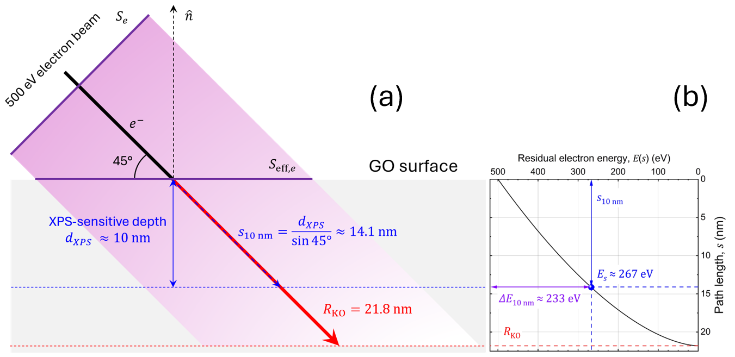
Figure S4. Geometrical scheme and K-O-derived CSDA estimate used to evaluate the nominal electron energy loss within the XPS-sensitive depth of GO. (a) For 500 eV electrons incident at ${45}^{∘}$, the 10 nm XPS information depth corresponds to a trajectory length $s_{10 nm}=\frac{d_{XPS}}{\sin{{45}^{∘}}}≈14.1$ nm (blue dashed line), shorter than the K-O range $R_{KO}≈21.8$ nm (red thick line). (b) Residual electron energy calculated from $E\left(s\right)=E_{0}{\left(1-s/{R_{KO}}\right)}^{1/1.67}$. At $s_{10 nm}$, $E_{s}≈267$eV, giving a nominal energy loss $ΔE\left(10 nm\right)≈233$eV in the XPS-sensitive region. This estimate is used as a first-order approximation of the near-surface deposited energy, not as a full electron-transport simulation.
Figure S4 summarizes the two-step procedure used to estimate the nominal energy loss of 500 eV electrons within the XPS-sensitive depth. In Fig. S4(a), the Kanaya–Okayama range, $R_{KO}$, is defined along the nominal electron trajectory, whereas the XPS information depth is measured normal to the sample surface. For an electron trajectory inclined by 45° with respect to the sample surface, the path length corresponding to a normal XPS-sensitive depth of $d_{XPS}=10$ nm is:
$$s_{10 nm}=\frac{d_{XPS}}{\sin{{45}^{∘}}}=\frac{10 nm}{\sin{{45}^{∘}}}≈14.1 nm.$$
Since $s_{10 nm}$ is shorter than the nominal K-O range, $R_{KO}≈21.8$ nm, the incident electrons are not expected to be fully stopped within the first 10 nm. This geometrical relation was then combined with a K-O-derived continuous-slowing-down-type approximation to estimate the fraction of the incident electron energy nominally lost within the XPS-probed region, as shown in Fig. S4(b).
The corresponding residual electron energy was estimated by inverting the K–O power-law range–energy relation within this continuous-slowing-down-type approximation.
Starting from the K–O power-law range–energy relation,
$$R\left(E\right)=KE^{n},$$
with $n=1.67$, the nominal range associated with the initial energy $E_{0}$ is $R\left(E_{0}\right)=KE_{0}^{n}$. Within a continuous-slowing-down-type approximation (CSDA), the residual range after a path length $s$ was assumed to be $R\left(E_{0}\right)-s$. Therefore,
$$K{\left[E\left(s\right)\right]}^{n}=KE_{0}^{n}-s.$$
Dividing by $K$, factoring $E_{0}^{n}$, and using $R\left(E_{0}\right)=KE_{0}^{n}=R_{KO}$, gives:
$${\left[E\left(s\right)\right]}^{n}=E_{0}^{n}\left(1-\frac{s}{R_{KO}}\right).$$
The residual electron energy is thus:
$$\begin{aligned}E\left(s\right)=E_{0}{\left(1-\frac{s}{R_{KO}}\right)}^{1/1.67}.\#\left(S11\right)\end{aligned}$$
This expression is a K–O-derived continuous-slowing-down-type approximation and is not a depth-dependent energy-loss equation directly provided by the K-O formalism. The resulting residual-energy curve is reported in Fig. S4(b). At an incidence angle of 45° with respect to the sample surface, the nominal XPS information depth $d_{XPS}=10 nm$ corresponds to a path length $s_{10 nm}≈14.1 nm$. Using this value, the estimated residual energy is:
$E\left(s_{10 nm}\right)≈267 eV$,
giving a nominal energy loss:
$ΔE\left(10 nm\right)=E_{0}-E\left(s_{10 nm}\right)≈233 eV$.
Because an energy loss of 233 eV per electron corresponds to an effective potential drop of 233 V, the nominal power deposited (eq. (S9)) within the first 10 nm can be estimated as:
$$P_{abs,e}=I∙V=1.7×{10}^{-7} A∙233 V=3.96×{10}^{-5} Js^{-1}$$
and the absorbed energy over 2 h irradiation time is:
$E_{abs,e}=P_{abs,e}∙t_{e}=2.85×{10}^{-1} J$.
Under these conditions the irradiated mass is:
$m_{e}=ρS_{eff,e}d=0.973 g {cm}^{3}∙0.127 {cm}^{2}∙1×{10}^{-6}cm=1.24×{10}^{-7} g=1.24×{10}^{-10} kg$.
The corresponding absorbed dose, Eq. $\left(S3\right)$, in the XPS-sensitive depth, is:
$$D_{e}=\frac{E_{abs,e}}{m_{e}}=2.30×{10}^{9} Gy$$
and the dose rate, Eq. $\left(S4\right)$, is:
$${\dot{D}}_{e}=\frac{P_{abs,e}}{m_{e}}=1.15×{10}^{9} Gy h^{-1}$$
SRIM/TRIM was not used for the electron-dose estimate because the code is designed for ion transport in matter rather than for low-energy electron transport.
SI.3.4 Electron-to-X-ray dose ratio
Following the procedure described above, the electron-to-X-ray absorbed-dose ratio under the maximum exposure conditions is:
$$\frac{D_{e}}{D_{X}}=\frac{2.30×{10}^{9}}{1.80×{10}^{8}}≈13$$
The corresponding dose-rate ratio is:
$$\frac{{\dot{D}}_{e}}{{\dot{D}}_{X}}=\frac{1.15×{10}^{9}}{5.15×{10}^{6}}≈224$$
These values show that the electron beam delivers a substantially higher estimated local physical dose and dose rate than the Mg Kα soft X-ray source. The difference arises from the higher estimated near-surface power deposited by the electron beam and from the smaller irradiated mass associated with its smaller effective footprint, while the same nominal 10 nm XPS-sensitive depth is used for both sources. The lower apparent dose-normalized epoxide-depletion efficiency observed for electron irradiation in the main text therefore shows that the estimated physical dose is not a source-independent measure of the chemical response. The calculated dose values are used here only to compare the two irradiation conditions within the stated assumptions.
SI.3.5 Assumptions and limitations
The K-O formalism [S4] was used here only as a first-order analytical estimate of the characteristic interaction depth of 500 eV electrons in GO. This approach provides an effective electron range based on average material parameters, namely atomic weight, atomic number, density and incident electron energy, but it does not describe the full spatial distribution of the deposited energy. In particular, it does not explicitly account for backscattering, secondary-electron emission, surface charging, nanoscale roughness, chemical heterogeneity or the layered structure of GO. Moreover, because the electron energy used here is only 500 eV, the calculation lies in a very low-energy regime where surface effects and deviations from bulk-like transport can become significant. Therefore, the K-O depth should be regarded as an order-of-magnitude estimate of the electron-affected thickness, rather than as a precise electron dose-deposition profile. A more rigorous determination of the electron energy-deposition profile would require dedicated low-energy electron transport simulations, for example using Monte Carlo-based approaches.
SI References
[S1] Jiménez Riobóo, R. J., Climent-Pascual, E., Díez-Betriu, X., Jiménez-Villacorta, F., Prieto, C. & de Andrés, A. Elastic constants of graphene oxide few-layer films: correlations with interlayer stacking and bonding. J. Mater. Chem. C 3, 4868–4875 (2015). https://doi.org/10.1039/C4TC02883J.
[S2] CXRO, the center for X-ray optics, actual website, https://cxro.lbl.gov, 2019.
[S3] Henke, B. L., Gullikson, E. M. & Davis, J. C. X-ray interactions: photoabsorption, scattering, transmission, and reflection at E = 50–30000 eV, Z = 1–92. Atomic Data and Nuclear Data Tables 54, 181–342 (1993). https://doi.org/10.1006/adnd.1993.1013 .
[S4] Kanaya, K. & Okayama, S. Penetration and energy-loss theory of electrons in solid targets. Journal of Physics D: Applied Physics 5, 43-58 (1972). https://doi.org/10.1088/0022-3727/5/1/308.

