S. Fig 1a-j. Estimates of the weighted average of stability (WAASB) and mean performance (WAASBY) for ten evaluated traits among 12 CMS lines across four test locations, calculated using equal weights (50:50) for grain yield and stability.
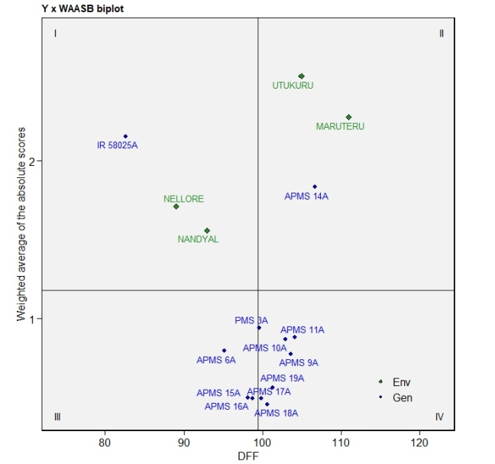 | 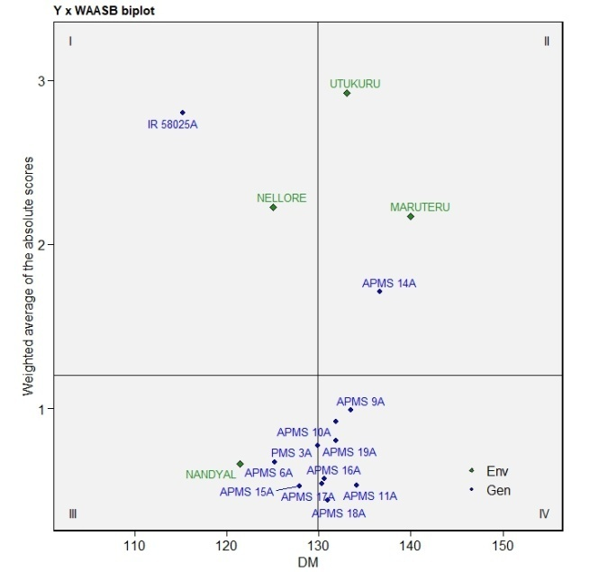
S. Fig. 1a Days to 50% flowering | S. Fig. 1b Days to maturity
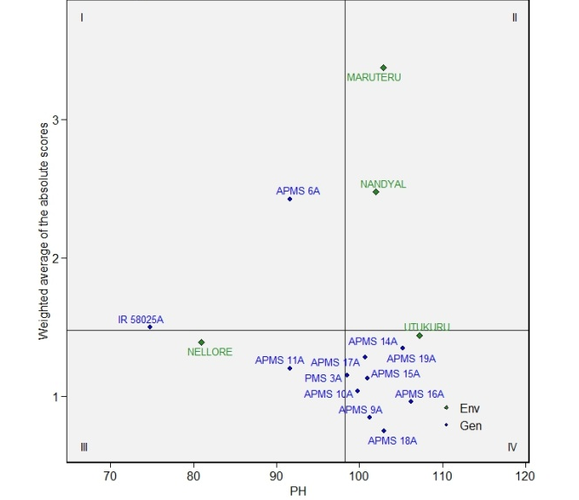 | 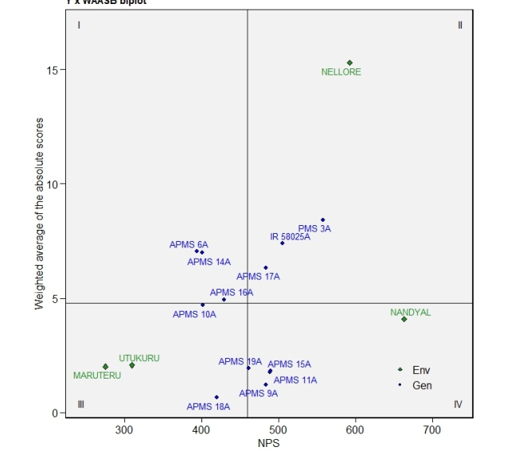
S. Fig. 1c Plant height | S. Fig. 1d Number of panicles m⁻²
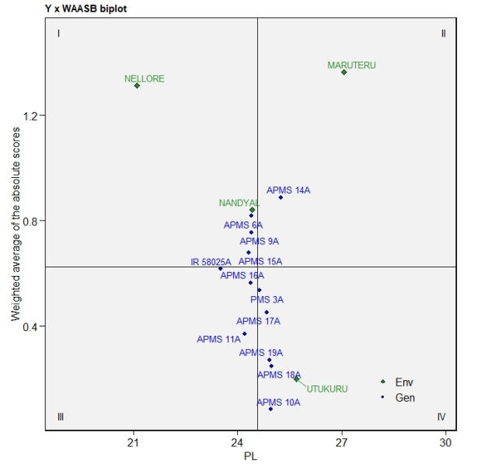 | 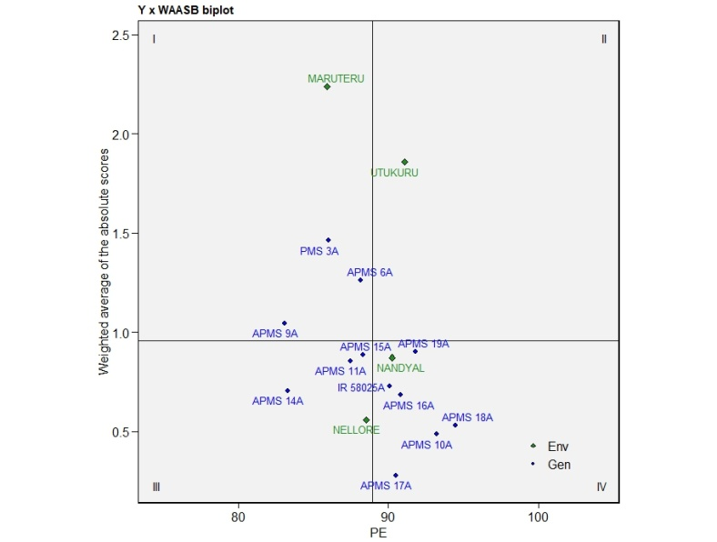
S. Fig. 1e Panicle length | S. Fig. 1f Panicle extraction %
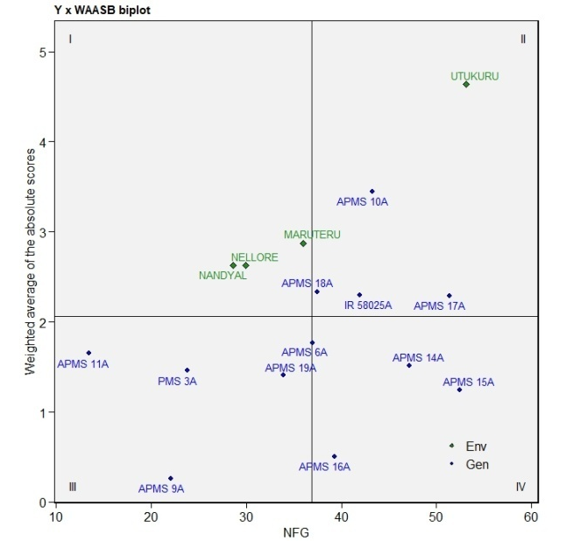 | 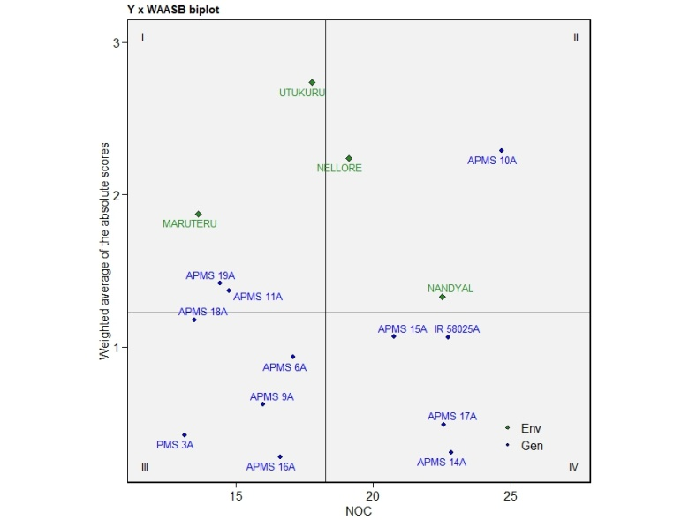
S. Fig. 1g Nuber of filled grains | S. Fig. 1h Natural out crossing %
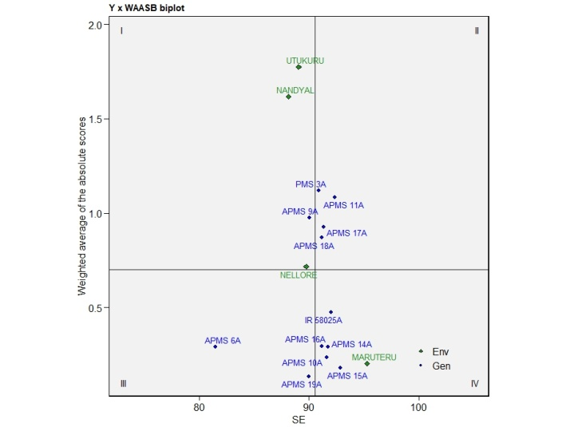 | 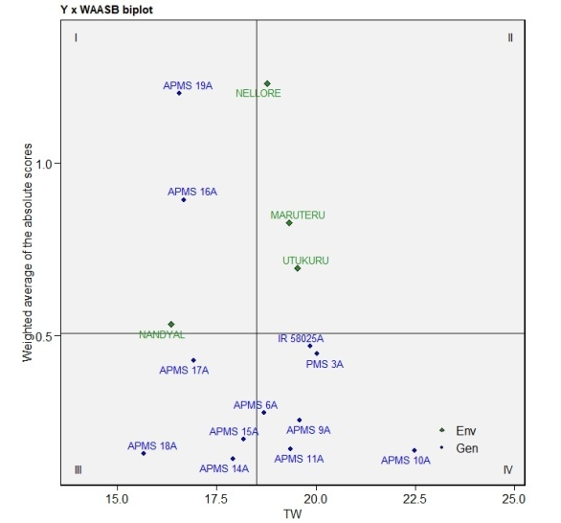
S. Fig. 1i Stigma extraction % | S. Fig. 1j Test weight

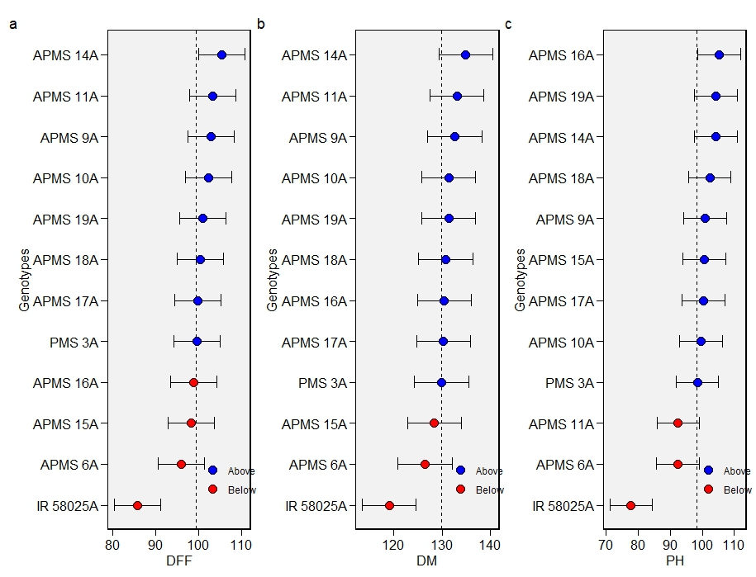
S. Fig. 2a Days to 50% flowering | S. Fig. 2b Days to maturity | S. Fig. 2c Plant height
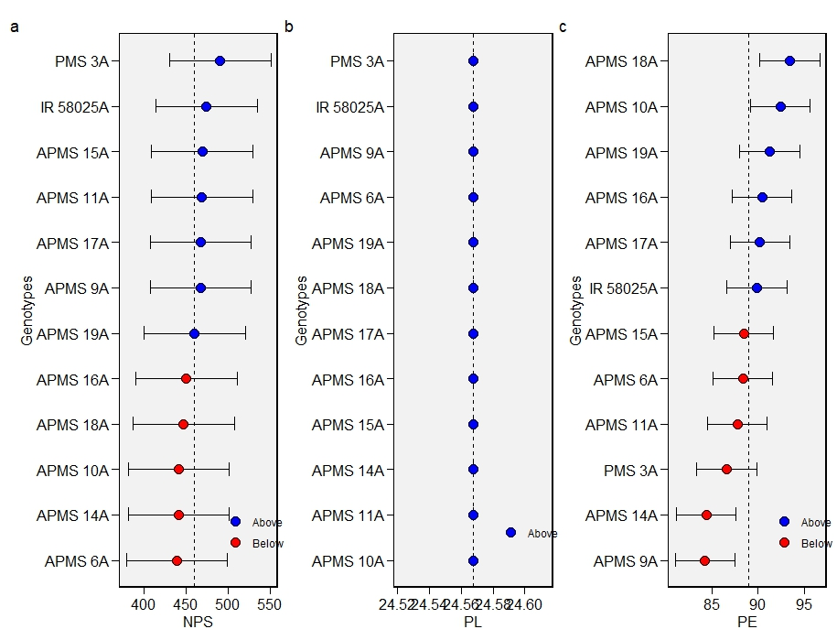
S. Fig. 2d Number of panicles m⁻² | S. Fig. 2e Panicle length | S. Fig. 2f Panicle extraction %
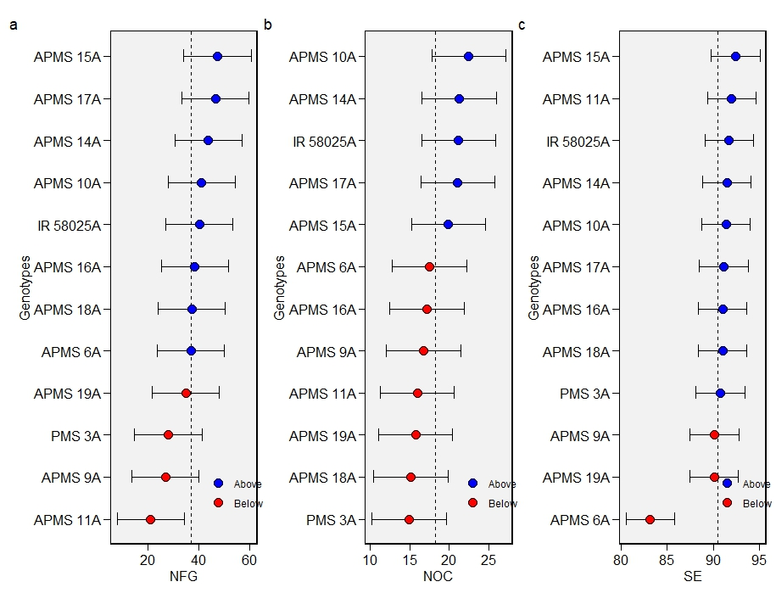
S. Fig. 2g Nuber of filled grains | S. Fig. 2h Natural out crossing % | S. Fig. 2i Stigma extraction %
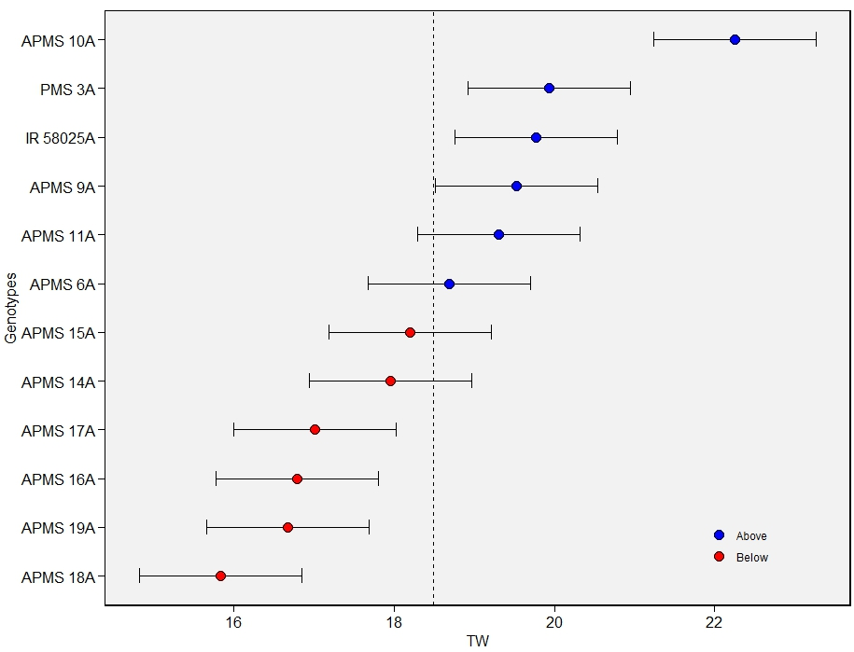
S. Fig. 2j Test weight

