Supporting Information

Increases of temperature response for CO₂ emission in a biochar-amended vegetable field soil

Rong Huang^{1, 2}, Zifang Wang³, Yi Xiao ¹, Luo Yu⁴, Xuesong Gao¹, Changquan Wang^{1,} *, Bing Li¹, Qi Tao¹, Qiang Xu¹, Ming Gao^{2,3} *
¹ College of Resources, Sichuan Agricultural University, Chengdu 611130, China
²Chongqing key Laboratory of Soil Multi-scale Interfacial Process, Chongqing 400715, China
³College of Resources and Environment, Southwest University, Chongqing 400715, China
⁴Chongqing Bishan District Flood Control and Drought Relief Dispatch Center, Chongqing 402760, China
* Corresponding author: Ming Gao, Changquan Wang
E-mail address: gaoming@swu.edu.cn (M. Gao)
w.changquan@163.com (C.Q. Wang)
Present address: College of Resources, Sichuan Agricultural University, Number 211, Huimin Road, Wenjiang District, Chengdu City, Sichuan Province 611130, PR China
Postcode: 611130

1 Text, 3 Tables, and 1 Figure
Text S1 Calculations of Ea and A
The activation energy was calculated via using the exponential Arrhenius function according to Thiessen et al. (2013):
$y=A×e^{\frac{\text{-Ea}}{R⋅T}}$ (Eq. S1)
Where, y is the flux of CO₂ over time (mg m⁻² h⁻¹), A is the constant, E_{a} is the activation energy (J mol⁻¹), R is the universal gas constant (8.314 J mol⁻¹ K⁻¹), T is the soil temperature in Kelvin (K). In chemical kinetics, E_{a} is defined as the necessary energy for reacting molecules to break and form new bonds after a collision.
A new equation (Eq. S2) can be obtained by a natural logarithm of y in Eq. S1.
$\ln{y=\ln{A-(\frac{E_{a}}{R})×(\frac{1}{T})}}$ (Eq. S2)
As a result, the linear regression of the natural logarithms of CO₂ flux against the reciprocal of absolute soil temperature could be used to obtain the daily E_{a}. To estimate the average E_{a} during the experiment period, we multiplied the slope values by the gas constant R.

Table S1 Timetable for straw return to soil, vegetable transplantation, fertilization and vegetable harvesting during four vegetable growth seasons over November 2016 to November 2017.
Planting | Straw return date | Transplantation  date |  | Basal fertilizer application date | Topdressing  date | Harvesting  date
Lettuce | 2016/10/20 | 2016/10/27 |  | 2016/10/30 | 2016/12/09 | 2017/01/09
Cabbage |  | 2017/01/11 |  | 2017/01/10 | 2017/02/21  2017/03/27 | 2017/05/04
Chili | 2017/05/05 | 2017/05/11 |  | 2017/05/10 | 2017/06/19 | 2017/07/20  2017/08/18  2017/09/14
Lettuce |  |  | 2017/09/17 | 2017/09/21 | 2017/11/01 | 2017/11/27
This scheme is the same as our previous study (Huang et al. 2020).
Table S2 Correlation among cumulative CO₂ emission, Cumulative CH₄ emission, temperature response and soil parameters
 | Cumulative CO₂ emission | Cumulative CH₄ emission | Q₁₀ | E_{a} | DOC | MBC | SOC | pH | WFPS | Vegetable yield
Cumulative CO₂ emission | 1 | −0.958** | −0.074 | −0.006 | 0.024 | 0.061 | 0.887** | −0.389 | −0.356 | 0.724*
Cumulative CH₄ emission |  | 1 | 0.171 | 0.111 | 0.124 | −0.146 | −0.888** | 0.525 | 0.477 | −0.788*
Q₁₀ |  |  | 1 | 0.837** | 0.732* | 0.266 | 0.102 | 0.765* | 0.559 | −0.616
E_{a} |  |  |  | 1 | 0.933** | 0.094 | 0.080 | 0.873** | 0.792* | −0.678*
DOC |  |  |  |  | 1 | -0.067 | 0.052 | 0.811** | 0.733* | −0.600
MBC |  |  |  |  |  | 1 | 0.392 | 0.069 | −0.332 | 0.012
SOC |  |  |  |  |  |  | 1 | −0.255 | −0.379 | 0.626
pH |  |  |  |  |  |  |  | 1 | 0.881** | −0.890**
WFPS |  |  |  |  |  |  |  |  | 1 | −0.829**
Asterisks (*, **) indicate significant correlation at P < 0.05 and P < 0.01, respectively. Control, no fertilizer; CF, chemical fertilizer only; BCF, biochar combined with chemical fertilizer; Q₁₀, the temperature sensitivity of CO₂ emission; E_{a}, activation energy of CO₂ emission, DOC, dissolved organic carbon; MBC, microbial biomass carbon; SOC, soil organic carbon; WFPS, soil water-filled pore space.
Table S3 Vegetable yields in different treatments (kg ha⁻¹)
 | Lettuce | Cabbage | Chili | Lettuce | Total
Control | 16358±2971a | 57554±7039b | 576±40b | 28314±3113b | 102802±647b
CF | 20535±2299a | 113832±8808a | 1252±270a | 35318±212a | 170937±7513a
BCF | 21061±2476a | 121336±5271a | 1066±120a | 37994±2582a | 181456±7388a

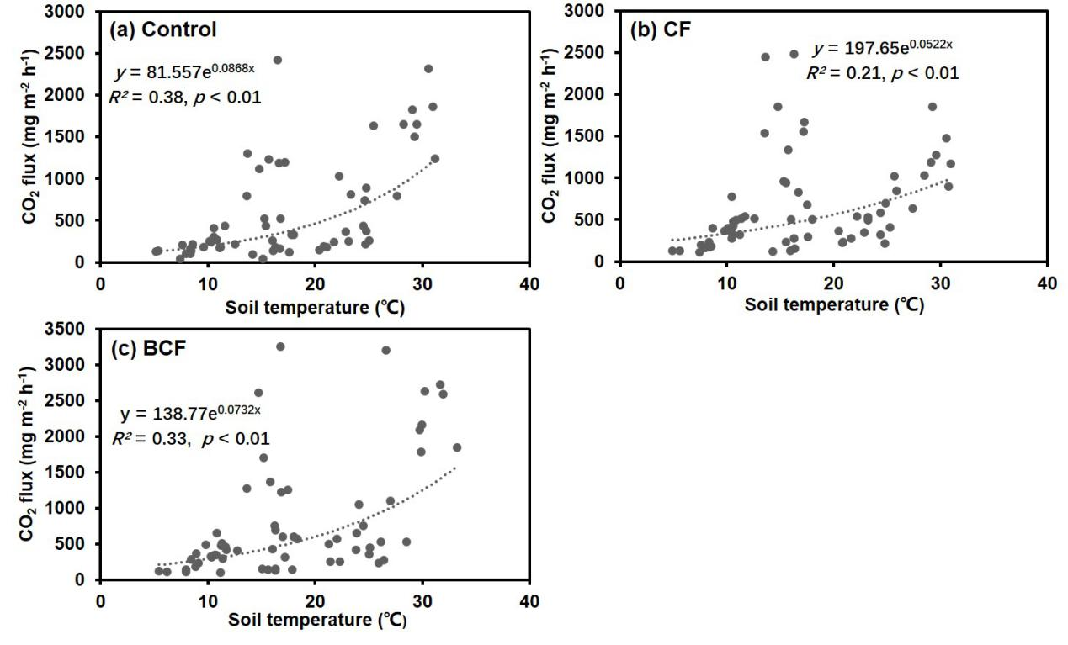
Fig. S1 Exponential relationship of CO₂ flux and soil temperature in control (a), CF (b), BCF (c) treatments.

Reference
Huang, R., Liu, J., He, X., Xie, D., Ni, J., Xu, C., Zhang, Y., Ci, E., Wang, Z., Gao, M., 2020. Reduced mineral fertilization coupled with straw return in field mesocosm vegetable cultivation helps to coordinate greenhouse gas emissions and vegetable production. J. Soils Sediment, 20(4), 1834–1845. https://doi.org/10.1007/s11368-019-02477-2
Thiessen, S., Gleixner, G., Wutzler, T., Reichstein, M., 2013. Both priming and temperature sensitivity of soil organic matter decomposition depend on microbial biomass – An incubation study. Soil Biol. Biochem. 57, 739–748.

