Supplementary Material

Supplementary Methods
The primary analytic sample comprised all 2,557 eligible participants. Common system outcomes were analyzed using modified Poisson regression with HC3 robust standard errors. Age was represented by a natural spline with 3 degrees of freedom. The primary model included sex and nonlinear age; expanded models additionally adjusted for current smoking, current drinking, and BMI. Sex-by-age interaction tests jointly evaluated all spline interaction coefficients. Holm adjustment was applied separately to the six common-system sex associations and to the six interaction tests.
Reproductive and endocrine outcomes were analyzed using mean bias-reduced logistic regression because of sparse events. Overall burden was evaluated in two stages: presence of any symptom in all eligible participants, followed by multisystem involvement among symptom-positive participants. Adult-only models assessed sensitivity to inclusion of participants younger than 18 years.
Latent class models used the six common system indicators in all eligible participants. One- through seven-class solutions were screened with 100 random starts per solution. The selected four-class model was refitted after 1,000 random starts. Classification quality was summarized using entropy, maximum posterior probability, and class-specific average posterior probabilities. Pairwise bivariate residual statistics evaluated local independence; Holm correction was applied across 15 indicator pairs.

Supplementary Table S1. Participant flow
Stage | Description | Participants, n
1 | Initially screened patients with first-episode anxiety disorder | 2,873
2 | Excluded because of incomplete records, missing key variables, or exclusion criteria | 316
3 | Eligible analytic sample | 2,557
4a | At least one somatic symptom | 2,106
4b | No somatic symptoms | 451
Note: The reanalysis used all 2,557 eligible participants for the primary system-specific analyses.

Supplementary Table S2. Characteristics by symptom status
Characteristic | No symptoms (N=451) | At least one symptom (N=2,106) | P value
Female, n (%) | 284 (63.0) | 1494 (70.9) | <0.001
Age, years | 43.2 (19.2) | 49.2 (16.3) | <0.001
BMI, kg/m² | 24.0 (3.7) | 23.5 (3.8) | 0.010
Current smoker, n (%) | 111 (24.6) | 390 (18.5) | 0.003
Current drinker, n (%) | 117 (25.9) | 481 (22.8) | 0.158
Note: P values were calculated using Welch t tests for continuous variables and Pearson chi-square tests for categorical variables.
Supplementary Table S3. Age-group- and sex-specific symptom prevalence
Outcome | <=18 Male | <=18 Female | 19-30 Male | 19-30 Female | 31-45 Male | 31-45 Female | >=46 Male | >=46 Female
Any somatic symptom | 57 (64.0) | 110 (71.9) | 51 (67.1) | 92 (69.7) | 144 (79.6) | 232 (84.7) | 360 (83.1) | 1060 (87.0)
Circulatory | 16 (18.0) | 25 (16.3) | 16 (21.1) | 47 (35.6) | 29 (16.0) | 64 (23.4) | 71 (16.4) | 374 (30.7)
Respiratory | 14 (15.7) | 26 (17.0) | 16 (21.1) | 32 (24.2) | 19 (10.5) | 77 (28.1) | 66 (15.2) | 393 (32.2)
Digestive | 12 (13.5) | 37 (24.2) | 10 (13.2) | 18 (13.6) | 59 (32.6) | 57 (20.8) | 68 (15.7) | 360 (29.5)
Urinary | 2 (2.2) | 4 (2.6) | 7 (9.2) | 3 (2.3) | 16 (8.8) | 3 (1.1) | 32 (7.4) | 14 (1.1)
Reproductive | 0 (0.0) | 1 (0.7) | 3 (3.9) | 1 (0.8) | 2 (1.1) | 4 (1.5) | 15 (3.5) | 0 (0.0)
Neurological | 12 (13.5) | 29 (19.0) | 7 (9.2) | 17 (12.9) | 38 (21.0) | 50 (18.2) | 175 (40.4) | 282 (23.1)
Endocrine | 0 (0.0) | 0 (0.0) | 0 (0.0) | 0 (0.0) | 2 (1.1) | 3 (1.1) | 8 (1.8) | 4 (0.3)
Motor | 11 (12.4) | 13 (8.5) | 3 (3.9) | 3 (2.3) | 25 (13.8) | 16 (5.8) | 60 (13.9) | 32 (2.6)
Note: Each cell reports n/N (%). Age groups are descriptive and were not used as the primary interaction model.

Supplementary Table S4. Bias-reduced logistic models for rare symptom systems
Outcome | Model | Events, n | Female vs male OR (95% CI) | P value | Age per 10 years OR (95% CI) | P value
Reproductive | Minimal | 26 | 0.13 (0.05–0.32) | <0.001 | 1.10 (0.88–1.38) | 0.391
Reproductive | Full | 26 | 0.15 (0.05–0.42) | <0.001 | 1.10 (0.88–1.37) | 0.390
Endocrine | Minimal | 17 | 0.28 (0.11–0.71) | 0.008 | 1.37 (1.01–1.86) | 0.041
Endocrine | Full | 17 | 0.18 (0.06–0.57) | 0.003 | 1.37 (1.02–1.84) | 0.034
Note: Estimates were obtained using mean bias-reduced logistic regression because the outcomes were very rare. The primary model included sex and age per 10-year increase; the expanded model additionally included current smoking, current drinking, and BMI. Results are exploratory; no age-by-sex interaction was fitted and no multiplicity adjustment was applied.

Supplementary Table S5. Any symptom and multisystem burden models
Outcome | Population | Model | n | Events, n | Female vs male aPR (95% CI) | P value
Any somatic symptom | All eligible participants | Minimal | 2557 | 2106 | 1.05 (1.01–1.10) | 0.012
Any somatic symptom | All eligible participants | Full | 2557 | 2106 | 1.04 (0.98–1.09) | 0.209
Two or more systems among symptom-positive participants | Participants with at least one symptom | Minimal | 2106 | 549 | 1.05 (0.89–1.23) | 0.569
Two or more systems among symptom-positive participants | Participants with at least one symptom | Full | 2106 | 549 | 1.08 (0.87–1.35) | 0.463
Three or more systems among symptom-positive participants | Participants with at least one symptom | Minimal | 2106 | 134 | 0.77 (0.54–1.09) | 0.140
Three or more systems among symptom-positive participants | Participants with at least one symptom | Full | 2106 | 134 | 0.88 (0.53–1.46) | 0.626
Note: aPRs were estimated using modified Poisson regression with HC3 robust standard errors. The two-part strategy modeled any symptom in all eligible participants and multisystem involvement only among symptom-positive participants.

Supplementary Table S6. Sensitivity analyses of sex associations in six common systems
System | Minimal model, all participants aPR (95% CI) | Full model, all participants aPR (95% CI) | Full model, adults ≥18 years aPR (95% CI)
Circulatory | 1.67 (1.41–1.99) | 1.74 (1.38–2.18) | 1.80 (1.42–2.28)
Respiratory | 1.96 (1.63–2.35) | 2.22 (1.77–2.80) | 2.36 (1.86–2.99)
Digestive | 1.38 (1.17–1.62) | 1.25 (1.01–1.54) | 1.28 (1.03–1.59)
Urinary | 0.19 (0.12–0.30) | 0.16 (0.09–0.28) | 0.14 (0.08–0.25)
Neurological | 0.67 (0.59–0.77) | 0.68 (0.57–0.82) | 0.66 (0.55–0.80)
Motor | 0.29 (0.21–0.40) | 0.28 (0.19–0.40) | 0.24 (0.16–0.35)
Note: All estimates compare females with males. The adult-only analysis assessed sensitivity to inclusion of children and adolescents.

Supplementary Table S7A. Latent class information criteria
Classes | Log-likelihood | Parameters | AIC | BIC | Adjusted BIC
1 | -6670.98 | 6 | 13353.95 | 13389.03 | 13369.97
2 | -6485.69 | 13 | 12997.38 | 13073.38 | 13032.08
3 | -6439.00 | 20 | 12918.00 | 13034.93 | 12971.39
4 | -6385.72 | 27 | 12825.44 | 12983.29 | 12897.51
5 | -6371.43 | 34 | 12810.86 | 13009.64 | 12901.62
6 | -6361.30 | 41 | 12804.60 | 13044.31 | 12914.04
7 | -6358.53 | 48 | 12813.07 | 13093.70 | 12941.19

Supplementary Table S7B. Latent class classification quality and stability
Classes | Entropy | Minimum class, % | Mean maximum posterior | Minimum AvePP | Best likelihood repeats | Iterations | Converged
1 | 1.000 | 100.0 | 1.000 | 1.000 | 0 | 1 | Yes
2 | 0.874 | 19.3 | 0.965 | 0.866 | 94 | 204 | Yes
3 | 0.825 | 9.0 | 0.908 | 0.619 | 51 | 742 | Yes
4 | 0.886 | 12.9 | 0.950 | 0.887 | 1 | 1641 | Yes
5 | 0.830 | 6.4 | 0.919 | 0.883 | 2 | 4544 | Yes
6 | 0.789 | 5.5 | 0.873 | 0.670 | 1 | 5000 | No
7 | 0.853 | 1.4 | 0.897 | 0.720 | 1 | 5000 | No
Note: The four-class solution was selected because it minimized BIC and adjusted BIC and had favorable entropy, class size, posterior classification quality, and interpretability. Models with six and seven classes did not converge before the maximum number of iterations.
Supplementary Table S8A. Number of affected systems
Affected systems | All eligible participants, n (%) | Symptom-positive participants, n (%)
0 | 451 (17.6) | —
1 | 1557 (60.9) | 1557 (73.9)
2 | 415 (16.2) | 415 (19.7)
3 | 121 (4.7) | 121 (5.7)
4 | 12 (0.5) | 12 (0.6)
5 | 1 (0.0) | 1 (0.0)

Supplementary Table S8B. Twenty most frequent symptom-system combinations
Rank | Symptom-system combination | n | % of symptom-positive participants
1 | Neurological | 412 | 19.6
2 | Respiratory | 359 | 17.0
3 | Digestive | 354 | 16.8
4 | Circulatory | 337 | 16.0
5 | Circulatory + Respiratory | 91 | 4.3
6 | Circulatory + Digestive | 72 | 3.4
7 | Respiratory + Digestive | 70 | 3.3
8 | Motor | 57 | 2.7
9 | Circulatory + Respiratory + Digestive | 39 | 1.9
10 | Circulatory + Neurological | 37 | 1.8
11 | Neurological + Motor | 35 | 1.7
12 | Digestive + Neurological | 30 | 1.4
13 | Respiratory + Neurological | 25 | 1.2
14 | Urinary | 24 | 1.1
15 | Circulatory + Respiratory + Neurological | 15 | 0.7
16 | Reproductive | 11 | 0.5
17 | Digestive + Motor | 8 | 0.4
18 | Urinary + Neurological | 8 | 0.4
19 | Circulatory + Digestive + Neurological | 7 | 0.3
20 | Circulatory + Motor | 7 | 0.3
Note: Percentages use the 2,106 symptom-positive participants as the denominator.

Supplementary Table S9A. Pairwise Phi correlations among all eligible participants
System | Circulatory | Respiratory | Digestive | Urinary | Reproductive | Neurological | Endocrine | Motor
Circulatory | 1.00 | 0.01 | -0.05 | -0.05 | -0.04 | -0.17 | -0.01 | -0.06
Respiratory | 0.01 | 1.00 | -0.07 | -0.04 | -0.03 | -0.21 | -0.01 | -0.06
Digestive | -0.05 | -0.07 | 1.00 | -0.00 | -0.06 | -0.20 | -0.02 | -0.05
Urinary | -0.05 | -0.04 | -0.00 | 1.00 | 0.16 | -0.02 | 0.18 | 0.10
Reproductive | -0.04 | -0.03 | -0.06 | 0.16 | 1.00 | -0.02 | 0.09 | 0.05
Neurological | -0.17 | -0.21 | -0.20 | -0.02 | -0.02 | 1.00 | -0.03 | 0.09
Endocrine | -0.01 | -0.01 | -0.02 | 0.18 | 0.09 | -0.03 | 1.00 | 0.02
Motor | -0.06 | -0.06 | -0.05 | 0.10 | 0.05 | 0.09 | 0.02 | 1.00

Supplementary Table S9B. Pairwise Phi correlations among symptom-positive participants
System | Circulatory | Respiratory | Digestive | Urinary | Reproductive | Neurological | Endocrine | Motor
Circulatory | 1.00 | -0.07 | -0.13 | -0.07 | -0.06 | -0.26 | -0.03 | -0.09
Respiratory | -0.07 | 1.00 | -0.15 | -0.06 | -0.05 | -0.30 | -0.03 | -0.10
Digestive | -0.13 | -0.15 | 1.00 | -0.03 | -0.07 | -0.29 | -0.04 | -0.09
Urinary | -0.07 | -0.06 | -0.03 | 1.00 | 0.16 | -0.04 | 0.18 | 0.09
Reproductive | -0.06 | -0.05 | -0.07 | 0.16 | 1.00 | -0.03 | 0.09 | 0.05
Neurological | -0.26 | -0.30 | -0.29 | -0.04 | -0.03 | 1.00 | -0.05 | 0.06
Endocrine | -0.03 | -0.03 | -0.04 | 0.18 | 0.09 | -0.05 | 1.00 | 0.01
Motor | -0.09 | -0.10 | -0.09 | 0.09 | 0.05 | 0.06 | 0.01 | 1.00
Note: Negative coefficients among symptom-positive participants partly reflect conditioning on the presence of at least one symptom.

Supplementary Table S10. Local-independence diagnostics for the final four-class model
Indicator pair | Bivariate residual chi-square | Unadjusted P | Holm-adjusted P | Interpretation
Circulatory - Respiratory | 0.000 | 0.987 | 1.000 | No residual association after Holm correction
Circulatory - Digestive | 0.003 | 0.957 | 1.000 | No residual association after Holm correction
Circulatory - Urinary | 0.041 | 0.840 | 1.000 | No residual association after Holm correction
Circulatory - Neurological | 0.001 | 0.973 | 1.000 | No residual association after Holm correction
Circulatory - Motor | 0.105 | 0.746 | 1.000 | No residual association after Holm correction
Respiratory - Digestive | 2.681 | 0.102 | 1.000 | No residual association after Holm correction
Respiratory - Urinary | 0.263 | 0.608 | 1.000 | No residual association after Holm correction
Respiratory - Neurological | 0.312 | 0.577 | 1.000 | No residual association after Holm correction
Respiratory - Motor | 4.862 | 0.027 | 0.357 | No residual association after Holm correction
Digestive - Urinary | 0.924 | 0.336 | 1.000 | No residual association after Holm correction
Digestive - Neurological | 0.002 | 0.965 | 1.000 | No residual association after Holm correction
Digestive - Motor | 1.122 | 0.289 | 1.000 | No residual association after Holm correction
Urinary - Neurological | 7.650 | 0.006 | 0.079 | No residual association after Holm correction
Urinary - Motor | 13.140 | <0.001 | 0.004 | Residual association after Holm correction
Neurological - Motor | 0.051 | 0.822 | 1.000 | No residual association after Holm correction
Note: Bivariate residuals are chi-square statistics with 1 degree of freedom. P values were adjusted across 15 indicator pairs using the Holm method. Only the urinary-motor pair remained significant after adjustment.

Supplementary Figures
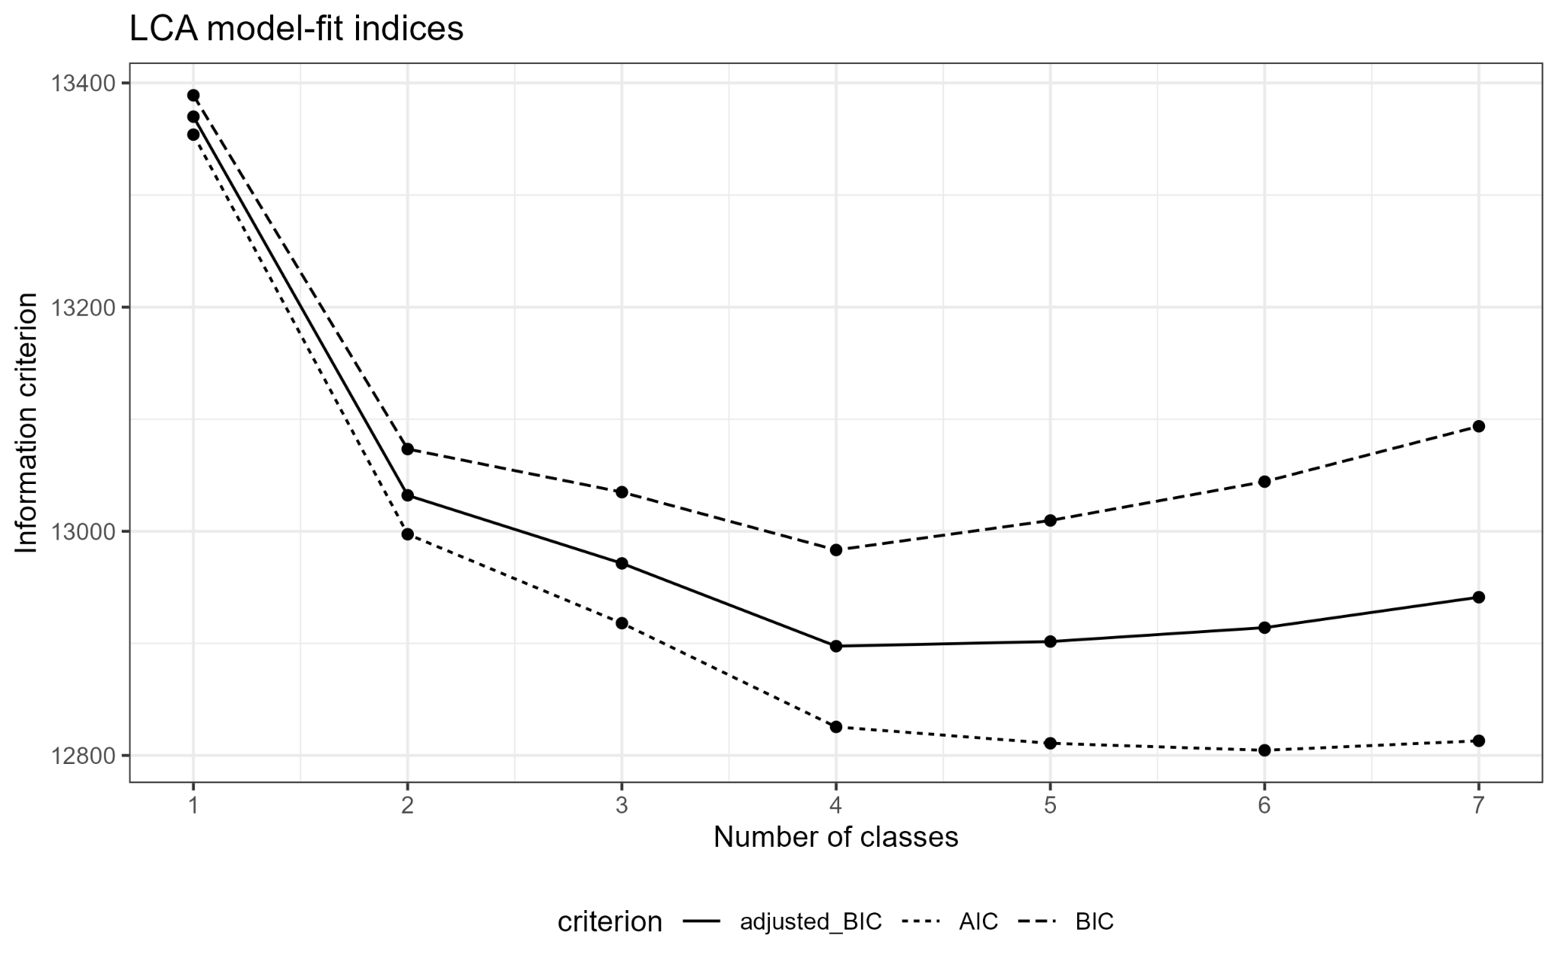
Figure S1. Information criteria for one- through seven-class latent class models. Lower values indicate better relative fit. The four-class solution minimized BIC and sample-size-adjusted BIC.
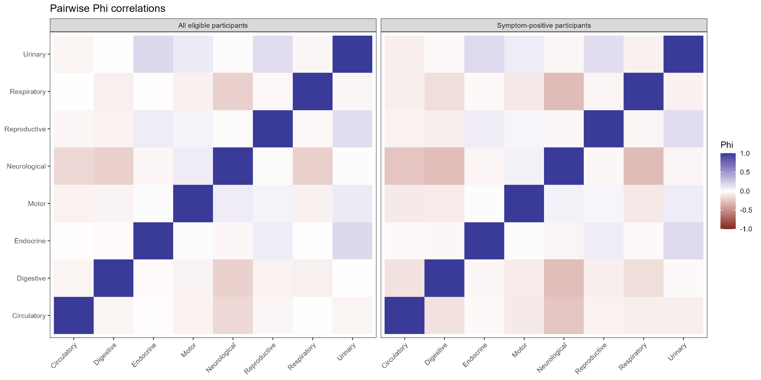
Figure S2. Pairwise Phi correlations among the eight symptom systems in all eligible participants and among symptom-positive participants.

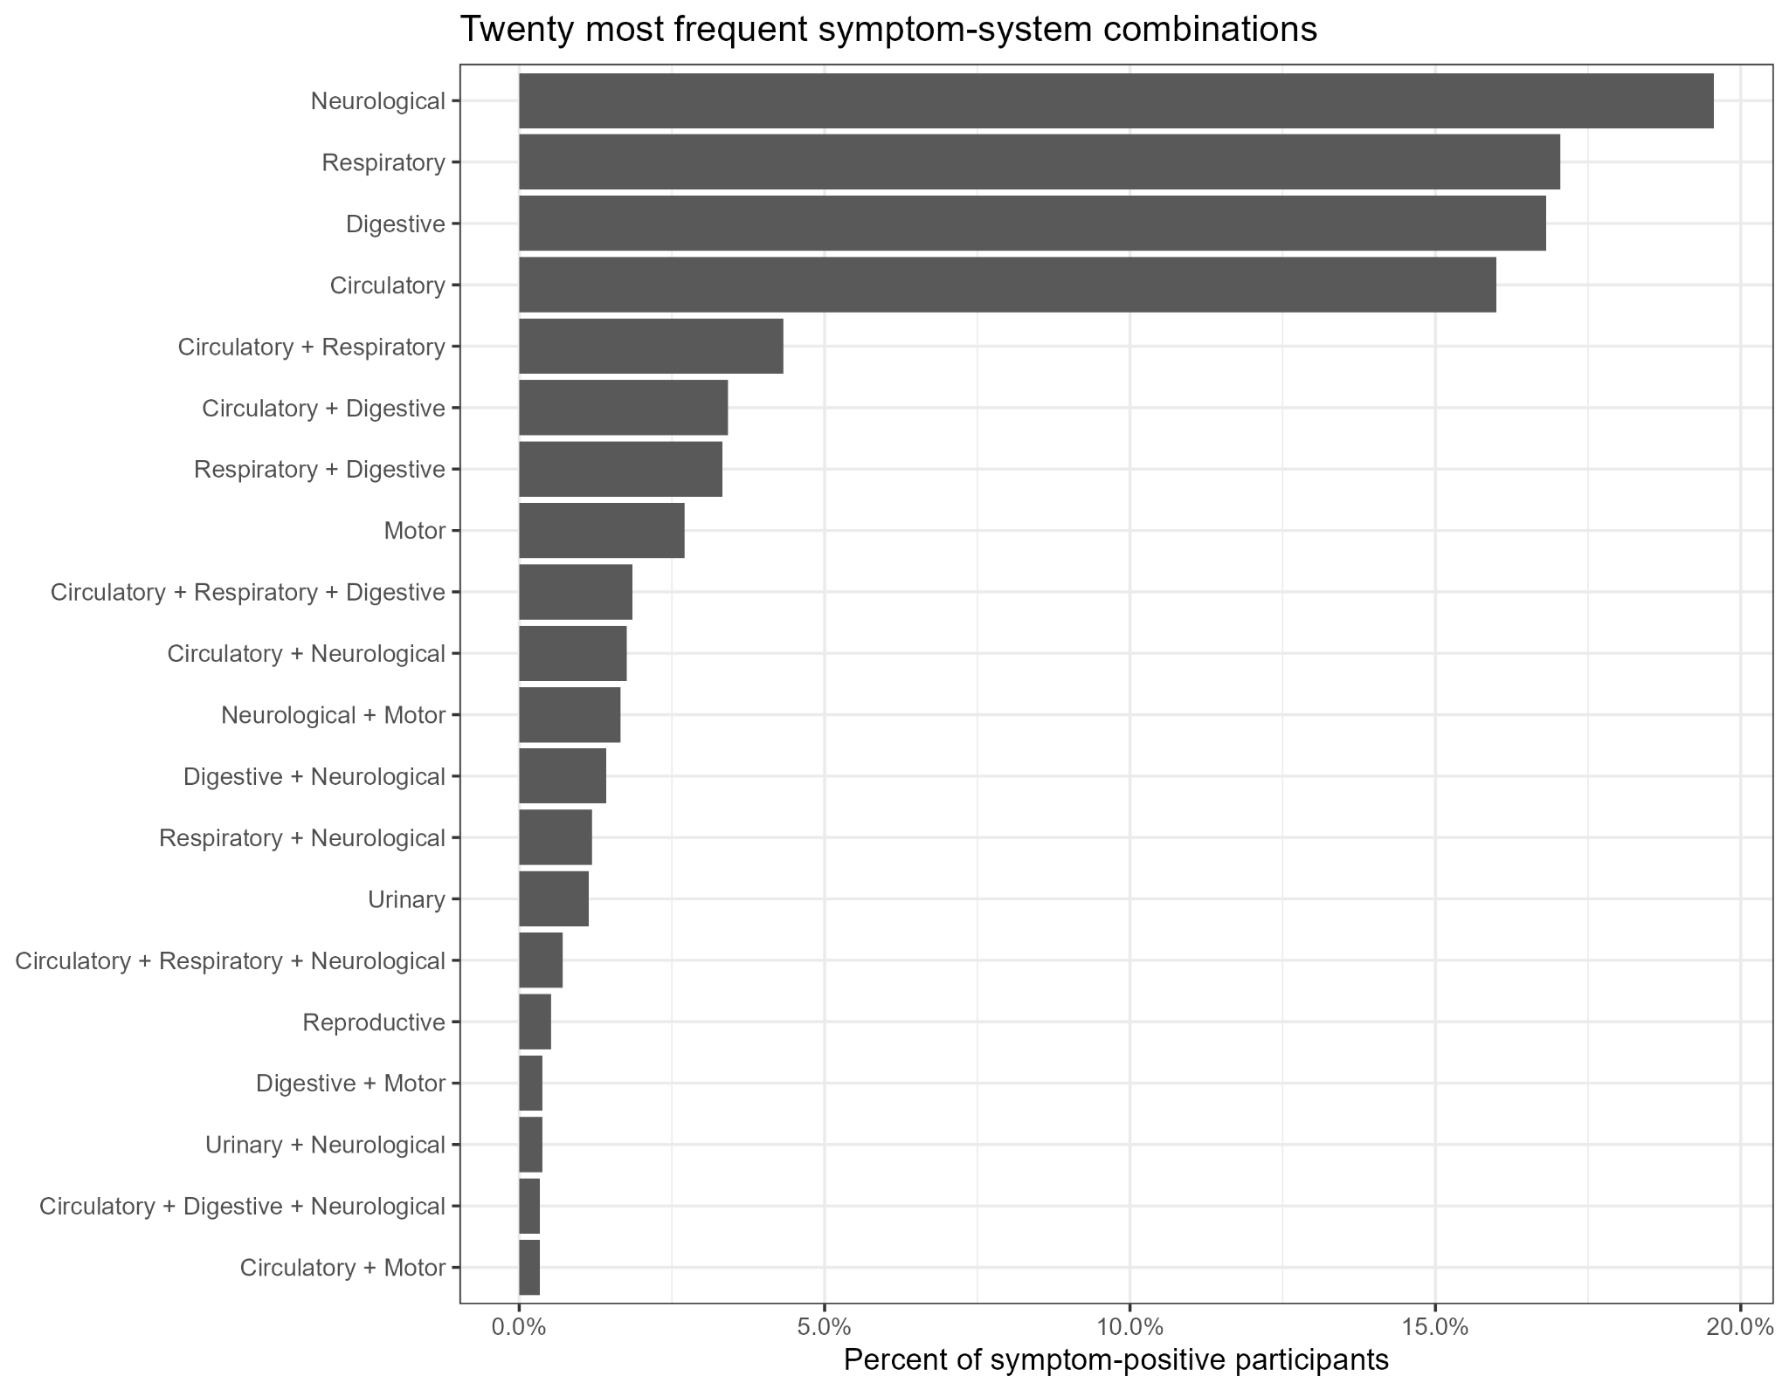
Figure S3. Twenty most frequent symptom-system combinations among the 2,106 symptom-positive participants.

