Figure S1. Extension Phase Participant Flow Diagram by Neflamapimod Drug Batchj

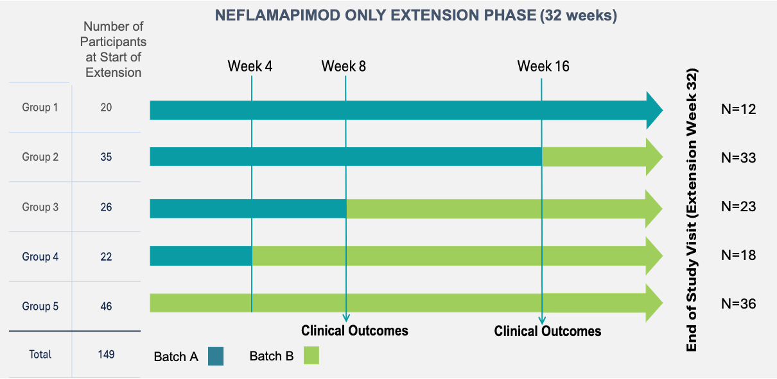

Figure S2. Pharmacokinetic Results by Neflamapimod Drug Product

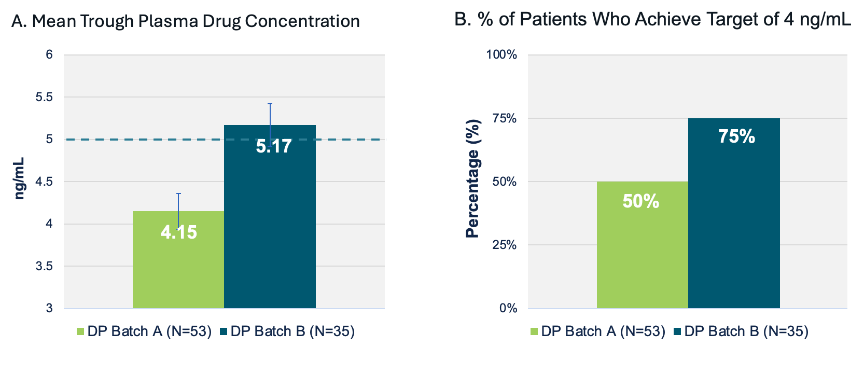
Legend. A. Mean trough plasma drug concentration (C_{Trough}) by neflamapimod drug product batch (P=0.003 for the difference between Batch A and DBatch B). The dashed line is the 5 ng/mL concentration that was the expected mean C_{Trough} at steady state for 40mg TID based on data from prior clinical studies. B. Percentage of participants within each neflamapimod batch group whose C_{Trough} exceeded the individual participant target of 4 ng/mL deriuved in prior PK-PD analyses (P=0.02 for difference vetween DP Batch A and DP Batch B in the percentage of participants who achieved a C_{Trough} of 4 ng/mL). Plasma samples for C_{Trough} obtained at Week 2 of the randomized phase and Week 4 of the extension phase. Participants/caregivers were instructed to not take their morning dose of study drug on those visit dates, come to the clinical site and provide a sample for pharmacokinetic determination prior to taking their morning dose. The time that the sample was obtained and the time of the last dose of study drug was recorded. To obtain a true C_{Trough} value, pharmacokinetic modeling was utilized to regress back to 12-hour post-dose timepoint using the measured value and time post-dose the sample was obtained, which varied between 8 and up to more than 20 hours after the evening dose (mean = 15.5 hours post evening dose).

Figure S3. Mean change in CDR-SB and ADCS-CGIC during first 16 weeks of the Extension Phase with DP Batch B, compared to DP Batch A

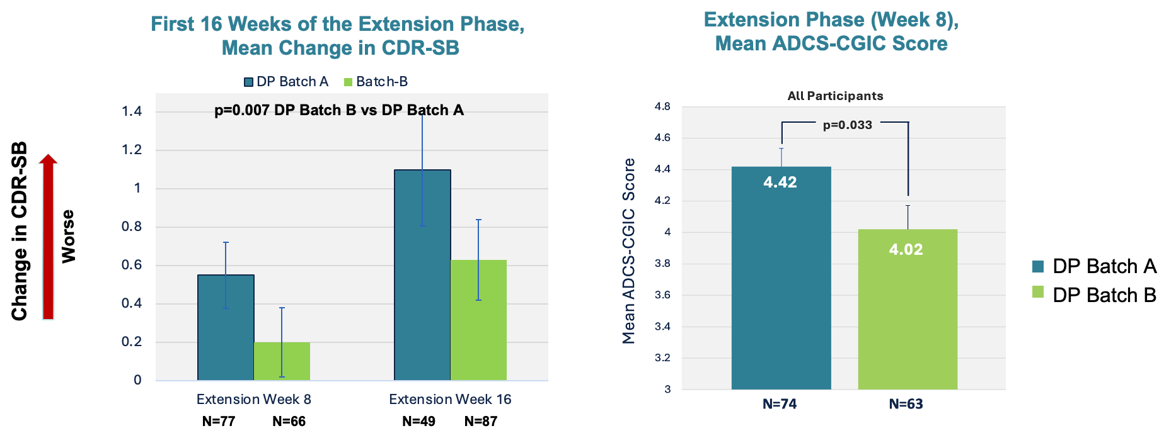

Legend. DP Batch A: Batch of neflamapimod capsules utilized during the placebo-controlled period and in a subset of participants during the extension. Due to batch- to-batch variability in polymorphic solid- state forms, did not achieve expected plasma drug concentrations for 40mg TID. DP Batch B: Achieved the expected plasma drug concentrations for 40mg TID.
Change in CDR-SB: Change from start of extension phase (study week 16; end of placebo-controlled period) analyzed by linear mixed effects (LME) model incorporating data from both week 8 and 16 of the extension.
Alzheimer's Disease Collaborative Study (ADCS) - Clinical Global Impression of Change (CGIC): obtained at week 8 of the extension to assess clinical global impression of change from start of extension to week 8 of the extension, analyzed by Mann-Whitney rank sum test.

Figure S4. Pharmacokinetic-Pharmacodynamic Relationship in 24-Week Placebo-Controlled Study¹ of Neflamapimod in Early Alzheimer’s Disease (AD)
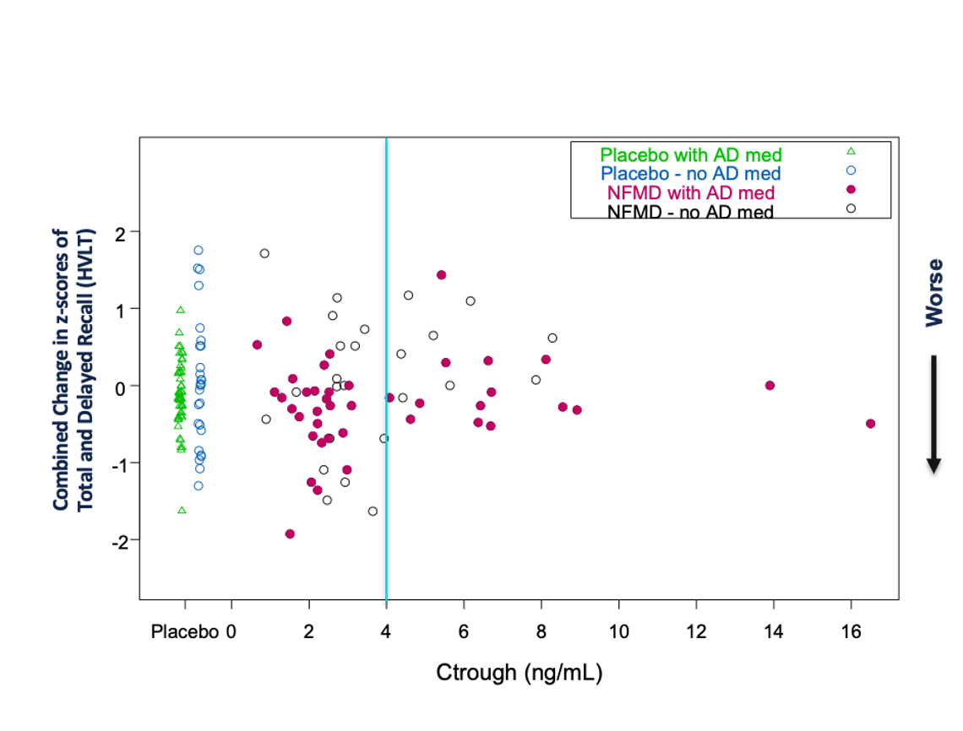

Adapted from Prins et al. Alzheimer's Research & Therapy (2021) 13:106 https://doi.org/10.1186/s13195-021-00843-2

Figure S5. Neflamapimod Concentration Effect Relationships
