A novel Gorilla-derived oncolytic Adenovirus with natural selective replication in lung cancer cells

Romina Scalaª, Ilaria Cela^{b,c}, Emily Capone^{c,d}, Valentina Proganòª, Angiolo Pierantoniª, Stefano Collocaª, Gianluca Sala^{b,c,}* and Angelo Raggioli^{a,*,#}

ªReiThera Srl, Castel Romano, Rome, Italy
^{b}Department of Innovative Technologies in Medicine & Dentistry, “G. d’Annunzio” University of Chieti-Pescara, Chieti, Italy
^{c}Center for Advanced Studies and Technology (CAST), “G. d’Annunzio” University of Chieti-Pescara, Chieti, Italy
^{d}Department of Science, “G. d’Annunzio” University of Chieti-Pescara, Chieti, Italy

Running Head: Novel tumor-selective oncolytic adenovirus

#Address correspondence to Angelo Raggioli, angelo.raggioli@reithera.com.
*These authors share senior authorship
Supplementary Figure S1. Production, infectivity, and transduction properties of GRAd32-Luciferase and GRAd32Fk25-Luciferase
GRAd32-Luciferase (GRAd32-Luc) and GRAd32Fk25-Luciferase (GRAd32Fk25-Luc) were compared in terms of productivity, manufacturability, infectivity, and functional transduction.
(A) Cell-specific productivity, expressed as viral genomes per cell (vg/cell), was comparable between the two vectors, reaching 9.12 × 10^4 vg/cell for GRAd32-Luc and 7.93 × 10^4 vg/cell for GRAd32Fk25-Luc, indicating that replacement of the fiber knob does not substantially impair viral production.
(B) Purification yield at passage 2 (P2). GRAd32Fk25-Luc was successfully purified and reached suitable physical titers. Because GRAd32 and GRAd32Fk25 share the same hexon protein, and the Sartorius purification process is primarily driven by hexon-dependent physicochemical properties, major differences in purification behavior were not expected. Consistent with this, GRAd32Fk25-Luc showed a purification yield of 37.5%, compared with 50% for GRAd32-Luc.
(C) Infectious titer measured on HEK293 cells by hexon staining and expressed as IFU/mL. Infectious titer was moderately lower for GRAd32Fk25-Luc than for GRAd32-Luc.
(D) Specific infectivity expressed as vg/IFU ratio. Consistent with panel C, GRAd32Fk25-Luc displayed a higher vg/IFU ratio. Since HEK293 cells express sufficient CAR to support efficient infection by the parental GRAd32 fiber, this assay may underestimate the potential advantage conferred by the GRAd25 fiber knob in CD46-dependent cellular contexts.
(E) Luciferase expression following infection at MOI 250 in HeLa and the indicated cancer cell lines. MOI was normalized to physical titer and A549 cells were excluded from this analysis. Because the assay was performed under non-replicative conditions, luciferase expression reflects functional entry/transduction rather than viral amplification. The GRAd25 fiber knob altered the transduction profile of GRAd32 in a cell-dependent manner. Increased luciferase activity was observed primarily in cell types known to express relatively low levels of CAR, including MRC-5 and SK-OV-3 cells, consistent with improved entry in cellular contexts where CAR-mediated infection may be limiting. In other cell lines, transduction was unchanged or reduced.
Together, these findings demonstrate that GRAd32Fk25-Luc can be efficiently produced, purified, titrated, and functionally evaluated, supporting the feasibility of the GRAd32Fk25 platform. Data represent the mean ± SD of three independent experiments.

Supplementary Figure S2. Evaluation of fiber-modified GRAd entry in various cell lines
Luciferase activity (expressed in arbitrary units, a.u.) was measured in MRC5, A549, NCI-H727, NCI-H1299, and NCI-H1975 cells 48 hours post-transduction. Cells were infected with either the control vector GRAd32 (blue bars) or the fiber-modified vector GRAd32Fk25 (orange bars) at a multiplicity of infection (MOI) of 100. Data represent the mean ± SD of three independent experiments.

Supplementary Figure S3. Total and nuclease-resistant viral genomes following GRAd32Fk25 infection
A549 and MRC5 cells were infected with GRAd32Fk25 at MOI 100 and harvested 48 hours post-infection. Viral genomes were quantified by ddPCR either directly (− nuclease: total viral genomes) or following nuclease treatment (+ nuclease: nuclease-resistant viral genomes). Values are expressed as viral genomes per ml (vg/mL). Similar to parental GRAd32, GRAd32Fk25 showed high levels of viral genome accumulation in A549 cells, whereas both total and nuclease-resistant viral genomes remained markedly reduced in MRC5 cells, indicating that the replication restriction observed in normal cells is maintained despite replacement of the fiber knob.

Supplementary Figure S5B
Western blot analysis of EV20 antibody expression in A549, NCI-H727, and NCI-H1975 cells. Cells were infected with viral vectors encoding EV20 in single-chain format. In each panel, lanes 1–4 correspond to infected cells expressing EV20 in single-chain format, resulting in the detection of a single immunoreactive band. Lane 5 was left empty. Lane 6 contains purified EV20 antibody in its conventional heavy-chain plus light-chain format, resulting in two distinct bands corresponding to the heavy and light chains. The molecular weight marker shown in the leftmost lane is Invitrogen SeeBlue™ Plus2 Pre-stained Protein Standard, LC5925, Thermo Fisher Scientific.

Supplementary Figure S5C
Western blot analysis of EV20 expression following infection with GRAd25 or GRAd32Fk25. Cells were infected at the indicated multiplicities of infection (MOI), and EV20 expression was assessed by Western blot. Lane M contains the molecular weight marker, Invitrogen SeeBlue™ Plus2 Pre-stained Protein Standard, LC5925, Thermo Fisher Scientific. Lanes 1 and 2 correspond to GRAd25 infection at MOI 100 and MOI 10, respectively; lane 3 corresponds to mock-infected cells. Lanes 4 and 5 correspond to GRAd32Fk25 infection at MOI 100 and MOI 10, respectively; lane 6 corresponds to mock-infected cells. Lane 7 contains purified EV20 antibody used as a Western blot positive control; however, the control failed, likely due to antibody degradation caused by repeated freeze–thaw cycles. Two separate mock controls are shown in lanes 3 and 6 because GRAd25 and GRAd32Fk25 infections were performed in separate plates. The bands observed at lower molecular weights than the expected EV20 single-chain signal and the heavy chain of the positive control are considered non-specific.

Supplementary Figure S5H
Western blot analysis of HER3 signaling in A375M cells treated with conditioned media derived from the indicated lung cancer cell lines. A375M cells were treated with supernatants produced by A549, NCI-H727, or NCI-H1975 cells that were either mock-infected or infected with GRAd32Fk25-EV20sc at MOI 100, in the presence of NRG-1β where indicated. HER3, phospho-HER3, AKT, phospho-AKT, and actin were analyzed by Western blot; samples were run on two separate gels to allow probing of the indicated targets, with actin included as loading control on both gels. Lane M contains the molecular weight marker Prestained Protein SHARPMASS VI, EC-EPS025500. Lane 1, untreated cells without NRG-1β; lane 2, untreated cells with NRG-1β; lane 3, EV20 antibody with NRG-1β; lane 4, heat-treated EV20 antibody with NRG-1β; lane 5, mock A549 supernatant with NRG-1β; lane 6, supernatant from A549 cells infected with GRAd32Fk25-EV20sc at MOI 100 with NRG-1β; lane 7, mock NCI-H727 supernatant with NRG-1β; lane 8, supernatant from NCI-H727 cells infected with GRAd32Fk25-EV20sc at MOI 100 with NRG-1β; lane 9, mock NCI-H1975 supernatant with NRG-1β; lane 10, supernatant from NCI-H1975 cells infected with GRAd32Fk25-EV20sc at MOI 100 with NRG-1β.

Supplementary Figure S1

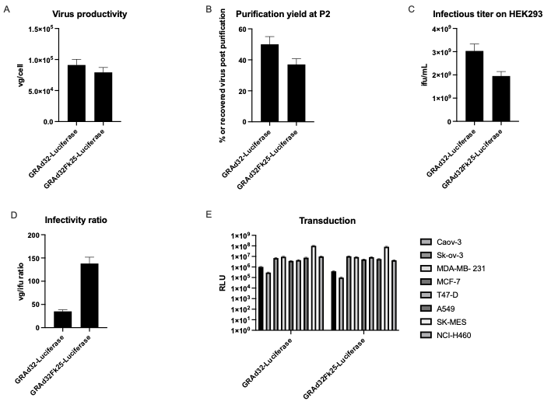

Supplementary Figure S2

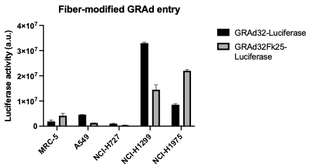

Supplementary Figure S3
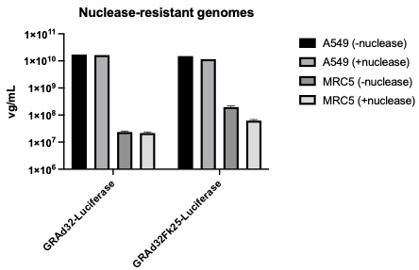

Supplementary Figure S5B

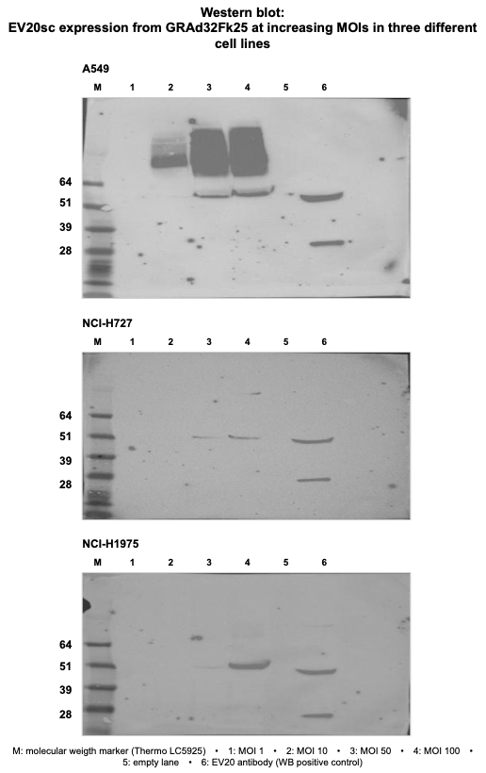

Supplementary Figure S5C

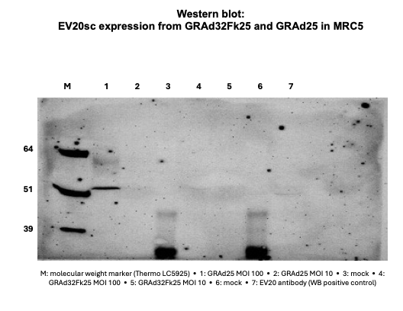

Supplementary Figure S5H

