Supplementary Material
Supplementary Methods, Tables, and Figures
Dynamic evolution of subchorionic hematoma and its association with pregnancy outcomes and mode of delivery: a real-world cohort study

Supplementary Methods
- Calculation of the SCH-to-gestational tissue ratio
The SCH-to-gestational tissue ratio was calculated for each ultrasound examination to quantify the relative burden of subchorionic hematoma across different gestational stages. Different calculation methods were applied according to gestational age.
Early pregnancy
For ultrasound examinations performed before 12 weeks of gestation, the relative burden of SCH was estimated using the SCH-to-gestational-sac area ratio. Both the SCH and the gestational sac were approximated as ellipses based on their long and short diameters. The ratio was calculated as:
R = Aₕ / Aₙ = (L × W) / (r₁ × r₂)
Where L and W are the long and short diameters of the hematoma, and r₁ and r₂ are the long and short diameters of the gestational sac. The measurement method is illustrated in Supplementary Figure S1.
Second and third trimesters
For ultrasound examinations performed at or after 12 weeks of gestation, the relative burden of SCH was estimated using the SCH-to-total gestational tissue volume ratio:
R = Vₕ/ Vₕ + Vₚ + Vₐ + Vf
where:
• Vₕ: SCH volume (approximated as an ellipsoid)
Vₕ ≈ (4/3) × π × (L/2) × (W/2) × (H/2)
• Vₚ: placental volume (approximated as a cuboid)
Vₚ ≈ L × W × T
• Vₐ: amniotic fluid volume (approximated using the maximum vertical pocket as a sphere)
Vₐ ≈ (4/3) × π × (A/2)³
• V_{f}: fetal volume (approximated as an ellipsoid using biparietal diameter and femur length).
V_{f} ≈ (4/3)π × (BPD/2)² × (FL/2)
The ultrasonographic measurements used in the volume-based calculation are illustrated in Supplementary Figure S2.
All SCH-to-gestational tissue ratios were recorded as continuous, dimensionless variables.
- Standardization of SCH location
The anatomical location of SCH was extracted from the original ultrasonographic reports and standardized according to its relationship with the gestational sac, placenta, fetal membranes, and lower uterine segment. Based on the terminology routinely used in our institutional ultrasound reports, SCH was classified into one of four predefined categories:
- Peri-gestational-sac SCH: Hematoma located adjacent to the gestational sac during early pregnancy before complete placental formation.
- Intraplacental SCH: Hematoma located within the placental parenchyma.
- Retro-membranous SCH: Hematoma located between the fetal membranes and the uterine wall without direct placental involvement.
- Lower uterine segment SCH: Hematoma located predominantly within the lower uterine segment, superior to the internal cervical os.
The standardized SCH location was treated as a categorical variable and included in subsequent descriptive analyses and regression models.
- Classification of SCH burden
To facilitate stratified analyses and clinical interpretation, the SCH-to-gestational tissue ratio was further converted into an ordinal categorical variable according to gestational-age-specific thresholds. Because the anatomical composition of gestational tissues and the ultrasonographic assessment methods differ substantially across gestational stages, separate grading criteria were applied before and after 12 weeks of gestation.
The grading thresholds were defined with reference to previously reported SCH classification approaches and adapted according to the gestational-age-specific measurement methods used in the present study. These categories were applied for exploratory stratification and statistical analyses rather than as independent diagnostic criteria.
For pregnancies before 12 weeks of gestation, SCH burden was graded based on the SCH-to-gestational-sac area ratio:
- Low grade: R < 1/3
- Medium grade: 1/3 ≤ R ≤ 2/3
- High grade: R > 2/3
For pregnancies at or after 12 weeks of gestation, SCH burden was graded based on the SCH-to-total gestational tissue volume ratio:
- Low grade: R < 0.05
- Medium grade: 0.05 ≤ R ≤ 0.25
- High grade: R > 0.25
The resulting SCH grade was stored as an ordinal categorical variable (Low, Medium, High) and was used for descriptive analyses, subgroup comparisons, regression analyses, and trend analyses.
- Definition of longitudinal SCH variables
Because SCH represents a dynamic ultrasonographic finding that may change in size and relative burden during pregnancy, all available ultrasound examinations documenting SCH were reviewed chronologically for each participant. The SCH-to-gestational tissue ratio was calculated for each examination using the gestational-age-specific methods described above.
To characterize the temporal evolution of SCH burden, three longitudinal SCH ratio variables were derived:
- Initial SCH ratio: defined as the SCH-to-gestational tissue ratio measured at the first ultrasound examination confirming the presence of SCH.
- Maximum SCH ratio: defined as the highest SCH-to-gestational tissue ratio recorded during the follow-up period.
- Final SCH ratio: defined as the SCH-to-gestational tissue ratio measured at the last available ultrasound examination during pregnancy follow-up.
These longitudinal SCH ratio variables were retained as continuous measures and were used in subsequent correlation analyses and regression models.
- Definitions of pregnancy outcomes and delivery modes
Definition of pregnancy outcomes
Pregnancy outcomes were classified according to gestational age at pregnancy loss or delivery based on the final clinical outcome documented in the electronic medical records.
The pregnancy outcomes were categorized into four groups:
- Miscarriage / inevitable abortion: pregnancy loss occurring before 22 weeks of gestation.
- Extremely preterm birth: delivery occurring at ≥22 and <28 weeks of gestation.
- Preterm birth: delivery occurring at ≥28 and <37 weeks of gestation.
- Full-term birth: delivery occurring at ≥37 weeks of gestation.
For logistic regression analyses, full-term birth was defined as the outcome event, whereas all other pregnancy outcomes were considered non-full-term outcomes.
Definition of delivery modes
Delivery mode was determined based on the final pregnancy outcome documented in the electronic medical records. Four categories were used:
- Spontaneous vaginal delivery: vaginal delivery occurring without instrumental assistance.
- Assisted vaginal delivery: vaginal delivery requiring obstetric instrumental assistance, including vacuum-assisted or forceps-assisted delivery.
- Cesarean section: delivery performed by cesarean operation.
- Miscarriage-related procedure: procedures performed for pregnancy loss, including surgical evacuation or other related interventions.
Delivery mode was treated as a categorical variable and was used for descriptive analyses and correlation analyses evaluating the association between SCH characteristics and mode of delivery. Unless otherwise specified, all derived variables described above were incorporated into the statistical analyses presented in the main manuscript.
Supplementary Figure S1
Ultrasonographic measurements used for calculating the SCH-to-gestational-sac area ratio before 12 weeks of gestation.
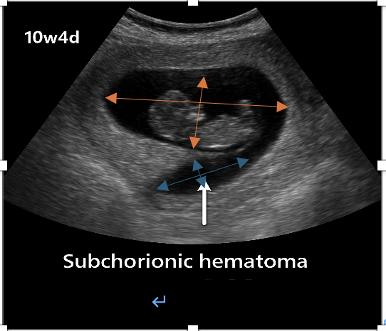
Blue arrows indicate the long (L) and short (W) diameters of the subchorionic hematoma (SCH), whereas orange arrows indicate the long (r₁) and short (r₂) diameters of the gestational sac. These measurements were used to calculate the SCH-to-gestational-sac area ratio described in the Supplementary Methods.
Supplementary Figure S2
Ultrasonographic measurements used for calculating the SCH-to-total gestational tissue volume ratio at or after 12 weeks of gestation.
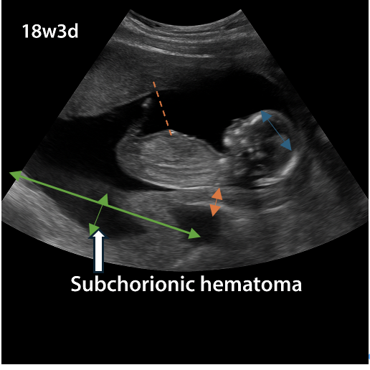
Green arrows indicate the long (L) and short (W) diameters of the SCH. Orange arrows indicate placental thickness (T), whereas placental length (Lp) was measured along the maximal placental axis. The red dashed line indicates the maximum vertical pocket of amniotic fluid (A). Blue arrows indicate the biparietal diameter (BPD). Femur length (FL), obtained during routine fetal biometry, was incorporated into the estimation of fetal volume but is not illustrated in this representative image.

Supplementary Table S1
Variable | Definition | Variable type
Initial SCH ratio | SCH ratio at first ultrasound | Continuous
Maximum SCH ratio | Highest SCH ratio during follow-up | Continuous
Final SCH ratio | SCH ratio at last ultrasound | Continuous
SCH location | Peri-gestational-sac / Intraplacental / Retro-membranous / Lower uterine segment | Categorical
SCH grade | Low / Medium / High | Ordinal
Pregnancy outcome | Four categories | Categorical
Delivery mode | Four categories | Categorical

Supplementary Table S2. Univariate logistic regression analyses for factors associated with full-term birth
Variable | Comparison / Unit | β | OR | 95% CI | P value
Gravidity | Per additional pregnancy | -0.179 | 0.836 | 0.782–0.894 | <0.001
Previous miscarriage | Per additional miscarriage | -0.460 | 0.632 | 0.458–0.870 | 0.005
Parity | Per additional birth | -0.233 | 0.792 | 0.660–0.951 | 0.012
Number of clinical visits | Per additional visit | 0.115 | 1.122 | 1.055–1.192 | <0.001
Maternal age at delivery (years) | Per one-year increase | 0.069 | 1.071 | 1.039–1.104 | <0.001
BMI category before delivery | Per category increase | -0.211 | 0.810 | 0.698–0.940 | 0.006
IVF conception | Yes vs. No | 0.295 | 1.343 | 1.032–1.748 | 0.028
Gestational age at first SCH detection (weeks) | Per one-week increase | 0.055 | 1.057 | 1.034–1.079 | <0.001
SCH location | Retro-membranous vs. peri-gestational-sac | 0.417 | 1.517 | 1.009–2.282 | 0.045
 | Intraplacental vs. peri-gestational-sac | 0.725 | 2.064 | 1.470–2.899 | <0.001
 | Lower uterine segment vs. peri-gestational-sac | 0.717 | 2.049 | 1.223–3.435 | 0.006
Notes: Binary logistic regression analyses were performed with full-term birth as the outcome event. Continuous variables were modeled per unit increase unless otherwise specified. BMI category was analyzed as an ordinal variable. For SCH location, peri-gestational-sac SCH served as the reference category. Variables showing statistically significant associations in the univariate analyses were subsequently included in the multivariable logistic regression analysis.

