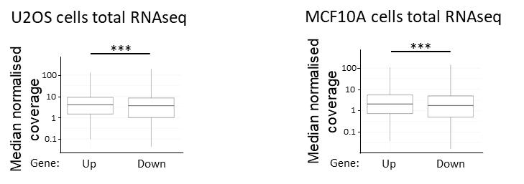

Supplementary figure 1, related to figure 1A. Expression of downstream genes in tandem gene pairs is lower than expression of upstream genes.
Analysis of strand specific total RNA-seq profiles representing the normalized coverage in the gene population for tandem genes in U2OS and MCF10A cells. Analyses are shown for one representative replicate out of two for MCF10A cells and out of four for U2OS cells. Amongst these loci only pairs with a mean of the normalized coverage computed on the gene body >0 and an intergenic region size of more than 100 nt and less than 100kb were considered. A minimum threshold on upstream genes expression was applied to -RT gene class in order to avoid biasing our analysis due to a difference in the level of expression of upstream genes in between the -RT and +RT classes (4071 loci for MCF10A cells and 4707 loci for U2OS cells). Boxplots show the median, first and third quantiles of the level of normalized coverage per gene.
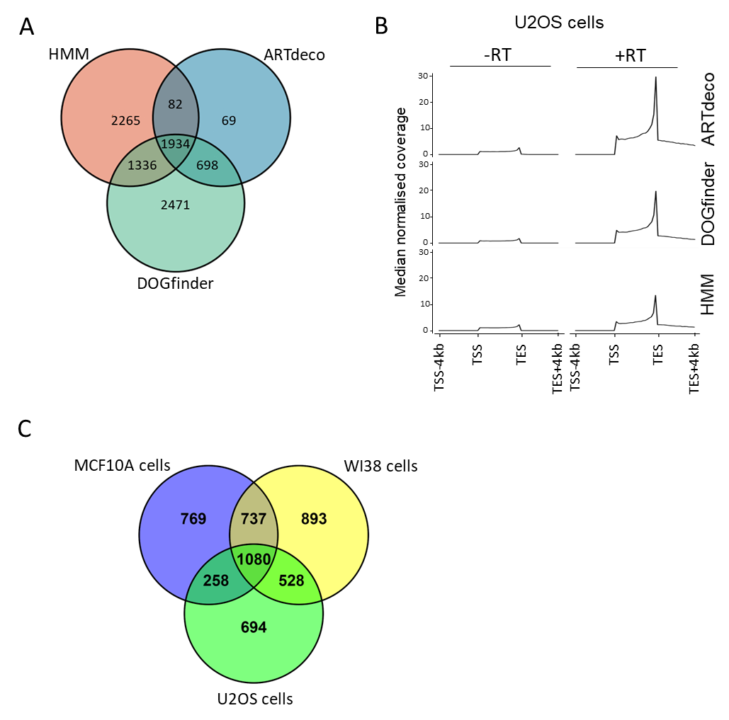

Supplementary figure 2. Detection of read-through by ARTdeco and DOGfinder recapitulate the results obtained with the HMM algorithm.
(A) Venn diagram showing the number of specific and common read-through transcripts detected by the HMM, DOGfinder and ARTdeco pipelines in U2OS cells. (B) Metagene analyses of strand specific total RNA-seq profiles representing the median within the gene population of the normalized coverage at genes producing or not read-through transcripts in U2OS cells. Three different algorithms were used to detect read-through transcripts from genes with a mean of the normalized coverage computed on the gene body >0 (2090 read-through transcripts detected with ARTDeco, 4990 with DOGfinder and 4181 with HMM). Note that the HMM algorithm is less biased for highly expressed genes in the +RT class (C) Venn diagram showing the number of specific and common read-through transcripts detected in WI38, U2OS and MCF10A cell lines using the HMM pipeline.

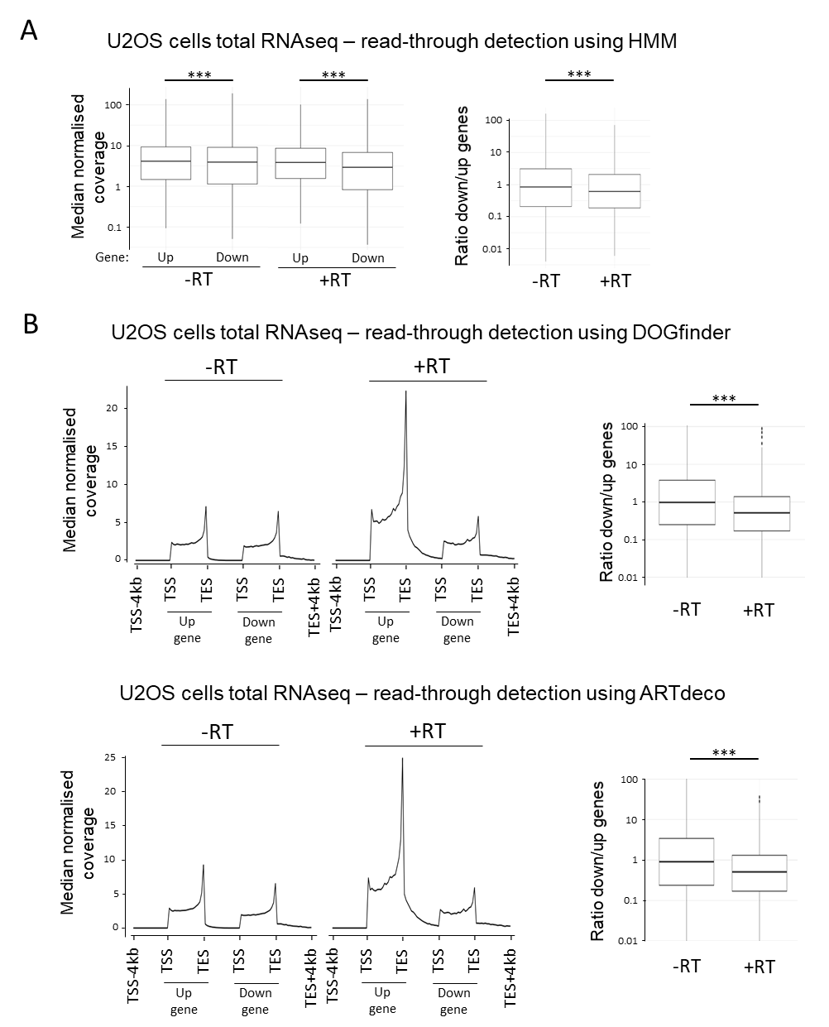
Supplementary figure 3, related to figure 1B. Read-through transcription limits the expression of downstream genes in tandem gene pairs in U2OS cells.
(A) Boxplots showing the median, first and third quantiles of the median normalized coverage for tandem genes (left panel) or the median, first and third quantiles of the ratio of the normalized coverage of the downstream gene on the upstream gene in the -RT and +RT classes (right panel) (from total RNAseq data from U2OS cells as in Figure 1). Tandem gene pairs were separated into two classes based on the production of read-through (RT) transcripts from the upstream gene or not as indicated. Amongst these loci only pairs with a mean of the normalized coverage computed on the gene body >0 and an intergenic region size of more than 100nt and less than 100kb were considered. Analyses are shown for one replicate out of four. A minimum threshold on upstream genes expression was applied to -RT gene class in order to avoid biasing our analysis due to a difference in the level of expression of upstream genes in between the -RT and +RT classes. ***p<0.01 by Wilcoxon-Mann-Whitney test and adjusted by the Benjamini-Hochberg procedure. (B) Same as in figure 1B (for left panels) and supplementary figure 3A (for right panels) except that read-through transcripts were detected using the DOGfinder or ARTdeco pipelines.

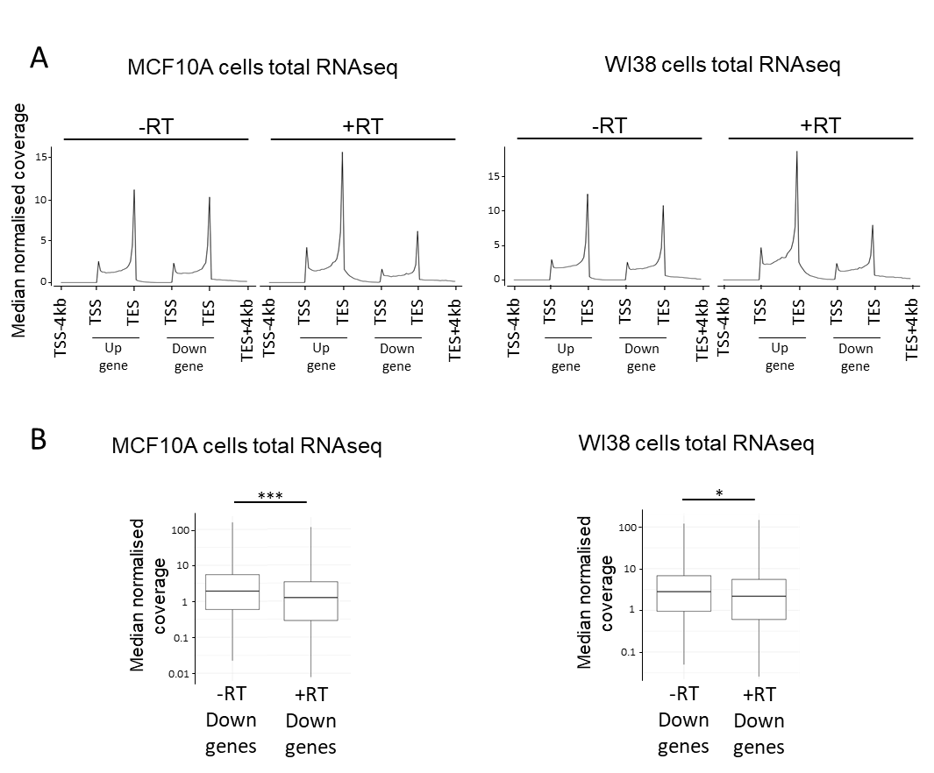
Supplementary figure 4, related to figure 1B. Read-through transcription limits the expression of downstream genes in tandem gene pairs.
(A) Metagene analyses of strand specific total RNA-seq profiles representing the median within the gene population of the normalized coverage in tandem genes and intergenic regions in MCF10A and WI38 cells. Analyses are shown for one representative replicate out of two. Tandem gene pairs were separated into two classes based on the production of read-through (RT) transcripts from the upstream gene or not as indicated. Amongst these loci only pairs with a mean of the normalized coverage computed on the gene body >0 and an intergenic region size of more than 100nt and less than 100kb were considered. A minimum threshold on upstream genes expression was applied to -RT gene class in order to avoid biasing our analysis due to a difference in the level of expression of upstream genes in between the -RT and +RT classes (3871 and 4051 loci in the -RT class, 897 and 915 loci in the +RT class for WI38 cells and MCF10A cells, respectively). (B) Boxplots showing the median, first and third quantiles of the median normalized coverage for downstream genes from the -RT and +RT classes in tandem gene pairs from total RNAseq data from MCF10A and WI38 cells. Tandem genes were selected as in (A). ***p<0.01 and *p<0.05 by Wilcoxon-Mann-Whitney test and adjusted by the Benjamini-Hochberg procedure.
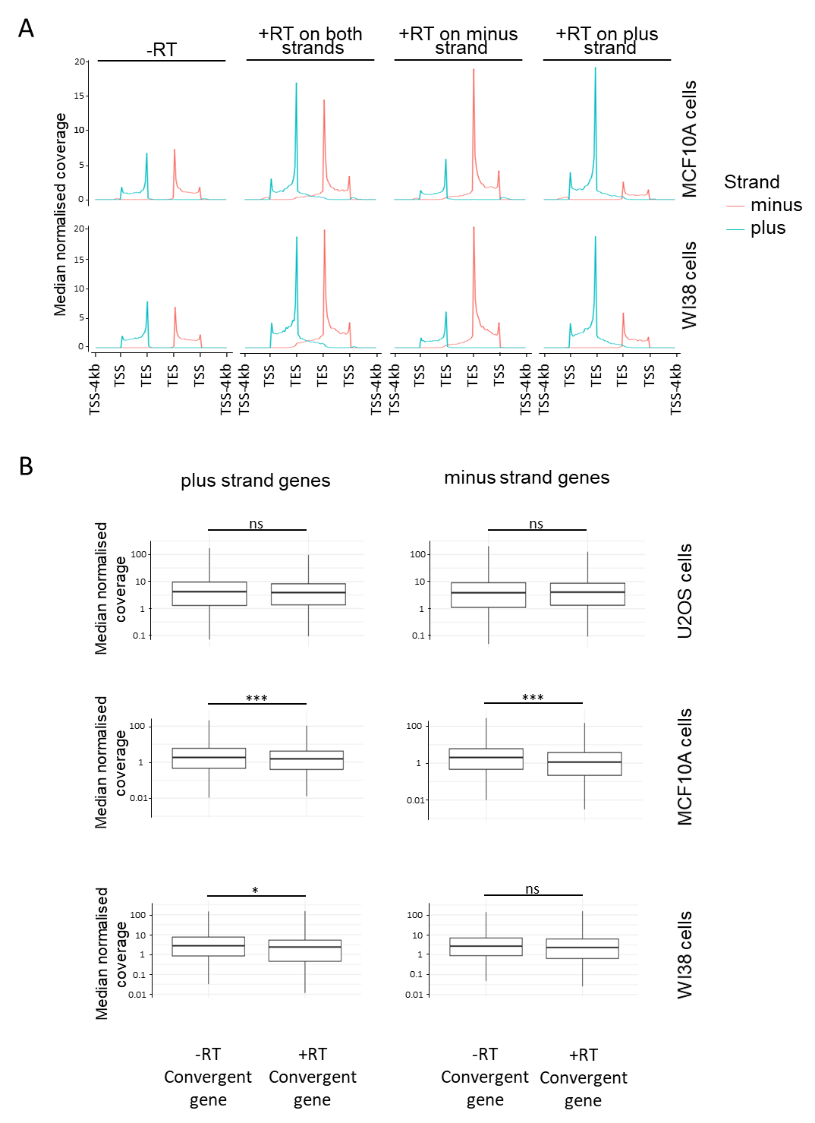
Supplementary figure 5, related to figure 1C
(A) Metagene analysis of strand specific total RNA-seq profiles representing the median within the gene population of the normalized coverage in convergent genes and intergenic regions in MCF10A and WI38 cells. Analyses are shown for one replicate out of two. Amongst these loci only pairs with a mean of the normalized coverage computed on the gene body >0 and an intergenic region size of more than 100 nt and less than 100kb were considered. Convergent genes loci were analysed and separated based on the strand from which the gene producing read-through transcripts is located, as indicated (919 and 832 loci in the -RT class, 327 and 343 loci in the +RT on both strands class, 543 and 493 loci in the +RT on the minus strand class, 470 and 482 loci in the +RT on the plus strand class for MCF10A and WI38 cells respectively). (B) Boxplots showing the median, first and third quantiles of the median normalized coverage for genes located on the strand opposite to the one on which the gene producing the read-through is located for the -RT and +RT classes using data from the indicated cell lines. Convergent genes were selected as in (A). ***p<0.01, *p<0.05, ns: non-significant by Wilcoxon-Mann-Whitney test and adjusted by the Benjamini-Hochberg procedure.

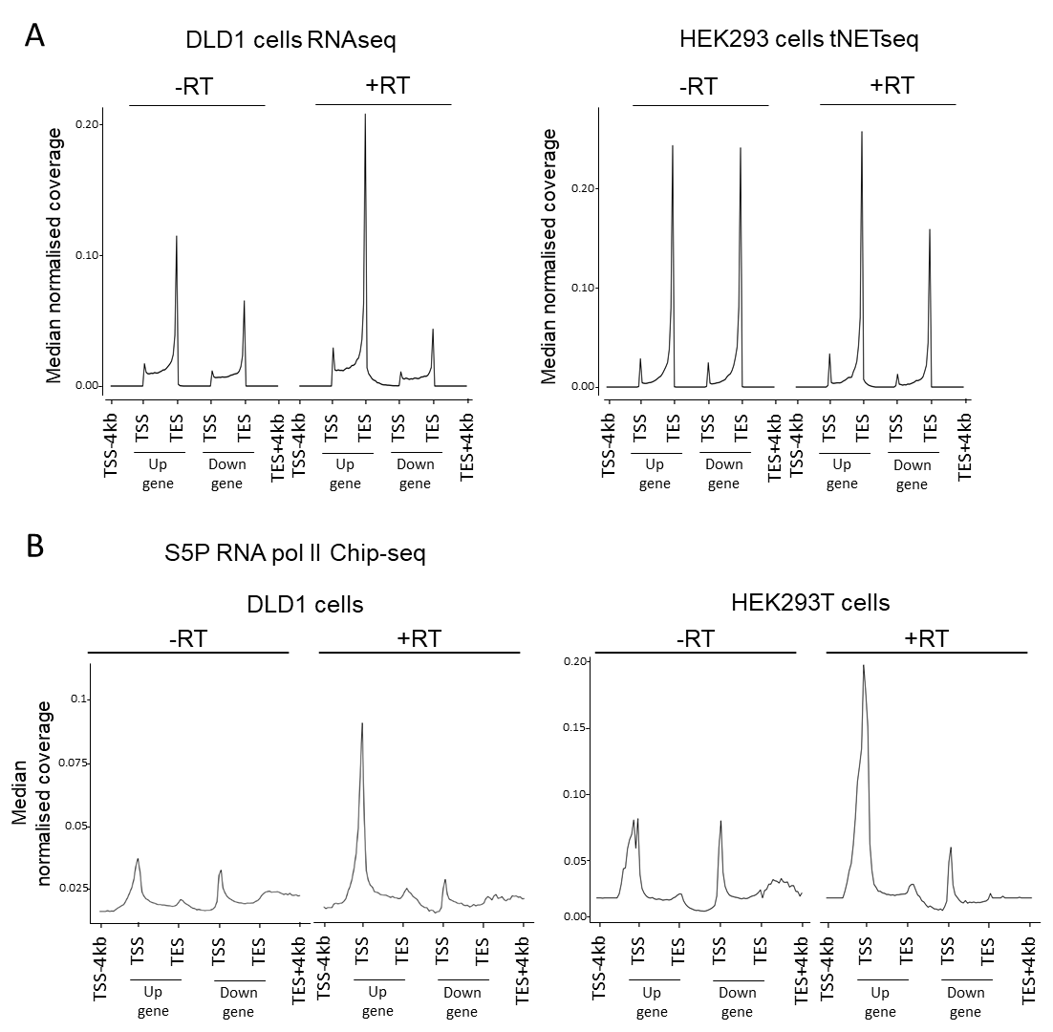
Supplementary figure 6, related to figure 2. Read-through transcription from the upstream gene limits the loading of RNA pol II CTD Ser5P loaded on the promoter of downstream genes.
(A) Metagene analyses of strand specific total RNA-seq or tNETseq profiles representing the median within the gene population of the normalized coverage in tandem genes and intergenic regions in published data from DLD1 and HEK293 cells. Only tandem gene pairs with an intergenic region size of more than 100 nt and less than 100kb, and a mean of the normalized coverage computed on the gene body >0 were considered. In addition, a minimum threshold on upstream genes’ expression was applied to -RT gene class in order to avoid biasing our analysis due to a difference in the level of expression of upstream genes in between the -RT and +RT classes (3699 and 3294 tandem gene pairs for the -RT class and 569 and 1030 tandem gene pairs for the +RT class in DLD1 and HEK293T cells, respectively). (B) Metagene analysis of published Ser5P RNA pol II ChIP-seq data in DLD1 and HEK293T cells representing the median within the gene population of the normalized coverage in tandem genes and intergenic regions. Only tandem genes pairs with an intergenic region size of more than 100 nt and less than 100kb, and an expression level amongst the 75% most expressed genes (based on RNAseq and tNET-seq data analyses) were considered. In addition, a minimum threshold on upstream genes’ expression was applied to -RT gene class in order to avoid biasing our analysis due to a difference in the level of expression of upstream genes in between the -RT and +RT classes (3699 and 3294 tandem gene pairs for the -RT class and 569 and 1030 tandem gene pairs for the +RT class in DLD1 and HEK293T cells, respectively).

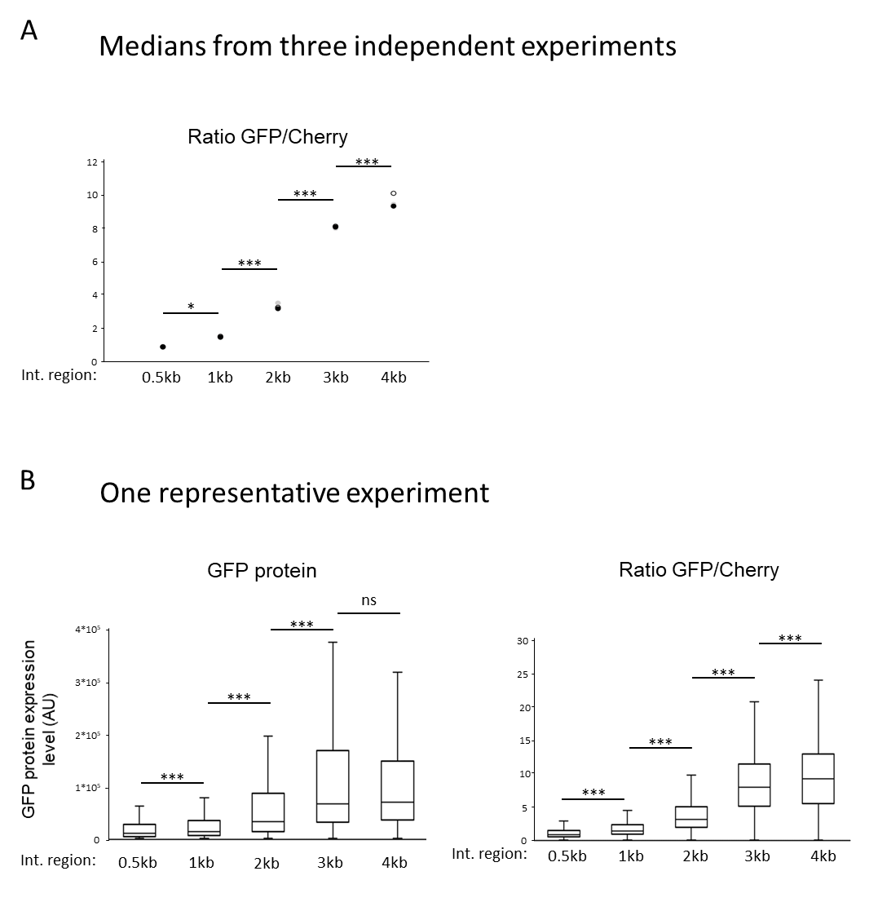
Supplementary figure 7, related to figure 3. The level of transcriptional interference depends on the distance travelled by RNA pol II downstream of the polyA site.
(A) The GFP and mCherry protein expression levels were measured by flow cytometry in U2OS cells transfected with the reporter systems harboring different intergenic region sizes, as indicated. The ratio of GFP over mCherry expression was calculated for each individual cell in the population. The dot plots show the medians for 10 000 cells from three independent experiments identified by circles of different colors. *p<0.05, ***p<0.01 by paired Welch test. (B) Left panel: GFP protein expression level measured by flow cytometry in U2OS cells transfected with the different reporter systems as in (A). The boxplots show the median, first and third quantiles for 10 000 cells in each condition, for one representative experiment out of three. ***p<0.01, ns: non-significant by Wilcoxon-Mann-Whitney test and adjusted by the Benjamini-Hochberg procedure. Right panel: same as left panel except that the ratio of GFP over mCherry expression was calculated for each individual cell in the population.
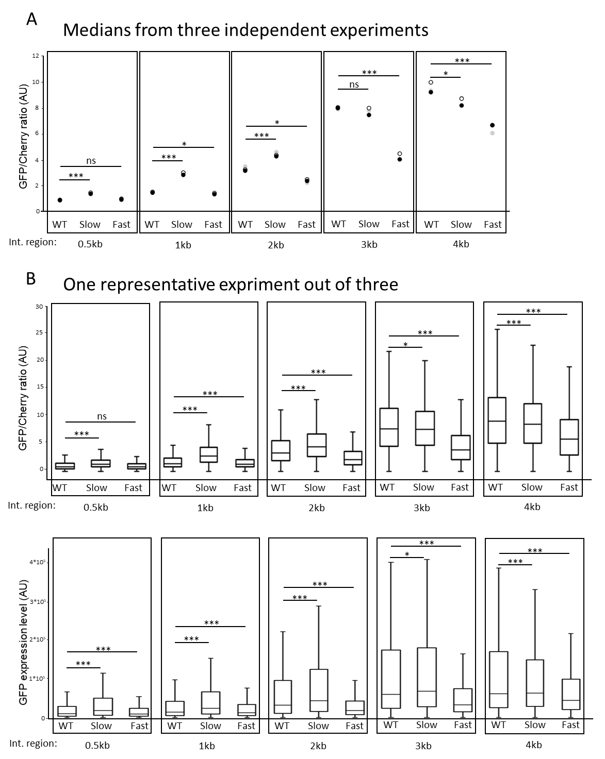
Supplementary figure 8, related to figure 4A. The level of transcriptional interference is determined by RNA pol II speed on transiently transfected reporter systems.
(A) GFP and mCherry protein expression levels were measured by flow cytometry in U2OS cells co-transfected with plasmids encoding either the 0.5kb-IntR, 1kb-IntR, 2kb-IntR, 3kb-IntR or 4kb-IntR reporter systems together with the WT, Slow or Fast RNA pol II mutants expression vectors and treated with alpha-amanitin for 48 hours. The ratio of GFP over mCherry expression was calculated for each individual cell in the population. Dot plots show the median for 10 000 cells in each condition, for three independent experiments. *p<0.05, ***p<0.01, ns: non-significant by Welch t-test. (B) Top panel: same as in (A), except that the boxplots show the median, first and third quantiles for 10 000 cells in each condition, for one representative experiment out of three. *p<0.05, ***p<0.01, ns: non-significant by Wilcoxon-Mann-Whitney test and adjusted by the Benjamini-Hochberg procedure. Bottom panel: same as top panel except that the GFP expression level is shown.

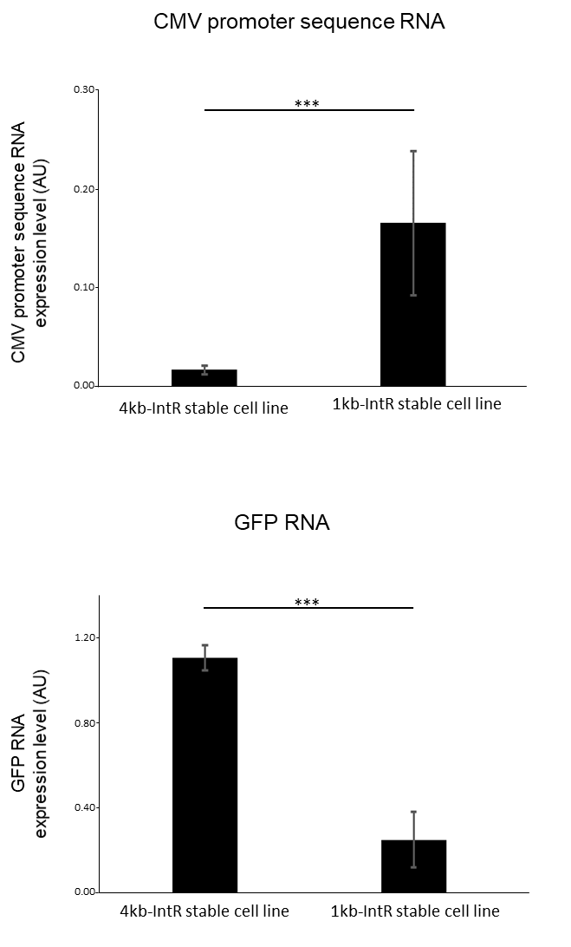
Supplementary figure 9. The level of expression of reporter genes in a chromatin context recapitulates that measured on plasmids.
GFP and CMV promoter sequence RNA expression level was measured by RT-qPCR in the 4kb-IntR and 1kb-IntR reporter cell lines and normalized relative to GAPDH mRNA expression level. The means and standard deviations from three to six independent experiments are shown. ***p<0.01 by Welch t-test.
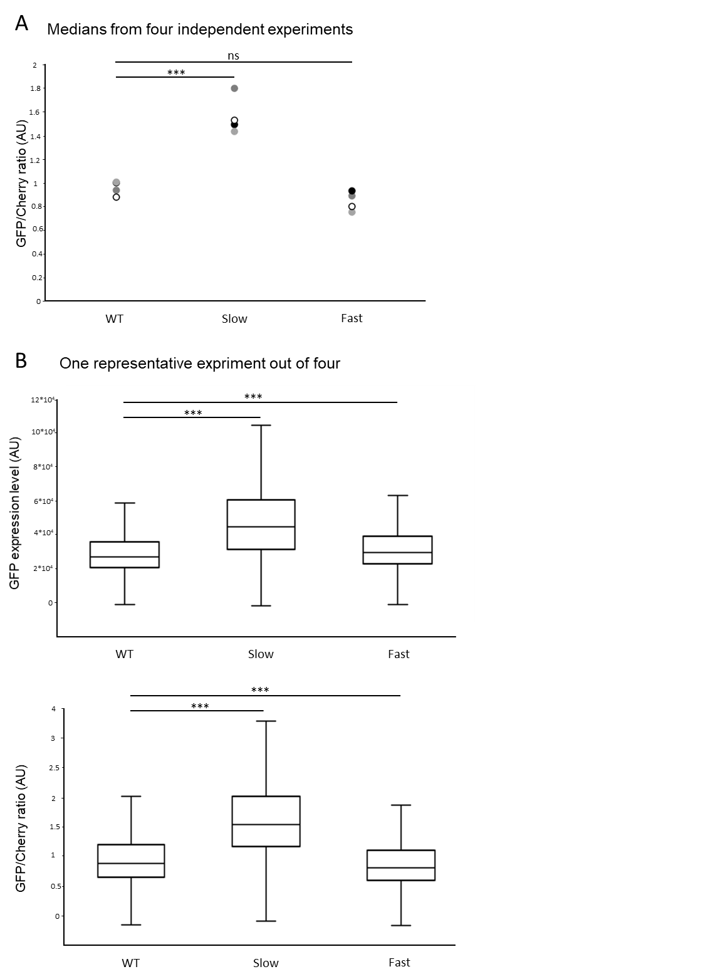
Supplementary figure 10, related to figure 4B. The level of transcriptional interference is determined by RNA pol II speed on the integrated 1kb-IntR reporter system.
(A) The 1kb-IntR reporter cell line was transfected with plasmids encoding the WT, Slow or Fast RNA pol II mutants and treated with alpha-amanitin for 48 hours. The GFP and mCherry protein expression levels were measured by flow cytometry and the ratio of GFP over mCherry expression was calculated for each individual cell in the population. Dot plots show the median for 10 000 cells in each condition, for four independent experiments identified by circles of different colors. ***p<0.01, ns: non-significant by Welch t-test. (B) Top panel: same as in (A), except that GFP protein expression levels were measured by flow cytometry and boxplots show the median, first and third quantiles for 10 000 cells in each condition, for one representative experiment out of four. ***p<0.01 by Wilcoxon-Mann-Whitney test and adjusted by the Benjamini-Hochberg procedure. Bottom panel: same as top panel except that the GFP over mCherry expression ratio was calculated for each individual cell in the population.
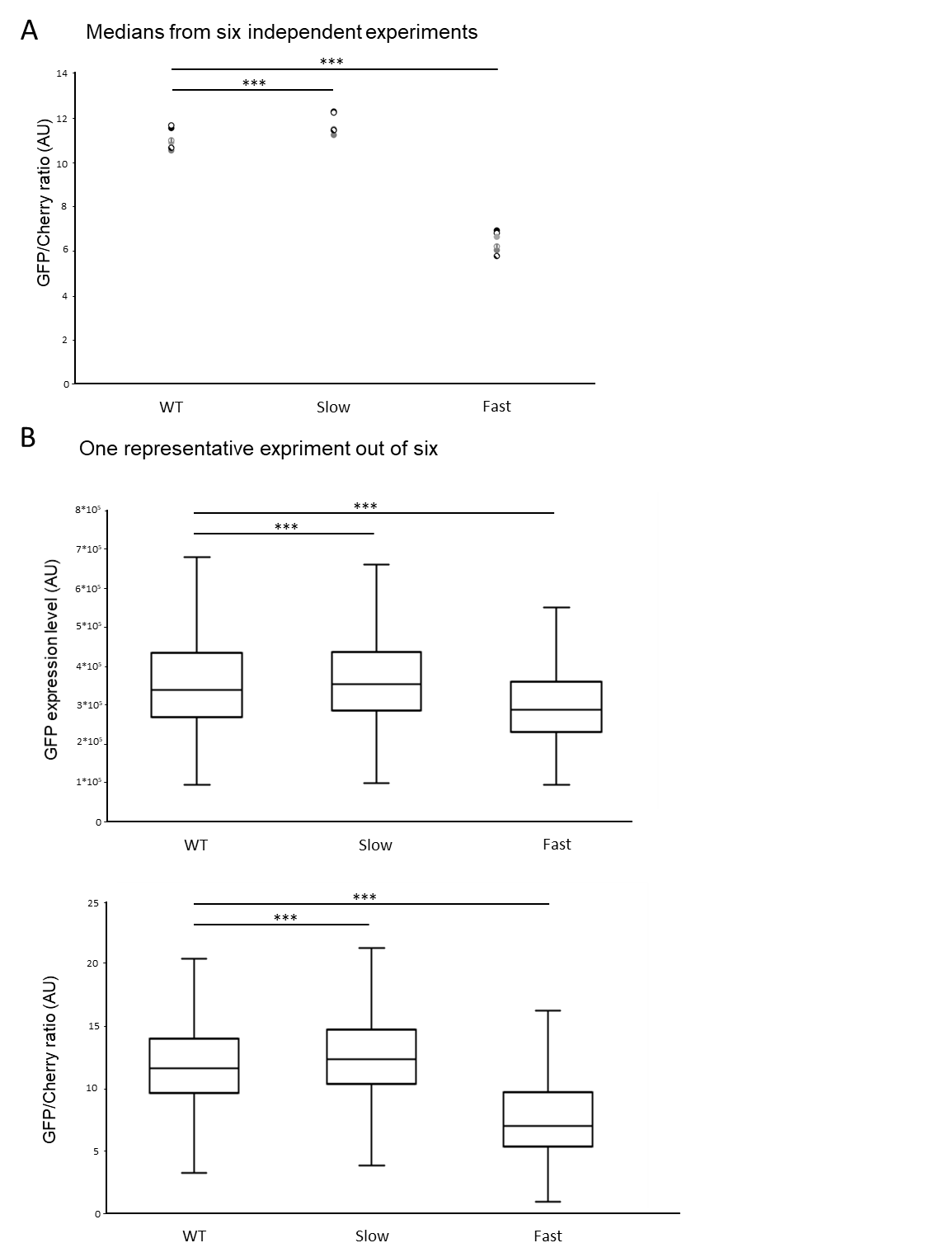
Supplementary figure 11, related to figure 4C. The level of transcriptional interference is determined by RNA pol II speed on the integrated 4kb-IntR reporter system.
(A) The 4kb-IntR reporter cell line was transfected with plasmids encoding the WT, Slow or Fast RNA pol II mutants and treated with alpha-amanitin for 48 hours. The GFP and mCherry protein expression levels were measured by flow cytometry and the ratio of GFP over mCherry expression was calculated for each individual cell in the population. Dot plots show the median for 10 000 cells in each condition, for six independent experiments identified by circles of different colors. ***p<0.01 by Welch t-test. (B) Top panel: same as in (A), except that GFP protein expression levels were measured by flow cytometry and boxplots show the median, first and third quantiles for 10 000 cells in each condition, for one representative experiment out of six. ***p<0.01 pvalue by Wilcoxon-Mann-Whitney test and adjusted by the Benjamini-Hochberg procedure. Bottom panel: same as top panel except that the GFP over mCherry expression ratio was calculated for each individual cell in the population.

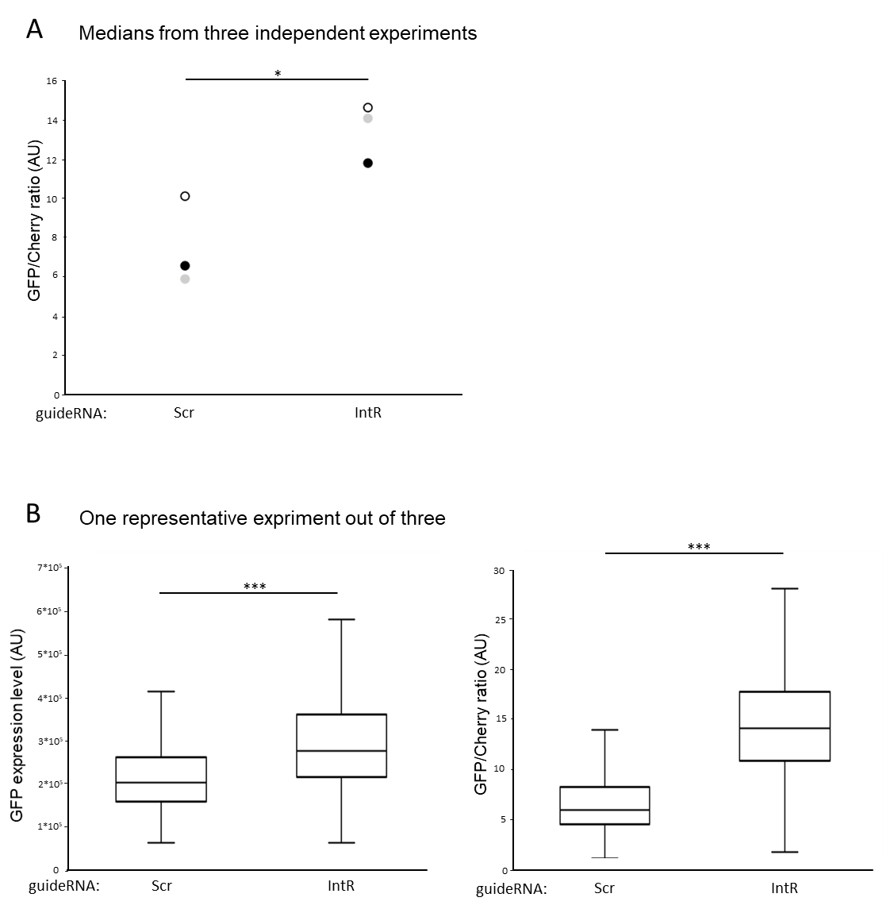
Supplementary figure 12, related to figure 5A.
(A) The 4kb-IntR reporter cell line was co-transfected with the plasmid encoding the Fast RNA pol II mutant, a plasmid encoding the dCas9 protein, and either a control guide RNA (Scr) or a guide RNA targeting the non-transcribed strand in the intergenic region between mCherry and GFP (IntR). The GFP and mCherry protein expression levels were measured by flow cytometry and the ratio of GFP over mCherry expression was calculated for each individual cell in the population. Dot plots show the medians for 10 000 cells in each condition from three independent experiments identified by circles of different colors. *p<0.05 by Student’s t-test. (B) Left panel: same as in (A), except that GFP protein expression levels were measured by flow cytometry and boxplots show the median, first and third quantiles for 10 000 cells in each condition, for one representative experiment out of three. ***p<0.01 pvalue by Wilcoxon-Mann-Whitney test and adjusted by the Benjamini-Hochberg procedure. Right panel: same as in (A), except that the boxplots show the median, first and third quantiles of the GFP/Cherry ratio for 10 000 cells in each condition, for one representative experiment out of three. ***p<0.01 pvalue by Wilcoxon-Mann-Whitney test and adjusted by the Benjamini-Hochberg procedure.

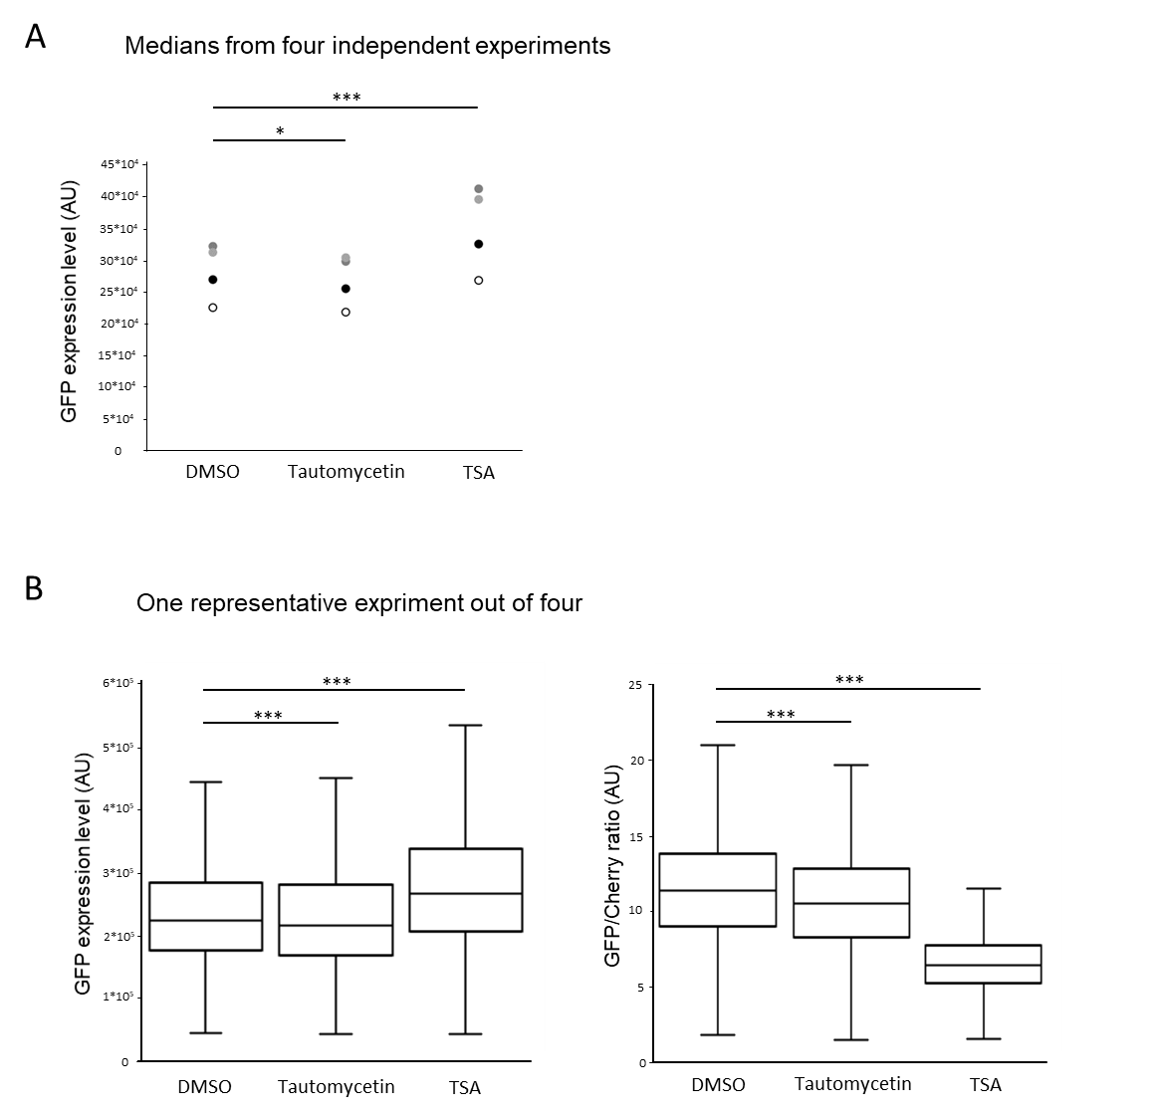
Supplementary figure 13, related to figure 5B.
(A) GFP protein expression levels were measured by flow cytometry in the 4kb-IntR cell line treated with either the histone deacetylase inhibitor trichostatin A (TSA) at 3.3 µM, an inhibitor of the PP1 phosphatase Tautomycetin at 500nM or DMSO as a control. Dot plots show the medians for 10 000 cells from four independent experiments identified by circles of different colors. *p<0.05, ***p<0.01 by Student’s t-test. (B) Left panel: same as in (A), except that GFP protein expression levels were measured by flow cytometry and boxplots show the median, first and third quantiles for 10 000 cells in each condition, for one representative experiment out of four. ***p<0.01 by Wilcoxon-Mann-Whitney test and adjusted by the Benjamini-Hochberg procedure. Right panel: same as in (A), except that the boxplots show the median, first and third quantiles of the GFP/Cherry ratio for 10 000 cells in each condition, for one representative experiment out of four. ***p<0.01 by Wilcoxon-Mann-Whitney test and adjusted by the Benjamini-Hochberg procedure.

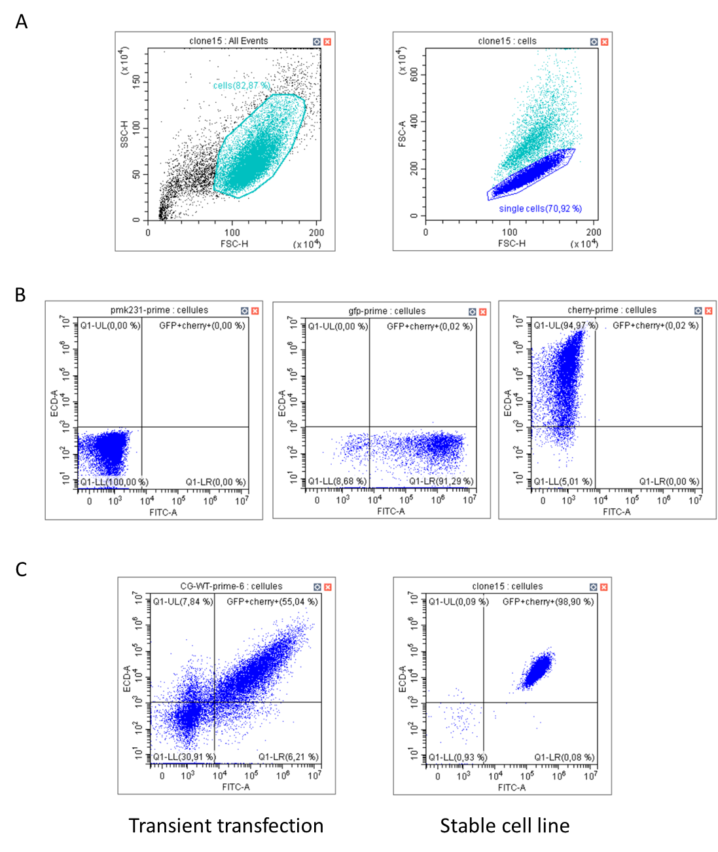Supplementary figure 14. Flow cytometry analyses of the reporter system.
(A) Side scatter height versus forward scatter height were plotted in order to select for cells (left panel). Forward scatter height versus Forward scatter width were then plotted in order to select for single cells (right panel). (B) Scatter plot of ECD-A versus FITC-A for cells transfected with either the original pMK231 plasmid (left panel), a plasmid encoding the GFP protein (central panel), or a plasmid encoding the mCherry protein (right panel). These analyses were used to set up adequate compensation. (C) Examples of cells transiently transfected with the reporter system (left panel) or the stable cell line (right panel), analysed cells are included in the upper right panel “GFP+Cherry+”.

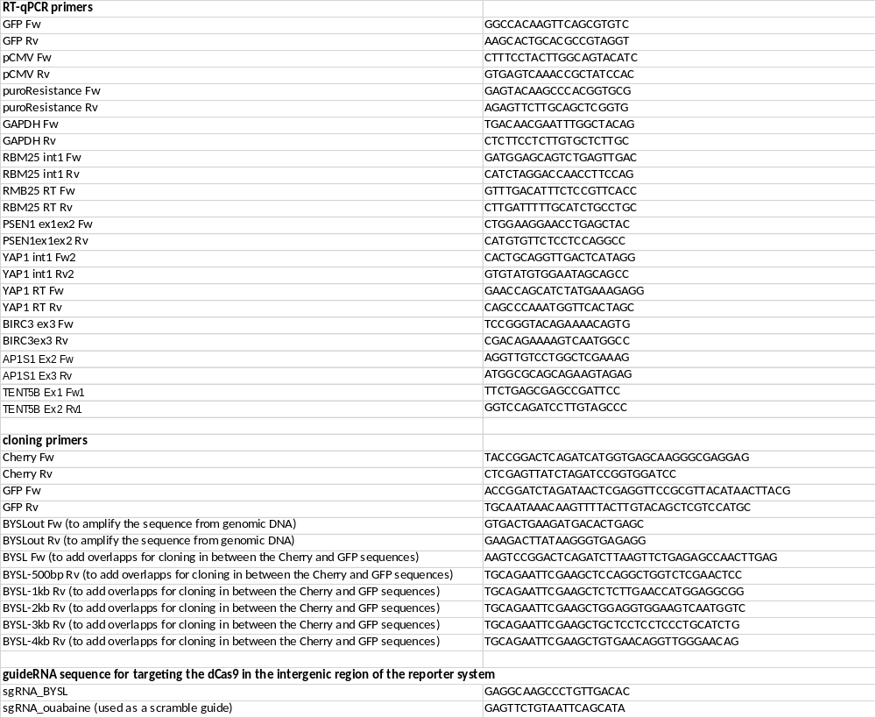

Supplementary Table 1. List of primers used in this study.

