Supplementary Figures

Metaproteomic portrait of the gut microbiome in children with Down syndrome (Marzano Valeria et al.).
Supplementary Figure 1. Scatter plot graphs of quantified extracted proteins (panel A), and purified peptides (panel B). from stools of children with Down Syndrome (DS). Mean values are evidenced as black bar
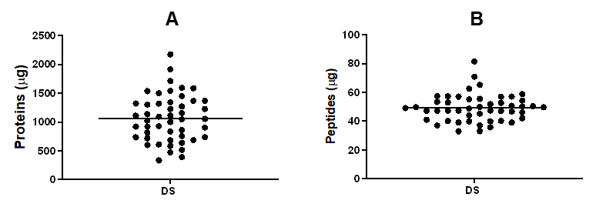

Supplementary Figure 2. Relative distribution (%) of the three major phyla associated with differentially expressed Protein Groups across three stratification strategies: (A) presence/absence of autoimmune thyroid disease; (B) immunological diseases; and (C) behavioral disorders. Upper and lower panels represent age group 1 and age group 2, respectively.
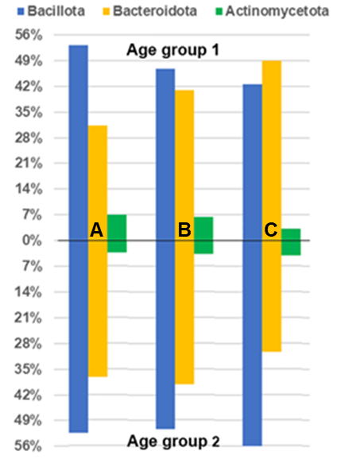

Supplementary Figure 3. Cluster analyses were conducted on differentially expressed KEGG pathways that were associated with the identified bacterial protein groups (PGs) found in stool samples from patients with DS with or without autoimmune thyroid diseases. The color coding of orange and blue denotes over-expressed and under-expressed KEGG pathways in the presence of the diseases/disorders, respectively. The mean intensity abundance of PGs with the same KEGG pathways for each sample was calculated. Statistically significant pathways were then identified by computing a Mann-Whitney test and adjusted p-value for false discovery rate (using Benjamini-Hochberg correction for independent or positively correlated tests). For the number of KEGG pathways, their regulation, and associations with PGs, please refer to the Supplementary File 4.
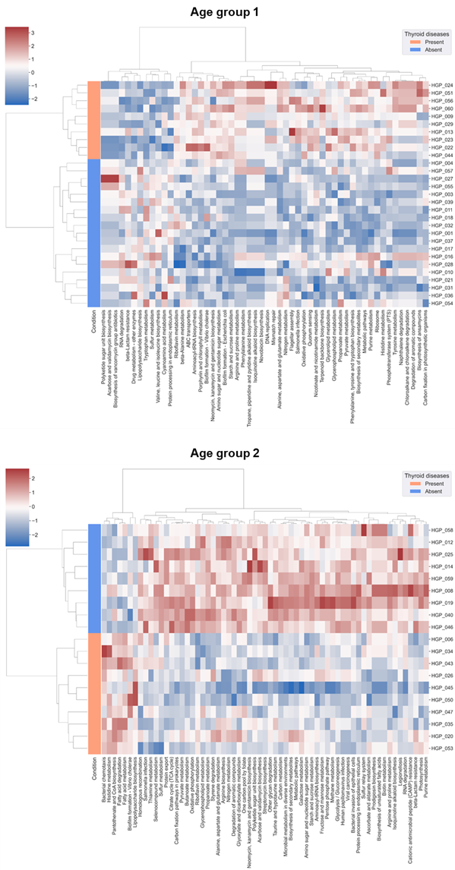
Supplementary Figure 4. Cluster analyses were conducted on differentially expressed KEGG pathways that were associated with the identified bacterial protein groups (PGs) found in stool samples from patients with DS with or without immune-related comorbidities. The color coding of orange and blue denotes over-expressed and under-expressed KEGG pathways in the presence of the diseases/disorders, respectively. The mean intensity abundance of PGs with the same KEGG pathways for each sample was calculated. Statistically significant pathways were then identified by computing a Mann-Whitney test and adjusted p-value for false discovery rate (using Benjamini-Hochberg correction for independent or positively correlated tests). For the number of KEGG pathways, their regulation, and associations with PGs, please refer to the Supplementary File 4.
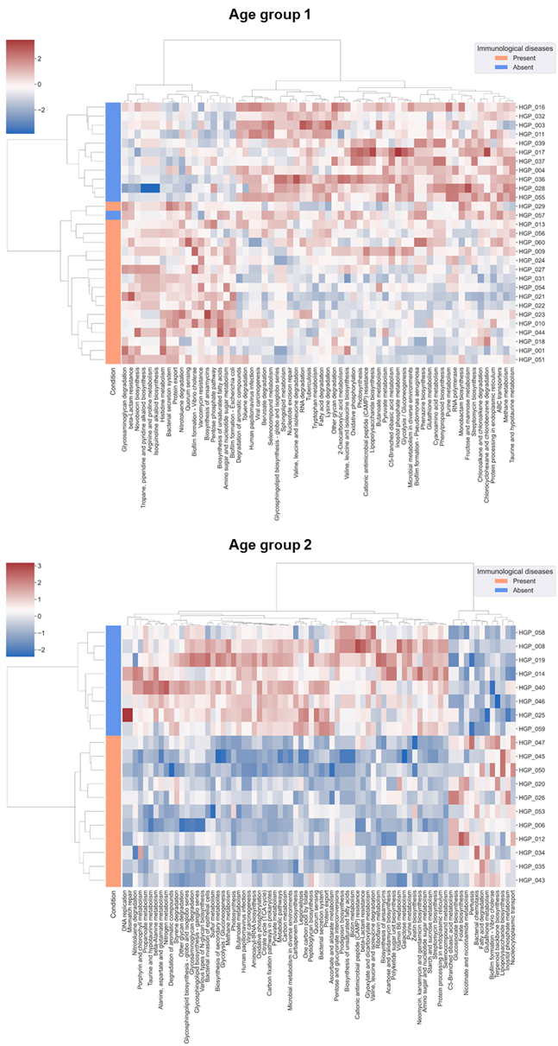
Supplementary Figure 5. Cluster analyses were conducted on differentially expressed KEGG pathways that were associated with the identified bacterial protein groups (PGs) found in stool samples from patients with DS with or without immune-related comorbidities. The color coding of orange and blue denotes over-expressed and under-expressed KEGG pathways in the presence of the diseases/disorders, respectively. The mean intensity abundance of PGs with the same KEGG pathways for each sample was calculated. Statistically significant pathways were then identified by computing a Mann-Whitney test and adjusted p-value for false discovery rate (using Benjamini-Hochberg correction for independent or positively correlated tests). For the number of KEGG pathways, their regulation, and associations with PGs, please refer to the Supplementary File 4.
