Supplementary Material

Microbial Communities of Ascocarps and Soils in a Natural Habitat of Tuber indicum
Deyuan Wang^{1, 2}, Qiang Xu^{1, 2}, Wenjiao Guo³, Fanlin Wu¹, Juan Chen⁴, Peigui Liu⁵, Wei Tian^{1*} and Peng Qiao^{2*}
* Correspondence:
Wei Tian
tianweixiaoxiao@163.com
Peng Qiao
qiaopeng3000buy@163.com

Fig. S1 Rarefaction curves for bacterial (a) and fungal (b) operational taxonomic units (OTUs) in different samples (cut-off at 97% similarity). The curves reach saturation for all samples studied, meaning the sequencing depth is enough for diversity analysis. T, fruiting bodies of T. indicum; SS, soils inside brûlé; NSS, soils outside brûlé. Qthers, unclassified taxa.
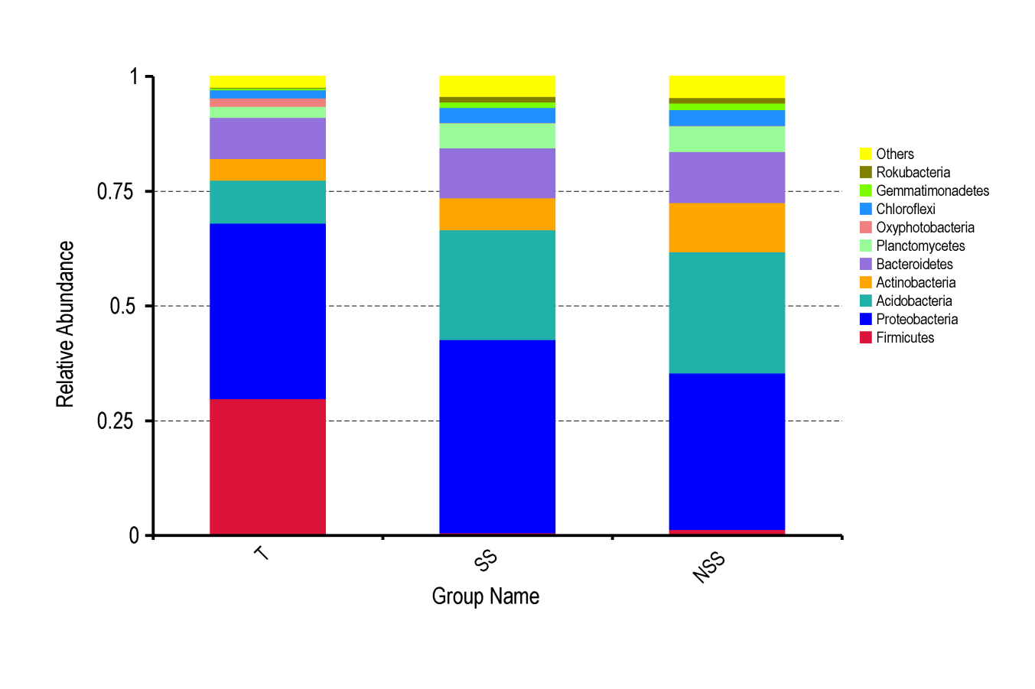
Fig. S2 Taxonomic composition of bacterial communities of T, SS and NSS at the phylum levels.

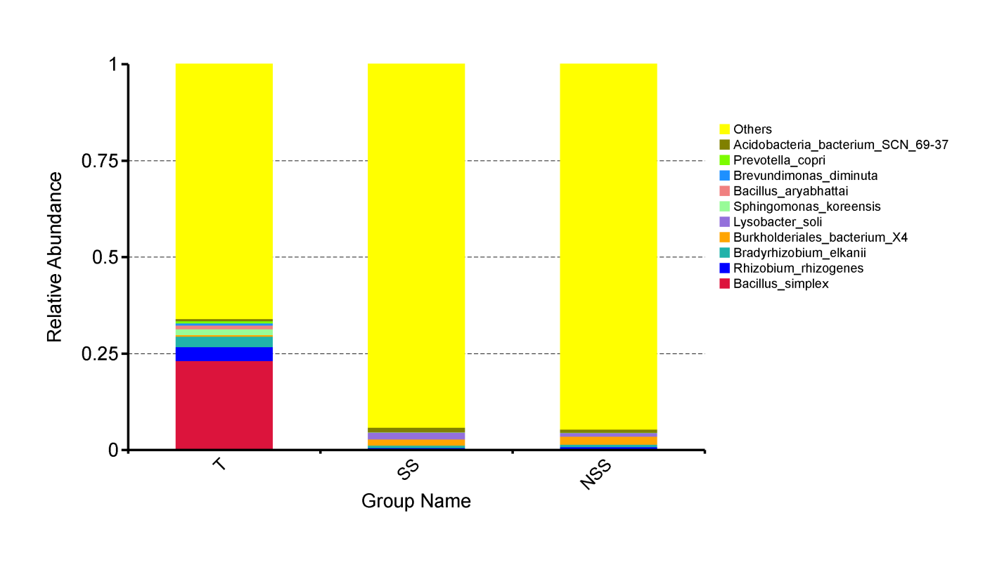
Fig. S3 Taxonomic composition of bacterial communities of T, SS and NSS at the species levels.
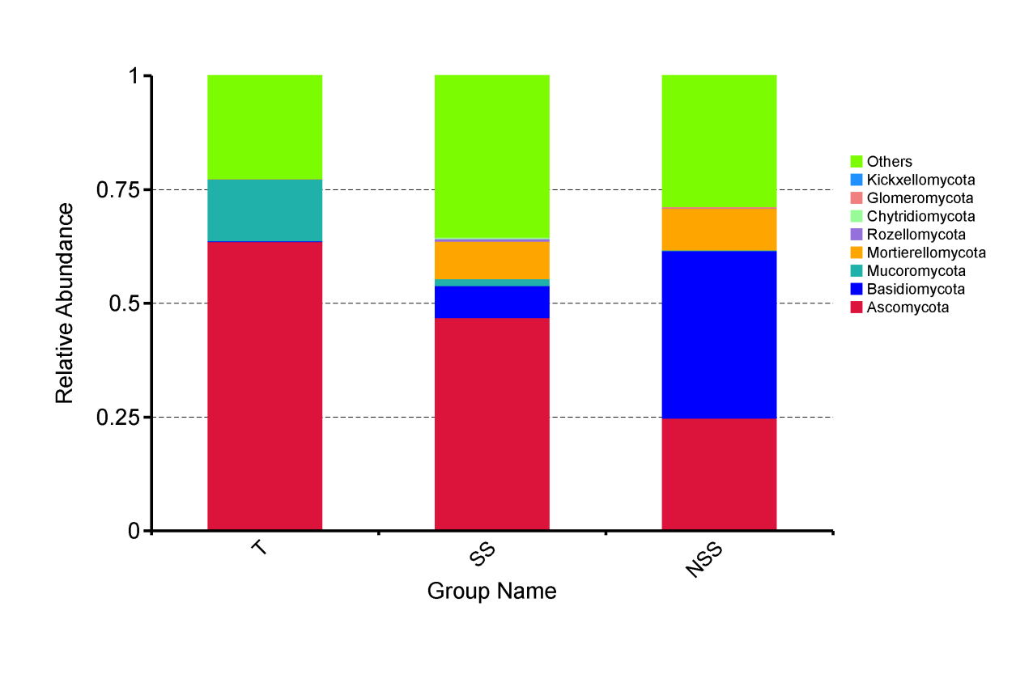
Fig. S4 Taxonomic composition of fungal communities of T, SS and NSS at the phylum levels.
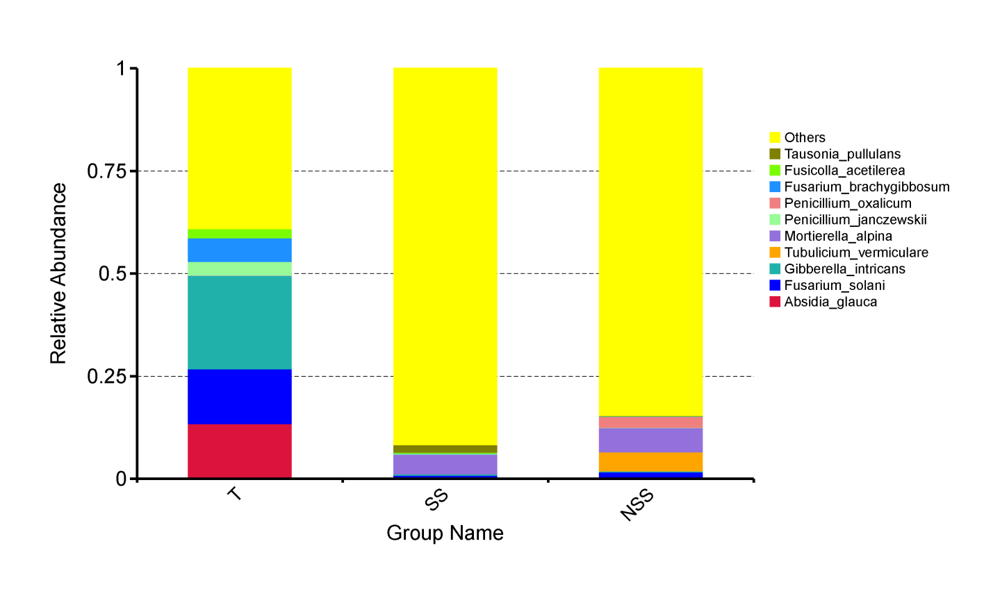
Fig. S5 Taxonomic composition of fungal communities of T, SS and NSS at the species levels.

